Supplementary material
to
Cooperation of enzymes involved in carbohydrate digestion of Colorado potato beetle (Leptinotarsa decemlineata, Say)

Eszter Szilágyiª, Csaba Hámori^{b}, Piroska Bíró-Molnárª, Lili Kandra^{b}, Judit Remenyikª, Gyöngyi Gyémánt^{b*}
ªInstitute of Food Technology, Faculty of Agricultural and Food Sciences and Environmental Management, University of Debrecen, H-4032 Debrecen, Hungary
^{b}Department of Inorganic and Analytical Chemistry, Faculty of Sciences and Technology, University of Debrecen, H-4032 Debrecen, Hungary

Figure S1. Thermal stability of Leptinotarsa decemlineata α-amylase on GalG2-CNP substrate

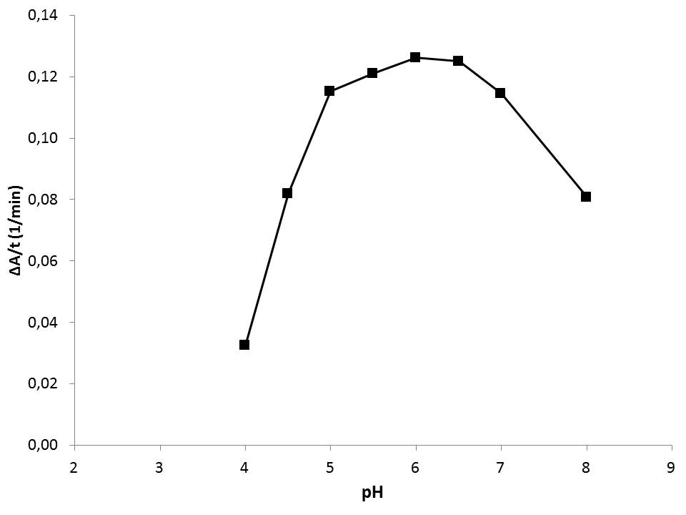
Figure S2. The pH dependence of α-amylase activity from L. decemlineata larvae measured on GalG₂CNP substrate

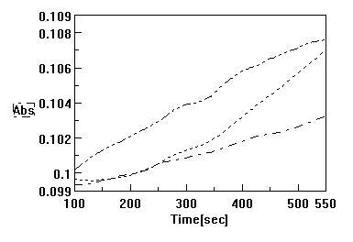
Figure S3. Kinetic curves of enzyme reactions on PNP-α-G: , PNP-β-G: and GalG2CNP: substrates using L. decemlineata gut extract as enzyme source.

