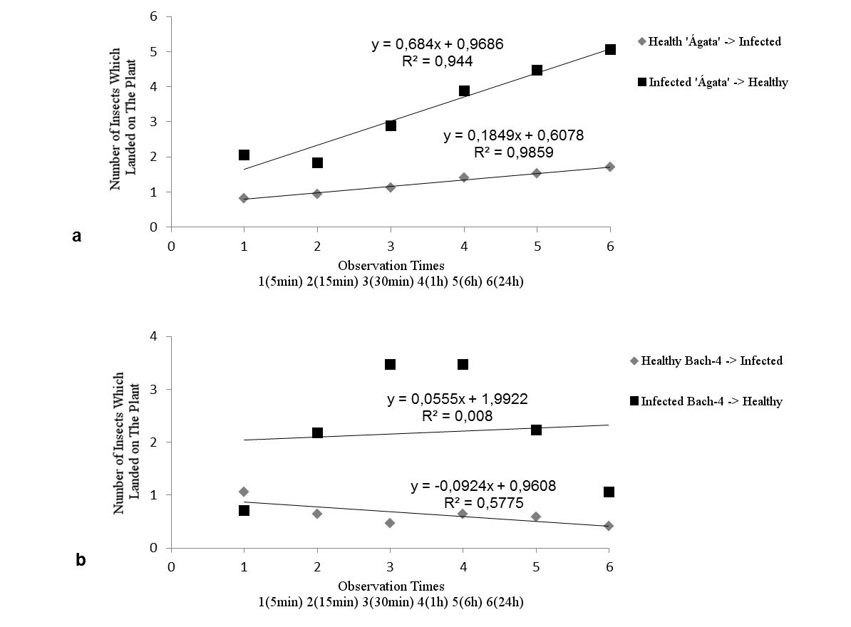
Supplementary Figure 1 – Linear correlation of the number of adults of Bemisia tabaci biotype B moving from mock-inoculated (healthy) to ToCV-infected plant, or from ToCV-infected to mock-inoculated (healthy) in two potato clones, ‘Agata’ (a) and Bach-4 (b). This dispersal assay was conducted in a greenhouse. Each experimental unit consisted on a cage where twenty non-viruliferous whitefly adults were released either on mock-inoculated or on ToCV-infected plants (n = 15). The number of B. tabaci biotype B on the neighbor plant (ToCV-infected or mock-inoculated) was recorded at 5, 15, 30 and 60 min, and 6 and 24 h.

