The influence of antibiotics on gut bacteria diversity associated with laboratory-reared Bactrocera dorsalis

Lijun Liu^{1#}, Zhenzhen Bai^{1#}, Md Shibly Noman¹, Lingyu Zeng¹, Meng Luo¹, Zhihong Li^{1*}

¹Department of Entomology, College of Plant Protection, China Agricultural University, Beijing 100193, China.

#: These authors contributed equally to this work.
*: Correspondence and requests for materials should be addressed to Zhihong Li. (email: lizh@cau.edu.cn)

Supplementary materials
Supplementary Tab. 1. The quality control results for control and treatment groups. CK represents the control group supplied with normal diet; T represents the treatment group supplied with diet with antibiotic at different concentrations; L: larvae; F: female adults; M: male adults.
Supplementary Tab. 2. The sequence and OTU number and Alpha indices for control and treatment groups. CK represents the control group supplied with normal diet; T represents the treatment group supplied with diet with antibiotic at different concentrations; L: larvae; F: female adults; M: male adults.

Supplementary Fig. 1. The Chao rarefaction curves of samples among the control and treatment groups. A: larvae; B: female adults; C: male adults. CK: control group; T1-T4: four treatment groups feeding on antibiotics in four combinations according to Table 1.
Supplementary Fig. 2. Bray tree of bacteria diversity among the control and treatment groups. A: larvae; B: female adults; C: male adults. CK: control group; T1-T4: four treatment groups feeding on antibiotics in four combinations according to Table 1. L: larvae; F: female adults; M: male adults.
Supplementary Fig. 3. Genus level of gut bacteria in the control and treatment groups. A: larvae; B: female adults; C: male adults. Red: control group; dark green: T1 treatment group; green: T2 treatment group; blue: T3 treatment group; purple: T4 treatment group. T1-T4: Four treatment groups feeding on antibiotics in four combinations according to Table 1. L: larvae; F: female adults; M: male adults.
Supplementary Tab 1. The quality control results for control and treatment groups
Sample | Raw_num | Clean_num | Organelle_num | Chimeras_num | Filtered_num
CK-L | 57911 | 56235 | 106 | 767 | 55358
T1-L | 51515 | 49717 | 264 | 548 | 48905
T2-L | 48048 | 46304 | 164 | 465 | 45675
T3-L | 61361 | 59799 | 305 | 1847 | 57632
T4-L | 51351 | 50050 | 152 | 524 | 49369
CK-F | 82007 | 79962 | 0 | 992 | 78970
T1-F | 28018 | 26732 | 348 | 589 | 25786
T2-F | 48419 | 46815 | 18 | 1220 | 45572
T3-F | 21570 | 20687 | 242 | 1065 | 19379
T4-F | 28121 | 26271 | 362 | 1144 | 24748
CK-M | 56829 | 55659 | 1 | 141 | 55517
T1-M | 25788 | 24784 | 301 | 1031 | 23449
T2-M | 29433 | 28265 | 125 | 717 | 27417
T3-M | 26769 | 25521 | 126 | 554 | 24830
T4-M | 46276 | 44648 | 1 | 144 | 44501

CK represents the control group supplied with normal diet;
T represents the treatment group supplied with diet with antibiotic at different concentrations;
L: larvae; F: female adults; M: male adults.
Supplementary Tab 2. The sequence and OTU number and Alpha indices for control and treatment groups
Sample | Seq_num | OTU_num | Shannon_index | ACE_index | Coverage
CK-L | 54128 | 612 | 2.3 | 705 | 1.00
T1-L | 47616 | 772 | 2.6 | 876 | 1.00
T2-L | 44530 | 614 | 2.4 | 744 | 1.00
T3-L | 56073 | 762 | 2.7 | 835 | 1.00
T4-L | 48092 | 805 | 2.8 | 893 | 1.00
CK-F | 76200 | 319 | 1.2 | 356 | 1.00
T1-F | 24865 | 834 | 3.6 | 907 | 1.00
T2-F | 43679 | 687 | 3.6 | 809 | 1.00
T3-F | 18672 | 744 | 4.9 | 803 | 1.00
T4-F | 23877 | 977 | 4.7 | 1050 | 1.00
CK-M | 53812 | 234 | 1.1 | 302 | 1.00
T1-M | 22612 | 785 | 4.1 | 851 | 1.00
T2-M | 26302 | 826 | 3.3 | 987 | 1.00
T3-M | 23843 | 870 | 3.6 | 974 | 1.00
T4-M | 42711 | 651 | 3.6 | 779 | 1.00

CK represents the control group supplied with normal diet;
T represents the treatment group supplied with diet with antibiotic at different concentrations;
L: larvae; F: female adults; M: male adults.
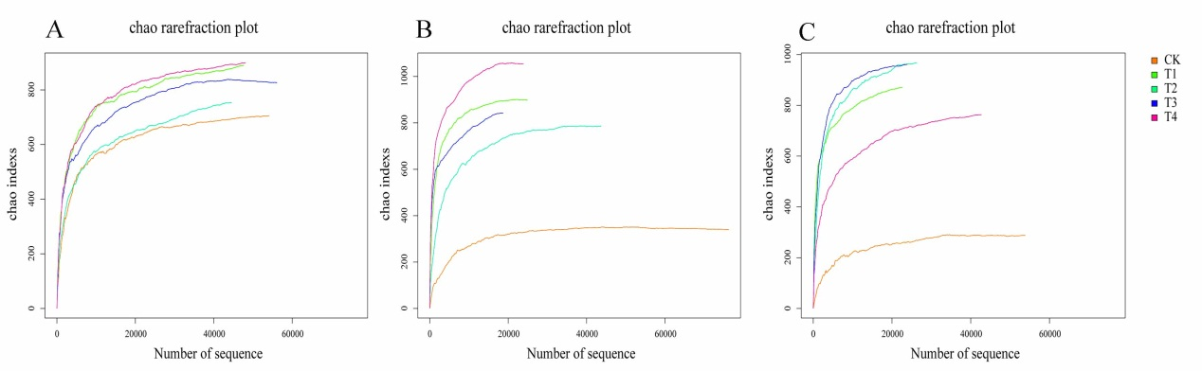

Supplementary Fig. 1. The Chao rarefraction curves of samples among the control and treatment groups. A: larvae; B: female adults; C: male adults. CK: control group; T1-T4: four treatment groups feeding on antibiotics in four combinations according to Table 1.

Supplementary Fig. 2. Bray tree of bacteria diversity among the control and treatment groups. A: larvae; B: female adults; C: male adults. CK: control group; T1-T4: four treatment groups feeding on antibiotics in four combinations according to Table 1. L: larvae; F: female adults; M: male adults.

A

B

C
Supplementary Fig. 3. Genus level of gut bacteria in the control and treatment groups. A: larvae; B: female adults; C: male adults. Red: control group; dark green: T1 treatment group; green: T2 treatment group; blue: T3 treatment group; purple: T4 treatment group. T1-T4: Four treatment groups feeding on antibiotics in four combinations according to Table 1. L: larvae; F: female adults; M: male

