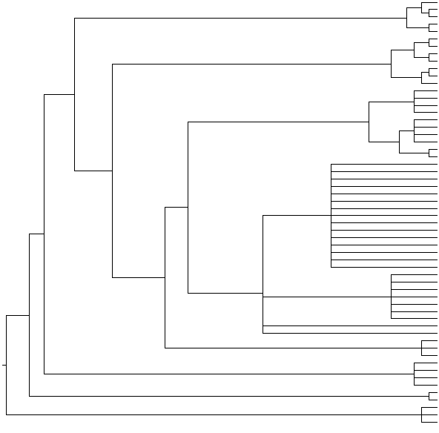

**Female: Populations A, B and C Male: *A. e. maura***

**Female: Populations A and B Male: *A. e. erinacei***

**Pulicidae**

*Archaeopsylla erinacei (Corse, France)* Clone 5 *LT745884*

*Archaeopsylla erinacei* (Corse, France)Clone 6 *LT745885*

*Archaeopsylla erinacei* (Corse, France) Clone 3 *LT745883*

*Archaeopsylla erinacei* (Corse, France) *LT627352*

*Archaeopsylla erinacei* (Corse, France) *LT627352*

*Archaeopsylla erinacei* (Corse, France) Clone 1, 2, 4 and 7 *LT745882*

*Archaeopsylla erinacei* (Corse, France) *LT627352*

*Archaeopsylla erinacei* (Corse, France) *LT703438*

*Archaeopsylla erinacei* (Corse, France) *LT703438*

*Archaeopsylla erinacei* (Sevilla, Spain) Clone 4 *LT745880*

*Archaeopsylla erinacei* (Sevilla, Spain) Clone 2, 3, 5, 7 and 8 *LT745878*

*Archaeopsylla erinacei* (Sevilla, Spain) Clone 1 *LT745879*

*Archaeopsylla erinacei* (Sevilla, Spain) *LT604114*

*Archaeopsylla erinacei* (Sevilla, Spain) *LT604114*

*Archaeopsylla erinacei* (Sevilla, Spain) *LT604114*

*Archaeopsylla erinacei* (Sevilla, Spain) *LT604114*

*Archaeopsylla erinacei* (Sevilla, Spain) *LT604114*

*Archaeopsylla erinacei* (Sevilla, Spain) *LT604114*

*Archaeopsylla erinacei* (Sevilla, Spain) *LT604114*

**FIGURE S1**

**Panorpidae (Mecoptera)**

**100/100**

**65/96**

**100/98**

**100/100**

**83/-**

**90/-**

**100/100**

**100/100**

**100/100**

**80/92**

**100/100**

**100/96**

**100/97**

**100/95**

**100/94**

**98/86**

**95/88**

**99/91**

**96/87**

**100/100**

*Panorpa meridionalis LT604124*

*Panorpa meridionalis LT604124*

*Panorpa meridionalis LT604124*

**Ceratophyllidae**

*Citellophilus tesquorum altaicus EU770312*

*Citellophilus tesquorum dzetysuensis EU770316*

*Nosopsyllus barbarus* from Granada (Spain) *LN881537*

*Nosopsyllus fasciatus* from Dinant (Belgium) *LT158060*

*Nosopsyllus barbarus* from Dos Hermanas (Spain) *LN881537*

*Nosopsyllus fasciatus* from Chertal (Belgium) *LT158059*

**Leptopsyllidae**

*Leptopsylla sp. EF504223*

*Leptopsylla sp. EF504221*

*Amphipsylla quadratoides quadratoides* *AY072642*

*Ophthalmopsylla kiritschenkoi GQ161960*

*Ophthalmopsylla extrema GQ161956*

**Tungidae**

*Tunga penetrans* *DQ844716*

*Tunga penetrans trimamillata AY425820*

*Tunga penetrans* *DQ844724*

**Ctenophthalmidae**

*Neopsylla stevensi AY337033*

*Neopsylla specialis AF353120*

*Neopsylla teratura AF353122*

*Neopsylla siboi AF353113*

**Stenoponiidae**

*Stenoponia tripectinata tripectinata LK937042*

*Stenoponia tripectinata tripectinata LK937038*

*Stenoponia tripectinata tripectinataLK937039*

*Archaeopsylla erinacei* (Sevilla, Spain) Clone 6 *LT745881*

*Archaeopsylla erinacei* (Sevilla, Spain) *LT604114*

*Archaeopsylla erinacei* (Sevilla, Spain) *LT604114*

*Archaeopsylla erinacei* (Sevilla, Spain) *LT604114*

*Archaeopsylla erinacei* (Sevilla, Spain) *LT604114*

*Ctenocephalides canis* from Iran *LN827905*

*Ctenocephalides canis* from Iran *LN864485*

*Ctenocephalides felis* from South Africa *LN827903*

*Ctenocephalides felis* from Iran *LN827903*

*Ctenocephalides felis* from Cádiz (Spain) *LN827903*

*Ctenocephalides felis* from Mallorca (Spain) *LN827903*

*Xenopsylla cheopis* from El Hierro (Spain) *LT604121*

*Xenopsylla cheopis DQ295059*

*Xenopsylla cheopis* from El Hierro (Spain) *LT604121*

*Xenopsylla cheopis DQ295061*