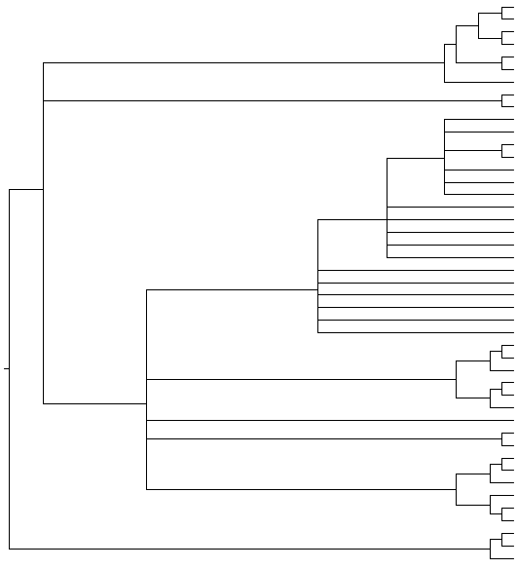

**Female: Populations A and B Male: *A. e. erinacei***

**Female: Populations A, B and C Male: *A. e. maura***

**Pulicidae**

*Archaeopsylla erinacei* (Sevilla,Spain) *LT604120*

*Archaeopsylla erinacei* (Sevilla,Spain) *LT604120*

*Archaeopsylla erinacei* (Sevilla,Spain) *LT604119*

*Archaeopsylla erinacei* (Sevilla,Spain) *LT604119*

*Archaeopsylla erinacei* (Sevilla,Spain) *LT604119*

*Archaeopsylla erinacei* (Corse, France) *LT627350*

*Archaeopsylla erinacei* (Corse, France) *LT627350*

*Archaeopsylla erinacei* (Corse, France) *LT627350*

*Archaeopsylla erinacei* (Corse, France) *LT703441*

*Archaeopsylla erinacei* (Corse, France)*LT703441*

FIGURE S4

**Panorpidae (Mecoptera)**

**100/100**

**100/100**

**98/90**

**100/99**

**99/80**

**100/85**

**100/100**

**Ceratophyllidae**

**100/100**

*Xenopsylla cheopis* from El Hierro (Spain) *LT604122*

**100/97**

**95/81**

**100/99**

**70/61**

**65/-**

**74/77**

**87/93**

**99/93**

**100/100**

**63/-**

*Ctenocephalides felis felis KM890759*

*Ctenocephalides felis* from Mallorca (Spain) *LN897470*

*Ctenocephalides felis* from South Africa *LN897470*

*Ctenocephalides felis damarensis KM890641*

*Ctenocephalides canis LN897471*

*Ctenocephalides canis LN897471*

*Cediopsylla inaequalis inaequalis KM890600*

*Spilopsyllus cuniculi KM890622*

*Echidnophaga oschanini KM890719*

*Xenopsylla ramesis KM890637*

*Xenopsylla skjrabini KM890718*

*Xenopsylla conformis conformis KM890723*

*Synopsyllus girardi* *KM890686*

*Panorpa meridionalis LT604127*

*Panorpa meridionalis LT604128*

*Panorpa meridionalis LT604127*

*Xenopsylla cheopis* from El Hierro (Spain) *LT604122*

*Archaeopsylla erinacei erinacei KM890725*

*Archaeopsylla erinacei* (Sevilla,Spain) *LT604119*

*Archaeopsylla erinacei* (Sevilla,Spain) *LT604119*

*Archaeopsylla erinacei* (Sevilla,Spain) *LT604120*

*Archaeopsylla erinacei* (Sevilla,Spain) *LT604120*

*Archaeopsylla erinacei* (Sevilla,Spain) *LT604120*

*Archaeopsylla erinacei* (Sevilla,Spain) *LT604118*

*Archaeopsylla erinacei* (Sevilla,Spain) *LT604117*

**Leptopsyllidae**

*Ophthalmopsylla praefecta praefecta KM890714*

*Nosopsyllus fasciatus LT158043*

*Nosopsyllus fasciatus LT158049*

*Nosopsyllus barbarus LN897462*

*Nosopsyllus barbarus LN897460*

*Nosopsyllus iranus theodori KM890603*

*Nosopsyllus laeviceps ellobii KM890720*

**Stenoponiidae**

*Stenoponia tripectinata tripectinata* from Tenerife (Spain) *LN897473*

*Stenoponia tripectinata tripectinata* from Gran Canaria (Spain) *LN897473*