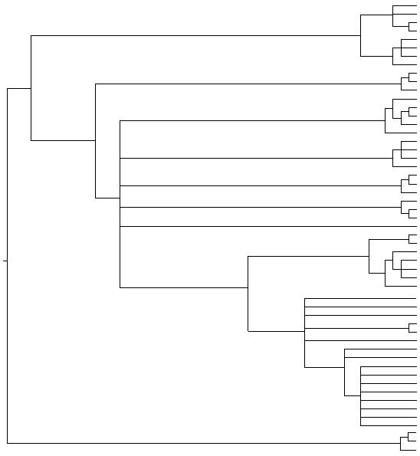

**Female: Populations A, B and C Male: *A. e. maura***

**Female: Populations A and B Male: *A. e. erinacei***

**Pulicidae**

*Archaeopsylla erinacei* (Corse, France) *LT703440*

*Archaeopsylla erinacei* (Corse, France) *LT627349*

*Archaeopsylla erinacei* (Corse, France) *LT627349*

*Archaeopsylla erinacei* (Corse, France) *LT627348*

**Panorpidae (Mecoptera)**

**65/-**

*Archaeopsylla erinacei* (Corse, France) *LT703439*

*Panorpa meridionalis LT604126*

*Panorpa meridionalis LT604125*

*Panorpa meridionalis LT604125*

*Archaeopsylla erinacei* (Sevilla,Spain) *LT604115*

*Archaeopsylla erinacei* (Sevilla,Spain) *LT604116*

*Archaeopsylla erinacei* (Sevilla,Spain) *LT604116*

*Archaeopsylla erinacei* (Sevilla,Spain) *LT604115*

*Archaeopsylla erinacei* (Sevilla,Spain) *LT604116*

*Archaeopsylla erinacei* (Sevilla,Spain) *LT604116*

*Archaeopsylla erinacei* (Sevilla,Spain) *LT604116*

*Archaeopsylla erinacei* (Sevilla,Spain) *LT604116*

*Archaeopsylla erinacei* (Sevilla,Spain) *LT604116*

*Archaeopsylla erinacei* (Sevilla,Spain) *LT604116*

*Archaeopsylla erinacei erinacei KM890990*

*Ctenocephalides felis LN827896*

*Ctenocephalides canis LN827901*

*Ctenocephalides felis felis KP684196*

*Ctenocephalides felis felis KF684891*

*Ctenocephalides felis strongylus KF684876*

*Ctenocephalides orientis KF684871*

*Ctenocephalides canis KP684210*

*Synopsyllus girardi KM890952*

*Xenopsylla skrjabini KM890983*

*Xenopsylla conformis conformis KM890988*

*Xenopsylla cunicularis KF479238*

*Pulex irritans KF479247*

*Pulex irritans KF479246*

*Pulex s*p *KM891015*

*Xenopsylla robertsi KM890906*

*Spilopsyllus cuniculi JN008918*

*Spilopsyllus cuniculi KF479237*

*Spilopsyllus cuniculi KF479236*

*Echidnophaga iberica KF479239*

*Echidnophaga ambulans ambulans KR363632*

*Echidnophaga myrmecobii JN008919*

*Echidnophaga gallinacea JN008921*

*Echidnophaga* sp *JN008922*

**Ctenophthalmidae**

*Paraceras melis melis KF479245*

*Neopsylla sellaris KJ471029*

*Neopsylla paranoma KJ471028*

**Stenoponiidae**

*Stenoponia tripectinata tripectinata KF479244*

*Stenoponia tripectinata tripectinata LK937073*

*Stenoponia tripectinata tripectinata LK937071*

*Stenoponia tripectinata tripectinata LK937072*

**Ceratophyllidae**

*Nosopsyllus barbarus*) *LN881550*

*Nosopsyllus barbarus*) *LN881549*

*Nosopsyllus fasciatus LT158041*

*Nosopsyllus fasciatus LT158040*

**100/100**

**81/81**

**98/95**

**100/100**

**100/97**

**96/76**

**96/82**

**100/95**

**61/85**

**100/95**

**100/93**

**62/68**

**100/100**

**100/100**

**100/100**

**85/80**

**100/98**

FIGURE S3