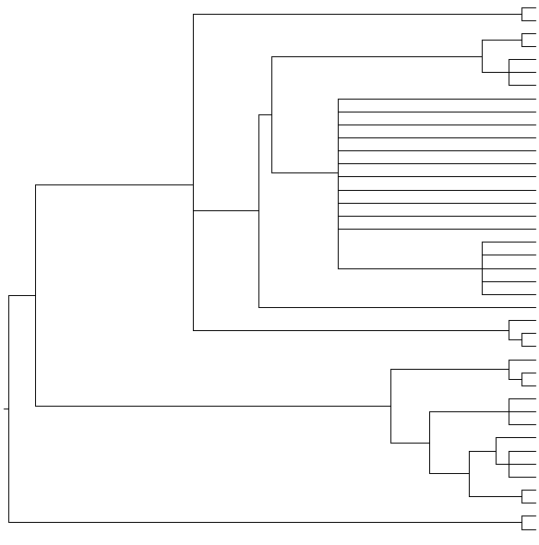

**Female: Populations A and B Male: *A. e. erinacei***

**Female: Populations A, B and C Male: *A. e. maura***

**Pulicidae**

*Archaeopsylla erinacei* (Corse, France) *LT627351*

*Archaeopsylla erinacei* (Corse, France) *LT703437*

*Archaeopsylla erinacei* (Sevilla, Spain) *LT604112*

*Archaeopsylla erinacei* (Sevilla, Spain) *LT604112*

*Archaeopsylla erinacei* (Sevilla, Spain) *LT604112*

FIGURE S2

**100/100**

**100/100**

**100/100**

*Archaeopsylla erinacei* (Corse, France) *LT703437*

*Archaeopsylla erinacei* (Corse, France) *LT627351*

*Archaeopsylla erinacei* (Corse, France) *LT627351*

**Ceratophyllidae**

*Nosopsyllus fasciatus* *LT158053*

*Nosopsyllus barbarus* *LN881538*

**Stenoponiidae**

**Tungidae**

*Archaeopsylla erinacei* (Sevilla, Spain) *LT604112*

*Archaeopsylla erinacei* (Sevilla, Spain) *LT604112*

**100/100**

**100/100**

**100/100**

**100/100**

**100/100**

**96/92**

**100/100**

**100/93**

**94/65**

**100/100**

**91/81**

**80/-**

**-/62**

**100/100**

**Pulicidae**

**Culicidae (Diptera)**

*Archaeopsylla erinacei* (Sevilla, Spain) *LT604112*

*Archaeopsylla erinacei* (Sevilla, Spain) *LT604112*

*Archaeopsylla erinacei* (Sevilla, Spain) *LT604112*

*Archaeopsylla erinacei* (Sevilla, Spain) *LT604112*

*Archaeopsylla erinacei* (Sevilla, Spain) *LT604112*

*Archaeopsylla erinacei* (Sevilla, Spain) *LT604113*

*Anopheles moucheti nigerensis AM232662*

*Anopheles moucheti bervoetsi AM232663*

*Citellophilus tesquorum altaicus EU770312*

*Citellophilus tesquorum dzetysuensis EU770316*

*Nosopsyllus fasciatus* *LT158055*

*Nosopsyllus barbarus* *LN881539*

*Tunga penetrans EU169196*

*Tunga penetrans EU169197*

*Tunga penetrans EU169194*

*Spilopsyllus cuniculi EU170157*

*Pulex irritans GQ387496*

*Pulex irritans EU169198*

*Stenoponia tripectinata tripectinata LK93706*2

*Stenoponia tripectinata tripectinata LK937053*

*Stenoponia tripectinata tripectinata LK937057*

*Echidnophaga gallinaea* *EU169199*

*Ctenocephalides felis* from Cádiz (Spain) *LN827902*

*Ctenocephalides felis* from South Africa *LN827902*

*Xenopsylla cheopis* *DQ295061*

*Xenopsylla cheopis* *DQ295060*

*Ctenocephalides canis* from Nashtarood (Iran) *HF563590*

*Ctenocephalides canis* from Kotra (Iran) *HF563590*

*Ctenocephalides felis* from Iran *LN827902*