Supplementary information
This assumption is based on microclimate recordings made in a sugarcane field at three different locations relative to the sugarcane stalk: 1) in the leaf sheaths where eggs are most probably deposited and adult moths can be found (Atkinson, 1979), 2) at the base of the stalk (ground level, where pupae have been seen) and 3) inside the stalk where larvae feed. Furthermore, developing life-stages are seldom exposed to direct solar radiation. During the mid-winter and -summer months, temperatures were recorded for 21 consecutive days using calibrated thermochron iButton data loggers (8-bit Model DS1921; iButton, Dallas, TX, USA; 0.5 °C accuracy) set to record at 30-minute intervals. There were no significant differences between the temperatures at the three locations in the sugarcane stalk (N = 1924 data points per stalk location, GLZ: χ² = 4.71, d.f. = 2, P = 0.10) when all the data was grouped. However, when we tested for the effect of season (i.e. summer or winter) in combination with the location of the recordings, there was a significant interaction effect between season and location (GLZ: χ² = 7.30, d.f. = 2, P = 0.03). In the winter, temperatures recoded inside the sugarcane stalk were on average significantly cooler (16.32 ± 0.15 s.e. °C) than the base of the stalk (16.61 ± 0.10 °C). Under summer conditions the leaf sheaths where adult moths and eggs are commonly found are significantly warmer (24.71 ± 0.12 °C) than the base of the stalk (23.98 ± 0.05 °C) and the inside stalk temperature (24.26 ± 0.09 °C).
Recorded microclimate data were compared to the local weather station data at Mount Edgecombe (station number 461: 29.7S, 31.033E) within a 3km radius from where recordings were done. Recordings were done for the winter month: June and summer month: December during the year: 2012. There was no significant difference between the daily average temperature recorded from the sugarcane stalk and the average daily temperature obtained from the weather station (Kruskal-Wallis χ² = 40.46, d.f. = 38, P = 0.36).
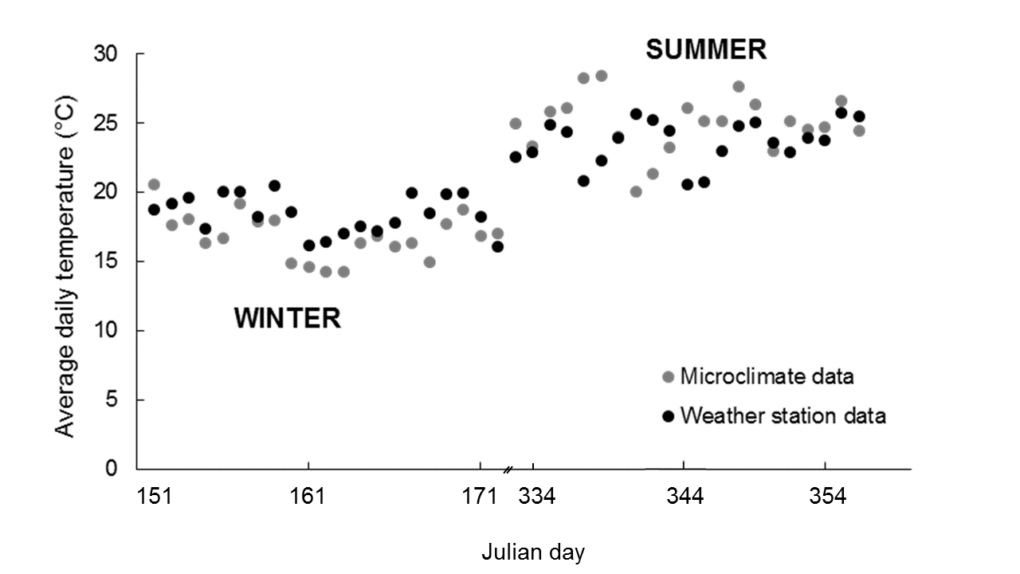
Figure 1 Average daily temperature recordings from a microsite in a sugarcane plantation and weather station at Mount Edgecombe, KwaZulu Natal, South Africa. Recordings were compared for the winter month: June (Julian day 151-181) and summer month: December (Julian day 334-365) for the year 2012.

References
Watt, W. B. (1968) Adaptive significance of pigment polymorphisms in Colias Butterflies. I. Variation of melanin pigment in relation to thermoregulation. Evolution 69, 1486−1496.
Kingsolver, J.G. & Moffat, R.J. (1982) Thermoregulation and the determinents of heat transfer in Colias butterflies. Oecologia 53, 27−33.
Atkinson, P.R. (1979) Distribution and natural hosts of Eldana saccharina Walker in Natal, its oviposition sites and feeding patterns. Proceedings of the South African Sugar Technologists' Association 53, 111−115.

