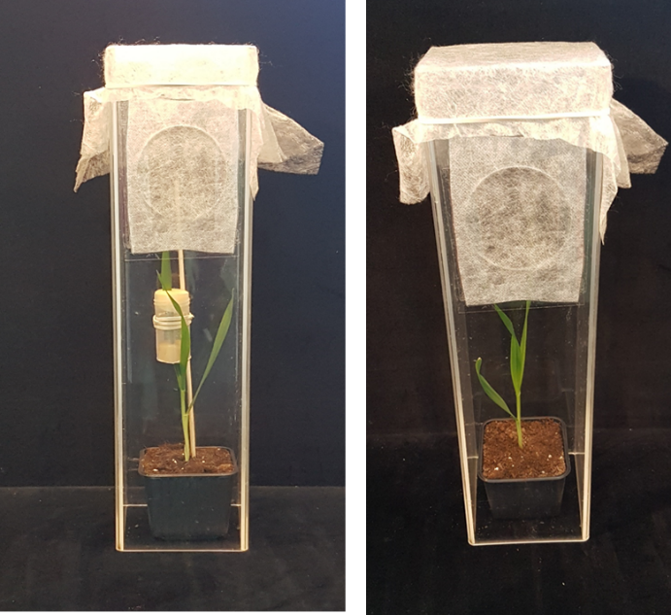

Supplementary Figure 1. The aphid bioassay as carried out on barley.
Left: Aphids were added on the sponge closing the lower end of the small cage, which was supported by a wooden stick. Right: After 2 h, the upper sponge of the small cage was removed to allow for air diffusion. After 24 h, the stick and the small cage were removed and the aphids could move freely on the plants.

