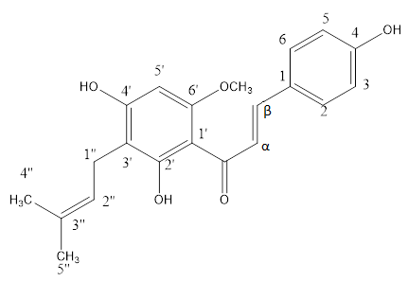
Fig. 1. Chemical structure of xanthohumol

