Supplementary Table & Figures for :
Baker & Tann (Long-term patterns in the abundance of Helicoverpa armigera).

Note : Table S1 & Figs S1-S4 are also published in Baker & Tann (….). Bull. Ent. Res. In Press.

Table S1. Trap site locations near Narrabri (GPS coordinates).
Site Name | Location
Appletrees [East] | 30°07’49”S/149°36’24”E
Appletrees [Home] | 30°07’68”S/149°34’73”E
Auscott [East] | 30°09’59”S/149°41’45”E
Auscott [Office] | 30°11’29”S/149°40’08”E
ACRI [Chico] | 30°11’42”S/149°36’24”E
ACRI [Field 18] | 30°13’41”S/149°35’37”E
ACRI [Leitch] | 30°10’47”S/149°35’35”E
Lochelgin | 30°13’43”S/149°34’10”E
Merinda | 30°09’37”S/149°33’02”E
Greenbah | 30°09’43”S/149°32’99”E
Togo [North] | 30°05’08”S/149°33’56”E
Togo [South] | 30°06’59”S/149°33’45”E
Wentworth | 30°13’36”S/149°39’34”E
Yarral Field 5 | 30°12’21”S/149°37’12”E
Yarral [Home] | 30°13’15”S/149°37’35”E

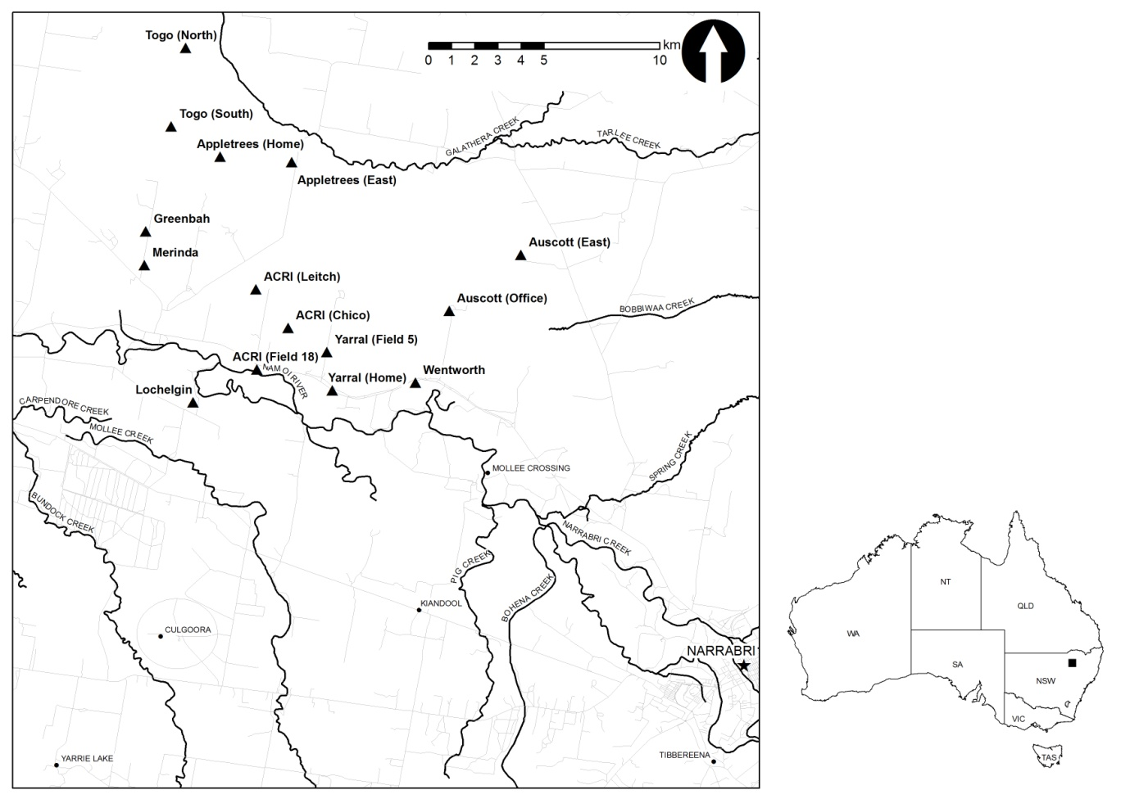
Fig. S1. Locations of the 15 pheromone trap sites near Narrabri, northern New South Wales. Main rivers (bold lines); roads (faint lines).

Fig. S2. Frequencies (%) of the most common habitat types adjacent to pheromone traps during spring each year throughout the trapping period near ACRI.

Fig. S3. Frequencies (%) of the most common habitat types adjacent to pheromone traps during summer each year throughout the trapping period near ACRI.

Fig. S4. Average daily maximum temperatures (°C) recorded at Narrabri West Post Office (Australian Bureau of Meteorology Station No : 53030) until December 2001; thereafter at Narrabri Airport (Station No : 54308). Data are provided for the autumn (March, April, May) and winter (June, July, August) preceding the moth activity season, spring (September, October, November) at the start of the moth activity season, and summer (December, January, February) at the end of the activity season.

Fig. S5. Hectares of canola, chickpea, cotton and sorghum grown annually (1992 to 2014) in the Narrabri Statistical Local Areas (summed) of N.S.W. Data provided by Neil Clark Business Intelligence. No data were available for chickpeas in 2007-08.

Fig. S6. Hectares of canola, chickpea, cotton and sorghum grown annually (1992 to 2014) in the Gunnedah Statistical Local Areas (summed) of N.S.W. Data provided by Neil Clark Business Intelligence. No data were available for canola in 1996-97, nor for chickpeas in 2007-08.

