Supplementary Figure 1. Directed acyclic graphs for the main analysis.
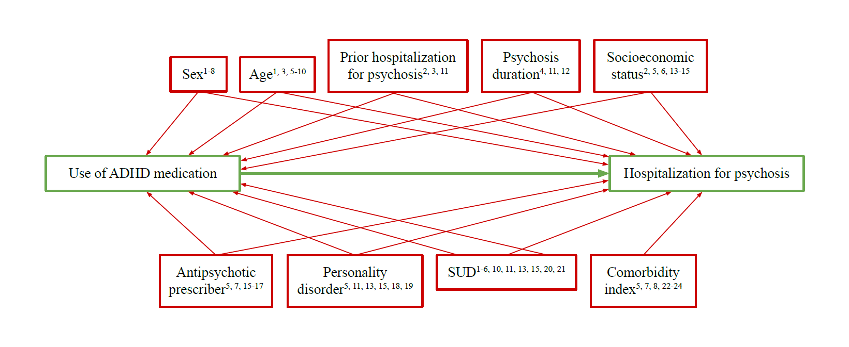
SUD, substance use disorder.

References
1. Rubio JM, Schoretsanitis G, John M, Tiihonen J, Taipale H, Guinart D, et al. Psychosis relapse during treatment with long-acting injectable antipsychotics in individuals with schizophrenia-spectrum disorders: an individual participant data meta-analysis. Lancet Psychiatry 2020; 7(9): 749-61.
2. Bowtell M, Ratheesh A, McGorry P, Killackey E, O'Donoghue B. Clinical and demographic predictors of continuing remission or relapse following discontinuation of antipsychotic medication after a first episode of psychosis. A systematic review. Schizophr Res 2018; 197: 9-18.
3. Olivares JM, Sermon J, Hemels M, Schreiner A. Definitions and drivers of relapse in patients with schizophrenia: a systematic literature review. Ann Gen Psychiatry 2013; 12(1): 32.
4. Schoeler T, Petros N, Di Forti M, Pingault JB, Klamerus E, Foglia E, et al. Association between continued cannabis use and risk of relapse in first-episode psychosis: a quasi-experimental investigation within an observational study. JAMA Psychiatry 2016; 73(11): 1173-9.
5. Martinez-Raga J, Ferreros A, Knecht C, de Alvaro R, Carabal E. Attention-deficit hyperactivity disorder medication use: factors involved in prescribing, safety aspects and outcomes. Ther Adv Drug Saf 2017; 8(3): 87-99.
6. Carolan D. ADHD stimulant medication misuse and considerations for current prescribing practice: a literature review. Ir J Med Sci 2022; 191(1): 313-20.
7. Sibley MH. Why are stimulant medication prescriptions rising globally? Lancet Psychiatry 2018; 5(10): 774-6.
8. Brumbaugh S, Tuan WJ, Scott A, Latronica JR, Bone C. Trends in characteristics of the recipients of new prescription stimulants between years 2010 and 2020 in the United States: an observational cohort study. EClinicalMedicine 2022; 50: 101524.
9. Hui CL, Tang JY, Leung CM, Wong GH, Chang WC, Chan SK, et al. A 3-year retrospective cohort study of predictors of relapse in first-episode psychosis in Hong Kong. Aust N Z J Psychiatry 2013; 47(8): 746-53.
10. Mattingly GW, Wilson J, Ugarte L, Glaser P. Individualization of attention-deficit/hyperactivity disorder treatment: pharmacotherapy considerations by age and co-occurring conditions. CNS Spectr 2021; 26(3): 202-21.
11. Levy E, Traicu A, Iyer S, Malla A, Joober R. Psychotic disorders comorbid with attention-deficit hyperactivity disorder: an important knowledge gap. Can J Psychiatry 2015; 60(3 Suppl 2): S48-52.
12. Pothimas N, Bhatarasakoon P, Chanprasit C, Kitsumban V. A cross-sectional study of factors predicting relapse in people with schizophrenia. Pacific Rim Int J Nurs Res 2020; 24(4): 448-59.
13. Corbeil O, Essiambre AM, Béchard L, Roy AA, Huot-Lavoie M, Brodeur S, et al. Real-life effectiveness of transitioning from paliperidone palmitate 1-monthly to paliperidone palmitate 3-monthly long-acting injectable formulation. Ther Adv Psychopharmacol 2022; 12: 20451253221136021.
14. Almuqrin A, Georgiades A, Mouhitzadeh K, Rubinic P, Mechelli A, Tognin S. The association between psychosocial stress, interpersonal sensitivity, social withdrawal and psychosis relapse: a systematic review. Schizophrenia (Heidelb) 2023; 9(1): 22.
15. Puntis S, Oke J, Lennox B. Discharge pathways and relapse following treatment from early intervention in psychosis services. BJPsych Open 2018; 4(5): 368-74.
16. Fusar-Poli P, McGorry PD, Kane JM. Improving outcomes of first-episode psychosis: an overview. World Psychiatry 2017; 16(3): 251-65.
17. Stockl KM, Hughes TE, Jarrar MA, Secnik K, Perwien AR. Physician perceptions of the use of medications for attention deficit hyperactivity disorder. J Manag Care Pharm 2003; 9(5): 416-23.
18. Strålin P, Hetta J. First episode psychosis: register-based study of comorbid psychiatric disorders and medications before and after. Eur Arch Psychiatry Clin Neurosci 2021; 271(2): 303-13.
19. Bahorik AL, Eack SM. Examining the course and outcome of individuals diagnosed with schizophrenia and comorbid borderline personality disorder. Schizophr Res 2010; 124(1-3): 29-35.
20. Harstad E, Levy S. Attention-deficit/hyperactivity disorder and substance abuse. Pediatrics 2014; 134(1): e293-301.
21. Brikell I, Wimberley T, Albiñana C, Pedersen EM, Vilhjálmsson BJ, Agerbo E, et al. Genetic, clinical, and sociodemographic factors associated with stimulant treatment outcomes in ADHD. Am J Psychiatry 2021; 178(9): 854-64.
22. Filipcic I, Simunovic Filipcic I, Ivezic E, Matic K, Tunjic Vukadinovic N, Vuk Pisk S, et al. Chronic physical illnesses in patients with schizophrenia spectrum disorders are independently associated with higher rates of psychiatric rehospitalization; a cross-sectional study in Croatia. Eur Psychiatry 2017; 43: 73-80.
23. Šprah L, Dernovšek MZ, Wahlbeck K, Haaramo P. Psychiatric readmissions and their association with physical comorbidity: a systematic literature review. BMC Psychiatry 2017; 17(1): 2.
24. Köhler O, Petersen L, Benros ME, Mors O, Gasse C. Concomitant NSAID use during antipsychotic treatment and risk of 2-year relapse - a population-based study of 16,253 incident patients with schizophrenia. Expert Opin Pharmacother 2016; 17(8): 1055-62.

Supplementary Figure 2. Risk of hospitalization for mental disorders (including psychosis) in the year after ADHD medication initiation.
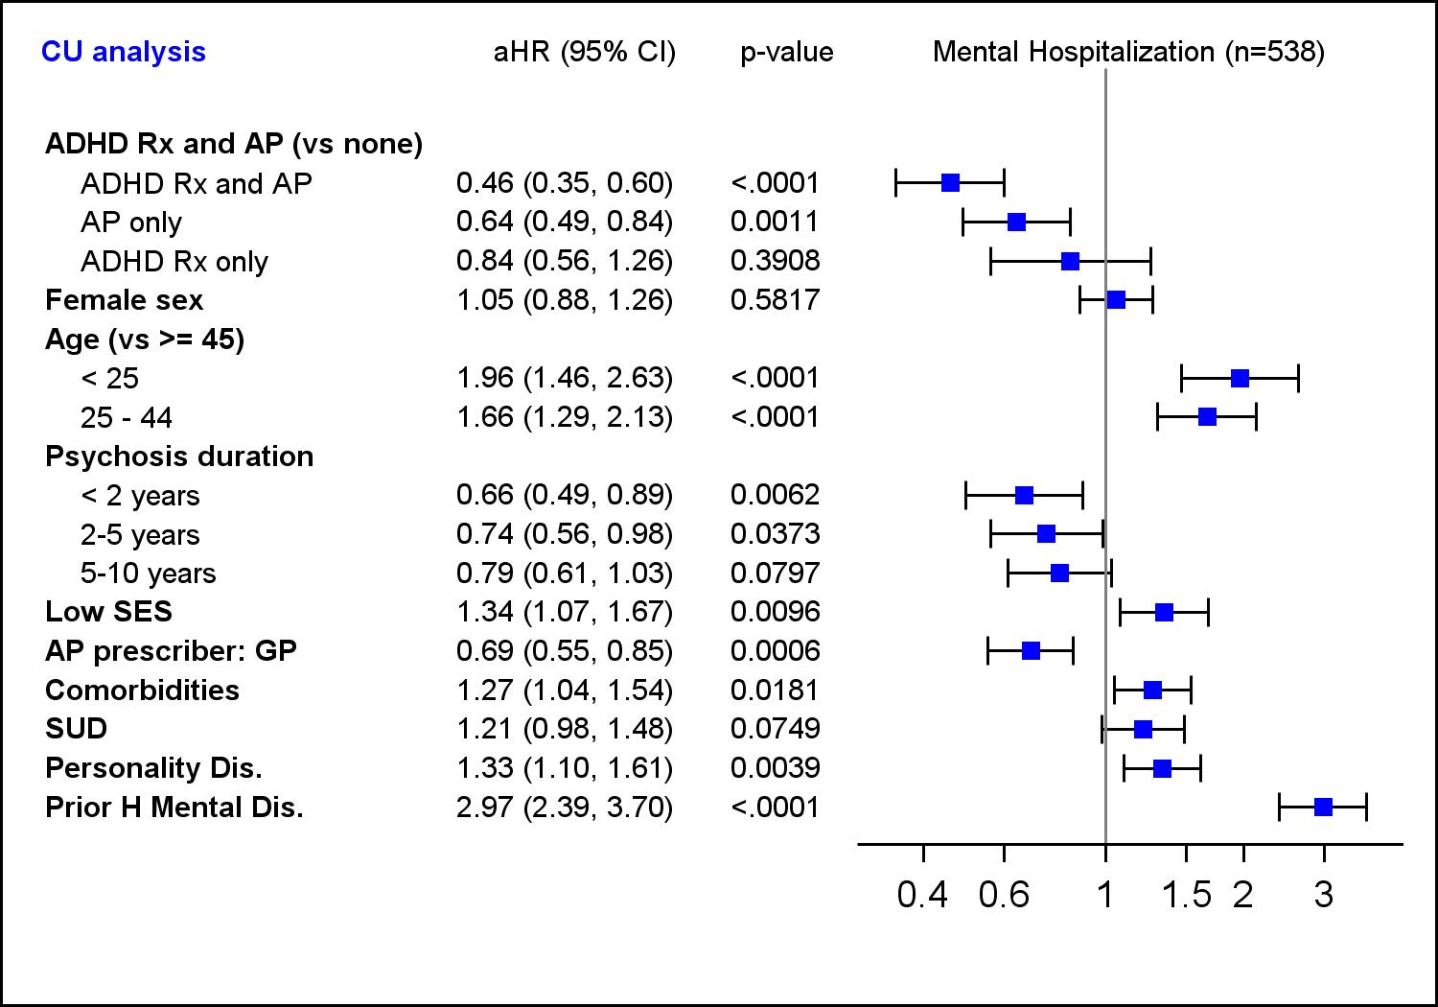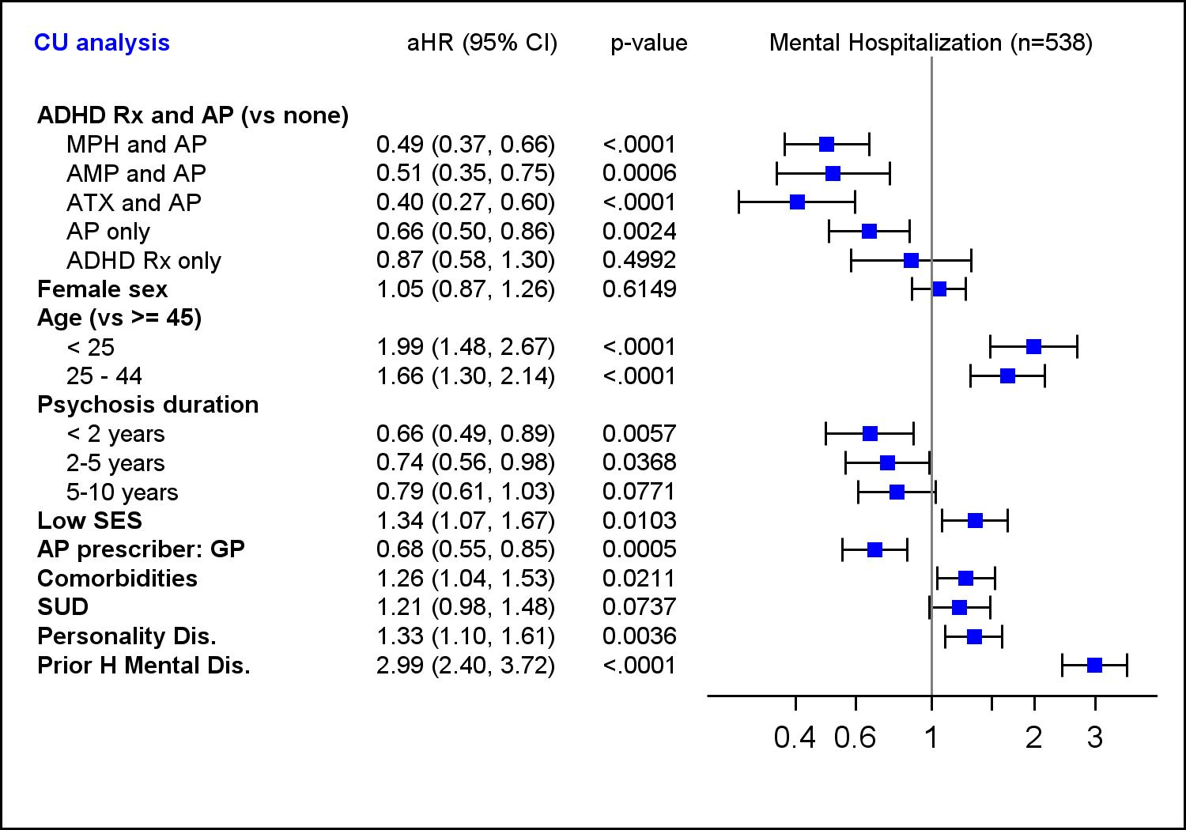
ADHD, attention-deficit/hyperactivity disorder; aHR, adjusted hazard ratio; AMP, amphetamine; AP, antipsychotic; ATX, atomoxetine; CI, confidence interval; CU, current use; GP, general practitioner; H, hospitalization; MPH, methylphenidate; Rx, medication; SES, socioeconomic status; SUD, substance use disorder.
aHR (95% CI) associated with each covariable.

Supplementary Figure 3. Risk of hospitalization for mental disorders other than psychosis in the year after ADHD medication initiation.
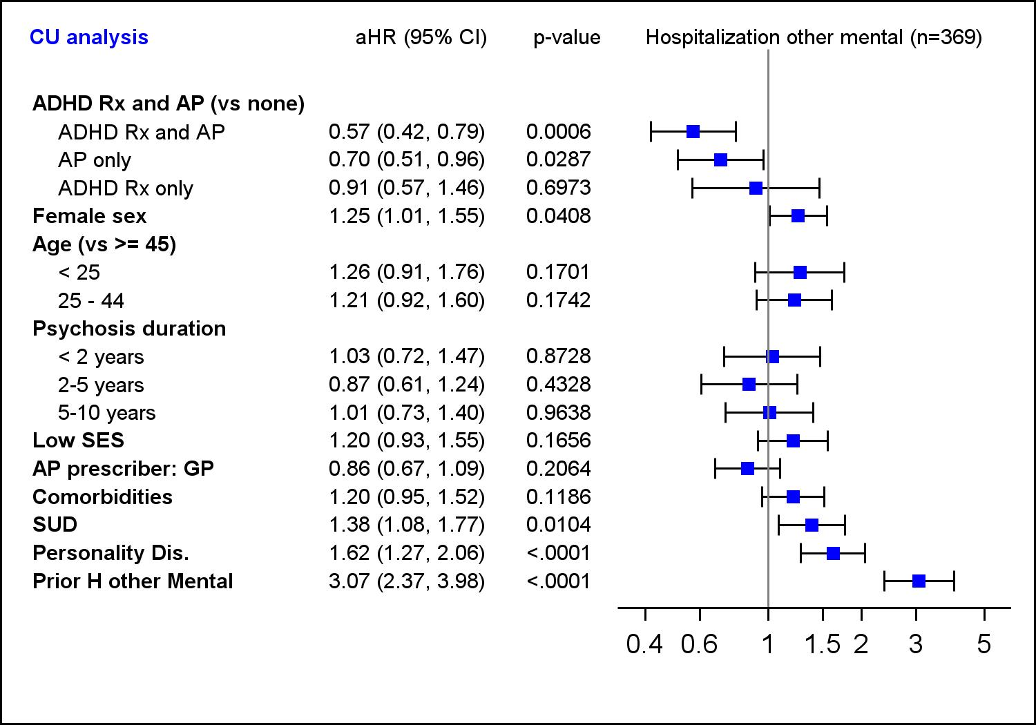
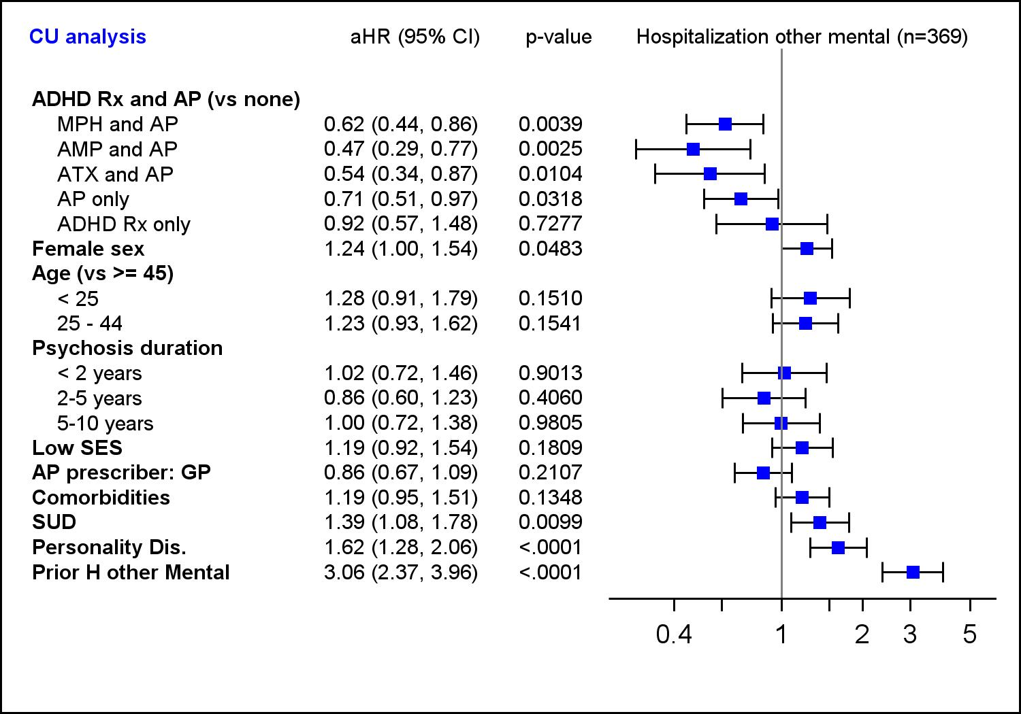
ADHD, attention-deficit/hyperactivity disorder; aHR, adjusted hazard ratio; AMP, amphetamine; AP, antipsychotic; ATX, atomoxetine; CI, confidence interval; CU, current use; GP, general practitioner; H, hospitalization; MPH, methylphenidate; Rx, medication; SES, socioeconomic status; SUD, substance use disorder
aHR (95% CI) associated with each covariable.

Supplementary Table 1. List and description of ICD-9 and ICD-10 for psychosis.
ICD-9 | Description | ICD-10 | Description
295 | Schizophrenic disorders | F20 | Schizophrenia
295.0 | Simple type | F20.0 | Paranoid schizophrenia
295.1 | Hebephrenic type | F20.1 | Hebephrenic schizophrenia
295.2 | Catatonic type | F20.2 | Catatonic schizophrenia
295.3 | Paranoid type | F20.3 | Undifferentiated schizophrenia
295.4 | Acute schizophrenic episode | F20.4 | Post-schizophrenic depression
295.5 | Latent schizophrenia | F20.5 | Residual schizophrenia
295.6 | Residual schizophrenia | F20.6 | Simple schizophrenia
295.7 | Schizo-affective type | F20.8 | Other
295.8 | Other | F20.9 | Unspecified
295.9 | Unspecified | F21 | Schizotypal disorder
297 | Paranoid states | F22 | Persistent delusional disorders
297.0 | Paranoid state, simple | F22.0 | Delusional disorder
297.1 | Paranoia | F22.8 | Other
297.2 | Paraphrenia | F22.9 | Unspecified
297.3 | Induced psychosis | F23 | Acute and transient psychotic disorders
297.8 | Other | F23.0 | Acute polymorphic psychotic disorder without symptoms of schizophrenia
297.9 | Unspecified | F23.1 | Acute polymorphic psychotic disorder with symptoms of schizophrenia
298 | Other nonorganic psychoses | F23.2 | Acute schizophrenia-like psychotic disorder
298.0 | Depressive type | F23.3 | Other acute predominantly delusional psychotic disorders
298.1 | Excitative type | F23.8 | Other
298.2 | Reactive confusion | F23.9 | Unspecified
298.3 | Acute paranoid reaction | F24 | Induced delusional disorder
298.4 | Psychogenic paranoid psychosis | F25 | Schizoaffective disorders
298.8 | Other and unspecified reactive psychosis | F25.0 | Manic type
298.9 | Unspecified psychosis | F25.1 | Depressive type
 |  | F25.2 | Mixed type
 |  | F25.8 | Other
 |  | F25.9 | Unspecified
 |  | F28 | Other nonorganic psychotic disorders
 |  | F29 | Unspecified nonorganic psychosis

Supplementary Table 2. List and description of ICD-10 for mental disorders.
ICD-10 | Description
F00-F99 | Mental and behavioural disorders
F00-F09 | Organic, including symptomatic, mental disorders
F10-F19 | Mental and behavioural disorders due to psychoactive substance use
F20-F29 | Schizophrenia, schizotypal and delusional disorders
F30-F39 | Mood [affective] disorders
F40-F49 | Neurotic, stress-related and somatoform disorders
F50-F59 | Behavioural syndromes associated with physiological disturbances and physical factors
F60-F69 | Disorders of adult personality and behaviour
F70-F79 | Mental retardation
F80-F89 | Disorders of psychological development
F90-F98 | Behavioural and emotional disorders with onset usually occurring in childhood and adolescence
F99 | Unspecified mental disorder
R44-R46 | Symptoms and signs involving cognition, perception, emotional state and behaviour
R44 | Other symptoms and signs involving general sensations and perceptions - hallucinations
R45 | Symptoms and signs involving emotional state
R46 | Symptoms and signs involving appearance and behaviour
X60-Y91
X60-X84 | Intentional self-harm
X85-Y09 | Assault
Y10-Y34 | Event of undetermined intent
Y35-Y36 | Legal intervention and operations of war
Y90 | Evidence of alcohol involvement determined by blood alcohol level
Y91 | Evidence of alcohol involvement determined by level of intoxication

Supplementary Table 3. Comparison between the study cohort and the comparison group.
Baseline characteristics | COHORT | COMPARISON GROUPª | p-value
Total, n | 2219 | 7802 | -
Sex, n (%)  Female  Male | 879 (39.6)  1340 (60.4) | 3056 (39.2)  4746 (60.8) | .7061
Age, mean ± SD | 37.0 (15.0) | 38.3 (14.5) | .0003
Low socioeconomic status, n (%) | 1629 (73.4) | 5998 (76.9) | .0007
Duration of SZSPD diagnosis, mean ± SD | 5.6 (3.8) | 6.0 (3.9) | .0001
Initial prescriber of ADHD medication, n (%)  Psychiatrist  General practitioner  Other MD | 1460 (65.8)  711 (32.0)  48 (2.2) | - | -
Prescriber of AP, n (%)  Psychiatrist  General practitioner  Other MD | 1597 (72.0)  599 (27.0)  23 (1.0) | 5378 (68.9)  2338 (30.0)  86 (1.1) | .0227
Comorbidity index (≥ 1), n (%) | 524 (23.6) | 1364 (17.5) | <.0001
Substance-related disorders, n (%) | 755 (34.0) | 1472 (18.9) | <.0001
Personality disorder, n (%) | 633 (28.5) | 991 (12.7) | <.0001
Lithium use, n (%) | 269 (12.1) | 730 (9.4) | .0001
Antidepressant use, n (%) | 1388 (62.6) | 3316 (42.5) | <.0001
Benzodiazepine use, n (%) | 1180 (53.2) | 3099 (39.7) | <.0001
Divalproex use, n (%) | 337 (15.2) | 1047 (13.4) | .0332
Lamotrigine use, n (%) | 157 (7.1) | 252 (3.2) | <.0001
Number of ambulatory visits, mean ± SD | 16.0 (16.5) | 12.2 (14.5) | <.0001
Prior hospitalization for psychosis, n (%) | 346 (15.6) | 1196 (15.3) | .7617
Prior hospitalization for other mental dis., n (%) | 579 (26.1) | 873 (11.2) | <.0001
Prior hospitalization for mental dis., n (%) | 822 (37.0) | 1912 (24.5) | <.0001
Prior hospitalization for non-mental dis., n (%) | 305 (13.7) | 745 (9.6) | <.0001
ADHD, attention-deficit/hyperactivity disorder; AP, antipsychotic; MD, medical doctor; SD, standard deviation; SZSPD, schizophrenia spectrum psychotic disorder.
ªPatients in the comparison group were matched for sex, birth year (±3 years), date of first psychosis (±1 year), and use of AP 30 days before or after the index date.

Supplementary Table 4. Initial dosage of ADHD medication.
Initial ADHD medication | n | Average (SD) | Median (IQR)
Methylphenidate | 1589 | 21 mg (14 mg) | 18 mg (10 – 27 mg)
Amphetamines
Dexamphetamine | 78 | 12 mg (8 mg) | 10 mg (10 – 15 mg)
Amphetamine | 64 | 18 mg (14 mg) | 80 mg (40 – 120 mg)
Lisdexamfetamine | 197 | 26 mg (9 mg) | 30 mg (20 – 30 mg)
Atomoxetine | 291 | 38 mg (21 mg) | 40 mg (25 – 40 mg)
ADHD, attention-deficit/hyperactivity disorder; IQR, interquartile range; mg, milligram; SD, standard deviation.

