Supplementary figures
Figure S1. Screen plot and Parallel Analysis of eigenvalues for the Scale Assessment of Negative Symptoms.

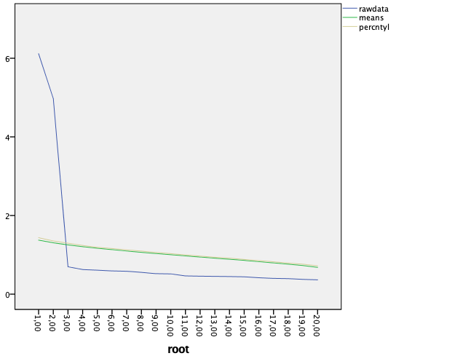
Eigenvalues

Figure S2. Confirmatory Factor Analyses.
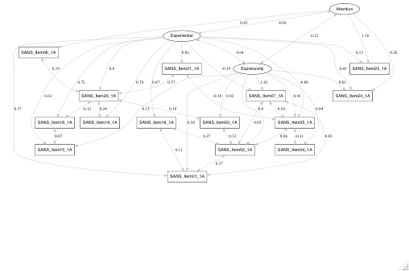

Figure S3: Association between changes in Cortical Thickness and four clinical covariates for 10 years follow-up, including medication, cognition, positive, disorganization symptoms and attrition.

Figure S4: Whole-brain cortical thickness changes for expressivity and experiential SANS factors after correcting for medication.

Figure S5: Regional long-term cortical thickness changes for expressivity SANS factors after correcting for medication. Violin plots of CT longitudinal changes of regions showing a significant group effect.

