Supplementary Online Content
Dose-response association of handgrip strength and risk of depression: a longitudinal study of 115 601 older adults from 24 countries
Supplementary Table 1. Country weights for study participants stratified by sex.
Figure 1. Simplified DAG used for the selection of covariables for the association between handgrip strength and risk of depression.
Figure 2. Association of handgrip strength with risk of depression with complete case analyses.
Figure 3. Association of handgrip strength with risk of depression after removing participants who developed depression within the first two years of follow-up.
Figure 4. Association of handgrip strength with risk of depression accounting for mortality and attrition as competing risk.
Figure 5. Association of handgrip strength with risk of depression accounting for Nelson–Aalen cumulative hazard estimate to the survival time in the imputation model.

Table 1. Country weights for study participants stratified by sexª
 | Men | Women
Country
Austria | 3,971,306 | 4,200,660
Belgium | 5,140,743 | 5,337,874
Bulgaria | 3,727,030 | 3,931,942
Croatia | 2,035,607 | 2,234,538
Czech Republic | 18,478,468 | 19,686,977
Denmark | 2,684,213 | 2,735,229
Estonia | 629,579 | 725,196
Finland | 2,567,723 | 2,678,763
France | 30,587,080 | 32,592,276
Germany | 40,296,958 | 4,2172,474
Greece | 5,438,858 | 5,548,456
Hungary | 4,797,763 | 5,309,383
Ireland | 2,031,416 | 2,038,846
Israel | 3,418,244 | 3,511,856
Italy | 28,144,391 | 29,825,093
Luxembourg | 4,786,760 | 5,300,395
Netherlands | 8,092,628 | 8,227,240
Poland | 2,076,648 | 2,083,266
Portugal | 5,077,470 | 5,425,560
Romania | 10,391,006 | 10,928,679
Slovenia | 978,181 | 1,022,293
Spain | 21,535,302 | 22,117,853
Switzerland | 3,640,621 | 3,796,494
Sweden | 4,477,600 | 4,551,972
ªYear 2004

Figure 1. Simplified DAG used for the selection of covariables for the association between handgrip and risk of depression

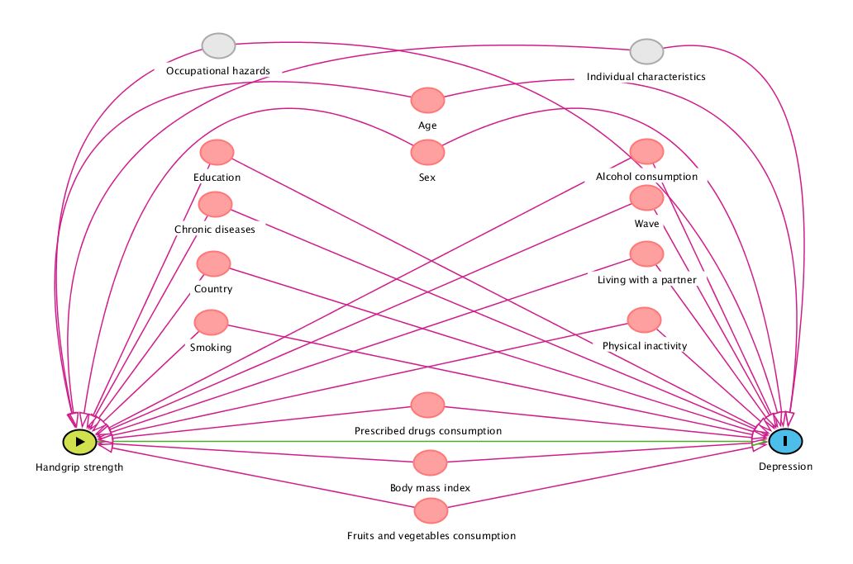
Nodes: Green (with ►) = exposure, Blue (with I) = outcome, Red = ancestor of exposure and outcome (confounder), White = adjusted variable, Grey = unobserved (latent) variable.
Arrows: Green = causal path, red = biasing path, black = blocked path

Figure 2. Association of handgrip strength with risk of depression with complete case analyses
Model A, adjusted for age and sex.
Model B, adjusted for age, sex, education, country, body mass index, wave, physical inactivity, smoking, alcohol, partner, chronic diseases, prescribed drugs consumption and fruits and vegetables consumption.

Figure 3. Association of handgrip strength with risk of depression after removing participants who developed depression within the first two years of follow-up

Model A, adjusted for age and sex.
Model B, adjusted for age, sex, education, country, body mass index, wave, physical inactivity, smoking, alcohol, partner, chronic diseases, prescribed drugs consumption and fruits and vegetables consumption.

Figure 4. Association of handgrip strength with risk of depression accounting for mortality and attrition as competing risk

Model A, adjusted for age and sex.
Model B, adjusted for age, sex, education, country, body mass index, wave, physical inactivity, smoking, alcohol, partner, chronic diseases, prescribed drugs consumption and fruits and vegetables consumption.

eFigure 5. Association of handgrip strength with risk of depression accounting for Nelson–Aalen cumulative hazard estimate to the survival time in the imputation model

Model A, adjusted for age and sex.
Model B, adjusted for age, sex, education, country, body mass index, wave, physical inactivity, smoking, alcohol, partner, chronic diseases, prescribed drugs consumption and fruits and vegetables consumption.

