Supplementary Material

Table S1: Definition of psychiatric history
Exclusion criteria | Codes | Sources | Comments
Psychiatric history | All hospital admission for psychiatric illness or use of psychopharmacy | NPR, DNPR, PCRR
Hospital admission for psychiatric illness | ICD-8: 29*, 30*;  ICD-10: F0-F9,  A-diagnosis | NPR, PCRR | At least one contact
Use of psychopharmacy | ATC: N05, N06 | DNPR | At least one dispensed prescription

Table S2: Definition of exposure
Exposure | Codes | Sources | Comments
Thyroid disease
Any thyroid-related disease | ICD-8: 240-246;  ICD-10: E00-E06;  A and B-diagnoses  ATC: H03BB02, H03AA01, H03BB01, H03BA02 | NPR, DNPR | At least one diagnosis or prescription
Hyperthyroidism | ICD-8: 24401, 24402, 24403, 24408, 24409;  ICD-10: E05, E062;  A and B-diagnoses  Methimazole ATC: H03BB02, H03BB01;  Propyltiouracil, ATC: H03BA02 | NPR, DNPR | At least one diagnosis or prescription
Hypothyroidism | ICD-10: E02-03, E063; A and B-diagnoses  Levothyroxine, ATC: H03AA01 | NPR, DNPR | At least one diagnosis or prescription
Other thyroid disease | ICD-10: E00, E01, E04, E060, E061, E064, E065, E069  No use of thyoid medication, ATC: H03BB02, H03AA01, H03BB01, H03BA02 | NPR  DNPR | Any thyroid-related disease not qualifying as hyper- or hypothyroidism
Diabetes
Any type of diabetes | ICD-8: 249, 250;  ICD-10: E10-14, H36.0, O24 (excluding O24.4);  A and B-diagnoses  ATC: A10A*, A10B* | NPR, DNPR | At least one diagnosis or at least two prescriptions
Type I/Insulin-dependent diabetes | For first diagnosis before 1995: <30 years at first diagnosis, after 1995: first prescription ATC= A10A | NPR, DNPR | At least one diagnosis or at least two prescriptions
Type II/ Insulin nondependent | For first diagnosis before 1995: >=30 years at first diagnosis, after 1995: first prescription ATC= A10B | NPR, DNPR | At least one diagnosis or at least two prescriptions
Other diabetes | ICD-10: E12, E13, E14, H360 (retinopathy)  No consistent diabetes medication, i.e. maximum one prescription of A10A*, A10B* each. | NPR, DNPR | Any type of diabetes not qualifying as type I or type II diabetes.
Gestational diabetes mellitus (GDM) | ICD-8: 63474;  CD-10: O24.4;  A and B-diagnoses | NPR
Polycystic ovary syndrome (PCOS) | ICD-8: 256.90;  ICD-10: E28.2;  A and B-diagnoses | NPR

Table S3: Definition of outcome
Outcome | Codes | Sources | Comments
Postpartum depression | All hospital admission for depression or use of antidepressants within 6 months after delivery | NPR, DNPR, PCRR
Hospital admission for depression | ICD-8: 29609, 29629, 29689, 29699, 29809, 30049, 3011.  ICD-10: F320–F329.  A-diagnosis | NPR, PCRR | At least one contact in 6 months after delivery
Use of antidepressants | ATC: N06A | DNPR | At least one dispensed prescription in 6 months after delivery

Table S4: Definition of covariates
Covariate | Codes | Sources | Comments
Calendar year | 1996-1999, 2000-2004, 2005-2009, 2010-2014, 2015-2018 | MBR, CPR
Maternal age at delivery | Grouped as <20, 20-24 25-29, 30-34, 35-39, 40+ years | CPR
Parity | Grouped as 0, 1, 2+ | CPR
Multiple delivery | Yes, no | MBR
Maternal education | Coded by DISCED and grouped as missing, unclassified, Short education: primary/lower secondary. Medium education: upper secondary/vocational/lower tertiary. Long education: Bachelor’s degree or equivalent/Master/Doctoral | Statistics Denmark
Cohabitation | Cohabitating/married: ’Registreret partnerskab’, ’Samboende par’, ’Samlevende par’, ’Ægtepar’, ’Ægtepar forskellig køn’, ’Ægtepar samme køn’.  Living alone: ’Enlig’, ’Ikke hjemmeboende børn’. | Statistics Denmark | Based on the variable familie_type
Employment status | Working: ’Lønmodtager’, ’Medarbejdende ægtefælle’, ’Selvstændig’.  Not working: ’Arbejdsløs mindst halvdelen af året’, ’Børn under 15 år ultimo året’, ’Førtdspenstioner’, ’Efterlønsmodtager mv.’, ’Kontanthjælpsmodtager’, Modtager af sygedagpenge, uddannelsesgodtørelse, orlovsydelser mm.’, ’Under uddannelse’. | Statistics Denmark | Based on the variable pre_socio
Length of follow-upª | Days until delivery and PPD, six months after delivery, death, emigration or 7 June 2018, whatever comes first | CPR, NPR, MBR
Abbreviations: CPR Central Person Register(1), ICD8 International Classification of Diseases version 8, ICD10 International Classification of Diseases version 10, NPR National Patient Register(2), PCRR Psychiatric Central Research Register(3), DNPR Danish National Prescription Register(4), MBR Medical Birth Registry(5), ATC Anatomic Therapeutic Classification.
ª Length of follow-up was included in all analyses to account for the fact that a small group of women (1.8% of the cohort) do not have 6 months of follow-up.

Figure S1: Risk ratio (RR) of PPD by history of endocrine disorder in the last 10 years before pregnancy, in women WITH psychiatric history
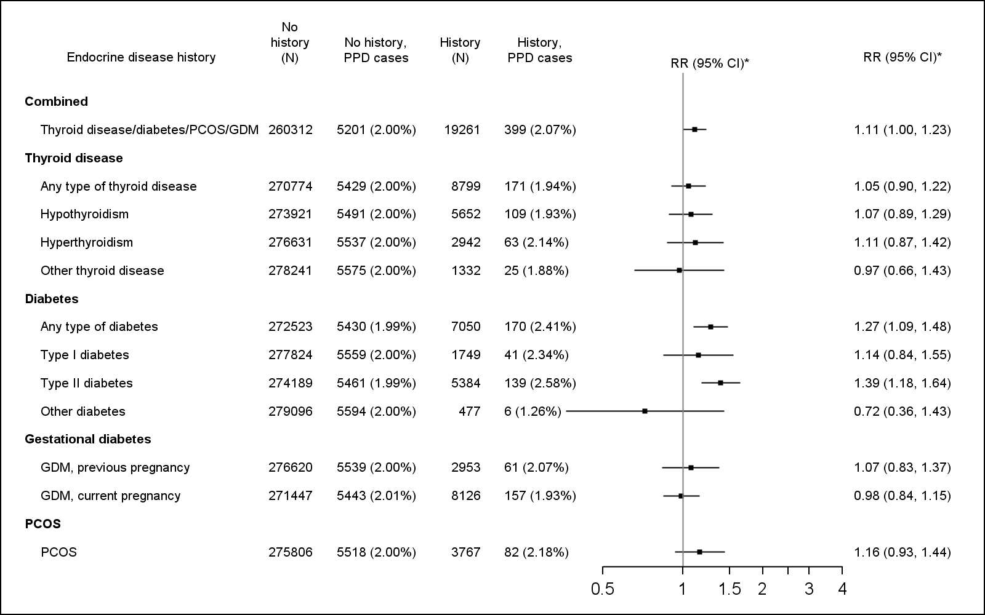
Abbreviations: RR, risk ratio; PPD, postpartum depression; PCOS, polycystic ovary syndrome; GDM, gestational diabetes mellitus.
* Adjusted for calendar year, length of follow-up, parity, multiple delivery, maternal education, cohabitation, employment status, calendar year*maternal age.

Table S5: Risk ratio (RR) of PPD by endocrine disease history, in women without psychiatric history, extended definitionª
Endocrine disease history | Endocrine history |  | No Endocrine history |  | Endocrine history vs no history
 | Deliveries (N) | No. of PPD cases (%) | Deliveries (N) | No. of PPD cases (%) | RR (95% CI)^{b}
Combined | 40,243 | 288 (0.72%) | 913,795 | 4,844 (0.53%) | 1.41 (1.25, 1.59)
Thyroid disease | 18,748 | 128 (0.68%) | 935,290 | 5,004 (0.54%) | 1.38 (1.16, 1.65)
Diabetes | 13,780 | 99 (0.72%) | 940,258 | 5,033 (0.54%) | 1.35 (1.11, 1.65)
PCO | 7,095 | 57 (0.80%) | 946,943 | 5,075 (0.54%) | 1.50 (1.15, 1.94)
GDM, previous pregnancy | 6,034 | 44 (0.73%) | 948,003 | 5,088 (0.54%) | 1.41 (1.05, 1.90)
Abbreviations: RR, risk ratio; PPD, postpartum depression; PCOS, polycystic ovary syndrome; GDM, gestational diabetes mellitus.
ª Psychiatric history defined as a hospital contact and/or 2 or more prescriptions of psychotropic drugs
^{b} Adjusted for calendar year, length of follow-up, parity, multiple delivery, maternal education, cohabitation, employment status, calendar year*maternal age.

Table S6: External informationª on distribution of BMI and RR for PPD given BMI group used in the external adjustment for BMI^{b}
BMI | No endocrine disorder | Endocrine disorder | RR(6)_{BMI vs PPD}
<18.5 | P₀₁=8.7% | P₁₁=5.6% | RR₁=1.52
18.5-24 | 60.6% | 44.9% | Ref
25-34 | P₀₂=27.0% | P₁₂=40.1% | RR₂=1.04
35 | P₀₃=3.7% | P₁₃=9.4% | RR₃=1.39
ª Distribution of BMI in women with and without endocrine disorder is derived from unpublished register data.
^{b} Calculation of adjusted RR adjusted for BMI as a polytomous confounder:(7)
RR_{adj}=RR_{obs} * (RR₁p₀₁+ RR₂p₀₂ +RR₃p₀₃ + (1- p₀₁ - p₀₂ -p₀₃))/ (RR₁p₁₁+ RR₂p₁₂ +RR₃p₁₃ + (1- p₁₁ – p₁₂ –p₁₃)) = 1.42 * (1.52*0.087+1.04*0.27+1.39*0.037 + (1- 0.087 – 0.27 – 0.037))/(1.52*0.056+1.04*0.401+1.39*0.094 + (1- 0.056 – 0.401 – 0.094))
= 1.41 with confidence interval (1.23, 1.60).

Literature
1. Pedersen CB. The Danish civil registration system. Scand J Public Health. 2011 Jul;39(7):22–5.
2. Schmidt M, Schmidt SAJ, Sandegaard JL, Ehrenstein V, Pedersen L, Sørensen HT. The Danish National patient registry: A review of content, data quality, and research potential. Clin Epidemiol. 2015 Nov;7:449–90.
3. Mors O, Perto GP, Mortensen PB. The Danish psychiatric central research register. Scand J Public Health. 2011 Jul;39(7):54–7.
4. Wallach Kildemoes H, Toft Sørensen H, Hallas J. The Danish national prescription registry. Scand J Public Health. 2011 Jul;39(7):38–41.
5. Bliddal M, Broe A, Pottegård A, Olsen J, Langhoff-Roos J. The Danish Medical Birth Register. Eur J Epidemiol. 2018 Jan 19;33(1):27–36.
6. Silverman ME, Reichenberg A, Savitz DA, Cnattingius S, Lichtenstein P, Hultman CM, et al. The risk factors for postpartum depression: A population-based study. Depress Anxiety. 2017 Feb 1;34(2):178–87.
7. Lash TL, Fox MP, Fink AK. Applying Quantitative Bias Analysis to Epidemiologic Data. 2009;

