Supplementary Material

Model specification:

$Y_{ij}=π_{0i}+π_{1i}{time}_{ij} + π_{2i}{time}_{ij}^{2} +ε_{ij}$ (Eq. 1)
$π_{0i}=γ_{00}+γ_{01}{group}_{i}+γ_{01}{month}_{i}+ζ_{0i}$ (Eq. 2)
$π_{1i}=γ_{10}+γ_{11}{group}_{i}+ζ_{1i}$ (Eq. 3)
$π_{2i}=γ_{20}+γ_{21}{group}_{i}+ζ_{2i}$ (Eq. 4)
The growth curve model is presented mathematically in Equation (1) to (4). Equation (1) addresses intra-individual growth where $Y_{ij}$, depressive or anxiety symptoms for the individual i at time j, is a function of time and its quadratic term. $π_{0i}$ represents the individual i’s initial status. $π_{1i}$ and $π_{2i}$ represent growth rates and $ε_{ij}$ is the residual term. Equation (2) to (4) addresses inter-individual differences in the initial status (intercept) and growth rates. $γ_{00}$, $γ_{10}$and $γ_{20}$ represent the population average initial status (intercept) and growth rates. $ζ_{0i}$, $ζ_{1i}$ and $ζ_{2i}$ are parameter residuals.

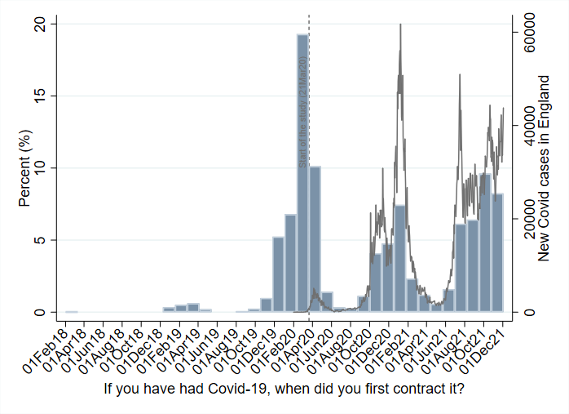
Fig S1. The date of first contract (N=4,938) compared to the national statistics of COVID-19 cases in England
Sources: COVID-19 Social Study, https://coronavirus.data.gov.uk/

Other countries in the UK (18%)
Not completed Covid-19 module in Nov 2021 (58%)
Missing data general (N=11%)
Missing data on Covid-19 (1%)
Not had COVID-19 by Nov 2021 (N=88%)
First contract before 21 Mar 2020 (28%)
*See Fig S2
Covid-19 sample
(N=3 211)
Covid-19 sample
(N=3 115)
Had Covid-19 more than once (3%)
Total sample size
(N=73 242)
Living in England
(N=59 803)
Completed the Covid-19 module in Nov 2021
(N=25 289)
Analytical sample
(N=22 528)
Covid-19 sample
(N=4 938)
Covid-19 sample
(N=4 887)
Fig S2. Sample selection process

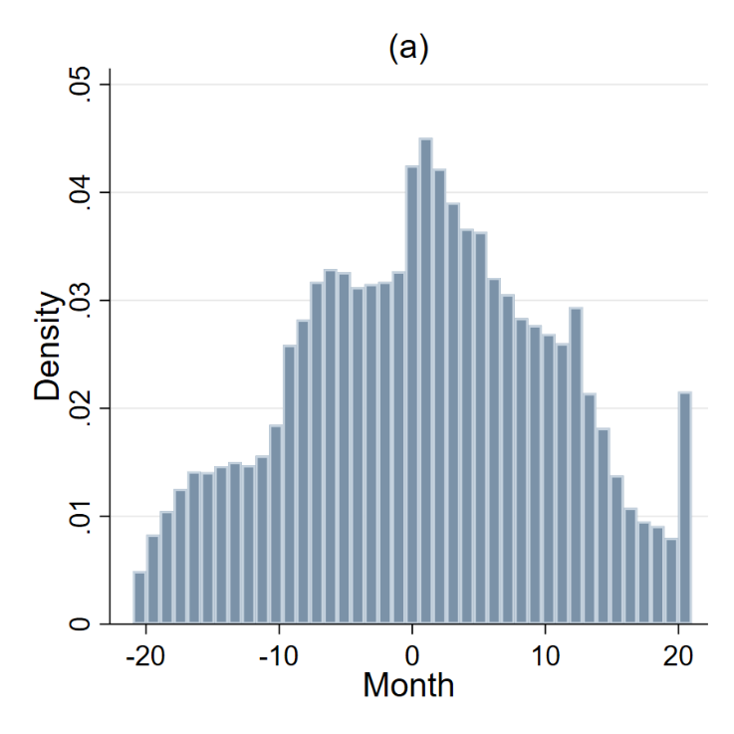
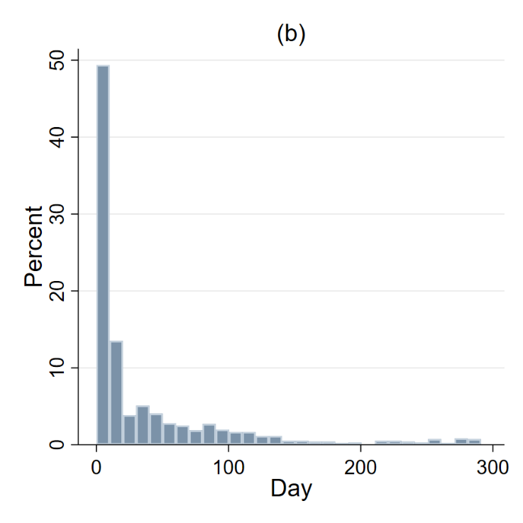
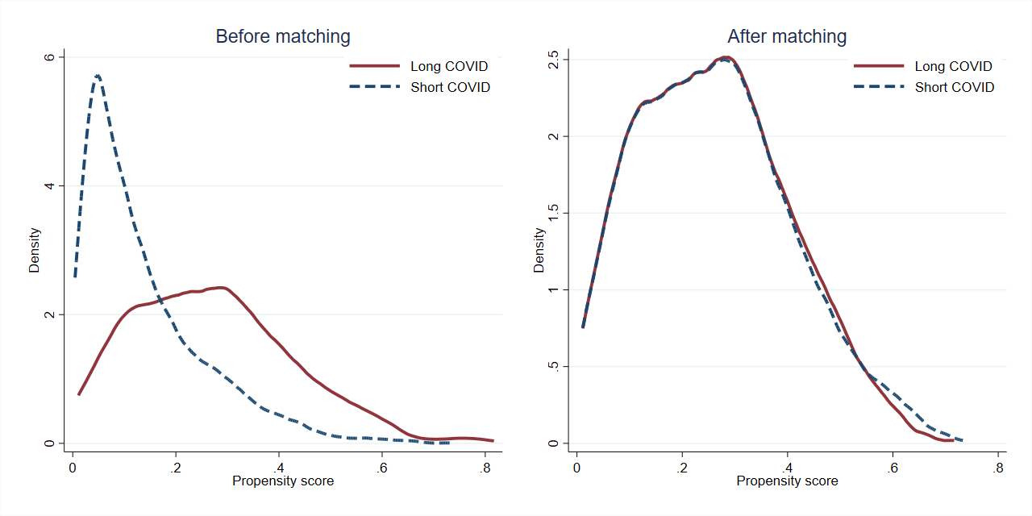
Fig S3. (a) Distribution of survey months since contracting COVID-19 in the one-to-one matched sample (total number of observations=13,325), (b) Distribution of the gap (day) between self-reported COVID-19 date and the closest survey date (either before or after, number of participants=962)
Fig S4. Propensity score density before and after matching
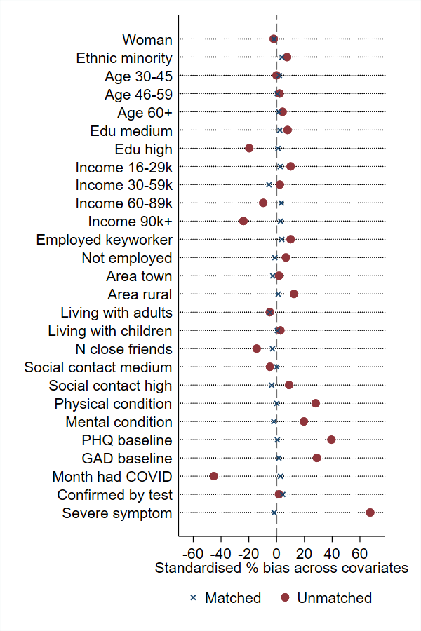
Fig S5. Standardised percentage bias for each covariate before and after matching
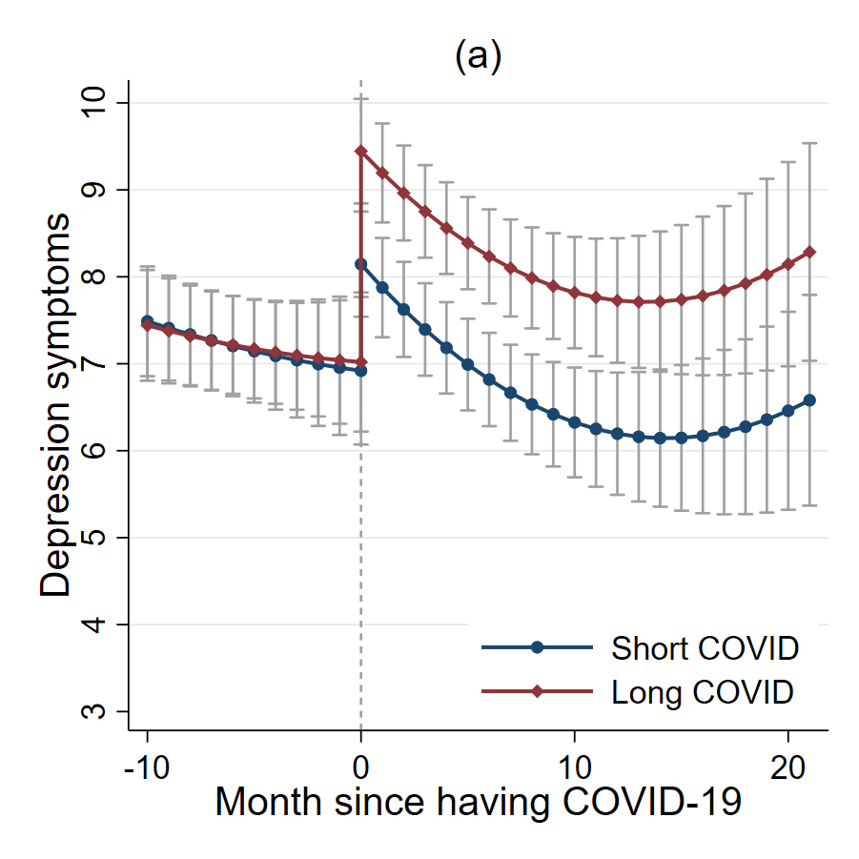
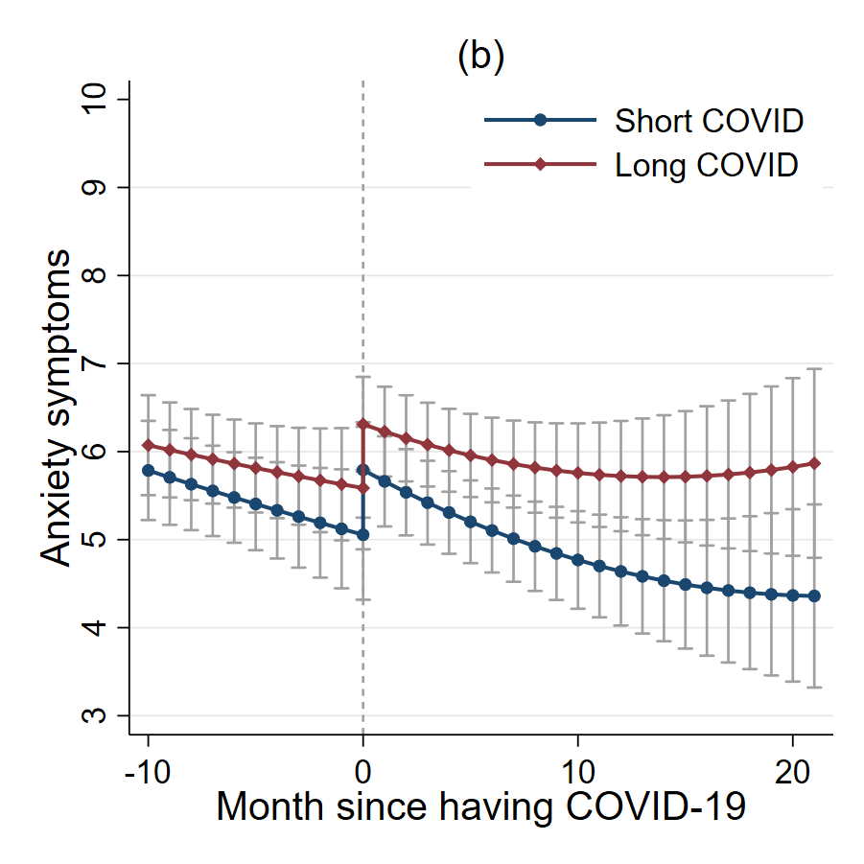
Fig S6. Predicted growth trajectories by Covid-19 group with 95% confidence intervals

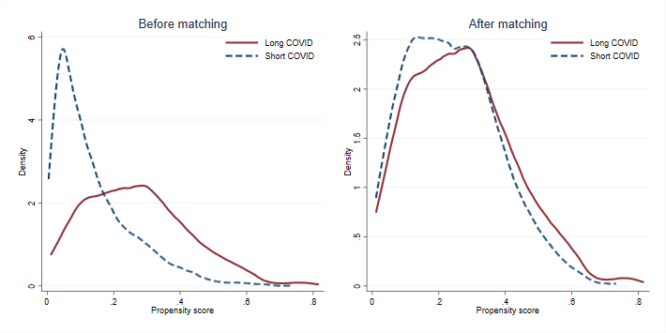
Fig S7. Propensity score density before and after matching based on one-to-many nearest neighbour matching

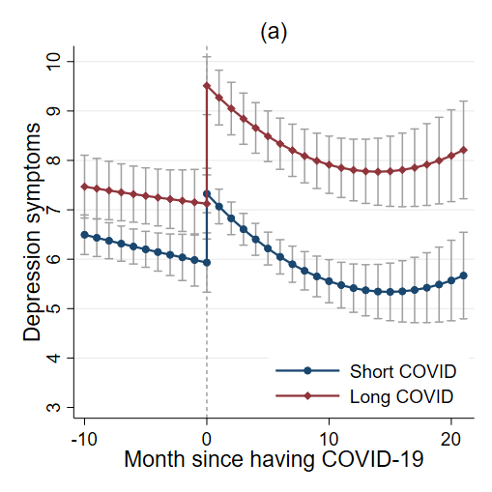
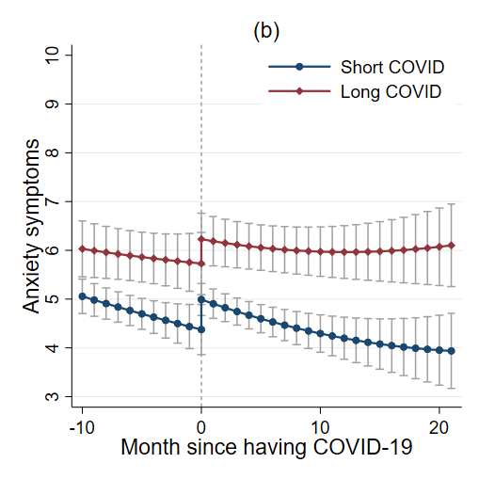
Fig S8. Predicted growth trajectories by Covid-19 group with 95% confidence intervals based on one-to-many nearest neighbour matching
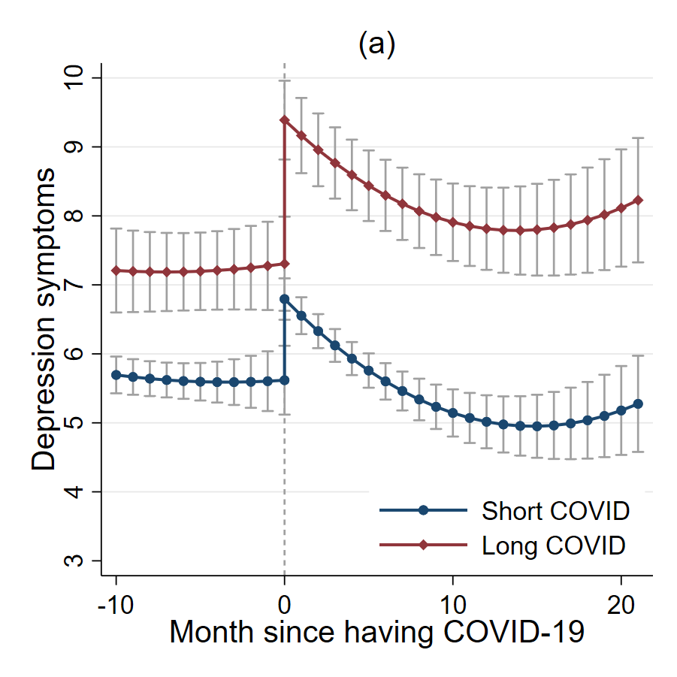
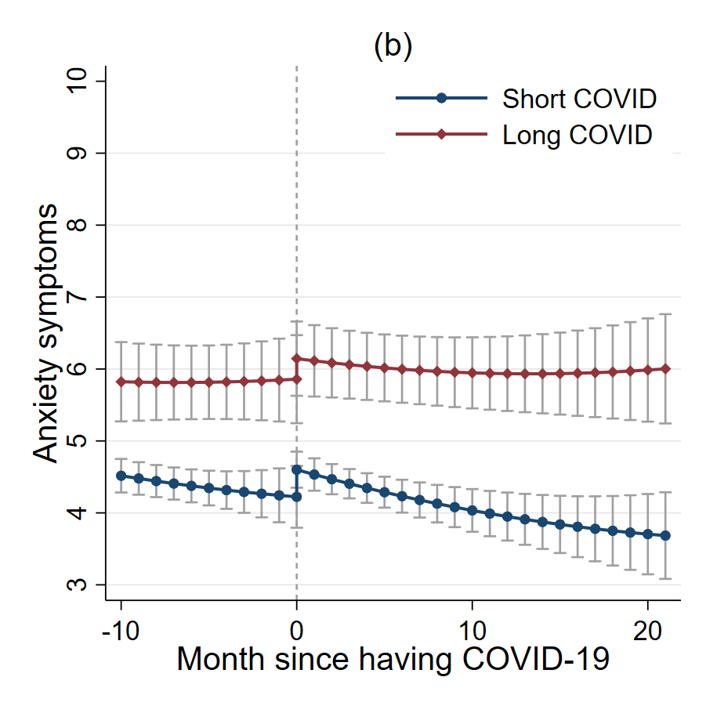
Fig S9. Predicted growth trajectories by Covid-19 group with 95% confidence intervals based on kernel matching (NB these sensitivity analyses yielded less balanced matches so apparent differences in pre-infection mental health should be interpreted with caution)

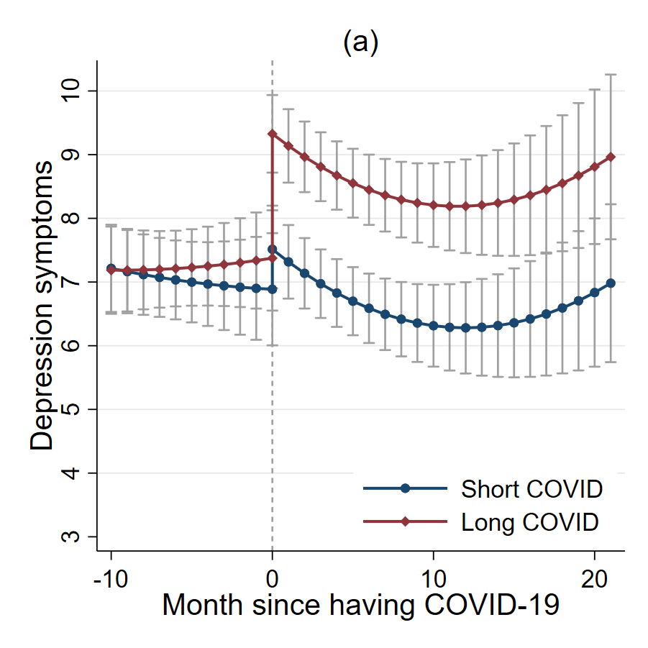
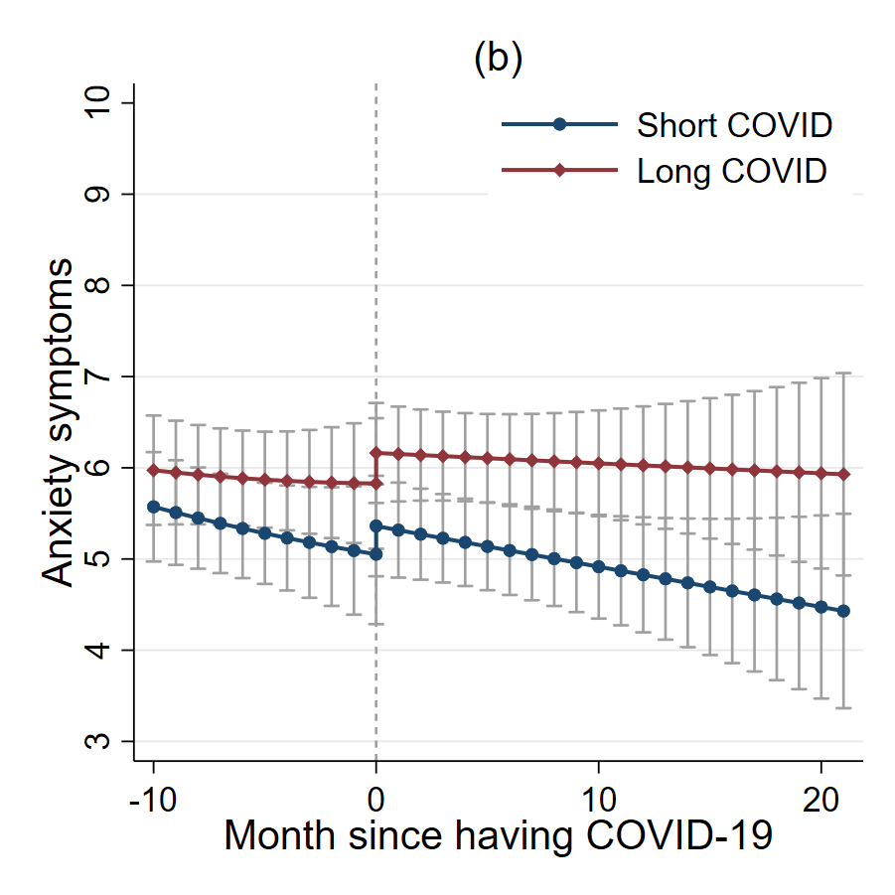
Fig S10. Predicted growth trajectories by Covid-19 group with 95% confidence intervals based on one-to-one matching excluding cases based on symptoms
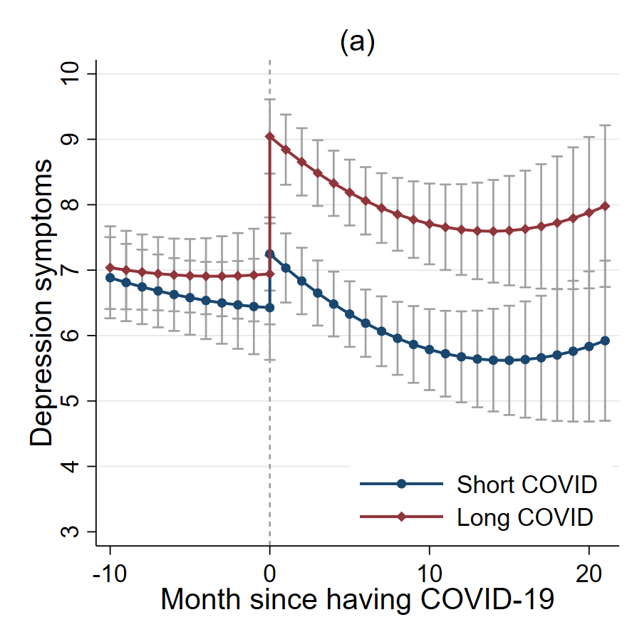
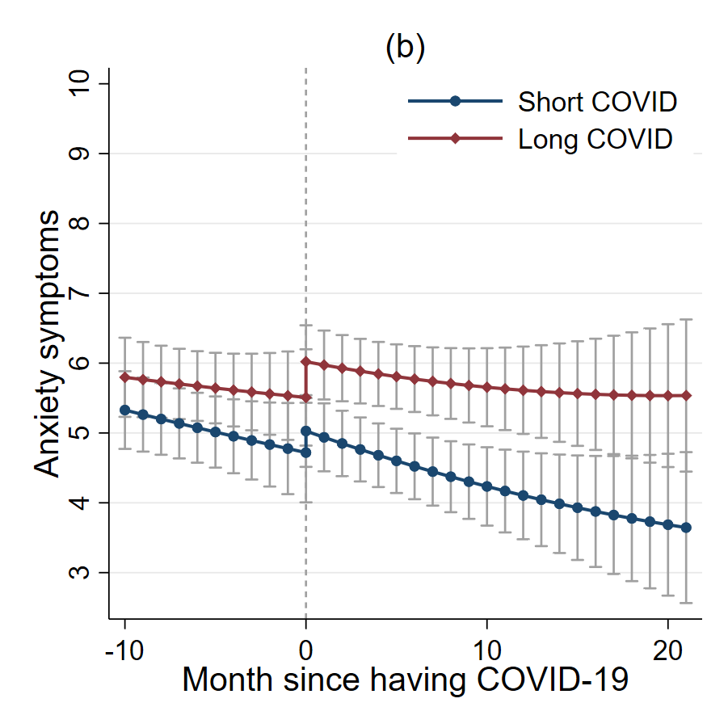
Fig S11. Predicted growth trajectories by Covid-19 group with 95% confidence intervals based on one-to-one matching excluding people who were unsure about their long Covid diagnosis
Table S1 Results from Propensity Score Matching (one-to-one matching without replacement)
 | Coef. | SE | 95% CI | p
Women (vs men) | -0.33 | 0.13 | [-0.60--0.07] | 0.013
Ethnic minority (vs white) | 0.30 | 0.23 | [-0.16-0.76] | 0.197
Age 30-45 (vs 18-29) | 0.48 | 0.24 | [0.01-0.95] | 0.046
Age 46-59 (vs 18-29) | 0.45 | 0.24 | [-0.01-0.91] | 0.056
Age 60+ (vs 18-29) | 0.64 | 0.26 | [0.13-1.14] | 0.013
Education: A levels or equivalent (vs GCSE or below) | -0.23 | 0.19 | [-0.60-0.13] | 0.208
Education: Degree or above (vs GCSE or below) | -0.40 | 0.16 | [-0.72--0.09] | 0.013
Income: ≤£16,000-29,999 (vs <£16,000) | -0.18 | 0.19 | [-0.55-0.19] | 0.334
Income: ≤£30,000-59,999 (vs <£16,000) | -0.25 | 0.19 | [-0.61-0.12] | 0.187
Income: ≤£60,000-89,999 (vs <£16,000) | -0.48 | 0.22 | [-0.91--0.05] | 0.029
Income: ≥£90,000 (vs <£16,000) | -0.93 | 0.26 | [-1.43--0.42] | <0.001
Employed, non-keyworker (vs Employed, keyworker) | 0.14 | 0.13 | [-0.11-0.39] | 0.282
Not employed (vs Employed, keyworker) | -0.03 | 0.15 | [-0.32-0.27] | 0.864
Area of living: Town (vs City) | 0.09 | 0.12 | [-0.15-0.34] | 0.452
Area of living: Rural (vs City) | 0.51 | 0.15 | [0.21-0.81] | 0.001
Living with adult only (vs Living alone) | 0.13 | 0.17 | [-0.2-0.46] | 0.444
Living with children (vs Living alone) | 0.39 | 0.18 | [0.03-0.74] | 0.032
Number of close friends | -0.01 | 0.02 | [-0.05-0.03] | 0.655
Social contact: Once or twice a week (vs Twice a month or less) | -0.08 | 0.13 | [-0.33-0.18] | 0.553
Social contact: Three times a week or more (vs Twice a month or less) | -0.05 | 0.14 | [-0.33-0.23] | 0.733
Physical health condition: Yes (vs No) | 0.32 | 0.11 | [0.10-0.54] | 0.004
Mental health condition Yes (vs No) | 0.01 | 0.15 | [-0.28-0.29] | 0.955
Baseline depressive symptoms | 0.05 | 0.02 | [0.02-0.08] | 0.002
Baseline anxiety symptoms | 0.00 | 0.02 | [-0.03-0.04] | 0.885
Month had COVID-19 | -0.09 | 0.01 | [-0.11--0.07] | <0.001
Confirmed by testing (COVID-19 or antibody test): Yes (vs No) | 0.69 | 0.14 | [0.41-0.98] | <0.001
Severe symptoms (hospitalised or had to stay in bed): Yes (vs No) | 1.37 | 0.13 | [1.12-1.63] | <0.001
Constant | -2.47 | 0.41 | [-3.28--1.66] | <0.001

Table S2 Sample characteristics by matched Covid-19 group
 |  | Long Covid  (N=481) | Short Covid  (N=481)
Gender | Men | 21.8% | 21.0%
 | Women | 78.2% | 79.0%
Ethnicity | White | 94.2% | 95.0%
 | Ethnic minority | 5.8% | 5.0%
Age group | 18-29 | 6.0% | 7.7%
 | 30-45 | 31.6% | 30.8%
 | 46-59 | 39.1% | 38.9%
 | 60+ | 23.3% | 22.7%
Education | GCSE or below | 15.4% | 16.6%
 | A levels or equivalent | 19.5% | 18.7%
 | Degree or above | 65.1% | 64.7%
Annual income | <£16,000 | 14.3% | 14.8%
 | ≤£16,000-29,999 | 23.7% | 22.7%
 | ≤£30,000-59,999 | 38.3% | 41.0%
 | ≤£60,000-89,999 | 16.2% | 15.0%
 | ≥£90,000 | 7.5% | 6.7%
Employment status | Employed, keyworker | 39.1% | 40.1%
 | Employed, non-keyworker | 32.6% | 31.0%
 | Not employed | 28.3% | 28.9%
Area of living | City | 32.0% | 31.0%
 | Town | 46.8% | 48.2%
 | Rural | 21.2% | 20.8%
Living status | Living alone | 14.8% | 12.5%
 | Living with adult only | 48.2% | 50.7%
 | Living with children | 37.0% | 36.8%
Social contact | Twice a month or less | 35.3% | 33.7%
 | Once or twice a week | 33.3% | 33.3%
 | Three times a week or more | 31.4% | 33.1%
Number of close friends |  | 4.7 (3.1) | 4.8 (3.1)
Physical health condition | Yes | 44.1% | 44.1%
 | No | 55.9% | 55.9%
Mental health condition | Yes | 23.1% | 23.9%
 | No | 76.9% | 76.1%
Baseline depressive symptoms |  | 8.3 (5.9) | 8.2 (6.0)
Baseline anxiety symptoms |  | 6.5 (5.4) | 6.4 (5.2)
Month had COVID-19 |  | 10.5 (6.5) | 10.3 (7.1)
Confirmed by testing (COVID-19 or antibody test) | Yes | 74.6% | 72.8%
 | No | 25.4% | 27.2%
Severe symptoms (hospitalised or had to stay in bed) | Yes | 81.7% | 82.5%
 | No | 18.3% | 17.5%

Table S3. Detailed Covid experience measures by matched Covid-19 group
 |  | Long Covid | Short Covid | Total
Test | Yes, a medical professional has formally diagnosed me with long Covid | 112  23.3% | -- | 112 11.6%
 | Yes, I have not been formally diagnosed but consider myself to have Long Covid | 369  76.7% | -- | 369 38.4%
 | No, I do not consider myself to have Long Covid | -- | 369  76.7% | 369 38.4%
 | I am unsure | -- | 112  23.3% | 112 11.6%
 | Total | 481 | 481 | 962
 |  | 100% | 100% | 100%
Severity  (first 1-2 weeks) | I was hospitalised | 30 | 16 | 46
 |  | 6.2% | 3.3% | 4.8%
 | I experienced symptoms and had to rest in bed | 363 | 381 | 744
 |  | 75.5% | 79.2% | 77.3%
 | I experienced symptoms but was able to carry on with daily activities | 79 | 71 | 150
 |  | 16.4% | 14.8% | 15.6%
 | I was asymptomatic | 9 | 13 | 22
 |  | 1.9% | 2.7% | 2.3%
 | Total | 481 | 481 | 962
 |  | 100% | 100% | 100%
Symptoms | My symptoms were worse at the beginning (the first 1-2 weeks) and then got better | 23 | 179 | 202
 |  | 4.8% | 37.6% | 21.2%
 | My symptoms were worse at the beginning (the first 1-2 weeks) and then mostly got better but some lingered | 152 | 167 | 319
 |  | 32.0% | 35.1% | 33.5%
 | After the first 1-2 weeks, my symptoms got better but then the same symptoms kept coming back | 67 | 21 | 88
 |  | 14.1% | 4.4% | 9.3%
 | After the first 1-2 weeks, my symptoms got better but I then developed new symptoms | 60 | 15 | 75
 |  | 12.6% | 3.2% | 7.9%
 | Most of my symptoms lasted for 2-3 weeks | 25 | 39 | 64
 |  | 5.3% | 8.2% | 6.7%
 | Most of my symptoms lasted for 4-12 weeks | 62 | 23 | 85
 |  | 13.1% | 4.8% | 8.9%
 | Most of my symptoms lasted for more than 12 weeks | 81 | 6 | 87
 |  | 17.1% | 1.3% | 9.2%
 | I cannot answer this question (e.g. you had COVID very recently) | 5 | 26 | 31
 |  | 1.1% | 5.5% | 3.3%
 | Total | 475 | 476 | 951
 |  | 100% | 100% | 100%

