Supplementary Figure 1) Mean weekly rates of stress-related presentations in term and holiday times in 2018/19 and 2020/21 by sex and year of age.
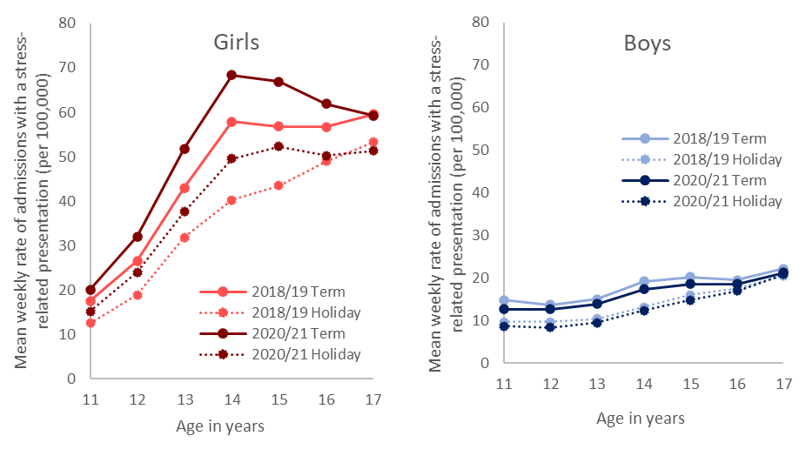
Figure note: data points reflect discreet 1 year age bands. Connecting lines are shown for ease of reading. Data for the year 2019/20 are not shown. Overall mean weekly rates of stress-related admissions were higher in term times than holidays for girls and boys of all ages (t test of weekly counts, p<0.005 in all instances), except boys aged 17 years (p=0.11).

Supplementary Figures 2 and 3 show age and sex-specific incident rate ratios (IRRs) and associated 95% confidence intervals for the weekly rate of admission with a stress-related presentation in 2018/19-2020/21. Figure 1 shows IRRs for term-time (versus holiday periods) and Figure 2 shows IRRs for admissions in 2020/21 (versus 2018/19).
Figure 2
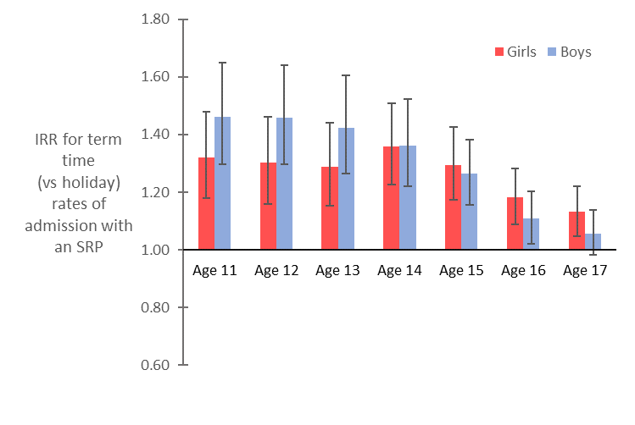
Figure 3
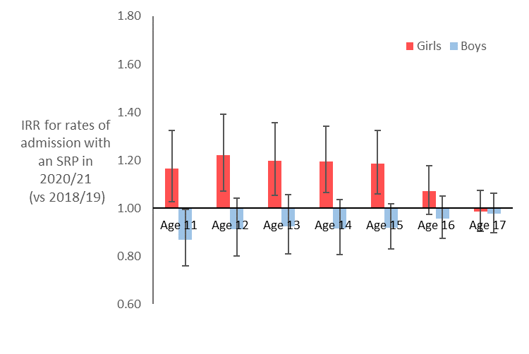
Figure note: IRRs were estimated from age and sex-specific negative binomial regression models for the weekly rate of admission with a stress-related presentation. Models included mid-year population estimates as an offset, term (vs holiday) as the exposure and year of admission as a covariate (3-level factor).

Supplementary Table 1: International Classification of Diseases and Related Health Problems version 10 (ICD-10) code list for stress-related presentations

Category | Group | ICD-code | ICD-10 Description
Pain-related presentations | Abdominal/pelvic pain | R10 ¹ | Abdominal and pelvic pain
 | Headache | R51 | Headache
 |  | G442 | Tension-type headache
 | Other pain | M54 | Panniculitis affecting regions of neck and back
 |  | M626 | Muscle strain
 |  | M796 | Pain in limb
 |  | R52 | Acute pain
Other somatic presentations | Circulatory/respiratory signs | R00 | Abnormalities of heart beat
 |  | R03 | Abnormal blood pressure reading, without diagnosis
 |  | R05 | Cough
 |  | R06 | Abnormalities of breathing
 |  | R07 | Pain in throat and chest
 | Digestive symptoms | R11-14 | Nausea and vomiting, Heartburn, Dysphagia, Flatulence and related conditions
 |  | R194 | Change in bowel habit
 | Skin symptoms | R20-21 | Disturbances of skin sensation, rash and other nonspecific skin eruption
 |  | R231 | Pallor
 |  | R234 | Changes in skin texture
 |  | R238 | Other and unspecified skin changes
 | Nervous/musculoskeletal symptoms | R25 | Abnormal involuntary movements
 |  | R26 | Abnormalities of gait and mobility
 |  | R27 | Other lack of co-ordination
 |  | R292-294 | Abnormal reflex, Abnormal posture, Clicking hip
 |  | R298 | Other and unspecified signs and symptoms involving nervous and musculoskeletal systems
 | Cognitive symptoms | R400-401 | Somnolence, Stupor
 |  | R41-42 | Other symptoms and signs involving cognitive functions and awareness, Dizziness and giddiness
Other somatic presentations (continued) | Malaise/Fatigue/Syncope | R53 | Malaise and fatigue
 |  | R55 | Syncope and collapse
 | Other/general symptoms | R44 | Other symptoms and signs involving general sensations and perceptions
 |  | R45 | Symptoms and signs involving emotional state
 |  | R46 | Symptoms and signs involving appearance and behaviour
 |  | R47 | Dysphasia and aphasia
 |  | R49 | Voice disturbances
 |  | Z563-564 | Stressful work schedule, Discord with boss and workmates
 |  | Z711 | Person with feared complaint in whom no diagnosis is made
 |  | Z733 | Stress, not elsewhere classified
Mental health & behavioural presentations | Anxiety/Depression | F31 | Bipolar affective disorder
 |  | F320 | Mild depressive episode
 |  | F321 | Moderate depressive episode
 |  | F322 | Severe depression without psychotic symptoms
 |  | F323 | Severe depression with psychotic symptoms
 |  | F328 | Other depressive episodes
 |  | F329 | Depressive episode, unspecified
 |  | F330 | Recurrent depressive disorder, current episode mild
 |  | F331 | Recurrent depressive disorder, current episode moderate
 |  | F332 | Recurrent depressive disorder, current episode severe without psychotic symptoms
 |  | F333 | Recurrent depressive disorder, current episode severe with psychotic symptoms
 |  | F338 | Other recurrent depressive disorders
 |  | F339 | Recurrent depressive disorder, unspecified
 |  | F341 | Dysthymia
 |  | F40 | Agoraphobia
 |  | F410 | Social phobias
 |  | F411 | Generalized anxiety disorder
 |  | F412 | Mixed anxiety and depressive disorder
Mental health & behavioural presentations (cont.) | Anxiety/Depression (cont.) | F43 | Other mixed anxiety disorder
 | Mental health | F20-F29 | Schizophrenia, schizotypal and delusional disorders
 |  | F30-F39 | Mood disorders
 |  | F40-F49 | Neurotic, stress-related and somatoform disorders
 |  | F50-F59 | Behavioural syndromes associated with physiological disturbances and physical factors
 |  | F60-F69 | Disorders of adult personality and behaviour
 |  | F90-F98 | Behavioural and emotional disorders with onset usually occurring in childhood and adolescence
 |  | F99 | Unspecified mental disorder
 | Obsessive-compulsive / Dissociative / Eating disorders | F42 | Obsessive-compulsive disorder
 |  | F44 | Dissociative [conversation] disorders
 |  | F45 | Somatoform disorders
 |  | F50 | Eating disorders
 | Sleep disorders | F51 | Nonorganic sleep disorders
 |  | G47 | Disorders of initiating and maintaining sleep [insomnias]
 | Drug / Alcohol abuse | F10-F19 | Mental and behavioural disorders due to psychoactive substance use
 |  | F55 | Abuse of non-dependence-producing substances
 |  | R780 | Finding of alcohol in blood
 |  | R781-R785 | Findings of drugs and other substances, not normally found in blood
 |  | T51 | Toxic effect of alcohol
 |  | Y15 ² | Poisoning by drugs, medicaments and biological substances
 |  | Y90 ^{2, 3} | Evidence of alcohol involvement determined by blood alcohol level
 |  | Y91 ^{2, 3} | Evidence of alcohol involvement determined by level of intoxication
 |  | Z040 ^{2, 3} | Blood-alcohol and blood-drug test
 |  | Z502 ^{2, 3} | Alcohol rehabilitation
 |  | Z503 ^{2, 3} | Drug rehabilitation
 |  | Z714 ^{2, 3} | Alcohol abuse counselling and surveillance
 |  | Z715 ^{2, 3} | Drug abuse counselling and surveillance
 |  | Z721 ^{2, 3} | Alcohol use
Mental health & behavioural presentations (cont.) | Drug / Alcohol abuse (cont.) | Z722 ^{2, 3} | Drug use
 |  | Z915 ^{2, 4} | Personal history of self-harm
 | Self-harm / Poisoning / Cutting | T36-50 ³ | Poisoning by drugs, medicaments and biological substances
 |  | Y10-14 ² | Poisoning [drugs], undetermined intent
 |  | Y16-19 ² | Poisoning [chemicals], undetermined intent
 |  | S00 ³ | Superficial injury of scalp
 |  | S10 ³ | Superficial injury of neck
 |  | S20 ³ | Superficial injury of thorax
 |  | S30 ³ | Superficial injury of lower back and pelvis
 |  | S40 ³ | Superficial injury of shoulder and upper arm
 |  | S50 ³ | Superficial injury of forearm
 |  | S60 ³ | Superficial injury of wrist and hand
 |  | S70 ³ | Superficial injury of hip and thigh
 |  | S80 ³ | Superficial injury of lower leg
 |  | S90 ³ | Superficial injury of ankle and foot
 |  | X60-63 ² | Intentional self-poisoning (drugs)
 |  | X64-X69 ² | Intentional self-harm (self-poisoning)
 |  | X70-X84 2 | Intentional self-harm (hanging, drowning, firearm, explosive material, fire, steam, sharp/blunt object, jumping, crashing motor vehicle, other)
 |  | Z642 ² | Intentional self-poisoning by and exposure to other and unspecified drugs, medicaments and biological substances
 |  | Z915 ^{2, 4} | Personal history of self-harm

ICD-10 = International Classification of Diseases and Related Health Problems version 10. Supplementary Table 1 outlines the ICD-10 code list that was developed as part of this study to identify a stress-related presentation in Hospital Episode Statistics Admitted Patient Care (HES APC) data based on information recorded in the diagnosis fields. In HES APC up to 20 diagnosis fields can be recorded per admission using ICD-10 codes. An admission was categorised as a stress-related presentation if an ICD-10 code listed in Supplementary Table 1 was recorded in the primary diagnostic position, or in any diagnostic position for some mental health and behavioural presentations, as indicated.¹ Admissions with a primary diagnostic code of R10 (Abdominal and pelvic pain) were not categorised as a stress-related presentation if a medical or surgical cause was indicated by an operation or subsidiary diagnostic code for the same admission (as detailed in Supplementary Table 2).² An admission was categorised as a stress-related presentation if this ICD-10 code was recorded in any diagnostic coding position.³ An admission was categorised as a stress-related presentation if this ICD-10 code was recorded in the primary diagnostic coding position and one of the following self-harm codes were also recorded in another diagnostic position: X60-63 (Intentional self-poisoning (drugs)), X64-X69 (Intentional self-harm (self-poisoning)), X70-X84 (Intentional self-harm (hanging, drowning, firearm, explosive material, fire, steam, sharp/blunt object, jumping, crashing motor vehicle, other)), Z642 (Intentional self-poisoning by and exposure to other and unspecified drugs, medicaments and biological substances) or Z915 (personal history of self-harm).⁴ For admissions that included Z915 (personal history of self-harm), where the diagnostic codes reflected more than one category (e.g., drug/alcohol abuse and self-harm presentations), the presentation was classified as Self-harm/ Poisoning / Cutting only, such that the groups were mutually exclusive.
Supplementary Table 2) Diagnostic and operation codes indicating a medical or surgical cause for presentations of abdominal pain

 | Code | Description
Diagnosis | N832 | Other and unspecified ovarian cysts
 | A099 | Gastroenteritis and colitis of unspecified origin
 | K529 | Noninfective gastroenteritis and colitis, unspecified
 | E282 | Polycystic ovarian syndrome
 | N390 | Urinary tract infection, site not specified
 | K589 | Irritable bowel syndrome without diarrhoea
Operation | Y752 | Laparoscopic approach to the abdominal cavity not elsewhere classified
 | H013 | Emergency excision of normal appendix
 | H029 | Unspecified excision of appendix
 | H012 | Emergency excision of normal appendix not elsewhere classified
 | H019 | Unspecified emergency excision of appendix
 | H021 | Interval appendectomy
 | H023 | Prophylactic appendectomy NEC
 | H024 | Incidental appendectomy
 | H028 | Other specified excision of appendix
 | H011 | Emergency excision of abnormal appendix and drainage HFQ

In Hospital Episode Statistics Admitted Patient Care data, up to 20 diagnosis fields and 24 operation fields can be recorded per admission using standardised coding systems (International Classification of Diseases and Related Health Problems version 10 (ICD-10) codes for diagnoses and Office of Population Censuses and Surveys version 4 (OPCS-4) for operations). Admissions with a primary diagnostic code of R10 (Abdominal and pelvic pain) were not categorised as a stress-related presentation if a medical or surgical cause was indicated by a subsidiary diagnostic code or any operation code listed in Supplementary Material 4 recorded for the same admission.

