Manuscript: How safe are psychological interventions for adult PTSD? A meta-analysis on the incidence and relative risk of deterioration, adverse events and serious adverse events

Supplement 1: PRISMA-P checklist
Supplement 2: Search string used for systematic literature search.
Supplement 3: References of related reviews and meta-analyses scrutinized as part of the systematic literature search.
Supplement 4: Trial characteristics of included trials.
Supplement 5: References of included trials.
Supplement 6: Incidence and relative risk of pre-to-posttreatment deterioration (top) and pre-to-follow-up deterioration (bottom) – extended Table version.
Supplement 7: Moderator results – incidences of pre-to-posttreatment deterioration.
Supplement 8: Publication bias and outlier checks.
Supplement 9: Moderator results – incidences of pre-to-posttreatment adverse events.
Supplement 10: Moderator results – incidences of pre-to-posttreatment serious adverse events.
Supplement 11: Risk of bias assessment.
Supplement 1: PRISMA-P checklist
Section/topic | # | Checklist item | Reported on page #
TITLE
Title | 1 | Identify the report as a systematic review, meta-analysis, or both. | 1
ABSTRACT
Structured summary | 2 | Provide a structured summary including, as applicable: background; objectives; data sources; study eligibility criteria, participants, and interventions; study appraisal and synthesis methods; results; limitations; conclusions and implications of key findings; systematic review registration number. | 2
INTRODUCTION
Rationale | 3 | Describe the rationale for the review in the context of what is already known. | 3
Objectives | 4 | Provide an explicit statement of questions being addressed with reference to participants, interventions, comparisons, outcomes, and study design (PICOS). | 4
METHODS
Protocol and registration | 5 | Indicate if a review protocol exists, if and where it can be accessed (e.g., Web address), and, if available, provide registration information including registration number. | 4
Eligibility criteria | 6 | Specify study characteristics (e.g., PICOS, length of follow-up) and report characteristics (e.g., years considered, language, publication status) used as criteria for eligibility, giving rationale. | 4
Information sources | 7 | Describe all information sources (e.g., databases with dates of coverage, contact with study authors to identify additional studies) in the search and date last searched. | 4-5
Search | 8 | Present full electronic search strategy for at least one database, including any limits used, such that it could be repeated. | 4 & Supplement 2
Study selection | 9 | State the process for selecting studies (i.e., screening, eligibility, included in systematic review, and, if applicable, included in the meta-analysis). | 4
Data collection process | 10 | Describe method of data extraction from reports (e.g., piloted forms, independently, in duplicate) and any processes for obtaining and confirming data from investigators. | 5
Data items | 11 | List and define all variables for which data were sought (e.g., PICOS, funding sources) and any assumptions and simplifications made. | 5-6
Risk of bias in individual studies | 12 | Describe methods used for assessing risk of bias of individual studies (including specification of whether this was done at the study or outcome level), and how this information is to be used in any data synthesis. | 5
Summary measures | 13 | State the principal summary measures (e.g., risk ratio, difference in means). | 6
Synthesis of results | 14 | Describe the methods of handling data and combining results of studies, if done, including measures of consistency (e.g., I²) for each meta-analysis. | 7
Risk of bias across studies | 15 | Specify any assessment of risk of bias that may affect the cumulative evidence (e.g., publication bias, selective reporting within studies). | 6-7
Additional analyses | 16 | Describe methods of additional analyses (e.g., sensitivity or subgroup analyses, meta-regression), if done, indicating which were pre-specified. | 6-7
RESULTS
Study selection | 17 | Give numbers of studies screened, assessed for eligibility, and included in the review, with reasons for exclusions at each stage, ideally with a flow diagram. | 8 & Fig. 1
Study characteristics | 18 | For each study, present characteristics for which data were extracted (e.g., study size, PICOS, follow-up period) and provide the citations. | 8 (summary)  Supplement 4 (per trial)
Risk of bias within studies | 19 | Present data on risk of bias of each study and, if available, any outcome level assessment (see item 12). | Supplement 11
Results of individual studies | 20 | For all outcomes considered (benefits or harms), present, for each study: (a) simple summary data for each intervention group (b) effect estimates and confidence intervals, ideally with a forest plot. | Supplement 8
Synthesis of results | 21 | Present results of each meta-analysis done, including confidence intervals and measures of consistency. | 8-13 &  Table 1-3 & Supplement 6
Risk of bias across studies | 22 | Present results of any assessment of risk of bias across studies (see Item 15). | 8 & Supplement 7+9
Additional analysis | 23 | Give results of additional analyses, if done (e.g., sensitivity or subgroup analyses, meta-regression [see Item 16]). | Table 1-3 & Supplement 6-10
DISCUSSION
Summary of evidence | 24 | Summarize the main findings including the strength of evidence for each main outcome; consider their relevance to key groups (e.g., healthcare providers, users, and policy makers). | 13-14
Limitations | 25 | Discuss limitations at study and outcome level (e.g., risk of bias), and at review-level (e.g., incomplete retrieval of identified research, reporting bias). | 15
Conclusions | 26 | Provide a general interpretation of the results in the context of other evidence, and implications for future research. | 14-15
FUNDING
Funding | 27 | Describe sources of funding for the systematic review and other support (e.g., supply of data); role of funders for the systematic review. | 17
From: Moher D, Liberati A, Tetzlaff J, Altman DG, The PRISMA Group (2009). Preferred Reporting Items for Systematic Reviews and Meta-Analyses: The PRISMA Statement. PLoS Med 6(7): e1000097. doi:10.1371/journal.pmed1000097
Supplement 2: Search string used for systematic literature search.

Databases | Search Terms
MEDLINE and PsycINFO | ( TI ( ptsd OR ptss OR post-traumatic stress OR posttraumatic stress OR post-traumatic syndrome OR posttraumatic syndrome) OR AB ( ptsd OR ptss OR post-traumatic stress OR posttraumatic stress OR post-traumatic syndrome OR posttraumatic syndrome ) OR SU ( ptsd OR ptss OR post-traumatic stress OR posttraumatic stress OR post-traumatic syndrome OR posttraumatic syndrome ) ) AND ( TI ( treatment* OR intervention* OR therap* OR psychotherap* OR exposure OR counse*ing OR trial* ) OR AB ( treatment* OR intervention* OR therap* OR psychotherap* OR exposure OR counse*ing OR trial* ) OR SU ( treatment* OR intervention* OR therap* OR psychotherap* OR exposure OR counse*ing OR trial* ) )
PTSDpubs | (ptsd OR ptss OR post-traumatic stress OR posttraumatic stress OR post-traumatic syndrome OR posttraumatic syndrome) AND (treatment* OR intervention* OR therap* OR psychotherap* OR exposure OR counse*ing OR trial*)
Web of Science | ALL=( ptsd OR ptss OR post-traumatic stress OR posttraumatic stress OR post-traumatic syndrome OR posttraumatic syndrome ) AND ALL=( treatment* OR intervention* OR therap* OR psychotherap* OR exposure OR counse*ing OR trial* )
Note that the search string contains APA thesaurus/MeSH search terms (i.e., “posttraumatic stress”, “treatment”, “intervention”, “psychotherapy”, “exposure” and “counseling” as well as additional terms (e.g., “post-traumatic stress”, “PTSD”, “trial”, “therapy”) in case a particular trial was not registered under these APA thesaurus/MeSH search terms.

Supplement 3: References of related reviews and meta-analyses scrutinized as part of the systematic literature search.

1 Althobaiti S, Kazantzis N, Ofori-Asenso R, Romero L, Fisher J, Mills KE et al. Efficacy of interpersonal psychotherapy for post-traumatic stress disorder: A systematic review and meta-analysis. J Affect Disord 2020; 264: 286–94.
2 Alves-Costa F, Hamilton-Giachritsis C, Christie H, van Denderen M, Halligan S. Psychological interventions for individuals bereaved by homicide: a systematic review. Trauma Violence Abuse 2021; 22 (4): 793–803.
3 Anderson GS, Di Nota PM, Groll D, Carleton RN. Peer support and crisis-focused psychological interventions designed to mitigate post-traumatic stress injuries among public safety and frontline healthcare personnel: a systematic review. Int J Environ Res Public Health 2020; 17 (20): 7645.
4 Astill Wright L, Horstmann L, Holmes EA, Bisson JI. Consolidation/reconsolidation therapies for the prevention and treatment of PTSD and re-experiencing: a systematic review and meta-analysis. Transl Psychiatry 2021; 11 (1): 1–14.
5 Baas M am, van Pampus MG, Braam L, Stramrood CAI, Jongh A de. The effects of PTSD treatment during pregnancy: systematic review and case study. Eur J Psychotraumatol 2020; 11 (1): 1762310.
6 Badesha K, Wilde S, Dawson DL. Mental health mobile app use to manage psychological difficulties: an umbrella review. Ment Health Rev, in press.
7 Bakker A, Riper H, Olff M. E-health applications in the field of traumatic stress. Eur J Psychotraumatol 2020; 11 (1): 1762317.
8 Balkin RS, Lenz AS, Russo GM, Powell BW, Gregory HM. Effectiveness of EMDR for decreasing symptoms of over‐arousal: A meta‐analysis. J Couns Dev 2022; 100 (2): 115–22.
9 Barawi KS, Lewis C, Simon N, Bisson JI. A systematic review of factors associated with outcome of psychological treatments for post-traumatic stress disorder. Eur J Psychotraumatol 2020; 11 (1): 1774240.
10 Barnett P, Arundell L-L, Saunders R, Matthews H, Pilling S. The efficacy of psychological interventions for the prevention and treatment of mental health disorders in university students: a systematic review and meta-analysis. J Affect Disord 2021; 280: 381–406.
11 Bellanti DM, Kelber MS, Workman DE, Beech EH, Belsher BE. Rapid review on the effectiveness of telehealth interventions for the treatment of behavioral health disorders. Mil Med 2022; 187 (5-6): e577-e588.
12 Belsher BE, Beech E, Evatt D, Smolenski DJ, Shea MT, Otto JL et al. Present‐centered therapy (PCT) for post‐traumatic stress disorder (PTSD) in adults. Cochrane Database Syst Rev 2019 (11): CD012898.
13 Benfer N, Spitzer EG, Bardeen JR. Efficacy of third wave cognitive behavioral therapies in the treatment of posttraumatic stress: A meta-analytic study. J Anxiety Disord 2021; 78: 102360.
14 Bennett A, Crosse K, Ku M, Edgar NE, Hodgson A, Hatcher S. Interventions to treat post-traumatic stress disorder (PTSD) in vulnerably housed populations and trauma-informed care: a scoping review. BMJ Open 2022; 12 (3): e051079.
15 Bisson JI, Olff M. Prevention and treatment of PTSD: the current evidence base. Eur J Psychotraumatol 2021; 12 (1): 1824381.
16 Booysen DD, Kagee A. The feasibility of prolonged exposure therapy for PTSD in low-and middle-income countries: a review. Eur J Psychotraumatol 2020; 11 (1): 1753941.
17 Bourassa KJ, Hendrickson RC, Reger GM, Norr AM. Posttraumatic stress disorder treatment effects on cardiovascular physiology: A systematic review and agenda for future research. J Trauma Stress 2021; 34 (2): 384–93.
18 Brochu R, Lefrançois J, Matte-Landry A, Grondin F, Bastien CH. Recension systématique sur l’efficacité des traitements des symptômes post-traumatiques nocturnes chez les victimes d’agression sexuelle. Can Psychol, in press.
19 Brooks E, Spokas M, Goldschmidt D. Exclusion of suicidal participants from randomized controlled trials for posttraumatic stress disorder: A meta‐analysis. J Trauma Stress 2021; 34 (6): 1209–18.
20 Brouzos A, Vatkali E, Mavridis D, Vassilopoulos SP, Baourda VC. Psychoeducation for Adults with Post-Traumatic Stress Symptomatology: A Systematic Review and Meta-Analysis. J Contemp Psychother 2021; 52: 155–64.
21 Brown RL, Wood A, Carter JD, Kannis‐Dymand L. The metacognitive model of post‐traumatic stress disorder and metacognitive therapy for post‐traumatic stress disorder: A systematic review. Clin Psychol Psychother 2022; 29 (1): 131–46.
22 Brownlow JA, Miller KE, Gehrman PR. Treatment of sleep comorbidities in posttraumatic stress disorder. Curr Treat Options Psychiatry 2020; 7 (3): 301–16.
23 Bruijn L de, Stramrood CA, Lambregtse-van den Berg, Mijke P, Rius Ottenheim N. Treatment of posttraumatic stress disorder following childbirth. J Psychosom Obstet Gynecol 2020; 41 (1): 5–14.
24 Byrne G. A systematic review of treatment interventions for individuals with intellectual disability and trauma symptoms: a review of the recent literature. Trauma Violence Abuse 2022; 23 (2): 541–54.
25 Castro-Vale I, & Carvalho D. The pathways between cortisol-related regulation genes and PTSD psychotherapy. Healthcare 2020; 8(4): 376.
26 Cloitre M. Complex PTSD: Assessment and treatment. Eur J Psychotraumatol 2021; 12 (sup1): 1866423.
27 Connolly SM, Vanchu-Orosco M, Warner J, Seidi PA, Edwards J, Boath E et al. Mental health interventions by lay counsellors: a systematic review and meta-analysis. Bull World Health Organ 2021; 99 (8): 572.
28 Contractor AA, Weiss NH, Forkus SR, Keegan F. Positive internal experiences in PTSD interventions: A critical review. Trauma Violence Abuse 2022; 23 (1): 101–16.
29 Cook JM. Treatment of Traumatic Stress in Older Adults: Advances to Celebrate and a Request for More and Better. Am J Geriatr Psychiatry 2020; 28 (12): 1328–9.
30 Corrigan J-P, Fitzpatrick M, Hanna D, Dyer KFW. Evaluating the effectiveness of phase-oriented treatment models for PTSD—A meta-analysis. Traumatology 2020; 26 (4): 447.
31 Coventry PA, Meader N, Melton H, Temple M, Dale H, Wright K et al. Psychological and pharmacological interventions for posttraumatic stress disorder and comorbid mental health problems following complex traumatic events: Systematic review and component network meta-analysis. PLoS Med 2020; 17 (8): e1003262.
32 Cramer H, Anheyer D, Saha FJ, Dobos G. Yoga for posttraumatic stress disorder–a systematic review and meta-analysis. BMC Psychiatry 2018; 18 (1): 1–9.
33 Cuijpers P, van Veen SC, Sijbrandij M, Yoder W, Cristea IA. Eye movement desensitization and reprocessing for mental health problems: A systematic review and meta-analysis. Cogn Behav Ther 2020; 49 (3): 165–80.
34 Davis AA, Zachry CE, Berke DS. Physical interventions for the treatment of trauma and stressor-related disorders: A comprehensive systematic review. Ment Health Phys Act 2021; 20: 100401.
35 Dawson RL, Calear AL, McCallum SM, McKenna S, Nixon RDV, O'Kearney R. Exposure‐based writing therapies for subthreshold and clinical posttraumatic stress disorder: A systematic review and meta‐analysis. J Trauma Stress 2021; 34 (1): 81–91.
36 Deng W, Hu D, Xu S, Liu X, Zhao J, Chen Q et al. The efficacy of virtual reality exposure therapy for PTSD symptoms: A systematic review and meta-analysis. J Affect Disord 2019; 257: 698–709.
37 Dworschak C, Heim E, Maercker A. Efficacy of internet-based interventions for common mental disorder symptoms and psychosocial problems in older adults: A systematic review and meta-analysis. Internet Interv 2022; 27: 100498.
38 Dyer KFW, Corrigan J-P. Psychological treatments for complex PTSD: A commentary on the clinical and empirical impasse dividing unimodal and phase-oriented therapy positions. Psychol Trauma 2021; 13 (8): 869–76.
39 Edwards‐Stewart A, Smolenski DJ, Bush NE, Cyr B-A, Beech EH, Skopp NA et al. Posttraumatic stress disorder treatment dropout among military and veteran populations: A systematic review and meta‐analysis. J Trauma Stress 2021; 34 (4): 808–18.
40 Emmelkamp PMG, Meyerbröker K. Virtual reality therapy in mental health. Annu Rev Clin Psychol 2021; 17: 495–519.
41 Ennis N, Sijercic I, Monson CM. Trauma-focused cognitive-behavioral therapies for posttraumatic stress disorder under ongoing threat: A systematic review. Clin Psychol Rev 2021; 88: 102049.
42 Eshuis LV, van Gelderen MJ, van Zuiden M, Nijdam MJ, Vermetten E, Olff M et al. Efficacy of immersive PTSD treatments: A systematic review of virtual and augmented reality exposure therapy and a meta-analysis of virtual reality exposure therapy. J Psychiatr Res 2021; 143: 516–27.
43 Fernandez E, Woldgabreal Y, Day A, Pham T, Gleich B, Aboujaoude E. Live psychotherapy by video versus in‐person: A meta‐analysis of efficacy and its relationship to types and targets of treatment. Clin Psychol Psychother 2021; 28 (6): 1535–49.
44 Ferrandez S, Soubelet A, Vankenhove L. Positive interventions for stress‐related difficulties: A systematic review of randomized and non‐randomized trials. Stress Health 2022; 38 (2): 210–21.
45 Fischer S, Schumacher T, Knaevelsrud C, Ehlert U, Schumacher S. Genes and hormones of the hypothalamic–pituitary–adrenal axis in post-traumatic stress disorder. What is their role in symptom expression and treatment response? J Neural Transm 2021; 128 (9): 1279–86.
46 Flint DD, Ferrell EL, Engelman J. Clinical research on behavioral activation as treatment for post‐traumatic stress disorder: A brief review and meta‐analysis. Behav Interv 2020; 35 (2): 325–35.
47 Fodor LA, Coteț CD, Cuijpers P, Szamoskozi Ș, David D, Cristea IA. The effectiveness of virtual reality based interventions for symptoms of anxiety and depression: A meta-analysis. Sci Rep 2018; 8 (1): 1–13.
48 Forman-Hoffman V, Middleton JC, Feltner C, Gaynes BN, Weber RP, Bann C et al. Psychological and pharmacological treatments for adults with posttraumatic stress disorder: a systematic review update, 2018. https://doi.org/10.23970/AHRQEPCCER207.
49 Fortin M, Fortin C, Savard-Kelly P, Guay S, El-Baalbaki G. The effects of psychotherapies for posttraumatic stress disorder on quality of life in the civilian population: A meta-analysis of RCTs. Psychol Trauma 2021; 13 (6): 673–83.
50 Gehringer R, Freytag A, Krause M, Schlattmann P, Schmidt K, Schulz S et al. Psychological interventions for posttraumatic stress disorder involving primary care physicians: systematic review and Meta-analysis of randomized controlled trials. BMC Fam Pract 2020; 21 (1): 1–12.
51 Gerger H, Werner CP, Gaab J, Cuijpers P. Comparative efficacy and acceptability of expressive writing treatments compared with psychotherapy, other writing treatments, and waiting list control for adult trauma survivors: A systematic review and network meta-analysis. Psychol Med 2021: 1–13.
52 Goldberg SB, Riordan KM, Sun S, Kearney DJ, Simpson TL. Efficacy and acceptability of mindfulness-based interventions for military veterans: A systematic review and meta-analysis. J Psychosom Res 2020; 138: 110232.
53 Grau PP, Kusch MM, Williams MT, Loyo KT, Zhang X, Warner RC et al. A review of the inclusion of ethnoracial groups in empirically supported posttraumatic stress disorder treatment research. Psychol Trauma 2021; 14 (1): 55–65.
54 Greene LR. The research-practice psychotherapy wars: The case of group psychotherapy in the treatment of PTSD. Int J Group Psychother 2021; 71 (3): 393–423.
55 Grubaugh AL, Brown WJ, Wojtalik JA, Myers US, Eack SM. Meta-analysis of the treatment of posttraumatic stress disorder in adults with comorbid severe mental illness. J Clin Psychiatry 2021; 82 (3): 33795.
56 Haerizadeh M, Sumner JA, Birk JL, Gonzalez C, Heyman-Kantor R, Falzon L et al. Interventions for posttraumatic stress disorder symptoms induced by medical events: a systematic review. J Psychosom Res 2020; 129: 109908.
57 Hall NA, Everson AT, Billingsley MR, Miller MB. Moral injury, mental health and behavioural health outcomes: A systematic review of the literature. Clin Psychol Psychother 2022; 29 (1): 92–110.
58 Hamblen JL, Grubbs KM, Cole B, Schnurr PP, Harik JM. “Will it work for me?” Developing patient‐friendly graphical displays of posttraumatic stress disorder treatment effectiveness. J Trauma Stress 2022; 35 (3): 999–1010.
59 Han H-R, Miller HN, Nkimbeng M, Budhathoki C, Mikhael T, Rivers E et al. Trauma informed interventions: A systematic review. PLoS One 2021; 16 (6): e0252747.
60 Harris JI, Chamberlin ES, Engdahl B, Ayre A, Usset T, Mendez D. Spiritually integrated interventions for PTSD and moral injury: A review. Curr Treat Options Psychiatry 2021; 8: 196–212.
61 Hediger K, Wagner J, Künzi P, Haefeli A, Theis F, Grob C et al. Effectiveness of animal-assisted interventions for children and adults with post-traumatic stress disorder symptoms: a systematic review and meta-analysis. Eur J Psychotraumatol 2021; 12 (1): 1879713.
62 Hilton L, Maher AR, Colaiaco B, Apaydin E, Sorbero ME, Booth M et al. Meditation for posttraumatic stress: Systematic review and meta-analysis. Psychol Trauma 2017; 9 (4): 453–60.
63 Hoeboer CM, Kleine RA de, Molendijk ML, Schoorl M, Oprel DA, Mouthaan J et al. Impact of dissociation on the effectiveness of psychotherapy for post-traumatic stress disorder: Meta-analysis. BJPsych Open 2020; 6 (3): E53.
64 Hollins Martin CJ, Reid K. A scoping review of therapies used to treat psychological trauma post perinatal bereavement. J Reprod Infant Psychol, in press.
65 Hoskins MD, Bridges J, Sinnerton R, Nakamura A, Underwood JFG, Slater A et al. Pharmacological therapy for post-traumatic stress disorder: a systematic review and meta-analysis of monotherapy, augmentation and head-to-head approaches. Eur J Psychotraumatol 2021; 12 (1): 1802920.
66 Howard R, Berry K, Haddock G. Therapeutic alliance in psychological therapy for posttraumatic stress disorder: A systematic review and meta‐analysis. Clin Psychol Psychother 2022; 29 (2): 373–99.
67 Hutchinson R, King N, Majumder P. How effective is group intervention in the treatment for unaccompanied and accompanied refugee minors with mental health difficulties: A systematic review. Int J Soc Psychiatry 2022; 68 (3): 484–99.
68 Illingworth BJG, Lewis DJ, Lambarth AT, Stocking K, Duffy JMN, Jelen LA et al. A comparison of MDMA-assisted psychotherapy to non-assisted psychotherapy in treatment-resistant PTSD: A systematic review and meta-analysis. J Psychopharmacol 2021; 35 (5): 501–11.
69 Jericho B, Luo A, Berle D. Trauma‐focused psychotherapies for post‐traumatic stress disorder: A systematic review and network meta‐analysis. Acta Psychiatr Scand 2022; 145 (2): 132–55.
70 Jones C, Miguel-Cruz A, Smith-MacDonald L, Cruikshank E, Baghoori D, Chohan AK et al. Virtual trauma-focused therapy for military members, veterans, and public safety personnel with posttraumatic stress injury: systematic scoping review. JMIR mHealth uHealth 2020; 8 (9): e22079.
71 Joss D, Teicher MH. Clinical effects of mindfulness-based interventions for adults with a history of childhood maltreatment: a scoping review. Curr Treat Options Psychiatry 2021; 8 (2): 31–46.
72 Kamkuimo SA, Girard B, Menelas B-AJ. A narrative review of virtual reality applications for the treatment of post-traumatic stress disorder. Appl Sci 2021; 11 (15): 6683.
73 Kaptan SK, Dursun BO, Knowles M, Husain N, Varese F. Group eye movement desensitization and reprocessing interventions in adults and children: A systematic review of randomized and nonrandomized trials. Clin Psychol Psychother 2021; 28 (4): 784–806.
74 Kip A, Priebe S, Holling H, Morina N. Psychological interventions for posttraumatic stress disorder and depression in refugees: A meta‐analysis of randomized controlled trials. Clin Psychol Psychother 2020; 27 (4): 489–503.
75 Kitchiner NJ, Lewis C, Roberts NP, Bisson JI. Active duty and ex-serving military personnel with post-traumatic stress disorder treated with psychological therapies: systematic review and meta-analysis. Eur J Psychotraumatol 2019; 10 (1): 1684226.
76 Kizilhan JI, Wenzel T. Positive psychotherapy in the treatment of traumatised Yezidi survivors of sexualised violence and genocide. Int Rev Psychiatry 2020; 32 (7-8): 594–605.
77 Klatte R, Strauss B, Flückiger C, Färber F, Rosendahl J. Defining and assessing adverse events and harmful effects in psychotherapy study protocols: A systematic review. Psychotherapy, in press.
78 Kline AC, Cooper AA, Rytwinski NK, Feeny NC. The effect of concurrent depression on ptsd outcomes in trauma-focused psychotherapy: A meta-analysis of randomized controlled trials. Behav Ther 2021; 52 (1): 250–66.
79 Knaust T, Felnhofer A, Kothgassner OD, Höllmer H, Gorzka R-J, Schulz H. Virtual trauma interventions for the treatment of post-traumatic stress disorders: a scoping review. Front Psychol 2020; 11: 2877.
80 Kuhfuß M, Maldei T, Hetmanek A, Baumann N. Somatic experiencing–effectiveness and key factors of a body-oriented trauma therapy: a scoping literature review. Eur J Psychotraumatol 2021; 12 (1): 1929023.
81 Kysar-Moon A, Vasquez M, Luppen T. Trauma-sensitive yoga interventions and posttraumatic stress and depression outcomes among women: a systematic review and analysis of randomized control trials. Int J Yoga Therap 2021; 31 (1): 23.
82 Le Alden, Matthews LR, Wagner SL, Fyfe T, Randall C, Regehr C et al. Systematic literature review of psychological interventions for first responders. Work Stress 2021; 35 (2): 193–215.
83 Lee E, Faber J, Bowles K. A Review of Trauma Specific Treatments (TSTs) for Post-Traumatic Stress Disorder (PTSD). Clin Soc Work J 2022; 50: 147–59.
84 Leichsenring F, Steinert C, Rabung S, Ioannidis JPA. The efficacy of psychotherapies and pharmacotherapies for mental disorders in adults: an umbrella review and meta‐analytic evaluation of recent meta‐analyses. World Psychiatry 2022; 21 (1): 133–45.
85 Lely JCG, Kleber RJ. From Pathology to Intervention and Beyond. Reviewing Current Evidence for Treating Trauma-Related Disorders in Later Life. Front Psychiatry 2022; 13: 814130.
86 Lely JCG, Smid GE, Jongedijk RA, W. Knipscheer J, Kleber RJ. The effectiveness of narrative exposure therapy: A review, meta-analysis and meta-regression analysis. Eur J Psychotraumatol 2019; 10 (1): 1550344.
87 Lenferink LI, Meyerbröker K, Boelen PA. PTSD treatment in times of COVID-19: a systematic review of the effects of online EMDR. Psychiatry Res 2020; 293: 113438.
88 Levinson DB, Halverson TF, Wilson SM, Fu R. Less dropout from prolonged exposure sessions prescribed at least twice weekly: A meta‐analysis and systematic review of randomized controlled trials. J Trauma Stress 2022: 1–13.
89 Lewis C, Bisson J. Managing the risk of post-traumatic stress disorder (PTSD): Best practice for prevention, detection and treatment. Acta Psychiatr Scand 2022; 145 (2): 113–5.
90 Lewis C, Roberts NP, Andrew M, Starling E, Bisson JI. Psychological therapies for post-traumatic stress disorder in adults: Systematic review and meta-analysis. Eur J Psychotraumatol 2020; 11 (1): 1729633.
91 Lewis C, Roberts NP, Gibson S, Bisson JI. Dropout from psychological therapies for post-traumatic stress disorder (PTSD) in adults: Systematic review and meta-analysis. Eur J Psychotraumatol 2020; 11 (1): 1709709.
92 Liebman RE, Whitfield KM, Sijercic I, Ennis N, Monson CM. Harnessing the healing power of relationships in trauma recovery: A systematic review of cognitive-behavioral conjoint therapy for PTSD. Curr Treat Options Psychiatry 2020; 7 (3): 203–20.
93 Linde DS, Bakiewicz A, Normann AK, Hansen NB, Lundh A, Rasch V. Intimate partner violence and electronic health interventions: systematic review and meta-analysis of randomized trials. J Med Internet Res 2020; 22 (12): e22361.
94 Liu Q, Zhu J, Zhang W. The efficacy of mindfulness‐based stress reduction intervention 3 for post‐traumatic stress disorder (PTSD) symptoms in patients with PTSD: A meta‐analysis of four randomized controlled trials. Stress Health 2022: 1–11.
95 Liu Z, Ren L, Xiao C, Zhang K, Demian P. Virtual reality aided therapy towards health 4.0: a two-decade bibliometric analysis. Int J Environ Res Public Health 2022; 19 (3): 1525.
96 Liyanage S, Addison S, Ham E, Hilton NZ. Workplace interventions to prevent or reduce post‐traumatic stress disorder and symptoms among hospital nurses: a scoping review. J Clin Nurs 2022; 31 (11-12): 1477–87.
97 Lorimer B, Kellett S, Nye A, Delgadillo J. Predictors of relapse and recurrence following cognitive behavioural therapy for anxiety-related disorders: a systematic review. Cogn Behav Ther 2021; 50 (1): 1–18.
98 Lu J-Y, Tung T-H, Shen S-A, Huang C, Chen P-S. The effects of psychotherapy for depressed or posttraumatic stress disorder women with childhood sexual abuse history: Meta-analysis of randomized controlled trials. Medicine 2020; 99 (17): e19776.
99 Luo X, Che X, Lei Y, Li H. Investigating the influence of self-compassion-focused interventions on posttraumatic stress: a systematic review and meta-analysis. Mindfulness 2021; 12 (12): 2865–76.
100 Madnick D, Spokas M. Reporting and inclusion of specific sociodemographic groups in the adult PTSD treatment outcome literature within the United States: A systematic review. Clin Psychol: Sci Pract, in press.
101 Maglione MA, Chen C, Bialas A, Motala A, Chang J, Akinniranye O et al. Combat and operational stress control interventions and PTSD: a systematic review and meta-analysis. Mil Med 2022; 187 (7-8): e846-e855.
102 Maglione MA, Chen C, Franco M, Gizaw M, Shahidinia N, Baxi S et al. Effect of patient characteristics on posttraumatic stress disorder treatment retention among veterans: A systematic review. J Trauma Stress 2022; 35 (2): 718–28.
103 Maglione MA, Chen C, Franco M, Gizaw M, Shahidinia N, Baxi SM et al. Predictors of PTSD Treatment Retention and Response: A Systematic Review, 2022.
104 Maher AR, Apaydin EA, Hilton L, Chen C, Troxel W, Hall O et al. Sleep management in posttraumatic stress disorder: a systematic review and meta-analysis. Sleep Med 2021; 87: 203–19.
105 Malik N, Facer-Irwin E, Dickson H, Bird A, MacManus D. The effectiveness of trauma-focused interventions in prison settings: a systematic review and meta-analysis. Trauma Violence Abuse, in press.
106 Manthey A, Sierk A, Brakemeier E-L, Walter H, Daniels JK. Does trauma-focused psychotherapy change the brain? A systematic review of neural correlates of therapeutic gains in PTSD. Eur J Psychotraumatol 2021; 12 (1): 1929025.
107 Marchand WR, Sandoval K, Lackner R, Parker SC, Herrmann T, Yabko B et al. Mindfulness-based interventions for military veterans: a systematic review and analysis of the literature. Complement Ther Clin Pract 2021; 42: 101274.
108 Masin-Moyer M, Kim JC, Engstrom M, Solomon P. A scoping review of the Trauma Recovery and Empowerment Model (TREM). Trauma Violence Abuse 2020; 23 (3): 699–715.
109 Matsumoto K, Hamatani S, Shimizu E. Effectiveness of Videoconference-Delivered cognitive behavioral therapy for adults with psychiatric disorders: systematic and meta-analytic review. J Med Internet Res 2021; 23 (12): e31293.
110 Mavranezouli I, Megnin-Viggars O, Daly C, Dias S, Welton NJ, Stockton S et al. Psychological treatments for post-traumatic stress disorder in adults: A network meta-analysis. Psychol Med 2020; 50 (4): 542–55.
111 McGranahan MJ, O'Connor PJ. Exercise training effects on sleep quality and symptoms of anxiety and depression in post-traumatic stress disorder: A systematic review and meta-analysis of randomized control trials. Ment Health Phys Act 2021; 20: 100385.
112 McLean CP, Levy HC, Miller ML, Tolin DF. Exposure therapy for PTSD: A meta-analysis. Clin Psychol Rev 2022; 91: 102115.
113 Melton H, Meader N, Dale H, Wright K, Jones-Diette J, Temple M et al. Interventions for adults with a history of complex traumatic events: the INCiTE mixed-methods systematic review. Health Technol Assess 2020; 24 (43): 1.
114 Meyerbröker K, Morina N. The use of virtual reality in assessment and treatment of anxiety and related disorders. Clin Psychol Psychother 2021; 28 (3): 466–76.
115 Moore BA, Pujol L, Waltman S, Shearer DS. Management of post-traumatic stress disorder in veterans and military service members: a review of pharmacologic and psychotherapeutic interventions since 2016. Curr Psychiatry Rep 2021; 23 (2): 1–7.
116 Morgan L, Aldington D. Comorbid chronic pain and post-traumatic stress disorder in UK veterans: a lot of theory but not enough evidence. Br J Pain 2020; 14 (4): 256–62.
117 Morganstein JC, Wynn GH, West JC. Post-traumatic stress disorder: update on diagnosis and treatment. BJPsych Adv 2021; 27 (3): 184–6.
118 Nascimento JCP, Santos, Kauanny Vitoria Gurgel dos, Dantas, Joyce Karolayne dos Santos, Dantas DV, Dantas RAN. Non-pharmacological therapies for the treatment of post-traumatic stress disorder among emergency responders: a scoping review. Rev Esc Enferm USP 2021; 55: e03724.
119 Nosè M, Ballette F, Bighelli I, Turrini G, Purgato M, Tol W et al. Psychosocial interventions for post-traumatic stress disorder in refugees and asylum seekers resettled in high-income countries: Systematic review and meta-analysis. PLoS One 2017; 12 (2): e0171030.
120 Olthuis JV, Wozney L, Asmundson GJG, Cramm H, Lingley-Pottie P, McGrath PJ. Distance-delivered interventions for PTSD: A systematic review and meta-analysis. J Anxiety Disord 2016; 44: 9–26.
121 O'Neil ME, Harik JM, McDonagh MS, Cheney TP, Hsu FC, Cameron DC et al. Development of the PTSD‐repository: A publicly available repository of randomized controlled trials for posttraumatic stress disorder. J Trauma Stress 2020; 33 (4): 410–9.
122 Ottisova L, Gillard JA, Wood M, Langford S, John‐Baptiste Bastien R, Madinah Haris A et al. Effectiveness of psychosocial interventions in mitigating adverse mental health outcomes among disaster‐exposed health care workers: A systematic review. J Trauma Stress 2022; 35 (2): 746–58.
123 Parkes M. Working with older people and complex posttraumatic stress disorder: a review of the field and case study using schema therapy. Clin Psychol 2021; 25 (2): 187–97.
124 Parmigiani G, Tortora L, Meynen G, Mandarelli G, Ferracuti S. Virtual reality interventions for victims of crime: A systematic review. J Trauma Stress 2022; 35: 804–12.
125 Peeters N, van Passel B, Krans J. The effectiveness of schema therapy for patients with anxiety disorders, OCD, or PTSD: A systematic review and research agenda. Br J Clin Psychol, in press.
126 Pierce ZP, Black JM. The neurophysiology behind trauma-focused therapy modalities used to treat post-traumatic stress disorder across the life course: a systematic review. Trauma Violence Abuse, in press.
127 Portigliatti Pomeri A, La Salvia A, Carletto S, Oliva F, Ostacoli L. EMDR in cancer patients: A systematic review. Front Psychol 2021; 11: 590204.
128 Proudlock S, Peris J. Using EMDR therapy with patients in an acute mental health crisis. BMC Psychiatry 2020; 20 (1): 1–9.
129 Purnell LR, Graham ACJ, Bloomfield MAP, Billings J. Reintegration interventions for CPTSD: a systematic review. Eur J Psychotraumatol 2021; 12 (1): 1934789.
130 Qian J, Zhou X, Sun X, Wu M, Sun S, Yu X. Effects of expressive writing intervention for women's PTSD, depression, anxiety and stress related to pregnancy: A meta-analysis of randomized controlled trials. Psychiatry Res 2020; 288: 112933.
131 Qureshi A, Dickenson E, Wall P. Psychological treatments for post-traumatic stress disorder, anxiety and depression following major physical civilian trauma: A systematic review and meta-analysis. Trauma 2021; 23 (4): 276–87.
132 Raghuraman S, Stuttard N, Hunt N. Evaluating narrative exposure therapy for post‐traumatic stress disorder and depression symptoms: A meta‐analysis of the evidence base. Clin Psychol Psychother 2021; 28 (1): 1–23.
133 Ramachandran HJ, Bin Mahmud MS, Rajendran P, Jiang Y, Cheng L, Wang W. Effectiveness of mindfulness‐based interventions on psychological well‐being, burnout and post‐traumatic stress disorder among nurses: A systematic review and meta‐analysis. J Clin Nurs, in press.
134 Reuman L, Thompson-Hollands J, Abramowitz JS. Better together: A review and recommendations to optimize research on family involvement in CBT for anxiety and related disorders. Behav Ther 2021; 52 (3): 594–606.
135 Rigutto C, Sapara AO, Agyapong VIO. Anxiety, depression and posttraumatic stress disorder after terrorist attacks: a general review of the literature. Behav Sci 2021; 11 (10): 140.
136 Rosen V, Ortiz NF, Nemeroff CB. Double trouble: treatment considerations for patients with comorbid PTSD and depression. Curr Treat Options Psychiatry 2020; 7 (3): 258–74.
137 Rozek DC, Baker SN, Rugo KF, Steigerwald VL, Sippel LM, Holliday R et al. Addressing co‐occurring suicidal thoughts and behaviors and posttraumatic stress disorder in evidence‐based psychotherapies for adults: A systematic review. J Trauma Stress 2022; 35 (2): 729–45.
138 Ruini C, Mortara CC. Writing Technique Across Psychotherapies—From Traditional Expressive Writing to New Positive Psychology Interventions: A Narrative Review. J Contemp Psychother 2022; 52: 23–34.
139 Sable-Smith A, Hiroto K, Periyakoil VS. Assessment and Treatment of Post-Traumatic Stress Disorder at the End of Life# 398. Palliat Med 2020; 23 (9): 1270–2.
140 Sciarrino NA, Warnecke AJ, Teng EJ. A systematic review of intensive empirically supported treatments for posttraumatic stress disorder. J Trauma Stress 2020; 33 (4): 443–54.
141 Seiiedi-Biarag L, Mirghafourvand M, Ghanbari-Homayi S. The effect of cognitive-behavioral therapy on psychological distress in the mothers of preterm infants: a systematic review and meta-analysis. J Psychosom Obstet Gynecol 2020; 41 (3): 167–76.
142 Shorey S, Downe S, Chua JYX, Byrne SO, Fobelets M, Lalor JG. Effectiveness of psychological interventions to improve the mental well-being of parents who have experienced traumatic childbirth: a systematic review and meta-analysis. Trauma Violence Abuse, in press.
143 Siehl S, Robjant K, Crombach A. Systematic review and meta-analyses of the long-term efficacy of narrative exposure therapy for adults, children and perpetrators. Psychother Res 2021; 31 (6): 695–710.
144 Sijbrandij M, Kunovski I, Cuijpers P. Effectiveness of internet‐delivered cognitive behavioral therapy for posttraumatic stress disorder: A systematic review and meta‐analysis. Depress Anxiety 2016; 33 (9): 783–91.
145 Simon N, Robertson L, Lewis C, Roberts NP, Bethell A, Dawson S et al. Internet‐based cognitive and behavioural therapies for post‐traumatic stress disorder (PTSD) in adults. Cochrane Database Syst Rev 2021 (5): CD011710.
146 Slade P, Molyneux R, Watt A. A systematic review of clinical effectiveness of psychological interventions to reduce post traumatic stress symptoms following childbirth and a meta-synthesis of facilitators and barriers to uptake of psychological care. J Affect Disord 2021; 281: 678–94.
147 Smith AN, Laugharne R, Oak K, Shankar R. Eye Movement Desensitisation and Reprocessing Therapy for People with Intellectual Disability in the Treatment of Emotional Trauma and Post Traumatic Stress Disorder: A Scoping Review. J Ment Health Res Intellect Disabil 2021; 14 (3): 237–84.
148 Snoek A, Nederstigt J, Ciharova M, Sijbrandij M, Lok A, Cuijpers P et al. Impact of comorbid personality disorders on psychotherapy for post-traumatic stress disorder: systematic review and meta-analysis. Eur J Psychotraumatol 2021; 12 (1): 1929753.
149 Sohal M, Singh P, Dhillon BS, Gill HS. Efficacy of journaling in the management of mental illness: a systematic review and meta-analysis. Fam Med Community Health 2022; 10 (1): e001154.
150 Springer KS, Levy HC, Tolin DF. Remission in CBT for adult anxiety disorders: a meta-analysis. Clin Psychol Rev 2018; 61: 1–8.
151 Stefanopoulou E, Lewis D, Mughal A, Larkin J. Digital interventions for PTSD symptoms in the general population: a review. Psychiatr Q 2020; 91 (4): 929–47.
152 Steubl L, Sachser C, Baumeister H, Domhardt M. Mechanisms of change in Internet-and mobile-based interventions for PTSD: a systematic review and meta-analysis. Eur J Psychotraumatol 2021; 12 (1): 1879551.
153 Stevens NR, Miller ML, Puetz A-K, Padin AC, Adams N, Meyer DJ. Psychological intervention and treatment for posttraumatic stress disorder during pregnancy: A systematic review and call to action. J Trauma Stress 2021; 34 (3): 575–85.
154 Storm MP, Christensen KS. Comparing treatments for post-traumatic stress disorder-a systematic review. Dan Med J 2021; 68 (9): A09200643.
155 Sun L-N, Gu J-W, Huang L-J, Shang Z-L, Zhou Y-G, Wu L-L et al. Military-related posttraumatic stress disorder and mindfulness meditation: a systematic review and meta-analysis. Chin J Traumatol 2021; 24 (04): 221–30.
156 Sun Z, Yu C, Zhou Y, Liu Z. Psychological interventions for healthcare providers with PTSD in life-threatening pandemic: systematic review and meta-analysis. Front Psychiatry 2021; 12: 697783.
157 Taylor J, McLean L, Korner A, Stratton E, Glozier N. Mindfulness and yoga for psychological trauma: systematic review and meta-analysis. J Trauma Dissociation 2020; 21 (5): 536–73.
158 Thomas N, McDonald C, Boer K de, Brand RM, Nedeljkovic M, Seabrook L. Review of the current empirical literature on using videoconferencing to deliver individual psychotherapies to adults with mental health problems. Psychol Trauma 2021; 94 (3): 854–83.
159 Tran K, Moulton K, Santesso N, Rabb D. Cognitive processing therapy for post-traumatic stress disorder: a systematic review and meta-analysis. Canadian Agency for Drugs and Technologies in Health, 2016.
160 Turrini G, Tedeschi F, Cuijpers P, Del Giovane C, Kip A, Morina N et al. A network meta-analysis of psychosocial interventions for refugees and asylum seekers with PTSD. BMJ Glob Health 2021; 6 (6): e005029.
161 van de Kamp MM, Scheffers M, Hatzmann J, Emck C, Cuijpers P, Beek PJ. Body‐and movement‐oriented interventions for posttraumatic stress disorder: A systematic review and meta‐analysis. J Trauma Stress 2019; 32 (6): 967–76.
162 van Dis E am, van Veen SC, Hagenaars MA, Batelaan NM, Bockting CLH, van den Heuvel RM et al. Long-term outcomes of cognitive behavioral therapy for anxiety-related disorders: a systematic review and meta-analysis. JAMA Psychiatry 2020; 77 (3): 265–73.
163 van Loenen I, Scholten W, Muntingh A, Smit J, Batelaan N. The Effectiveness of Virtual Reality Exposure–Based Cognitive Behavioral Therapy for Severe Anxiety Disorders, Obsessive-Compulsive Disorder, and Posttraumatic Stress Disorder: Meta-analysis. J Med Internet Res 2022; 24 (2): e26736.
164 van Lotringen CM, Jeken L, Westerhof GJ, Klooster PM ten, Kelders SM, Noordzij ML. Responsible Relations: A Systematic Scoping Review of the Therapeutic Alliance in Text-Based Digital Psychotherapy. Front Digit Health 2021; 3: 689750.
165 Vitte P, Bragg K, Graham D, Davidson J, Bratten T, Angus-Leppan G. The role of canines in the treatment of posttraumatic stress disorder: A systematic review. Psychol Trauma 2021; 13 (8): 899–906.
166 Waterman LZ, Cooper M. Self-administered EMDR therapy: potential solution for expanding the availability of psychotherapy for PTSD or unregulated recipe for disaster? BJPsych Open 2020; 6 (6): e115.
167 Weber M, Schumacher S, Hannig W, Barth J, Lotzin A, Schäfer I et al. Long-term outcomes of psychological treatment for posttraumatic stress disorder: a systematic review and meta-analysis. Psychol Med 2021; 51 (9): 1420–30.
168 Wei Y, Chen S. Narrative exposure therapy for posttraumatic stress disorder: A meta-analysis of randomized controlled trials. Psychol Trauma 2021; 13 (8): 877–84.
169 Whitfield J, LePoire E, Stanczyk B, Ratzliff A, Cerimele JM. Remote Collaborative Care With Off-Site Behavioral Health Care Managers: A Systematic Review of Clinical Trials. J Acad Consult Liaison Psychiatry 2021; 63 (1): 71–85.
170 Williston SK, Grossman D, Mori DL, Niles BL. Mindfulness interventions in the treatment of posttraumatic stress disorder. Prof Psychol: Res Pract 2021; 52 (1): 46.
171 Wright N, Jordan M, Lazzarino R. Interventions to support the mental health of survivors of modern slavery and human trafficking: A systematic review. Int J Soc Psychiatry 2021; 67 (8): 1026–34.
172 Yasinski C, Maples-Keller J, Trautner H, Job G, Rauch S am, McDonald WM et al. A review of PTSD augmentation strategies for older adults and case of rTMS-augmented prolonged exposure. Am J Geriatr Psychiatry 2020; 28 (12): 1317–27.
173 Zhang D, Lee EKP, Mak ECW, Ho CY, Wong SYS. Mindfulness-based interventions: an overall review. Br Med Bull 2021; 138 (1): 41–57.
174 Zhou Y, Bai Z, Wu W, Fan Z, Wu C, Li L et al. Impacts of Internet-Based Interventions for Veterans With PTSD: A Systematic Review and Meta-Analysis. Front Psychol 2021; 12: 711652.
175 Zhou Y, Sun L, Wang Y, Wu L, Sun Z, Zhang F et al. Developments of prolonged exposure in treatment effect of post‐traumatic stress disorder and controlling dropout rate: A meta‐analytic review. Clin Psychol Psychother 2020; 27 (4): 449–62.
176 Zhu L, Li L, Li X, Wang L. Mind–Body Exercises for PTSD Symptoms, Depression, and Anxiety in Patients With PTSD: A Systematic Review and Meta-Analysis. Front Psychol 2021; 12: 738211.

Supplement 4: Trial characteristics of included trials.
Publication, conditions/category,  (number & length of sessions) | Number of completers at posttreatment assessment | Assessment of deterioration | Assessment of adverse events | % fulfilling PTSD diagnosis at baseline | Outcome measure | Country | Mean age (SD or range) | Longest follow-up in months | Treatment format | Stat. analysis | % female | Type of trauma | Quality sum score (out of 8)
Andersen et al., 2021¹  TF-CBT/TF-CBT (10 sessions, 60 – 90 min.)  SPT /non-tf-Other (10 sessions, 60 min.) | 43  46 | n.a. | Serious adverse events (unspecified) | 100 | CAPS | Australia and Denmark | 39.71 (13.3)  44.49 (11.6) | 12 | Individual  Individual | Compl. | 73.6  72 | Motor vehicle accident | 7
Blanchard et al., 2003²  CBT/TF-CBT (10 sessions, n.r.)  SPT/non-tf-Other (10 sessions, n.r.)  WL/PCC | 27  27  24 | n.a. | Adverse events (moving from no depression to depression and from no GAD to GAD from pre-to-posttreatment) | 77.78  77.78  87.50 | CAPS | USA | 40.60 (11.00)  40.60 (13.10)  42.10 (10.90) | 3 | Individual  Individual | ITT | 78  78  63 | Motor vehicle accident | 6
Bohus et al., 2013³  DBT-PTSD/TF-CBT (23 sessions, 45 min.)  TAU/ACC (n.r.) | 34  34 | Pre-to-follow-up increase in CAPS (liberal) | Serious adverse events (suicide attempts) | 100 | CAPS | Germany | 35.14 (10.60)  36.71 (9.84) | 3 | Individual  Individual | ITT | 100 | Childhood sexual abuse | 7
Bormann et al., 2013⁴  MM/non-tf-Other (6 sessions, 90 min.)  TAU/ACC | 66  70 | n.a. | Adverse events (unspecified) | 100 | CAPS | USA | 57.00 (10.10) | r.b.i. | Group  Individual | ITT | 3 | Combat | 6
Brom et al., 2017⁵  SE/non-tf-Other (15 sessions, 60 min.)  WL/PCC | 28  30 | n.a. | Adverse events (unspecified) | 100 | CAPS | Israel | 40.51 (13.05) | r.b.i. | Individual | Compl. | 46  57 | Multiple types | 7
Bryant et al., 2011⁶  CBT/TF-CBT (8 sessions, 60 min.)  TAU/ACC (8 sessions, n.r.) | 16  12 | n.a. | Adverse events (unspecified) | 100 | PSS-I | Thailand | 42.30 (6.30)  43.9 (11.9) | 3 | Individual  Individual | ITT | 100  91 | Terror | 5
Bryant et al., 2019⁷  CBT long/TF-CBT (12 sessions, 90 min.)  WL/PCC | 27  27 | n.a. | Serious adverse events (any signs of psychiatric crisis such as imminent suicidal risk or need for acute protection) | 100 | CAPS | Australia | 44.7 (10.7)  43.4 (7.8) | r.b.i. | Individual | Compl. | 12  29 | Multiple types | 4
Buhmann et al., 2016⁸  TF-CBT/TF-CBT (16 sessions, n.r.)  WL/PCC | 52  48 | n.a. | Serious adverse events (e.g., emergency psychiatric admission) and adverse vents (unspecified) reported separately | 100 | HTQ | Denmark | 46.00 (8.00)  47.00 (8.00) | n.a. | Individual | Compl. | 42  39 | Mass conflict | 6
Butollo et al., 2016⁹  DET/tf-Other (24 sessions, n.r.)  CPT/TF-CBT (24 sessions, n.r.) | 48  59 | Reliable change index (PDS, conservative) | Adverse events (significant worsening in GSI and BSI as defined by reliable change index) | 100 | PDS | Germany | 37.99 (12.10)  33.67 (10.30) | 6 | Individual  Individual | ITT | 65  68 | Multiple types | 7
Chard 2005¹⁰  CPT/TF-CBT (17 sessions à 90 min. group +  10 sessions à 60 min. individual)  MA/PCC (17 phone-calls à 5-10 min.) | 28  28 | Pre-to-post increase in CAPS | n.a. | 100 | CAPS | USA | 32.77 (8.87) | r.b.i. | Combi  Individual | Compl. | 100 | Childhood sexual abuse | 6
Cloitre et al., 2002¹¹  STAIR/TF-CBT (16 sessions, 8 à 60 min. + 8  à 90 min.)  WL/PCC | 22  24 | Pre-to-post increase in CAPS (liberal) | n.a. | 100 | CAPS | USA | 34.00 (7.22) | r.b.i. | Individual | Compl. | 100 | Childhood sexual and/or physical abuse | 5
Cloitre et al., 2010¹²  STAIR/TF-CBT (16 sessions, 90 min.)  Skills comparator/ACC (n.r.) | 25  26 | ≥ 1 SD pre-to-post increase in CAPS OR absolute pre-to-post increase in CAPS of ≥ 7 points (conservative) | n.a. | 100 | CAPS | USA | 33.20 (n.r.)  37.10 (n.r.) | 6 | Individual  Individual | ITT | 100 | Childhood sexual and/or physical abuse | 8
Davis et al., 2020¹³  HYP/non-tf-Other (16 sessions, 90 min.)  WLP/ACC (16 sessions, 90 min.) | 70  70 | n.a. | Adverse events (unspecified) | 100 | CAPS | USA | 49.9 (12.6)  51.2 (13.3) | 7 | Group  Group | Compl. | 34 | Multiple types | 6
Duffy et al., 2007¹⁴  CBT/TF-CBT (12 sessions, n.r.)  WL/PCC | 20  29 | Pre-to-post increase in PDS (liberal) | n.a. | 100 | PDS | Northern Ireland | 44.1 (11.3)  43.7 (12.3) | r.b.i. | Individual | ITT | 34  45 | Terror | 7
Ehlers et al., 2014¹⁵  Standard CT/TF-CBT (12 sessions, 20h in total)  EFST/non-tf-Other (12 sessions, 20h in total)  WL/PCC | 31  27  30 | Absolute pre-to-post increase in CAPS or PDS of ≥ 10 points or 6,15 points, respectively (conservative) | Adverse events (significant increases in  dissociation,  suicidal intent, or hyperarousal) | 100 | CAPS | UK | 41.50 (11.70)  37.80 (9.90)  36.80 (10.50) | 10 | Individual  Individual | ITT | 58  57  60 | Multiple types | 8
Ertl et al., 2011¹⁶  NET/TF-CBT (8 sessions, 90-120 min.)  SC/ACC (8 sessions, 90-120 min.)  WL/PCC | 26ª  24ª  28ª | Absolute pre-to-post increase in CAPS of ≥ 15 points (conservative) | n.a. | 100 | CAPS | Uganda | 18.66 (3.77)  18.32 (4.30)  18.07 (3.55) | 12 | Individual  Individual | Compl. | 55  68  43 | Various types including childhood soldier victimization | 6
Foa et al., 2018¹⁷  massed PE/TF-CBT (10 sessions, 90 min.)  PCT/non-tf-Other (10 sessions, 90 min.)  MA/PCC (4 sessions, 10-15 min.) | 93  88  40 | n.a. | Serious adverse events (e.g., suicide attempt) and adverse events (unspecified) reported separately | 100 | PSS-I | USA | 32.65 (7.54) 32.54 (7.45)  32.70 (7.68) | 6 | Individual  Individual | ITT | 15  15  5 | Combat | 8
Forbes et al., 2012¹⁸  CPT/TF-CBT (12 sessions, 60 min.)  TAU/ACC (n.r.) | 24  23 | n.a. | Adverse events (unspecified) | 100 | CAPS | Australia | 53.13 (13.97)  53.62 (13.33) | 3 | Individual  Individual | ITT | 7  0 | Combat | 7
Ford et al., 2011¹⁹  TARGET/tf-Other (12 sessions, 50 min.)  PCT/non-tf-Other (12 sessions, n.r.)  WL/PCC | 34  35  35 | CAVE: n.r. for WL. Absolute pre-to-post increase in CAPS of ≥ 7 points (conservative) | Serious adverse events (unspecified) | 80  74  87 | CAPS | USA | 30.70 (6.90) | r.b.i. | Individual  Individual | ITT | 100  100  100 | Multiple types | 6
Ford et al., 2013²⁰  TARGET/tf-Other (12 sessions, 75 min.)  SGT/non-tf-Other (12 sessions, 75 min.) | 38  34 | Absolute pre-to-post increase in CAPS of ≥ 7 points (conservative) | Serious adverse events (requiring crisis care) | 82  74 | CAPS | USA | 34.60 (8.60)  38.00 (7.80) | n.a. | Individual  Group | Compl. | 100  100 | Multiple types | 6
Galovski et al., 2012²¹  MCPT/TF-CBT (4-18 sessions, n.r.)  SMDT/PCC (n.r.) | 38  37 | n.a. | Adverse events (unspecified) | 100 | CAPS | USA | 39.80 (11.74) | r.b.i. | Individual | ITT | 69 | Sexual or physical assault | 8
Ghafoori et al., 2017²²  PE/TF-CBT (12 sessions, 60-90 min.)  PCT/non-tf-Other (12 sessions, 60-90 min.) | 47  24 | n.a. | Adverse events (unspecified) | 100 | PCL-5 | USA | 35.10 (12.80)  35.30 (10.40) | n.a. | Individual  Individual | ITT | 83  83 | Physical assault and other types | 6
Gray et al., 2019²³  RTM/TF-CBT (3 sessions, 120 min.)  WL/PCC | 36  33 | n.a. | Serious adverse events (need for emergency treatment) | 100 | PSS-I | USA | 48.60 (13.30) | r.b.i. | Individual | ITT | 0 | Combat and other types | 7
Gray et al., 2021²⁴  RTM/TF-CBT (3 sessions, ≤120 min.)  WL/PCC | 14  15 | n.a. | Adverse events (unspecified) | 100 | PSS-I | USA | n.r.  n.r. | r.b.i. | Individual | ITT | 100 | Multiple types | 6
Ivarsson et al., 2014²⁵  iCBT/TF-CBT (8 sessions, 28 min. of contact  to therapists on average)  SC/ACC (n.r.) | 26  29 | Reliable change index (IES-R, conservative) | n.a. | 100 | IES-R | Sweden | 44.80 (11.20)  47.20 (12.20) | r.b.i. | Individual | ITT | 77  87 | Multiple types | 8
Johnson et al., 2011²⁶  HOPE/TF-CBT (12 sessions, 60-90 min.)  TAU/ACC (n.r.) | 34  34 | n.a. | Serious adverse events (unspecified) | 88.60  85.70 | CAPS | USA | 32.55 (8.00) | 6 | Individual  Group | Compl. | 100 | IPV | 5
Johnson et al., 2016²⁷  HOPE/TF-CBT (16 sessions, 60 min.)  TAU/ACC (n.r.) | 26  25 | 50% pre-to-post increase in CAPS (conservative) | Incidence not reported separately for groups | 93.30  96.70 | CAPS | USA | 33.30 (10.48) 33.20 (10.39) | 6 | Individual  Group | Compl. | 100 | IPV and other types | 6 (Post + FU1)  5 (FU2)
Johnson et al., 2020²⁸  HOPE/TF-CBT (16 sessions, 50– 60 min.)  PCT+/non-tf-Other (16 sessions, 50– 60 min.) | 65  77 | n.a. | Serious adverse events (unspecified) | 100 | CAPS | USA | 34.34 (9.46)  35.87 (8.78) | 12 | Individual  Individual | Compl. | 100 | IPV | 6
Kearney et al., 2021²⁹  CPT-C/TF-CBT (12 sessions, 90 min.)  LKM/non-tf-Other (12 sessions, 90 min.) | 57  63 | Absolute pre-to-post increase in CAPS of ≥ 20 points (conservative) | Adverse events (increase of 2 PROMIS scores on PHQ-9) | 100 | CAPS | USA | 56.1 (13.7)  58.2 (12.5) | 6 | Group  Group | ITT | 16 | Multiple types | 8
Kelly et al., 2021³⁰  CPT/TF-CBT (12 sessions, 90 min.)  Trauma-Sensitive Yoga/non-tf-Other (10  sessions, 60 min.) | 20  38 | n.a. | Adverse events (unspecified) | 100 | CAPS | USA | 48.38 (11.1) | 3 | Group  Group | Compl. | 100 | Military Sexual Trauma | 5 (Post) 4 (FU)
Lang et al., 2019³¹  CM/non-tf-Other (10 sessions, 90 min.)  VC/ACC (10 sessions, 90 min.) | 14  14 | n.a. | Adverse events (unspecified) | 100 | CAPS | USA | 49.10 (14.50) | n.a. | Group  Group | Compl. | 25 | Combat | 5
Langkaas et al., 2017³²  PE/TF-CBT (10 sessions, 90-120 min.)  IR/tf-Other (10 sessions, 90-120 min.) | 30  31 | Reliable change index (PSS-I, conservative) | n.a. | 100 | PSS-I | Norway | 45.20 (9.70) | 12 | Individual  Individual | ITT | 58 | Multiple types | 8
Lehavot et al., 2021³³  DESTRESS-WV/TF-CBT (16 sessions, n.r.)  Phone monitoring/ACC (9 sessions, 15 min.) | 43  48 | Reliable change index (PCL-5, conservative) | n.a. | 100 | PCL-5 | USA | 49.9 (11.3)  48.9 (12.2) | 6 | Individual | ITT | 100 | Multiple types | 7
Lely et al., 2019³⁴  NET/TF-CBT (11 sessions, 90 min.)  PCT/non-tf-Other (11 sessions, 90 min.) | 15  12 | Absolute pre-to-post increase in CAPS of ≥ 10 points (conservative) | n.a. | 100 | CAPS | NL | 62.65 (5.89)  62.47 (6.24) | 4 | Individual  Individual | ITT | 28  27 | Multiple types | 7
Lewis et al., 2017³⁵  iCBT/TF-CBT (n.r.)  WL/PCC | 15  27 | n.a. | Adverse events (unspecified) | 100 | CAPS | UK | 39.29 (12.70) | 3 | Individual | ITT | 60 | Multiple types | 7
Littleton et al., 2016³⁶  FSTTP/tf-Other (n.r.)  iPSY-EDU/ACC (n.r.) | 23  28 | Reliable change index (PSS-I, conservative) | Adverse events (significant worsening of depression or anxiety as defined by reliable change index) | 100 | PSS-I | USA | 22 (18-42) | 3 | Individual  Individual | Compl. | 100 | Rape and other IPV | 6 (Post) 5 (FU1)
Litz et al., 2021³⁷  CPT-C/TF-CBT (12 sessions, 60 min.)  AD/non-tf-Other (6-8 sessions, 90 min.) | 33  37 | Reliable change index (CAPS, conservative) | Serious adverse events (e.g., suicide attempt) and adverse events (e.g., increased psychiatric symptoms) reported separately | 100 | CAPS | USA | 30.30 (6.43)  29.80 (6.39) | r.b.i. | Individual  Individual | Compl. | 8 | Combat | 6
Markowitz et al., 2015³⁸  IPT/non-tf-Other (14 sessions, 50 min.)  PE/TF-CBT (10 sessions, 90 min.)  RT/ACC (10 sessions, 90 min.) | 38  36  30 | n.a. | Adverse events (worsening of comorbid symptoms such as depression) | 100 | CAPS | USA | 41.00 (9.10)  47.50 (10.60)  34.80 (5.10) | 3 | Individual  Individual  Individual | ITT | 70  55  88 | Multiple types | 7
Mitchell et al., 2014³⁹  YI/non-tf-Other (12 sessions, 75 min.)  WL/PCC | 14  12 | n.a. | Adverse events (unspecified) | 71  71 | PCL | USA | 44.37  (12.37) | 1 | Group | ITT | 100  100 | Multiple types | 5
Monson et al., 2006⁴⁰  CPT/TF-CBT (12 sessions, n.r.)  WL/PCC | 24  27 | Reliable change index (CAPS, conservative) | Serious adverse events (unspecified) | 100 | CAPS | USA | 54.00 (6.30) | 1 | Individual | ITT | 6,7  13,3 | Combat | 7
Monson et al., 2012⁴¹  CBCT/TF-CBT (15 sessions, n.r.)  WL/PCC | 16  19 | n.a. | Serious adverse events (severe intimate aggression) | 100 | CAPS | USA & Canada | 40.40 (11.30)  33.80 (10.50) | r.b.i. | Couple | ITT | 65  85 | Multiple types | 7
NCT00607815⁴²  CPT/TF-CBT (12 sessions, 65 min.)  PCT/non-TF-PIs (12 sessions, 65. min) | 43  36 | n.a. | Adverse events and serious adverse events (unspecified) | 100 | CAPS | USA | 29.50 (7.11)  32.11 (7.85) | 12 | Individual  Individual | ITT | 0  0 | Combat | 5
Neuner et al., 2010⁴³  NET/TF-CBT (5-17 sessions, 120 min.)  TAU/ACC (n.r.) | 14  16 | Reliable change index (PDS, conservative) | n.a. | 100 | PDS | Germany (refugees) | 31.10 (7.80)  31.60 (7.70) | 6 | Individual  Individual | ITT | 31  31 | Physical torture and other types | 7
Nidich et al., 2018⁴⁴  PE/TF-CBT (12 sessions, 90 min.)  TMed/non-tf-Other (12 sessions, 90 min.)  HE/ACC (12 sessions, 90 min.) | 57  53  56 | n.a. | Serious adverse events (e.g., drug overdose, psychiatric hospitalization) | 100 | CAPS | USA | 48.50 (15.60)  46.40 (14.30)  46.20 (16.40) | n.a. | Individual  Individual  Individual | ITT | 18  18  15 | Combat | 7
Niles et al., 2012⁴⁵  t-MBSR/non-tf-Other (8 sessions; 2 f2f à 45  min., 6 tele à 20 min.)  t-PSY-EDU/ACC (8 sessions; 2 f2f à 45 min., 6  tele à 20 min.) | 13  14 | Absolute pre-to-post increase in CAPS or PCL-M of ≥ 20 points or 10 points, respectively (conservative) | Adverse events (unspecified) | 100 | CAPS (post)  PCL-M (FU) | USA | 52.00 (13.00) | 1.50 | Individual  Individual | Compl. | 0 | Combat or mass violence | 5
Reger et al., 2016⁴⁶  PE/TF-CBT (10 sessions, 90-120 min.)  WL/PCC | 32  47 | Reliable change index (CAPS, conservative) | n.a. | 100 | CAPS | USA | 30.89 (7.09)  30.39 (6.45) | r.b.i. | Individual | ITT | 4  2 | Nonsexual  assault | 8
Resick et al., 2015⁴⁷  gCPT/TF-CBT (12 sessions, 90 min.)  gPCT/non-tf-Other (12 sessions, 90 min.) | 53  51 | Absolute pre-to-post increase in PSS-I of ≥ 15 points (conservative) | Serious adverse events (e.g., suicide attempt) and adverse events (e.g., increased depression severity) reported separately | 100 | PSS-I | USA | 31.80 (7.30)  32.40 (7.90) | 12 | Group  Group | ITT | 7  8 | Combat and other types | 6
Robjant et al., 2019⁴⁸  NET/TF-CBT (6 sessions á 90-120 min.  individual, 6 sessions á 90-120 group)  TAU/ACC (n.r.) | 43  44 | Reliable change index (PSS-I, conservative) | Adverse events (significant worsening of depression defined by reliable change index) | 100 | PSS-I | DRC | 18 (16-25)  18 (16-25) | 9 | Combi  Individual | Compl. | 100 | Child soldiers | 7
Schnurr et al., 2007⁴⁹  PE/TF-CBT (10 sessions, 90 min.)  PCT/non-tf-Other (10 sessions, 90 min.) | 120  126 | n.a. | Serious adverse events (suicide attempt, death, psychiatric hospitalization) | 100 | CAPS | USA | 44.60 (9.39)  44.90 (9.47) | 6 | Individual  Individual | ITT | 100 | Sexual Trauma and other types | 7
Suris et al., 2013⁵⁰  CPT/TF-CBT (12 sessions, n.r.)  PCT/non-tf-Other (12 sessions, n.r.) | 52  34 | n.a. | Serious adverse events (e.g., suicide attempt by overdose) | 100 | CAPS | USA | 44.60 (10.50)  48.40 (8.20) | 12 | Individual  Individual | Compl. | 83  88 | Military Sexual Trauma | 7
Taylor et al., 2003⁵¹  PE/TF-CBT (8 sessions, 90 min.)  EMDR/EMDR (8 sessions, 90 min.)  RT/ACC (8 sessions, 90 min.) | 15  15  15 | Pre-to-post increase in CAPS (liberal) | n.a. | 100 | CAPS | Canada | 37.00 (10.00) | 3 | Individual  Individual  Individual | ITT | 75 | Multiple types | 6
ter Heide et al., 2016⁵²  EMDR/EMDR (9 sessions, 3x60+6x90 min.)  TAU/ACC (12 sessions, 60 min.) | 32  31 | Absolute pre-to-post increase in CAPS of ≥ 10 points (conservative) | Severe adverse events (e.g., suicide attempts) | 100 | CAPS | NL | 43.10 (10.70)  39.80 (11.90) | 3 | Individual  Individual | Compl | 17  39 | Multiple types | 7
van den Berg et al., 2015⁵³  EMDR/EMDR (8 sessions, 90 min.)  PE/TF-CBT (8 sessions, 90 min.)  WL/PCC | 44  47  39 | n.a. | Severe adverse events (unspecified) | 100 | CAPS | NL | 40.40 (11.30)  42.60 (10.30)  40.30 (9.70) | 6 | Individual  Individual | ITT | 55  57  51 | Multiple types | 8
van Gelderen et al., 2020⁵⁴  3MDR/EMDR (6 sessions, 70-90 min.)  NTCC/ACC | 19  20 | Reliable change index (CAPS, conservative) | Serious adverse events (e.g., suicidal intent) | 100 | CAPS | NL | 42.41 (9.80)  41.93 (9.12) | r.b.i. | Individual  Individual | ITT | 4.5  0 | Multiple types | 7
Wells et al., 2015⁵⁵  MCT/non-tf-Other (8 sessions, 60 min.)  PE/TF-CBT (8 sessions, 60 min.)  WL/PCC | 10  10  10 | Reliable change index (IES, conservative) | n.a. | 100 | IES | UK | 40.60 (11.90)  40.50 (10.90)  42.70 (18.50) | 3 | Individual  Individual | Compl. | 36  36  40 | Multiple types | 6
Zoellner et al., 2017⁵⁶  IE + Placebo/TF-CBT (5 sessions, 50 min.)  WL/PCC | 15  10 | n.a. | Adverse events (unspecified) | 100 | PSS-I | USA | 37.50 (12.40) | 3 | Individual | ITT | 71 | Multiple types | 6
Abbreviations: AD = Adaptive Disclosure; BSI = Brief Symptom Inventory; CAPS = Clinician-Administered PTSD Scale; CBCT = Cognitive-Behavior Couple Therapy; CBT = Cognitive-Behavioral Therapy; CBT long = trial involved an ordinary (i.e., long) version and a massed version (i.e., brief) of CBT delivery; CM = Compassion Meditation; Compl. = Completer analysis; CPT = Cognitive-Processing Therapy; CPT-C = Cognitive-Processing Therapy (cognitive only); CT = Cognitive Therapy; DBT-PTSD = Dialectic Behavior Therapy for PTSD; DESTRESS-WV = Delivery of Self Training and Education for Stressful Situations – Women Veterans version; DET = Dialogical Exposure Therapy; DRC = Democratic Republic of the Congo; EFST = Emotion Focused Supportive Therapy; EMDR = Eye Movement Desensitization and Reprocessing; f2f = face to face; FSTTP = From Survivor to Thriver Program; gCPT = Group Cognitive-Processing Therapy; gPCT = Group Present-Centered Therapy; GSI = Global Symptom Inventory; HE = Health Education; HOPE = Helping to Overcome PTSD through Empowerment; HYP = Holistic Yoga Program; iCBT = Internet-based Cognitive Behavioral Therapy; IE + placebo = Imaginal Exposure plus pill placebo; IES = Impact of Event Scale; IES-R = Impact of Event Scale - Revised; iPSY-EDU = Psycho-educational self-help website; IPT = Inter-Personal Therapy; IPV = Intimate Partner Violence; IR = Imagery Rescripting; ITT = Intent-To-Treat analysis; LKM = Loving-Kindness Meditation; MA = Minimal Attention; MCPT = Modified Cognitive Processing Therapy; MCT = Meta-Cognitive Therapy; min. = minutes; MM = Mantram Meditation; massed PE = trial involved a massed and a spaced version of PE delivery; n.a. = not assessed or not applicable; NET = Narrative Exposure Therapy; NL = the Netherlands; n.r. = not reported; NTCC = Non-specific Treatment Component Control; PCL-5 = PTSD Checklist for DSM-5; PCL-M = PTSD Check-List - Military Version; PCT = Present-Centered Therapy; PDS = Posttraumatic Diagnostic Scale; PE = Prolonged Exposure; PHQ-9 = Patient Health Questionnaire – 9 item version; PSS-I = PTSD Symptom Scale – Interview; PSY-EDU = Psychoeducation; r.b.i. = reported but irrelevant (i.e., no meaningful group comparison possible at follow-up); RT = Relaxation Therapy/Training; RTM = Reconsolidation of Traumatic Memories; SC = Supportive Counselling; SGT = Supportive Group Therapy; SMDT = Symptom-Monitoring Delayed Treatment group; SPT = Supportive Psychotherapy; STAIR = Skills Training in Affective and Interpersonal Regulation; TARGET = Trauma Affect Regulation Guide for Education and Therapy; TAU = Treatment-As-Usual; TF-CBT = Trauma-Focused Cognitive Behavioral Therapy; TMed = Transcendental Meditation; t-MBSR = telehealth Mindfulness-Based Stress Reduction; t-PSY-EDU = telehealth psychoeducation; UK = United Kingdom; USA = United States of America; VC = Veteran.Calm; WL = Wait-List control group; YI = Yoga Intervention.

Supplement 5: References of included trials
1 Andersen TE, Ravn SL, Armfield N, Maujean A, Requena SS, Sterling M. Trauma-focused cognitive behavioural therapy and exercise for chronic whiplash with comorbid posttraumatic stress disorder: a randomised controlled trial. Pain 2021; 162 (4): 1221–32.
2 Blanchard EB, Hickling EJ, Devineni T, Veazey CH, Galovski TE, Mundy E et al. A controlled evaluation of cognitive behaviorial therapy for posttraumatic stress in motor vehicle accident survivors. Behav Res Ther 2003; 41 (1): 79–96.
3 Bohus M, Dyer AS, Priebe K, Krüger A, Kleindienst N, Schmahl C et al. Dialectical behaviour therapy for post-traumatic stress disorder after childhood sexual abuse in patients with and without borderline personality disorder: a randomised controlled trial. Psychother Psychosom 2013; 82 (4): 221–33.
4 Bormann JE, Thorp SR, Wetherell JL, Golshan S, Lang AJ. Meditation-based mantram intervention for veterans with posttraumatic stress disorder: A randomized trial. Psychol Trauma 2013; 5 (3): 259–67.
5 Brom D, Stokar Y, Lawi C, Nuriel-Porat V, Ziv Y, Lerner K et al. Somatic Experiencing for Posttraumatic Stress Disorder: A Randomized Controlled Outcome Study. J Trauma Stress 2017; 30 (3): 304–12.
6 Bryant RA, Ekasawin S, Chakrabhand S, Suwanmitri S, Duangchun O, Chantaluckwong T. A randomized controlled effectiveness trial of cognitive behavior therapy for post-traumatic stress disorder in terrorist-affected people in Thailand. World Psychiatry 2011; 10 (3): 205–9.
7 Bryant RA, Kenny L, Rawson N, Cahill C, Joscelyne A, Garber B et al. Efficacy of exposure-based cognitive behaviour therapy for post-traumatic stress disorder in emergency service personnel: a randomised clinical trial. Psychol Med 2019; 49 (9): 1565–73.
8 Buhmann CB, Nordentoft M, Ekstroem M, Carlsson J, Mortensen EL. The effect of flexible cognitive–behavioural therapy and medical treatment, including antidepressants on post-traumatic stress disorder and depression in traumatised refugees: pragmatic randomised controlled clinical trial. Br J Psychiatry 2016; 208 (3): 252–9.
9 Butollo W, Karl R, König J, Rosner R. A Randomized Controlled Clinical Trial of Dialogical Exposure Therapy versus Cognitive Processing Therapy for Adult Outpatients Suffering from PTSD after Type I Trauma in Adulthood. Psychother Psychosom 2016; 85 (1): 16–26.
10 Chard KM. An evaluation of cognitive processing therapy for the treatment of posttraumatic stress disorder related to childhood sexual abuse. J Consult Clin Psychol 2005; 73 (5): 965–71.
11 Cloitre M, Koenen KC, Cohen LR, Han H. Skills training in affective and interpersonal regulation followed by exposure: A phase-based treatment for PTSD related to childhood abuse. J Consult Clin Psychol 2002; 70 (5): 1067–74.
12 Cloitre M, Stovall-McClough KC, Nooner K, Zorbas P, Cherry S, Jackson CL et al. Treatment for PTSD related to childhood abuse: a randomized controlled trial. Am J Psychiatry 2010; 167 (8): 915–24.
13 Davis LW, Schmid AA, Daggy JK, Yang Z, O'Connor CE, Schalk N et al. Symptoms improve after a yoga program designed for PTSD in a randomized controlled trial with veterans and civilians. Psychol Trauma 2020; 12 (8): 904–12.
14 Duffy M, Gillespie K, Clark DM. Post-traumatic stress disorder in the context of terrorism and other civil conflict in Northern Ireland: randomised controlled trial. BMJ 2007; 334 (7604): 1147.
15 Ehlers A, Hackmann A, Grey N, Wild J, Liness S, Albert I et al. A randomized controlled trial of 7-day intensive and standard weekly cognitive therapy for PTSD and emotion-focused supportive therapy. Am J Psychiatry 2014; 171 (3): 294–304.
16 Ertl V, Pfeiffer A, Schauer E, Elbert T, Neuner F. Community-implemented trauma therapy for former child soldiers in Northern Uganda: a randomized controlled trial. JAMA 2011; 306 (5): 503–12.
17 Foa EB, McLean CP, Zang Y, Rosenfield D, Yadin E, Yarvis JS et al. Effect of Prolonged Exposure Therapy Delivered Over 2 Weeks vs 8 Weeks vs Present-Centered Therapy on PTSD Symptom Severity in Military Personnel: A Randomized Clinical Trial. JAMA 2018; 319 (4): 354–64.
18 Forbes D, Lloyd D, Nixon RDV, Elliott P, Varker T, Perry D et al. A multisite randomized controlled effectiveness trial of cognitive processing therapy for military-related posttraumatic stress disorder. J Anxiety Disord 2012; 26 (3): 442–52.
19 Ford JD, Steinberg KL, Zhang W. A randomized clinical trial comparing affect regulation and social problem-solving psychotherapies for mothers with victimization-related PTSD. Behav Ther 2011; 42 (4): 560–78.
20 Ford JD, Chang R, Levine J, Zhang W. Randomized clinical trial comparing affect regulation and supportive group therapies for victimization-related PTSD with incarcerated women. Behav Ther 2013; 44 (2): 262–76.
21 Galovski TE, Blain LM, Mott JM, Elwood L, Houle T. Manualized therapy for PTSD: flexing the structure of cognitive processing therapy. J Consult Clin Psychol 2012; 80 (6): 968–81.
22 Ghafoori B, Hansen MC, Garibay E, Korosteleva O. Feasibility of Training Frontline Therapists in Prolonged Exposure: A Randomized Controlled Pilot Study of Treatment of Complex Trauma in Diverse Victims of Crime and Violence. J Nerv Ment Dis 2017; 205 (4): 283–93.
23 Gray R, Budden-Potts D, Bourke F. Reconsolidation of Traumatic Memories for PTSD: A randomized controlled trial of 74 male veterans. Psychother Res 2019; 29 (5): 621–39.
24 Gray RM, Budden-Potts D, Schwall RJ, Bourke FF. An open-label, randomized controlled trial of the reconsolidation of traumatic memories protocol (RTM) in military women. Psychol Trauma 2021; 13 (6): 641–51.
25 Ivarsson D, Blom M, Hesser H, Carlbring P, Enderby P, Nordberg R et al. Guided internet-delivered cognitive behavior therapy for post-traumatic stress disorder: A randomized controlled trial. Internet Interventions 2014; 1 (1): 33–40.
26 Johnson DM, Zlotnick C, Perez S. Cognitive behavioral treatment of PTSD in residents of battered women's shelters: results of a randomized clinical trial. J Consult Clin Psychol 2011; 79 (4): 542–51.
27 Johnson DM, Johnson NL, Perez SK, Palmieri PA, Zlotnick C. Comparison of Adding Treatment of PTSD During and After Shelter Stay to Standard Care in Residents of Battered Women's Shelters: Results of a Randomized Clinical Trial. J Trauma Stress 2016; 29 (4): 365–73.
28 Johnson DM, Palmieri PA, Zlotnick C, Johnson NL, Hoffman L, Holmes SC et al. A Randomized Controlled Trial Comparing HOPE Treatment and Present-Centered Therapy in Women Residing in Shelter with PTSD from Intimate Partner Violence. Psychol Women Q 2020; 44 (4): 539–53.
29 Kearney DJ, Malte CA, Storms M, Simpson TL. Loving-Kindness Meditation vs Cognitive Processing Therapy for Posttraumatic Stress Disorder Among Veterans: A Randomized Clinical Trial. JAMA Netw Open 2021; 4 (4): e216604-e216604.
30 Kelly U, Haywood T, Segell E, Higgins M. Trauma-sensitive yoga for post-traumatic stress disorder in women veterans who experienced military sexual trauma: interim results from a randomized controlled trial. J Altern Complement Med 2021; 27 (S1): S45-S59.
31 Lang AJ, Malaktaris AL, Casmar P, Baca SA, Golshan S, Harrison T et al. Compassion Meditation for Posttraumatic Stress Disorder in Veterans: A Randomized Proof of Concept Study. J Trauma Stress 2019; 32 (2): 299–309.
32 Langkaas TF, Hoffart A, Øktedalen T, Ulvenes PG, Hembree EA, Smucker M. Exposure and non-fear emotions: A randomized controlled study of exposure-based and rescripting-based imagery in PTSD treatment. Behav Res Ther 2017; 97: 33–42.
33 Lehavot K, Millard SP, Thomas RM, Yantsides K, Upham M, Beckman K et al. A randomized trial of an online, coach-assisted self-management PTSD intervention tailored for women veterans. J Consult Clin Psychol 2021; 89 (2): 134–42.
34 Lely JCG, Knipscheer JW, Moerbeek M, Heide FJJ ter, van den Bout J, Kleber RJ. Randomised controlled trial comparing narrative exposure therapy with present-centred therapy for older patients with post-traumatic stress disorder. Br J Psychiatry 2019; 214 (6): 369–77.
35 Lewis CE, Farewell D, Groves V, Kitchiner NJ, Roberts NP, Vick T et al. Internet-based guided self-help for posttraumatic stress disorder (PTSD): Randomized controlled trial. Depress Anxiety 2017; 34 (6): 555–65.
36 Littleton H, Grills AE, Kline KD, Schoemann AM, Dodd JC. The From Survivor to Thriver program: RCT of an online therapist-facilitated program for rape-related PTSD. J Anxiety Disord 2016; 43: 41–51.
37 Litz BT, Rusowicz-Orazem L, Doros G, Grunthal B, Gray M, Nash W et al. Adaptive disclosure, a combat-specific PTSD treatment, versus cognitive-processing therapy, in deployed marines and sailors: A randomized controlled non-inferiority trial. Psychiatry Res 2021; 297: 113761.
38 Markowitz JC, Petkova E, Neria Y, van Meter PE, Zhao Y, Hembree E et al. Is Exposure Necessary? A Randomized Clinical Trial of Interpersonal Psychotherapy for PTSD. Am J Psychiatry 2015; 172 (5): 430–40.
39 Mitchell KS, Dick AM, DiMartino DM, Smith BN, Niles B, Koenen KC et al. A pilot study of a randomized controlled trial of yoga as an intervention for PTSD symptoms in women. J Trauma Stress 2014; 27 (2): 121–8.
40 Monson CM, Schnurr PP, Resick PA, Friedman MJ, Young-Xu Y, Stevens SP. Cognitive processing therapy for veterans with military-related posttraumatic stress disorder. J Consult Clin Psychol 2006; 74 (5): 898–907.
41 Monson CM, Fredman SJ, Macdonald A, Pukay-Martin ND, Resick PA, Schnurr PP. Effect of cognitive-behavioral couple therapy for PTSD: a randomized controlled trial. JAMA 2012; 308 (7): 700–9.
42 NCT00607815 PI: Chard, KM. A Comparison of Cognitive Processing Therapy (CPT) Versus Present Centered Therapy (PCT) for Veterans, unpublished trial. https://clinicaltrials.gov/ct2/show/study/NCT00607815.
43 Neuner F, Kurreck S, Ruf M, Odenwald M, Elbert T, Schauer M. Can asylum-seekers with posttraumatic stress disorder be successfully treated? A randomized controlled pilot study. Cogn Behav Ther 2010; 39 (2): 81–91.
44 Nidich S, Mills PJ, Rainforth M, Heppner P, Schneider RH, Rosenthal NE et al. Non-trauma-focused meditation versus exposure therapy in veterans with post-traumatic stress disorder: A randomised controlled trial. Lancet Psychiatry 2018; 5 (12): 975–86.
45 Niles BL, Klunk-Gillis J, Ryngala DJ, Silberbogen AK, Paysnick A, Wolf EJ. Comparing mindfulness and psychoeducation treatments for combat-related PTSD using a telehealth approach. Psychol Trauma 2012; 4 (5): 538–47.
46 Reger GM, Koenen-Woods P, Zetocha K, Smolenski DJ, Holloway KM, Rothbaum BO et al. Randomized controlled trial of prolonged exposure using imaginal exposure vs. virtual reality exposure in active duty soldiers with deployment-related posttraumatic stress disorder (PTSD). J Consult Clin Psychol 2016; 84 (11): 946–59.
47 Resick PA, Wachen JS, Mintz J, Young-McCaughan S, Roache JD, Borah AM et al. A randomized clinical trial of group cognitive processing therapy compared with group present-centered therapy for PTSD among active duty military personnel. J Consult Clin Psychol 2015; 83 (6): 1058–68.
48 Robjant K, Koebach A, Schmitt S, Chibashimba A, Carleial S, Elbert T. The treatment of posttraumatic stress symptoms and aggression in female former child soldiers using adapted Narrative Exposure therapy - a RCT in Eastern Democratic Republic of Congo. Behav Res Ther 2019; 123: 103482.
49 Schnurr PP, Friedman MJ, Engel CC, Foa EB, Shea MT, Chow BK et al. Cognitive behavioral therapy for posttraumatic stress disorder in women: a randomized controlled trial. JAMA 2007; 297 (8): 820–30.
50 Surís A, Link-Malcolm J, Chard K, Ahn C, North C. A randomized clinical trial of cognitive processing therapy for veterans with PTSD related to military sexual trauma. J Trauma Stress 2013; 26 (1): 28–37.
51 Taylor S, Thordarson DS, Maxfield L, Fedoroff IC, Lovell K, Ogrodniczuk J. Comparative efficacy, speed, and adverse effects of three PTSD treatments: exposure therapy, EMDR, and relaxation training. J Consult Clin Psychol 2003; 71 (2): 330–8.
52 terHeide FJJ, Mooren TM, van de Schoot R, Jongh A, Kleber RJ. Eye movement desensitisation and reprocessing therapy v. stabilisation as usual for refugees: randomised controlled trial. Br J Psychiatry 2016; 209 (4): 311–8.
53 van den Berg DPG, Bont PAJM de, van der Vleugel BM, Roos C, Jongh A, van Minnen A et al. Prolonged exposure vs eye movement desensitization and reprocessing vs waiting list for posttraumatic stress disorder in patients with a psychotic disorder: a randomized clinical trial. JAMA Psychiatry 2015; 72 (3): 259–67.
54 van Gelderen MJ, Nijdam MJ, Haagen JFG, Vermetten E. Interactive Motion-Assisted Exposure Therapy for Veterans with Treatment-Resistant Posttraumatic Stress Disorder: A Randomized Controlled Trial. Psychother Psychosom 2020; 89 (4): 215–27.
55 Wells A, Walton D, Lovell K, Proctor D. Metacognitive Therapy Versus Prolonged Exposure in Adults with Chronic Post-traumatic Stress Disorder: A Parallel Randomized Controlled Trial. Cogn Ther Res 2015; 39 (1): 70–80.
56 Zoellner LA, Telch M, Foa EB, Farach FJ, McLean CP, Gallop R et al. Enhancing Extinction Learning in Posttraumatic Stress Disorder With Brief Daily Imaginal Exposure and Methylene Blue: A Randomized Controlled Trial. J Clin Psychiatry 2017; 78 (7): e782-e789.

Supplement 6: Incidence and relative risk of pre-to-posttreatment deterioration (top) and pre-to-follow-up deterioration (bottom) – extended Table version.
Comparison | k | Proportionª | τ² | 95% CI | I² | NNT | k^{b} | RR | 95% CI | I²
PRE-TO-POSTTREATMENT
Psychological interventions  vs. PCC – f2f data only^{c} | 8 | 0.83% | 0.00 | 0.00% - 3.32% | 0.00 | 9.76 | 6 | 0.21 | 0.15 – 0.28 | 0.00
 | 8 | 11.08% | 0.04 | 2.82% - 22.88% | 82.20***
Psychological interventions  vs. PCC – conservative data only | 5 | 0.14% | 0.00 | 0.00% - 2.62% | 0.00 | 12.74 | 4 | 0.18 | 0.10 – 0.31 | 0.00
 | 5 | 7.99% | 0.02 | 1.03% - 19.02% | 72.40**
TF-CBT^{d}  vs. PCC | 8 | 0.85% | 0.00 | 0.00% - 3.33% | 0.00 | 9.78 | 6 | 0.21 | 0.15 – 0.28 | 0.00
 | 8 | 11.08% | 0.04 | 2.82% - 22.88% | 82.20***
TF-CBT  vs. PCC – conservative data only | 5 | 0.16% | 0.00 | 0.00% - 2.66% | 0.00 | 12.77 | 4 | 0.18 | 0.11 – 0.29 | 0.00
 | 5 | 7.99% | 0.02 | 1.03% - 19.02% | 72.40**
Psychological interventions  vs. ACC | 9 | 0.38% | 0.00 | 0.00% - 2.21% | 0.00 | 25.06 | 8 | 0.36 | 0.14 – 0.92 | 0.00
 | 9 | 4.37% | 0.01 | 1.10% - 9.07% | 46.20
Psychological interventions  vs. ACC - conservative data only | 8 | 0.46% | 0.00 | 0.00% - 2.42% | 0.00 | 26.04 | 7 | 0.36 | 0.12 – 1.09 | 0.00
 | 8 | 4.30% | 0.01 | 0.89% - 9.36% | 51.80*
Psychological interventions  vs. ACC – f2f data only | 5 | 0.13% | 0.00 | 0.00% - 2.36% | 0.00 | 14.79 | 5 | 0.26 | 0.16 – 0.42 | 0.00
 | 5 | 6.89% | 0.00 | 2.81% - 12.20% | 0.00
TF-CBT  vs. ACC | 7 | 0.58% | 0.00 | 0.00% - 2.74% | 0.00 | 26.95 | 7 | 0.41 | 0.14 – 1.17 | 0.00
 | 7 | 4.29% | 0.00 | 1.11% - 8.86% | 28.70
TF-CBT  vs. ACC – conservative data only | 6 | 0.74% | 0.00 | 0.00% - 3.07% | 0.00 | 28.74 | 6 | 0.42 | 0.11 – 1.53 | 0.00
 | 6 | 4.22% | 0.01 | 0.92% - 9.12% | 38.10
TF-CBT  vs. ACC – f2f data only | 6 | 0.09% | 0.00 | 0.00% - 1.99% | 0.00 | 16.31 | 6 | 0.28 | 0.19 – 0.41 | 0.00
 | 6 | 6.22% | 0.00 | 2.64% - 10.84% | 0.00
TF-CBT  vs. other interventions | 11 | 4.27% | 0.01 | 1.10% - 8.81% | 60.20 | 294.12 | 8 | 1.05 | 0.59 – 1.86 | 0.00
 | 11 | 4.61% | 0.01 | 1.68% - 8.51% | 40.60
TF-CBT  vs. other interventions – conservative data only | 10 | 4.76% | 0.01 | 1.30% - 9.68% | 62.70** | 303.03 | 8 | 1.05 | 0.59 – 1.86 | 0.00
 | 10 | 5.09% | 0.01 | 1.94% - 9.26% | 42.80
TF-CBT  vs. other interventions –individual data only/ outlier-adjusted^{e} | 10 | 2.87% | 0.00 | 0.69% - 5.99% | 26.50 | 105.26 | 7 | 0.77 | 0.41 – 1.45 | 0.00
 | 10 | 3.82% | 0.01 | 1.05% - 7.72% | 36.40%
PRE-TO-FOLLOW-UP
Psychological interventions  vs. ACC | 8 | 2.77% | 0.01 | 0.00% - 8.50% | 59.40* | 19.69 | 6 | 0.61 | 0.14 – 2.69 | 31.30
 | 8 | 7.85% | 0.02 | 1.91% -16.43% | 68.70**
Psychological interventions  vs. ACC – conservative data only | 6 | 4.33% | 0.02 | 0.09% - 12.20% | 62.60* | 47.17 | 4 | 0.89 | 0.10 – 7.84 | 34.70
 | 6 | 6.45% | 0.03 | 0.34% - 17.08% | 74.30**
Psychological interventions  vs. ACC – f2f data only | 6 | 2.42% | 0.02 | 0.00% - 9.96% | 65.20* | 10.28 | 5 | 0.55 | 0.17 – 1.81 | 7.70
 | 6 | 12.15% | 0.01 | 4.53% - 22.18% | 54.00
TF-CBT  vs. ACC | 5 | 1.09% | 0.01 | 0.00% - 5.80% | 25.20 | 14.95 | 4 | 0.39 | 0.02 – 8.66 | 55.90
 | 5 | 7.78% | 0.02 | 1.02% - 18.46% | 66.70*
TF-CBT  vs. ACC – f2f data only | 4 | 0.00% | 0.00 | 0.00% - 2.49% | 0.00 | 9.45 | 4 | 0.13 | 0.02 – 0.81 | 0.00
 | 4 | 10.58% | 0.02 | 1.94% - 23.49% | 55.40
TF-CBT  vs. other interventions | 5 | 0.74% | 0.00 | 0.00% - 3.75% | 0.00 | 30.12 | 4 | 0.39 | 0.13 – 1.21 | 0.00
 | 5 | 4.06% | 0.01 | 0.15% - 11.07% | 47.20
TF-CBT  vs. other interventions  – conservative data only | 4 | 0.98% | 0.00 | 0.00% - 4.35% | 0.00 | 34.13 | n.a. (k = 3)
 | 4 | 3.91% | 0.01 | 0.00% - 12.43% | 58.00
TF-CBT  vs. other interventions – individual data only | 4 | 0.38% | 0.00 | 0.00% - 4.05% | 0.00 | 19.80 | n.a. (k = 3)
 | 4 | 5.43% | 0.01 | 0.02% - 15.97% | 54.40
ACC = Active Control Conditions; CI =confidence interval; conservative data only = only includes trials assessing clinically significant deterioration (rather than any deterioration); f2f data only = only includes trials with face-to-face delivery of intervention (rather than mainly or fully internet/technology-based delivery); I² = amount of unexplained variance (in %) including the magnitude of statistical significance of the corresponding Q statistic as indicated by the asterisks; individual data only = only includes trials with individual delivery format of intervention (rather than group or mixed format); k = number of trials included in the analysis for the given comparison; n.a. = not applicable; NNT = numbers-needed-to-treat (i.e., to avoid one case of deterioration when the given treatment is compared to the given control group/other intervention); other intervention = other interventions (i.e., non-TF-CBT interventions); PCC = Passive Control Conditions; RR = relative risk; TF-CBT = Trauma-Focused Cognitive Behavior Therapy. Data in bold font indicates that 95% CI of RR excludes the null (i.e., differential risk).
ªnote that proportion refers to the proportion of participants per group who deteriorated (i.e., worsening of PTSD symptomatology)
^{b}note that trials with zero cases (i.e., deterioraters) for both comparison groups did not contribute to the RR calculation (i.e., absolute risk = 0.00) and are therefore not part of k
^{c}note that all trials comparing with a passive control condition and reporting on pre-to-posttreatment deterioration delivered the psychological intervention in individual delivery format
^{d}note that the number of trials is the same to the overarching analysis (i.e., all psychological interventions) since one of the trials was a multi-arm trial that also included a TF-CBT arm
^{e}note that this analysis is identical to the outlier-adjusted analysis since the identified outlier (i.e., Resick et al.) was the only study applying a non-individual format (i.e., group treatment)
* p < .05, ** p < .01, *** p < .001

Supplement 7: Moderator results – incidences of pre-to-posttreatment deterioration.
Comparison | Analyzed potential moderator | kª | b₁ | I²
TF-CBT | % with depressive comorbidity | n.a. (k = 5)
 | Trial quality/risk of bias | 11 | -0.04 | 58.18*
 | Age | 11 | < 0.00 | 62.88**
 | % females | 11 | < -0.00 | 62.76**
 | % on concurrent psychotropic medication | n.a. (k = 6)
 | Total treatment length in minutes | 10 | < 0.00 | 61.45**
vs. other interventions | % with depressive comorbidity | n.a. (k = 5)
 | Trial quality/risk of bias | 11 | 0.01 | 48.06
 | Age | 11 | < 0.00 | 46.50
 | % females | 11 | < 0.00 | 47.59
 | % on concurrent psychotropic medication | n.a. (k = 6)
 | Total treatment length in minutes | 10 | < 0.00 | 25.55
TF-CBT | % with depressive comorbidity | n.a. (k = 5)
 | Trial quality/risk of bias | 10 | -0.05 | 59.06*
 | Age | 10 | < 0.00 | 65.57**
 | % females | 10 | < -0.00 | 65.71**
 | % on concurrent psychotropic medication | n.a. (k = 5)
 | Total treatment length in minutes | n.a. (k = 9)
vs. other interventions  - conservative data only | % with depressive comorbidity | n.a. (k = 5)
 | Trial quality/risk of bias | 10 | 0.01 | 50.58*
 | Age | 10 | < 0.00 | 49.07
 | % females | 10 | < 0.00 | 49.63
 | % on concurrent psychotropic medication | n.a. (k = 5)
 | Total treatment length in minutes | n.a. (k = 9)
TF-CBT | % with depressive comorbidity | n.a. (k = 5)
 | Trial quality/risk of bias | 10 | -0.01 | 33.18
 | Age | 10 | < 0.00 | 32.21
 | % females | 10 | < 0.00 | 24.11
 | % on concurrent psychotropic medication | n.a. (k = 6)
 | Total treatment length in minutes | n.a. (k = 9)
vs. other interventions  - individual data only | % with depressive comorbidity | n.a. (k = 5)
 | Trial quality/risk of bias | 10 | 0.03 | 42.94
 | Age | 10 | < 0.00 | 39.84
 | % females | 10 | < 0.00 | 37.91
 | % on concurrent psychotropic medication | n.a. (k = 6)
 | Total treatment length in minutes | n.a. (k = 9)
Conservative data only = only trials included with a definition targeting clinically significant deterioration (rather than any pre-to-post deterioration); I² = remaining amount of unexplained variance including the magnitude of statistical significance of the corresponding Q statistic as indicated by the asterisks; individual data only = only trials included that delivered the psychological intervention in individual format (rather than group or mixed format); k = number of trials included in the analysis for the given comparison; n.a. = number of trials too small (k < 10) to conduct analysis; other interventions = non-TFCBT interventions (e.g., EMDR); TF-CBT = Trauma-Focused Cognitive Behavior Therapy.
ªnote that number of trials may differ depending on how many trials reported information on the respective moderator
* p < .05, ** p < .01, *** p < .001

Supplement 8: Publication bias and outlier checks.
Note: In line with recommendations, publication bias checks were only performed when k ≥ 10. Heterogeneity and radial plots are only depicted when an outlier was identified.

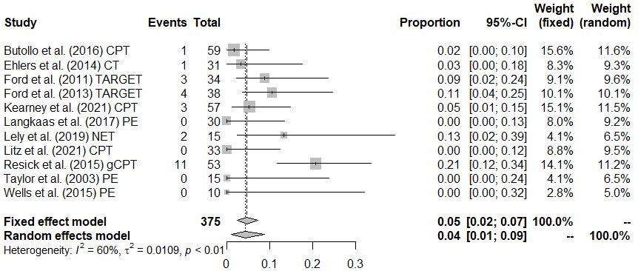
Forest plot depicting the incidences of pre-to-posttreatment deterioration for Trauma-Focused Cognitive Behavior Therapy
Abbreviations. CT = Cognitive Therapy; CPT = Cognitive Processing Therapy; gCPT = group Cognitive Processing Therapy; NET = Narrative exposure therapy; PE = Prolonged exposure; TARGET = Trauma Affect Regulation: Guide for Education and Therapy.

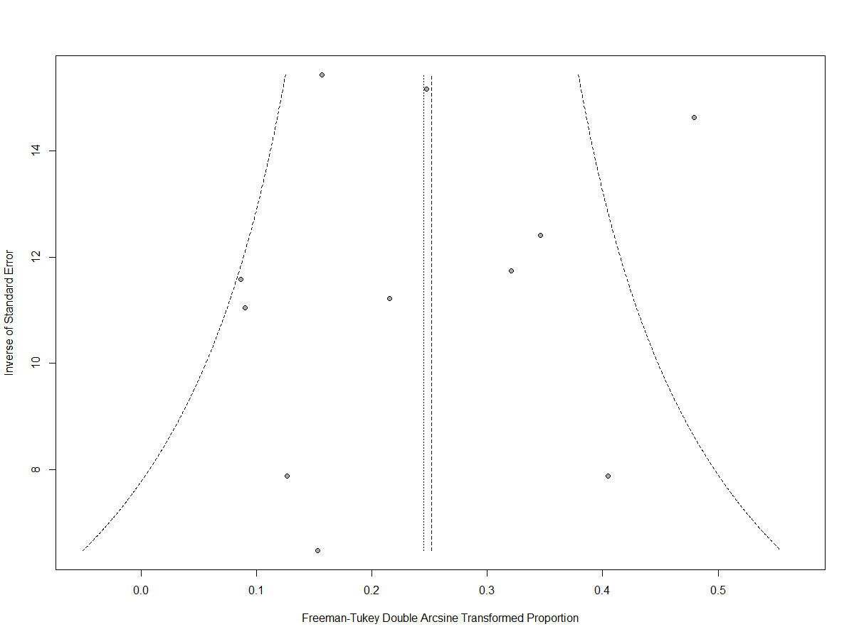
Funnel plot - incidences of pre-to-posttreatment deterioration for Trauma-Focused Cognitive Behavior Therapy

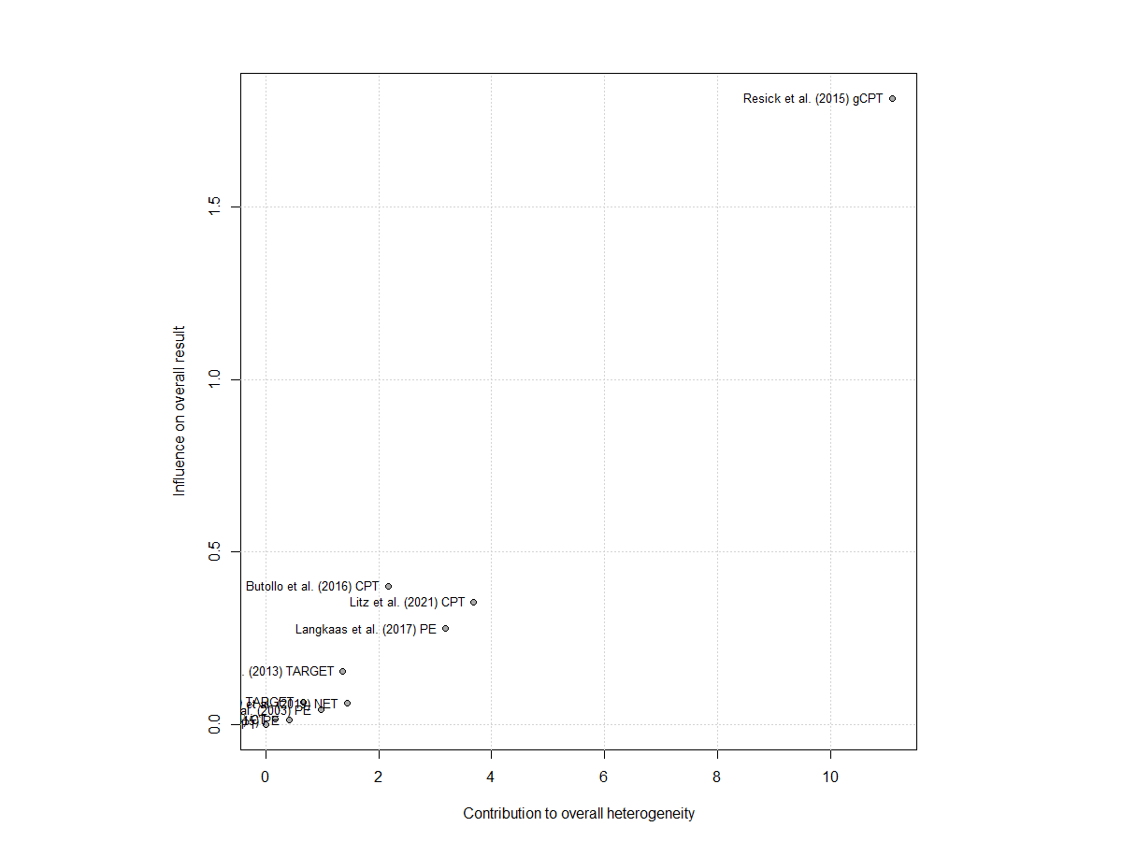
Heterogeneity plot - incidences of pre-to-posttreatment deterioration for Trauma-Focused Cognitive Behavior Therapy

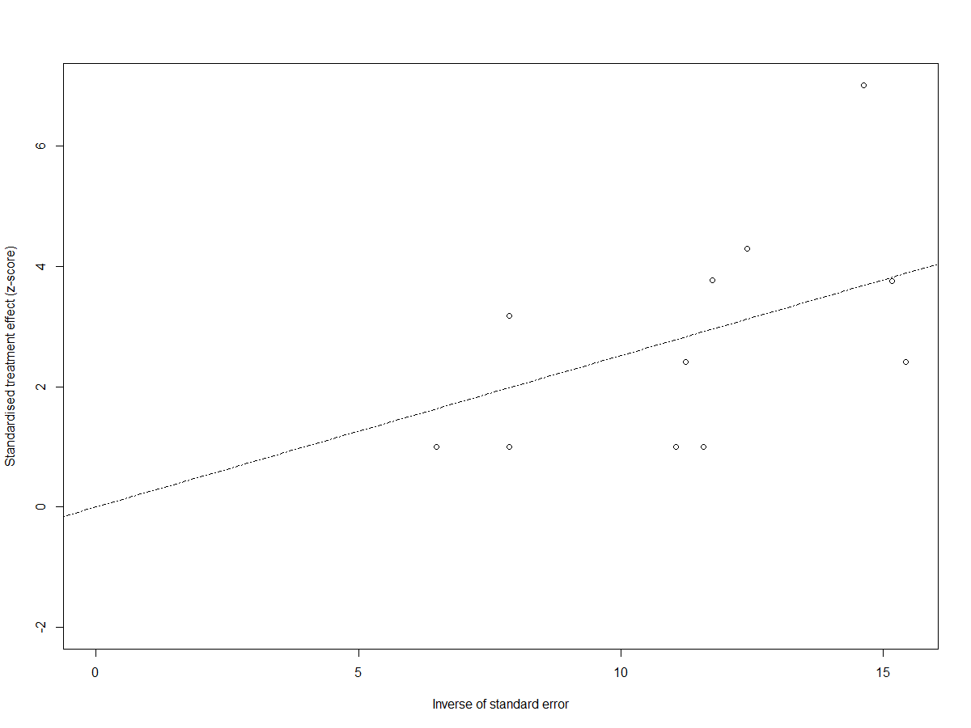
Radial plot - incidences of pre-to-posttreatment deterioration for Trauma-Focused Cognitive Behavior Therapy
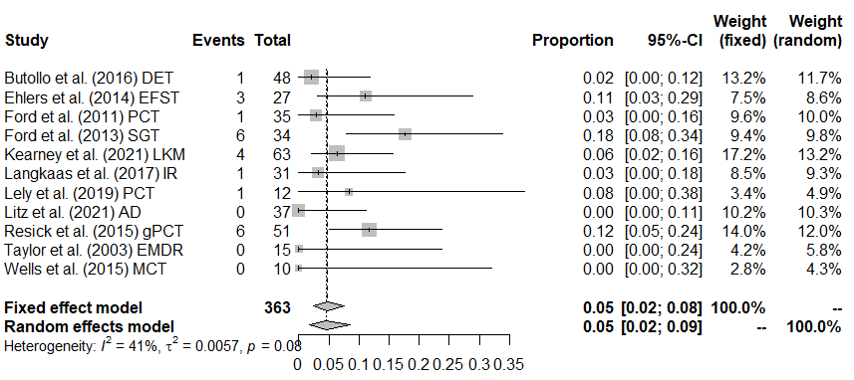
Forest plot depicting incidences of pre-to-posttreatment deterioration for other psychological interventions
Abbreviations. AD = Adaptive Disclosure; EFST = Emotion-Focused Supportive Therapy; EMDR = Eye Movement Desensitization and Reprocessing; IR = Imagery Rescripting; LKM = Loving Kindness Meditation; MCT = Meta-Cognitive Therapy; PCT = Present Centered Therapy; SGT = Supportive Group Therapy

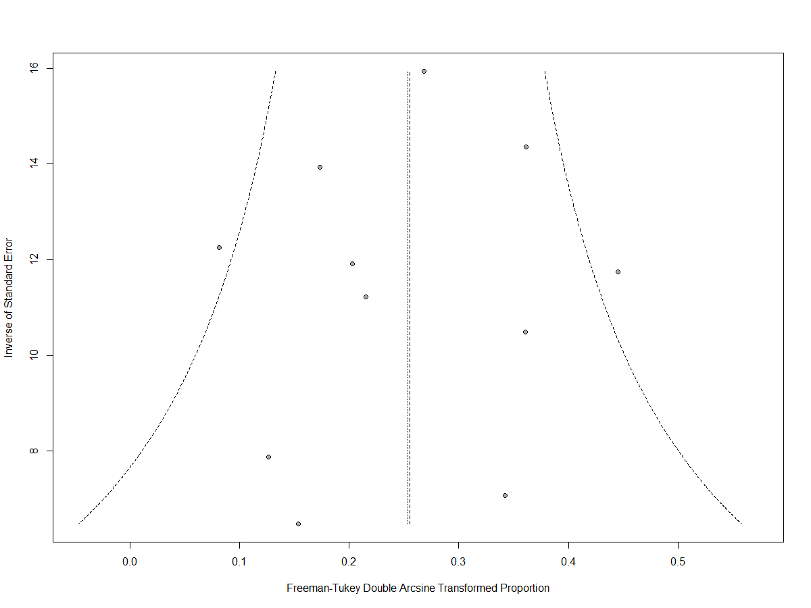
Funnel plot - incidences of pre-to-posttreatment deterioration for other psychological interventions

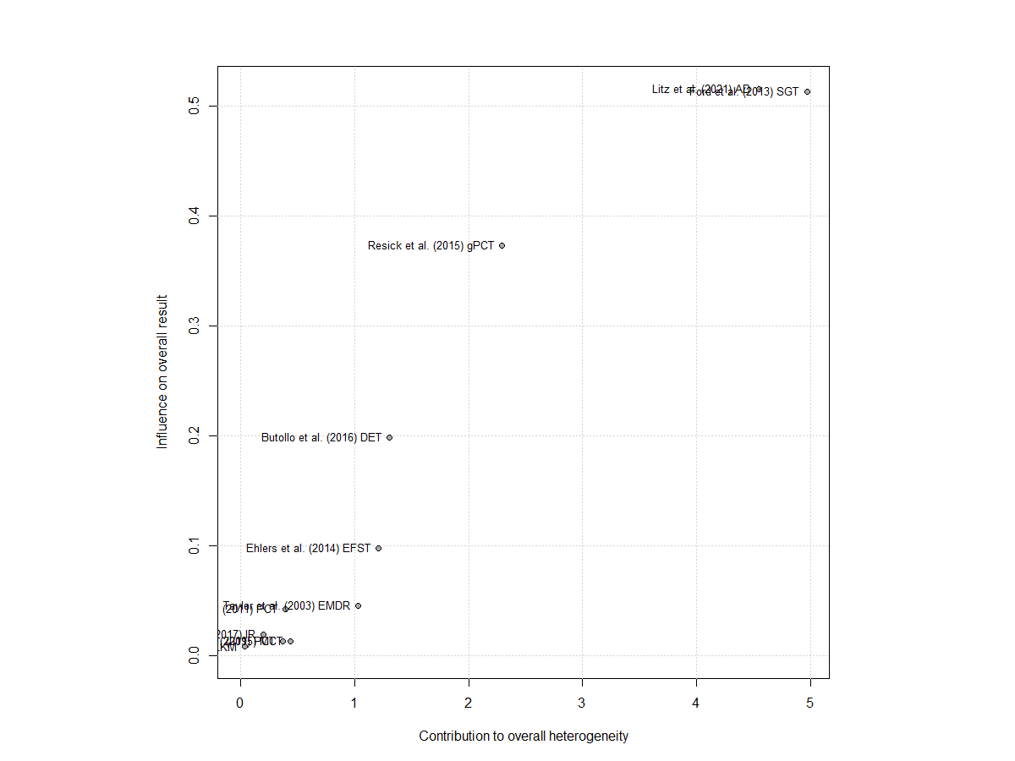
Heterogeneity plot - incidences of pre-to-posttreatment deterioration for other psychological interventions

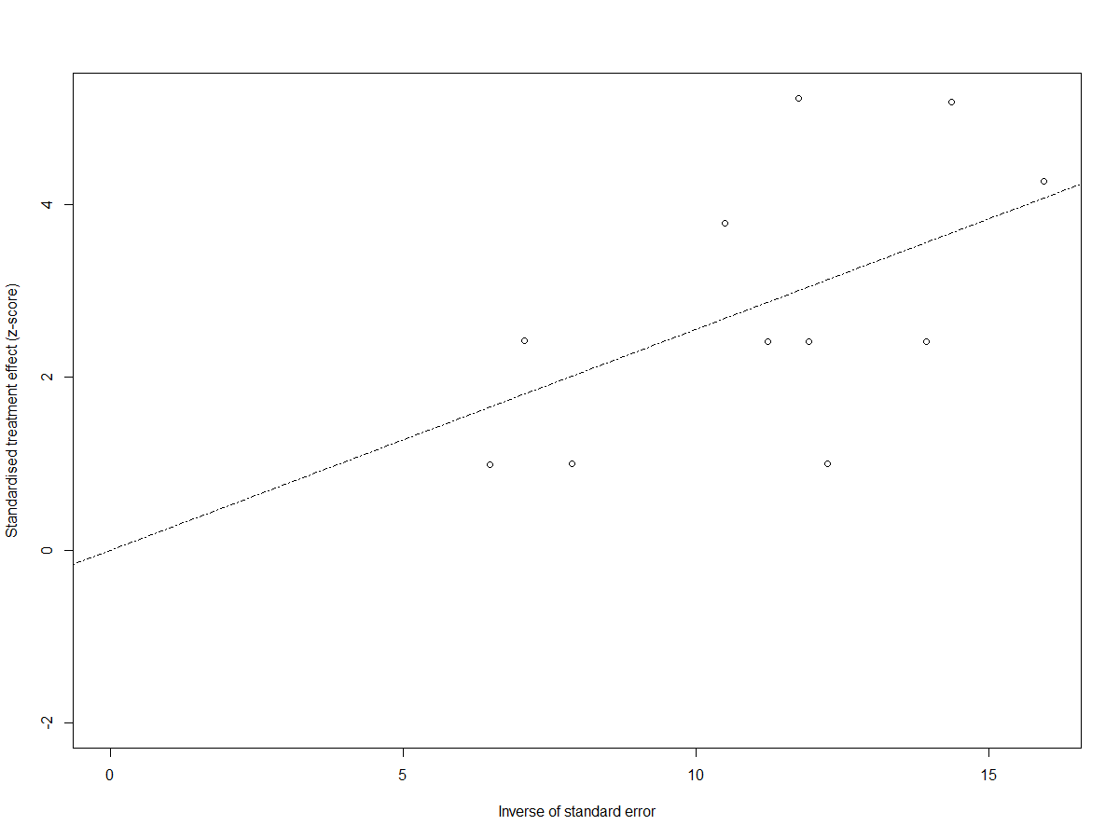
Radial plot - incidences of pre-to-posttreatment deterioration for other psychological interventions

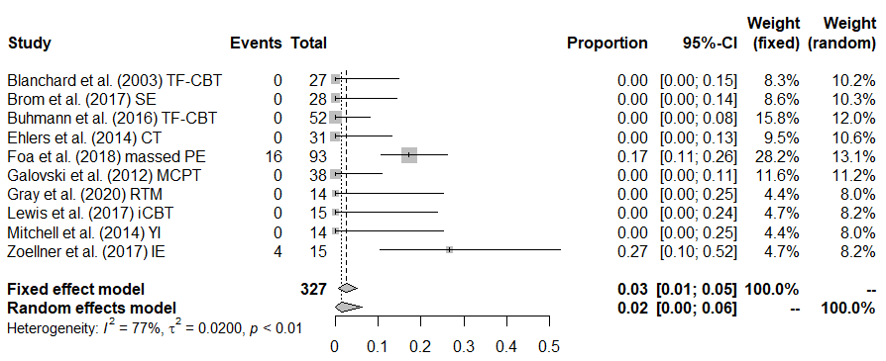
Forest plot depicting the incidences of pre-to-posttreatment adverse events for psychological interventions
Abbreviations. CT = Cognitive Therapy; IE = Imaginal Exposure; massed PE = massed Prolonged Exposure (i.e., intensely delivered PE); MCPT = Modified Cognitive Processing Therapy; RTM = Reconsolidation of Traumatic Memories; SE = Somatic Experiencing; TF-CBT = Trauma-Focused Cognitive Behavior Therapy; YI = Yoga Intervention.

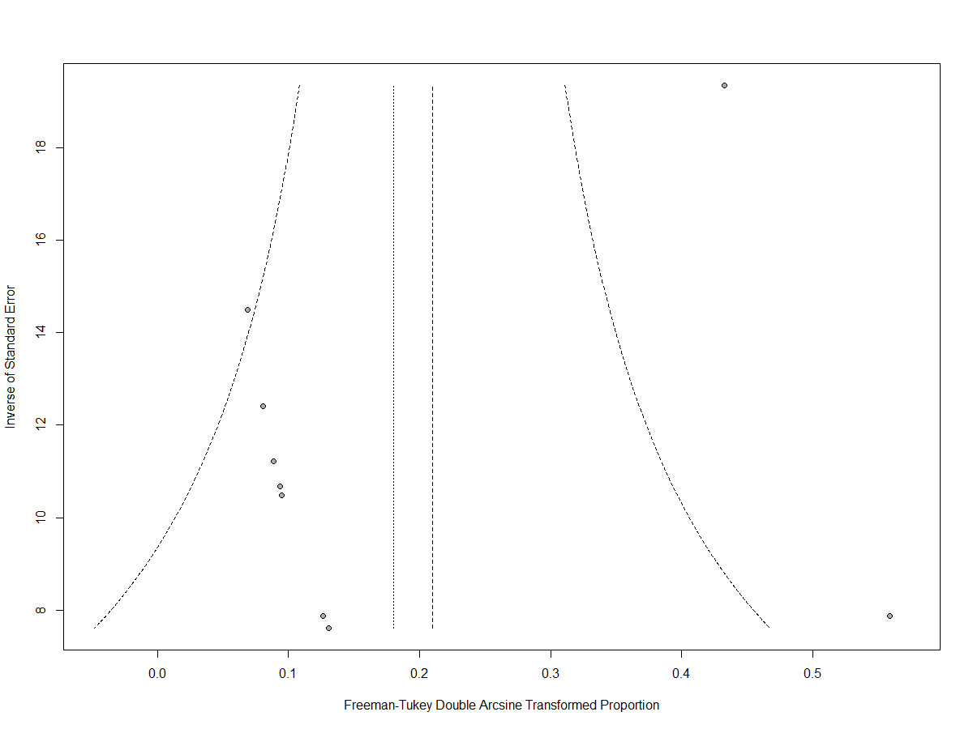
Funnel plot - incidences of pre-to-posttreatment adverse events for psychological interventions

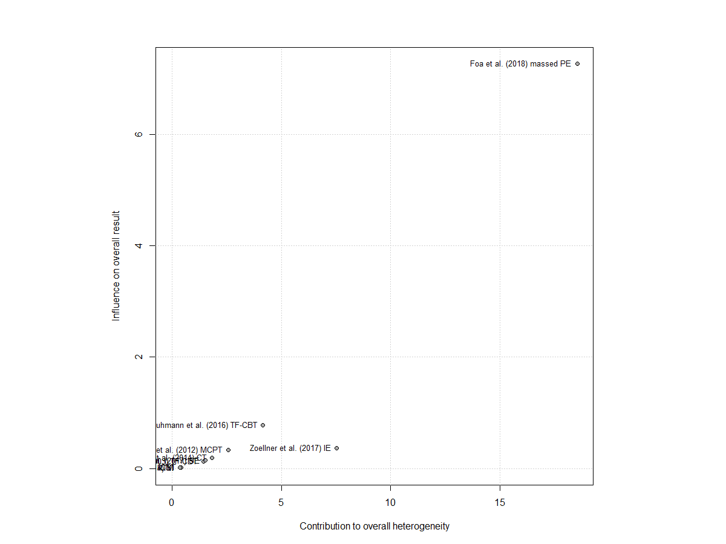
Heterogeneity plot - incidences of pre-to-posttreatment adverse events for psychological interventions

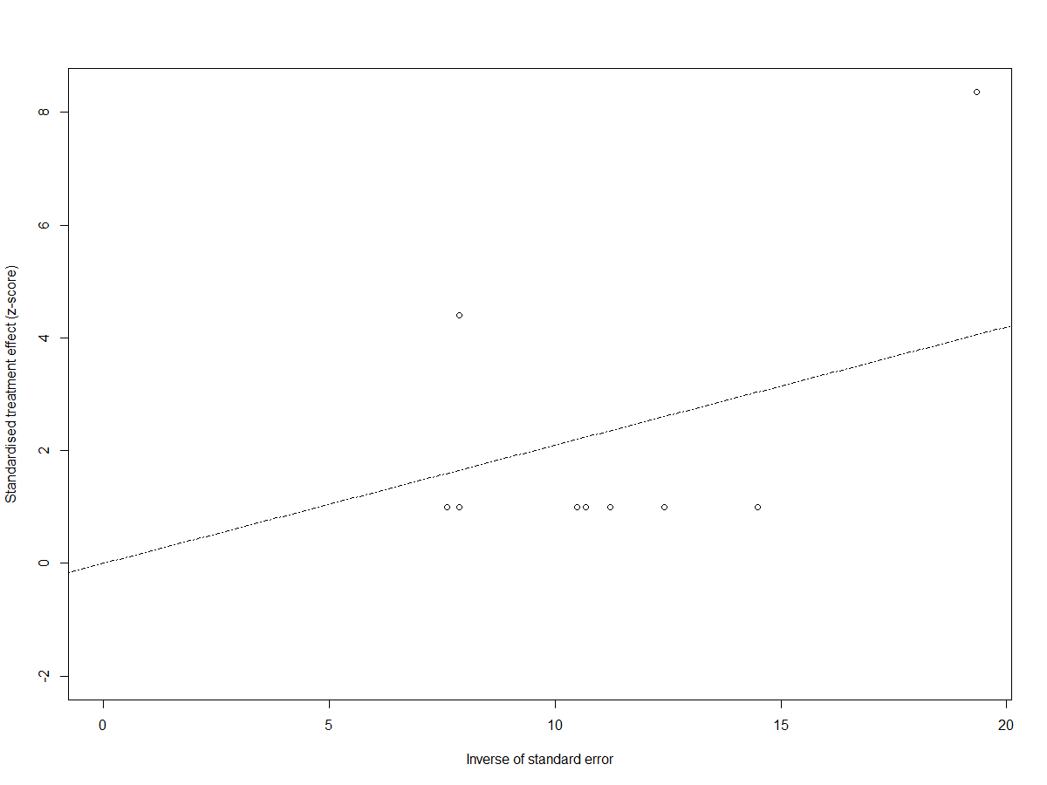
Radial plot - incidences of pre-to-posttreatment adverse events for psychological interventions

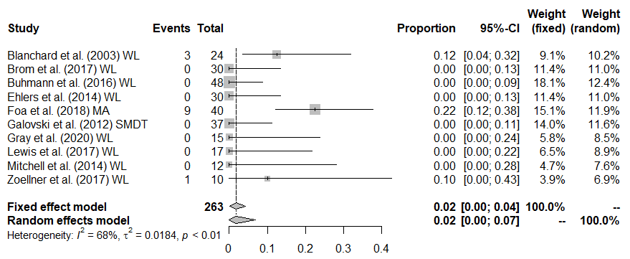
Forest plot depicting the incidences of pre-to-posttreatment adverse events for passive control conditions
Abbreviations. SMDT = Symptom Monitoring Delayed Treatment; WL = Wait-List controls.

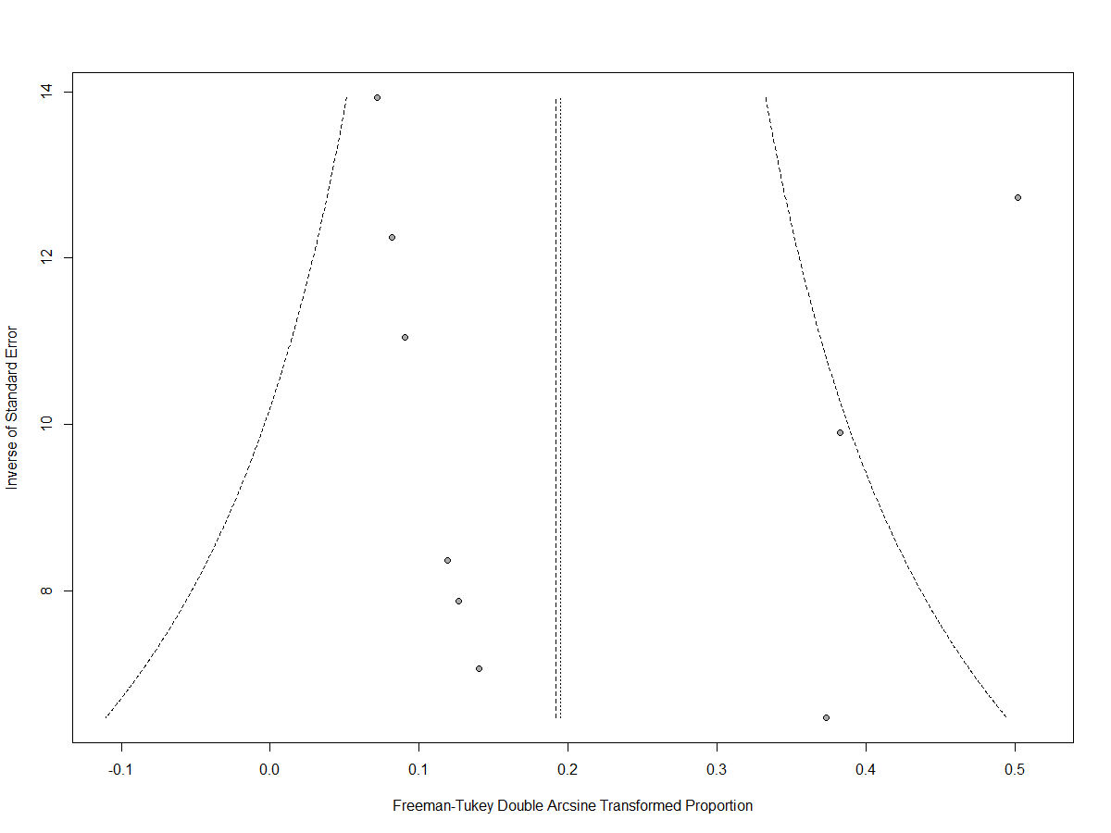
Funnel plot - incidences of pre-to-posttreatment adverse events for passive control conditions

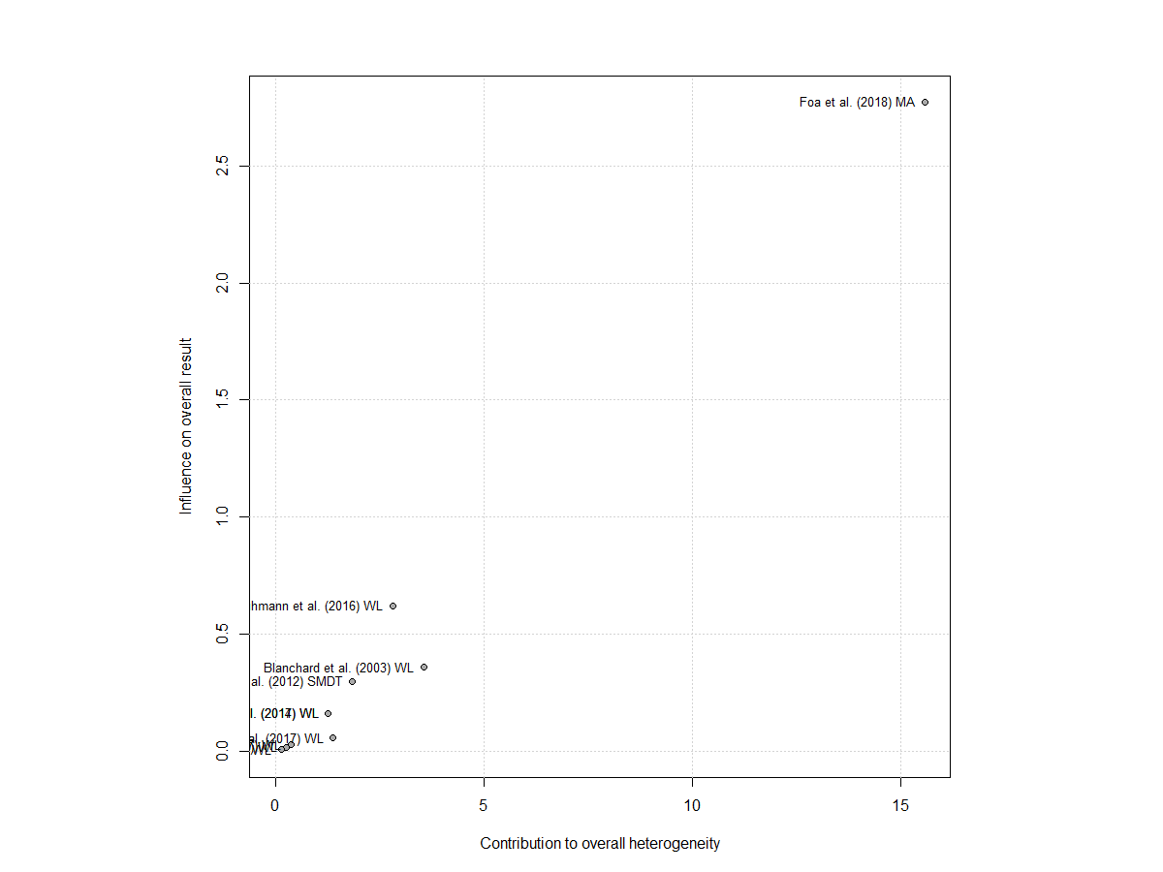
Heterogeneity plot - incidences of pre-to-posttreatment adverse events for passive control conditions

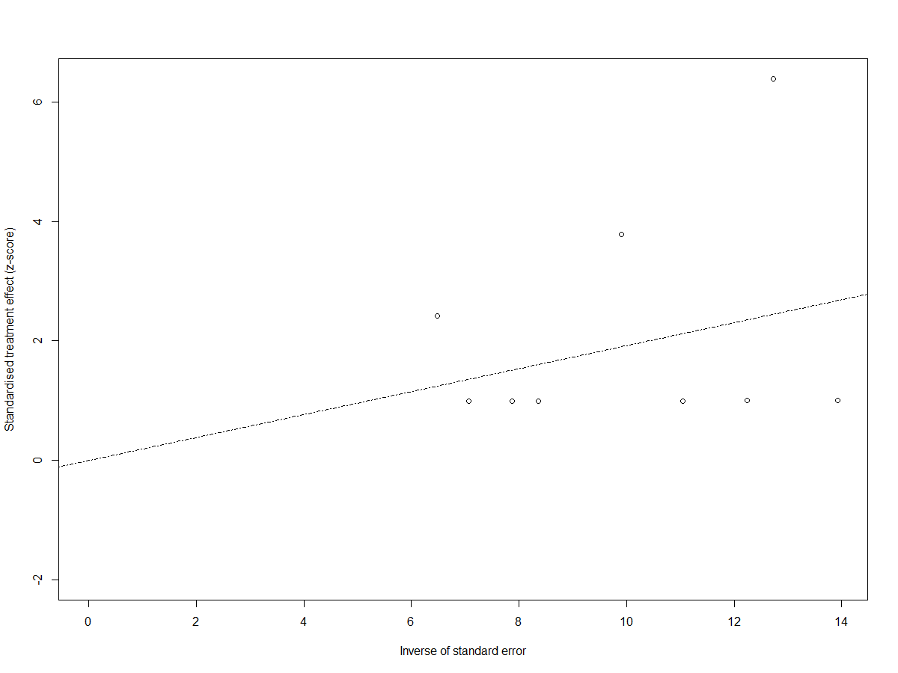
Radial plot - incidences of pre-to-posttreatment adverse events for passive control conditions
Supplement 9: Moderator results – incidences of pre-to-posttreatment adverse events.
Comparison | Analyzed potential moderator | kª | b₁ | I²
Psychological interventions | % with depressive comorbidity | n.a. (k = 5)
 | Trial quality/risk of bias | 10 | 0.00 | 74.04***
 | Age | 10 | -0.02* | 53.37*
 | % females | 10 | -0.00 | 67.71**
 | % on concurrent psychotropic medication | n.a. (k = 3)
 | Total treatment length in minutes | n.a. (k = 6)
vs. PCC | % with depressive comorbidity | n.a. (k = 5)
 | Trial quality/risk of bias | 10 | -0.01 | 69.25***
 | Age | 10 | -0.02 | 55.50*
 | % females | 10 | -0.00 | 64.97**
 | % on concurrent psychotropic medication | n.a. (k = 4)
 | Total treatment length in minutes | n.a. (k = 7)
I² = remaining amount of unexplained variance including the magnitude of statistical significance of the corresponding Q statistic as indicated by the asterisks; k = number of trials included in the analysis for the given comparison; n.a. = number of trials too small (k < 10) to conduct analysis; PCC = Passive Control Conditions.
ªnote that number of trials may differ depending on how many trials reported information on the respective moderator
* p < .05, ** p < .01, *** p < .001

Supplement 10: Moderator results – incidences of pre-to-posttreatment serious adverse events.
Comparison | Analyzed potential moderator | kª | b₁ | I²
TF-CBT | % with depressive comorbidity | n.a. (k = 3)
 | Trial quality/risk of bias | 12 | 0.04 | 0.00
 | Age | 12 | 0.01 | 0.00
 | % females | 12 | -0.00 | 25.25
 | % on concurrent psychotropic medication | n.a. (k = 4)
 | Total treatment length in minutes | n.a. (k = 9)
vs. other interventions | % with depressive comorbidity | n.a. (k = 3)
 | Trial quality/risk of bias | 12 | 0.08 | 51.25*
 | Age | 12 | 0.01 | 61.95**
 | % females | 12 | -0.00 | 67.56***
 | % on concurrent psychotropic medication | n.a. (k = 4)
 | Total treatment length in minutes | n.a. (k = 9)
TF-CBT | % with depressive comorbidity | n.a. (k = 3)
 | Trial quality/risk of bias | 11 | 0.04 | 0.00
 | Age | 11 | 0.00 | 0.00
 | % females | 11 | -0.00 | 0.00
 | % on concurrent psychotropic medication | n.a. (k = 4)
 | Total treatment length in minutes | n.a. (k = 8)
vs. other interventions | % with depressive comorbidity | n.a. (k = 3)
 | Trial quality/risk of bias | 11 | 0.07 | 53.68*
 | Age | 11 | 0.01 | 63.70**
 | % females | 11 | -0.00 | 66.12***
 | % on concurrent psychotropic medication | n.a. (k = 4)
 | Total treatment length in minutes | n.a. (k = 8)
I² = remaining amount of unexplained variance including the magnitude of statistical significance of the corresponding Q statistic as indicated by the asterisks; individual data only = only trials included that delivered the psychological intervention in individual format (rather than group or mixed format); k = number of trials included in the analysis for the given comparison; n.a. = number of trials too small (k < 10) to conduct analysis; other interventions = non-TF-CBT interventions (e.g., EMDR); TF-CBT = trauma-focused cognitive behavior therapy.
ªnote that number of trials may differ depending on how many trials reported information on the respective moderator
* p < .05, ** p < .01, *** p < .001
Supplement 11: Risk of bias assessment.
Trial | Q1 -100% PTSD rate | Q2 -manual-based | Q3 -therapist training | Q4 -integrity checks | Q5 -ITT analyses | Q6 –  N > 50 | Q7 -independent randomization | Q8 -blinded outcome assessment | Q sum score (out of 8)
Andersen et al. (2021) | 1 | 1 | 1 | 1 | 0 | 1 | 1 | 1 | 7
Blanchard et al. (2003) | 0 | 1 | 1 | 1 | 1 | 1 | 0 | 1 | 6
Bohus et al. (2013) | 1 | 1 | 1 | 1 | 1 | 1 | 0 | 1 | 7
Bormann et al. (2013) | 1 | 0 | 0 | 1 | 1 | 1 | 1 | 1 | 6
Brom et al. (2017) | 1 | 1 | 1 | 1 | 0 | 1 | 1 | 1 | 7
Bryant et al. (2011) | 1 | 0 | 1 | 0 | 1 | 0 | 1 | 1 | 5
Bryant et al. (2019) | 1 | 0 | 0 | 1 | 0 | 0 | 1 | 1 | 4
Buhmann et al. (2016) | 1 | 0 | 1 | 1 | 1 | 1 | 1 | 1 | 7
Butollo et al. (2016) | 1 | 1 | 1 | 1 | 1 | 1 | 0 | 1 | 7
Chard (2005) | 1 | 1 | 1 | 1 | 0 | 1 | 0 | 1 | 6
Cloitre et al. (2002) | 1 | 1 | 1 | 1 | 0 | 0 | 0 | 1 | 5
Cloitre et al. (2010) | 1 | 1 | 1 | 1 | 1 | 1 | 1 | 1 | 8
Davis et al. (2020) | 1 | 1 | 0 | 1 | 0 | 1 | 1 | 1 | 6
Duffy et al. (2007) | 1 | 1 | 1 | 0 | 1 | 1 | 1 | 1 | 7
Ehlers et al. (2014) | 1 | 1 | 1 | 1 | 1 | 1 | 1 | 1 | 8
Ertl et al. (2011) | 1 | 1 | 1 | 1 | 0 | 1 | 0 | 1 | 6
Foa et al. (2018) | 1 | 1 | 1 | 1 | 1 | 1 | 1 | 1 | 8
Forbes et al. (2012) | 1 | 1 | 0 | 1 | 1 | 1 | 1 | 1 | 7
Ford et al. (2011) | 0 | 1 | 1 | 1 | 1 | 1 | 1 | 0 | 6
Ford et al. (2013) | 0 | 1 | 1 | 1 | 0 | 1 | 1 | 1 | 6
Galovski et al. (2012) | 1 | 1 | 1 | 1 | 1 | 1 | 1 | 1 | 8
Ghafoori et al. (2017) | 1 | 0 | 1 | 1 | 1 | 1 | 1 | 0 | 6
Gray et al. (2019) | 1 | 1 | 0 | 1 | 1 | 1 | 1 | 1 | 7
Gray et al. (2020) | 1 | 1 | 1 | 1 | 0 | 0 | 1 | 1 | 6
Ivarsson et al. (2014) | 1 | 1 | 1 | 1 | 1 | 1 | 1 | 1 | 8
Johnson et al. (2011) | 0 | 1 | 1 | 1 | 0 | 1 | 1 | 0 | 5
Johnson et al. (2016) posttreatment | 0 | 1 | 1 | 1 | 0 | 1 | 1 | 1 | 6
Johnson et al. (2016) follow-up | 0 | 1 | 1 | 1 | 0 | 0 | 1 | 1 | 5
Johnson et al. (2020) | 1 | 1 | 1 | 1 | 0 | 1 | 0 | 1 | 6
Kearney et al. (2021) | 1 | 1 | 1 | 1 | 1 | 1 | 1 | 1 | 8
Kelly et al. (2021) posttreatment | 1 | 1 | 1 | 0 | 0 | 1 | 1 | 0 | 5
Kelly et al. (2021) follow-up | 1 | 1 | 1 | 0 | 0 | 0 | 1 | 0 | 4
Lang et al. (2019) | 1 | 1 | 1 | 0 | 0 | 0 | 1 | 1 | 5
Langkaas et al. (2017) | 1 | 1 | 1 | 1 | 1 | 1 | 1 | 1 | 8
Lehavot et al. (2021) | 1 | 0 | 1 | 1 | 1 | 1 | 0 | 1 | 7
Lely et al. (2019) | 1 | 1 | 1 | 1 | 1 | 0 | 1 | 1 | 7
Lewis et al. (2017) | 1 | 1 | 1 | 1 | 1 | 0 | 1 | 1 | 7
Littleton et al. (2016) posttreatment | 1 | 1 | 1 | 1 | 0 | 1 | 1 | 0 | 6
Littleton et al. (2016) follow-up | 1 | 1 | 1 | 1 | 0 | 0 | 1 | 0 | 5
Litz et al. (2021) | 1 | 1 | 0 | 1 | 0 | 1 | 1 | 1 | 6
Markowitz et al. (2015) | 1 | 0 | 1 | 1 | 1 | 1 | 1 | 1 | 7
Mitchell et al. (2014) | 0 | 1 | 1 | 0 | 1 | 0 | 1 | 1 | 5
Monson et al. (2006) | 1 | 1 | 1 | 1 | 1 | 1 | 0 | 1 | 7
Monson et al. (2012) | 1 | 1 | 1 | 1 | 1 | 0 | 1 | 1 | 7
NCT00607815 | 1 | 1 | 0 | 0 | 1 | 1 | 0 | 1 | 5
Neuner et al. (2010) | 1 | 1 | 1 | 1 | 1 | 0 | 1 | 1 | 7
Nidich et al. (2018) | 1 | 1 | 0 | 1 | 1 | 1 | 1 | 1 | 7
Niles et al. (2012) | 1 | 1 | 1 | 1 | 0 | 0 | 1 | 0 | 5
Reger et al. (2016) | 1 | 1 | 1 | 1 | 1 | 1 | 1 | 1 | 8
Resick et al. (2015) | 1 | 0 | 1 | 1 | 1 | 1 | 0 | 1 | 6
Robjant et al. (2019) | 1 | 1 | 1 | 1 | 0 | 1 | 1 | 1 | 7
Schnurr et al. (2007) | 1 | 0 | 1 | 1 | 1 | 1 | 1 | 1 | 7
Suris et al. (2013) | 1 | 1 | 1 | 1 | 0 | 1 | 1 | 1 | 7
Taylor et al. (2003) | 1 | 1 | 1 | 1 | 1 | 0 | 0 | 1 | 6
ter Heide et al. (2016) | 1 | 1 | 1 | 1 | 0 | 1 | 1 | 1 | 7
van den Berg et al. (2015) | 1 | 1 | 1 | 1 | 1 | 1 | 1 | 1 | 8
van Gelderen et al. (2020) | 1 | 1 | 1 | 1 | 1 | 0 | 1 | 1 | 7
Wells et al. (2015) | 1 | 1 | 1 | 1 | 0 | 0 | 1 | 1 | 6
Zoellner et al. (2017) | 1 | 1 | 1 | 1 | 1 | 0 | 1 | 0 | 6

