Supplementary Materials
- Table S1 PRISMA 2020 checklist
- Table S2 Full search strategy in electronic databases
- Table S3 Newcastle-Ottawa Scale for assessing the quality of included studies
- Fig. S1 Funnel plot for publication bias in main analysis of life expectancy
- Fig. S2 Funnel plot for publication bias after the trim and fill procedure for life expectancy
- Fig. S3 Subgroup analysis of pooled life expectancy stratified by study periods
- Fig. S4 Subgroup analysis of weighted average YPLL stratified by study periods
Table S1 PRISMA checklist.
Section and Topic | Item # | Checklist item | Location where item is reported
TITLE
Title | 1 | Identify the report as a systematic review. | Page 1
ABSTRACT
Abstract | 2 | See the PRISMA 2020 for Abstracts checklist. | Page 2
INTRODUCTION
Rationale | 3 | Describe the rationale for the review in the context of existing knowledge. | Page 3
Objectives | 4 | Provide an explicit statement of the objective(s) or question(s) the review addresses. | Page 4
METHODS
Eligibility criteria | 5 | Specify the inclusion and exclusion criteria for the review and how studies were grouped for the syntheses. | Page 5
Information sources | 6 | Specify all databases, registers, websites, organisations, reference lists and other sources searched or consulted to identify studies. Specify the date when each source was last searched or consulted. | Page 4
Search strategy | 7 | Present the full search strategies for all databases, registers and websites, including any filters and limits used. | Page 4
Selection process | 8 | Specify the methods used to decide whether a study met the inclusion criteria of the review, including how many reviewers screened each record and each report retrieved, whether they worked independently, and if applicable, details of automation tools used in the process. | Page 5
Data collection process | 9 | Specify the methods used to collect data from reports, including how many reviewers collected data from each report, whether they worked independently, any processes for obtaining or confirming data from study investigators, and if applicable, details of automation tools used in the process. | Page 5
Data items | 10a | List and define all outcomes for which data were sought. Specify whether all results that were compatible with each outcome domain in each study were sought (e.g. for all measures, time points, analyses), and if not, the methods used to decide which results to collect. | Pages 5-6
 | 10b | List and define all other variables for which data were sought (e.g. participant and intervention characteristics, funding sources). Describe any assumptions made about any missing or unclear information. | Page 6
Study risk of bias assessment | 11 | Specify the methods used to assess risk of bias in the included studies, including details of the tool(s) used, how many reviewers assessed each study and whether they worked independently, and if applicable, details of automation tools used in the process. | Page 6
Effect measures | 12 | Specify for each outcome the effect measure(s) (e.g. risk ratio, mean difference) used in the synthesis or presentation of results. | Pages 5-6
Synthesis methods | 13a | Describe the processes used to decide which studies were eligible for each synthesis (e.g. tabulating the study intervention characteristics and comparing against the planned groups for each synthesis (item #5)). | Page 5
 | 13b | Describe any methods required to prepare the data for presentation or synthesis, such as handling of missing summary statistics, or data conversions. | Pages 6-7
 | 13c | Describe any methods used to tabulate or visually display results of individual studies and syntheses. | Page 7
 | 13d | Describe any methods used to synthesize results and provide a rationale for the choice(s). If meta-analysis was performed, describe the model(s), method(s) to identify the presence and extent of statistical heterogeneity, and software package(s) used. | Pages 6-7
 | 13e | Describe any methods used to explore possible causes of heterogeneity among study results (e.g. subgroup analysis, meta-regression). | Page 6
 | 13f | Describe any sensitivity analyses conducted to assess robustness of the synthesized results. | Page 7
Reporting bias assessment | 14 | Describe any methods used to assess risk of bias due to missing results in a synthesis (arising from reporting biases). | Page 6
Certainty assessment | 15 | Describe any methods used to assess certainty (or confidence) in the body of evidence for an outcome. | Pages 6-7
RESULTS
Study selection | 16a | Describe the results of the search and selection process, from the number of records identified in the search to the number of studies included in the review, ideally using a flow diagram. | Page 8
 | 16b | Cite studies that might appear to meet the inclusion criteria, but which were excluded, and explain why they were excluded. | Page 8
Study characteristics | 17 | Cite each included study and present its characteristics. | Page 8 & Tables 2-5
Risk of bias in studies | 18 | Present assessments of risk of bias for each included study. | Table S3
Results of individual studies | 19 | For all outcomes, present, for each study: (a) summary statistics for each group (where appropriate) and (b) an effect estimate and its precision (e.g. confidence/credible interval), ideally using structured tables or plots. | Table 2-5
Results of syntheses | 20a | For each synthesis, briefly summarise the characteristics and risk of bias among contributing studies. | Page 11 & Table S3
 | 20b | Present results of all statistical syntheses conducted. If meta-analysis was done, present for each the summary estimate and its precision (e.g. confidence/credible interval) and measures of statistical heterogeneity. If comparing groups, describe the direction of the effect. | Pages 9-10 & Table 2
 | 20c | Present results of all investigations of possible causes of heterogeneity among study results. | Pages 9-10
 | 20d | Present results of all sensitivity analyses conducted to assess the robustness of the synthesized results. | Pages 9-10
Reporting biases | 21 | Present assessments of risk of bias due to missing results (arising from reporting biases) for each synthesis assessed. | Page 11
Certainty of evidence | 22 | Present assessments of certainty (or confidence) in the body of evidence for each outcome assessed. | Pages 9-10 & Tables 2-5
DISCUSSION
Discussion | 23a | Provide a general interpretation of the results in the context of other evidence. | Pages 11-13
 | 23b | Discuss any limitations of the evidence included in the review. | Pages 14-15
 | 23c | Discuss any limitations of the review processes used. | Pages 14-15
 | 23d | Discuss implications of the results for practice, policy, and future research. | Pages 13-14
OTHER INFORMATION
Registration and protocol | 24a | Provide registration information for the review, including register name and registration number, or state that the review was not registered. | Page 4
 | 24b | Indicate where the review protocol can be accessed, or state that a protocol was not prepared. | Page 4
 | 24c | Describe and explain any amendments to information provided at registration or in the protocol. | Page 4
Support | 25 | Describe sources of financial or non-financial support for the review, and the role of the funders or sponsors in the review. | Page 16
Competing interests | 26 | Declare any competing interests of review authors. | Page 16
Availability of data, code and other materials | 27 | Report which of the following are publicly available and where they can be found: template data collection forms; data extracted from included studies; data used for all analyses; analytic code; any other materials used in the review. | Page 15

Table S2 Full search strategy in electronic databases.
EMBASE
- Exp bipolar disorder/
- Bipolar.mp.
- Bipolar affective disorder.mp.
- Severe mental illness.mp.
- Mental disorder.mp.
- Exp mania/
- Affective disorder.mp. or exp mood disorder/
- Exp life expectancy/
- Exp lifespan/
- Years of potential life lost.mp.
- Years of life lost.mp.
- Life years.mp.
- Life years lost.mp.
- Survival rate.mp.
- Exp premature mortality/
- 1 or 2 or 3 or 4 or 5 or 6 or 7
- 8 or 9 or 10 or 11 or 12 or 13 or 14 or 15
- 16 and 17
MEDLINE
- Exp Bipolar Disorder/
- Bipolar.mp.
- Bipolar affective disorder.mp.
- Severe mental illness.mp.
- Exp Mental Disorders/
- Mania.mp.
- Affective disorder.mp. or exp Mood Disorders/
- Exp Life Expectancy/
- Lifespan.mp.
- Years of potential life lost.mp.
- Years of life lost.mp.
- Life years.mp.
- Life years lost.mp.
- Survival rate.mp.
- Exp Mortality, Premature/
- 1 or 2 or 3 or 4 or 5 or 6 or 7
- 8 or 9 or 10 or 11 or 12 or 13 or 14 or 15
- 16 and 17
Web of Science
- TS=(“bipolar disorder”)
- TS=(“severe mental illness”)
- TS=(“Mental disorder”)
- TS=(“bipolar affective disorder”)
- TS=(bipolar)
- TS=(“life expectancy”)
- TS=(lifespan)
- TS=(“survival rate”)
- TS=(“years of potential life lost”)
- TS=(“life years lost”)
- TS=(“life years”)
- TS=(“premature mortality”)
- TS=(“years of life lost”)
- TS=(“mood disorder”)
- TS=(“affective disorder)
- TS=mania
- 1 or 2 or 3 or 4 or 5 or 14 or 15 or 16
- 6 or 7 or 8 or 9 or 10 or 11 or 12 or 13
- 17 and 18
PsycINFO
- Exp Bipolar Disorder/
- Severe mental illness.mp. or exp Serious Mental Illness/
- Exp Mental Disorders/
- Bipolar affective disorder.mp
- Exp Life Expectancy/
- Survival rate.mp.
- Exp Life Span/
- Years of potential life lost.mp.
- Life years lost.mp.
- Life years.mp.
- Premature mortality.mp.
- Years of life lost.mp.
- Mood disorder.mp. or exp Affective Disorders/
- Exp Mania/
- 1 or 2 or 3 or 4 or 13 or 14
- 6 or 7 or 8 or 9 or 10 or 11 or 12
- 15 and 16

Table S3 Newcastle-Ottawa Scale for assessing the quality of included studies.ª
Studies | Representati-veness of the exposed cohort | Selection of the non-exposed cohort | Ascertainment of exposure | Demonstration that outcome of interest was not present at start of study | Control for Sex  (Comparability) | Assessment of outcome | Was follow-up long enough for outcome | Adequacy of follow-up of cohorts | Quality
Chang¹¹ et al 2011 | 1 | 1 | 1 | 1 | 1 | 1 | 0 | 1 | Good
Kodesh¹³ et al 2012 | 1 | 1 | 1 | 1 | 1 | 1 | 1 | 1 | Good
Ajeunmobi⁷ et al 2013 | 1 | 1 | 1 | 1 | 0 | 1 | 1 | 1 | Fair
Crump³ et al 2013 | 1 | 1 | 1 | 1 | 1 | 1 | 1 | 1 | Good
Laursen¹⁴ et al 2013 | 1 | 1 | 1 | 1 | 1 | 1 | 1 | 1 | Good
Fekadu¹⁵ et al 2015 | 1 | 1 | 1 | 1 | 0 | 1 | 1 | 1 | Fair
Kessing¹⁷ et al 2015 | 1 | 1 | 1 | 1 | 1 | 1 | 1 | 1 | Good
Pan¹⁸ et al 2020 | 1 | 1 | 1 | 1 | 1 | 1 | 0 | 1 | Good
Das-Munshi¹⁹ et al 2020 | 1 | 1 | 1 | 1 | 1 | 1 | 0 | 1 | Good
Weye²⁰ et al 2020 | 1 | 1 | 1 | 1 | 1 | 1 | 1 | 1 | Good
Iturralde²¹ et al 2021 | 1 | 1 | 1 | 1 | 0 | 1 | 1 | 1 | Fair
ª Quality of studies was evaluated based on domains of selection of study groups, comparability of groups and outcome ascertainment, and was categorized into “good”, “fair” or “poor”. Following the method of Hjorthøj et al. (2017),²⁷ in comparability domain, only “Control for sex” item was assessed and “Control for other covariates” item was removed as no additional covariates were controlled for in life expectancy and YPLL estimation. The scoring scheme was as follows: “Good” quality required ≥3 marks in selection, 1 mark in comparability, and ≥2 marks in outcome. “Fair” quality required 2 marks in selection and ≥2 marks in outcome. “Poor” quality reflected ≤1 mark in selection or ≤1 mark in outcome.

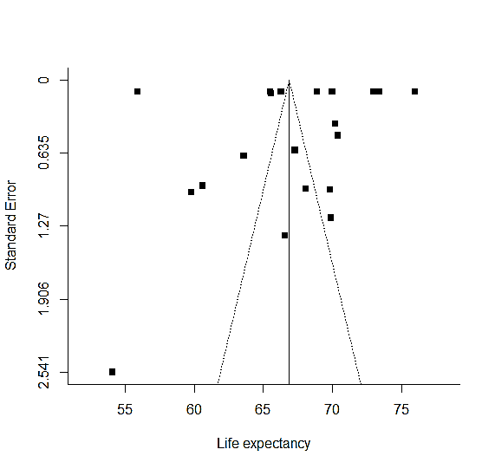
Fig. S1 Funnel plot for publication bias in main analysis of life expectancy.

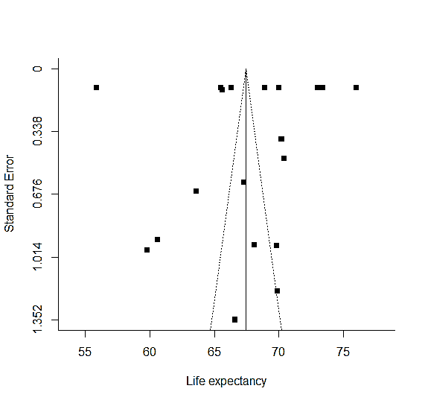
Fig. S2 Funnel plot for publication bias after the trim and fill procedure for
life expectancy.

Study periods |  | Life expectancy (95% CI) | Difference (SE) | P
2000 – 2005ª |  | 62.71 (58.21 – 67.21) | Reference | -
2006 – 2010^{b} |  | 69.12 (65.98 – 72.25) | 6.40 (2.80) | 0.022
2011 – 2015^{c} |  | 66.49 (62.00 – 70.98) | 3.78 (3.24) | 0.245
Fig. S3 Subgroup analysis of pooled life expectancy stratified by study periods.
ª Study period of 2000–2005 included study in Finland and Sweden in Laursen et al (2013),¹⁴ and Fekadu et al. (2015).¹⁵
^{b} Study period of 2006–2010 included Chang et al. (2011),¹¹ Kodesh et al. (2012),¹³ Crump et al. (2013),³ Kessing et al. (2015)¹⁷ and the 2005 study cohort in Pan et al. (2020).¹⁸
^{c} Study period of 2011–2015 included the 2010 study cohort in Pan et al. (2020),¹⁸ Das-Munshi et al. (2020)¹⁹ and Iturralde et al. (2021).²¹

Study periods |  | YPLL (95% CI)
2000 – 2005ª |  | 17.71 (17.53 - 17.88)
2006 – 2010^{b} |  | 12.76 (12.59 - 12.94)
2011 – 2015^{c} |  | 12.71 (12.54 - 12.89)
Fig. S4 Subgroup analysis of weighted average years of potential life lost (YPLL) stratified by study periods.
ª Study period of 2000–2005 included study in Finland and Sweden in Laursen et al (2013),¹⁴ Ajetunmobi et al. (2013)⁷ and Fekadu et al. (2015).¹⁵
^{b} Study period of 2006–2010 included Chang et al. (2011),¹¹ Kodesh et al. (2012),¹³ Crump et al. (2013),³ Kessing et al. (2015)¹⁷, the 2005 study cohort in Pan et al. (2020),¹⁸ and Weye et al. (2020).²⁰
^{c} Study period of 2011–2015 included the 2010 study cohort in Pan et al. (2020),¹⁸ Das-Munshi et al. (2020)¹⁹ and Iturralde et al. (2021).²¹

