Supplementary Figure 1. Operational example on how is defined a patient’s AP use trajectory during the 1-year period before initiation clozapine (nine possible categories: oral olanzapine [O OLAN], oral risperidone [O RISP], oral quetiapine [O QUET], oral new second-generation APs [mainly aripiprazole] [O New SGA], oral first-generation APs [mainly haloperidol, O FGA], long-acting injectable second-generation APs [mainly paliperidone, LAI SGA], long-acting injectable first-generation APs [mainly zuclopenthixol, haloperidol, flupentixol, and fluphenazine, LAI FGA], two or more AP categories [Poly without CLOZ], and no AP use [No AP]).

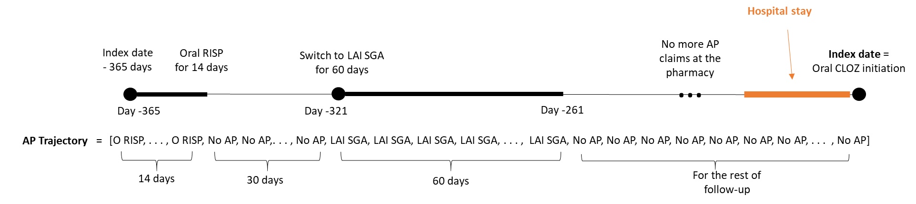

Supplementary Figure 2. Operational example on how is defined a patient’s clozapine use trajectory during the 1-year period after its initiation (three possible categories: oral clozapine in monotherapy or polytherapy [O CLOZ], other AP excluding clozapine [Other AP], and no AP use [No AP].

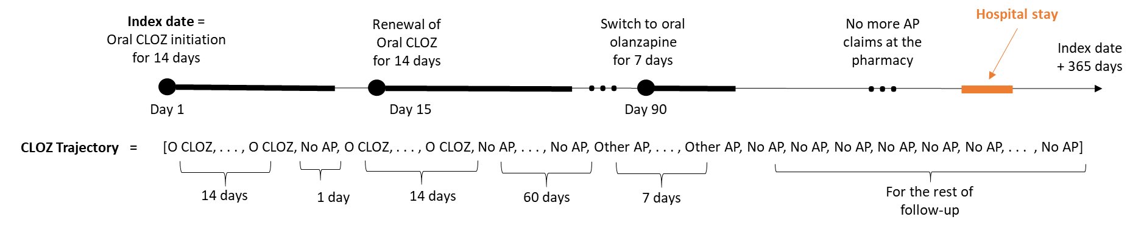

Supplementary Figure 3. State Distribution Plot of AP treatment trajectories one year before and 3 years after oral clozapine initiation (index date) stratified by baseline adherence level. Hospitalization trajectories are also presented in the right side of the figure.

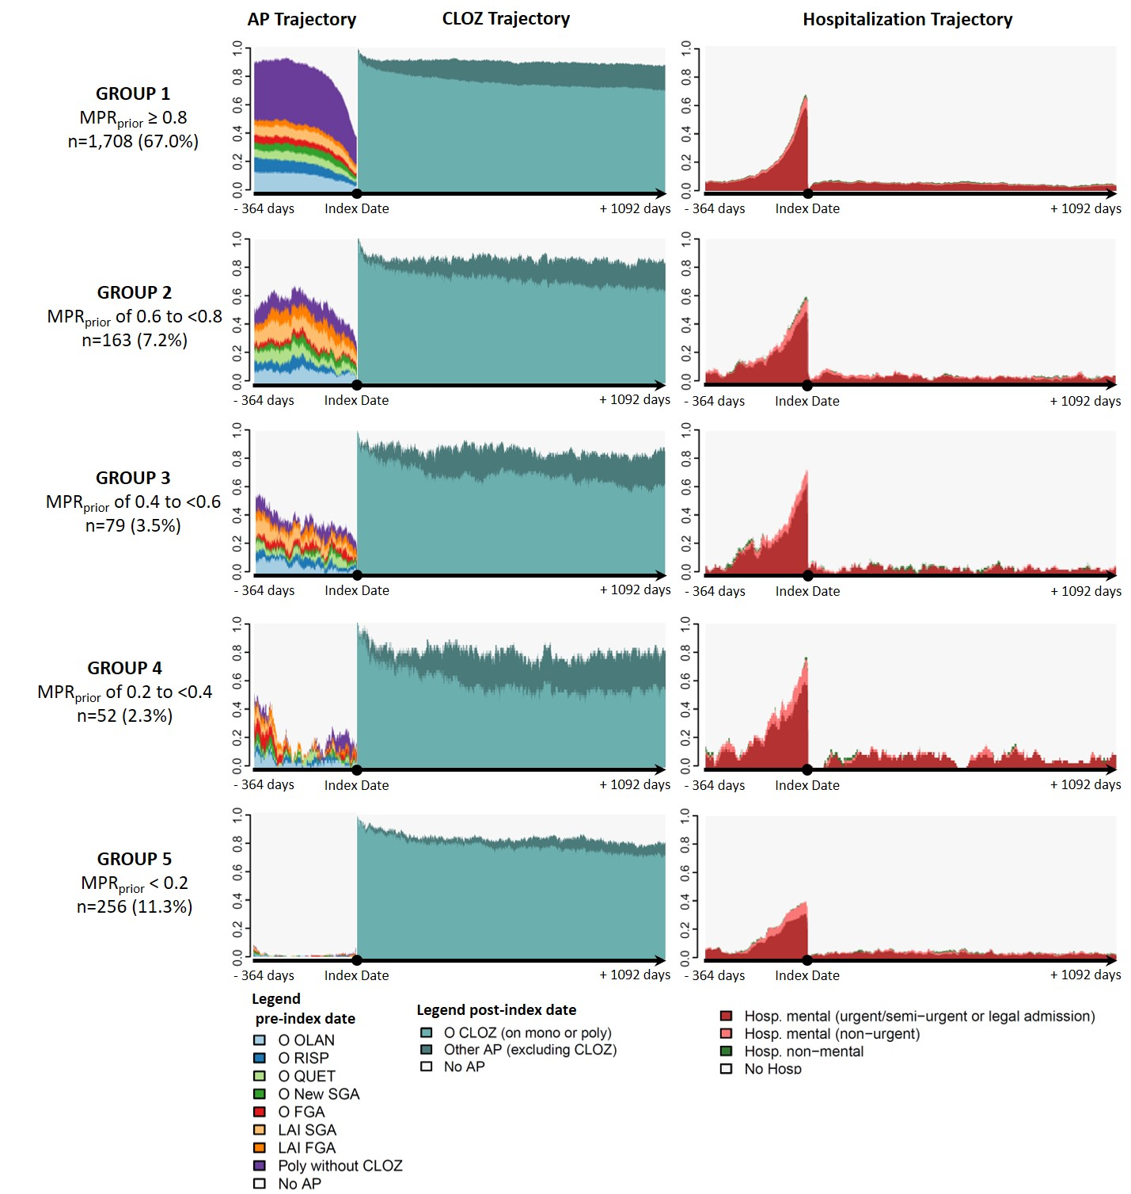
Supplementary Table 1. Association between previous AP adherence level and poor adherence to any APs (dependent variable 1: MPR_{AP} <0.9) and poor adherence to clozapine (dependent variable 2: MPR_{CLOZ} <0.9) after initiation of clozapine: results of the multiple logistic regression (reference: Group 1)

 | Good adherence to any APs  n=2,971 (92.0%) | Poor adherence to any APs  n=257 (8.0%) | Crude OR  (95% CI) | Adjusted OR  (95% CI)
Group 1: MPR_{prior} ≥ 0.8 | 2,310 (94.6%) | 131 (5.4%) | REF | REF
Group 2: MPR_{prior} in [0.6, 0.8 [ | 189 (83.3%) | 38 (16.7%) | 3.54 (2.40 – 5.24) | 3.33 (2.24 – 4.94)
Group 3: MPR_{prior} in [0.4, 0.6 [ | 92 (80.7%) | 22 (19.3%) | 4.22 (2.56 – 6.93) | 3.99 (2.40 – 6.62)
Group 4: MPR_{prior} in [0.2, 0.4 [ | 57 (75.0%) | 19 (25.0%) | 5.88 (3.40 – 10.2) | 5.72 (3.26 – 10.0)
Group 5: MPR_{prior} <0.2 | 323 (87.3%) | 47 (12.7%) | 2.57 (1.80 – 3.65) | 2.10 (1.46 – 3.02)
 | Good adherence to CLOZ  n=2,544 (78.8%) | Poor adherence to CLOZ  n=684 (21.2%) | Crude OR  (95% CI) | Adjusted OR  (95% CI)
Group 1: MPR_{prior} ≥ 0.8 | 1,949 (79.8%) | 492 (20.2%) | REF | REF
Group 2: MPR_{prior} in [0.6, 0.8 [ | 162 (71.4%) | 65 (28.6%) | 1.59 (1.17 – 2.16) | 1.54 (1.14 – 2.10)
Group 3: MPR_{prior} in [0.4, 0.6 [ | 77 (67.5%) | 37 (32.5%) | 1.90 (1.27 – 2.85) | 1.93 (1.28 – 2.91)
Group 4: MPR_{prior} in [0.2, 0.4 [ | 47 (61.8%) | 29 (38.2%) | 2.44 (1.52 – 3.92) | 2.53 (1.56 – 4.08)
Group 5: MPR_{prior} <0.2 | 309 (83.5%) | 61 (16.5%) | 0.78 (0.58 – 1.05) | 0.81 (0.60 – 1.11)

Supplementary Table 2. Association between previous AP adherence level and poor adherence to any APs (dependent variable 1: MPR_{AP} <0.8) and poor adherence to clozapine (dependent variable 2: MPR_{CLOZ} <0.8) 3 years after initiation of clozapine: results of the multiple logistic regression (reference: Group 1) on a sub-cohort of patients with schizophrenia initiating oral clozapine between 2006 and 2014 (n=2,258)

 | Good adherence to any APs  n=2,038 (90.3%) | Poor adherence to any APs  n=220 (9.7%) | Crude OR  (95% CI) | Adjusted OR  (95% CI)
Group 1: MPR_{prior} ≥ 0.8 | 1579 (92.4%) | 129 (7.6%) | REF | REF
Group 2: MPR_{prior} in [0.6, 0.8 [ | 139 (85.3%) | 24 (14.7%) | 2.11 (1.32 – 3.38) | 2.20 (1.36 – 3.56)
Group 3: MPR_{prior} in [0.4, 0.6 [ | 67 (84.8%) | 12 (15.2%) | 2.19 (1.16 – 4.16) | 2.31 (1.21 – 4.43)
Group 4: MPR_{prior} in [0.2, 0.4 [ | 42 (80.8%) | 10 (19.2%) | 2.92 (1.43 – 5.94) | 3.01 (1.46 – 6.22)
Group 5: MPR_{prior} <0.2 | 211 (82.4%) | 45 (17.6%) | 2.61 (1.81 – 3.77) | 2.75 (1.87 – 4.04)
 | Good adherence to CLOZ  n=1,643 (72.8%) | Poor adherence to CLOZ  n=615 (27.2%) | Crude OR  (95% CI) | Adjusted OR  (95% CI)
Group 1: MPR_{prior} ≥ 0.8 | 1260 (73.8%) | 448 (26.2%) | REF | REF
Group 2: MPR_{prior} in [0.6, 0.8 [ | 108 (66.3%) | 55 (33.7%) | 1.43 (1.02 – 2.02) | 1.57 (1.10 – 2.23)
Group 3: MPR_{prior} in [0.4, 0.6 [ | 52 (65.8%) | 27 (34.2%) | 1.46 (0.91 – 2.35) | 1.60 (0.98 – 2.61)
Group 4: MPR_{prior} in [0.2, 0.4 [ | 30 (57.7%) | 22 (42.3%) | 2.06 (1.18 – 3.62) | 2.22 (1.26 – 3.93)
Group 5: MPR_{prior} <0.2 | 193 (75.4%) | 63 (24.6%) | 0.92 (0.68 – 1.24) | 1.00 (0.73 – 1.38)

Supplementary Table 3. Association between previous AP adherence level and outcome one year after initiation of clozapine: results of the multinomial logistic regression (reference category of outcome: Good adherence to CLOZ)

 | Good adherence to CLOZ  n=2,662 (82.5%) | Poor adherence to CLOZ & Good adherence to APs  n=415 (12.9%) | Adjusted OR  (95% CI) | Poor adherence to any APs n=151 (4.7%) | Adjusted OR  (95% CI)
Group 1: MPR_{prior} ≥ 0.8 | 2,025 (83.0%) | 344 (14.1%) | REF | 72 (3.0%) | REF
Group 2: MPR_{prior} in [0.6, 0.8 [ | 178 (78.4%) | 26 (11.4%) | 0.95 (0.62-1.47) | 23 (10.1%) | 3.49 (2.11-5.77)
Group 3: MPR_{prior} in [0.4, 0.6 [ | 86 (75.4%) | 17 (14.9%) | 1.28 (0.74-2.20) | 11 (9.6%) | 3.54 (1.79-7.00)
Group 4: MPR_{prior} in [0.2, 0.4 [ | 52 (68.4%) | 12 (15.8%) | 1.52 (0.80-2.91) | 12 (15.8%) | 6.36 (3.19-12.6)
Group 5: MPR_{prior} <0.2 | 321 (86.8%) | 16 (4.3%) | 0.34 (0.20-0.57) | 33 (8.9%) | 3.01 (1.89-4.81)

As a summary for all patients’ AP utilization trajectories, State Distribution Plots show the proportion of patients (Y axis) of AP use for each day of the baseline one year period before and 3 years after the initiation of clozapine (index date).
As opposed to the MPR calculation, the AP trajectories representation do not take into account days spent at the hospital since pharmacy data were not available during hospitalization. This explains the AP utilization drop just before index date (as shown by the hospitalization trajectories on the right side of the figure).
With a 2-year clearance period without oral clozapine before the index date.
Adjusted for covariables of Table 1 statistically associated (p<0.1) with the dependent variable 2: Benzodiazepine use, Hospitalization for SCZ/Psychosis, Substance-related disorders
Adjusted for covariables of Table 1 statistically associated (p<0.1) with the dependent variable 2: Personality disorder, Hospitalization for SCZ/Psychosis, Hospitalization for other mental disorders, Hospitalization for non-mental disorders, Substance-related disorders, Number of ambulatory visits
Adjusted for covariables of Table 1 statistically associated (p<0.1) with the dependent variable 2: Age, Antidepressant use, First clozapine prescribed by GP, Substance-related disorders
Adjusted for covariables of Table 1 statistically associated (p<0.1) with the dependent variable 2: Age, Incident, Comorbidity index, Hospitalization for SCZ/Psychosis, Hospitalization for non-mental disorders, Substance-related disorders, number of ambulatory visits
Adjusted for covariables of Table 1 statistically associated (p<0.1) with the dependent variable: age, Hospitalization for SCZ/Psychosis, Hospitalization for non-mental disorders, Substance-related disorders, Number of ambulatory visits

