SUPPLEMENTARY MATERIAL

INDEX

Supplementary Table 1. MOOSE Checklist for Meta-analyses of Observational Studies 6

1. Supplementary Methods 7

Reporting quality of included meta-analyses (AMSTAR-2) 8

Umbrella Review criteria 8

Grading of Recommendations, Assessment, Development and Evaluations (GRADE) 9

Sensitivity analyses 9

2. Search strategy 9

3. List of excluded studies, with reason 10

4. Supplementary Table 2. Description of included meta-analyses 13

5. Umbrella review Criteria for each meta-analysis 19

5.1. Premenstrual syndrome (Cao et al, 2020) 19

a. Supplementary Figure 1. Forest plot Premenstrual syndrome meta-analysis 19

b. Egger’s test 19

c. Supplementary Figure 2. Funnel plot Premenstrual syndrome meta-analysis 19

d. Excess of significance test 20

5.2. Violence experience (Zhang et al, 2019) 21

a. Supplementary Figure 3. Forest plot Violence experience meta-analysis 21

b. Egger’s test 21

c. Supplementary Figure 4. Funnel plot Violence experience meta-analysis 22

d. Excess of significance test 22

5.3. Unintended pregnancy (Qiu et al, 2020) 23

a. Supplementary Figure 5. Forest plot Unintended pregnancy meta-analysis 23

b. Egger’s test 23

c. Supplementary Figure 6. Funnel Plot Unintended pregnancy meta-analysis 24

d. Excess of significance test 24

5.4. 5HTTLPR polymorphism (Li et al, 2020) 24

a. Supplementary Figure 7. Forest plot 5HTTLPR polymorphism meta-analysis 24

b. Egger’s test 24

c. Supplementary Figure 8. Funnel plot 5HTTLPR polymorphism 25

d. Excess of significance test 25

5.5. C-Section (Xu et al, 2017) 26

a. Supplementary Figure 9. Forest plot C-Section meta-analysis 26

b. Egger’s test 26

c. Supplementary Figure 10. Funnel Plot C-section meta-analysis 27

d. Excess of significance test 27

5.6. Gestational diabetes (Azami et al, 2019) 28

a. Supplementary Figure 11. Forest plot Gestational diabetes meta-analysis 28

b. Egger’s test 28

c. Supplementary Figure 12. Funnel plot Gestational diabetes meta-analysis 28

d. Excess of significance test 28

5.7. Preterm delivery (De Paula Eduardo et al, 2019) 29

a. Supplementary Figure 13. Forest plot Preterm delivery meta-analysis 29

b. Egger’s test 29

c. Supplementary Figure 14. Funnel plot Preterm delivery meta-analysis 30

d. Excess of significance test 30

5.8. Anemia during pregnancy (Azami et al, 2019) 30

a. Supplementary Figure 15. Forest plot Anemia during pregnancy meta-analysis 30

b. Egger’s test 30

c. Supplementary Figure 16. Funnel plot Anemia during pregnancy meta-analysis 31

d. Excess of significance test 31

5.9. Vitamin D deficiency (Wang et al, 2018) 31

a. Supplementary Figure 17. Forest plot Vitamin D deficiency meta-analysis 31

b. Egger’s test 32

c. Supplementary Figure 18. Funnel plot Vitamin D deficiency meta-analysis 32

d. Excess of significance test 32

5.10. Post-partum anemia (Azami et al, 2019) 33

a. Supplementary Figure 19. Forest plot Post-partum anemia meta-analysis 33

b. Egger’s test 33

c. Supplementary Figure 20. Funnel plot Post-partum anemia meta-analysis 33

d. Excess of significance test 33

5.11. Medically assisted conception (Gressier et al, 2015) 34

a. Supplementary Figure 21. Forest plot Medically assisted conception meta-analysis 34

b. Egger’s test 34

c. Supplementary Figure 22. Funnel plot Medically assisted conception meta-analysis 35

d. Excess of significance test 35

5.12. Labor epidural analgesia (Koutanis et al, 2020) 35

a. Supplementary Figure 23. Forest plot Labor epidural analgesia meta-analysis 35

b. Egger’s test 36

c. Supplementary Figure 24. Funnel plot Labor epidural analgesia meta-analysis 36

d. Excess of significance test 36

6. Supplementary Table 3. Sensitivity analysis including only cohort studies 38

6.1. Forest Plots of sensitivity analysis including only cohort studies 39

a. Supplementary Figure 25. Premenstrual syndrome (Cao et al, 2020) 39

b. Supplementary Figure 26. Violence experience (Zhang et al, 2019) 39

c. Supplementary Figure 27. Unintended pregnancy (Qiu et al, 2020) 40

d. 5HTTLPR polymorphism (Li et al., 2020) 40

e. Supplementary Figure 28. C-Section (Xu et al, 2017) 41

f. Supplementary Figure 29. Gestational diabetes (Azami et al, 2019) 41

g. Supplelmentary Figure 30. Preterm delivery (De Paula Eduardo et al, 2019) 42

h. Anemia during pregnancy (Azami et al, 2019) 42

i. Supplementary Figure 31. Vitamin D deficiency (Wang et al, 2018) 42

j. Supplementary Figure 32. Post-partum anemia (Azami et al, 2019) 42

k. Supplementary Figure 33. Medically assisted conception (Gressier et al, 2015) 43

l. Supplementary Figure 34. Labor epidural analgesia (Kountanis et al, 2020) 43

7. Supplementary Table 4. Sensitivity analysis including only PPD indicated with standard criteria 44

7.1. Forest Plots of the sensitivity analysis including only indicated with standard criteria. 45

a. Supplementary Figure 35. Premenstrual syndrome (Cao et al, 2020) 45

b. Supplementary Figure 36. Violence experience (Zhang et al, 2019) 45

c. Supplementary Figure 37. Unintended pregnancy (Qiu et al, 2020) 46

d. Supplementary Figure 38. 5HTTPRL polymorphism (Li et al, 2020) 46

e. Supplementary Figure 39. C-Section (Xu et al, 2017) 47

f. Supplementary Figure 40. Gestational diabetes (Azami et al, 2019) 47

g. Supplementary Figure 41. Preterm delivery (De Paula Eduardo et al, 2019) 48

h. Anemia during pregnancy (Azami et al, 2019) 48

i. Vitamin D deficiency (Wang et al. 2018) 48

j. Supplementary Figure 42. Post-partum anemia (Azami et al, 2019) 48

k. Supplementary Figure 43. Labor epidural analgesia (Kountanis et al, 2020) 48

l. Supplementary Figure 44. Medically assisted conception (Gressier et al, 2015) 49

8. Supplementary Table 5. Sensitivity analysis including only PPD diagnosed after 7 days 50

8.1. Forest Plots of the sensitivity analysis including only PPD diagnosed after 7 days 51

a. Supplementary Figure 45. Premenstrual syndrome (Cao et al, 2020) 51

b. Supplementary Figure 46. Violence experience (Zhang et al, 2019) 52

c. Supplementary Figure 47. Unintended pregnancy (Qiu et al, 2020) 53

d. Supplementary Figure 48. 5HTTLPR polymorphism (Li et al, 2020) 53

e. Supplementary Figure 49. C-Section (Xu et al, 2017) 54

f. Supplementary Figure 50. Gestational diabetes (Azami et al, 2019) 54

g. Supplementary Figure 51. Preterm delivery (De Paula Eduardo et al, 2019) 55

h. Anemia during pregnancy (Azami et al, 2019) 55

i. Supplementary Figure 52. Vitamin D deficiency (Wang et al, 2018) 55

j. Post-partum anemia (Azami et al, 2019) 55

k. Supplementary Figure 53. Medically assisted conception (Gressier et al, 2015) 55

l. Supplementary Figure 54. Labor epidural analgesia (Koutanis et al, 2020) 56

9. Supplementary References 56

# **Supplementary Table 1. MOOSE Checklist for Meta-analyses of Observational Studies**

|  |  |  |
| --- | --- | --- |
| **Item No** | **Recommendation** | **Reported on Page No** |
| Reporting of background should include | | |
| 1 | Problem definition | 3-4 |
| 2 | Hypothesis statement | 4 |
| 3 | Description of study outcome(s) | 3-4 |
| 4 | Type of exposure or intervention used | 4-5 |
| 5 | Type of study designs used | 4-5 |
| 6 | Study population | 4-5 |
| Reporting of search strategy should include | | |
| 7 | Qualifications of searchers (eg, librarians and investigators) | Title page, 5-6 |
| 8 | Search strategy, including time period included in the synthesis and key words | 5-6 |
| 9 | Effort to include all available studies, including contact with authors | Supplementary Methods, 5-6 |
| 10 | Databases and registries searched | 5, Supplementary Methods |
| 11 | Search software used, name and version, including special features used (eg, explosion) | 8 |
| 12 | Use of hand searching (eg, reference lists of obtained articles) | 5-6, Supplementary Methods |
| 13 | List of citations located and those excluded, including justification | Supplementary content 3, references |
| 14 | Method of addressing articles published in languages other than English | - |
| 15 | Method of handling abstracts and unpublished studies | 5-6, Supplementary Methods |
| 16 | Description of any contact with authors | -- |
| Reporting of methods should include | | |
| 17 | Description of relevance or appropriateness of studies assembled for assessing the hypothesis to be tested | 4-5 |
| 18 | Rationale for the selection and coding of data (eg, sound clinical principles or convenience) | 4-7 |
| 19 | Documentation of how data were classified and coded (eg, multiple raters, blinding and interrater reliability) | Supplementary Methods, 5 |
| 20 | Assessment of confounding (eg, comparability of cases and controls in studies where appropriate) | 5-8, Supplementary Methods |
| 21 | Assessment of study quality, including blinding of quality assessors, stratification or regression on possible predictors of study results | 6-7, Supplementary Methods |
| 22 | Assessment of heterogeneity | 7-8 |
| 23 | Description of statistical methods (eg, complete description of fixed or random effects models, justification of whether the chosen models account for predictors of study results, dose-response models, or cumulative meta-analysis) in sufficient detail to be replicated | 5-10, Supplementary Methods |
| 24 | Provision of appropriate tables and graphics | Supplementary Methods |
| Reporting of results should include | | |
| 25 | Graphic summarizing individual study estimates and overall estimate | Fig 2, supplementary content 5-8 |
| 26 | Table giving descriptive information for each study included | Supplementary Table3 |
| 27 | Results of sensitivity testing (eg, subgroup analysis) | 9-10, Supplementary content 6-8; |
| 28 | Indication of statistical uncertainty of findings | Fig2, table2-3 |

|  |  |  |
| --- | --- | --- |
| Reporting of discussion should include | | |
| 29 | Quantitative assessment of bias (eg, publication bias) | 14-18 |
| 30 | Justification for exclusion (eg, exclusion of non-English language citations) | Supplementary content 3 |
| 31 | Assessment of quality of included studies | 11-15 |
| Reporting of conclusions should include | | |
| 32 | Consideration of alternative explanations for observed results | 14-19 |
| 33 | Generalization of the conclusions (ie, appropriate for the data presented and within the domain of the literature review) | 17-21 |
| 34 | Guidelines for future research | 20-21 |
| 35 | Disclosure of funding source | 29 |

*From*: Stroup DF, Berlin JA, Morton SC, et al, for the Meta-analysis Of Observational Studies in Epidemiology (MOOSE) Group. Meta-analysis of Observational Studies in Epidemiology. A Proposal for Reporting. *JAMA*. 2000;283(15):2008-2012. doi: 10.1001/jama.283.15.2008.

# **Supplementary Methods**

Literature search

Two researchers (CG and GS) independently searched Medline, Embase and PsycINFO from database inception until August 2020 for systematic reviews with quantitative synthesis (meta-analyses) of observational studies investigating the association between any risk factor and PPD. The search was updated on December 1st 2020. No date or language restrictions or restrictions on the patient population, were applied. We additionally performed a manual search of reference lists from relevant studies.

Two reviewers (CG, GS) independently searched titles/abstracts for eligibility, and when a consensus could not be achieved a third reviewer was consulted (CB). The full texts of potentially eligible articles were retrieved, and the same two investigators independently scrutinized each study for eligibility. Any discrepancies were resolved by a third reviewer (CB).

Eligibility criteria

Reviews were considered eligible if the authors had performed a systematic search to identify pertinent studies and performed a meta-analysis. We considered systematic reviews of observational studies (both case–control and prospective/retrospective cohort studies) that examined the association between exposure to any risk factor and the risk of developing PPD. We excluded systematic reviews that did not present study-level data, such as for example relative risks (RR) or odds ratios (OR) with 95% confidence intervals (CI). When more than one MA on the same research question was available, the systematic review with the largest number of component studies that provided study-level effect sizes (ES) was considered for inclusion, as previously described.1-3

We excluded: 1) meta-analyses of other study designs, 2) published in languages other than English, 3) pooled analyses that examined a non-systematic selection of observational studies, and non-systematic reviews, network meta-analyses.

Data extraction

From each included systematic review two investigators (CG, GS) independently extracted information on first author, year of publication, outcomes, number of included studies and reported summary meta-analytic estimates. All primary observational studies included in each systematic review were retrieved and carefully inspected by two members (CG and GS) of the research team. The following information was extracted: year of publication, outcome, criteria used to define the occurrence of the PPD, criteria used to diagnose PPD, timing of the diagnosis, type of risk factor, number of cases and controls, total sample, study-specific risk estimates adjusted to the largest number of potential confounders (RR, OR or hazard ratio [HR]) and the corresponding 95% CI, studied population and study design (case–control or cohort).

**Reporting quality of included meta-analyses (AMSTAR-2)**

AMSTAR-2 assesses reviews on the following categories: (i) formulation of the research question; (ii) a priori design provided; (iii) explanation for the chosen study design of the included studies; (iv) comprehensive literature search; (v) study selection; (vi) data extraction; (vii) presence of a list of excluded studies, along with reason for exclusion; (viii) comprehensive description of the main features of the included studies; (ix) risk of bias assessment; (x) information about the sources of funding for the studies included in the review; (xi) methods for statistical combination of results; (xii) assessment of the potential impact of risk of bias of individual studies on the meta-analysis result; (xiii) discussion/interpretation of the potential impact of risk of bias of individual studies on the meta-analysis results; (xiv) discussion of the heterogeneity observed in the study results; (xv) likelihood of publication bias; and (xvi) declaration of study authors’ conflict of interest. Of these 16 domains, seven can particularly affect the validity of the review and its conclusion and are considered ‘critical domains’ (domains 2–4–7–9–11–13–15). Each item allows for the following response options: yes, partial yes or no. The AMSTAR-2 is not intended to be scored. AMSTAR-2 proposes a scheme for interpreting weaknesses detected in critical and non-critical items: ‘high-quality’ studies show no or one non critical weakness; ‘moderate-quality’ studies show more than one non-critical weakness but no critical flaws; ‘low-quality’ studies show one critical flaw with or without non-critical weaknesses; ‘critically low’ quality studies show more than one critical flaw with or without non-critical weaknesses (as represented in the Supplementary Box 1 below).4,5

**Supplementary Box 1. Rating the reporting quality of the review according to AMSTAR-2\***

|  |
| --- |
| • High  No or one non-critical weakness: the systematic review provides an accurate and comprehensive summary of the results of the available studies that address the question of interest;  • Moderate  More than one non-critical weakness*: the systematic review has more than one weakness but no critical flaws. It may provide an accurate summary of the results of the available studies that were included in the review;  • Low  One critical flaw with or without non-critical weaknesses: the review has a critical flaw and may not provide an accurate and comprehensive summary of the available studies that address the question of interest;  • Critically low  More than one critical flaw with or without non-critical weaknesses: the review has more than one critical flaw and should not be relied on to provide an accurate and comprehensive summary of the available studies**.** |

*Multiple non-critical weaknesses may diminish confidence in the review, and it may be appropriate to move the overall appraisal down from moderate to low confidence.

From: Shea BJ, Reeves BC, Wells G, Thuku M, Hamel C, Moran J, Moher D, Tugwell P, Welch V, Kristjansson E, Henry DA. AMSTAR 2: a critical appraisal tool for systematic reviews that include randomised or non-randomised studies of healthcare interventions, or both. Bmj 2017, 358, j4008.

**Umbrella Review criteria**

**Supplementary Box 2. Criteria for evaluation of the credibility of the evidence according to the Umbrella review Criteria\***

|  |  |
| --- | --- |
| **Classification** | **Criteria** |
| Convincing evidence (Class I) | * More than 1,000 cases * Significant summary associations (p<10-6) per random-effects calculations * No evidence of small-study effects * No evidence of excess of significance bias * Prediction intervals not including the null value * Largest study nominally significant (p<0.05) * Not large heterogeneity (i.e., *I2*< 50%) |
| Highly Suggestive evidence (Class II) | * More than 1,000 cases * Significant summary associations (p<10-6) per random-effects calculation * Largest study nominally significant (p<0.05) |
| Suggestive Evidence (Class III) | * More than 1,000 cases * Significant summary associations (p<10-3) per random-effects calculations |
| Weak evidence | * All other associations with p < 0.05 |
| Non-significant associations | * All associations with p >0.05 |

* From: Machado MO, Veronese N, Sanches M, Stubbs B, Koyanagi A, Thompson T, Tzoulaki I, Solmi M, Vancampfort D, Schuch FB, Maes M, Fava GA, Ioannidis JP, Carvalho AF. The association of depression and all-cause and cause-specific mortality: an umbrella review of systematic reviews and meta-analyses. *BMC medicine* **2018,** *16* (1), 112

## **Grading of Recommendations, Assessment, Development and Evaluations (GRADE)**

We strictly followed the GRADE method for all ratings except for consistency, as for consistency we relied on visual inspection of the forest plots only, and we did not use the I2 statistics. This choice was made because meta-analyses of observational studies include extremely large sample sizes, and therefore, estimates are very precise (narrow confidence intervals) leading to artificially high I2 values.6

**Supplementary Box 3. Interpretation of the quality of the evidence according to the GRADE methodology\***

|  |  |
| --- | --- |
| **Quality level** | **Interpretation** |
| High certainty | We are very confident that the true effect lies close to that of the estimate of the effect. |
| Moderate certainty | The true effect is likely to be close to the estimate of the effect, but there is a possibility that it is substantially different. |
| Low certainty | The true effect may be substantially different from the estimate of the effect. |
| Very low certainty | the true effect is likely to be substantially different from the estimate of effect |

* From: Balshem H, Helfand M, Schunemann HJ, Oxman AD, Kunz R, Brozek J, Vist GE, Falck-Ytter Y, Meerpohl J, Norris S, Guyatt GH. GRADE guidelines: 3. Rating the quality of evidence. *J Clin Epidemiol* **2011,** *64* (4), 401-6.

## **Sensitivity analyses**

For the sensitivity analysis based on standardized diagnostic criteria we considered only studies in which PPD was identified using a validated tool, clinically administered, such as any edition of ICD or DSM, or Structured Clinical Interview for DSM (SCID), Composite International Diagnostic Interview (CIDI), Mini-International Neuropsychiatric Interview (MINI) the Postpartum Depression Screening Scale (PDSS), or the Edinburg Postnatal depression scale (EPDS) with a score ≥13. The 10-item Edinburgh Postnatal Depression Scale (EPDS) is the most commonly used screening tool during pregnancy and postpartum,7-10 and the cut-off of 12/13, has been reported as having a sensitivity for identifying diagnosable PPD, ranging from 0.67 to 1.00 and specificity of 0.87 or more.11

In the third sensitivity analysis we excluded all studies where assessments were conducted within seven days after the delivery aiming to remove the confounder of “maternity blues”. Maternity blues refer to a cluster of generally transient affective symptoms that mainly manifest shortly after delivery12 and may have different phenomenological and pathophysiological correlates.

We evaluated the umbrella review criteria and the GRADE for each sensitivity analysis performed.

# **Search strategy**

“depression, postpartum"[MeSH Terms] OR ("depression"[All Fields] AND "postpartum"[All Fields]) OR "postpartum depression"[All Fields] OR ("postpartum"[All Fields] AND "depression"[All Fields])) AND ("review"[Publication Type] OR "review literature as topic"[MeSH Terms] OR "review"[All Fields]) AND (risk factor[All Fields] OR risk factor's[All Fields] OR risk factore[All Fields] OR risk factored[All Fields] OR risk factors[All Fields] OR risk factors,[All Fields] OR risk factory[All Fields])

# **List of excluded studies, with reason**

|  |  |
| --- | --- |
| **Reference** | **Reason for exclusion** |
| 1. Azami, M., G. Badfar, Z. Khalighi, P. Qasemi, M. Shohani, A. Soleymani and S. Abbasalizadeh (2019). "The association between anemia and postpartum depression: A systematic review and meta-analysis." Caspian Journal of Internal Medicine **10**(2): 115-124. | Anemia- not the largest |
| 1. Accortt, E. E., A. C. Cheadle and C. Dunkel Schetter (2015). "Prenatal depression and adverse birth outcomes: an updated systematic review." Matern Child Health J **19**(6): 1306-1337. | Population not meeting inclusion criteria |
| 1. Aghajafari, F., N. Letourneau, N. Mahinpey, N. Cosic and G. Giesbrecht (2018). "Vitamin D Deficiency and Antenatal and Postpartum Depression: A Systematic Review." Nutrients **10**(4). | Not largest on vitamin D |
| 1. Anderson, G. and M. Maes (2013). "Postpartum depression: Psychoneuroimmunological underpinnings and treatment." Neuropsychiatric Disease and Treatment **9**: 277-287. | Design not meeting inclusion criteria |
| 1. Arafa, A. and J. Y. Dong (2019). "Gestational diabetes and risk of postpartum depressive symptoms: A meta-analysis of cohort studies." J Affect Disord **253**: 312-316. | Gestational diabetes not thelargest |
| 1. Bacchus, L. J., M. Ranganathan, C. Watts and K. Devries (2018). "Recent intimate partner violence against women and health: A systematic review and meta-analysis of cohort studies." BMJ Open **8**(7). | Violence- not the largest |
| 1. Bell, A. F. and E. Andersson (2016). "The birth experience and women's postnatal depression: A systematic review." Midwifery **39**: 112-123. | No meta-analysis |
| 1. Beck CT. A meta-analysis of predictors of postpartum depression.Nurs Res. 1996;45(5):297-303. | No study-level data |
| 1. Beydoun, H. A., M. A. Beydoun, J. S. Kaufman, B. Lo and A. B. Zonderman (2012). "Intimate partner violence against adult women and its association with major depressive disorder, depressive symptoms and postpartum depression: Systematic review and meta-analysis." Am J Epidemiol **175**: S133-S133. | Not largest on violence |
| 1. Biaggi, A., S. Conroy, S. Pawlby and C. M. Pariante (2016). "Identifying the women at risk of antenatal anxiety and depression: A systematic review." Journal of affective disorders **191**: 62-77. | No meta-analysis |
| 1. Boyce, P. M. (2003). "Risk factors for postnatal depression: a review and risk factors in Australian populations." Arch Womens Ment Health **6**: S43-50. | No meta-analysis |
| 1. Caropreso, L., T. de Azevedo Cardoso, M. Eltayebani and B. N. Frey (2020). "Preeclampsia as a risk factor for postpartum depression and psychosis: a systematic review and meta-analysis." Arch Womens Ment Health **23**(4): 493-505. | Design not meeting inclusion criteria |
| 1. Castro, R. A., U. Ehlert and S. Fischer (2019). "The hypothalamic-pituitary-gonadal (HPG) axis in female depressive disorders during gestation and postpartum – A systematic review and meta-analysis." Psychoneuroendocrinology **107**: 77-78. | Population not meeting inclusion criteria |
| 1. Chowdhury, R., B. Sinha, M. J. Sankar, S. Taneja, N. Bhandari, N. Rollins, R. Bahl and J. Martines (2015). "Breastfeeding and maternal health outcomes: a systematic review and meta-analysis." Acta Paediatr **104**(467): 96-113. | Population not meeting inclusion criteria |
| 1. Dama, M., M. Steiner and R. V. Lieshout (2016). "Thyroid peroxidase autoantibodies and perinatal depression risk: A systematic review." J Affect Disord **198**: 108-121. | No meta-analysis |
| 1. Delahaije, D. H., C. D. Dirksen, L. L. Peeters and L. J. Smits (2013). "Anxiety and depression following preeclampsia or hemolysis, elevated liver enzymes, and low platelets syndrome. A systematic review." Acta Obstet Gynecol Scand **92**(7): 746-761. | No meta-analysis |
| 1. Dennis, C. L. and K. McQueen (2009). "The relationship between infant-feeding outcomes and postpartum depression: a qualitative systematic review." Pediatrics **123**(4): e736-751. | No meta-analysis |
| 1. Falah-Hassani, K., R. Shiri, S. Vigod and C.-L. Dennis (2015). "Prevalence of postpartum depression among immigrant women: A systematic review and meta-analysis." Journal of psychiatric research **70**: 67-82. | Outcome not meeting inclusion criteria |
| 1. Fellmeth, G., M. Fazel and E. Plugge (2017). "Migration and perinatal mental health in women from low- and middle-income countries: a systematic review and meta-analysis." Bjog **124**(5): 742-752. | Design not meeting inclusion criteria |
| 1. Gelaye, B., M. B. Rondon, R. Araya and M. A. Williams (2016). "Epidemiology of maternal depression, risk factors, and child outcomes in low-income and middle-income countries." Lancet Psychiatry **3**(10): 973-982. | Design not meeting inclusion criteria, no meta-analysis |
| 1. Gong, S., Y. Fan, L. Li and F. Meng (2017). "Influence of doula delivery on postpartum depression in puerperae: A meta-analysis." Chinese Journal of Evidence-Based Medicine **17**(9): 1037-1042. | Article in Chinese |
| 1. Gulamani, S. S., S. S. Premji, Z. Kanji and S. I. Azam (2013). "A review of postpartum depression, preterm birth, and culture." J Perinat Neonatal Nurs **27**(1): 51-52. | Pre-term birth – not the largest |
| 1. Hinkle, S. N., G. B. Louis, P. Albert, S. Rawal, Y. Zhu and C. Zhang (2016). "A longitudinal study of antenatal and postpartum depression and gestational diabetes (GDM) risk: Untangling the bidirectional relation in a multiracial cohort." Diabetes **65**: A359-A359. | Gestational diabetes- not the largest |
| 1. O’Hara MW, Swain AM. Rates and risk of postpartum depression – a meta-analysis. Int Rev Psychiatry. 1996;8(1):37-54. | No study-level data |
| 1. Hutchens, B. F., J. Kearney and H. P. Kennedy (2017). "Survivors of Child Maltreatment and Postpartum Depression: An Integrative Review." Journal of midwifery & women's health **62**(6): 706-722. | No meta-analysis |
| 1. Hymas, R. and L.-C. Girard (2019). "Predicting postpartum depression among adolescent mothers: A systematic review of risk." Journal of affective disorders **246**: 873-885. | No meta-analysis |
| 1. Jones, E. and E. Coast (2013). "Social relationships and postpartum depression in South Asia: a systematic review." The International journal of social psychiatry **59**(7): 690-700. | No meta-analysis |
| 1. Leung, B. M. and B. J. Kaplan (2009). "Perinatal depression: prevalence, risks, and the nutrition link--a review of the literature." J Am Diet Assoc **109**(9): 1566-1575. | No meta-analysis |
| 1. McCoy, S. J. B., J. M. Beal, S. B. M. Shipman, M. E. Payton and G. H. Watson (2006). "Risk factors for postpartum depression: a retrospective investigation at 4-weeks postnatal and a review of the literature." The Journal of the American Osteopathic Association **106**(4): 193-198. | No meta-analysis |
| 1. Moameri, H., M. Ostadghaderi, E. Khatooni and A. Doosti-Irani (2019). "Association of postpartum depression and cesarean section: A systematic review and meta-analysis." Clinical Epidemiology and Global Health **7**(3): 471-480. | Design not meeting inclusion criteria |
| 1. Mozurkewich, E. L. and C. Klemens (2012). "Omega-3 fatty acids and pregnancy: current implications for practice." Curr Opin Obstet Gynecol **24**(2): 72-77. | No meta-analysis |
| 1. Nakamura, A., J. van der Waerden, M. Melchior, C. Bolze, F. El-Khoury and L. Pryor (2019). "Physical activity during pregnancy and postpartum depression: Systematic review and meta-analysis." Journal of affective disorders **246**: 29-41. | Outcome not meeting inclusion criteria |
| 1. Nicklas, J. M., L. J. Miller, C. A. Zera, R. B. Davis, S. E. Levkoff and E. W. Seely (2013). "Factors associated with depressive symptoms in the early postpartum period among women with recent gestational diabetes mellitus." Matern Child Health J **17**(9): 1665-1672. | Gestational diabetes not largest |
| 1. O'Hara, M. W. and L. L. Gorman (2004). "Can Postpartum Depression Be Predicted?" Primary Psychiatry **11**(3): 42-47. | No meta-analysis |
| 1. Okun, M. L. (2016). "Disturbed Sleep and Postpartum Depression." Curr Psychiatry Rep **18**(7): 66. | No meta-analysis |
| 1. Olieman, R. M., F. Siemonsma, M. A. Bartens, S. Garthus-Niegel, F. Scheele and A. Honig (2017). "The effect of an elective cesarean section on maternal request on peripartum anxiety and depression in women with childbirth fear: A systematic review." BMC Pregnancy Childbirth **17**(1). | No meta-analysis |
| 1. Pao, C., J. Guintivano, H. Santos and S. Meltzer-Brody (2019). "Postpartum depression and social support in a racially and ethnically diverse population of women." Arch Womens Ment Health **22**(1): 105-114. | No meta-analysis |
| 1. Recto, P. and J. D. Champion (2017). "Psychosocial Risk Factors for Perinatal Depression among Female Adolescents: A Systematic Review." Issues in mental health nursing **38**(8): 633-642. | Population not meeting inclusion criteria |
| 1. Rosenberg, R. W. and A. H. Rosenbaum (1996). "Postpartum depression." Infertility and Reproductive Medicine Clinics of North America **7**(2): 331-339. | No meta-analysis |
| 1. Ross, G. P., H. Falhammar, R. Chen, H. Barraclough, O. Kleivenes and I. Gallen (2016). "Relationship between depression and diabetes in pregnancy: A systematic review." World J Diabetes **7**(19): 554-571. | Gestational diabetes- not the largest |
| 1. Ross, L. E. and C.-L. Dennis (2009). "The prevalence of postpartum depression among women with substance use, an abuse history, or chronic illness: a systematic review." Journal of women's health (2002) **18**(4): 475-486. | No meta-analysis |
| 1. Ross, L. E., K. McQueen, S. Vigod and C. L. Dennis (2011). "Risk for postpartum depression associated with assisted reproductive technologies and multiple births: a systematic review." Hum Reprod Update **17**(1): 96-106. | No meta-analysis |
| 1. Serati, M., M. Redaelli, M. Buoli and A. C. Altamura (2016). "Perinatal Major Depression Biomarkers: A systematic review." J Affect Disord **193**: 391-404. | Outcome not meeting inclusion criteria |
| 1. Seth, S., A. J. Lewis and M. Galbally (2016). "Perinatal maternal depression and cortisol function in pregnancy and the postpartum period: a systematic literature review." BMC Pregnancy Childbirth **16**(1): 124. | Outcome not meeting inclusion criteria |
| 1. Shapiro, G. D., W. D. Fraser and J. R. Seguin (2012). "Emerging risk factors for postpartum depression: serotonin transporter genotype and omega-3 fatty acid status." Can J Psychiatry **57**(11): 704-712. | Population not meeting inclusion criteria |
| 1. Sparling, T. M., N. Henschke, R. C. Nesbitt and S. Gabrysch (2017). "The role of diet and nutritional supplementation in perinatal depression: a systematic review." Maternal & child nutrition **13**(1). | Design not meeting inclusion criteria, no meta-analysis |
| 1. Underwood, L., K. Waldie, S. D'Souza, E. R. Peterson and S. Morton (2016). "A review of longitudinal studies on antenatal and postnatal depression." Arch Womens Ment Health **19**(5): 711-720. | Population not meeting inclusion criteria |
| 1. Upadhyay, R. P., R. Chowdhury, S. Aslyeh, K. Sarkar, S. K. Singh, B. Sinha, A. Pawar, A. K. Rajalakshmi and A. Kumar (2017). "Postpartum depression in India: a systematic review and meta-analysis." Bulletin of the World Health Organization **95**(10): 706-717C. | Population not meeting inclusion criteria |
| 1. Veisani, Y. and K. Sayehmiri (2012). "Prevalence of postpartum depression in Iran - A systematic review and meta-analysis." Iranian Journal of Obstetrics, Gynecology and Infertility **15**(14): 21-29. | No single study data avilable |
| 1. Vigod, S. N., L. Villegas, C. L. Dennis and L. E. Ross (2010). "Prevalence and risk factors for postpartum depression among women with preterm and low-birth-weight infants: a systematic review." Bjog **117**(5): 540-550. | No meta-analysis |
| 1. Villegas, L., K. McKay, C. L. Dennis and L. E. Ross (2011). "Postpartum Depression Among Rural Women From Developed and Developing Countries: A Systematic Review." Journal of Rural Health **27**(3): 278-288. | No study level data |
| 1. Wilson, L. M., A. J. Reid, D. K. Midmer, A. Biringer, J. C. Carroll and D. E. Stewart (1996). "Antenatal psychosocial risk factors associated with adverse postpartum family outcomes." Canadian Medical Association Journal **154**(6): 785-799. | No meta-analysis |
| 1. Wu, Q., H. L. Chen and X. J. Xu (2012). "Violence as a risk factor for postpartum depression in mothers: A meta-analysis." Arch Womens Ment Health **15**(2): 107-114. | Violence- not the largest |
| 1. Yildiz, P. D., S. Ayers and L. Phillips (2017). "The prevalence of posttraumatic stress disorder in pregnancy and after birth: A systematic review and meta-analysis." J Affect Disord **208**: 634-645. | Population not meeting inclusion criteria |
| 1. Yılmaz, E. A. and Ç. Gülümser (2015). "The risk factors, consequences, treatment, and importance of gestational depression." Turk Jinekoloji ve Obstetrik Dernegi Dergisi **12**(2): 102-113. | No meta-analysis |
| 1. Yim, I. S., L. R. Tanner Stapleton, C. M. Guardino, J. Hahn-Holbrook and C. Dunkel Schetter (2015). "Biological and psychosocial predictors of postpartum depression: systematic review and call for integration." Annu Rev Clin Psychol **11**: 99-137. | No meta-analysis |
| 1. Khan, R., A. Waqas, A. Bilal, Z. H. Mustehsan, J. Omar and A. Rahman (2020). "Association of Maternal depression with diet: A systematic review." Asian J Psychiatr 52: 102098. | No meta-analysis |
| 1. Orbach-Zinger, S., M. Heesen, S. Grigoriadis, P. Heesen and S. Halpern (2020). "A systematic review of the association between postpartum depression and neuraxial labor analgesia." Int J Obstet Anesth. | No meta-analysis |
| 1. Sun, L., S. Wang and X. Q. Li (2020). "Association between mode of delivery and postpartum depression: A systematic review and network meta-analysis." Aust N Z J Psychiatry: 4867420954284. | Design not meeting inclusion criteria |
| 1. Tolossa, T., G. Fetensa, M. T. Yilma, M. Abadiga, B. Wakuma, M. Besho, G. Fekadu and W. Etafa (2020). "Postpartum depression and associated factors among postpartum women in Ethiopia: a systematic review and meta-analysis, 2020." Public Health Rev 41: 21. | Population not meeting inclusion criteria |
| 1. Zhao, X. H. and Z. H. Zhang (2020). "Risk factors for postpartum depression: An evidence-based systematic review of systematic reviews and meta-analyses." Asian J Psychiatr 53: 102353. | No meta-analysis |
| 1. Tan, Q., S. Liu and D. Chen (2020). "Poor vitamin D status and the risk of maternal depression: a dose-response meta-analysis of observational studies." Public Health Nutr: 1-10 | Vitamin D- not the largest |
| 1. Ye, Z., L. Wang, T. Yang, L.-Z. Chen, T. Wang, L. Chen, L. Zhao, S. Zhang, L. Luo and J. Qin (2020). "Gender of infant and risk of postpartum depression: a meta-analysis based on cohort and case-control studies." The Journal of Maternal-Fetal & Neonatal Medicine: 1-10. | Population not meeting inclusion criteria |
| 1. Kang SY, Kim HB, Sunwoo S. Association between anemia and maternal depression: A systematic review and meta-analysis. Journal of Psychiatric Research. 2020;122:88-96. | Population not meeting inclusion criteria |

# **Supplementary Table 2. Description of included meta-analyses**

|  |  |  |  |  |  |  |  |  |  |  |  |  |  |  |
| --- | --- | --- | --- | --- | --- | --- | --- | --- | --- | --- | --- | --- | --- | --- |
|  | **First author** | **Year** | **Risk factor** | **PPD diagnosis** | **Scales cut-off** | **Time of assessment postpartum (days)** | **ES** | **Lower 95% CI** | **Upper 95% CI** | **N. with**  **the event** | **N. without the event** | **Total N. of participants** | **Type of metric** | **Study design** |
| Individual studies included in the PMS review  (Cao 2019) | Aydin | 2005 | physical and psychological | EPDS | 13 | NP | 1.5 | 1.1 | 2.1 | 252 | 476 | 728 | OR | cross-sectional |
| Bloch | 2005 | psychological/PMDD | EPDS | 10 | 2-4 | 1.5 | 0.69 | 3.21 | 18 | 192 | 210 | OR | cross-sectional |
| Boyle | 2000 | physical/psychological | EPDS | 13 | 42 | 16.3 | 3.2 | 102.7 | 26 | 25 | 51 | OR | cross-sectional |
| Buttner | 2013 | psychological | SCID | NA | NP | 1.97 | 1.02 | 3.79 | 139 | 339 | 478 | OR | cross-sectional |
| Lee | 2015 | physical and psychological, PMDD | EPDS | 10 | 10-14 | 10.36 | 2.78 | 38.04 | 23 | 143 | 166 | OR | cross-sectional |
| Martini | 2015 | psychological | CIDI-V | NA | NP | 1.74 | 0.55 | 5.47 | 24 | 282 | 306 | OR | cohort |
| McGill | 1995 | psychological | NP | NP | 42-63 | 1.76 | 1.25 | 2.5 | 173 | 1157 | 1330 | OR | cross-sectional |
| Pocan | 2013 | psychological | EPDS | 13 | 28-42 | 1.29 | 0.65 | 2.61 | 54 | 133 | 187 | OR | cross-sectional |
| Roomruangwong | 2016 | physical/psychological | EPDS | 11 | 28-42 | 1.84 | 0.97 | 3.5 | 53 | 260 | 313 | OR | cross-sectional |
| Saleh | 2012 | psychological | EPDS | 13 | >7 | 5.57 | 2.37 | 13.29 | 60 | 60 | 120 | OR | case-control |
| Spangenberg | 1991 | psychological | BDI | 10 | 14-42 | 3.76 | 1.12 | 14.57 | 22 | 59 | 81 | OR | cross-sectional |
| Turkcapar | 2015 | psychological | EPDS | 13 | 42-56 | 2.05 | 1.25 | 3.33 | 83 | 457 | 540 | OR | cohort |
| Wang | 2008 | physical/psychological | NP | NP | NP | 4.11 | 1.79 | 9.18 | NP | NP | 274 | OR | cohort |
| Zhang | 2011 | physical and psychological | NP | NP | NP | 1.7 | 1.13 | 2.56 | NP | NP | 479 | OR | cohort |
| Garcia | 2008 | psychological | EPDS | 9 | 42 | 1.81 | 1.03 | 3.18 | 100 | 234 | 334 | OR | case-control |
| Kara | 2007 | psychological | BDI | 17 | 30-90 | 2.6 | 1.01 | 6.8 | 28 | 135 | 163 | OR | cross-sectional |
| Limlomwongse | 2006 | psychological | EPDS | 10 | 42-56 | 2.3 | 1.4 | 3.8 | 89 | 436 | 525 | OR | cohort |
| Maliszewska | 2017 | physical and psychological | EPDS | 13 | 28-56 | 2.93 | 1.3 | 6.63 | 48 | 339 | 387 | OR | cross-sectional |
| Sylven | 2013 | physical and psychological | EPDS | 12 | 5 | 3.35 | 1.72 | 6.51 | 123 | 2195 | 2318 | OR | cohort |
| Individual studies included in the Violence review (Zhang 2019) | Meltzer-Brody | 2013 | violence experiences | EPDS | 11 | 42 | 3.76 | 1.46 | 9.67 | 43 | 144 | 187 | OR | prospective cohort |
| Milgrom | 2008 | violence experiences | EPDS | 13 | 42 | 3.12 | 1.7 | 1.9 | 925 | 11436 | 12361 | OR | prospective cohort |
| Abdollahi | 2014 | violence experiences | EPDS | 13 | 60 | 1.11 | 1.06 | 1.16 | 403 | 1680 | 2083 | OR | prospective cohort |
| Tachibana | 2015 | childhood abuse | EPDS | 9 | 30 | 1.23 | 0.78 | 1.93 | 169 | 1209 | 1378 | OR | prospective cohort |
| Seng | 2013 | childhood abuse | PDSS | 80 | 42 | 1.5 | 0.9 | 2.5 | 92 | 474 | 566 | OR | prospective cohort |
| McDonald | 2012 | violence experiences | EPDS | 10 | 120 | 1.98 | 1.3 | 3.01 | 205 | 1373 | 1578 | OR | prospective cohort |
| Ghosh | 2011 | violence experiences | EPDS | 13 | 4, 7 | 1.16 | 1.03 | 1.31 | 1505 | 4495 | 6000 | OR | prospective cohort |
| Gottfried | 2015 | sexual violence | BDI | 12 | 30-60 | 2.36 | 1.02 | 5.47 | 28 | 175 | 203 | OR | prospective cohort |
| Li yang | 2017 | any type | EPDS | 12 | 30 | 2.47 | 1.66 | 3.68 | 40 | 216 | 256 | OR | prospective cohort |
| Malta | 2012 | any type | EPDS | 10 | 120 | 1.78 | 1.26 | 2.51 | 177 | 1142 | 1319 | OR | prospective cohort |
| Dennis | 2017 | violence experiences | EPDS | 13 | 112 | 4.14 | 1.43 | 12.01 | 96 | 652 | 748 | OR | prospective cohort |
| Sheela | 2016 | domestic | EPDS | 13 | 4, 7 | 6.91 | 4.52 | 10.57 | 120 | 1480 | 1600 | OR | prospective cohort |
| Records | 2009 | violence experiences | EPDS | 12 | 30-60 | 4.81 | 2.61 | 8.86 | 22 | 92 | 114 | OR | prospective cohort |
| Leung | 2002 | domestic | EPDS | 10 | 42 | 2.94 | 1.58 | 5.49 | 50 | 644 | 694 | OR | prospective cohort |
| Woolhouse | 2011 | physical violence | EPDS | 13 | 365 | 3.22 | 2.33 | 4.45 | 35 | 166 | 1259 | OR | prospective cohort |
| Sorbo | 2014 | any adult violence | EPDS | 6 | 162 | 1.8 | 1.7 | 1.9 | 5716 | 47349 | 53065 | OR | prospective cohort |
| Gaillard | 2014 | physical violence | EPDS | 12 | 42-60 | 3.0 | 1.07 | 8.39 | 44 | 220 | 264 | OR | prospective cohort |
| Janssen | 2012 | violence experiences | EPDS | 13 | 35-70 | 3.37 | 2.04 | 5.56 | 5289 | 68412 | 73701 | OR | retrospective cohort |
| LaCoursiere | 2010 | violence experiences | EPDS | 12 | 42-60 | 1.16 | 0.69 | 1.96 | 174 | 853 | 1027 | OR | prospective cohort |
| Gartland | 2016 | any violence, childhood psychical, childhood sexual, emotional | EPDS | 13 | 365 | 1.41 | 1.1 | 1.82 | 276 | 1231 | 1507 | OR | prospective cohort |
| Turkcapar | 2015 | violence experiences | EPDS | 13 | 42-60 | 6.6 | 3.29 | 13.24 | 83 | 457 | 540 | OR | prospective cohort |
| Rogathi | 2017 | sexual violence | EPDS | 13 | NP | 1.98 | 1.22 | 3.22 | 122 | 891 | 1013 | OR | prospective cohort |
| Rogathi | 2017 | violence experiences | EPDS | 13 | 40 | 2.51 | 1.67 | 3.77 | 122 | 891 | 1013 | OR | prospective cohort |
| Escriba-Aguir | 2013 | violence experiences | EPDS | 11 | 35-365 | 4.11 | 1.23 | 13.73 | 197 | 717 | 914 | OR | prospective cohort |
| Budhathoki | 2012 | violence experiences | EPDS | 13 | 42 | 1.24 | 0.68 | 2.25 | 14 | 58 | 72 | OR | prospective cohort |
| Woolhouse | 2015 | violence experiences | EPDS | 13 | 365 | 0.75 | 0.38 | 1.5 | 339 | 1168 | 1507 | OR | prospective cohort |
| Ludermir | 2010 | violence experiences | EPDS | 12 | 84-168 | 1.54 | 1.13 | 2.1 | 270 | 775 | 1045 | OR | prospective cohort |
| Katon | 2014 | violence experiences | PHQ-9 | 10 | 42 | 0.53 | 0.24 | 1.15 | 83 | 1340 | 1423 | OR | prospective cohort |
| Patel | 2002 | violence experiences | EPDS | 12 | 42-60 | 2.32 | 1.65 | 3.26 | 59 | 193 | 252 | OR | prospective cohort |
| Valentine | 2011 | violence experiences | BDI | 4 | 84-365 | 1.7 | 0.83 | 3.5 | 83 | 107 | 190 | OR | prospective cohort |
| Flach | 2011 | violence experiences | EPDS | 13 | 56 | 1.29 | 1.02 | 1.63 | 2043 | 11574 | 13617 | OR | prospective cohort |
| Dolatian | 2010 | violence experiences | EPDS | 10 | 14-42 | 3.3 | 2.12 | 5.14 | 82 | 158 | 240 | OR | prospective cohort |
| Gausia | 2009 | violence experiences | EPDS | 10 | 42-60 | 1.0 | 0.28 | 3.61 | 76 | 270 | 346 | OR | prospective cohort |
| Individual studies included in the unintended pregnancy Review  (Qiu 2020) | Abbasi | 2013 | Unintended pregnancy | EPDS | 12 | 28 | 1.41 | 0.91 | 2.18 | 151 | 2821 | 2972 | OR | cohort |
| Abdollahi | 2014 | Unintended pregnancy | EPDS | 12 | 0-84 | 2.5 | 1.69 | 3.7 | NA | NA | 1449 | OR | cohort |
| Blom | 2010 | Unintended pregnancy | EPDS | 12 | 56 | 1.24 | 0.94 | 1.64 | 396 | 4545 | 4941 | OR | cohort |
| Boratav | 2016 | Unintended pregnancy | EPDS | 12 | 84-168 | 16.01 | 5.18 | 49.5 | 42 | 45 | 87 | OR | cohort |
| Brito | 2015 | Unintended pregnancy | EPDS | 12 | 224 | 1.42 | 1.03 | 1.96 | 274 | 782 | 1056 | OR | cohort |
| Ding | 2014 | Unintended pregnancy | EPDS | 10 | 42 | 1.79 | 0.93 | 3.42 | 52 | 162 | 214 | OR | cohort |
| Faisal-Cury | 2017 | Unintended pregnancy | SRQ-20 | NP | 308 | 0.96 | 0.59 | 1.57 | 87 | 614 | 701 | OR | cohort |
| Fiala | 2017 | Unintended pregnancy | EPDS | 10 | 42, 168 | 1.16 | 0.89 | 1.51 | 380 | 3388 | 3768 | OR | cohort |
| Fu | 2014 | Unintended pregnancy | EPDS | 12 | 84 | 1.33 | 1.03 | 1.71 | 26 | 187 | 213 | OR | cohort |
| Gausia | 2014 | Unintended pregnancy | EPDS | 10 | 42-56 | 1.1 | 0.5 | 2.41 | 76 | 270 | 346 | OR | cohort |
| Hall | 2018 | Unintended pregnancy | SRQ-20 | NP | 30 | 1.11 | 1.06 | 1.17 | 2619 | 1367 | 3986 | OR | cohort |
| Kheirabadi | 2010 | Unintended pregnancy | EPDS | 12 | 42-56 | 1.26 | 0.85 | 1.87 | 340 | 951 | 1291 | OR | cohort |
| Kim | 2008 | Unintended pregnancy | SCID | NP | 42 | 3 | 1.05 | 8.58 | 30 | 30 | 60 | OR | cohort |
| Kirpinar | 2010 | Unintended pregnancy | EPDS | 13 | 42 | 1.58 | 0.93 | 2.68 | 67 | 412 | 479 | OR | cohort |
| Lara | 2015 | Unintended pregnancy | SCID | NP | 42, 168 | 1.31 | 0.8 | 2.15 | 29 | 181 | 210 | OR | cohort |
| McCrory | 2013 | Unintended pregnancy | CESD-8 | NP | 252 | 1.36 | 1.19 | 1.55 | 1067 | 9073 | 10140 | OR | cohort |
| Mercier | 2013 | Unintended pregnancy | EPDS | 13 | 84, 352 | 1.5 | 0.94 | 2.4 | 49 | 639 | 688 | OR | cohort |
| Najman | 1991 | Unintended pregnancy | DSSI | NP | 180 | 2.77 | 1.98 | 3.88 | 224 | 6320 | 6544 | OR | cohort |
| Owoeye | 2006 | Unintended pregnancy | EPDS | ICD | 28-42 | 8.83 | 4.45 | 17.53 | 58 | 194 | 252 | OR | cohort |
| Petrosyan | 2011 | Unintended pregnancy | EPDS | 12 | 28-84 | 0.84 | 0.46 | 1.53 | 63 | 272 | 335 | OR | case-control |
| Prelog | 2019 | Unintended pregnancy | EPDS | 10 | 42 | 1.11 | 0.36 | 3.45 | 25 | 131 | 156 | OR | cohort |
| Qandil | 2016 | Unintended pregnancy | EPDS | 13 | 7-168 | 2.44 | 0.99 | 6.01 | 28 | 73 | 101 | OR | cohort |
| Rich-Edwards | 2006 | Unintended pregnancy | EPDS | 12 | 168 | 1.55 | 0.68 | 3.53 | 101 | 1177 | 1278 | OR | cohort |
| Roomruangwong | 2016 | Unintended pregnancy | EPDS | 11 | 28-56 | 4.78 | 1.78 | 12.83 | 53 | 260 | 313 | OR | case-control |
| Sadat | 2014 | Unintended pregnancy | EPDS | 13 | 58, 112 | 1.72 | 0.15 | 19.81 | 67 | 233 | 300 | OR | cohort |
| Turkcapar | 2015 | Unintended pregnancy | EPDS | 13 | 42-56 | 1.69 | 0.99 | 2.9 | 83 | 457 | 540 | OR | cohort |
| Underwood | 2017 | Unintended pregnancy | EPDS | 13 | 252 | 1.19 | 0.92 | 1.54 | 422 | 4879 | 5301 | OR | cohort |
| Weobong | 2015 | Unintended pregnancy | PHQ-9 | NP | 28, 84 | 1.26 | 1.05 | 1.51 | 1280 | 12080 | 13360 | OR | cohort |
| Yusuff | 2015 | Unintended pregnancy | EPDS | 12 | 28, 84,168 | 1.3 | 0.95 | 1.77 | 195 | 1167 | 1362 | OR | cohort |
| Individual studies included in the 5-HTTLPR polymorphism Review  (Li 2020) | Khabour | 2013 | 5-HTTLPR polymorphism | EPDS | 13 | 28-42 | 0.93 | 0.7 | 1.28 | 379 | 361 | 740 | OR | case-control |
| Liu | 2016 | 5-HTTLPR polymorphism | EPDS | 11 | NA | 0.6 | 0.43 | 0.83 | 267 | 333 | 600 | OR | case-control |
| Peng | 2015 | 5-HTTLPR polymorphism | EPDS | 15 | NA | 0.62 | 0.37 | 1.04 | 102 | 138 | 240 | OR | case-control |
| Zhang | 2014 | 5-HTTLPR polymorphism | EPDS | 15 | NA | 0.42 | 0.2 | 0.91 | 38 | 118 | 156 | OR | case-control |
| Zhang | 2015 | 5-HTTLPR polymorphism | EPDS | 15 | >42 | 0.7 | 0.47 | 1.03 | 141 | 379 | 520 | OR | case-control |
| Zimmermann-Peruzatto | 2012 | 5-HTTLPR polymorphism | BDI | 18 | NA | 0.83 | 0.39 | 1.78 | 147 | 109 | 256 | OR | case-control |
| Individual studies included in the C-section review (Xu 2017) | Sadat | 2014 | C-section | EPDS | 13 | 56 | 0.81 | 0.47 | 1.41 | 67 | 233 | 300 | OR | cohort |
| Mathisen | 2013 | C-section | EPDS | 10 | 42 | 4.19 | 1.1 | 16.01 | 32 | 54 | 86 | OR | cross-sectional |
| Ahmed | 2012 | C-section | EPDS | 10 | 42-56 | 1.51 | 1.07 | 2.13 | 232 | 603 | 835 | OR | cross-sectional |
| Xie | 2011 | C-section | EPDS | 13 | 8 | 1.98 | 1.02 | 3.84 | 103 | 431 | 534 | OR | cohort |
| Petrosyan | 2011 | C-section | EPDS | 12 | 28-84 | 0.59 | 0.21 | 1.65 | 63 | 272 | 335 | OR | case-control |
| Sword | 2011 | C-section | EPDS | 12 | 42 | 1.39 | 0.27 | 7.04 | NP | NP | 1758 | OR | cohort |
| Chaaya | 2002 | C-section | EPDS | 13 | 84-140 | 0.14 | 0.03 | 0.56 | 83 | 313 | 396 | OR | cohort |
| McMahon | 2011 | C-section | MINI | NA | 112 | 1.18 | 0.6 | 2.32 | 43 | 498 | 541 | OR | cohort |
| Alharbi | 2014 | C-section | EPDS | 10 | 56-84 | 0.96 | 0.56 | 1.64 | 117 | 235 | 352 | OR | case-control |
| Farr | 2014 | C-section | EPDS |  | 112 | 1.4 | 0.9 | 2.3 | 181 | 3440 | 3621 | OR | cohort |
| Burgut | 2013 | C-section | EPDS | 12 | 168 | 1.21 | 0.75 | 1.96 | 146 | 691 | 837 | OR | cohort |
| Burgut | 2013 | C-section | EPDS | 12 | 168 | 1.19 | 0.66 | 2.13 | 97 | 445 | 542 | OR | cohort |
| Xie | 2007 | C-section | EPDS | 13 | 42 | 0.73 | 0.32 | 1.66 | 52 | 248 | 300 | OR | cohort |
| Raisanen | 2013 | C-section | ICD-10 | NA | 42 | 1.38 | 1.08 | 1.77 | 400 | 472183 | 472583 | OR | case-control |
| Krause | 2009 | C-section | EPDS | 13 | 42 | 1.41 | 0.71 | 2.81 | 438 | 45 | 483 | OR | cross-sectional |
| Cryan | 2001 | C-section | EPDS | 13 | 42-84 | 1.65 | 0.74 | 3.66 | 108 | 269 | 377 | OR | cross-sectional |
| Nelson | 2013 | C-section | EPDS | 13 | 14-42 | 1.3 | 1.1 | 1.5 | 1106 | 16557 | 17663 | OR | cohort |
| Deng | 2014 | C-section | EPDS | 13 | 28 | 1.13 | 0.92 | 1.22 | 499 | 1324 | 1823 | OR | cross-sectional |
| Taherifard | 2013 | C-section | EPDS | 13 | 42-56 | 1.66 | 1.09 | 2 | 69 | 128 | 197 | OR | cross-sectional |
| Goshtasebi | 2013 | C-section | EPDS | 13 | 28-42 | 1.81 | 0.55 | 6.01 | 14 | 240 | 254 | OR | cohort |
| Iwata | 2015 | ELCS | EPDS | 9 | NP | 0.81 | 0.35 | 1.85 | 79 | 340 | 419 | OR | cohort |
| Barbadoro | 2012 | ELCS | Self-report | NA | NP | 1.56 | 1.05 | 2.29 | 128 | 4856 | 4984 | OR | cross-sectional |
| Imsiragic | 2014 | ELCS | EPDS | 9 | 42-63 | 0.43 | 0.11 | 1.67 | 47 | 180 | 227 | OR | cohort |
| Blom | 2010 | ELCS | EPDS | 13 | 56 | 0.99 | 0.56 | 1.75 | 255 | 3131 | 3386 | OR | cohort |
| Rowlands | 2012 | ELCS | Self-report | NA | 84 | 0.93 | 0.62 | 1.37 | 264 | 3641 | 3905 | OR | cohort |
| Nikpour | 2013 | ELCS | EPDS | 13 | 56 | 1.69 | 0.85 | 3.34 | 42 | 258 | 300 | OR | cross-sectional |
| Iwata | 2015 | EMCS | EPDS | 9 | NP | 2.88 | 1.47 | 5.63 | 94 | 336 | 430 | OR | cohort |
| Barbadoro | 2012 | EMCS | Self-report | NA | NP | 1.78 | 1.16 | 2.73 | 119 | 4357 | 4476 | OR | cross-sectional |
| Yang | 2011 | EMCS | ICD-9 | NA | 168 | 1.49 | 1.33 | 1.67 | 1940 | 7738 | 9678 | OR | case-control |
| Imsiragic | 2014 | EMCS | EPDS | 9 | 42-63 | 1.79 | 0.58 | 5.57 | 52 | 179 | 231 | OR | cohort |
| Blom | 2010 | EMCS | EPDS | 13 | 56 | 1.53 | 1.02 | 2.31 | 322 | 3131 | 3453 | OR | cohort |
| Patel | 2005 | EMCS | EPDS | 13 | 56 | 1.17 | 0.77 | 1.79 | 725 | 5570 | 6295 | OR | cohort |
| Rowlands | 2012 | EMCS | Self-report | NA | 84 | 0.89 | 0.59 | 1.34 | 268 | 3682 | 3950 | OR | cohort |
| Individual studies included in the Gestational diabetes Review (Azami 2019a) | Abdollahi | 2014 | GDM | EPDS | 13 | <84 | 2.93 | 1.46 | 5.88 | NP | NP | 1449 | RR | prospective cohort |
| Berger | 2014 | GDM | EPDS | 13 | <4 | 12.1 | 1.9 | 77.8 | 11 | 311 | 322 | RR | retrospective cohort |
| Burgut | 2013 | GDM | EPDS | 12 | <168 | 1.65 | 1.02 | 2.69 | 146 | 691 | 837 | RR | cross-sectional |
| Burgut | 2013 | GDM | EPDS | 12 | <168 | 1.09 | 0.63 | 1.91 | 97 | 445 | 542 | RR | cross-sectional |
| Dalfra | 2012 | GDM | CES-D | 16 | <56 | 5.7 | 4.2 | 7.3 | NP | NP | 245 | RR | prospective cohort |
| Katon | 2014 | GDM | PHQ-9 | 10 | <42 | 0.68 | 0.4 | 1.6 | 83 | 1340 | 1423 | RR | retrospective cohort |
| Kim | 2005 | GDM | CES-D | 10 | <56-84 | 1.22 | 0.54 | 2.77 | 134 | 1311 | 1445 | RR | prospective cohort |
| Liu | 2012 | GDM | 1-tem | NA | <252 | 0.8 | 0.4 | 1.6 | 214 | 3534 | 3748 | RR | prospective cohort |
| Räisänen | 2013 | GDM | ICD-10 | NA | <42 | 1.29 | 0.99 | 1.69 | 1438 | 509984 | 511422 | RR | case-control |
| Sundaram | 2014 | GDM | PHQ-2 | 3 | NP | 0.96 | 0.64 | 1.52 | 7496 | 54237 | 61733 | RR | retrospective cohort |
| Walmer | 2015 | GDM | ICD-9 | NA | NP | 1.46 | 1.16 | 1.83 | NP | NP | 18888 | RR | prospective cohort |
| Whiteman | 2015 | GDM | ICD-9 | NA | NP | 1.44 | 1.26 | 1.65 | 11519 | 1046128 | 1057647 | RR | retrospective cohort |
| Nahbandani | 2015 | GDM | EPDS | 12 | <35 | 1.79 | 1.37 | 2.2 | NP | NP | 262 | RR | prospective cohort |
| Hinkle | 2016 | GDM | EPDS | 10 | <42 | 4.62 | 1.26 | 16.98 | 15 | 66 | 81 | RR | prospective cohort |
| Miller | 2016 | GDM | PHQ-9 | 10 | NP | 0.74 | 0.33 | 1.66 | 42 | 263 | 305 | RR | prospective cohort |
| Silverma | 2017 | GDM | ICD-10 | NA | NP | 1.7 | 1.36 | 2.13 | 4397 | 703304 | 707701 | RR | prospective cohort |
| Zwolinska | 2017 | GDM | ICD-10 | NA | <42 | 1.33 | 0.56 | 3.19 | 3 | 67 | 70 | RR | prospective cohort |
| Varela | 2017 | GDM | EPDS | 13 | NP | 4.69 | 1.07 | 20.64 | 14 | 79 | 93 | RR | prospective cohort |
| Individual studies included in the Preterm review ((De Paula Eduardo 2019) | Helle | 2015 | Preterm | EPDS | 13 | 28-42 | 5.1 | 2.24 | 11.8 | 38 | 192 | 230 | OR | cross-sectional |
| Warzecha | 2016 | Preterm | EPDS | 10 | <6 | 1.8 | 1.1 | 3 | 77 | 279 | 356 | OR | cohort |
| Enatescu | 2017 | Preterm | EPDS | 13 | 42-56 | 5.66 | 2.69 | 11.93 | 39 | 124 | 163 | OR | cross-sectional |
| Liu | 2017 | Preterm | EPDS | 10 | 28 | 5.9 | 1.95 | 17.87 | 59 | 823 | 882 | OR | cross-sectional |
| Harris | 2018 | Preterm | EPDS | 11 | 2 | 2.89 | 0.95 | 8.77 | 17 | 67 | 84 | OR | cohort |
| Bansal | 2018 | Preterm | EPDS | 9 | <7 | 1.34 | 0.63 | 2.87 | 48 | 157 | 205 | OR | cross-sectional |
| Gray | 2012 | Preterm | EPDS | 13 | 112 | 0.71 | 0.3 | 1.68 | 25 | 192 | 217 | OR | case-control |
| Herguner | 2013 | Preterm | EPDS | 13 | 140 | 6.6 | 1.45 | 30.13 | 22 | 83 | 105 | OR | cross-sectional |
| Braarud | 2013 | Preterm | EPDS | 10 | >84 | 1.14 | 0.36 | 3.64 | 27 | 275 | 302 | OR | cohort |
| Mehler | 2014 | Preterm | EPDS | 13 | 84 | 1.59 | 0.16 | 16.01 | 4 | 78 | 82 | OR | case-control |
| Henderson | 2016 | Preterm | EPDS | 11 | 84 | 1.29 | 0.9 | 1.85 | 470 | 4108 | 4578 | OR | cross-sectional |
| Koutra | 2018 | Preterm | EPDS | 13 | 56 | 1.45 | 0.86 | 2.45 | 140 | 897 | 1037 | OR | cohort |
| Individual studies included in the Anemia review (Azami 2019b) | Goshtasebi | 2013 | postpartum Hb<11 g/dL | EPDS | 13 | 28-42 | 3.75 | 1.18 | 11.91 | 14 | 240 | 254 | RR | cohort |
| Corwin | 2013 | postpartum Hb<12 g/dL | CES-D | NA | 28 | 5.85 | 1.34 | 25.56 | 8 | 29 | 37 | RR | cohort |
| Armony | 2012a | postpartum Hb<11 g/dL | EPDS | 10 | 42 | 0.8 | 0.51 | 1.25 | 130 | 118 | 248 | RR | cohort |
| Parhizkar | 2012 | postpartum Hb<12 g/dL | EPDS | 10 | 28 | 2.02 | 1.23 | 3.31 | 316 | 84 | 400 | RR | cross-sectional |
| Alharbi | 2014 | postpartum Hb<11 g/dL | EPDS | 10 | 56-84 | 1.7 | 1.05 | 2.75 | 117 | 235 | 352 | RR | cohort |
| Akbari | 2008a | postpartum Hb<11 g/dL | EPDS | 10 | 28 | 3.22 | 1.49 | 6.94 | 28 | 81 | 109 | RR | cohort |
| Eckerdal | 2016 | postpartum Hb<11 g/dL | EPDS | 12 | 42 | 1.11 | 0.37 | 3.3 | 53 | 393 | 446 | RR | cohort |
| Paterson | 1994 | postpartum Hb<10.5 g/dL | EPDS | 14 | 10 | 1.33 | 0.79 | 2.24 | 70 | 658 | 728 | RR | cross-sectional |
| Armony | 2012b | during pregnancy (late pregnancy pilot sample) | EPDS | 10 | 42 | 1.27 | 0.68 | 2.39 | 54 | 81 | 135 | RR | cohort |
| Armony | 2012a | during pregnancy (late pregnancy) Hb<11 g/dL | EPDS | 10 | 42 | 1.25 | 0.89 | 1.76 | 165 | 315 | 480 | RR | cohort |
| Akbari | 2008 | during pregnancy  Hb<11 g/dL | EPDS | 10 | 28 | 1.80 | 1.20 | 2.7 | 40 | 119 | 159 | RR | cohort |
| Eckerdal | 2016 | during pregnancy  Hb<11 g/dL | EPDS | 11 | 42 | 1.78 | 0.96 | 3.3 | 18 | 88 | 106 | RR | cohort |
| Individual studies included in the Vitamin D deficiency Review (Wang 2018) | Robinson | 2014 | Serum Vit. D < 50 nmol/L | EPDS | 6 | 3 | 2.19 | 1.26 | 3.78 | 152 | 644 | 796 | OR | cohort |
| Fu | 2015 | Serum Vit. D < 50 nmol/L | EPDS | 12 | 90 | 7.17 | 3.81 | 12.94 | 26 | 187 | 213 | OR | cohort |
| Gould | 2015 | Serum Vit. D < 50 nmol/L | EPDS | 13 | 42-180 | 1.74 | 0.89 | 3.42 | 100 | 940 | 1040 | RR | cohort |
| Gur | 2014 | Serum Vit. D < 50 nmol/L | EPDS | 12 | 42 | 8.1 | 2.8 | 23.45 | 42 | 137 | 179 | OR | cohort |
| Individual studies included in the Medically assisted conception review (Gressier 2015) | Akyuz | 2010 | Medically assisted conception | NP | NP | 7-365 | 1.17 | 0.51 | 2.67 | 31 | 125 | 156 | OR | cohort |
| Fisher | 2005 | Medically assisted conception | EPDS | 13 | 1, 5 | 0.85 | 0.41 | 1.78 | 111 | 608 | 719 | OR | cohort |
| Gibson | 2000 | Medically assisted conception | EPDS | 13 | 365 | 0.69 | 0.15 | 3.21 | 7 | 119 | 126 | OR | case-control |
| Listijono | 2014 | Medically assisted conception | NP | NP | NP | 1.01 | 0.34 | 3 | 14 | 175 | 189 | OR | cohort |
| McMahon | 2011 | Medically assisted conception | MINI | NA | 112-126 | 1.01 | 0.54 | 1.89 | 43 | 498 | 541 | OR | cohort |
| Monti | 2011 | Medically assisted conception | EPDS | 12 | 84 | 8.4 | 0.39 | 182.68 | 2 | 62 | 64 | OR | case-control |
| Raguz | 2014 | Medically assisted conception | EPDS | 13 | 112 | 0.49 | 0.1 | 2.35 | 10 | 218 | 228 | OR | cohort |
| Warmelink | 2012 | Medically assisted conception | HADS | 8 | 56-168 | 0.6 | 0.18 | 2.04 | 61 | 367 | 428 | OR | cross-sectional |
| Individual studies included in the Labor epidural analgesia review (Kountanis 2020) | Johnstone | 2001 | Labor epidural analgesia | EPDS | 13 | 56 | 1.36 | 0.61 | 3 | 64 | 426 | 490 | OR | prospective cohort |
| Gaillard | 2014 | Labor epidural analgesia | EPDS | 12 | 42-56 | 1.1 | 0.4 | 3.03 | 44 | 220 | 264 | OR | prospective cohort |
| Ding | 2014 | Labor epidural analgesia | EPDS | 10 | 42 | 0.31 | 0.16 | 0.61 | 52 | 162 | 214 | OR | prospective cohort |
| Suhitharan | 2016 | Labor epidural analgesia | DSM-IV | NA | 28-56 | 0.47 | 0.27 | 0.8 | 62 | 417 | 479 | OR | case-control |
| Tobin | 2016 | Labor epidural analgesia | EPDS | 10 | 42-56 | 4.35 | 0.54 | 35.04 | 13 | 52 | 65 | OR | prospective cohort |
| Nahirney | 2017 | Labor epidural analgesia | EPDS | 10 | 42, 168 | 0.86 | 0.69 | 1.07 | 27 | 179 | 206 | OR | prospective cohort |
| Orbach-Zinger | 2018 | Labor epidural analgesia | EPDS | 10 | 42 | 1.45 | 0.87 | 2.42 | 87 | 1239 | 1326 | OR | prospective cohort |
| Wu | 2018 | Labor epidural analgesia | NP | NP | <365 | 1 | 0.87 | 1.16 | 707 | 79899 | 80606 | OR | cohort |
| Zhang | 2018 | Labor epidural analgesia | EPDS | 6 | 14-28 | 2.38 | 1.39 | 4.1 | 60 | 505 | 565 | OR | prospective cohort |
| Riazanova | 2018 | Labor epidural analgesia | EPDS | 10 | 42 | 0.79 | 0.23 | 2.68 | 10 | 200 | 210 | OR | prospective cohort |
| Eckerdal | 2019 | Labor epidural analgesia | EPDS | 12 | 42 | 1.52 | 1.12 | 2.08 | 193 | 1310 | 1503 | OR | cohort |

BDI: Beck Diagnostic Inventory; CES-D: Center for Epidemiologic Studies – Depression Scale; CIDI-V: Composite International Diagnostic Interview for Women; CI: confidence interval; C-section: caesarian section; DSM: Diagnostic and Statistical Manual of Mental Disorders; EPDS: Edinburgh Postnatal Depression Scale; ELCS: Elective C-section; EMCS: Emergency C-section; ES: effect size; GDM: Gestational Diabetes Mellitus; HADS: Hospital Anxiety and Depression Scale; Hb: haemoglobin ICD: International Classification of Diseases; K10: Anxiety and depression checklist; MINI: Mini-International Neuropsychiatric Interview; NA: not applicable; NP: not provided; N: number; OR: odds ratio; PDMS: Postpartum Depression Screening Scale; PHQ: Patient Health Questionnaire; PMS: Premenstrual Syndrome; RR: risk ratio; SCID: Structured Clinical Interview for DSM

# **Umbrella review Criteria for each meta-analysis**

## **Premenstrual syndrome (Cao et al, 2020)**

### **Supplementary Figure 1.** Forest plot Premenstrual syndrome meta-analysis

Random-effect meta-analysis

### **Egger’s test**

Linear regression test of funnel plot asymmetry

data: res8

t = 4.1731, df = 17, p-value = 0.0006376

alternative hypothesis: asymmetry in funnel plot

sample estimates:

bias se.bias intercept

2.25763814 0.54099649 0.07296334

### **Supplementary Figure 2.** Funnel plot Premenstrual syndrome meta-analysis

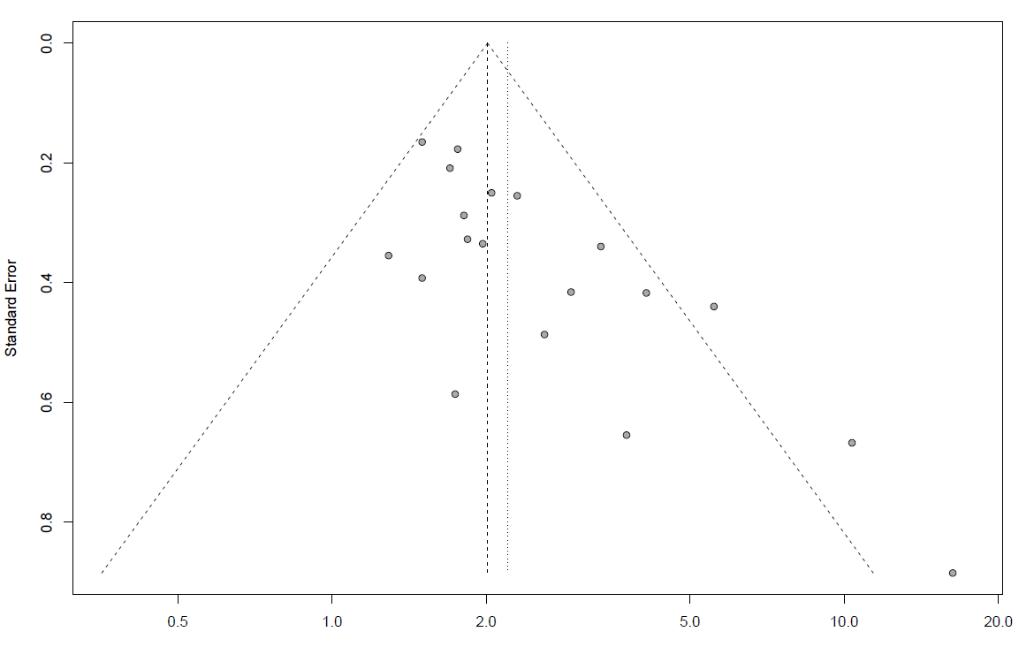

### **Excess of significance test**

Exact binomial test

data: data3$sum_final[data3$meta_id == 8] and data3$k[data3$meta_id == 8]

number of successes = 15, number of trials = 19, p-value =

0.9997

alternative hypothesis: true probability of success is greater than 0.9671896

95 percent confidence interval:

0.5808798 1.0000000

sample estimates:

probability of success

0.7894737

|  |  |  |  |  |  |
| --- | --- | --- | --- | --- | --- |
| metaid | kstud | Sum_power | p | Expected | Observed |
| 8 | 19 |  | 0.9997 | 18.3766 | 15 |

## **Violence experience (Zhang et al, 2019)**

### **Supplementary Figure 3.** Forest plot Violence experience meta-analysis

Random-effect meta-analysis

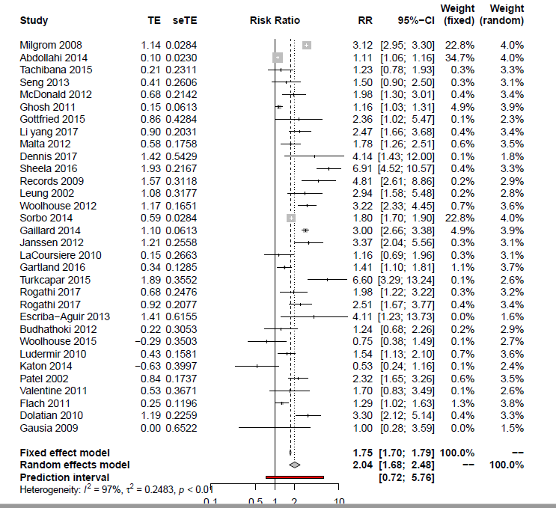

### **Egger’s test**

Linear regression test of funnel plot asymmetry

data: res7

t = 0.83039, df = 30, p-value = 0.4129

alternative hypothesis: asymmetry in funnel plot

sample estimates:

bias se.bias intercept

1.1027862 1.3280277 0.5057141

### **Supplementary Figure 4.** Funnel plot Violence experience meta-analysis

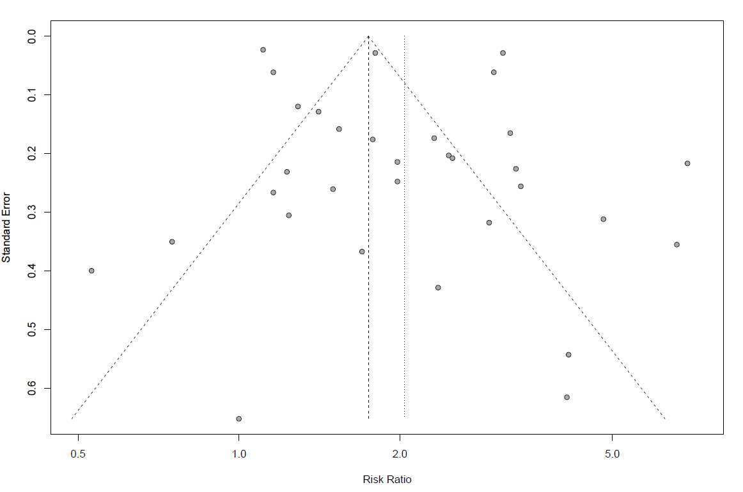

### **Excess of significance test**

Exact binomial test

data: data3$sum_final[data3$meta_id == 7] and data3$k[data3$meta_id == 7]

number of successes = 25, number of trials = 33, p-value = 0.9997

alternative hypothesis: true probability of success is greater than 0.9296533

95 percent confidence interval:

0.609285 1.000000

sample estimates:

probability of success

0.75

|  |  |  |  |  |  |
| --- | --- | --- | --- | --- | --- |
| metaid | kstud | Sum_power | p | Expected | Observed |
| 7 | 33 |  | 0.9997 | 30.67856 | 25 |

|  |  |  |  |  |  |
| --- | --- | --- | --- | --- | --- |
|  |  |  |  |  |  |

## **Unintended pregnancy (Qiu et al, 2020)**

### **Supplementary Figure 5.** Forest plot Unintended pregnancy meta-analysis

Random-effect meta-analysis

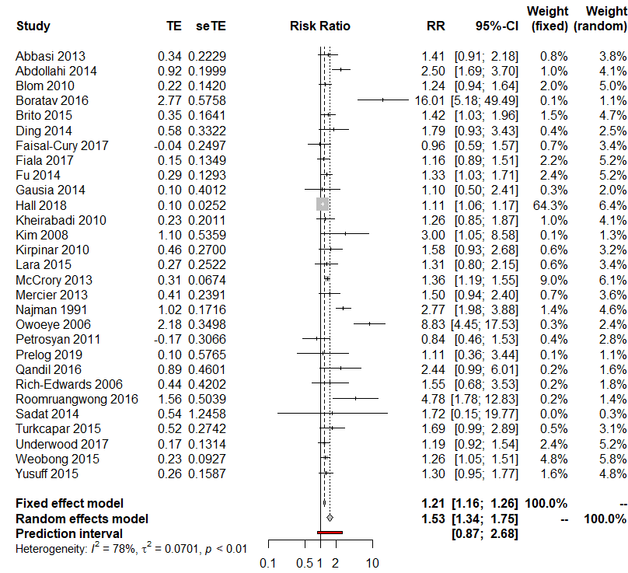

### **Egger’s test**

Linear regression test of

funnel plot asymmetry

data: res.11

t = 4.1383, df = 27,

p-value = 0.0003067

alternative hypothesis: asymmetry in funnel plot

sample estimates:

bias se.bias

1.69903679 0.41056489

intercept

0.07283381

### **Supplementary Figure 6.** Funnel Plot Unintended pregnancy meta-analysis

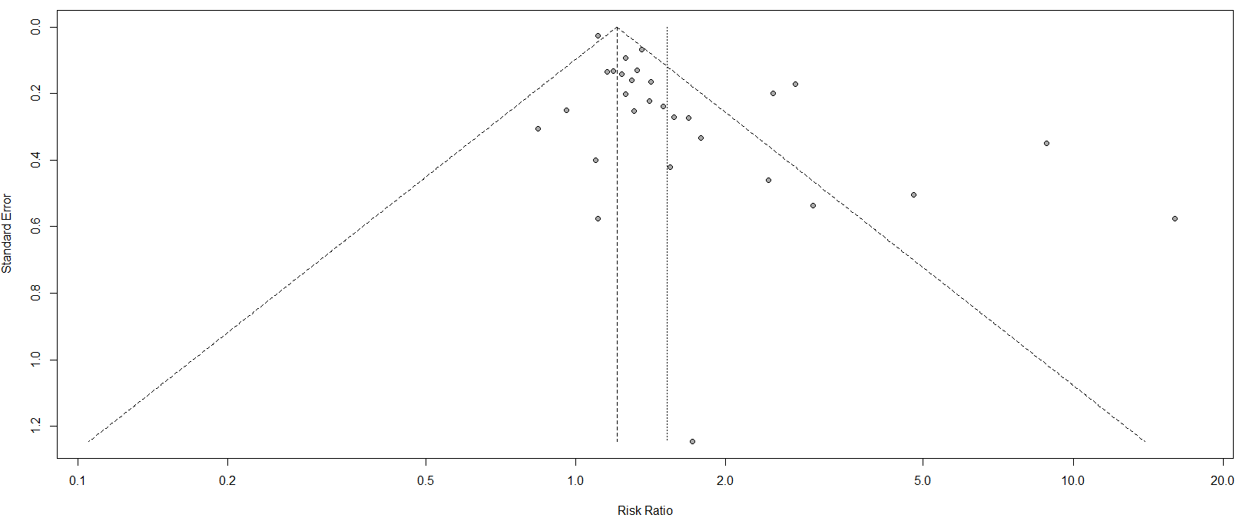

### **Excess of significance test**

Exact binomial test

data: dataf$sum_final[dataf$compid == "11"] and dataf$kstud[dataf$compid == "11"]

number of successes = 11, number of trials = 30, p-value = 1

alternative hypothesis: true probability of success is greater than 0.8024319

95 percent confidence interval:

0.2210594 1.0000000

sample estimates:

probability of success

0.3666667

|  |  |  |  |  |  |
| --- | --- | --- | --- | --- | --- |
| metaid | kstud | Sum_power | p | Expected | Observed |
| 11 | 29 |  | 1 | 24.92 | 11 |

## **5HTTLPR polymorphism (Li et al, 2020)**

### **Supplementary Figure 7.** Forest plot 5HTTLPR polymorphism meta-analysis

Random-effect meta-analysis

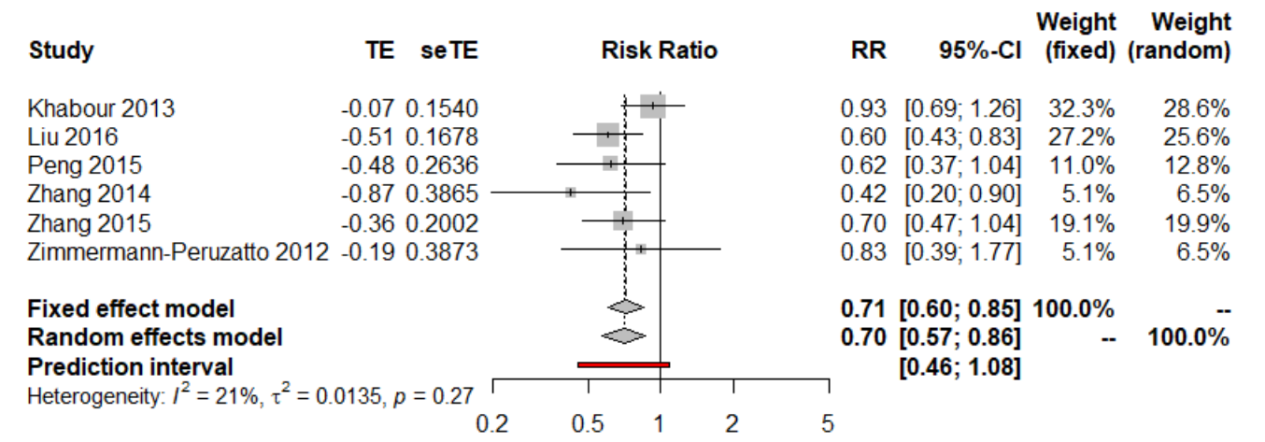

### **Egger’s test**

Linear regression test of funnel plot asymmetry

data: res.10

t = -1.0116, df = 4, p-value = 0.3689

alternative hypothesis: asymmetry in funnel plot

sample estimates:

bias se.bias intercept

-1.41064113 1.39445690 -0.05198015

### **Supplementary Figure 8.** Funnel plot 5HTTLPR polymorphism

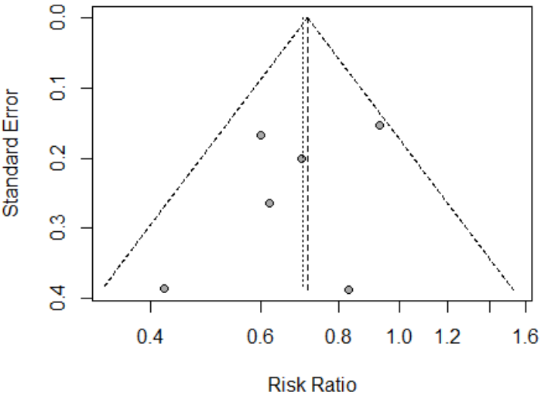

### **Excess of significance test**

data: data3$sum_final[data3$meta_id == 10] and data3$k[data3$meta_id == 10]

number of successes = 0, number of trials = 6, p-value = 1

alternative hypothesis: true probability of success is greater than 0.7571075

95 percent confidence interval:

0 1

sample estimates:

probability of success

0

|  |  |  |  |  |  |
| --- | --- | --- | --- | --- | --- |
| metaid | kstud | Sum_power | p | Expected | Observed |
| 10 | 6 |  | 1 | 4.54 | 0 |

## **C-Section (Xu et al, 2017)**

### **Supplementary Figure 9.** Forest plot C-Section meta-analysis

Random-effect meta-analysis

### **Egger’s test**

Linear regression test of funnel plot asymmetry

data: res.3

t = -0.98316, df = 31, p-value = 0.3331

alternative hypothesis: asymmetry in funnel plot

sample estimates:

bias se.bias intercept

-0.3605875 0.3667645 0.3272269

### **Supplementary Figure 10.** Funnel Plot C-section meta-analysis

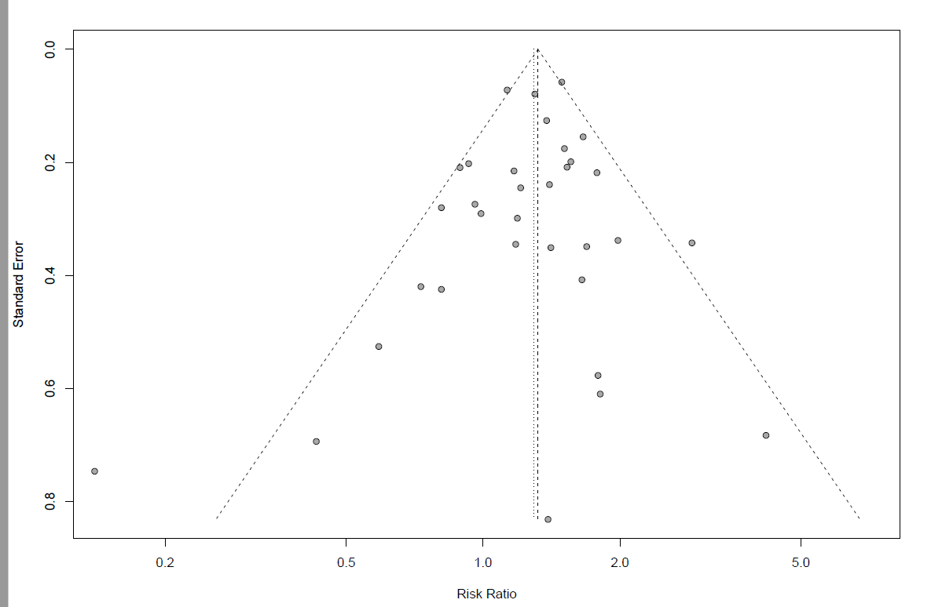

### **Excess of significance test**

data: data3$sum_final[data3$meta_id == 3] and data3$k[data3$meta_id == 3]

number of successes = 11, number of trials = 33, p-value = 1

alternative hypothesis: true probability of success is greater than 0.8682102

95 percent confidence interval:

0.1994765 1.0000000

sample estimates:

probability of success

0.3333333

|  |  |  |  |  |  |
| --- | --- | --- | --- | --- | --- |
| metaid | kstud | Sum_power | p | Expected | Observed |
| 3 | 33 |  | 1 | 28.65094 | 11 |

## **Gestational diabetes (Azami et al, 2019)**

### **Supplementary Figure 11.** Forest plot Gestational diabetes meta-analysis

### **Egger’s test**

Linear regression test of funnel plot asymmetry

data: res.2

t = 0.12053, df = 16, p-value = 0.9056

alternative hypothesis: asymmetry in funnel plot

sample estimates:

bias se.bias intercept

0.1326521 1.1005535 0.4720866

### **c. Supplementary Figure 12.** Funnel plot Gestational diabetes meta-analysis

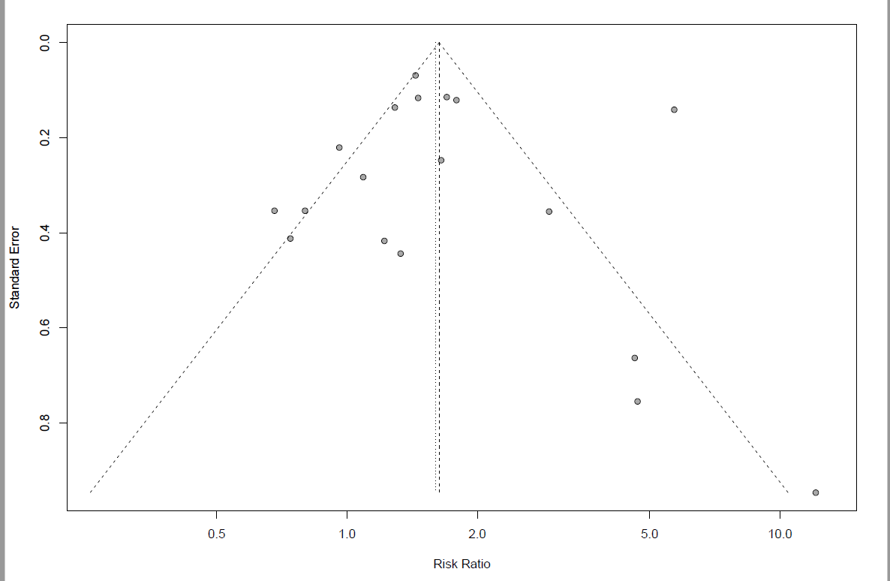

### **d. Excess of significance test**

Exact binomial test

data: data3$sum_final[data3$meta_id == 2] and data3$k[data3$meta_id == 2]

number of successes = 10, number of trials = 18, p-value = 1

alternative hypothesis: true probability of success is greater than 0.9033751

95 percent confidence interval:

0.3405981 1.0000000

sample estimates:

probability of success 0.5555556

|  |  |  |  |  |  |
| --- | --- | --- | --- | --- | --- |
| metaid | kstud | Sum_power | p | Expected | Observed |
| 2 | 18 | 16.26075 | 1 | 16.26075 | 10 |

## **Preterm delivery (De Paula Eduardo et al, 2019)**

### **Supplementary Figure 13.** Forest plot Preterm delivery meta-analysis

Random-effect meta-analysis

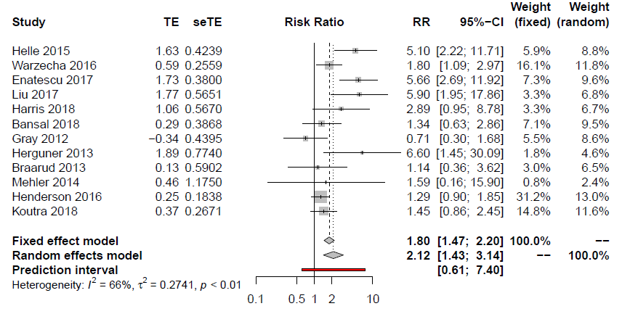

### **Egger’s test**

Linear regression test of funnel plot asymmetry

data: res4

t = 1.4936, df = 10, p-value = 0.1661

alternative hypothesis: asymmetry in funnel plot

sample estimates:

bias se.bias intercept

1.60934234 1.07746798 0.07293214

### **Supplementary Figure 14.** Funnel plot Preterm delivery meta-analysis

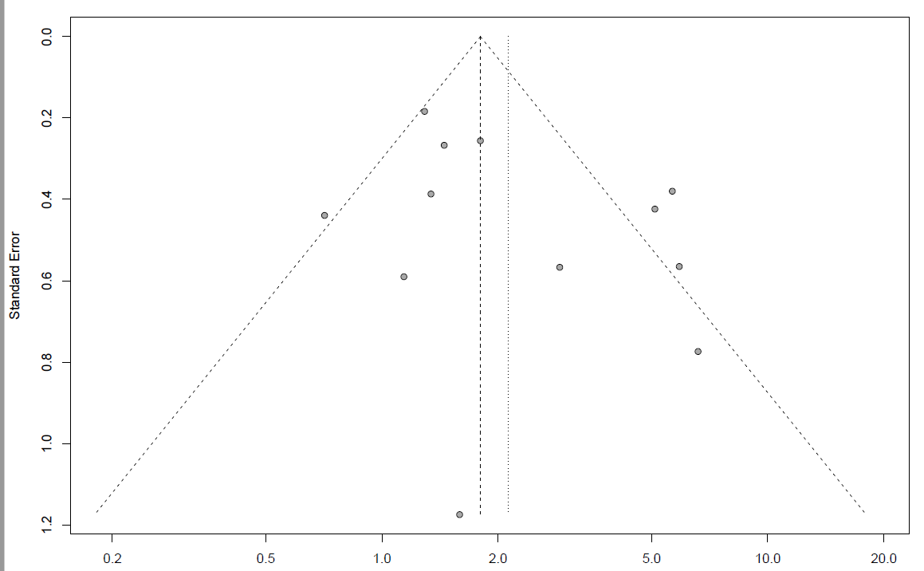

### **Excess of significance test**

Exact binomial test

data: data3$sum_final[data3$meta_id == 4] and data3$k[data3$meta_id == 4]

number of successes = 5, number of trials = 12, p-value = 1

alternative hypothesis: true probability of success is greater than 0.8576364

95 percent confidence interval:

0.1810248 1.0000000

sample estimates:

probability of success

0.4166667

|  |  |  |  |  |  |
| --- | --- | --- | --- | --- | --- |
| metaid | kstud | Sum_power | p | Expected | Observed |
| 4 | 12 |  | 1 | 10.29164 | 5 |

## **Anemia during pregnancy (Azami et al, 2019)**

### **Supplementary Figure 15.** Forest plot Anemia during pregnancy meta-analysis

Random-effect meta-analysis

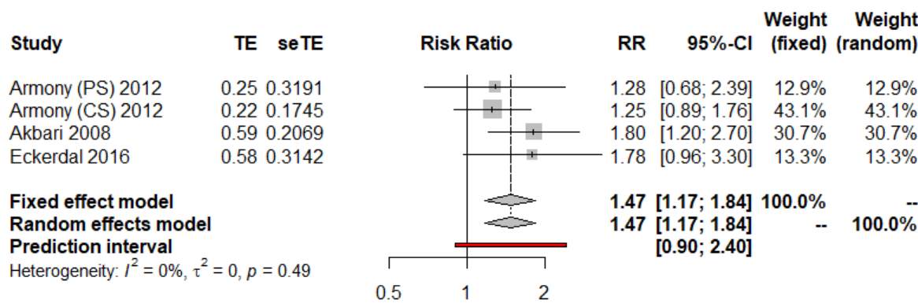

### **Egger’s test**

Linear regression test of funnel plot asymmetry

data: res4

t = 0.43329, df = 2, p-value = 0.7071

alternative hypothesis: asymmetry in funnel plot

sample estimates:

bias se.bias intercept

0.8961

691 2.0682900 0.1853614

### **Supplementary Figure 16.** Funnel plot Anemia during pregnancy meta-analysis

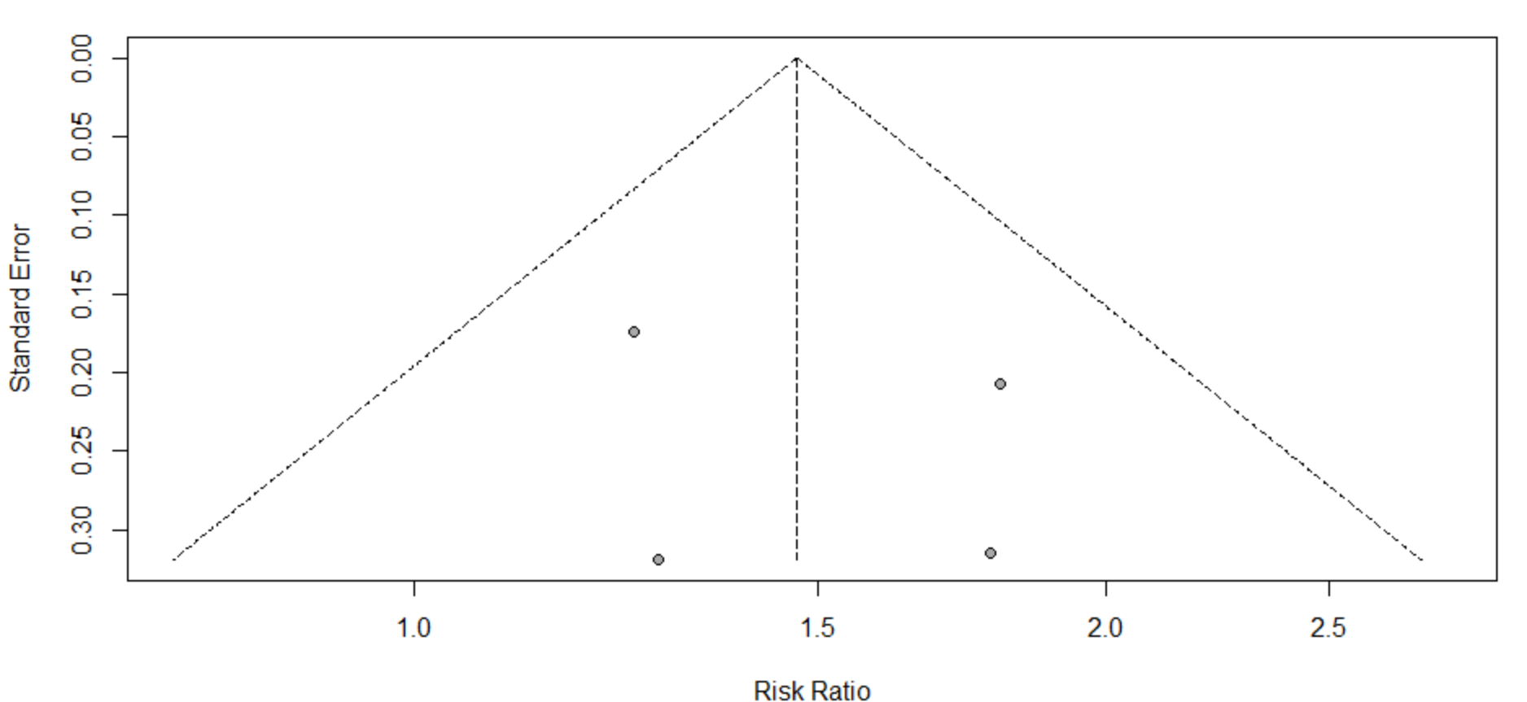

### **Excess of significance test**

data: dataf$sum_final[dataf$compid == "13"] and dataf$kstud[dataf$compid == "13"]

number of successes = 1, number of trials = 4, p-value =

0.9381

alternative hypothesis: true probability of success is greater than 0.5011359

95 percent confidence interval:

0.01274146 1.00000000

sample estimates:

probability of success

0.25

|  |  |  |  |  |  |
| --- | --- | --- | --- | --- | --- |
| metaid | kstud | Sum_power | p | Expected | Observed |
| 31363389 | 4 | 2.004544 | 0.9381 | 1 | 1 |

## **Vitamin D deficiency (Wang et al, 2018)**

### **Supplementary Figure 17.** Forest plot Vitamin D deficiency meta-analysis

Random-effect meta-analysis



### **Egger’s test**

Linear regression test of funnel plot asymmetry

data: res10

t = 0.64688, df = 2, p-value = 0.584

alternative hypothesis: asymmetry in funnel plot

sample estimates:

bias se.bias intercept

3.6437157937 5.6327383843 0.0007658716

### **Supplementary Figure 18.** Funnel plot Vitamin D deficiency meta-analysis

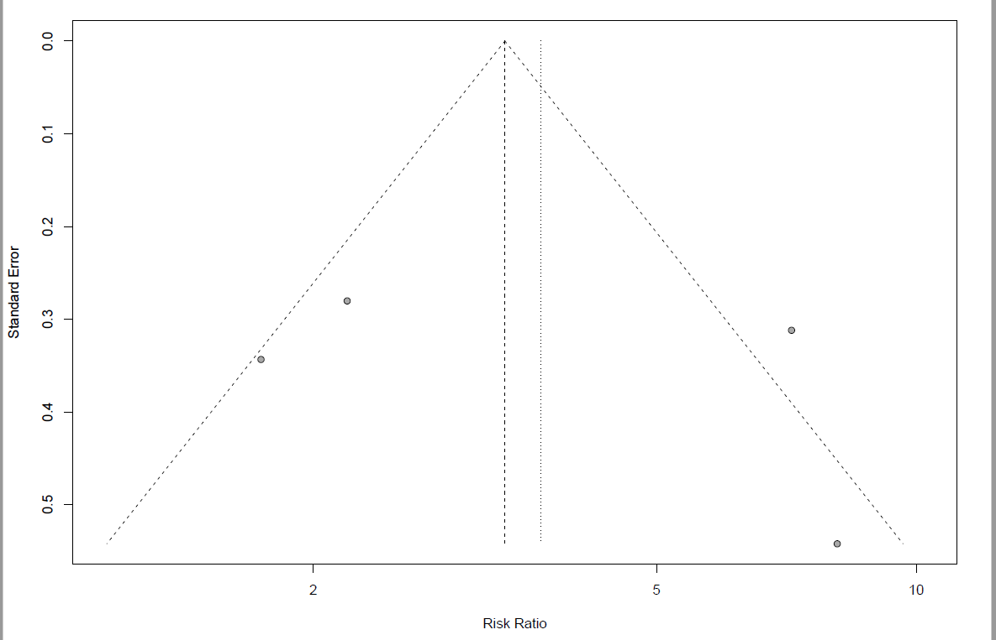

### **Excess of significance test**

data: data3$sum_final[data3$meta_id == 9] and data3$k[data3$meta_id == 9]

number of successes = 3, number of trials = 4, p-value = 1

alternative hypothesis: true probability of success is greater than 1

95 percent confidence interval:

0.2486046 1.0000000

sample estimates:

probability of success

0.75

|  |  |  |  |  |  |
| --- | --- | --- | --- | --- | --- |
| metaid | kstud | Sum_power | p | Expected | Observed |
| 9 | 4 |  | 1 | 4 | 3 |

## **Post-partum anemia (Azami et al, 2019)**

### **Supplementary Figure 19.** Forest plot Post-partum anemia meta-analysis

Random-effect meta-analysis

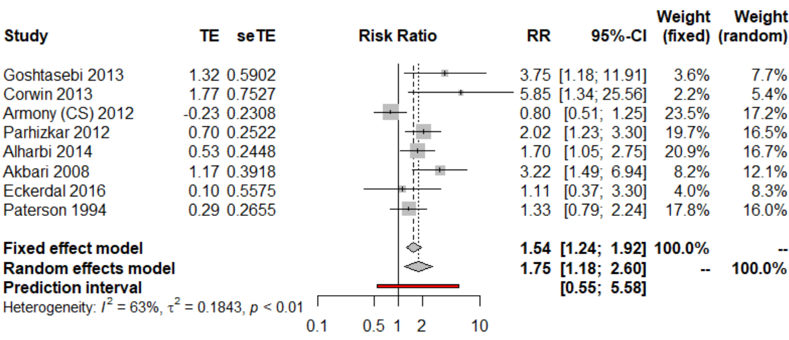

### **Egger’s test**

Linear regression test of funnel plot asymmetry

data: res.3

t = 1.7408, df = 6, p-value = 0.1324

alternative hypothesis: asymmetry in funnel plot

sample estimates:

bias se.bias intercept

2.4520542 1.4085735 -0.2901599

### **Supplementary Figure 20.** Funnel plot Post-partum anemia meta-analysis

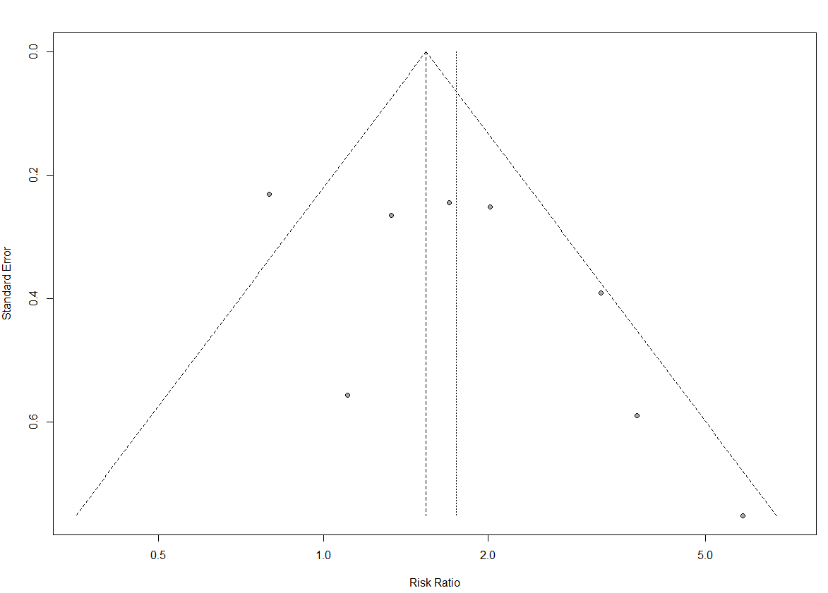

### **Excess of significance test**

data: dataf$sum_final[dataf$compid == "12"] and dataf$kstud[dataf$compid == "12"]

number of successes = 5, number of trials = 8, p-value =

0.9725

alternative hypothesis: true probability of success is greater than 0.8385608

95 percent confidence interval:

0.2892408 1.0000000

sample estimates:

probability of success

0.625

|  |  |  |  |  |  |
| --- | --- | --- | --- | --- | --- |
| metaid | kstud | Sum_power | p | Expected | Observed |
| 31363389 | 8 | 6.708487 | 0.9725 | 5 | 5 |

## **Medically assisted conception (Gressier et al, 2015)**

### **Supplementary Figure 21.** Forest plot Medically assisted conception meta-analysis

Random-effect meta-analysis

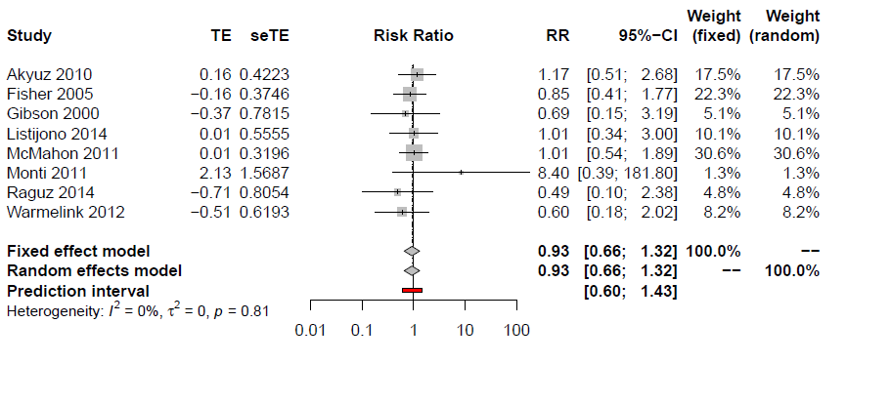

### **Egger’s test**

Linear regression test of funnel plot asymmetry

data: res6

t = 0.26864, df = 6, p-value = 0.7972

alternative hypothesis: asymmetry in funnel plot

sample estimates:

bias se.bias intercept

0.1910539 0.7111890 -0.1607966

### **Supplementary Figure 22.** Funnel plot Medically assisted conception meta-analysis

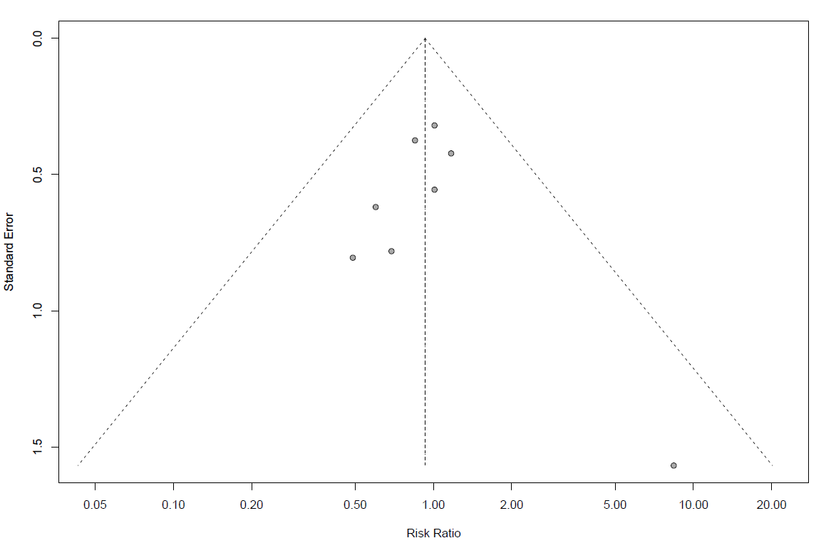

### **Excess of significance test**

Exact binomial test

data: data3$sum_final[data3$meta_id == 6] and data3$k[data3$meta_id == 6]

number of successes = 0, number of trials = 8, p-value = 1

alternative hypothesis: true probability of success is greater than 0.5733041

95 percent confidence interval:

0 1

sample estimates:

probability of success

0

|  |  |  |  |  |  |
| --- | --- | --- | --- | --- | --- |
| metaid | kstud | Sum_power | P | Expected | Observed |
| 6 | 8 |  | 1 | 4.586433 | 0 |
|  |  |  |  |  |  |

## **Labor epidural analgesia (Koutanis et al, 2020)**

### **Supplementary Figure 23.** Forest plot Labor epidural analgesia meta-analysis

Random-effect meta-analysis

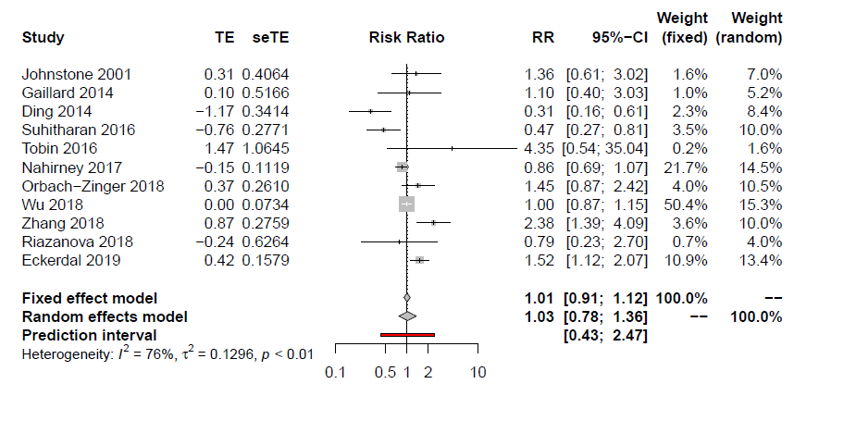

### **Egger’s test**

Linear regression test of funnel plot asymmetry

data: res5

t = 0.23128, df = 9, p-value = 0.8223

alternative hypothesis: asymmetry in funnel plot

sample estimates:

bias se.bias intercept

0.24288850 1.05018510 -0.02029752

### **Supplementary Figure 24.** Funnel plot Labor epidural analgesia meta-analysis

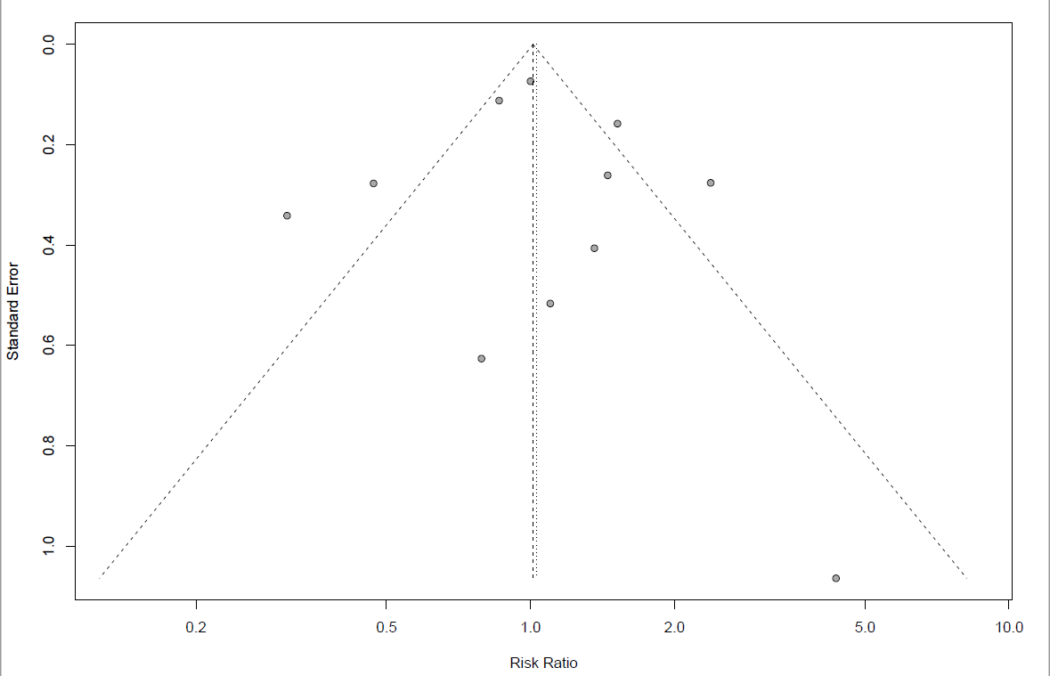

### **Excess of significance test**

Exact binomial test

data: data3$sum_final[data3$meta_id == 5] and data3$k[data3$meta_id == 5]

number of successes = 2, number of trials = 11, p-value = 1

alternative hypothesis: true probability of success is greater than 0.712358

95 percent confidence interval:

0.03331922 1.00000000

sample estimates:

probability of success 0.1818182

|  |  |  |  |  |  |
| --- | --- | --- | --- | --- | --- |
| metaid | kstud | Sum_power | p | Expected | Observed |
| 5 | 11 |  | 1 | 7.835938 | 2 |

# **Supplementary Table 3.** Sensitivity analysis including only cohort studies

|  |  |  |  |  |  |  |  |  |  |  |  |  |  |
| --- | --- | --- | --- | --- | --- | --- | --- | --- | --- | --- | --- | --- | --- |
|  | Features used for classification of level of evidence according to Umbrella review Criteria | | | | | | | | | | | | **GRADE certainty of evidence** |
| **Risk factor** | n | Random-effects ES (95% CI) | Number of cases* | Random-effects P-value | I2 | MA Predictive Intervals | Random-effects ES (95% CI) of the largest study | Egger’s test p-value | Significant studies | | | **Class of Evidence** |
| Observed | Expected** | p-value† |
| **Premenstrual syndrome** | 6 | 2.23  (1.74 to 2.86) | 709 | 2.71x10-10 | 10.3 | 1.42 to 3.5 | 1.7  (1.13 to 2.56) | 0.27 | 5 | 5.99 | 1.00 | **IV** | ⨁⨁◯◯ LOW |
| **Violence** | 27 | 1.92  (1.55 to 2.37) | 18554 | 1.69x10-9 | 97.5 | 0.67 to 5.5 | 1.11  (1.1 to 1.16) | 0.6 | 19 | 24.68 | 0.99 | **II** | ⨁◯◯◯ VERY LOW a |
| **Unintended pregnancy** | 27 | 1.53  (1.34 to 1.74) | 8168 | 3.49 x10-10 | 78 | 0.88 to 2.64 | 1.26  (1.1 to 1.5) | 3.25x10-4 | 10 | 23.5 | 1.00 | **II** | ⨁◯◯◯ VERY LOW a |
| **5HTTLPR polymorphism** | 0 | NA | NA | NA | NA | NA | NA | NA | NA | NA | NA | NA | NA |
| **C-section** | 20 | 1.17  (0.90 to 1.37) | 4226 | 0.061 | 39.2 | 0.73 to 1.85 | 1.3  (1.11 to 1.52) | 0.27 | 4 | 16.8 | 1.00 | **NSA** | ⨁◯◯◯ VERY LOW b |
| **Gestational diabetes** | 15 | 1.68  (1.25 to 2.27) | 24077 | 6.65x10-4 | 87.8 | 0.56 to 5.04 | 1.44  (1.26 to 1.65) | 0.82 | 9 | 14.064 | 1.00 | **III** | ⨁◯◯◯ VERY LOW a,c |
| **Pre-term** | 3 | 1.81  (1.19 to 2.77) | 261 | 0.0061 | 0.0 | 0.12 to 28.56 | 1.8  (1.09 to 2.97) | 0.9957 | 1 | 2.24 | 0.98 | **IV** | ⨁⨁◯◯ LOW |
| **Anemia during pregnancy** | 4 | NP | NP | NP | NP | NP | NP | NP | NP | NP | NP | NP | NP |
| **Vitamin D deficiency** | 4 | 3.67  (1.72 to 7.85) | 320 | 8.0x10-4 | 79.4 | 0.13 to 107.31 | 2.19  (1.26 to 3.79) | 0.584 | 3 | 4 | 1.00 | **III** | ⨁◯◯◯ VERY LOW a |
| **Post-partum anemia** | 6 | 1.9  (1.05 to 3.43) | 350 | 0.03 | 71.5 | 0.3 to 11.99 | 1.11  (0.37 to 3.3) | 0.1513 | 4 | 4 | 0.884 | **NSA** | ⨁◯◯◯ VERY LOW a |
| **Medically assisted conception** | 5 | 0.96  (0.66 to 1.39) | 209 | 0.81 | 0 | 0.52 to 1.76 | 1.01  (0.5 to 1.89) | 0.29 | 0 | 1.96 | 1.00 | **NSA** | ⨁◯◯◯ VERY LOW b |
| **Epidural analgesia** | 10 | 1.12  (0.85 to 1.48) | 1257 | 0.43 | 74.0 | 0.49 to 2.57 | 1.00  (0.87 to 1.15) | 0.554 | 2 | 6.836 | 0.99 | **NSA** | ⨁◯◯◯ VERY LOW a,b |

CI: confidence interval; GRADE: Grading of Recommendations, Assessment, Development and Evaluations; ES: effect-size; MA: meta-analysis; NA: not available; NP: not performed as all the studies of the main analysis fulfilled the criteria; NSA: no significant association; SE: standard error.

*number of women with postpartum depression.

**Observed and expected number of significant studies using effect of largest study (smallest SE) of each meta-analysis as plausible effect size.

†p value of excess significance test. All statistical tests two sided.

a Downgraded for very serious/serious inconsistency

b Downgraded for serious/very serious imprecision

c Downgraded for serious risk of bias

## **Forest Plots of sensitivity analysis including only cohort studies**

### **Supplementary Figure 25. Premenstrual syndrome (Cao et al, 2020)**

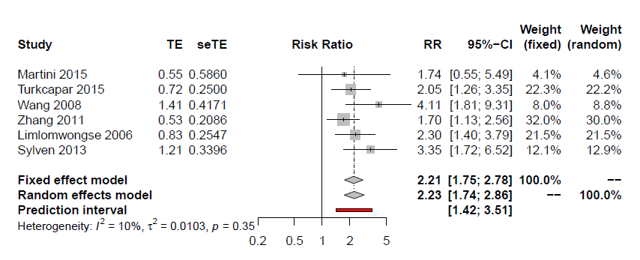

### **Supplementary Figure 26. Violence experience (Zhang et al, 2019)**

### **Supplementary Figure 27. Unintended pregnancy (Qiu et al, 2020)**

### **5HTTLPR polymorphism (Li et al., 2020)**

Not performed- no cohort studies included

### **Supplementary Figure 28. C-Section (Xu et al, 2017)**

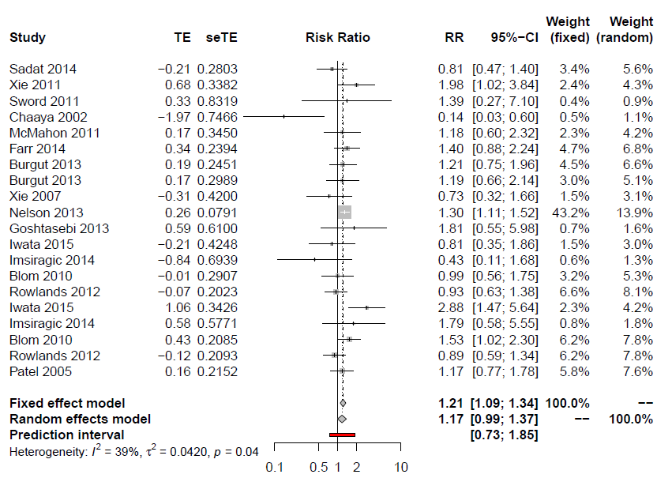

### **Supplementary Figure 29. Gestational diabetes (Azami et al, 2019)**

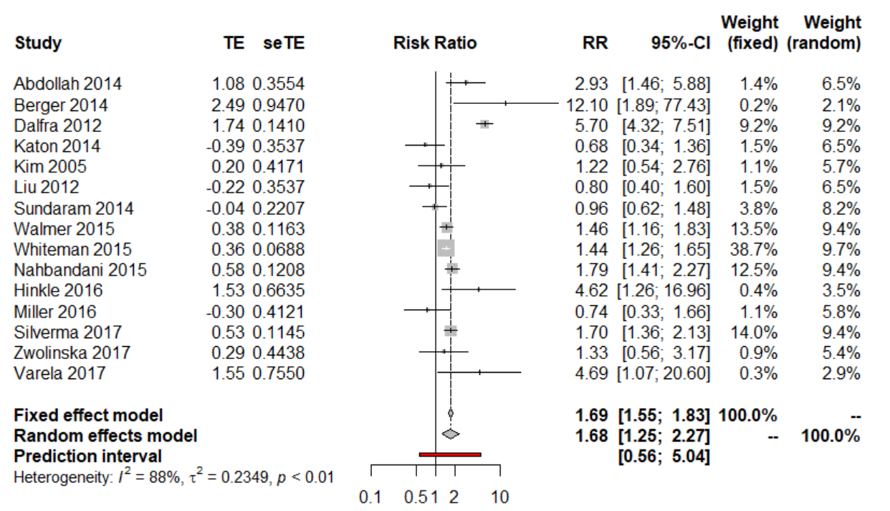

### **Supplelmentary Figure 30. Preterm delivery (De Paula Eduardo et al, 2019)**

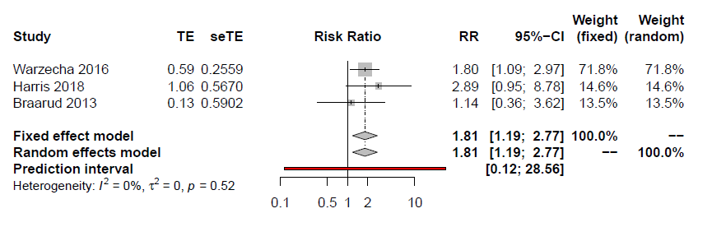

1. **Anemia during pregnancy (Azami et al, 2019)**

Not performed as all studies included in the main analysis fulfilled the criteria for the sensitivity. Check the main analysis.

### **Supplementary Figure 31. Vitamin D deficiency (Wang et al, 2018)**

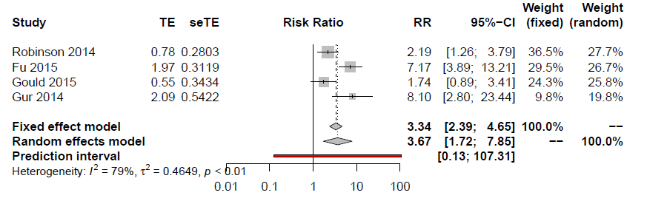

### **Supplementary Figure 32. Post-partum anemia (Azami et al, 2019)**

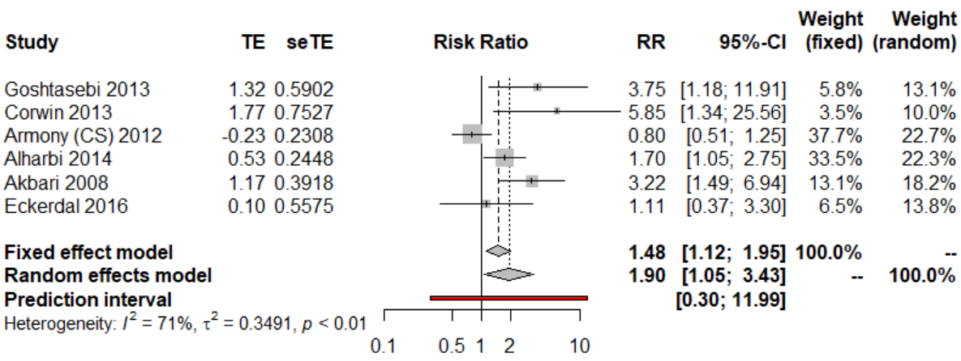

### **Supplementary Figure 33. Medically assisted conception (Gressier et al, 2015)**

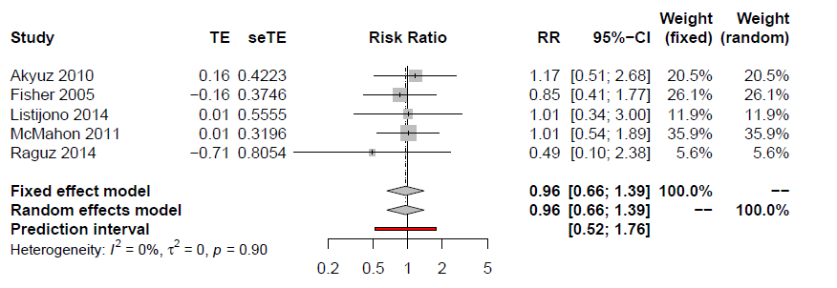

### **Supplementary Figure 34. Labor epidural analgesia (Kountanis et al, 2020)**

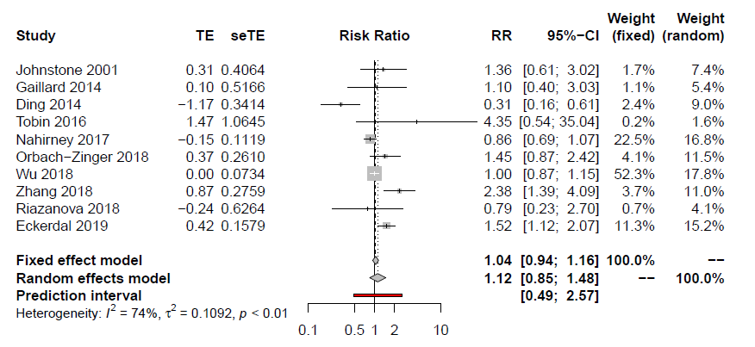

# **Supplementary Table 4.** Sensitivity analysis including only PPD indicated with standard criteria

|  |  |  |  |  |  |  |  |  |  |  |  |  |  |
| --- | --- | --- | --- | --- | --- | --- | --- | --- | --- | --- | --- | --- | --- |
|  | Features used for classification of level of evidence according to Umbrella review Criteria | | | | | | | | | | | | **GRADE certainty of evidence** |
| **Outcome** | n | Random-effects  ES  (95% CI) | Number of cases* | Random-effects P-value | I2 | MA Predictive Intervals | Random-effects ES (95% CI) of the largest study | Egger’s test p-value | Significant studies | | | **Class of Evidence** |
| Observed | Expected** | p-value† |
| **Premenstrual syndrome** | 8 | 2.23  (1.53 to 3.25) | 686 | 2.87x10-5 | 57.0 | 0.78 to 6.38 | 1.5  (1.09 to 2.07) | 0.04 | 6 | 7.48 | 0.988 | **IV** | ⨁◯◯◯ VERY LOW a,c |
| **Violence** | 16 | 1.96  (1.4 to 2.75) | 11547 | 8.01x10-5 | 98.0 | 0.48 to 8.1 | 1.11  (1.06 to 1.16) | 0.65 | 12 | 14.91 | 0.997 | **III** | ⨁◯◯◯ VERY LOW b |
| **Unintended pregnancy** | 9 | 1.96  (1.32 to 2.9) | 833 | 7.7 x 10-4 | 75 | 0.57 to 6.73 | 1.19  (0.92 to 1.54) | 0.11 | 2 | 8.57 | 1.00 | **IV** | ⨁◯◯◯ VERY LOW b |
| **5HTTPRL polymorphism** | 4 | 0.72  (0.54 to 0.95) | 660 | 0.02 | 0 | 0.27 to 1.92 | 0.93  (0.7 to 1.28) | 0.03 | 0 | 3.17 | 1.00 | **IV** | ⨁⨁◯◯ LOW |
| **C-section** | 17 | 1.31  (1.16 to 1.47) | 6266 | 1.36x10-5 | 46.3 | 0.94 to 1.81 | 1.49  (1.33 to 1.67) | 0.37 | 6 | 14.77 | 1.00 | **III** | ⨁⨁◯◯ LOW |
| **Gestational diabetes** | 8 | 1.57  (1.32 to 1.86) | 16344 | 2.62x10-7 | 48 | 1.03 to 2.39 | 1.44  (1.26 to 1.65) | 0.05 | 6 | 7.25 | 0.968 | **II** | ⨁◯◯◯ VERY LOW a,c |
| **Preterm** | 6 | 2.58  (1.18 to 5.61) | 268 | 0.02 | 76.5 | 0.21 to 31.06 | 1.45  (0.86 to 2.45) | 0.65 | 3 | 5.42 | 0.999 | **NSA** | ⨁◯◯◯ VERY LOW b,d |
| **Anemia during pregnancy** | 0 | NA | NA | NA | NA | NA | NA | NA | NA | NA | NA | **NA** | NA |
| **Vitamin D deficiency** | 1 | NA | NA | NA | NA | NA | NA | NA | NA | NA | NA | NA | NA |
| **Post-partum anemia** | 2 | 1.95  (0.73 to 5.2) | 84 | 0.18 | 61 | NA | 1.33  (0.79 to 2.24) | NA | 1 | 1 | 1.00 | **NSA** | ⨁◯◯◯ VERY LOW b,d |
| **Medically assisted conception** | 3 | 0.76  (0.41 to 1.39) | 128 | 0.37 | 0 | 0.01 to 39.63 | 0.85  (0.41 to 1.77) | 0.29 | 0 | 2.295 | 1.00 | **NSA** | ⨁◯◯◯ VERY LOW d |
| **Epidural analgesia** | 2 | 0.77  (0.27 to 2.16) | 202 | 0.61 | 78.6 | NA | 0.47  (0.27 to 0.81) | NO | 0 | 1.96 | 1.00 | **NSA** | ⨁◯◯◯ VERY LOW a,b,d |

CI: confidence interval; ES: effect-size; GRADE: Grading of Recommendations, Assessment, Development and Evaluations; MA: meta-analysis; NSA: no significant association; NA: not available

*number of women with postpartum depression.

** Observed and expected number of significant studies using effect of largest study (smallest SE) of each meta-analysis as plausible effect size;

† p-value of excess significance test. All statistical tests two sided;

a Downgraded for serious/very serious risk of bias

b Downgraded for serious/very serious inconsistency

c Downgraded for publication bias

d Downgraded for very serious imprecision

.

## **7.1. Forest Plots of the sensitivity analysis including only indicated with standard criteria.**

### **Supplementary Figure 35. Premenstrual syndrome (Cao et al, 2020)**

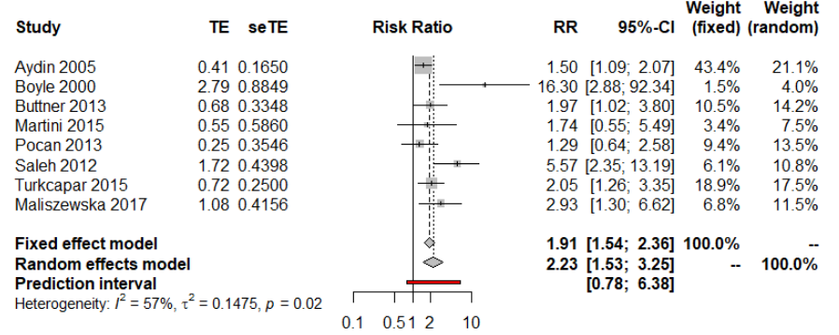

### **Supplementary Figure 36. Violence experience (Zhang et al, 2019)**

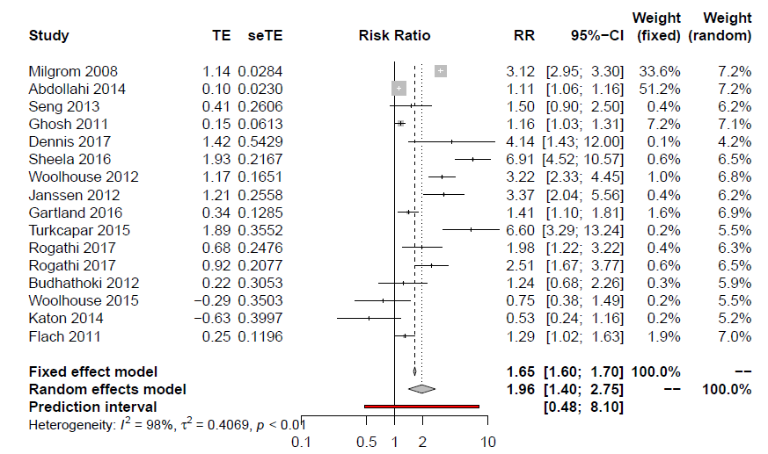

### **Supplementary Figure 37. Unintended pregnancy (Qiu et al, 2020)**

### **Supplementary Figure 38. 5HTTPRL polymorphism (Li et al, 2020)**

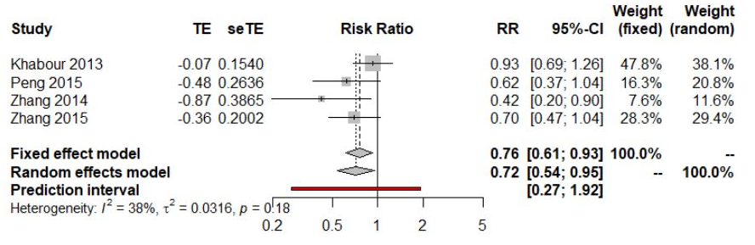

### **Supplementary Figure 39. C-Section (Xu et al, 2017)**

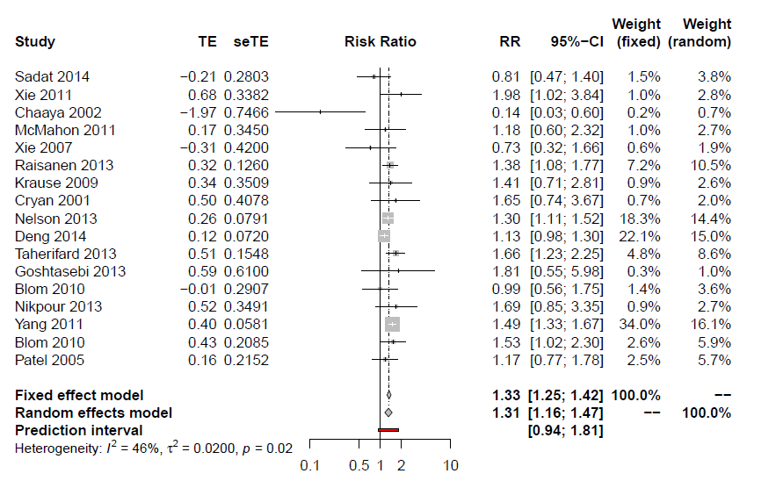

### **Supplementary Figure 40. Gestational diabetes (Azami et al, 2019)**

### **Supplementary Figure 41. Preterm delivery (De Paula Eduardo et al, 2019)**

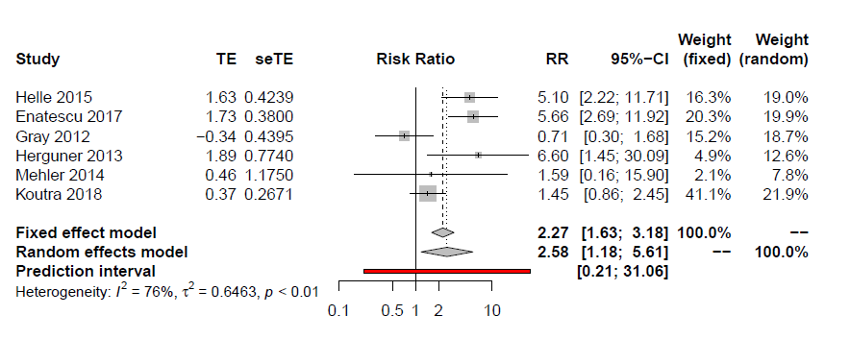

### **Anemia during pregnancy (Azami et al, 2019)**

### Not performed as all studies included in the main analysis fulfilled the criteria for the sensitivity. Check the main analysis

### **Vitamin D deficiency (Wang et al. 2018)**

Only one study available. Analysis not performed.

### **Supplementary Figure 42. Post-partum anemia (Azami et al, 2019)**

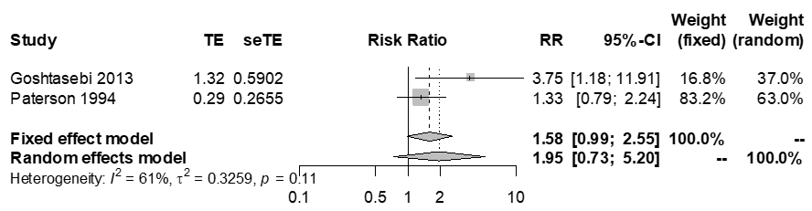

### **Supplementary Figure 43. Labor epidural analgesia (Kountanis et al, 2020)**

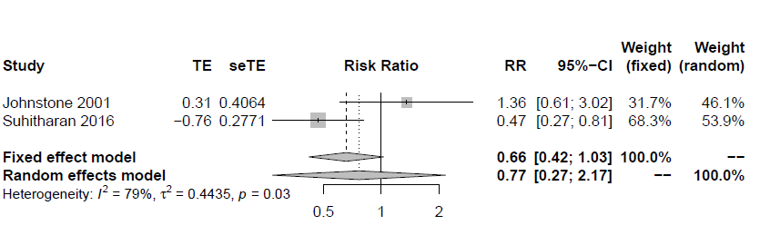

### **Supplementary Figure 44. Medically assisted conception (Gressier et al, 2015)**

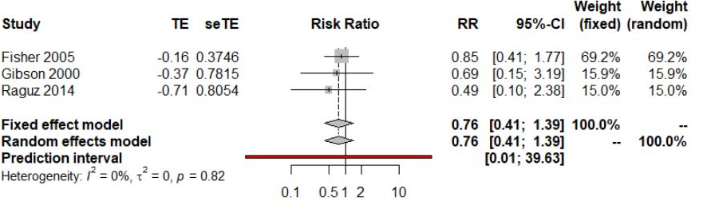

.

# **Supplementary Table 5.** Sensitivity analysis including only PPD diagnosed after 7 days

|  |  |  |  |  |  |  |  |  |  |  |  |  |  |
| --- | --- | --- | --- | --- | --- | --- | --- | --- | --- | --- | --- | --- | --- |
|  | Features used for classification of level of evidence according to Umbrella review Criteria | | | | | | | | | | | | **GRADE certainty of evidence** |
| **Outcome** | n | Random-effects  ES (95% CI) | Number of cases* | Random-effects P-value | I2 | MA Predictive Intervals | Random-effects ES (95% CI) of the largest study | Egger’s test p-value | Significant studies | | | **Class of Evidence** |
| Observed | Expected** | p-value† |
| **Premenstrual syndrome** | 12 | 2.42  (1.83 to 3.21) | 759 | 0.004 | 81.8 | 1.11 to 5.29 | 1.76  (1.24 to 2.49) | 0.004 | 10 | 1 | 0.99 | **IV** | ⨁◯◯◯ VERY LOW a,b |
| **Violence** | 9 | 2.03  (1.65 to 2.48) | 17235 | 0.0027 | 74.5 | 0.71 to 5.78 | 1.11  (1.06 to 1.16) | 0.455 | 4 | 7.66 | 0.9994 | **II** | ⨁◯◯◯ VERY LOW b |
| **Unintended pregnancy** | 28 | 1.49  (1.31 to 1.7) | 8284 | 1.86 x10-9 | 76.1 | 0.87 to 2.54 | 1.26  (1.05 to 1.51) | 0.0005 | 10 | 23.92 | 1.00 | **II** | ⨁◯◯◯ VERY LOW b,c |
| **5TTHPRL polymorphism** | 2 | 0.83  (0.63 to 1.09) | 520 | 0.18 | 21. | NA | 0.93  (0.7 to 1.28) | NA | 0 | 1.19 | 1.00 | **NSA** | ⨁◯◯◯ VERY LOW d |
| **C-section** | 29 | 1.2554  (1.23 to 1.392) | 7765 | 1.04x10-11 | 97.1 | 0.91 to 1.73 | 1.49  (1.33 to 1.67) | 0.171 | 8 | 24.99 | 1.00 | **III** | ⨁⨁◯◯ LOW |
| **Gestational diabetes** | 12 | 1.78  (1.16 to 2.73) | 2290 | 1.51x10-5 | 39.9 | 0.38 to 8.39 | 1.79  (1.41 to 2.27) | 0.653 | 6 | 10.44 | 0.9997 | **IV** | ⨁◯◯◯ VERY LOW a,b |
| **Pre-term** | 11 | 2.30  (1.34 to 3.97) | 824 | 0.85 | 76.5 | 0.42 to 12.73 | 1.29  (0.9 to 1.85) | 0.24 | 2 | 7.84 | 1.00 | **IV** | ⨁◯◯◯ VERY LOW |
| **Anemia during pregnancy** | 4 | NP | NP | NP | NP | NP | NP | NP | NP | NP | NP | NP | NP |
| **Vitamin D deficiency** | 3 | 4.51  (1.62 to 12.58) | 168 | 0.0086 | 88.6 | 0.00 to 966649.84 | 7.17  (3.89 to 13.21) | 0.8615 | 2 | 3 | 1.00 | **IV** | ⨁◯◯◯ VERY LOW b |
| **Post-partum anemia** | 8 | NP | NP | NP | NP | NP | NP | NP | NP | NP | NP | NP | NP |
| **Medically assisted conception** | 30 | 0.95  (0.62 to 1.44) | 154 | 6.26x10-10 | 47.5 | 0.52 to 1.72 | 1.01  (0.54 to 1.89) | 0.8929 | 22 | 27.68 | 0.9997 | **NSA** | ⨁◯◯◯ VERY LOW d |
| **Epidural analgesia** | 6 | 1.03  (0.78 to 1.36) | 1319 | 0.8 | 0 | 0.43 to 2.47 | 1  (0.87 to 1.15) | 0.8223 | 0 | 3.87 | 1.00 | **NSA** | ⨁◯◯◯ VERY LOW b,d |

CI: confidence interval; ES: effect size; GRADE: Grading of Recommendations, Assessment, Development and Evaluations; MA: meta-analysis; NA: not available; NP: not performed as all the studies of the main analysis fulfilled the criteria; NSA: no significant association; NSA: no significant association

*number of women with postpartum depression.

** Observed and expected number of significant studies using effect of largest study (smallest SE) of each meta-analysis as plausible effect size;

† p-value of excess significance test. All statistical tests two sided;

a Downgraded for serious risk of bias

b Downgraded for very serious inconsistency

c Downgraded for possible residual confounding

d Downgraded for serious imprecision

## **8.1. Forest Plots of the sensitivity analysis including only PPD diagnosed after 7 days**

### **Supplementary Figure 45. Premenstrual syndrome (Cao et al, 2020)**

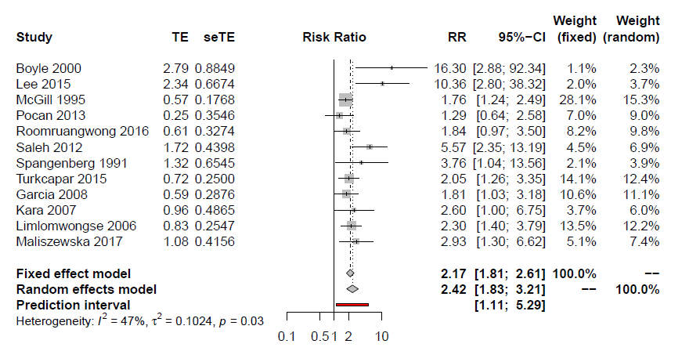

### **Supplementary Figure 46. Violence experience (Zhang et al, 2019)**

### **Supplementary Figure 47. Unintended pregnancy (Qiu et al, 2020)**

### **Supplementary Figure 48. 5HTTLPR polymorphism (Li et al, 2020)**

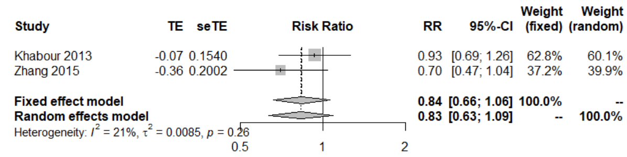

### **Supplementary Figure 49. C-Section (Xu et al, 2017)**

### **Supplementary Figure 50. Gestational diabetes (Azami et al, 2019)**

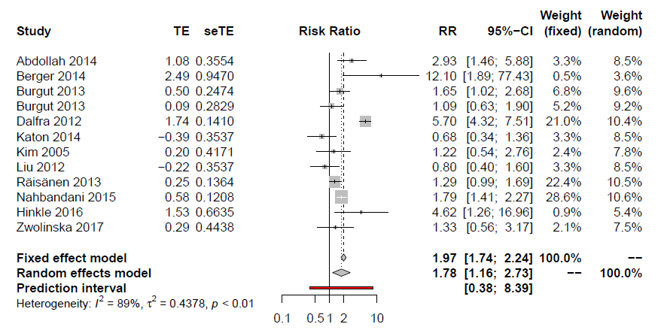

### **Supplementary Figure 51. Preterm delivery (De Paula Eduardo et al, 2019)**

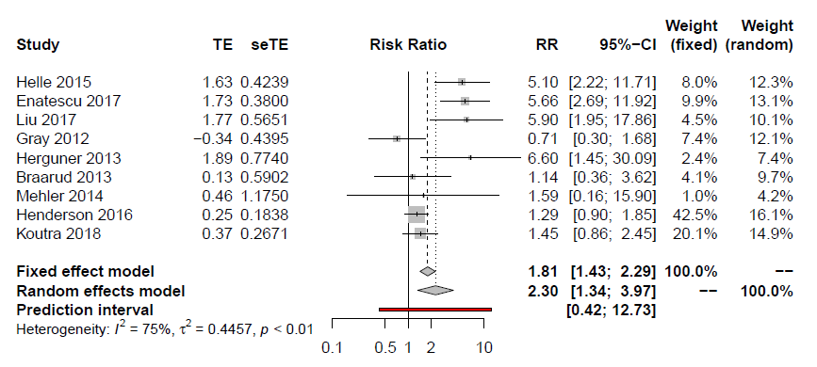

### **Anemia during pregnancy (Azami et al, 2019)**

Not performed as all the studies included in the main analysis fulfilled the criteria for the sensitivity. Check the main analysis.

### **Supplementary Figure 52. Vitamin D deficiency (Wang et al, 2018)**

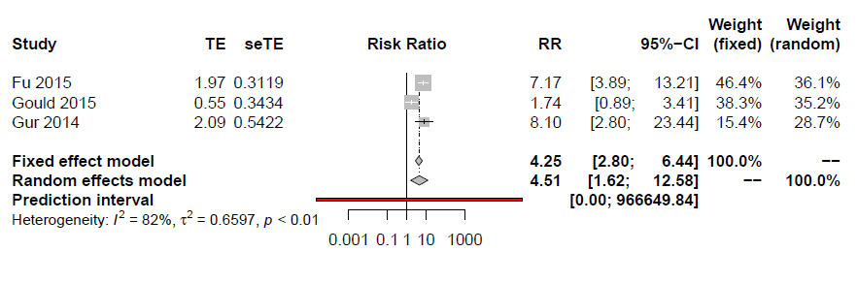

### **Post-partum anemia (Azami et al, 2019)**

Not performed as all the studies included in the main analysis fulfilled the criteria for the sensitivity. Check the main analysis.

### **Supplementary Figure 53. Medically assisted conception (Gressier et al, 2015)**

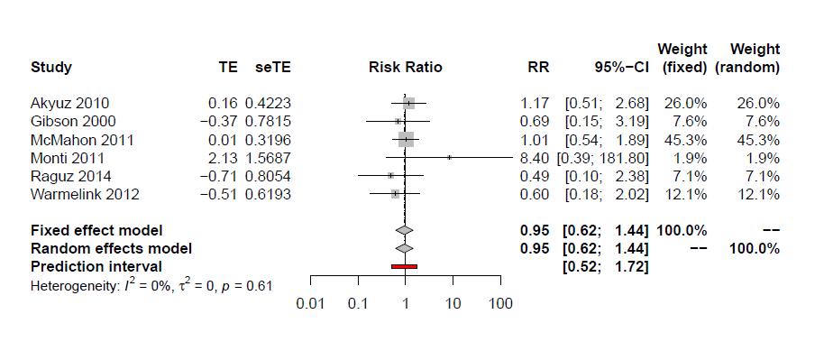

### **Supplementary Figure 54. Labor epidural analgesia (Koutanis et al, 2020)**

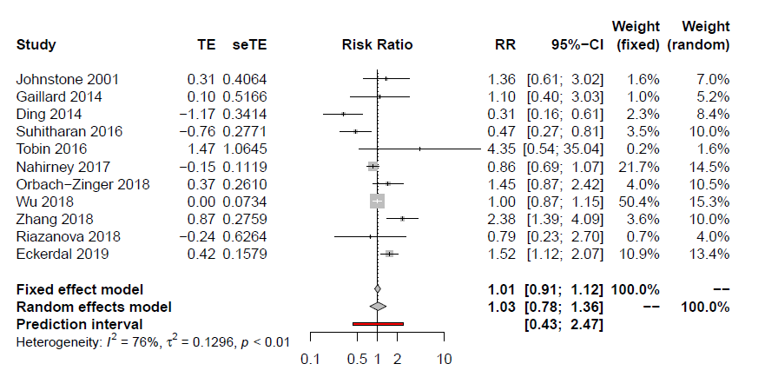

# **Supplementary References**

1. Radua J, Ramella-Cravaro V, Ioannidis JPA, et al. What causes psychosis? An umbrella review of risk and protective factors. *World Psychiatry* 2018; **17**(1): 49-66.

2. Raglan O, Kalliala I, Markozannes G, et al. Risk factors for endometrial cancer: An umbrella review of the literature. *Int J Cancer* 2018.

3. Theodoratou E, Tzoulaki I, Zgaga L, Ioannidis JP. Vitamin D and multiple health outcomes: umbrella review of systematic reviews and meta-analyses of observational studies and randomised trials. *BMJ* 2014; **348**: g2035.

4. Shea BJ, Reeves BC, Wells G, et al. AMSTAR 2: a critical appraisal tool for systematic reviews that include randomised or non-randomised studies of healthcare interventions, or both. *Bmj* 2017; **358**: j4008.

5. Solmi M, Correll CU, Carvalho AF, Ioannidis JPA. The role of meta-analyses and umbrella reviews in assessing the harms of psychotropic medications: beyond qualitative synthesis. *Epidemiol Psychiatr Sci* 2018; **27**(6): 537-42.

6. Iorio A, Spencer FA, Falavigna M, et al. Use of GRADE for assessment of evidence about prognosis: rating confidence in estimates of event rates in broad categories of patients. *Bmj* 2015; **350**: h870.

7. Howard LM, Molyneaux E, Dennis CL, Rochat T, Stein A, Milgrom J. Non-psychotic mental disorders in the perinatal period. *Lancet* 2014; **384**(9956): 1775-88.

8. Myers ER, Aubuchon-Endsley N, Bastian LA, et al. AHRQ Comparative Effectiveness Reviews. Efficacy and Safety of Screening for Postpartum Depression. Rockville (MD): Agency for Healthcare Research and Quality (US); 2013.

9. Mauri M, Oppo A, Montagnani MS, et al. Beyond "postpartum depressions": specific anxiety diagnoses during pregnancy predict different outcomes: results from PND-ReScU. *Journal of affective disorders* 2010; **127**(1-3): 177-84.

10. Sword W, Busser D, Ganann R, McMillan T, Swinton M. Women's care-seeking experiences after referral for postpartum depression. *Qualitative health research* 2008; **18**(9): 1161-73.

11. O'Connor E, Rossom RC, Henninger M, Groom HC, Burda BU. Primary Care Screening for and Treatment of Depression in Pregnant and Postpartum Women: Evidence Report and Systematic Review for the US Preventive Services Task Force. *Jama* 2016; **315**(4): 388-406.

12. Yamashita H, Yoshida K, Nakano H, Tashiro N. Postnatal depression in Japanese women. Detecting the early onset of postnatal depression by closely monitoring the postpartum mood. *Journal of affective disorders* 2000; **58**(2): 145-54.