**SUPPLEMENT**

**Supplemental Table 1.** Categorisation of diagnoses

|  |  |  |
| --- | --- | --- |
| **Label of diagnostic group** | **More detailed description of diagnostic group** | **ICD-10 code** |
| Any psychiatric or neurodevelopmental disorder | Intellectual disability excluded, cerebral palsy and impairments of vision or hearing not included | F10-F69 and F80-F99 |
| Substance abuse |  | F10-F19 |
| Psychosis | Non-afffective psychotic disorders | F20-F29 |
| Schizophrenia |  | F20 |
| Schizoaffective disorder |  | F25, F20 excluded |
| Other psychosis | Schizotypal disorder, delusional disorders, acute, transient, unspecified and other non-organic psychoses | F21-F24 and F28-F29, F20 and F25 excluded |
| Bipolar disorder | Bipolar disorder and mania | F30-F31 |
| Depressive disorders | Unipolar and unspecified affective disorders | F32-F39 |
| Anxiety disorders | Neurotic, stress-related and somatoform disorders | F40-F48 |
| Eating disorders |  | F50 |
| Personality disorders |  | F60-F61 |
| Learning disabilities | Speech, scholastic and coordination disorders | F80-F83 |
| Autism spectrum disorders |  | F84 |
| Infantile autism | Infantile autism and atypical autism | F84.0-F84.1 |
| Asperger's syndrome |  | F84.5, F84.0-F84.1 excluded |
| Other autism sprectrum disorder | Other or unspecified pervasive developmental disorder | F84.8-F84.9, F84.0-F84.5 excluded |
| ADHD | Attention-deficit/ hyperactivity disorders | F90 |
| Conduct disorder | Includes oppositional defiant disorder | F91, F90.1 |

**Supplemental Figure 1.** Proportion of cohort members being outside of education, employment, and training for different amount of years (panel A) and during different calendar years (panel B).

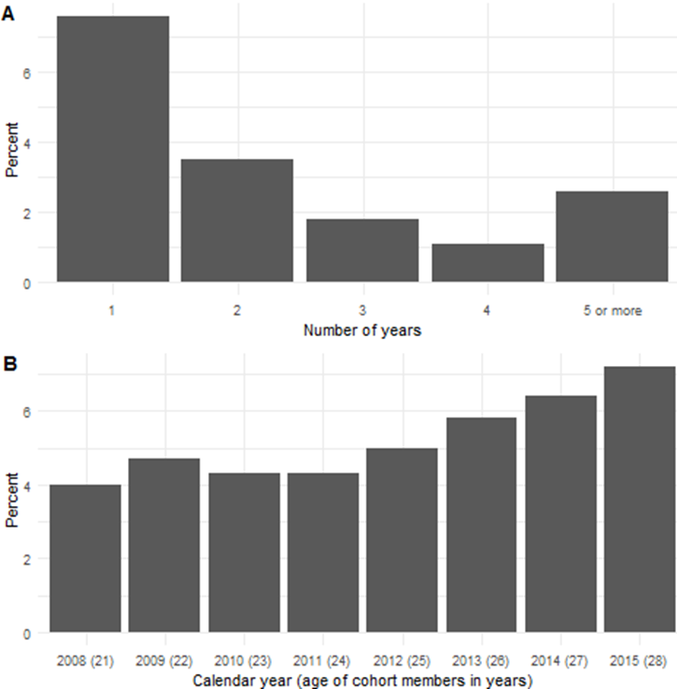

|  |  |  |  |  |  |
| --- | --- | --- | --- | --- | --- |
| **Supplemental Table 2.** Results of the univariate analyses of long-term NEET in subjects diagnosed with psychiatric or neurodevelopmental diagnoses in adolescence and multivariate analyses with sociodemographic characteristics (P<0.001) | | | | | |
|  | Univariate analysis |  | Multivariate analysis with parental factors¹ |  | Multivariate analysis with parental factors and upper secondary education² |
| Diagnostic group | OR (95 % CI) |  | OR (95 % CI) |  | OR (95 % CI) |
| Any psychiatric or neurodevelopmental disorder | 7.1 (6.4-7.9) |  | 6.7 (6.0-7.5) |  | 4.2 (3.8-4.8) |
| Substance abuse | 7.1 (5.8-8.6) |  | 5.6 (4.5-6.9) |  | 3.0 (2.4-3.7) |
| Psychosis | 23.9 (19.4-29.5) |  | 22.4 (18.0-27.9) |  | 12.0 (9.5-15.2) |
| Bipolar disorder | 8.87 (5.6-13.3) |  | 8.9 (5.6-13.6) |  | 4.5 (2.8-7.1) |
| Depressive disorders | 6.3 (5.5-7.2) |  | 6.4 (5.5-7.4) |  | 3.7 (3.2-4.3) |
| Anxiety disorders | 5.8 (5.0-6.7) |  | 5.7 (4.9-6.6) |  | 3.6 (3.1-4.3) |
| Eating disorders | 2.8 (1.9-3.9) |  | 3.9 (2.7-5.4) |  | 3.4 (2.3-4.8) |
| Personality disorders | 16.2 (12.2-21.3) |  | 14.8 (11.0-19.7) |  | 7.1 (5.2-9.6) |
| Learning disabilites | 5.6 (4.5-7.0) |  | 4.6 (3.7-5.7) |  | 3.1 (2.4-3.9) |
| Autism spectrum disorder | 30.5 (21.3-43.6) |  | 27.2 (18.7-39.3) |  | 17.3 (11.5-26.0) |
| ADHD | 8.0 (5.5-11.4) |  | 5.6 (3.8-8.1) |  | 3.1 (2.1-4.6) |
| Conduct disorder | 7.5 (6.1-9.2) |  | 5.3 (4.2-6.5) |  | 2.5 (2.0-3.1) |
| Abbreviations: NEET, not in education, employment or training; ADHD, attention-deficit/ hyperactivity disorder; OR, odds ratio; CI, confidence interval | | | | | |
| ¹ Covariates: parental education, parent received welfare support, parent with severe mental illness, gender. | | | | | |
| ² Covariates: not having a degree from secondary education, parental education, parent received welfare support, parent with severe mental illness, gender. | | | | | |

|  |  |  |  |  |  |
| --- | --- | --- | --- | --- | --- |
| **Supplemental Table 3.** Additional analyses of clinical factors in relation to long-term NEET status (P<0.001). | | | | | |
|  | Total |  | Long-term NEET |  | Univariate association |
| Clinical factor | n |  | n (%) |  | OR (95% CI) |
| Specific diagnosis of psychosis |  |  |  |  |  |
| Schizophrenia | 100 |  | 62 (62.0) |  | 63.8 (42.7-96.6) |
| Schizoaffective disorder | 19 |  | 9 (47.4) |  | 33.9 (13.4-84.2) |
| Other psychosis | 286 |  | 77 (26.9) |  | 14.5 (11.1-18.9) |
| Specific diagnosis of autism spectrum disorder | |  |  |  |  |
| Infantile autism | 13 |  | 9 (69.2) |  | 84.8 (27.6-313.1) |
| Aspergers syndrome | 76 |  | 33 (43.4) |  | 29.4 (18.5-46.2) |
| Other autism spectrum disorder | 36 |  | 13 (36.1) |  | 21.3 (10.5-41.6) |
| Hospitalisation |  |  |  |  |  |
| During the years 1987-1997 | 650 |  | 101 (15.5) |  | 7.3 (5.9-9.1) |
| During the years 1998-2007 | 1941 |  | 369 (19.0) |  | 11.5 (10.1-13.0) |
| Abbreviations: NEET, not in education, employment or training; OR, odds ratio; CI, confidence interval | | | | | |

**Supplemental Figure 2.** Psychiatric or neurodevelopmental diagnoses in adolescence and in relation to at least one, at least three or at least five years of NEET-status in young adulthood. All associations are statistically significant at p<0.001.



**Supplemental Figure 3.** Psychiatric or neurodevelopmental diagnoses in adolescence and in relation to long-term NEET-status in young adulthood for the full sample, and for samples without psychosis or ASD or without substance abuse. All associations are statistically significant at p<0.001