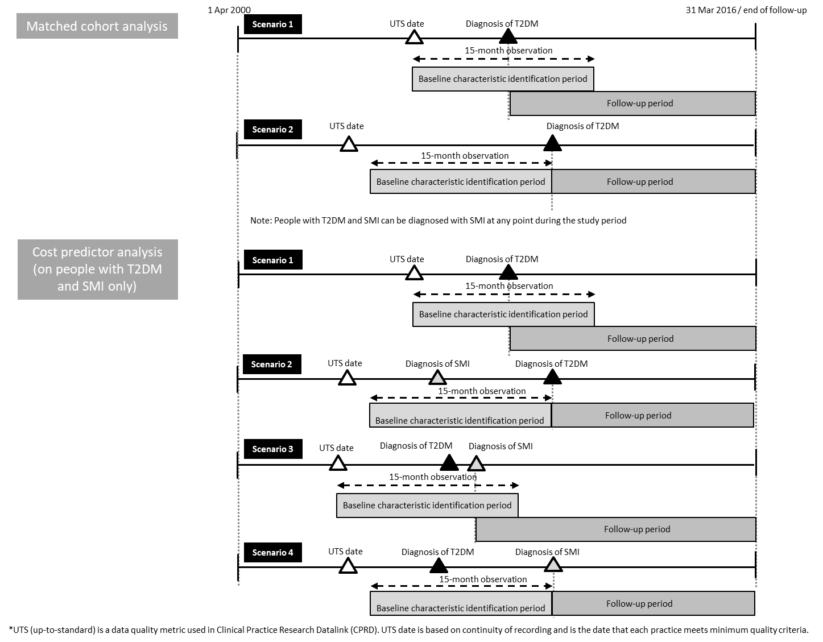

Appendix 1: Demonstration of start and end dates of follow-up period

Appendix 2: Overview of source of utilisation data and unit cost
Types of utilisation | Source of utilisation data | Source of unit cost
Primary care
GP consultation | CPRD | PSSRU 2018
Practice nurse consultation | CPRD | PSSRU 2018
Drug prescriptions | CPRD – BNF codes | PCA 2018
Diagnostic tests | CPRD – Read terms | Reference Costs 2017/18
Secondary care
Inpatient stay in general hospital | HES | Reference Costs 2017/18

Appendix 3: Types, HRG codes and unit costs of diagnostic test
Test | Reference Cost 2017/18  Code | Reference Cost 2017/18  Unit Cost
Full blood examination (FBE) | DAPS05 | £2.5058
Urea, electrolytes & creatinine (UEC) | DAPS04 | £1.1091
Liver function test (LFT) | DAPS05 | £2.5058
Haematology | DAPS05 | £2.5058
Clinical biochemistry | DAPS04 | £1.1091
Lipids_cholesterol | DAPS04 | £1.1091
Glucose | DAPS04 | £1.1091
Thyroid function test (TFT) | DAPS04 | £1.1091
Microbiology | DAPS07 | £7.5854
Cytology | DAPS01 | £12.0208
Immunology | DAPS06 | £6.3659
Histopathology, histology | DAPS02 | £32.7516
Phlebotomy | DAPS08 | £2.8322
Plain Xray | DAPF | £31.4858
Electrocardiogram (ECG) | EC22Z | £57.8413
Carbon monoxide transfer test | DZ56Z | £133.8350
Echo | RD51A | £65.1778
Ultrasound | RD40Z | £49.1028
CT scan | RD20A | £79.3178
Magnetic resonance imaging (MRI) | RD01A | £131.1462
Gastroscopy | FE21Z | £299.4195
Colonoscopy | FE32Z | £328.0856
Sigmoidoscopy | FE35Z | £182.4452
Arteriography | YR25Z | £85.2600
Dual energy X-ray absorptiometry (DEXA) | RD50Z | £77.4755
Contrast fluoroscopy | RD30Z | £118.2329
Airflow studies | DZ59Z | £68.0000

Appendix 4: Types of non-mental health related admissions (n=21,552 spells)
Type | Number of spells (%)
Digestive system | 3,684 (17.1%)
Urinary tract and male reproductive system | 3,231 (15.0%)
Cardiac surgery and primary cardiac conditions | 2,266 (10.5%)
Musculoskeletal system | 1,977 (9.2%)
Haematology, chemotherapy, radiotherapy and specialist palliative care | 1,675 (7.8%)
Immunology, infectious diseases and other contacts with health services | 1,421 (6.6%)
Respiratory system | 1,411 (6.6%)
Eyes and periorbita | 1,296 (6.0%)
Nervous system | 1,116 (5.2%)
Skin, breast and burns | 796 (3.7%)
Mouth head neck and ears | 577 (2.7%)
Vascular procedures and disorders and imaging interventions | 575 (2.7%)
Endocrine and metabolic system | 538 (2.5%)
Hepatobiliary and pancreatic system | 519 (2.4%)
Female reproductive system and assisted reproduction | 379 (1.8%)
Multiple trauma, emergency medicine and rehabilitation | 61 (0.3%)
Obstetrics | 30 (0.1%)

Appendix 5: Average resource use per person per year for people with SMI and T2DM (cases) and matched people with T2DM alone (controls) after removing extreme values
 | Unadjusted |  |  |  | Adjusted^{(d)} |  |  |  | P value^{(e)}
 | Total | Cases  (T2DM+SMI) | Controls  (T2DM only) |  | Total | Cases  (T2DM+SMI) | Controls  (T2DM only)
Resource use, mean (SD)
Primary care contacts^{(a)} | 15.7 (8.8) | 19.1 (9.8) | 14.5 (8.0) |  | 16.2 (5.7) | 19.9 (6.7) | 14.9 (4.8) |  | <.001***
Consultation only | 9.1 (5.6) | 11.5 (6.3) | 8.4 (5.0) |  | 9.4 (3.3) | 11.9 (3.8) | 8.5 (2.6) |  | <.001***
Medicine prescription related | 5.5 (3.9) | 6.3 (4.4) | 5.2 (3.7) |  | 5.7 (2.3) | 6.6 (2.6) | 5.3 (2.0) |  | 0.416
Test related | 1.2 (1.0) | 1.2 (1.0) | 1.1 (1.0) |  | 1.2 (0.4) | 1.4 (0.4) | 1.2 (0.4) |  | 0.836
Inpatient stays
Annual no. of admissions^{(b)} | 0.5 (0.7) | 0.6 (0.8) | 0.5 (0.7) |  | 0.8 (0.5) | 0.9 (0.6) | 0.7 (0.5) |  | 0.017*
Mental health related^{(c)} | 0.0 (0.1) | 0.1 (0.1) | 0.0 (0.0) |  | 0.3 (0.2) | 0.4 (0.3) | 0.2 (0.2) |  | 0.028*
Non-mental health related | 0.5 (0.7) | 0.6 (0.8) | 0.5 (0.7) |  | 0.8 (0.5) | 0.9 (0.5) | 0.7 (0.5) |  | 0.047*
Annual no. of inpatient days | 3.4 (8.0( | 6.4 (11.5) | 2.4 (6.1) |  | 5.7 (8.6) | 12.3 (13.8) | 3.5 (3.9) |  | <.001***
Mental health related | 0.3 (1.7) | 1.0 (3.2) | 0.0 (0.7) |  | 4.2 (4.0) | 7.7 (5.7) | 3.0 (2.3) |  | <.001***
Non-mental health related | 2.8 (6.3) | 4.4 (8.3) | 2.2 (5.4) |  | 4.6 (6.2) | 8.4 (9.6) | 3.3 (3.7) |  | <.001***
Cost, mean (SD)
Total | £2,184 (3,066) | £3,077 (3,731) | £1,884 (2,743) |  | £2,314 (1,942) | £3,508 (2,629) | £1,913 (1,441) |  | <.001***
Primary care contacts | £580 (455) | £725 (519) | £531 (420) |  | £599 (272) | £767 (325) | £543 (225) |  | <.001***
Inpatient stays | £1,571 (2,825) | £2,273 (3,485) | £1,335 (2,522) |  | £1,752 (2063) | £2,832 (2994) | £1,388 (1467) |  | <.001***
Mental health related | £62 (458) | £207 (805) | £15 (239) |  | £193 (955) | £771 (1,312) | £28 (169) |  | <.001***
Non-mental health related | £1,446 (2,603) | £1,853 (2,954) | £1,309 (2,459) |  | £1,589 (1,747) | £2,264 (2,352) | £1,362 (1,418) |  | <.001***
^{(a)} Including all the consultation records from medical staff with associated Read codes
^{(b)} Number of admissions is at the spell level. Hence, if a person transfers to another hospital, it will count as 2 admissions.
^{(c)} Episodes contain mental health related HRG codes.
^{(d)} Adjusted for age at diagnosis of T2DM, sex, ethnic group, time since diagnosis of T2DM, and characteristics at diagnosis of T2DM, including area deprivation, comorbid hypertension, comorbid CVD, number of Charlson comorbidities, medications (antidepressant and antidiabetes drugs) and financial year.
^{(e)} For difference between adjusted cases and controls.
*** p<0.001, ** p<0.01, * p<0.05

Appendix6: GLMs of healthcare resource use and costs
 | Primary care contacts (n=6383) |  | Number of admissions (n=6383) |  | Inpatient days (n=6383)
 | coefficient | 95% CI |  | coefficient | 95% CI |  | coefficient | 95% CI
Intercept | 2.93*** | [2.45, 3.40] |  | -0.02 | [-0.48, 0.45] |  | 1.33 | [-1.30, 3.95]
Group
Exposed | 0.15*** | [0.11, 0.20] |  | 0.31*** | [0.12, 0.50] |  | 1.66*** | [1.42, 1.91]
Unexposed | Reference |  |  | Reference |  |  | Reference
Age at diagnosis of having both T2DM and SMI | 0.00 | [-0.00, 0.00] |  | 0.01*** | [0.01, 0.01] |  | 0.02*** | [0.01, 0.03]
Sex
Male | Reference |  |  | Reference |  |  | Reference
Female | 0.14*** | [0.11, 0.17] |  | -0.04** | [-0.07, -0.01] |  | 0.01 | [-0.15, 0.17]
Ethnic group
White | Reference |  |  | Reference |  |  | Reference
Non-white (Asian, black, other, mixed) | -0.04 | [-0.08, 0.01] |  | 0.36*** | [0.32, 0.40] |  | 0.16 | [-0.10, 0.42]
Unknown | -0.33*** | [-0.39, -0.27] |  | -2.24*** | [-2.43, -2.06] |  | -2.68*** | [-3.03, -2.33]
Deprivation
1st quintile (least deprived) | Reference |  |  | Reference |  |  | Reference
2nd quintile | -0.27 | [-0.74, 0.19] |  | -0.04 | [-0.49, 0.41] |  | 0.46 | [-2.08, 3.00]
3rd quintile | -0.23 | [-0.69, 0.23] |  | 0.14 | [-0.32, 0.59] |  | 0.58 | [-1.96, 3.11]
4th quintile | -0.17 | [-0.63, 0.29] |  | 0.06 | [-0.39, 0.51] |  | 0.55 | [-1.99, 3.09]
5th quintile (most deprived) | -0.17 | [-0.63, 0.29] |  | -0.01 | [-0.46, 0.44] |  | 0.69 | [-1.85, 3.22]
Unknown | -0.17 | [-0.63, 0.29] |  | 0.12 | [-0.33, 0.57] |  | 0.54 | [-2.00, 3.08]
Comorbidities
Cardiovascular disease | 0.01 | [-0.03, 0.04] |  | 0.03* | [0.00, 0.06] |  | 0.08 | [-0.12, 0.27]
Hypertension | 0.08*** | [0.05, 0.12] |  | 0.19*** | [0.16, 0.22] |  | 0.08 | [-0.11, 0.27]
Number of Charlson comorbidities | 0.14*** | [0.12, 0.16] |  | 0.25*** | [0.23, 0.27] |  | 0.37*** | [0.26, 0.49]
Medication
Antidepressants | 0.23*** | [0.19, 0.26] |  | 0.16*** | [0.13, 0.19] |  | 0.16 | [-0.03, 0.35]
Antipsychotics
First generation | 0.19*** | [0.12, 0.25] |  | -0.07* | [-0.12, -0.02] |  | 0.12 | [-0.24, 0.48]
Second generation | 0.07* | [0.01, 0.12] |  | 0.04 | [-0.31, 0.17] |  | -0.25 | [-0.56, 0.06]
Antidiabetes | 0.09*** | [0.05, 0.13] |  | 0.18*** | [0.15, 0.22] |  | 0.14 | [-0.10, 0.38]
Time since diagnosis of T2DM (years) | 0.15*** | [0.15, 0.16] |  | 0.07*** | [0.07, 0.08] |  | -0.03 | [-0.06, 0.01]
Family | Negative binomial |  |  | Poisson |  |  | Gamma
Link | Log |  |  | Log |  |  | Log
Note: the financial year at T2DM diagnosis was adjusted in all the analyses
*** p<0.001, ** p<0.01, * p<0.05

Appendix 6 (continue)
 | Total costs (n=6383) |  | Primary care costs (n=6383) |  | Secondary care costs (n=6383)
 | coefficient | 95% CI |  | coefficient | 95% CI |  | coefficient | 95% CI
Intercept | 8.05*** | [6.65, 9.44] |  | 6.56*** | [5.89, 7.23] |  | 7.62*** | [5.50, 9.73]
Group
Exposed | 0.61*** | [0.48, 0.73] |  | 0.14*** | [0.08, 0.20] |  | 0.79*** | [0.60, 0.98]
Unexposed | Reference |  |  | Reference |  |  | Reference
Age at diagnosis of having both T2DM and SMI | 0.01*** | [0.01, 0.02] |  | -0.00 | [-0.00, 0.00] |  | 0.02*** | [0.01, 0.03]
Sex
Male | Reference |  |  | Reference |  |  | Reference
Female | 0.04 | [-0.04, 0.13] |  | 0.18*** | [0.14, 0.22] |  | 0.03 | [-0.10, 0.16]
Ethnic group
White | Reference |  |  | Reference |  |  | Reference
Non-white (Asian, black, other, mixed) | 0.16* | [0.02, 0.29] |  | 0.07* | [0.00, 0.13] |  | 0.18 | [-0.03, 0.39]
Unknown | -1.35*** | [-1.52, -1.17] |  | -0.43*** | [-0.51, -0.34] |  | -2.53*** | [-2.81, -2.26]
Deprivation
1st quintile (least deprived) | Reference |  |  | Reference |  |  | Reference
2nd quintile | -0.24 | [-1.60, 1.11] |  | -0.48 | [-1.12, 0.17] |  | -0.03 | [-2.08, 2.02]
3rd quintile | -0.07 | [-1.42, 1.28] |  | -0.37 | [-1.02, 0.27] |  | 0.11 | [-1.94, 2.16]
4th quintile | -0.10 | [-1.46, 1.25] |  | -0.32 | [-0.96, 0.33] |  | 0.08 | [-1.97, 2.13]
5th quintile (most deprived) | -0.09 | [-1.44, 1.27] |  | -0.34 | [-0.99, 0.30] |  | 0.07 | [-1.97, 2.12]
Unknown | -0.11 | [-1.47, 1.24] |  | -0.33 | [-0.98, 0.31] |  | 0.03 | [-2.02, 2.08]
Comorbidities
Cardiovascular disease | 0.05 | [-0.05, 0.15] |  | 0.02 | [-0.02, 0.07] |  | 0.06 | [-0.09, 0.21]
Hypertension | 0.11* | [0.02, 0.21] |  | 0.12*** | [0.08, 0.17] |  | 0.12 | [-0.03, 0.26]
Number of Charlson comorbidities | 0.29*** | [0.23, 0.35] |  | 0.21*** | [0.18, 0.24] |  | 0.33*** | [0.24, 0.43]
Medication
Antidepressants | 0.26*** | [0.16, 0.36] |  | 0.41*** | [0.36, 0.45] |  | 0.20** | [0.05, 0.36]
Antipsychotics
First generation | 0.12 | [-0.07, 0.31] |  | 0.30*** | [0.21, 0.40] |  | 0.06 | [-0.23, 0.35]
Second generation | -0.06 | [-0.22, 0.11] |  | 0.13** | [0.05, 0.20] |  | -0.11 | [-0.36, 0.13]
Antidiabetes | 0.14* | [0.02, 0.27] |  | 0.13*** | [0.08, 0.20] |  | 0.14 | [-0.06, 0.33]
Time since diagnosis of T2DM (years) | 0.06*** | [0.04, 0.08] |  | 0.16*** | [0.15, 0.17] |  | 0.02* | [0.00, 0.04]
Family | Gamma |  |  | Gamma |  |  | Gamma
Link | Log |  |  | Log |  |  | Log
Note: the financial year at T2DM diagnosis was adjusted in all the analyses
*** p<0.001, ** p<0.01, * p<0.05

