Supplementary Material
Contents
Appendix S1 – PRISMA 2009 Checklist 2
Appendix S2 – Database search terms 5
Appendix S3 – Data Extraction Form 6
Appendix S4 – Comparison of hierarchy of evidence criteria 15
Appendix S5 – Comparison of Systematic Review Inclusion Criteria 17
Appendix S6 – List of records assessed to identify unique patient-level models 19
Appendix S7 – Simplified Model Structures 23
Appendix S8 – Additional Model Detail 25
Appendix S9 – Quality Checklists 29

Appendix S1 – PRISMA 2009 Checklist

Section/topic |  | # |  | Checklist item |  | Reported on page #
TITLE
Title |  | 1 |  | Identify the report as a systematic review, meta-analysis, or both. |  | p.1
ABSTRACT
Structured summary |  | 2 |  | Provide a structured summary including, as applicable: background; objectives; data sources; study eligibility criteria, participants, and interventions; study appraisal and synthesis methods; results; limitations; conclusions and implications of key findings; systematic review registration number. |  | p.2
INTRODUCTION
Rationale |  | 3 |  | Describe the rationale for the review in the context of what is already known. |  | p.3
Objectives |  | 4 |  | Provide an explicit statement of questions being addressed with reference to participants, interventions, comparisons, outcomes, and study design (PICOS). |  | p.3-4
METHODS
Protocol and registration |  | 5 |  | Indicate if a review protocol exists, if and where it can be accessed (e.g., Web address), and, if available, provide registration information including registration number. |  | p.4
Eligibility criteria |  | 6 |  | Specify study characteristics (e.g., PICOS, length of follow-up) and report characteristics (e.g., years considered, language, publication status) used as criteria for eligibility, giving rationale. |  | p.4
Information sources |  | 7 |  | Describe all information sources (e.g., databases with dates of coverage, contact with study authors to identify additional studies) in the search and date last searched. |  | p.4
Search |  | 8 |  | Present full electronic search strategy for at least one database, including any limits used, such that it could be repeated. |  | Supplementary Appendix S2
Study selection |  | 9 |  | State the process for selecting studies (i.e., screening, eligibility, included in systematic review, and, if applicable, included in the meta-analysis). |  | p.4
Data collection process |  | 10 |  | Describe method of data extraction from reports (e.g., piloted forms, independently, in duplicate) and any processes for obtaining and confirming data from investigators. |  | p.4-5 & Supplementary Appendix S3
Data items |  | 11 |  | List and define all variables for which data were sought (e.g., PICOS, funding sources) and any assumptions and simplifications made. |  | p.5 & Supplementary Appendix S3
Risk of bias in individual studies |  | 12 |  | Describe methods used for assessing risk of bias of individual studies (including specification of whether this was done at the study or outcome level), and how this information is to be used in any data synthesis. |  | Models were not assessed for risk of bias
Summary measures |  | 13 |  | State the principal summary measures (e.g., risk ratio, difference in means). |  | Narrative synthesis with descriptive statistics
Synthesis of results |  | 14 |  | Describe the methods of handling data and combining results of studies, if done, including measures of consistency (e.g., I²) for each meta-analysis. |  | No quantitative synthesis undertaken
Section/topic | # |  | Checklist item |  | Reported on page #
Risk of bias across studies | 15 |  | Specify any assessment of risk of bias that may affect the cumulative evidence (e.g., publication bias, selective reporting within studies). |  | Not applicable to assessment of model structures
Additional analyses | 16 |  | Describe methods of additional analyses (e.g., sensitivity or subgroup analyses, meta-regression), if done, indicating which were pre-specified. |  | Pre-specified evidence hierarchy & quality/validation checklists.  p.4-5 & Supplementary appendix S4
RESULTS
Study selection | 17 |  | Give numbers of studies screened, assessed for eligibility, and included in the review, with reasons for exclusions at each stage, ideally with a flow diagram. |  | p.5, Figure 1, & Supplementary appendix S5
Study characteristics | 18 |  | For each study, present characteristics for which data were extracted (e.g., study size, PICOS, follow-up period) and provide the citations. |  | Supplementary appendix S3
Risk of bias within studies | 19 |  | Present data on risk of bias of each study and, if available, any outcome level assessment (see item 12). |  | NA
Results of individual studies | 20 |  | For all outcomes considered (benefits or harms), present, for each study: (a) simple summary data for each intervention group (b) effect estimates and confidence intervals, ideally with a forest plot. |  | NA
Synthesis of results | 21 |  | Present results of each meta-analysis done, including confidence intervals and measures of consistency. |  | Narrative Synthesis of models (p.5-8) & Tables 1 & 2
Risk of bias across studies | 22 |  | Present results of any assessment of risk of bias across studies (see Item 15). |  | See quality assessment (p.7-8) & Figures 2 & 3
Additional analysis | 23 |  | Give results of additional analyses, if done (e.g., sensitivity or subgroup analyses, meta-regression [see Item 16]). |  | Supplementary appendices S6, S7, S8
DISCUSSION
Summary of evidence | 24 |  | Summarize the main findings including the strength of evidence for each main outcome; consider their relevance to key groups (e.g., healthcare providers, users, and policy makers). |  | p. 9-10
Limitations | 25 |  | Discuss limitations at study and outcome level (e.g., risk of bias), and at review-level (e.g., incomplete retrieval of identified research, reporting bias). |  | p.10
Conclusions | 26 |  | Provide a general interpretation of the results in the context of other evidence, and implications for future research. |  | p.10
FUNDING
Funding | 27 |  | Describe sources of funding for the systematic review and other support (e.g., supply of data); role of funders for the systematic review. |  | p.1
From: Moher D, Liberati A, Tetzlaff J, Altman DG, The PRISMA Group (2009). Preferred Reporting Items for Systematic Reviews and Meta-Analyses: The PRISMA Statement. PLoS Med 6(7): e1000097. doi:10.1371/journal.pmed1000097
For more information, visit: www.prisma-statement.org.

Appendix S2 – Database search terms

Database | Disease Search terms (database specific)
Medline | - exp Schizophrenia, Paranoid/ or exp Schizophrenia, Disorganized/ or exp Schizophrenia/ or exp Schizophrenia, Childhood/ or exp Schizophrenia, Catatonic/ or schizophrenia.mp  - bipolar disorder.mp. or exp Bipolar Disorder/  - exp Depressive Disorder, Major/ or exp Stress Disorders, Post-Traumatic/ or exp Depressive Disorder/ or exp Depression/ or severe depression.mp.  - psychosis.mp. or exp Psychotic Disorders/  - 1 or 2 or 3 or 4
Embase | - exp catatonic schizophrenia/ or exp schizophrenia/ or exp latent schizophrenia/ or exp schizophrenia assessment/ or exp residual schizophrenia/ or exp schizophrenia spectrum disorder/ or exp paranoid schizophrenia/ or exp simple schizophrenia/ or exp treatment-resistant schizophrenia/ or schizophrenia.mp.  - exp bipolar disorder/ or bipolar disorder.mp.  - exp intensive care psychosis/ or exp depressive psychosis/ or exp schizoaffective psychosis/ or exp psychosis/ or exp acute psychosis/ or exp puerperal psychosis/ or exp manic psychosis/ or exp cocaine-induced psychosis/ or exp affective psychosis/ or exp endogenous psychosis/ or exp Korsakoff psychosis/ or exp paranoid psychosis/ or exp methamphetamine-induced psychosis/ or exp drug induced psychosis/ or exp alcohol psychosis/ or exp experimental psychosis/ or exp cannabis-induced psychosis/ or psychosis.mp.  - exp major depression/ or exp depression/ or severe depression.mp.  - 6 or 7 or 8 or 9
PsycINFO | - exp "FRAGMENTATION (SCHIZOPHRENIA)"/ or exp PARANOID SCHIZOPHRENIA/ or exp PROCESS SCHIZOPHRENIA/ or exp CHILDHOOD SCHIZOPHRENIA/ or exp UNDIFFERENTIATED SCHIZOPHRENIA/ or exp SCHIZOPHRENIA/ or exp CATATONIC SCHIZOPHRENIA/ or exp ACUTE SCHIZOPHRENIA/ or exp "SCHIZOPHRENIA (DISORGANIZED TYPE)"/ or schizophrenia.mp.  - exp Bipolar Disorder/ or bipolar disorder.mp.  - exp POSTPARTUM PSYCHOSIS/ or exp SENILE PSYCHOSIS/ or exp CHRONIC PSYCHOSIS/ or exp PSYCHOSIS/ or exp EXPERIMENTAL PSYCHOSIS/ or exp CHILDHOOD PSYCHOSIS/ or exp SYMBIOTIC INFANTILE PSYCHOSIS/ or exp ALCOHOLIC PSYCHOSIS/ or exp AFFECTIVE PSYCHOSIS/ or exp KORSAKOFFS PSYCHOSIS/ or exp ACUTE PSYCHOSIS/ or exp REACTIVE PSYCHOSIS/ or exp "PARANOIA (PSYCHOSIS)"/ or psychosis.mp.  - exp "Depression (Emotion)"/ or exp Major Depression/ or exp "Severity (Disorders)"/ or severe depression.mp.  - 11 or 12 or 13 or 14

Category | Economic Search terms (used across all databases)
Economic modelling | 16. simulation model$.ti,ab.  17. markov.ti,ab.  18. monte carlo.ti,ab.  19. decision tree$.ti,ab.  20. decision analy$.ti,ab.  21. modelling.ti,ab.  22. modeling.ti,ab.  23. decision model.ti,ab.  24. 16 or 17 or 18 or 19 or 20 or 21 or 22 or 23
Health outcomes and costs | 25. qaly$.ti,ab.  26. utility value$.ti,ab.  27. ((disability or quality) adj adjusted).ti,ab.  28. hui$1.ti,ab.  29. qwb.ti,ab.  30. (qald$ or qale$ or qtime$).ti,ab.  31. quality of well being scale.ti,ab.  32. (health adj2 stat$).ti,ab.  33. ((adjusted adj2 life) or qaly$).ti,ab.  34. (daly or qol or hql or hqol or hrqol or hr ql or hrql).tw.  35. cost-utility.ti,ab.  36. cost-effectiveness.ti,ab.  37. cost-benefit.ti,ab.  38. cost-minimisation.ti,ab.  39. cost-minimization.ti,ab.  40. QALY.ti,ab.  41. quality adjusted life year$.ti,ab.  42. cost.ti,ab.  43. life year$.ti,ab.  44. incremental cost-effectiveness ratio.ti,ab.  45. 25 or 26 or 27 or 28 or 29 or 30 or 31 or 32 or 33 or 34 or 35 or 36 or 37 or 38 or 39 or 40 or 41 or 42 or 43 or 44

Database | Combination of economic & disease search terms
Medline | 5 and 24 and 45
Embase | 10 and 24 and 45
PsychINFO | 15 and 24 and 45

Appendix S3 – Data Extraction Form

Reviewer:
Date form completed:
Study Details

Title:
Author:
Year Published:
Journal:
Citation:
Language:
Funding:

Economic evaluation details |  |  |  |  | Location in text (page/figure/  table/other)
Objective/scope of model:
Location (country/city)
Economic study design: | CEA  CUA  CCA  Health outcomes(s) | ☐  ☐  ☐  ☐ | CBA  CMA  Cost(s) only | ☐  ☐  ☐
Perspective of analysis: | Societal  Patient and patient family  Healthcare system  Healthcare provider | ☐  ☐  ☐  ☐ | Individual clinician  Insurer/third party payer  Other: | ☐  ☐  ☐
Primary costs/consequences/outcome measure(s) (please list):
Strategies/comparators:

Setting (describe):
Patient population characteristics (describe):
Clinical definition of disease & progression measures (describe):
Time horizon of analysis:
Was discounting used? | Discount rate for costs:  Discount rate for health outcomes: |  | No discounting  N/A (no information, not relevant) | ☐  ☐

Modelling details |  |  |  |  | Location in text (page/figure  /table/other)
Rationale for model structure: | Yes ☐  No ☐ | If Yes please specify:
Model structure (paste structure):
Description of model transitions
Structural assumptions (describe):
(Include here assumptions regarding the mechanism of action of the treatment effect)
Model type | Cohort-based decision tree (DT)  Cohort-based State Transition model (MM)  Individual patient-level DT  Individual patient-level MM  Discrete event simulation  Agent-based model  System dynamics model  Other: |  |  | ☐  ☐  ☐  ☐  ☐  ☐  ☐
Rationale for model type: | Yes ☐  No ☐ | If Yes please specify:
Cycle length (if relevant):
Well defined disease states/pathways? | Yes ☐  No ☐ | If Yes please specify:
Natural history of psychosis evolution (e.g. description of states, UHR->FEP->Remission->Relapse)
Were pre-psychosis states modelled? (e.g. ultra high risk groups pre-first episode?) | Yes ☐  No ☐ | If Yes please specify:
Was heterogeneity in the patient population modelled to reflect different relapse risks based on patient characteristics? | Yes ☐  No ☐ | If Yes please specify:
Were differing magnitudes of relapse severity modelled? (e.g. relapse not requiring hospitalisation?) | Yes ☐  No ☐ | If Yes please specify how:
Were relapse probabilities differentiated by number of previous relapses? | History of  previous relapse:  Yes ☐  No ☐ | If Yes please specify:
Were adverse events modelled? | Yes ☐  No ☐ | If Yes please specify:
Was treatment adherence explicitly modelled? | Yes ☐  No ☐ | If Yes please specify:
Is recovery allowed following relapse? | Yes ☐  No ☐ | If Yes please specify:
Was the long term health effect of psychosis comorbidities explicitly considered? Are patients modelled “on” and “off” comorbidities? | Yes ☐  No ☐ | If yes, please describe how health effects are attributed between the effects of comorbidities and psychosis. E.g. Are changes in LYs & QoL estimated for patients with and without comorbidities?
How was the treatment effect of the intervention modelled?
Are appropriate methods used to handle parameter uncertainty? Is parameter uncertainty linked back to baseline characteristics?

Data details |  |  |  |  |  |  |  |  | Location in text (page/figure  /table/other)
Are methods for identifying input data reported? (Has input data been identified systematically?) | Yes ☐  No ☐ | If Yes please specify:
Source of baseline clinical data:  Relapse and remission rate(s) | 1 Case series or analysis of reliable administrative databases specifically conducted for the study covering patients solely from the jurisdiction of interest.  2 Recent case series or analysis of reliable administrative databases covering patients solely from the jurisdiction of interest.  3 Recent case series or analysis of reliable administrative databases covering patients solely from another jurisdiction.  4 Old case series or analysis of reliable administrative databases. Estimates from RCTs  5 Estimates from previously published economic analyses: unsourced  6 Expert opinion  Other:  Specify relevant data sources:  More than 1 data source per parameter?  Reasons for excluding data sources?  Evidence synthesis performed?  Calibration? |  |  |  |  |  | ☐  ☐  ☐  ☐  ☐  ☐  ☐
Source of data:  Adverse event rate(s) | 1 Case series or analysis of reliable administrative databases specifically conducted for the study covering patients solely from the jurisdiction of interest  2 Recent case series or analysis of reliable administrative databases covering patients solely from the jurisdiction of interest  3 Recent case series or analysis of reliable administrative databases covering patients solely from another jurisdiction  4 Old case series or analysis of reliable administrative databases. Estimates from RCTs  5 Estimates from previously published economic analyses: unsourced  6 Expert opinion  Other:  Specify relevant data sources:  More than 1 data source per parameter?  Reasons for excluding data sources?  Evidence synthesis performed?  Calibration? |  |  |  |  |  | ☐  ☐  ☐  ☐  ☐  ☐  ☐
Source of data for Primary treatment effect measure(s): | 1+ Meta-analysis of RCTs with direct comparison between comparator therapies, measuring final outcomes.  1 Single RCT with direct comparison between comparator therapies, measuring final outcomes  2+ Meta-analysis of RCTs with direct comparison between comparator therapies, measuring surrogate outcomes  Meta-analysis of placebo-controlled RCTs with similar trial populations, measuring final outcomes for each individual therapy  2 Single RCT with direct comparison between comparator therapies, measuring surrogate outcomes  Single placebo-controlled RCTs with similar trial populations, measuring final outcomes for each individual therapy  3+ Meta-analysis of placebo-controlled RCTs with similar trial populations, measuring surrogate outcomes  3 Single placebo-controlled RCTs with similar trial populations, measuring surrogate outcomes for each individual therapy  4 Case-control or cohort studies  5 Non-analytic studies, for example, case reports, case series  6 Expert opinion  Other:  Specify relevant data sources:  More than 1 data source per parameter?  Reasons for excluding data sources?  Evidence synthesis performed?  Calibration? |  |  |  |  |  | ☐  ☐  ☐  ☐  ☐  ☐  ☐  ☐  ☐  ☐  ☐  ☐
Source of data for treatment effect extrapolation after end of follow-up?  What data has been used to inform the expected duration and magnitude of primary effect size?  Please also note details of any parametric extrapolation | 1 Analysis of reliable administrative databases specifically conducted for the study covering patients solely from the jurisdiction of interest  2 Recent analysis of reliable administrative databases covering patients solely from the jurisdiction of interest  3 Recent analysis of reliable administrative databases covering patients solely from another jurisdiction  4 Old analysis of reliable administrative databases.  5 Estimates from previously published economic analyses: unsourced  6 Expert opinion  Other:  Specify relevant data sources:  More than 1 data source per parameter?  Reasons for excluding data sources?  Evidence synthesis performed?  Calibration? |  |  |  |  |  | ☐  ☐  ☐  ☐  ☐  ☐
Currency/Price year:
Were QOL estimates derived: | Yes ☐  No ☐
Source of data for quality of life/utilities:  Please note reference for source. If multiple sources used, please specify source for each model state. | 1 Direct utility assessment for the specific study from a sample, e.g. SG, TTO:  a) of the general population  b) with knowledge of the disease(s) of interest  c) of patients with the disease(s) of interest  1 Indirect utility assessment from specific study from a patient sample with disease(s) of interest: using a tool validated for the patient population, e.g. EQ5D, HUI, SF36  2 Indirect utility assessment from specific study from a patient sample with disease(s) of interest using tool not validated for the patient population  3 Direct utility assessment from a previous study from a sample either:  a) of the general population  b) with knowledge of the disease(s) of interest  c) of patients with the disease(s) of interest  3 Indirect utility assessment from previous study from patient sample with disease(s) of interest: using tool validated for the patient population  4 Indirect utility assessment from previous study from patient sample with disease(s) of interest: using tool not validated for the patient population or method of elicitation unknown  5 Patient preference values obtained from a visual analogue scale  6 Delphi panels, expert opinion  Other:  Specify relevant data sources:  More than 1 data source per parameter?  Reasons for excluding data sources?  Evidence synthesis performed?  Calibration? |  |  |  |  |  |  | ☐  ☐  ☐  ☐  ☐  ☐  ☐  ☐  ☐  ☐  ☐  ☐  ☐
If validated tools were used, which instrument(s): | Rosser Index  EQ-5D  15D  SF-12 |  |  |  | ☐  ☐  ☐  ☐ | Health Utilities Index (HUI)  Quality of Well Being (QWB)  SF-36  SF-6 |  | ☐  ☐  ☐  ☐
Converted into utilities? | Yes ☐  No ☐ |  | If Yes report value set:
If direct elicitation was used, which approach(s): | Standard Gamble ☐  VAS ☐  Time trade-off ☐  Person trade-off ☐
Utility values combined with survival to form QALYs? | Yes ☐  No ☐
Were PANSS scores reported? | Yes ☐  No ☐
Was a common data source used for both baseline characteristics and event rates? | Yes ☐  No ☐ | If not, were sources combined appropriately to generate event rates based on common characteristics?
Were all data sources described and reported? | Yes ☐  No ☐ | Further details:
Were data incorporated as point estimate or distribution? | Point estimate ☐  Distribution ☐  Both ☐ |  |  | Which model inputs were incorporated as distributions?  Was the choice of distribution justified?
Model uncertainty | Methodological uncertainty ☐  If yes, describe:  Structural uncertainty ☐  If yes, describe:  Heterogeneity ☐  If yes, list subgroups:  Parameter uncertainty ☐  If yes, list method:
Result(s):
Provide point estimate of modelled cost-effectiveness

Quality summary
Comments, limitations of the study:

Study, natural history and effectiveness data:

Cost, Effects, methodology, uncertainty:
Generalizability:

The design of the data extraction form was informed by the Philips Checklist published in Health Technol Assess 2004;8(36). Questions were tailored through expert knowledge of the clinical area, and experience from previous structured model appraisals conducted within HERC, Oxford.

Appendix S4 – Comparison of hierarchy of evidence criteria

 | Baseline Relapse & Remission rate(s) | Primary treatment effect measure(s) | Treatment effect extrapolation after study follow-up | Side Effect rate(s) | Quality of life/utilities
1 | Case series or analysis of reliable administrative databases specifically conducted for the study covering patients solely from the jurisdiction of interest. | 1+ Meta-analysis of RCTs with direct comparison between comparator therapies, measuring final outcomes. | Analysis of reliable administrative databases specifically conducted for the study covering patients solely from the jurisdiction of interest | Case series or analysis of reliable administrative databases specifically conducted for the study covering patients solely from the jurisdiction of interest. | 1+ Direct utility assessment for the specific study from a sample: (a) of the general population (b) with knowledge of the disease(s) of interest (c) of patients with the disease(s) of interest
 |  | 1 Single RCT with direct comparison between comparator therapies, measuring final outcomes |  |  | 1 Indirect utility assessment from specific study from a patient sample with disease(s) of interest: using a tool validated for the patient population
2 | Recent case series or analysis of reliable administrative databases covering patients solely from the jurisdiction of interest. | 2+ Meta-analysis of RCTs with direct comparison between comparator therapies, measuring surrogate outcomes; or; meta-analysis of placebo-controlled RCTs with similar trial populations, measuring final outcomes for each individual therapy | Recent analysis of reliable administrative databases covering patients solely from the jurisdiction of interest | Recent case series or analysis of reliable administrative databases covering patients solely from the jurisdiction of interest. | Indirect utility assessment from specific study from a patient sample with disease(s) of interest using tool not validated for the patient population
 |  | 2 Single RCT with direct comparison between comparator therapies, measuring surrogate outcomes; or; Single placebo-controlled RCTs with similar trial populations, measuring final outcomes for each individual therapy
3 | Recent case series or analysis of reliable administrative databases covering patients solely from another jurisdiction. | 3+ Meta-analysis of placebo-controlled RCTs with similar trial populations, measuring surrogate outcomes | Recent analysis of reliable administrative databases covering patients solely from another jurisdiction | Recent case series or analysis of reliable administrative databases covering patients solely from another jurisdiction. | 3+ Direct utility assessment from a previous study from a sample either: (a) of the general population (b) with knowledge of the disease(s) of interest (c) of patients with the disease(s) of interest
 |  | 3 Single placebo-controlled RCTs with similar trial populations, measuring surrogate outcomes for each individual therapy |  |  | 3 Indirect utility assessment from previous study from patient sample with disease(s) of interest: using tool validated for the patient population
4 | Old case series or analysis of reliable administrative databases. Estimates from RCTs | Case-control or cohort studies | Old analysis of reliable administrative databases. | Old case series or analysis of reliable administrative databases. Estimates from RCTs | Indirect utility assessment from previous study from patient sample with disease(s) of interest: using tool not validated for the patient population or method of elicitation unknown
5 | Estimates from previously published economic analyses: unsourced | Non-analytic studies, for example, case reports, case series | Estimates from previously published economic analyses: unsourced | Estimates from previously published economic analyses: unsourced | Patient preference values obtained from a visual analogue scale
6 | Expert opinion | Expert opinion | Expert opinion | Expert opinion | Delphi panels, expert opinion

“Recent” evidence is judged to be evidence published after 1st January 2010. Contemporaneity is not judged against model publication date, as this project assesses the ability of existing economic models to inform ‘present-day’ decision making in Psychosis in 2020.
If an evidence source was not reported but required by the model structure, this was judged to be an assumption and therefore ranked as lowest quality evidence (6), rather than “Not Applicable”.

Appendix S5 – Comparison of Systematic Review Inclusion Criteria

First Author (Disease area) | Year | Databases Searched | Time Period | Inclusion Criteria
Mavranezouli (Bipolar) | 2017 | Embase, Medline, PsycInfo, NHS EED & HTA, CENTRAL | January 1990  to December 2015 | The study population comprised people of any age diagnosed with Bipolar Disorder (BD). Interventions and comparators were any pharmacological treatment administered for the management of an acute episode (manic, depressive, mixed or rapid cycling) or as maintenance therapy for BD, whether licensed or unlicensed for this particular indication, including pill placebo and no treatment. The intervention needed to be described. Studies assessing treatments for BD without reference to specific interventions, or studies assessing a mixture of different types of interventions, either as the intervention of interest or as the comparator, were excluded. In addition, studies assessing the costs and consequences of different levels of treatment coverage were also excluded. Only full economic evaluations, assessing both costs and consequences, were considered. These included cost-utility analyses (CUAs), cost-effectiveness analyses (CEAs), cost-benefit analyses (CBAs) or cost consequence analyses (CCAs). Studies that exclusively considered harms of the interventions, without assessing their clinical benefits, i.e. studies that did not assess the direct effect of interventions in treating BD, were not considered in the review. In addition, studies that exclusively measured resource use and/or healthcare cost elements as a proxy to clinical outcomes were also not considered as these were effectively cost analyses. The review considered studies based on decision analytic modelling, as well as economic analyses conducted alongside single primary studies (clinical trials or cohort studies). Cost-of-illness studies, literature reviews and book chapters were excluded. Conference or dissertation abstracts, editorials, letters, commentaries and notes were excluded as they did not provide enough details for their methodological quality to be judged. Papers published from 1990 until the date of the search (18 December 2015) were considered. This date restriction was imposed so that retrieved economic evidence was more applicable to current healthcare settings and costs. Only English-language papers were included.
Kolovos (Depression) | 2017 | PubMed, Embase, PsycInfo | January 2002 to October 2016 | Studies were included when they fulfilled the following criteria: (1) used a health economic model, (2) examined the cost effectiveness of treatments for adults with depression and (3) estimated quality-adjusted life-years (QALYs) or DALYs. Health economic models were defined as a mathematical representation of reality that can be used to estimate the cost effectiveness of health technologies for depression. Depression was defined as a diagnosis of major depressive disorder based on a structured clinical interview or a score on a standardized self-report measure of depressive symptom severity that indicates the presence of clinically relevant depression. We included studies using QALYs or DALYs, which is similar to the inclusion criteria used by Afzali et al. This approach was adopted to increase the homogeneity of the reviewed studies. At the same time, the amelioration of the QoL of patients with depression is one of the main goals of treatment for depression and thus a relevant outcome in the context of this study. No restrictions were applied on treatments evaluated (i.e. pharmacotherapy, psychotherapy, combination treatments, other) or the control groups. Studies on the prevention of depression were excluded. Any ambiguity around whether a study should be included was discussed with another author until consensus was reached
Jin (Schizophrenia) | 2020 | Embase, Medline, PsychInfo, NHS EED & HTA, Cochrane database of systematic reviews | January 2005 to January 2020 | Studies were included if they met all of the following criteria: (i) model-based economic evaluation adopting either a cost-effectiveness analysis (CEA) or cost-utility analysis (CUA) approach; (ii) young people (under 18 years of age) and/or adults (18 years and older) with a non-specific diagnosis of psychosis or with a diagnosis of schizophrenia (including schizoaffective disorder and delusional disorder); (iii) evaluation of antipsychotic medications versus each other, placebo or nothing. The reason why non-specific diagnosis of psychosis was included is because in clinical practice, it may take up many years before symptomatic patients receive a formal diagnosis of schizophrenia. Before a formal diagnosis of schizophrenia can be made, patients with symptoms of schizophrenia often receive a less specific umbrella diagnosis of ‘psychosis’. No restrictions by country, setting or currency were applied. Studies were excluded if they met any of the following criteria: (i) reviews, commentaries, letters, editorials, or abstracts; (ii) published before 2005; and (iii) not reported in English. Although no language restrictions were applied to the search, only papers published in English language were included in the review.

Appendix S6 – List of records assessed to identify unique patient-level models
Review articles
1. Hotopf M, Lewis G, Normand C. Are SSRIs a cost-effective alternative to tricyclics? Br J Psychiatry. 1996;168(4):404-9.
2. Crott R, Gilis P. Economic comparisons of the pharmacotherapy of depression: an overview. Acta Psychiatr Scand. 1998;97(4):241-52.
3. Wilde MI, Benfield P. Fluoxetine. A pharmacoeconomic review of its use in depression. Pharmacoeconomics. 1998;13(5 Pt 1):543-61.
4. Conner TM, Crismon ML, Still DJ. A critical review of selected pharmacoeconomic analyses of antidepressant therapy. Ann Pharmacother. 1999;33(3):364-72.
5. Jones MT, Cockrum PC. A critical review of published economic modelling studies in depression. Pharmacoeconomics. 2000;17(6):555-83.
6. Revicki DA. The new atypical antipsychotics: a review of pharmacoeconomic studies. Expert Opin Pharmacother. 2000;1(2):249-60.
7. Frank L, Revicki DA, Sorensen SV, Shih YC. The economics of selective serotonin reuptake inhibitors in depression: a critical review. CNS Drugs. 2001;15(1):59-83.
8. Knapp M, Ilson S, David A. Depot antipsychotic preparations in schizophrenia: the state of the economic evidence. Int Clin Psychopharmacol. 2002;17(3):135-40.
9. Basu A. Cost-effectiveness analysis of pharmacological treatments in schizophrenia: critical review of results and methodological issues. Schizophr Res. 2004;71(2-3):445-62.
10. Pirraglia PA, Rosen AB, Hermann RC, Olchanski NV, Neumann P. Cost-utility analysis studies of depression management: a systematic review. Am J Psychiatry. 2004;161(12):2155-62.
11. Haycox A. Pharmacoeconomics of long-acting risperidone: results and validity of cost-effectiveness models. Pharmacoeconomics. 2005;23 Suppl 1:3-16.
12. Hansen K, Lancon C, Toumi M. Pharmacoeconomic modelling in schizophrenia. Trap or support for decision makers? Eur J Health Econ. 2006;7(1):19-29.
13. Kaltenthaler E, Brazier J, De Nigris E, Tumur I, Ferriter M, Beverly C, et al. Computerized cognitive behavior theraphy for depression and anxiety update: A systematic review and economic evaluation. Health Technology Assessment. 2006;10(33):1-70.
14. Adi Y, Juarez-Garcia A, Wang D, Jowett S, Frew E, Day E, et al. Oral naltrexone as a treatment for relapse prevention in formerly opioid-dependent drug users: A systematic review and economic evaluation. Health Technology Assessment. 2007;11(6):iii-55.
15. Sadri H, Mittmann N. A qualitative review of recent economic evaluations of escitalopram. Journal of Pharmacy Technology. 2007;23(1):35-40.
16. Soares-Weiser K, Bravo Vergel Y, Beynon S, Dunn G, Barbieri M, Duffy S, et al. A systematic review and economic model of the clinical effectiveness and cost-effectiveness of interventions for preventing relapse in people with bipolar disorder. Health Technol Assess. 2007;11(39):iii-iv, ix-206.
17. Fleeman N, McLeod C, Bagust A, Beale S, Boland A, Dundar Y, et al. The clinical effectiveness and cost-effectiveness of testing for cytochrome P450 polymorphisms in patients with schizophrenia treated with antipsychotics: a systematic review and economic evaluation. Health Technol Assess. 2010;14(3):1-157, iii.
18. Amos A. Assessing the cost of early intervention in psychosis: a systematic review. Aust N Z J Psychiatry. 2012;46(8):719-34.
19. Haji Ali Afzali H, Karnon J, Gray J. A critical review of model-based economic studies of depression: modelling techniques, model structure and data sources. Pharmacoeconomics. 2012;30(6):461-82.
20. Molosankwe I, Patel A, Jose Gagliardino J, Knapp M, McDaid D. Economic aspects of the association between diabetes and depression: a systematic review. J Affect Disord. 2012;142 Suppl:S42-55.
21. Zimovetz EA, Wolowacz SE, Classi PM, Birt J. Methodologies used in cost-effectiveness models for evaluating treatments in major depressive disorder: A systematic review. Cost Effectiveness and Resource Allocation. 2012:1.
22. Achilla E, McCrone P. The cost effectiveness of long-acting/extended-release antipsychotics for the treatment of schizophrenia: a systematic review of economic evaluations. Appl Health Econ Health Policy. 2013;11(2):95-106.
23. Edwards SJ, Hamilton V, Nherera L, Trevor N. Lithium or an atypical antipsychotic drug in the management of treatment-resistant depression: a systematic review and economic evaluation. Health Technol Assess. 2013;17(54):1-190.
24. Abdul Pari AA, Simon J, Wolstenholme J, Geddes JR, Goodwin GM. Economic evaluations in bipolar disorder: a systematic review and critical appraisal. Bipolar Disord. 2014;16(6):557-82.
25. von Scheele B, Mauskopf J, Brodtkorb TH, Ainsworth C, Berardo CG, Patel A. Relationship between modeling technique and reported outcomes: case studies in models for the treatment of schizophrenia. Expert rev. 2014;14(2):235-57.
26. Hiroi S, Yamabe K, Inoue S, Kobayashi M. Study on cost-effectiveness analysis for treatment of major depression disease: A systematic review of literature from 2004-2014. Value in Health. 2015;18 (7):A410.
27. Greene M, Clark OA, Piedade A, Lemmer T, Hartry A. A systematic review of health economic studies on bipolar disorder type I in the United States. Value in Health. 2017;20 (5):A298.
28. Kolovos S, Bosmans JE, Riper H, Chevreul K, Coupe VMH, Van Tulder MW. Model-based economic evaluation of treatments for depression: A systematic literature review. PharmacoEconomics. 2017;1(3):149-65.
29. Mavranezouli I, Lokkerbol J. A Systematic Review and Critical Appraisal of Economic Evaluations of Pharmacological Interventions for People with Bipolar Disorder. Pharmacoeconomics. 2017;35(3):271-96.
30. Peterson K, Dieperink E, Anderson J, Boundy E, Ferguson L, Helfand M. Rapid evidence review of the comparative effectiveness, harms, and cost-effectiveness of pharmacogenomics-guided antidepressant treatment versus usual care for major depressive disorder. Psychopharmacology (Berl). 2017;234(11):1649-61.
31. Aceituno D, Vera N, Prina M, McCrone P. Early intervention in psychosis: A systematic review of cost-effectiveness studies. Early Intervention in Psychiatry. 2018;12 (Supplement 1):213.
32. Nemeth B, Fasseeh A, Molnar A, Bitter I, Horvath M, Koczian K, et al. A systematic review of health economic models and utility estimation methods in schizophrenia. Expert rev. 2018;18(3):267-75.
33. Zhou J, Millier A, Toumi M. Systematic review of pharmacoeconomic models for schizophrenia. J Mark Access Health Policy. 2018;6(1):1508272.
34. Aceituno D, Vera N, Prina AM, McCrone P. Cost-effectiveness of early intervention in psychosis: systematic review. Br J Psychiatry. 2019;215(1):388-94.
35. Health Quality O. Internet-Delivered Cognitive Behavioural Therapy for Major Depression and Anxiety Disorders: A Health Technology Assessment. Ont Health Technol Assess Ser. 2019;19(6):1-199.
36. Henrique ICB, de Mendonca Lima T, de Melo DO, Aguiar PM. Economic evaluations on the use of aripiprazole for patients with schizophrenia: A systematic review. Journal of Clinical Pharmacy and Therapeutics. 2020;45(1):1-15.
37. Jin H, Tappenden P, Robinson S, Achilla E, Aceituno D, Byford S. Systematic review of the methods of health economic models assessing antipsychotic medication for schizophrenia. PLoS ONE. 2020;15(7).
38. Jin H, Tappenden P, Robinson S, Achilla E, MacCabe JH, Aceituno D, et al. A Systematic Review of Economic Models Across the Entire Schizophrenia Pathway. PharmacoEconomics. 2020;38(6):537-55.
39. Schmidt M, Werbrouck A, Verhaeghe N, Putman K, Simoens S, Annemans L. Universal Mental Health Interventions for Children and Adolescents: A Systematic Review of Health Economic Evaluations. Applied Health Economics and Health Policy. 2020;18(2):155-75.
Patient Level Models Identified
1. Vera-Llonch M, Delea TE, Richardson E, Rupnow M, Grogg A, Oster G. Outcomes and Costs of Risperidone versus Olanzapine in Patients with Chronic Schizophrenia or Schizoaffective Disorders: A Markov Model. Value in Health. 2004;7(5):569-84.
2. Heeg BMS, Buskens E, Knapp M, van Aalst G, Dries PJT, de Haan L, et al. Modelling the treated course of schizophrenia: Development of a discrete event simulation model. PharmacoEconomics. 2005;23(1):17-33.
Additional papers identified based on model published in Heeg 2005:
Chue PS, Heeg BMS, Buskens E, van Hout BA. Modelling the impact of compliance on the costs and effects of long-acting risperidone in Canada. PharmacoEconomics. 2005;23(1):62-74.
Laux G, Heeg B, van Hout BA, Mehnert A. Costs and effects of long-acting risperidone compared with oral atypical and conventional depot formulations in Germany. Pharmacoeconomics. 2005;23 Suppl 1:49-61.
Damen J, Thuresson PO, Heeg B, Lothgren M. A pharmacoeconomic analysis of compliance gains on antipsychotic medications. Appl Health Econ Health Policy. 2008;6(4):189-97.
Heeg B, Buskens E, Botteman M, Caleo S, Ingham M, Damen J, et al. The cost-effectiveness of atypicals in the UK. Value Health. 2008;11(7):1007-21.
Heeg BM, Antunes J, Figueira ML, Jara JM, Marques Teixeira J, Palha AP, et al. Cost-effectiveness and budget impact of long-acting risperidone in Portugal: a modeling exercise. Curr Med Res Opin. 2008;24(2):349-58.
Treur M, Heeg B, Möller H-J, Schmeding A, van Hout B. A pharmaco-economic analysis of patients with schizophrenia switching to generic risperidone involving a possible compliance loss. BMC Health Services Research. 2009;9(1):32.
Hensen M, Heeg B, Löthgren M, van Hout B. Cost effectiveness of long-acting risperidone in Sweden. Appl Health Econ Health Policy. 2010;8(5):327-41.
Treur M, Baca E, Bobes J, Cañas F, Salvador L, Gonzalez B, et al. The cost-effectiveness of paliperidone extended release in Spain. J Med Econ. 2012;15 Suppl 1:26-34.
3. Sobocki P, Ekman M, Ågren H, Jönsson B, Rehnberg C. Model to assess the cost-effectiveness of new treatments for depression. International Journal of Technology Assessment in Health Care. 2006;22(4):469-77.
4. Klok RM, Al Hadithy AFY, van Schayk NPJT, Antonisse AJJ, Caro JJ, Brouwers JRBJ, et al. Pharmacoeconomics of quetiapine for the management of acute mania in bipolar I disorder. Expert Review of Pharmacoeconomics & Outcomes Research. 2007;7(5):459-67.
5. Furiak NM, Ascher-Svanum H, Klein RW, Smolen LJ, Lawson AH, Conley RR, et al. Cost-effectiveness model comparing olanzapine and other oral atypical antipsychotics in the treatment of schizophrenia in the United States. Cost Effectiveness and Resource Allocation. 2009;7(1):4.
Additional papers identified based on model published in Furiak 2009:
Furiak NM, Ascher-Svanum H, Klein RW, Smolen LJ, Lawson AH, Montgomery W, et al. Cost-effectiveness of olanzapine long-acting injection in the treatment of patients with schizophrenia in the United States: a micro-simulation economic decision model. Curr Med Res Opin. 2011;27(4):713-30.
Ascher-Svanum H, Furiak NM, Lawson AH, Klein TM, Smolen LJ, Conley RR, et al. Cost-effectiveness of several atypical antipsychotics in orally disintegrating tablets compared with standard oral tablets in the treatment of schizophrenia in the United States. Journal of Medical Economics. 2012;15(3):531-47.
Zhao J, Jiang K, Li Q, Zhang Y, Cheng Y, Lin Z, et al. Cost-effectiveness of olanzapine in the first-line treatment of schizophrenia in China. J Med Econ. 2019;22(5):439-46.
Lin Z, Xuan J. Cost-effectiveness of aripiprazole orally disintegrating tablets in the treatment of schizophrenia in China. Expert review of pharmacoeconomics & outcomes research. 2020;06.
6. Ekman M, Lindgren P, Miltenburger C, Meier G, Locklear JC, Chatterton ML. Cost Effectiveness of Quetiapine in Patients with Acute Bipolar Depression and in Maintenance Treatment after an Acute Depressive Episode. PharmacoEconomics. 2012;30(6):513-30.
7. Prukkanone B, Vos T, Bertram M, Lim S. Cost-Effectiveness Analysis for Antidepressants and Cognitive Behavioral Therapy for Major Depression in Thailand. Value in Health. 2012;15(1, Supplement):S3-S8.
8. Saylan M, Treur MJ, Postema R, Dilbaz N, Savas H, Heeg BM, et al. Cost-Effectiveness Analysis of Aripiprazole Augmentation Treatment of Patients with Major Depressive Disorder Compared to Olanzapine and Quetiapine Augmentation in Turkey: A Microsimulation Approach. Value in Health Regional Issues. 2013;2(2):171-80.
9. Tosh J, Kearns B, Brennan A, Parry G, Ricketts T, Saxon D, et al. Innovation in health economic modelling of service improvements for longer-term depression: demonstration in a local health community. BMC Health Services Research. 2013;13(1):150.
10. Dilla T, Möller J, O’Donohoe P, Álvarez M, Sacristán JA, Happich M, et al. Long-acting olanzapine versus long-acting risperidone for schizophrenia in Spain – a cost-effectiveness comparison. BMC Psychiatry. 2014;14(1):298.
11. Vataire A-L, Aballéa S, Antonanzas F, Roijen LH-v, Lam RW, McCrone P, et al. Core Discrete Event Simulation Model for the Evaluation of Health Care Technologies in Major Depressive Disorder. Value in Health. 2014;17(2):183-95.
12. Nguyen K-H, Gordon LG. Cost-Effectiveness of Repetitive Transcranial Magnetic Stimulation versus Antidepressant Therapy for Treatment-Resistant Depression. Value in Health. 2015;18(5):597-604.
13. Health Quality O. Psychotherapy for Major Depressive Disorder and Generalized Anxiety Disorder: A Health Technology Assessment. Ontario health technology assessment series. 2017;17(15):1-167.
Additional paper identified based on model published in Health Quality Ontario 2017:
Health Quality O. Internet-Delivered Cognitive Behavioural Therapy for Major Depression and Anxiety Disorders: A Health Technology Assessment. Ontario Health Technology Assessment Series. 2019;19(6):1-199.
14. Health Quality O. Cognitive Behavioural Therapy for Psychosis: A Health Technology Assessment. Ont Health Technol Assess Ser. 2018;18(5):1-141.
15. Jin H, Tappenden P, MacCabe JH, Robinson S, Byford S. Evaluation of the Cost-effectiveness of Services for Schizophrenia in the UK across the Entire Care Pathway in a Single Whole-Disease Model. JAMA Network Open. 2020;3(5).

Appendix S7 – Simplified Model Structures

Dilla (2014) – Schizophrenia  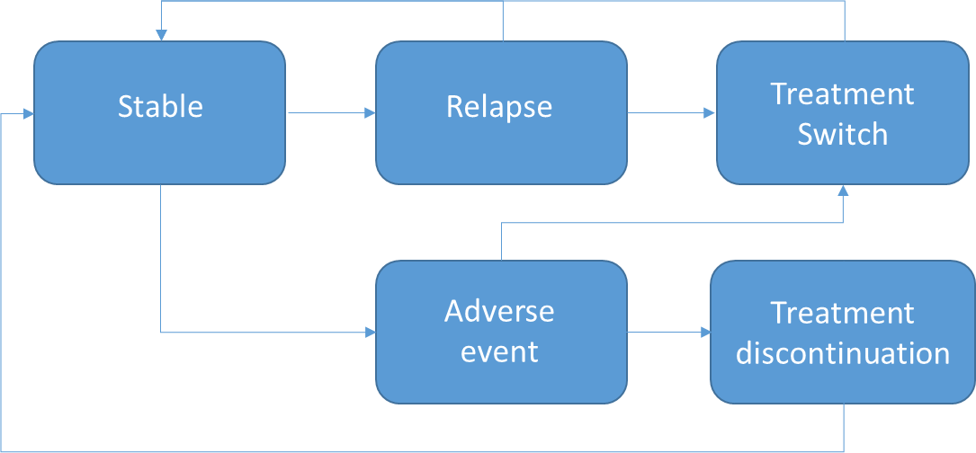 | Furiak (2009)– Schizophrenia  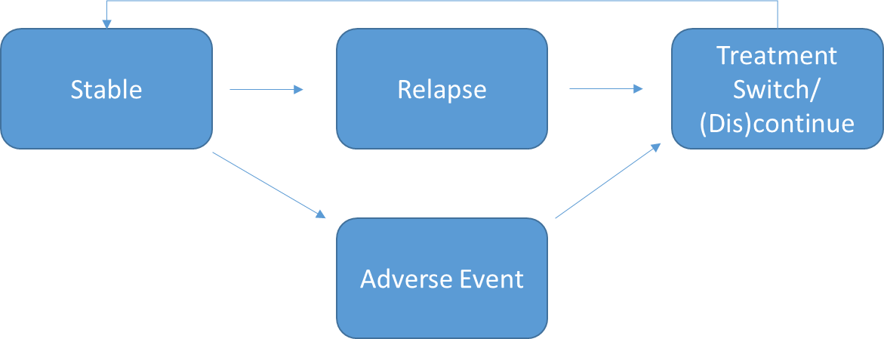 | Heeg (2005)– Schizophrenia  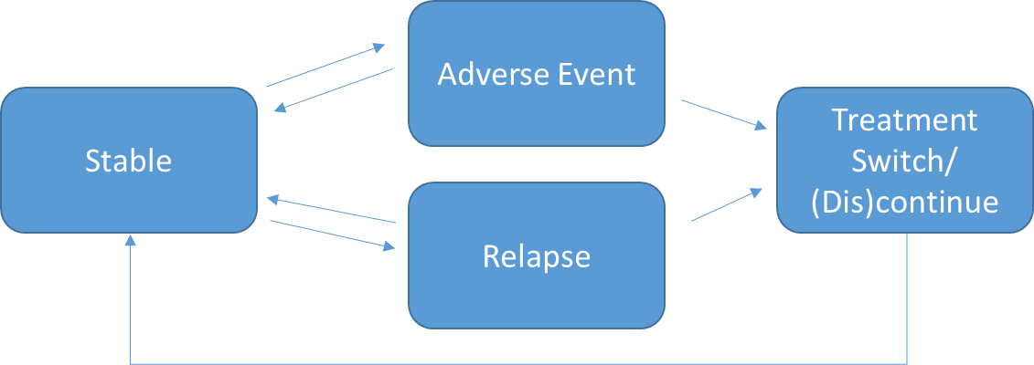
HTA Ontario (2018) – Schizophrenia  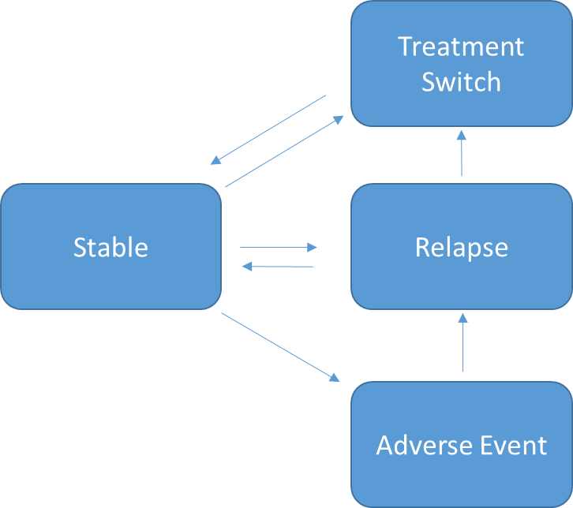 | Jin (2020) – Schizophrenia  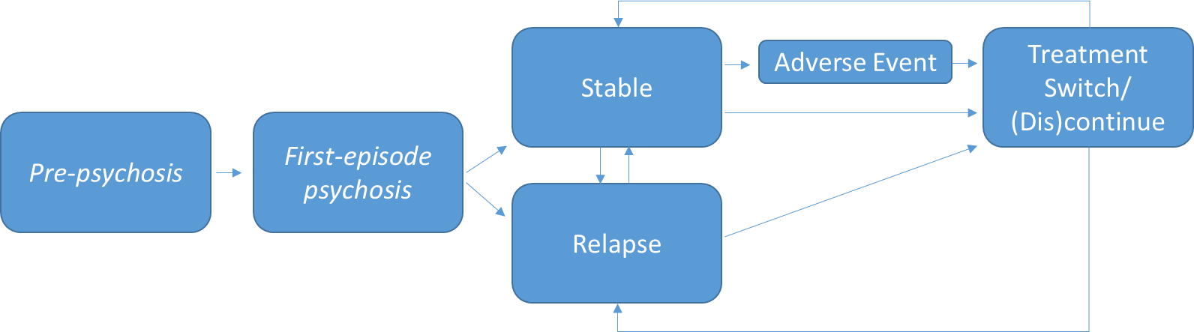 | Vera-Llonch (2004) – Schizophrenia  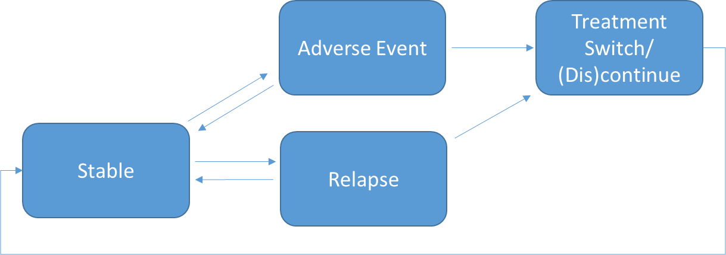
Ekman (2012) – Bipolar  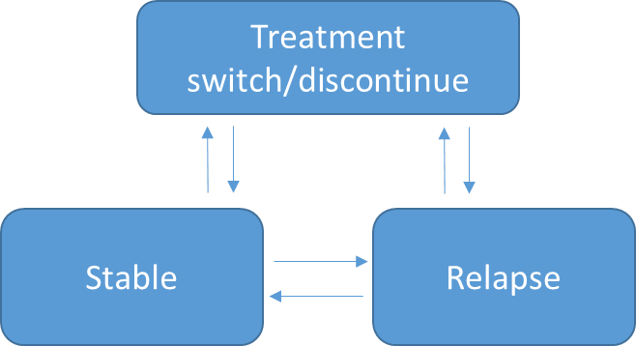 | Klok (2012) – Bipolar  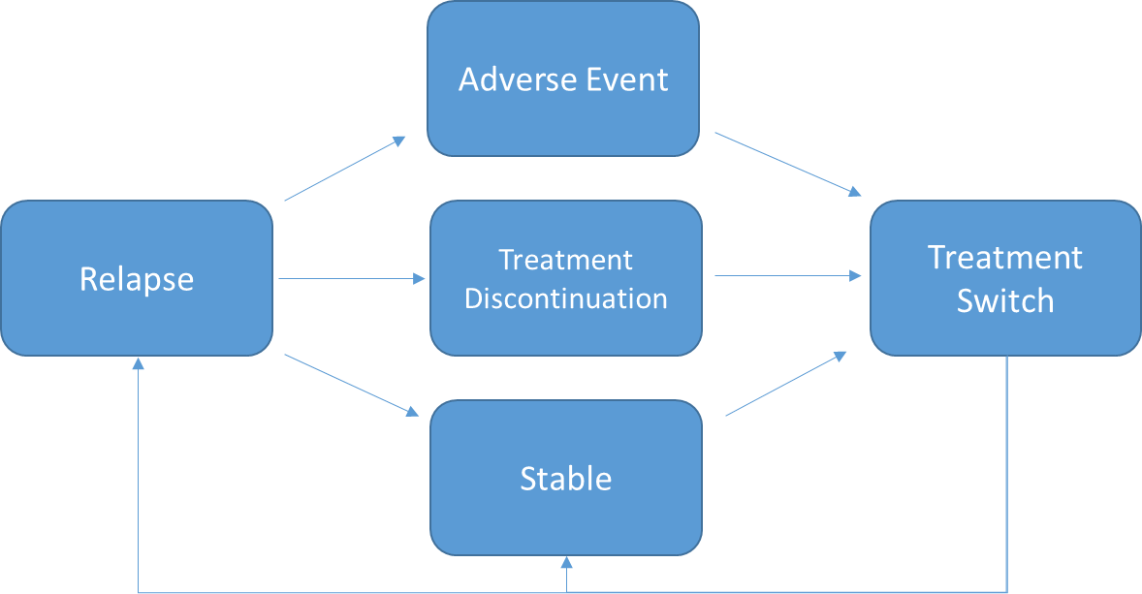 | HTA Ontario (2017) – Major Depressive Disorder  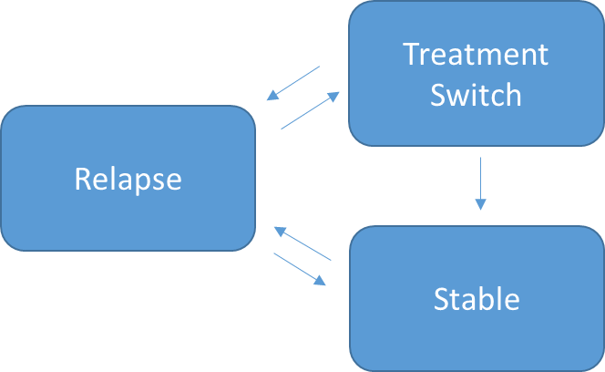
Nguyen (2015) – Major Depressive Disorder  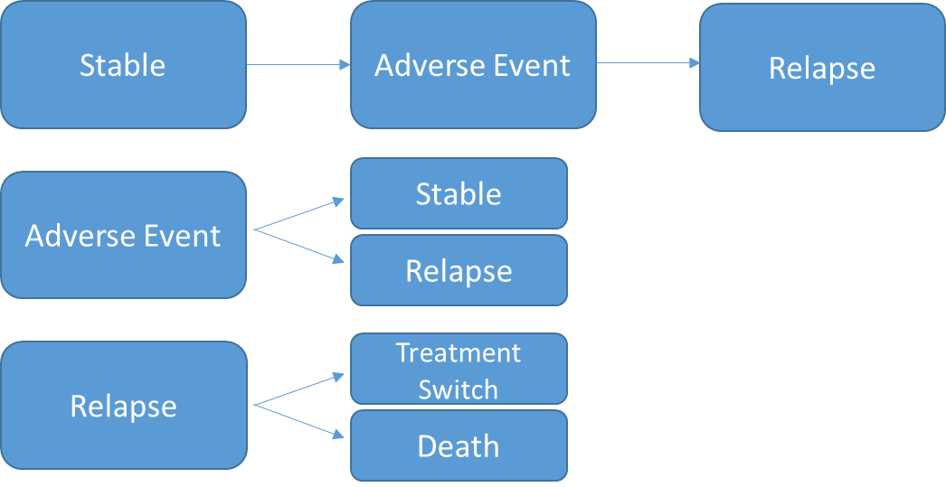 | Prukkanone (2012) – Major Depressive Disorder  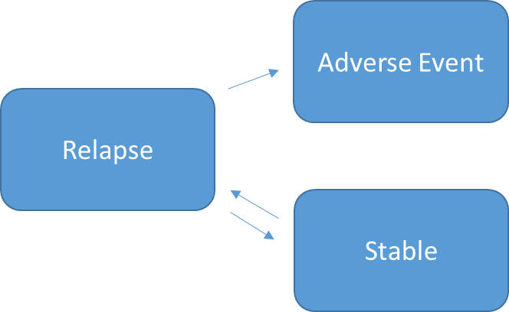 | Saylan (2013) – Major Depressive Disorder  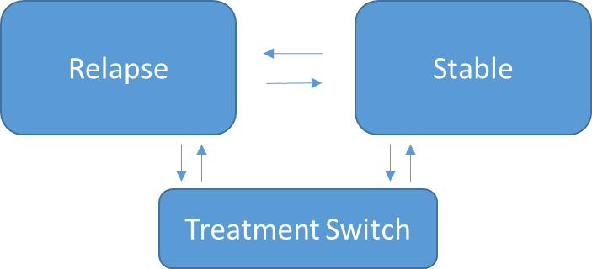
Sobocki (2006) – Major Depressive Disorder  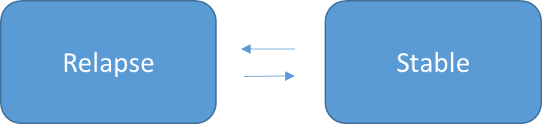 | Tosh (2013) – Major Depressive Disorder  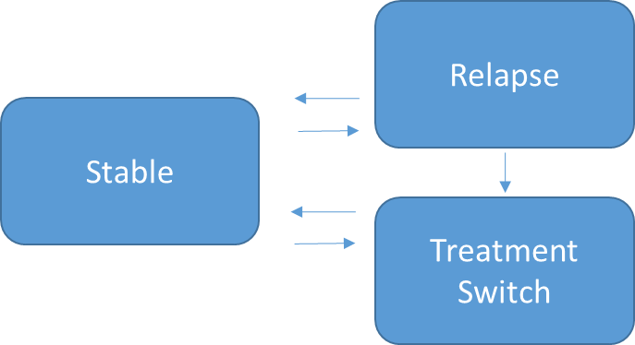 | Vataire (2014) – Major Depressive Disorder  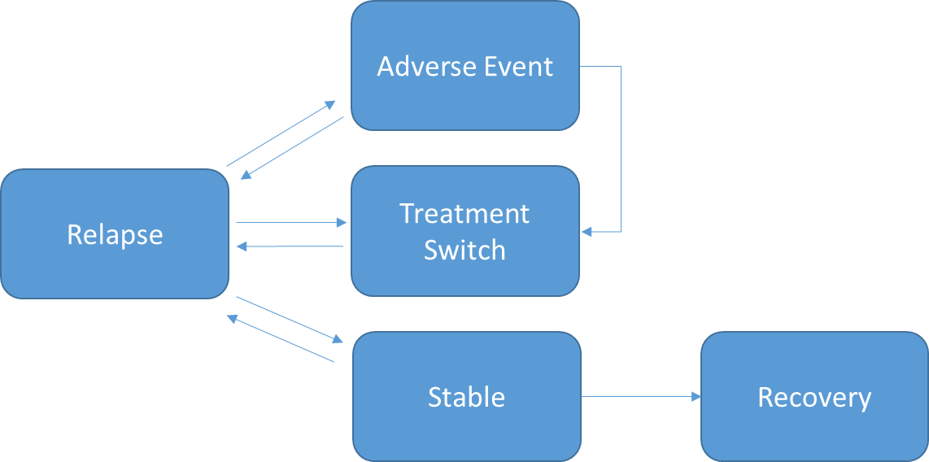

Appendix S8 – Additional Model Detail

 | Study Detail |  |  | Structural Complexity |  | Heterogeneity & Patient history
Author | Intervention | Comparator | Reported Result | Side Effects Modelled | Comorbidities Modelled | Patient Characteristics Incorporated | Implementation of Relapse History
Schizophrenia
Vera-Llonch (2004) ³⁸ | Risperidone | Olanzapine | Total costs per month were $2,163 for Risperidone & $2,316 for Olanzapine. Risperidone modelled to have fewer side effects with less treatment discontinuation. Relapse rates assumed equal for both therapies | Extrapyramidal Symptoms; Weight Gain; Prolactin-related disorders | - | - | -
Heeg (2005) ³⁹ | Hypothetical 20% increase in rate of treatment compliance | Contemporary rates of UK treatment compliance | Reduction in 5-year direct medical costs of schizophrenia by £16,147 per patient, and avoiding 0.55 psychotic episodes per patient | Extrapyramidal Symptoms; Weight Gain; Prolactin-related disorders; Drowsiness; Tardive dyskinesia; Neutropenia | - | Age, Sex, Disease severity | Continuous patient symptom scores (which define a patient relapse) are driven by duration of previous relapse, time between relapses, treatment, side effects, treatment compliance & modelled social/environmental factors
Furiak (2009) ⁴⁰ | Olanzapine, Risperidone, Quetiapine, Ziprasidone, Aripiprazole | - | Olanzapine is dominant (lowest costs, highest QALYs). No incremental comparison made between therapies against a specific standard of care | Extrapyramidal Symptoms; Weight Gain | Individual rates of emergent Diabetes for each treatment. Individual rate of hyperlipidaemia is modelled for each treatment & long-term Cardiovascular events are modelled using Framingham risk equations (with an RR for CHD of 2.67 given diabetes, & RR 4.47 for CHD given metabolic syndrome). | - | Adjusted relapse rate given for a patient history of 1,2 or 3 previous relapses
Dilla (2014) ⁴¹ | Olanzapine, Risperidone | Risperidone | Olanzapine is dominant (lower costs, higher QALYs). Incremental cost savings of €2,940 for gains of 0.04 LYs & 0.07 QALYs | Extrapyramidal Symptoms; Weight Gain; Drowsiness; Tardive dyskinesia; Sexual dysfunction; Post-injection syndrome | - | - | Risk of side effects, relapse rate, & patient-initiated discontinuation is updated based on number of previous relapses; with separate event risks for each individual treatment
HTA Ontario (2018) ⁴² | CBT provided by physicians or non-physicians in an individual setting | Standard Care (Mixed antipsychotic therapies) | CBT for psychosis delivered by physicians is dominated by non-physician delivery (more expensive, equal effect).  CBT for psychosis by non-physicians yielded an ICER of $21,520 per QALY gained compared to usual care | Extrapyramidal Symptoms; Prolactin-related disorders, Neutropenia | Probability of metabolic syndrome for 18 week treatment cycles for Risperidone (7.5%), Quetiapine (6.1%), Clozapine(15.1%). Annual risk for patients with metabolic syndrome to develop Diabetes (4.6%) & Coronary Heart Disease (1.8%) | - | Relapse probabilities are differentiated by treatment type (treatment is sequential). Given treatment switches caused by treatment failure, this indirectly implements differential relapse rates based on history, especially for treatment resistant patients failing two treatments (treated with clozapine). Explicit probabilities given for risk of 1st and 2nd relapse for patients who have discontinued treatment.
Jin (2020) ⁴³ | CBT for clinically high risk psychosis; Crisis resolution and home treatment team (CRHT) for acute Psychosis; Amisulpride, Aripiprazole, Haloperidol, Olanzapine, Placebo, Quetiapine, Risperidone as first-line antipsychotic for first episode psychosis (FEP), Family Intervention + Antipsychotic medication for FEP; Clozapine, Haloperidol, Olanzapine, Quetiapine, Risperidone for treatment resistant schizophrenia | UK Standard Care | CBT + usual practice dominates usual practice alone (cost saving £1,243, no QALY change). CRHT + hospital admission dominates hospital admission alone (cost saving £3,655, no QALY change). At £20,000 per QALY threshold, Amisulpride most cost effective first-line antipsychotic; Family intervention in addition to antipsychotic medication for FEP dominates antipsychotic medication alone; and Clozapine for treatment-resistant Schizophrenia is the most cost effective medication | Extrapyramidal Symptoms; Weight Gain; Neutropenia | Individual risk of impaired glucose tolerance for each therapy considered (inc. placebo). Annual transition probability of 2% from impaired glucose tolerance to Diabetes | Age, Sex, Disease severity, Duration of untreated period | -
Bipolar
Klok (2007) ⁴⁴ | Quetiapine/Lithium | Olanzepine/ Lithium; Risperidone/ Lithium | Quetiapine/Lithium costs €126 more per patient than Olanzepine/Lithium (for a reduction of 0.0362 modelled side effects); Quetiapine/Lithium costs €190 more per patient than Risperidone/Lithium (for a reduction of 0.158 modelled side effects) | Extrapyramidal Symptoms; Weight Gain | - | - | -
Ekman (2012) ⁴⁵ | Quetiapine | Olanzapine | £8,600 per QALY gained | Extrapyramidal Symptoms; Weight Gain | - | - | -
Major Depressive Disorder
Sobocki (2006) ⁴⁶ | Hypothetical antidepressant therapy with 50% improvement in remission rate at equal treatment cost to current therapy | Contemporary Standard Care for Swedish primary care: (83% initially prescribed an SSRI drug, 9% SNRI [venlafaxine], and 8% other antidepressants) | Net cost savings of 20,000 Swedish kronor and a gain of .073 QALYs per patient over a 5-year time horizon | - | - | Age, Sex, Disease Severity | HR of 1.15 for recurrent relapse if any previously modelled episodes
Prukkanone (2012) ⁴⁷ | CBT, Fluoxetine | Do Nothing' | Episodic Fluoxetine treatment 42,000 per DALY;  Continuation Fluoxetine treatment 33,000 per DALY;  Maintenance Fluoxetine treatment 38,000 per DALY;  Episodic CBT treatment 23,000;  Maintenance CBT treatment 11,000 per DALY  (Currency Thai Bhat) | - | - | - | -
Saylan (2013) ⁴⁸ | Aripiprazole | Olanzapine, Quetiapine | Aripiprazole dominant (Cost saving, & additional QALYs) vs both comparators | - | - | - | -
Tosh (2013) ⁴⁹ | Self-referral service back to therapy after discharge; Better management & prevention of dropout from psychological therapy; Widening access to non-therapy services | UK Standard Care | Self-referral service £11,378 per QALY; Better management & dropout prevention £2,227 per QALY; Widening access to non-therapy services £223 per QALY | - | - | Age, Disease Severity | Adjusted relapse risk determined by modelled health related quality of life, number of previous depressive episodes, & responsiveness to previous treatment(s)
Vataire (2014) ⁵⁰ | Hypothetical antidepressant therapy | - | Medium' Hypothetical strategy gave total costs of £3,892 & total QALYs of 3.684 over 5 years | Drowsiness; Sexual dysfunction; Headache; Insomnia; Diarrhoea | - | Age, Sex, Employment status | Adjusted time to recurrent relapse dependent on number of previous episodes
Nguyen (2015) ⁵¹ | Repetitive transcranial magnetic stimulation (rTMS) | Mixed Antidepressant therapy. Usual care includes SSRIs, SNRIs, tricyclics, NaSSAs, & monoamine oxidase inhibitors | rTMS dominant (0.07 higher QALYs & 187 AUD lower costs per patient) | Headache; Pain | - | - | -
HTA Ontario (2017) ⁵² | CBT (individual or group) delivered by physicians/non-physicians | Mixed Antidepressant therapy (Usual care) | CBT group (non-physician) $3,715 per QALY; CBT individual (physician) $ 43,443 per QALY | - | - | Disease Severity | Adjusted RR for next recurrent relapse of 1.18 applied for each prior episode. Adjusted relapse probability determined by time since previous event

Appendix S9 – Quality Checklists

ISPOR 2014

Study | Year | Relevance |  |  |  | Credibility
 |  | Population | Interventions | Outcomes | Context | External validation | Internal verification | Face validity | Design | Data | Analysis | Reporting | Interpretation | No conflict of interest
Vera-Llonch | 2004 | ✓ | ✓ |  | ✓ | ✓ |  |  | ✓ |  |  | ✓ | ✓
Heeg | 2005 | ✓ | ✓ | ✓ | ✓ |  |  | ✓ | ✓ |  | ✓ | ✓ | ✓ | ✓
Sobocki | 2006 | ✓ | ✓ | ✓ | ✓ |  |  | ✓ | ✓ | ✓ | ✓ | ✓ | ✓ | ✓
Klok | 2007 | ✓ | ✓ |  | ✓ |  |  | ✓ |  | ✓ |  |  | ✓
Furiak | 2009 |  | ✓ | ✓ | ✓ |  |  | ✓ | ✓ | ✓ | ✓ | ✓ | ✓
Ekman | 2012 |  | ✓ | ✓ | ✓ | ✓ | ✓ | ✓ | ✓ | ✓ | ✓ | ✓ | ✓
Prukkanone | 2012 |  | ✓ | ✓ | ✓ |  |  |  |  |  | ✓ |  | ✓ | ✓
Saylan | 2013 | ✓ | ✓ | ✓ | ✓ |  |  | ✓ |  | ✓ | ✓ |  | ✓ | ✓
Tosh | 2013 | ✓ | ✓ | ✓ | ✓ |  | ✓ | ✓ | ✓ | ✓ | ✓ | ✓ | ✓ | ✓
Dilla | 2014 |  | ✓ | ✓ | ✓ |  |  | ✓ | ✓ |  | ✓ |  | ✓
Vataire | 2014 |  | ✓ | ✓ | ✓ |  | ✓ | ✓ | ✓ | ✓ | ✓ | ✓ | ✓ | ✓
Nguyen | 2015 |  | ✓ | ✓ | ✓ |  |  | ✓ | ✓ | ✓ | ✓ | ✓ | ✓ | ✓
Ontario HTA [Depression] | 2017 | ✓ | ✓ | ✓ | ✓ |  |  | ✓ | ✓ | ✓ | ✓ | ✓ | ✓ | ✓
Ontario HTA [CBTp] | 2018 | ✓ | ✓ | ✓ | ✓ |  |  | ✓ | ✓ | ✓ | ✓ | ✓ | ✓ | ✓
Jin | 2020 | ✓ | ✓ | ✓ | ✓ | ✓ | ✓ | ✓ | ✓ | ✓ | ✓ | ✓ | ✓ | ✓

AdVISHE 2016
Study | Year | Conceptual model |  | Input Data |  | Computerised model |  |  |  | Operational Validation
 |  | Expert Face Validity | Cross Validity | Expert Face Validity | Regression model fit | External expert review | Extreme value testing | Patient tracing | Sub-module testing | Face Validity | Cross Validity | Alternate input comparison | Empirical Data comparison
Vera-Llonch | 2004 |  |  |  | NA |  |  |  |  |  |  |  | ✓
Heeg | 2005 | ✓ |  | ✓ | NA |  |  | ✓ |  | ✓ | ✓
Sobocki | 2006 |  | ✓ |  | ✓ |  |  |  |  |  | ✓
Klok | 2007
Furiak | 2009 | ✓ | ✓ | ✓ | NA | ✓ |  |  |  |  | ✓ | ✓
Ekman | 2012 |  | ✓ |  |  |  | ✓ |  |  |  | ✓ |  | ✓
Prukkanone | 2012 |  |  |  | NA
Saylan | 2013 |  |  |  |  |  |  |  |  |  | ✓
Tosh | 2013 | ✓ | ✓ |  | NA | ✓ | ✓ |  |  | ✓
Dilla | 2014 | ✓ |  | ✓ | NA |  |  |  |  | ✓
Vataire | 2014 | ✓ | ✓ | ✓ | NA | ✓ | ✓ |  |  | ✓ | ✓
Nguyen | 2015 |  |  |  | ✓ |  |  |  |  |  | ✓
Ontario HTA [Depression] | 2017 | ✓ | ✓ | ✓ |  |  |  |  |  | ✓
Ontario HTA [CBTp] | 2018 | ✓ | ✓ | ✓ |  |  |  |  |  | ✓ | ✓
Jin | 2020 | ✓ | ✓ | ✓ |  | ✓ | ✓ | ✓ | ✓ | ✓ | ✓ |  | ✓

