Supplementary Material
Information on all residents, including sex, birthdate and vital status, has been recorded in the Danish Civil Registration System since 1968,¹ along with a unique personal identification number that can be used to link data from national registries.

Ascertainment of eating disorders
Data from the Danish Psychiatric Central Research Register² and the Danish National Patient Register³ were used in combination to ascertain which individuals had been diagnosed with eating disorders: Anorexia Nervosa (AN) and Other Eating Disorders (OED). OED were further divided, where possible, into Bulimia Nervosa (BN) and Eating Disorders Not Otherwise Specified (EDNOS). The Danish Psychiatric Central Research Register contains records regarding all admissions to psychiatric inpatient facilities since 1969 and visits to outpatient psychiatric departments and emergency departments since 1995. The Danish National Patient Register holds information on diagnoses made during hospital visits. Both use the Danish modification of the International Classification of Diseases, Eighth Revision (ICD-8; from 1969 to 1993),⁴ and Tenth Revision (ICD-10; from 1994 onwards) ⁵ diagnostic systems.

Ascertainment of general medical conditions
The general medical conditions (MCs) included in Thornton et al⁶ were considered in our study, combining information on diagnoses from the Danish National Patient Register³ and the Cause of Death Register.⁷ The Cause of Death Register was used in order to capture MCs that people died from, but for which they had not received a hospital diagnosis. The diagnoses included in each MC category are shown in Table S1.

Study design
When considering prior eating disorders-later MCs, eating disorders were ascertained from 01 January 1983 or when the individual turned 6 years old (whichever occurred later), up to 2016. There were some differences in the follow-up periods depending on the MC of interest. For chronic MCs, follow-up also started at this time. However, a “washout period” was employed, to identify individuals who had been diagnosed with the MC of interest in the first six years of life. These individuals were considered to be prevalent cases follow-up commenced and were excluded from the analysis for that MC of interest. After the washout period, assessment of incident later MCs commenced (once 6 years of age had been reached, for a maximum period of 1983-2016). For acute MCs (i.e., infections and injuries), the same follow-up period was used but washing out of prevalent cases was unnecessary. No diagnostic code existed for immune disorders in ICD-8, so it was not possible to identify cases prior to 1994. Therefore the study period for analyses involving later immune disorders was different: follow-up could start at 6 years of age or 01/01/2000, whichever was later, after a washout period from 1994-1999 to identify and remove prevalent cases.
For prior MCs-later eating disorders, prior MCs could be assessed from 1977-2016; later eating disorders were ascertained once 6 years of age had been reached, for a maximum period of 1983-2016. When immune disorders were the prior MC of interest, assessment started on 01/01/1994, when diagnostic codes for immune disorders were available. Later eating disorders were ascertained for a maximum period of 2000-2016 (once an individual was 6 years of age), with a washout period of 1983-2000 The study periods for the analyses are shown in Figure S1.
The longest period an individual was followed-up for to ascertain whether a later diagnosis of a MC or eating disorder was made was 34 years (1983-2016); so the interval between diagnosis of a prior disorder and later disorder of interest could reach a maximum of 34 years. However, in the case of prior immune disorders-later eating disorder, the maximum possible intervals was 23 years (1994-2016).
For every index person with the prior disorder of interest, a reference group of up to 3 people was randomly selected. They were matched on sex and date of birth (born within 30 days). Additionally, they had to be “free” of the relevant prior disorder (not received a diagnosis) at or before the age that the index person was diagnosed with it, when follow-up for cumulative incidence proportions (CIPs) started. Follow-up for obtaining CIPs starts at the age the prior disorder is diagnosed, among those who receive a diagnosis. For those in the reference group, it starts at the age the person they were matched to was when they received a diagnosis. For simplicity, throughout this paper, start of CIP follow-up has been referred to as the “date of diagnosis” for both those with prior disorders and their respective reference groups.

Statistical analysis
Cox proportional hazards regression was used in the calculation of relative risks. When the rates of a later disorder are not proportional over time among the exposed and unexposed groups, the estimates can be interpreted as an average hazard ratio over the entire follow-up period.¹⁰
Table S1. Diagnoses included in each medical condition category
Medical condition category | Included diagnoses
Neurologic diseases | Headaches, migraine, epilepsy, sleep apnea
Infectious and parasitic diseases | Colitis, gastroenteritis, viral infection, genital warts
Immune system disorders | Sarcoidosis, hyperimmunglobulin E (IgE)‐syndrome
Respiratory diseases | Tonsillitis, acute respiratory infection, asthma
Gastrointestinal disorders | Gallstones, appendicitis, dyspepsia, gastritis
Skin and subcutaneous tissue disorders | Dermatitis, hives, eczema, psoriasis
Musculoskeletal system and connective tissues diseases | Lumbago (low back pain), joint pain, internal derangement of knee
Genitourinary system disease | Kidney inflammation, kidney stone, kidney infection, urinary tract infection, ureter stone
Circulatory system diseases | Hypertension, tachycardia, pulmonary embolism, cardiac arrhythmia
Endocrine system diseases | Polycystic ovarian syndrome, hyperthyroidism, thyrotoxicosis, autoimmune thyroiditis
Congenital malformations | Congenital non‐neoplastic nevus, congenital malformation of the breast, prominent ear, congenital heart defect
Injury, poisoning, and external causes of morbidity and mortality (excluding suicide) | Fall related accidents, concussion, sprain of ankle

Table S2. Baseline characteristics of those born in Denmark 1977-2010 (n=2,127,404)
Baseline characteristics of the study population |  | N | %
Sex | Male | 1,092,044 | 51.3
 | Female | 1,035,360 | 48.7
Birth year | 1977-1980 | 241,020 | 11.3
 | 1981-1990 | 558,990 | 26.3
 | 1991-2000 | 677,175 | 31.8
 | 2001-2010 | 650,219 | 30.6

Table S3. Hazard ratios and 95% confidence intervals for all pairs of prior eating disorders and later general medical conditions
Prior disorder  (eating disorder) | Later disorder  (MC) | Sex | Model A HRª  (95% CI) | Model B HR^{b}  (95% CI)
AN | Circulatory | All | 2.22 (2.01-2.45) | 2.05 (1.86-2.27)
AN | Circulatory | Females | 2.15 (1.94-2.39) | 1.99 (1.79-2.21)
AN | Circulatory | Males | 3.52 (2.49-4.97) | 3.17 (2.24-4.48)
AN | Endocrine | All | 1.81 (1.65-1.98) | 1.64 (1.50-1.80)
AN | Endocrine | Females | 1.75 (1.59-1.92) | 1.59 (1.45-1.74)
AN | Endocrine | Males | 4.49 (3.07-6.54) | 4.02 (2.75-5.86)
AN | Gastrointestinal | All | 1.47 (1.35-1.60) | 1.32 (1.21-1.44)
AN | Gastrointestinal | Females | 1.48 (1.35-1.61) | 1.32 (1.21-1.45)
AN | Gastrointestinal | Males | 1.34 (0.90-1.98) | 1.18 (0.80-1.74)
AN | Genitourinary | All | 1.34 (1.15-1.55) | 1.23 (1.06-1.43)
AN | Genitourinary | Females | 1.29 (1.11-1.5) | 1.19 (1.02-1.39)
AN | Genitourinary | Males | 2.19 (1.32-3.64) | 1.98 (1.19-3.29)
AN | Immune | All | 1.00 (0.61-1.63) | 0.94 (0.57-1.55)
AN | Immune | Females | 0.99 (0.59-1.64) | 0.93 (0.56-1.56)
AN | Immune | Males | - | -
AN | Infectious | All | 1.64 (1.53-1.75) | 1.50 (1.40-1.61)
AN | Infectious | Females | 1.63 (1.52-1.75) | 1.49 (1.39-1.60)
AN | Infectious | Males | 1.82 (1.38-2.40) | 1.64 (1.25-2.17)
AN | Injury | All | 1.04 (0.99-1.09) | 1.01 (0.96-1.06)
AN | Injury | Females | 1.05 (1.00-1.11) | 1.03 (0.97-1.08)
AN | Injury | Males | 0.90 (0.76-1.08) | 0.88 (0.73-1.05)
AN | Musculoskeletal | All | 1.05 (1.00-1.11) | 1.03 (0.97-1.09)
AN | Musculoskeletal | Females | 1.87 (1.77-1.98) | 1.04 (0.98-1.10)
AN | Musculoskeletal | Males | 0.88 (0.68-1.14) | 0.85 (0.65-1.10)
AN | Neurological | All | 1.66 (1.51-1.83) | 1.46 (1.32-1.61)
AN | Neurological | Females | 1.67 (1.51-1.85) | 1.47 (1.33-1.63)
AN | Neurological | Males | 1.50 (0.96-2.35) | 1.29 (0.82-2.02)
AN | Respiratory | All | 1.27 (1.19-1.37) | 1.21 (1.12-1.30)
AN | Respiratory | Females | 1.28 (1.19-1.37) | 1.21 (1.13-1.30)
AN | Respiratory | Males | 1.23 (0.90-1.69) | 1.15 (0.84-1.57)
AN | Skin | All | 1.62 (1.50-1.74) | 1.50 (1.39-1.62)
AN | Skin | Females | 1.64 (1.52-1.78) | 1.53 (1.41-1.65)
AN | Skin | Males | 1.21 (0.85-1.72) | 1.10 (0.77-1.56)
OED | Circulatory | All | 1.60 (1.43-1.79) | 1.45 (1.30-1.63)
OED | Circulatory | Females | 1.53 (1.36-1.73) | 1.40 (1.24-1.57)
OED | Circulatory | Males | 2.84 (1.94-4.18) | 2.51 (1.71-3.69)
OED | Endocrine | All | 1.76 (1.61-1.93) | 1.63 (1.49-1.78)
OED | Endocrine | Females | 1.73 (1.58-1.89) | 1.60 (1.46-1.75)
OED | Endocrine | Males | 3.17 (2.06-4.86) | 2.89 (1.89-4.44)
OED | Gastrointestinal | All | 1.88 (1.75-2.03) | 1.72 (1.60-1.86)
OED | Gastrointestinal | Females | 1.85 (1.71-2.00) | 1.69 (1.57-1.83)
OED | Gastrointestinal | Males | 2.55 (1.90-3.42) | 2.29 (1.71-3.07)
OED | Genitourinary | All | 1.59 (1.39-1.82) | 1.47 (1.29-1.68)
OED | Genitourinary | Females | 1.53 (1.33-1.76) | 1.42 (1.23-1.63)
OED | Genitourinary | Males | 2.72 (1.73-4.26) | 2.47 (1.57-3.87)
OED | Immune | All | 1.48 (1.01-2.18) | 1.43 (0.97-2.10)
OED | Immune | Females | 1.44 (0.96-2.15) | 1.39 (0.93-2.08)
OED | Immune | Males | 2.24 (0.56-8.96) | 2.14 (0.53-8.55)
OED | Infectious | All | 1.74 (1.63-1.87) | 1.63 (1.53-1.75)
OED | Infectious | Females | 1.71 (1.60-1.84) | 1.61 (1.50-1.72)
OED | Infectious | Males | 2.25 (1.75-2.90) | 2.07 (1.61-2.67)
OED | Injury | All | 1.26 (1.19-1.33) | 1.26 (1.20-1.34)
OED | Injury | Females | 1.31 (1.23-1.39) | 1.31 (1.23-1.39)
OED | Injury | Males | 0.99 (0.84-1.17) | 0.99 (0.84-1.17)
OED | Musculoskeletal | All | 1.18 (1.11-1.24) | 1.15 (1.09-1.21)
OED | Musculoskeletal | Females | 1.18 (1.11-1.25) | 1.15 (1.09-1.22)
OED | Musculoskeletal | Males | 1.13 (0.89-1.43) | 1.10 (0.87-1.39)
OED | Neurological | All | 1.97 (1.80-2.15) | 1.73 (1.58-1.89)
OED | Neurological | Females | 1.91 (1.74-2.09) | 1.67 (1.53-1.84)
OED | Neurological | Males | 3.15 (2.30-4.31) | 2.72 (1.99-3.73)
OED | Respiratory | All | 1.41 (1.32-1.52) | 1.33 (1.24-1.43)
OED | Respiratory | Females | 1.41 (1.31-1.52) | 1.33 (1.24-1.43)
OED | Respiratory | Males | 1.46 (1.08-1.99) | 1.38 (1.02-1.87)
OED | Skin | All | 1.57 (1.45-1.69) | 1.47 (1.36-1.59)
OED | Skin | Females | 1.55 (1.43-1.68) | 1.45 (1.34-1.57)
OED | Skin | Males | 1.89 (1.42-2.50) | 1.76 (1.32-2.33)
Abbreviations: HR – Hazard ratio, 95% CI – 95% confidence interval, AN – Anorexia Nervosa, OED – Other Eating Disorder, MC –medical condition
NB Where numbers were too small to meet reporting regulations for Danish register data a dash is shown
ª Model A adjusts for sex and age
^{b} Model B adjusts for sex, age and other mental disorders diagnosed prior to the exposure of interest

Table S4. Hazard ratios and 95% confidence intervals for all pairs of prior general medical conditions and later eating disorders
Prior disorder  (MC) | Later disorder  (Eating disorder) | Sex | Model A HRª  (95% CI) | Model B HR^{b}  (95% CI)
Circulatory | AN | All | 1.82 (1.58-2.10) | 1.98 (1.71-2.28)
Circulatory | AN | Females | 1.84 (1.59-2.13) | 1.99 (1.72-2.31)
Circulatory | AN | Males | 1.59 (0.88-2.89) | 1.77 (0.98-3.22)
Congenital | AN | All | 1.08 (1.01-1.16) | 1.35 (1.26-1.45)
Congenital | AN | Females | 1.08 (1.01-1.16) | 1.36 (1.27-1.47)
Congenital | AN | Males | 1.11 (0.87-1.40) | 1.20 (0.95-1.52)
Endocrine | AN | All | 1.53 (1.39-1.69) | 1.72 (1.56-1.91)
Endocrine | AN | Females | 1.49 (1.34-1.65) | 1.68 (1.51-1.86)
Endocrine | AN | Males | 2.42 (1.67-3.52) | 2.59 (1.78-3.76)
Gastrointestinal | AN | All | 1.55 (1.43-1.68) | 1.74 (1.60-1.88)
Gastrointestinal | AN | Females | 1.57 (1.45-1.71) | 1.76 (1.62-1.92)
Gastrointestinal | AN | Males | 1.23 (0.85-1.76) | 1.35 (0.94-1.94)
Genitourinary | AN | All | 1.48 (1.30-1.69) | 1.70 (1.49-1.93)
Genitourinary | AN | Females | 1.47 (1.29-1.68) | 1.69 (1.47-1.93)
Genitourinary | AN | Males | 1.69 (0.98-2.93) | 1.88 (1.09-3.26)
Immune | AN | All | 1.72 (1.07-2.77) | 1.82 (1.13-2.94)
Immune | AN | Females | 1.52 (0.90-2.57) | 1.61 (0.95-2.71)
Immune | AN | Males | - | -
Infectious | AN | All | 1.28 (1.21-1.35) | 1.51 (1.43-1.60)
Infectious | AN | Females | 1.28 (1.21-1.36) | 1.53 (1.44-1.62)
Infectious | AN | Males | 1.21 (0.98-1.50) | 1.32 (1.07-1.64)
Injury | AN | All | 1.30 (1.23-1.37) | 1.42 (1.35-1.50)
Injury | AN | Females | 1.32 (1.25-1.40) | 1.45 (1.37-1.54)
Injury | AN | Males | 0.95 (0.79-1.16) | 1.01 (0.83-1.23)
Musculoskeletal | AN | All | 1.18 (1.11-1.25) | 1.37 (1.29-1.45)
Musculoskeletal | AN | Females | 1.18 (1.11-1.26) | 1.37 (1.29-1.46)
Musculoskeletal | AN | Males | 1.12 (0.86-1.45) | 1.27 (0.97-1.64)
Neurological | AN | All | 1.23 (1.11-1.35) | 1.40 (1.27-1.54)
Neurological | AN | Females | 1.23 (1.12-1.36) | 1.42 (1.28-1.56)
Neurological | AN | Males | 1.15 (0.79-1.68) | 1.23 (0.84-1.79)
Respiratory | AN | All | 1.20 (1.15-1.26) | 1.44 (1.38-1.51)
Respiratory | AN | Females | 1.20 (1.14-1.26) | 1.45 (1.38-1.52)
Respiratory | AN | Males | 1.22 (1.03-1.45) | 1.33 (1.12-1.58)
Skin | AN | All | 1.18 (1.09-1.27) | 1.37 (1.27-1.48)
Skin | AN | Females | 1.19 (1.09-1.28) | 1.39 (1.28-1.50)
Skin | AN | Males | 1.10 (0.82-1.49) | 1.22 (0.91-1.64)
Circulatory | OED | All | 1.56 (1.37-1.77) | 1.64 (1.44-1.86)
Circulatory | OED | Females | 1.53 (1.34-1.75) | 1.61 (1.41-1.84)
Circulatory | OED | Males | 1.85 (1.21-2.83) | 1.99 (1.31-3.05)
Congenital | OED | All | 1.13 (1.06-1.20) | 1.36 (1.28-1.45)
Congenital | OED | Females | 1.10 (1.03-1.17) | 1.32 (1.24-1.42)
Congenital | OED | Males | 1.44 (1.20-1.72) | 1.74 (1.46-2.09)
Endocrine | OED | All | 1.68 (1.55-1.83) | 1.85 (1.70-2.01)
Endocrine | OED | Females | 1.61 (1.48-1.76) | 1.77 (1.62-1.93)
Endocrine | OED | Males | 2.91 (2.20-3.86) | 3.29 (2.48-4.35)
Gastrointestinal | OED | All | 1.55 (1.44-1.66) | 1.67 (1.56-1.79)
Gastrointestinal | OED | Females | 1.55 (1.44-1.66) | 1.67 (1.55-1.79)
Gastrointestinal | OED | Males | 1.53 (1.19-1.98) | 1.73 (1.34-2.24)
Genitourinary | OED | All | 1.48 (1.32-1.66) | 1.64 (1.46-1.83)
Genitourinary | OED | Females | 1.46 (1.30-1.64) | 1.61 (1.43-1.81)
Genitourinary | OED | Males | 1.86 (1.23-2.82) | 2.12 (1.40-3.21)
Immune | OED | All | 1.43 (0.91-2.25) | 1.55 (0.99-2.43)
Immune | OED | Females | 1.31 (0.80-2.13) | 1.41 (0.86-2.30)
Immune | OED | Males | - | -
Infectious | OED | All | 1.44 (1.38-1.52) | 1.67 (1.59-1.75)
Infectious | OED | Females | 1.40 (1.33-1.47) | 1.61 (1.53-1.69)
Infectious | OED | Males | 2.05 (1.76-2.39) | 2.47 (2.12-2.88)
Injury | OED | All | 1.62 (1.53-1.70) | 1.73 (1.64-1.82)
Injury | OED | Females | 1.63 (1.54-1.72) | 1.74 (1.65-1.84)
Injury | OED | Males | 1.45 (1.20-1.75) | 1.57 (1.30-1.90)
Musculoskeletal | OED | All | 1.28 (1.22-1.35) | 1.41 (1.34-1.48)
Musculoskeletal | OED | Females | 1.29 (1.23-1.36) | 1.42 (1.35-1.50)
Musculoskeletal | OED | Males | 1.10 (0.90-1.35) | 1.24 (1.01-1.52)
Neurological | OED | All | 1.46 (1.35-1.58) | 1.58 (1.46-1.70)
Neurological | OED | Females | 1.37 (1.26-1.49) | 1.48 (1.36-1.61)
Neurological | OED | Males | 2.60 (2.09-3.23) | 2.84 (2.29-3.54)
Respiratory | OED | All | 1.40 (1.34-1.45) | 1.62 (1.56-1.69)
Respiratory | OED | Females | 1.37 (1.31-1.42) | 1.58 (1.52-1.65)
Respiratory | OED | Males | 1.76 (1.54-2.02) | 2.11 (1.84-2.42)
Skin | OED | All | 1.33 (1.25-1.42) | 1.50 (1.40-1.60)
Skin | OED | Females | 1.32 (1.23-1.41) | 1.48 (1.38-1.58)
Skin | OED | Males | 1.52 (1.23-1.88) | 1.75 (1.42-2.16)
Circulatory | BN | All | 1.31 (1.08-1.58) | 1.39 (1.14-1.68)
Circulatory | BN | Females | 1.27 (1.04-1.55) | 1.35 (1.11-1.65)
Circulatory | BN | Males | 2.72 (1.11-6.66) | 2.84 (1.16-6.95)
Congenital | BN | All | 0.92 (0.83-1.02) | 1.12 (1.02-1.24)
Congenital | BN | Females | 0.93 (0.84-1.03) | 1.14 (1.03-1.26)
Congenital | BN | Males | 0.71 (0.38-1.32) | 0.79 (0.43-1.48)
Endocrine | BN | All | 1.44 (1.26-1.64) | 1.58 (1.38-1.80)
Endocrine | BN | Females | 1.43 (1.26-1.64) | 1.57 (1.37-1.79)
Endocrine | BN | Males | 1.85 (0.75-4.52) | 1.99 (0.81-4.88)
Gastrointestinal | BN | All | 1.32 (1.20-1.46) | 1.41 (1.27-1.56)
Gastrointestinal | BN | Females | 1.32 (1.19-1.46) | 1.40 (1.27-1.55)
Gastrointestinal | BN | Males | 1.48 (0.78-2.83) | 1.59 (0.83-3.03)
Genitourinary | BN | All | 1.29 (1.09-1.52) | 1.41 (1.19-1.67)
Genitourinary | BN | Females | 1.25 (1.06-1.49) | 1.37 (1.16-1.63)
Genitourinary | BN | Males | 3.23 (1.42-7.34) | 3.49 (1.53-7.92)
Immune | BN | All | 1.52 (0.79-2.92) | 1.62 (0.84-3.11)
Immune | BN | Females | 1.38 (0.69-2.76) | 1.47 (0.73-2.94)
Immune | BN | Males | - | -
Infectious | BN | All | 1.32 (1.23-1.42) | 1.53 (1.42-1.64)
Infectious | BN | Females | 1.32 (1.23-1.42) | 1.53 (1.42-1.64)
Infectious | BN | Males | 1.36 (0.87-2.15) | 1.52 (0.96-2.39)
Injury | BN | All | 1.56 (1.46-1.68) | 1.67 (1.55-1.79)
Injury | BN | Females | 1.57 (1.46-1.69) | 1.67 (1.55-1.80)
Injury | BN | Males | 1.39 (0.85-2.26) | 1.45 (0.89-2.37)
Musculoskeletal | BN | All | 1.16 (1.08-1.25) | 1.28 (1.19-1.37)
Musculoskeletal | BN | Females | 1.16 (1.08-1.25) | 1.28 (1.18-1.37)
Musculoskeletal | BN | Males | 1.18 (0.70-1.96) | 1.27 (0.76-2.12)
Neurological | BN | All | 1.15 (1.02-1.30) | 1.26 (1.12-1.42)
Neurological | BN | Females | 1.12 (0.99-1.27) | 1.23 (1.09-1.39)
Neurological | BN | Males | 2.51 (1.41-4.47) | 2.65 (1.49-4.71)
Respiratory | BN | All | 1.25 (1.17-1.33) | 1.46 (1.37-1.55)
Respiratory | BN | Females | 1.25 (1.18-1.33) | 1.46 (1.37-1.56)
Respiratory | BN | Males | 1.20 (0.82-1.76) | 1.33 (0.91-1.96)
Skin | BN | All | 1.32 (1.20-1.45) | 1.49 (1.36-1.64)
Skin | BN | Females | 1.31 (1.19-1.44) | 1.48 (1.35-1.63)
Skin | BN | Males | 1.74 (1.03-2.94) | 1.90 (1.12-3.21)
Circulatory | EDNOS | All | 1.79 (1.53-2.11) | 1.91 (1.63-2.25)
Circulatory | EDNOS | Females | 1.78 (1.50-2.12) | 1.89 (1.59-2.25)
Circulatory | EDNOS | Males | 1.90 (1.19-3.04) | 2.10 (1.32-3.35)
Congenital | EDNOS | All | 1.28 (1.19-1.38) | 1.60 (1.48-1.73)
Congenital | EDNOS | Females | 1.23 (1.13-1.34) | 1.53 (1.41-1.67)
Congenital | EDNOS | Males | 1.59 (1.32-1.92) | 2.03 (1.69-2.45)
Endocrine | EDNOS | All | 1.91 (1.72-2.12) | 2.13 (1.92-2.37)
Endocrine | EDNOS | Females | 1.80 (1.60-2.01) | 2.00 (1.79-2.24)
Endocrine | EDNOS | Males | 3.25 (2.42-4.35) | 3.76 (2.80-5.03)
Gastrointestinal | EDNOS | All | 1.78 (1.63-1.95) | 1.96 (1.79-2.15)
Gastrointestinal | EDNOS | Females | 1.79 (1.63-1.97) | 1.96 (1.78-2.16)
Gastrointestinal | EDNOS | Males | 1.71 (1.30-2.26) | 2.01 (1.52-2.65)
Genitourinary | EDNOS | All | 1.66 (1.44-1.92) | 1.89 (1.64-2.18)
Genitourinary | EDNOS | Females | 1.65 (1.42-1.92) | 1.87 (1.60-2.17)
Genitourinary | EDNOS | Males | 1.78 (1.12-2.85) | 2.12 (1.33-3.38)
Immune | EDNOS | All | 1.22 (0.66-2.28) | 1.35 (0.73-2.51)
Immune | EDNOS | Females | 1.11 (0.56-2.22) | 1.22 (0.61-2.44)
Immune | EDNOS | Males | - | -
Infectious | EDNOS | All | 1.54 (1.44-1.63) | 1.84 (1.73-1.96)
Infectious | EDNOS | Females | 1.46 (1.37-1.56) | 1.74 (1.63-1.86)
Infectious | EDNOS | Males | 2.14 (1.82-2.51) | 2.72 (2.31-3.20)
Injury | EDNOS | All | 1.65 (1.54-1.77) | 1.81 (1.68-1.94)
Injury | EDNOS | Females | 1.69 (1.57-1.82) | 1.84 (1.71-1.99)
Injury | EDNOS | Males | 1.34 (1.09-1.65) | 1.50 (1.22-1.84)
Musculoskeletal | EDNOS | All | 1.41 (1.32-1.51) | 1.58 (1.48-1.69)
Musculoskeletal | EDNOS | Females | 1.43 (1.34-1.54) | 1.60 (1.50-1.72)
Musculoskeletal | EDNOS | Males | 1.19 (0.95-1.48) | 1.38 (1.11-1.72)
Neurological | EDNOS | All | 1.75 (1.59-1.93) | 1.92 (1.74-2.11)
Neurological | EDNOS | Females | 1.63 (1.47-1.81) | 1.78 (1.61-1.98)
Neurological | EDNOS | Males | 2.70 (2.14-3.42) | 3.03 (2.40-3.84)
Respiratory | EDNOS | All | 1.53 (1.45-1.61) | 1.84 (1.74-1.94)
Respiratory | EDNOS | Females | 1.49 (1.41-1.57) | 1.78 (1.68-1.88)
Respiratory | EDNOS | Males | 1.83 (1.58-2.12) | 2.32 (2.00-2.68)
Skin | EDNOS | All | 1.34 (1.24-1.46) | 1.56 (1.43-1.69)
Skin | EDNOS | Females | 1.31 (1.20-1.44) | 1.51 (1.38-1.66)
Skin | EDNOS | Males | 1.57 (1.25-1.96) | 1.89 (1.51-2.37)
Abbreviations: HR – Hazard ratio, 95% CI – 95% confidence interval, AN – Anorexia Nervosa, OED – Other Eating Disorder, BN – Bulimia Nervosa, EDNOS – Eating Disorders Not Otherwise Specified, MC –medical condition
NB Where numbers were too small to meet reporting requirements for Danish register data a dash is shown
ª Model A adjusts for sex and age
^{b} Model B adjusts for sex, age and other mental disorders diagnosed prior to the exposure of interest

Figure S1. Study periods for the analyses
A – Prior eating disorders-later MCs
A i) All pairs except those with later immune disorders
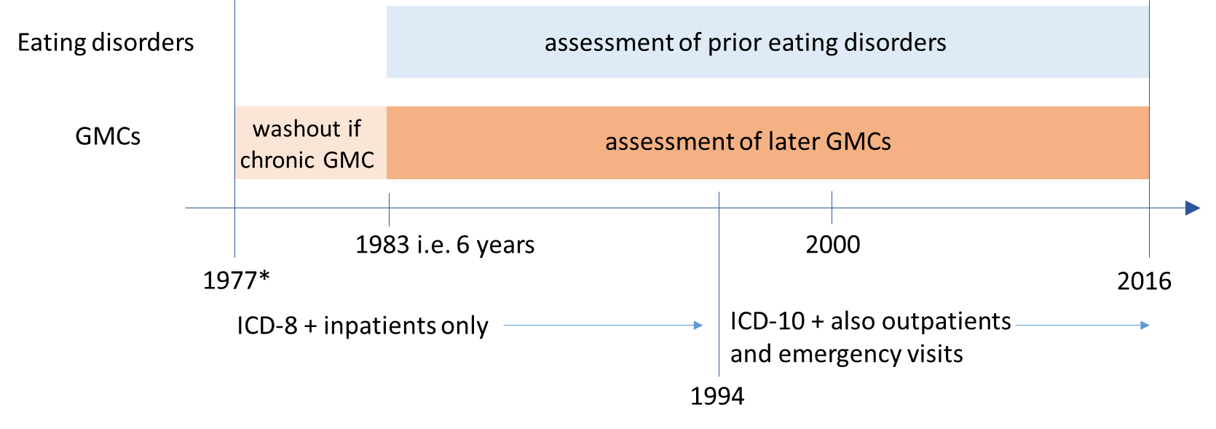
A ii) Pairs including later immune disorders
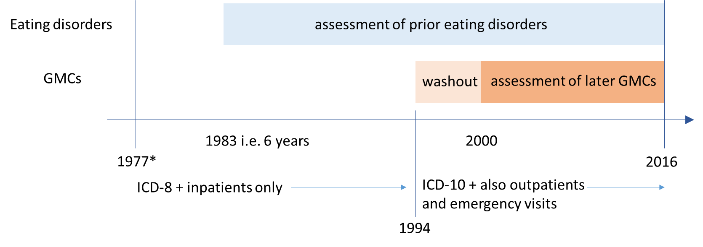

B – Prior MCs-later eating disorders
B i) All pairs except those with later immune disorders
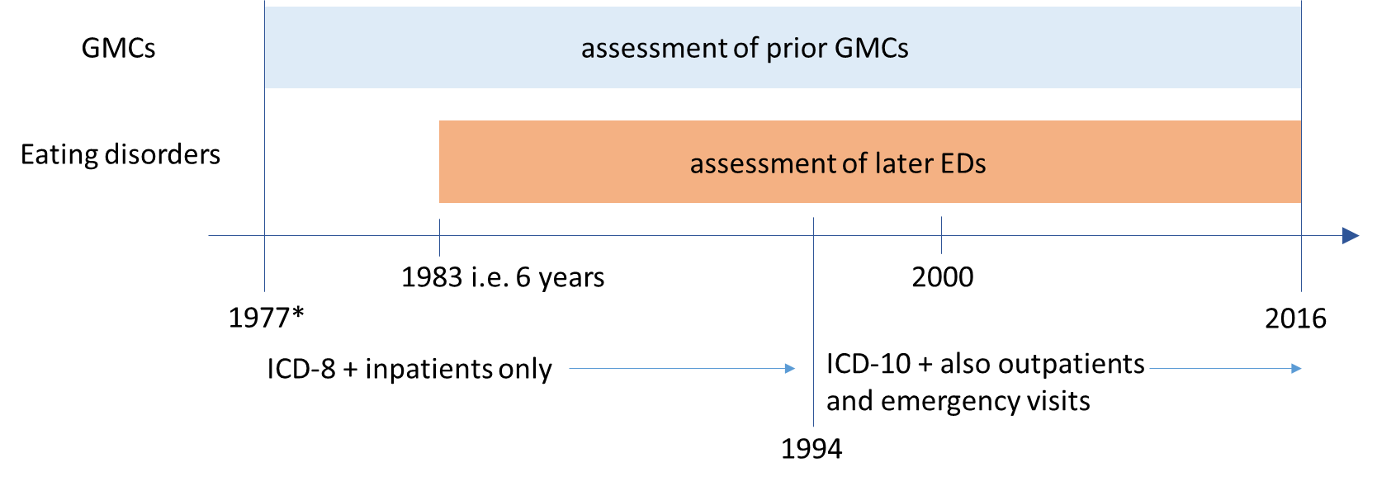

B ii) Pairs including later immune disorders
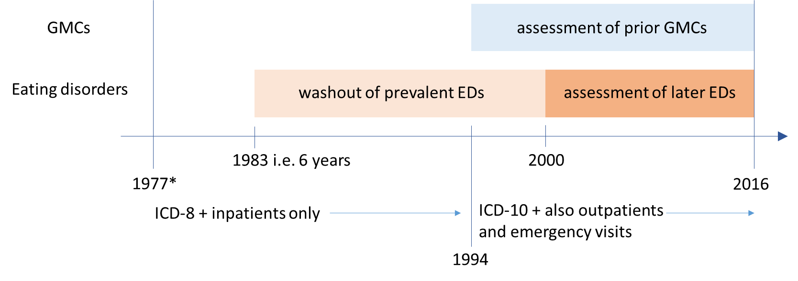
Figure S2A and S2B. Sex-specific bidirectional associations between anorexia nervosa and general medical conditions
The panels show the HRs and 95% CIs of the associations between anorexia nervosa and general medical conditions for females only (A) and males only (B). Estimates were obtained via Cox proportional hazards models with age as the underlying time scale, adjusting for sex, calendar time and other mental disorders with onset before the prior disorder under study. The line of unity is shown as a blue dashed line in each plot.
A - Females
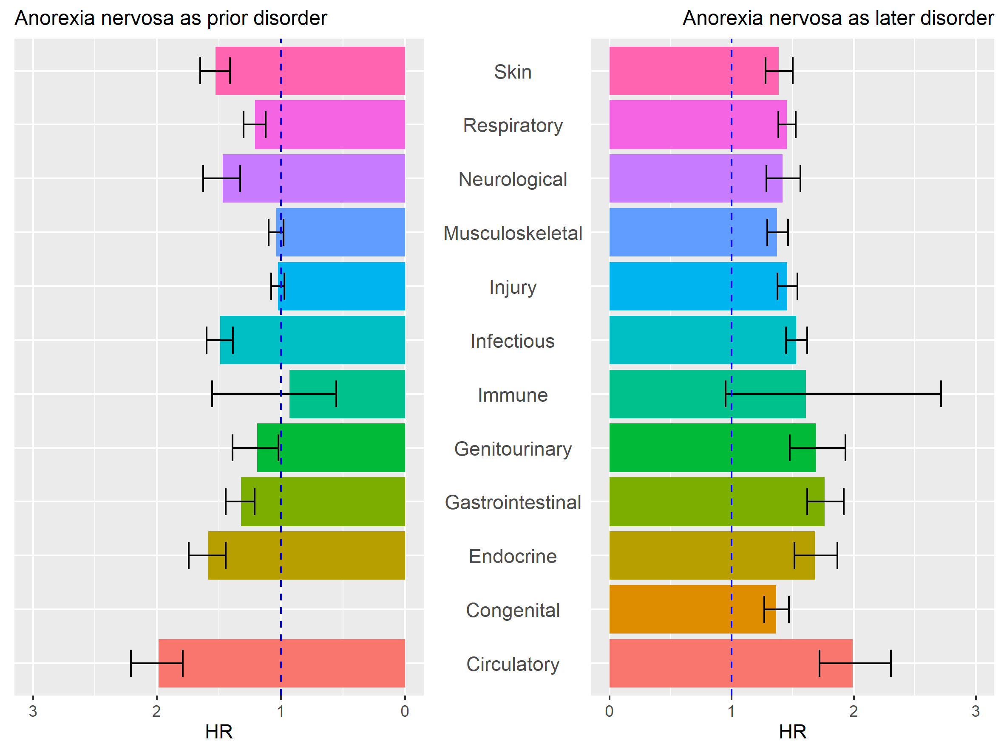
B - Males
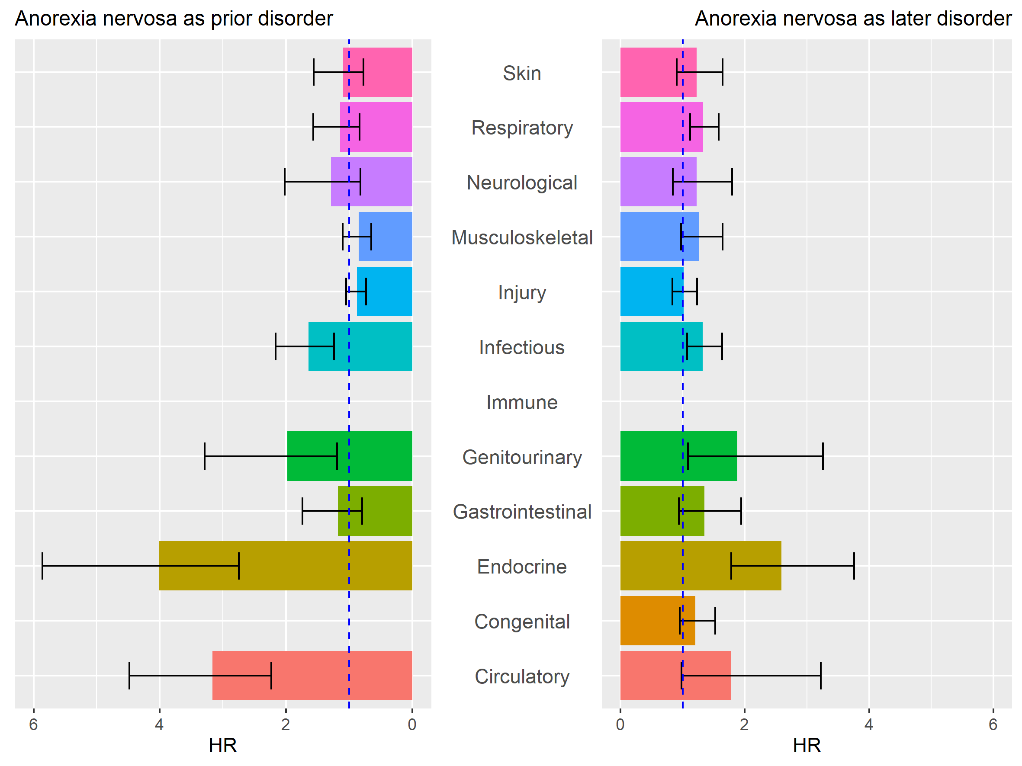
Figure S3A and S3B. Sex-specific bidirectional associations between other eating disorders and general medical conditions
The panels show the HRs and 95% CIs of the associations between other eating disorders and general medical conditions for females only (A) and males only (B). Estimates were obtained via Cox proportional hazards models with age as the underlying time scale, adjusting for sex, calendar time and other mental disorders with onset before the prior disorder under study. The line of unity is shown as a blue dashed line in each plot.
A – Females
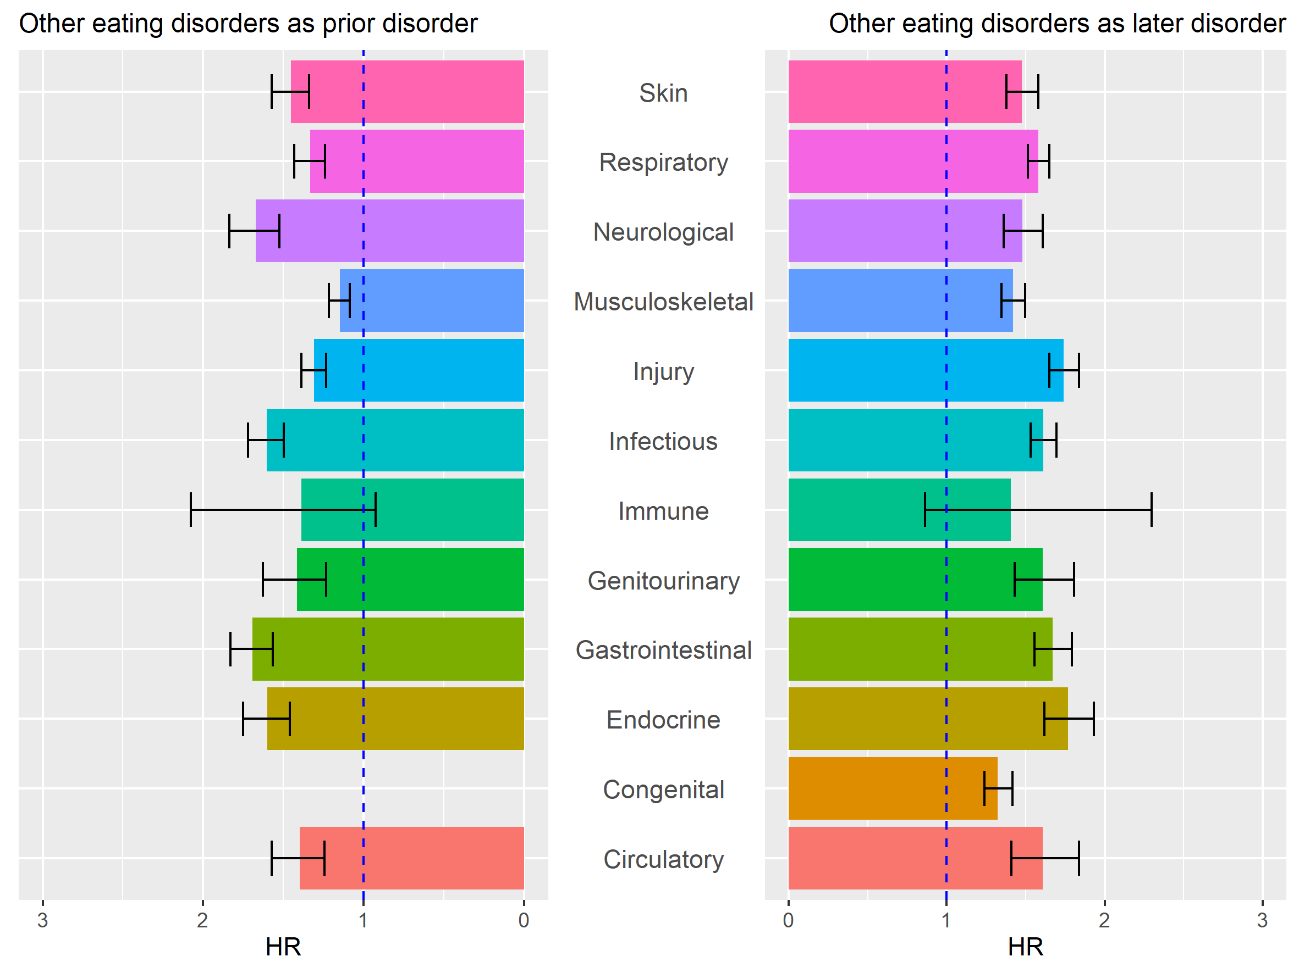
B – Males
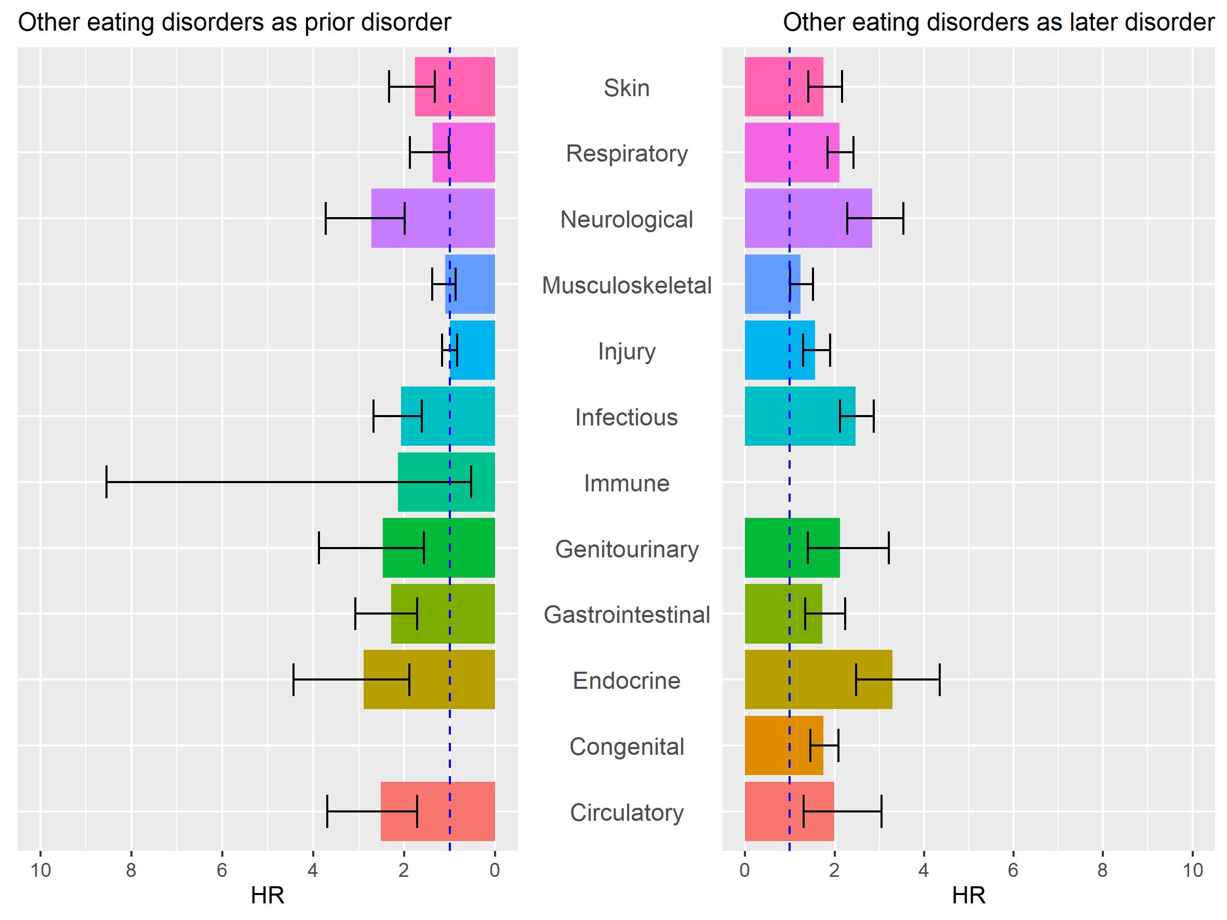
Figure S4A, S4B and S4C. The associations between prior general medical conditions and later bulimia nervosa
The panels show the HRs and 95% CIs of the associations between prior general medical conditions and later bulimia nervosa for all persons (A), females only (B) and males only (C). Estimates were obtained via Cox proportional hazards models with age as the underlying time scale, adjusting for sex, calendar time and other mental disorders with onset before the prior disorder under study. The line of unity is shown as a blue dashed line in each plot.
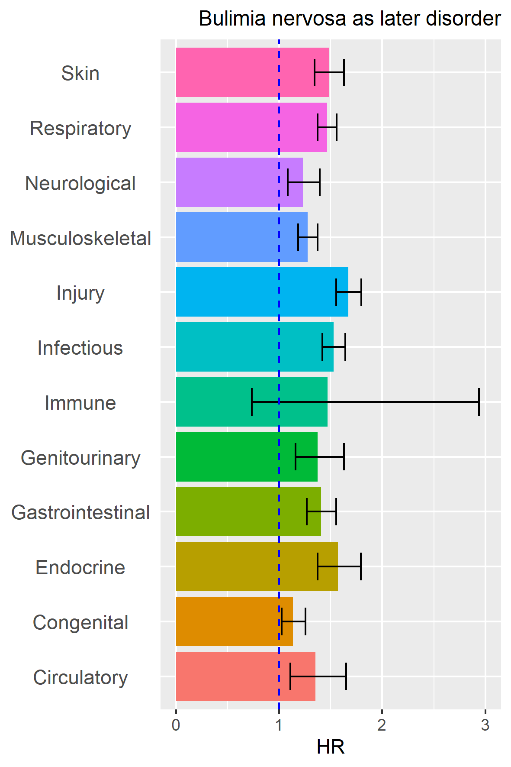
A – all persons B - females
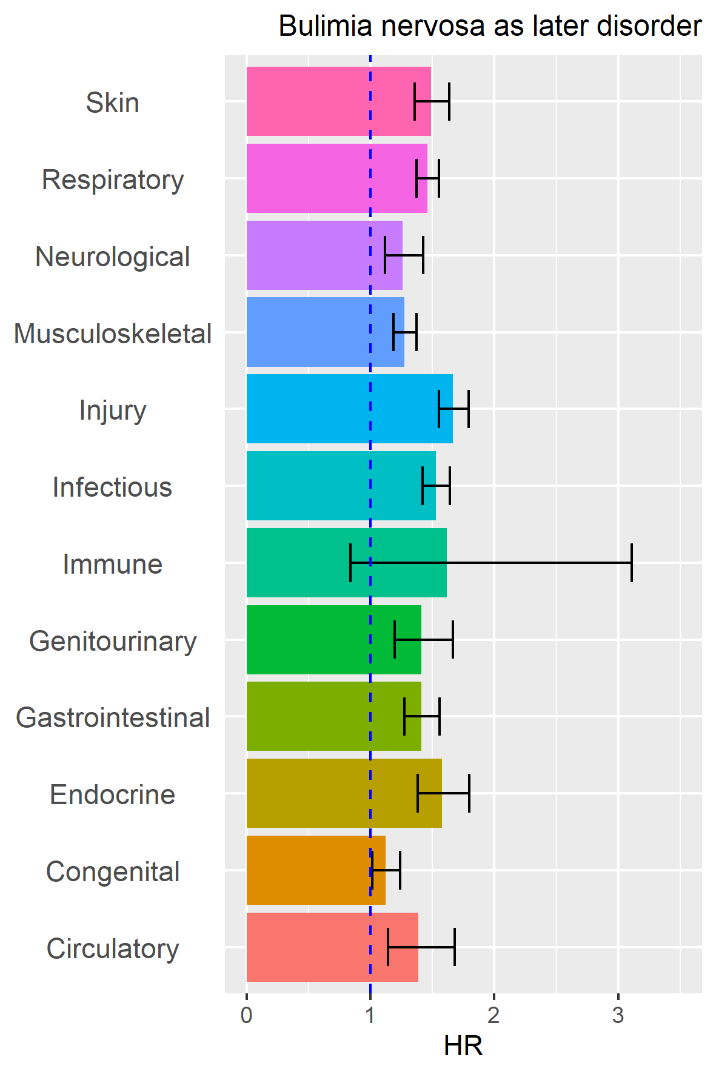
C - males
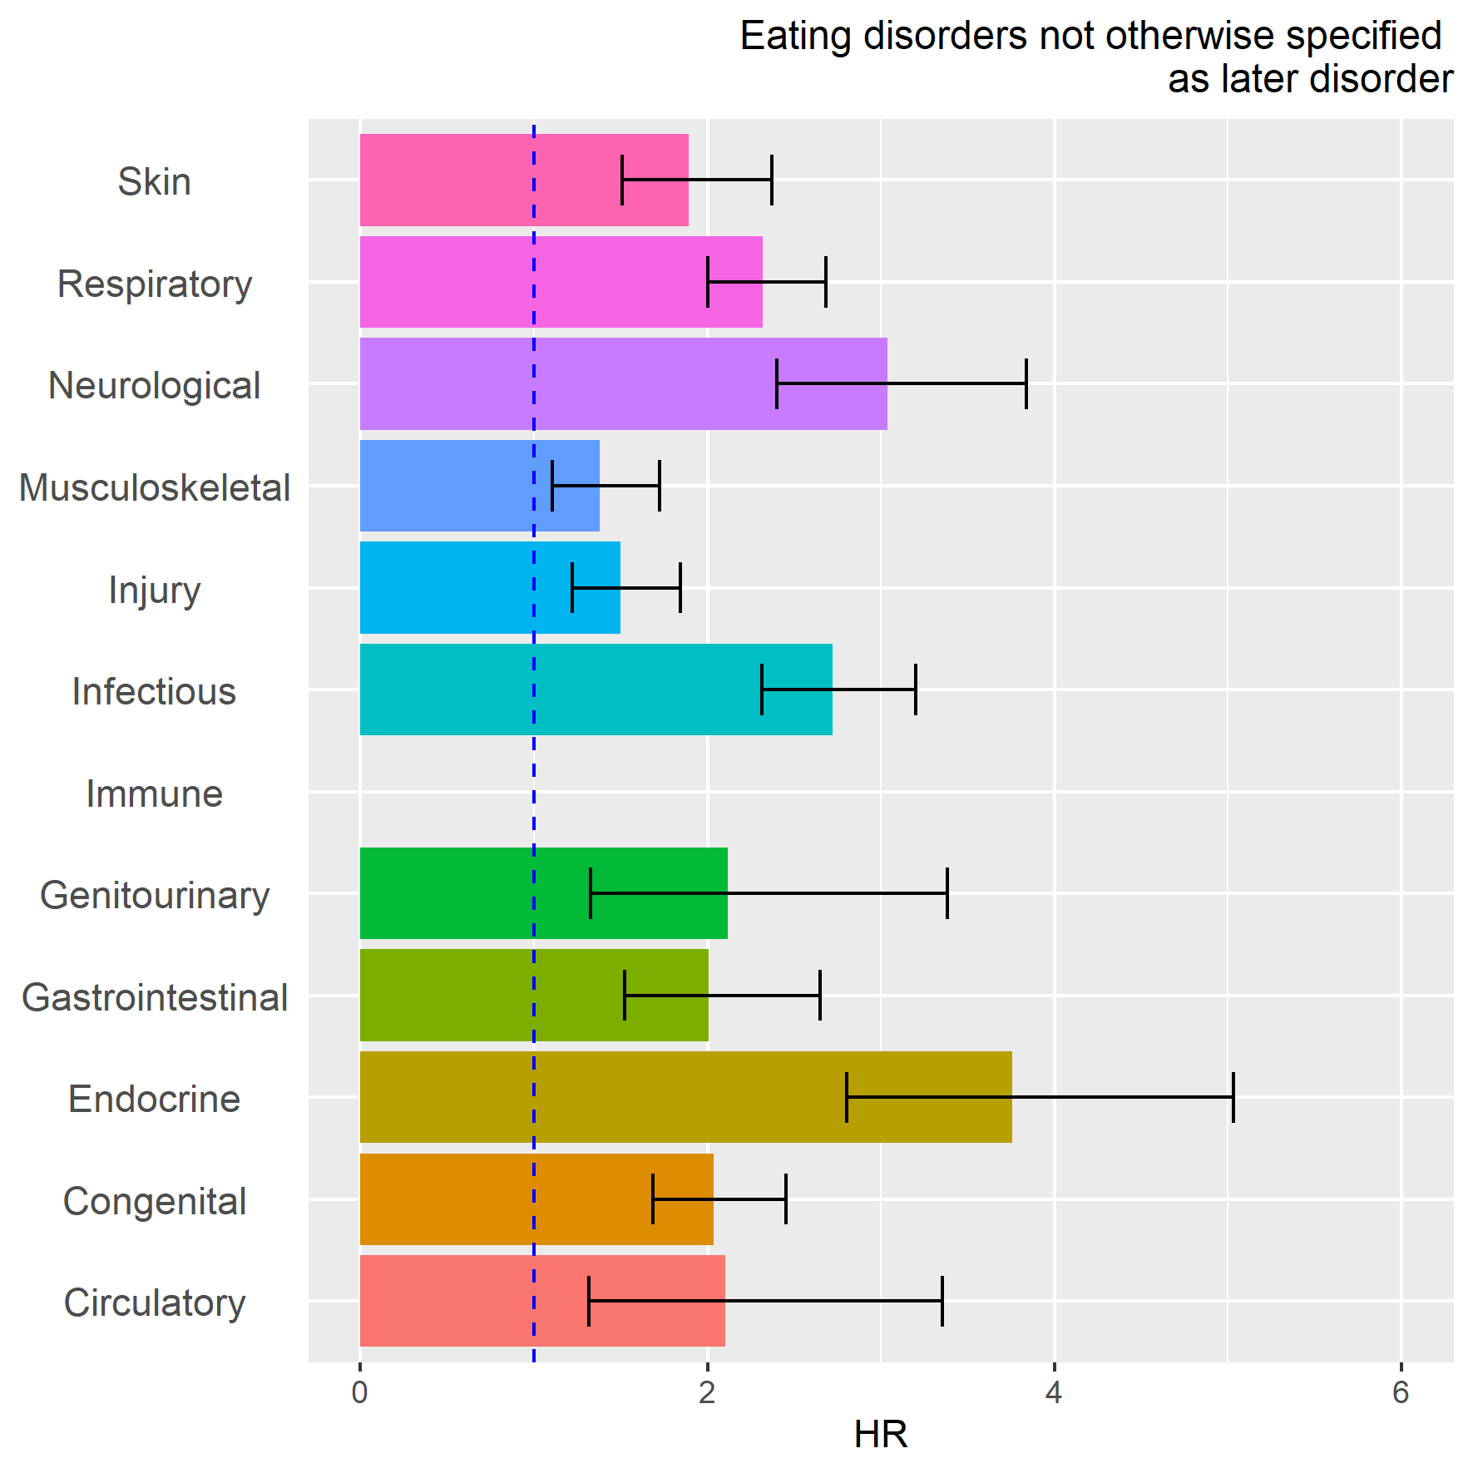
Figure S5. The associations between prior general medical conditions and later eating disorders not otherwise specified
The panel show the HRs and 95% CIs of the associations between prior general medical conditions and later eating disorders not otherwise specified for all persons (A), females only (B) and males only (C). Estimates were obtained via Cox proportional hazards models with age as the underlying time scale, adjusting for sex, calendar time and other mental disorders with onset before the prior disorder under study. The line of unity is shown as a blue dashed line in each plot.
A – all persons B – females
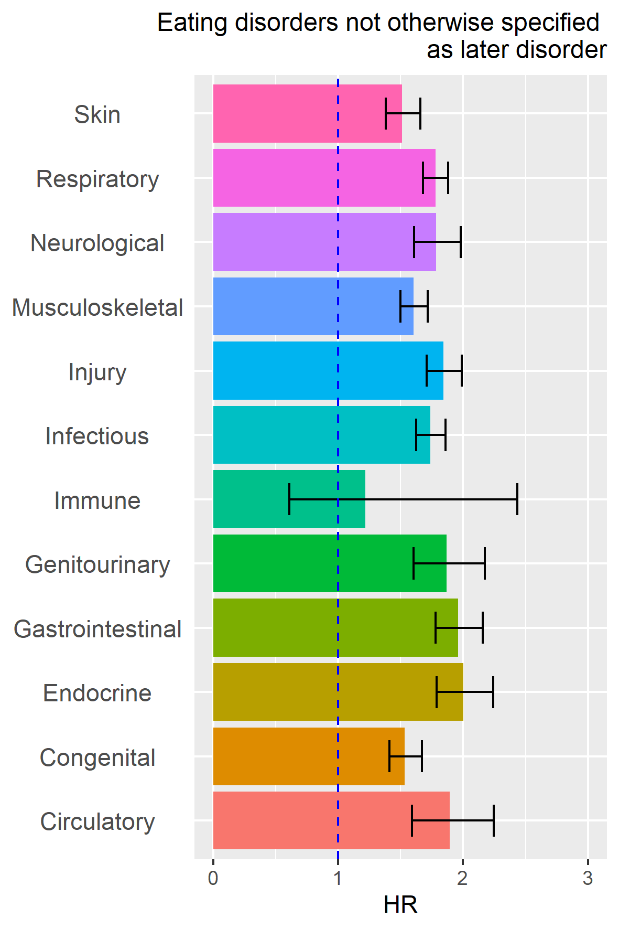
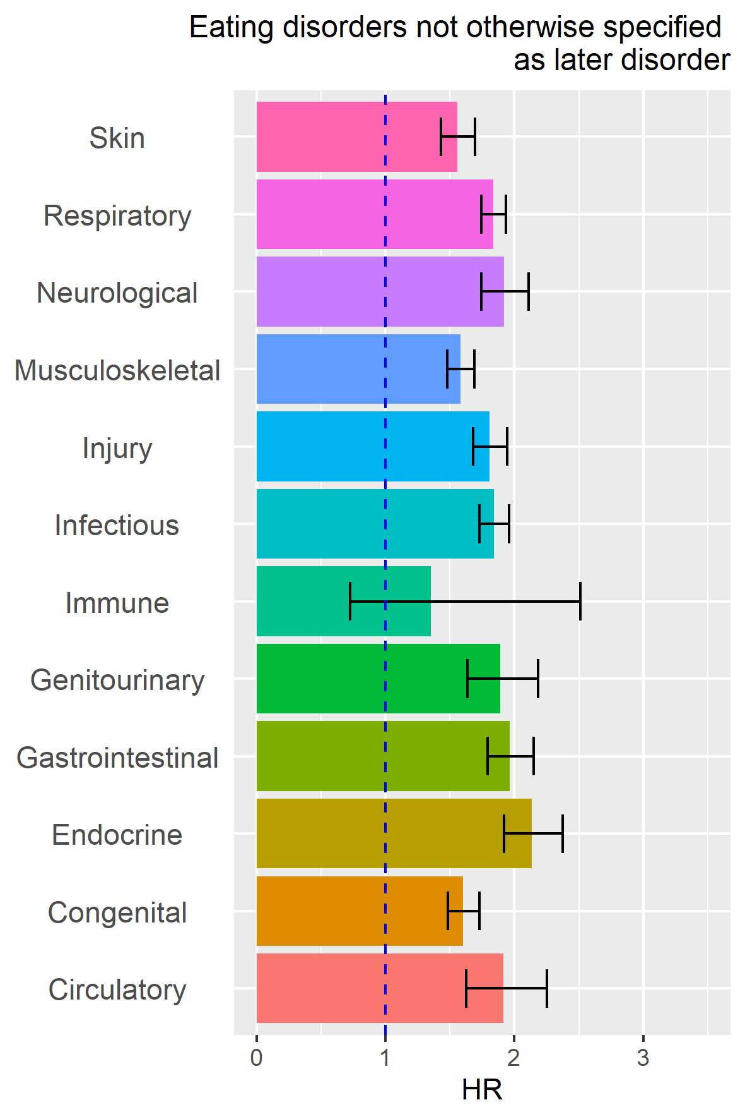
C - males
Figures S6A and S6B. Sex-specific absolute risks for general medical conditions and anorexia nervosa
Figure A shows sex-specific estimates of absolute risks for a later diagnosis with a general medical condition (MC), following a diagnosis of anorexia nervosa (AN). Figure B shows sex-specific absolute risks for a later diagnosis of AN, following a diagnosis of an MC. The cumulative incidence per 100 persons (solid lines for those with the prior disorder of interest, dashed lines for the matched reference groups) of receiving a diagnosis of each later disorder of interest, after a diagnosis of the prior disorder of interest. Males are shown in blue and females in red. Shaded grey areas around the lines for those with the prior disorder of interest represent 95% confidence intervals (in some panels obscured by the estimates line). The horizontal axes show the time since first diagnosis of the prior disorder. The vertical axes show the cumulative incidence per 100 persons (and 95% CI).
A – prior AN-later MCs
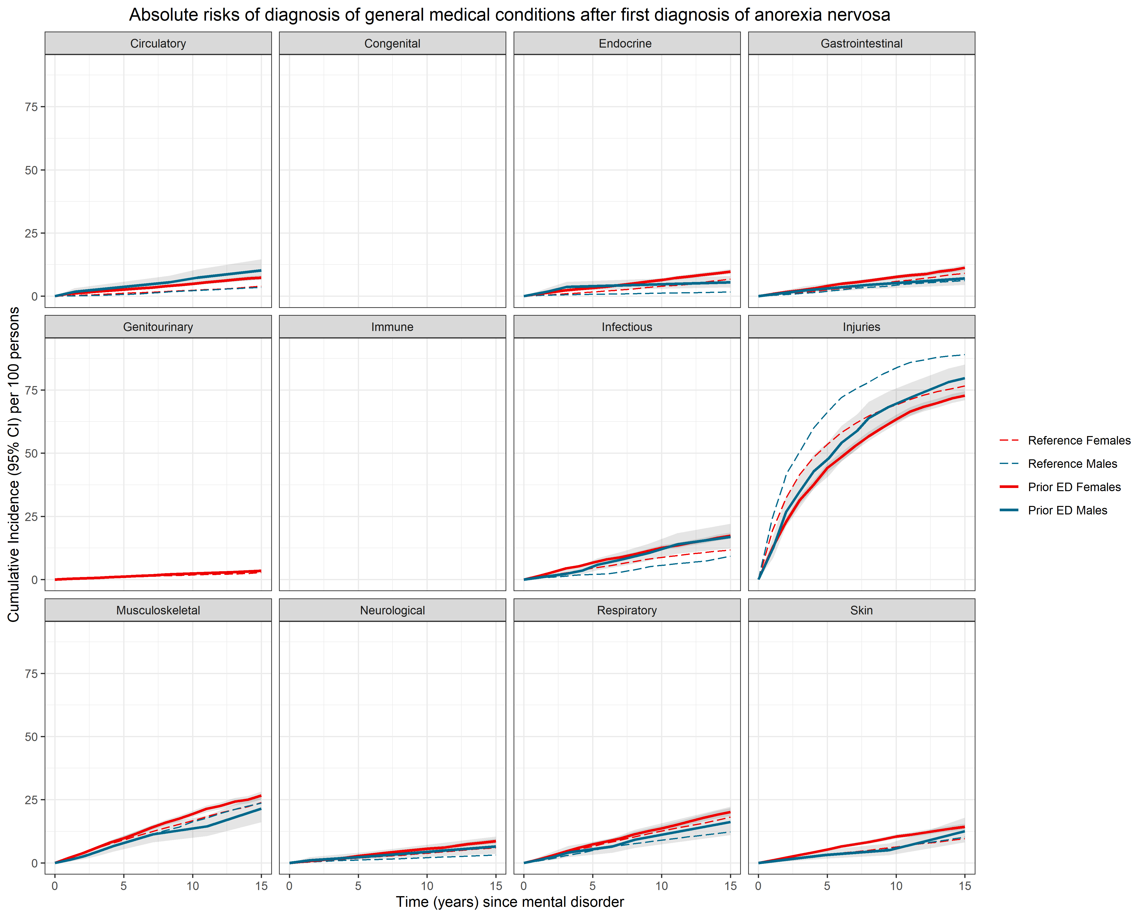

NB. We did not calculate absolute risks for later congenital malformations. Numbers for prior AN nervosa-later immune disorders were too small to meet the regulations for reporting Danish register data.

B – prior MCs-later AN
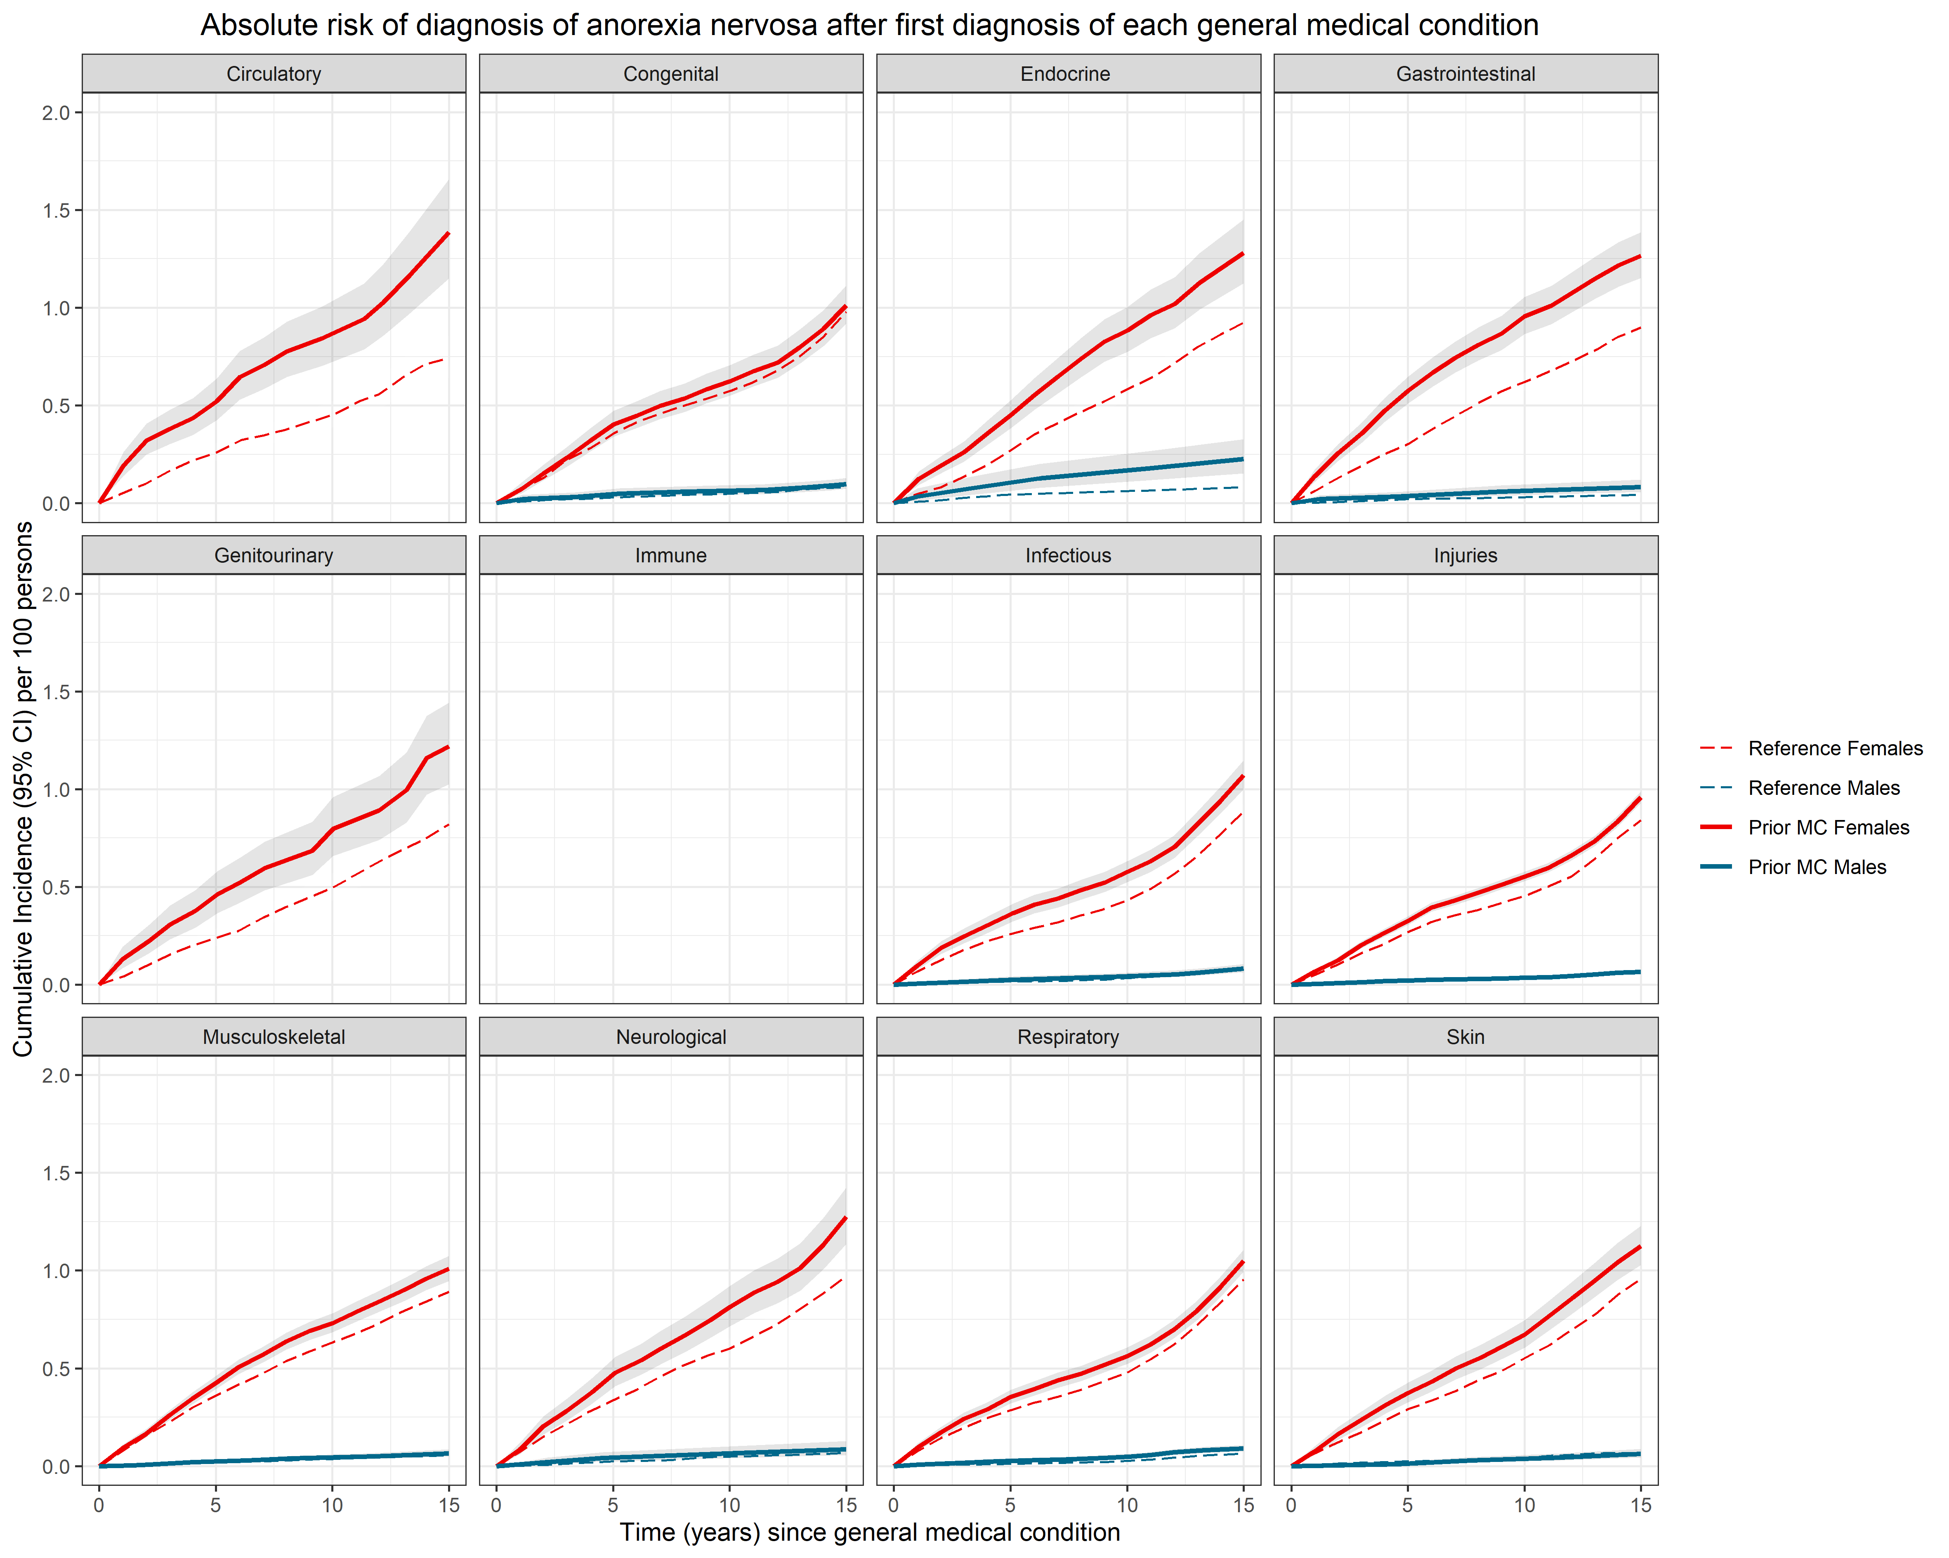

NB. Numbers for prior immune disorder-later AN for both sexes were too small to meet the regulations for reporting Danish register data; as were numbers for males for prior AN with later circulatory and genitourinary disorders

Figures S7A and S7B. Absolute risks for general medical conditions and other eating disorders
Figure A shows estimates of absolute risks for a later diagnosis within a general medical condition (MC), following a diagnosis of an other eating disorder (OED), for all persons. Figure B shows absolute risks for a later diagnosis of OED, following a diagnosis of an MC, for all persons. The cumulative incidence per 100 persons (solid lines for those with the prior disorder of interest, dashed lines for the matched reference groups) of receiving a diagnosis of each later disorder of interest, after a diagnosis of the prior disorder of interest. Shaded grey areas around the lines for those with the prior disorder of interest represent 95% confidence intervals (in some panels these are obscured by the estimates line). The horizontal axes show the time since first diagnosis of the prior disorder. The vertical axes show the cumulative incidence per 100 persons (and 95% CI). Note that vertical axes are not on the same scale for Figure A and Figure B.

A – prior OED-later MCs
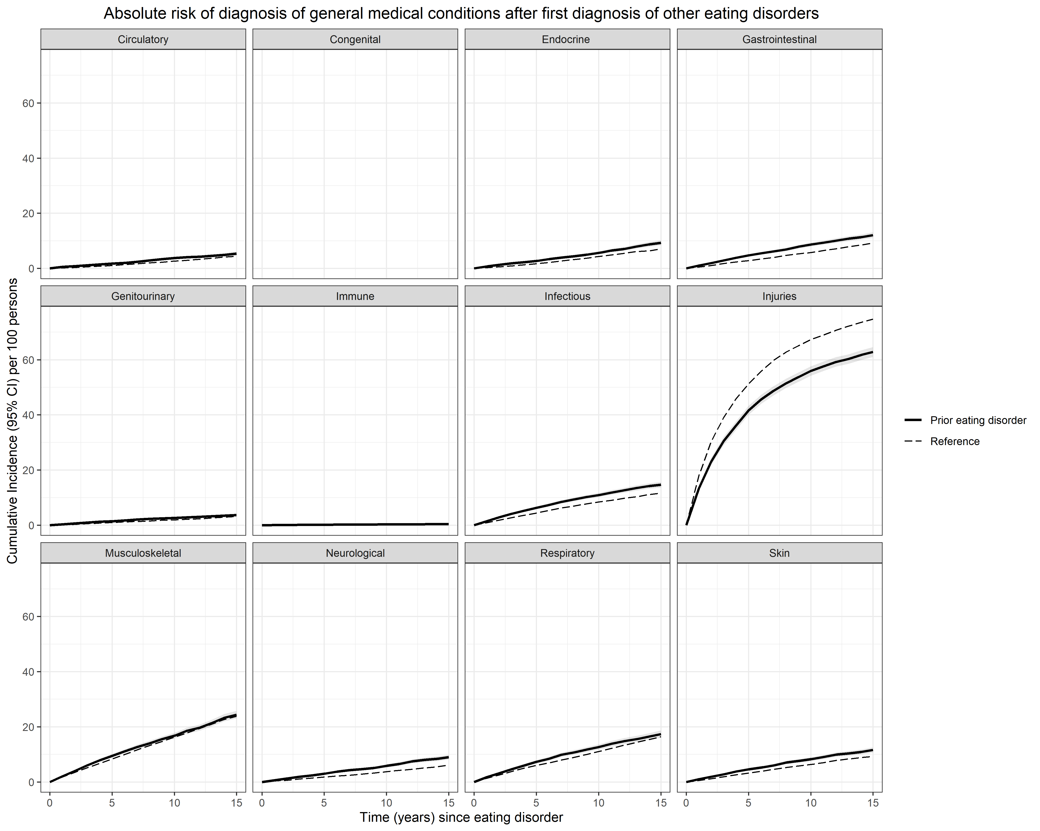
NB. We did not calculate absolute risks for later congenital malformations.
B – prior MCs-later OED
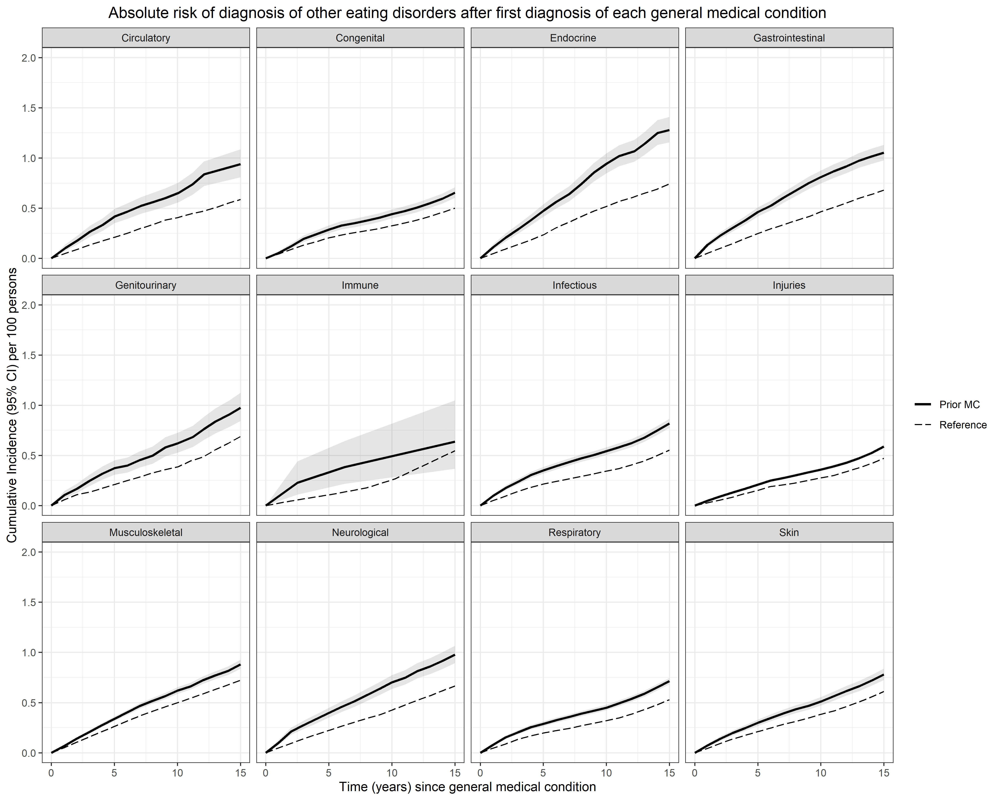

Figures S8A and S8B. Sex-specific absolute risks for general medical conditions and other eating disorders
Figure A shows sex-specific estimates of absolute risks for a later diagnosis with a general medical condition (MC), following a diagnosis of other eating disorders (OED). Figure B shows sex-specific absolute risks for a later diagnosis of OED, following a diagnosis of an MC. The cumulative incidence per 100 persons (solid lines for those with the prior disorder of interest, dashed lines for the matched reference groups) of receiving a diagnosis of each later disorder of interest, after a diagnosis of the prior disorder of interest. Males are shown in blue and females in red. Shaded grey areas around the lines for those with the prior disorder of interest represent 95% confidence intervals (in some panels obscured by the estimates line). The horizontal axes show the time since first diagnosis of the prior disorder. The vertical axes show the cumulative incidence per 100 persons (and 95% CI).
A – prior OED-later MCs
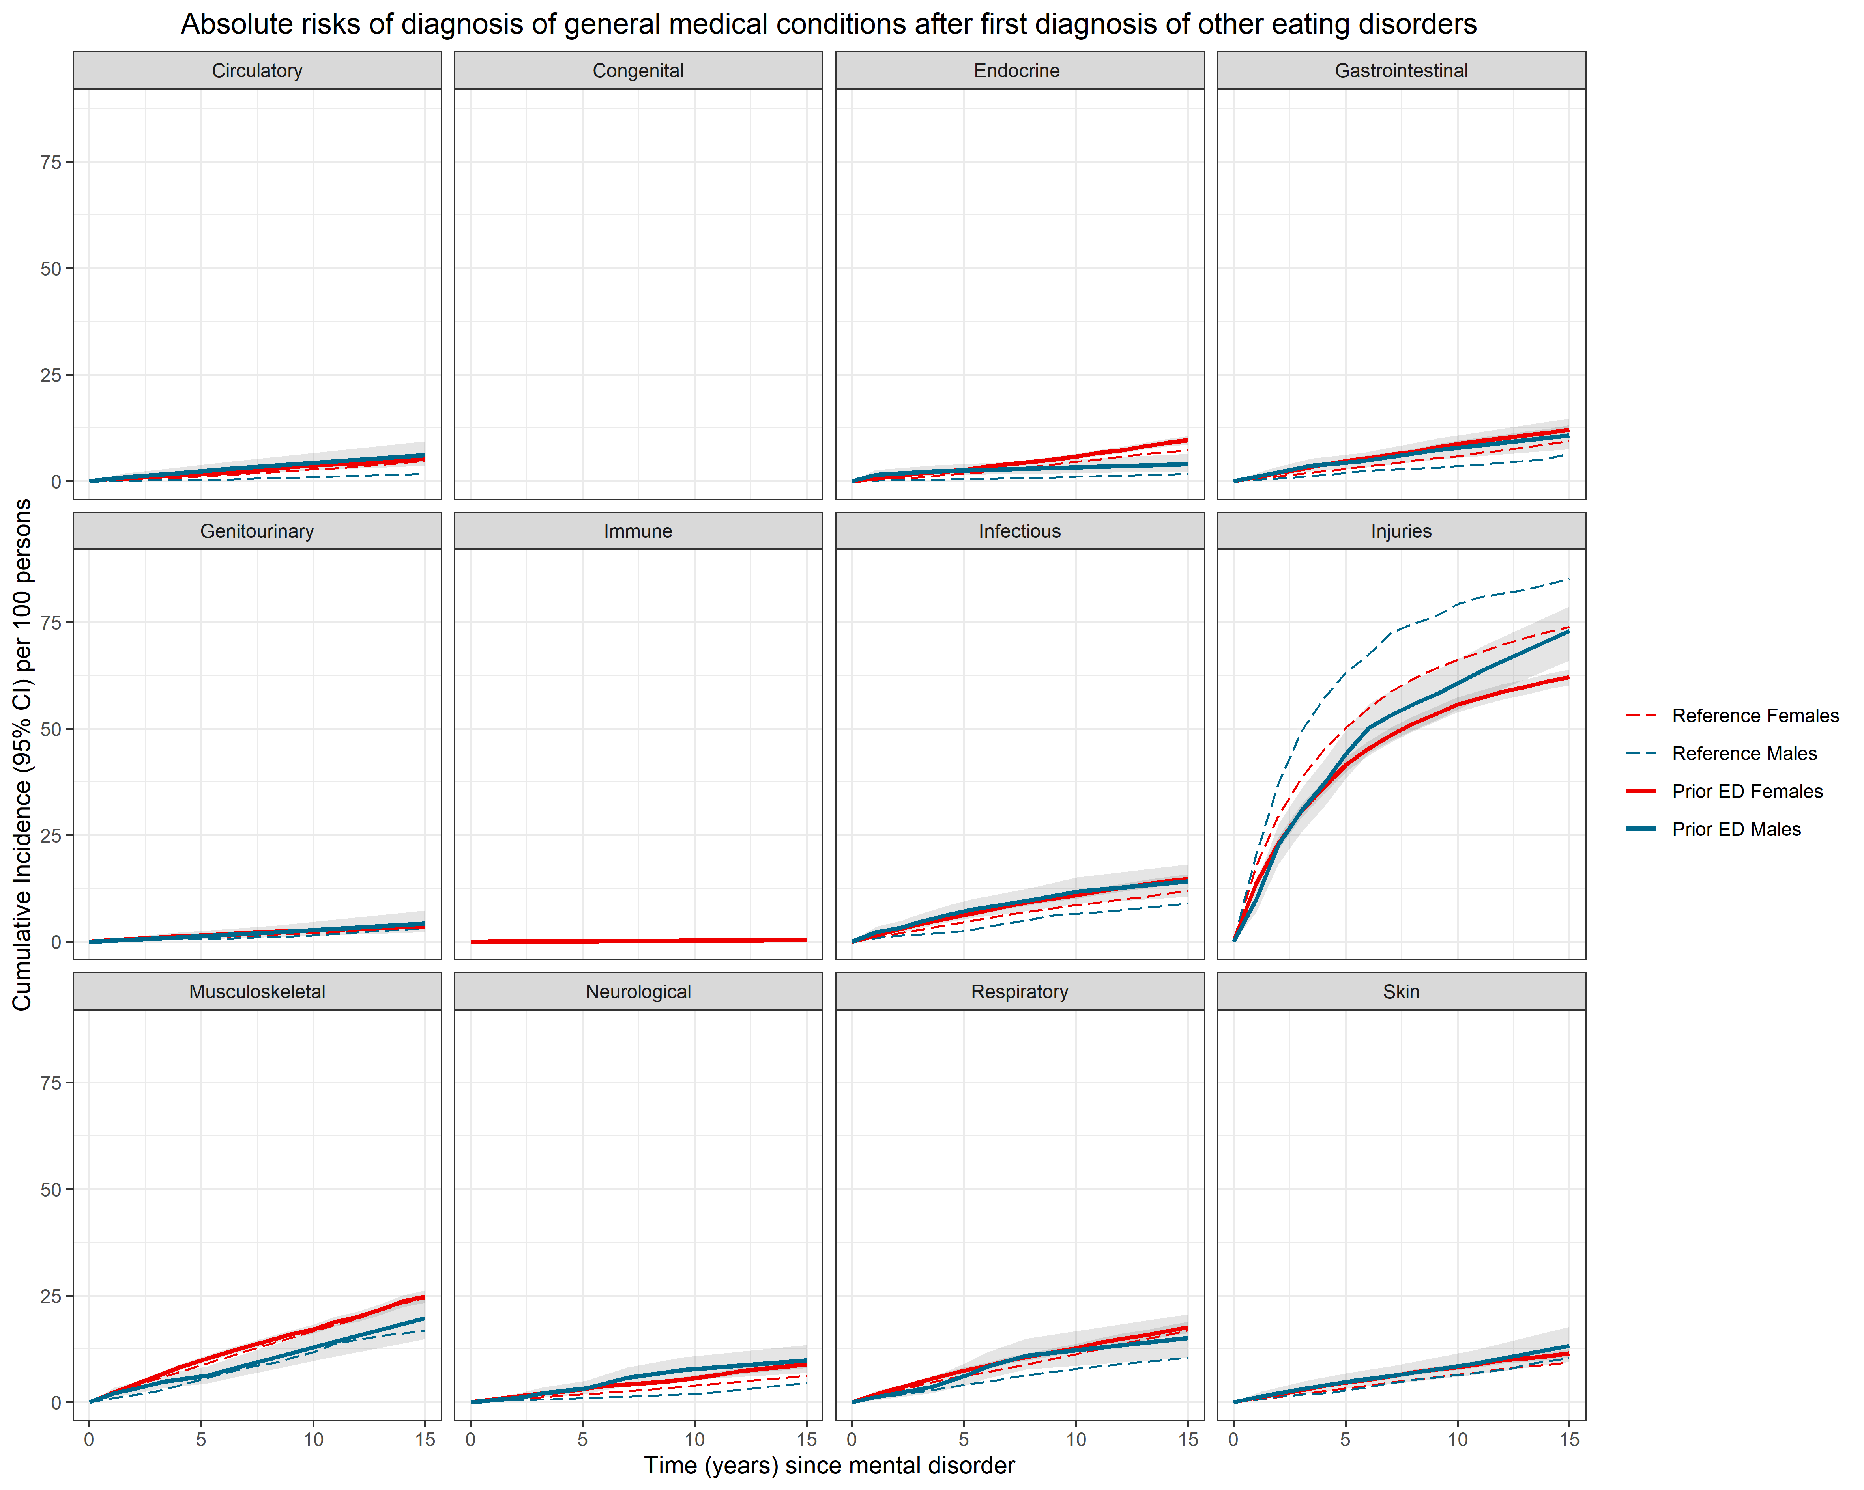

NB. We did not calculate absolute risks for later congenital malformations. Numbers for prior OED-later immune disorders for males were too small to meet the regulations for reporting Danish register data.

B – prior MCs-later OED
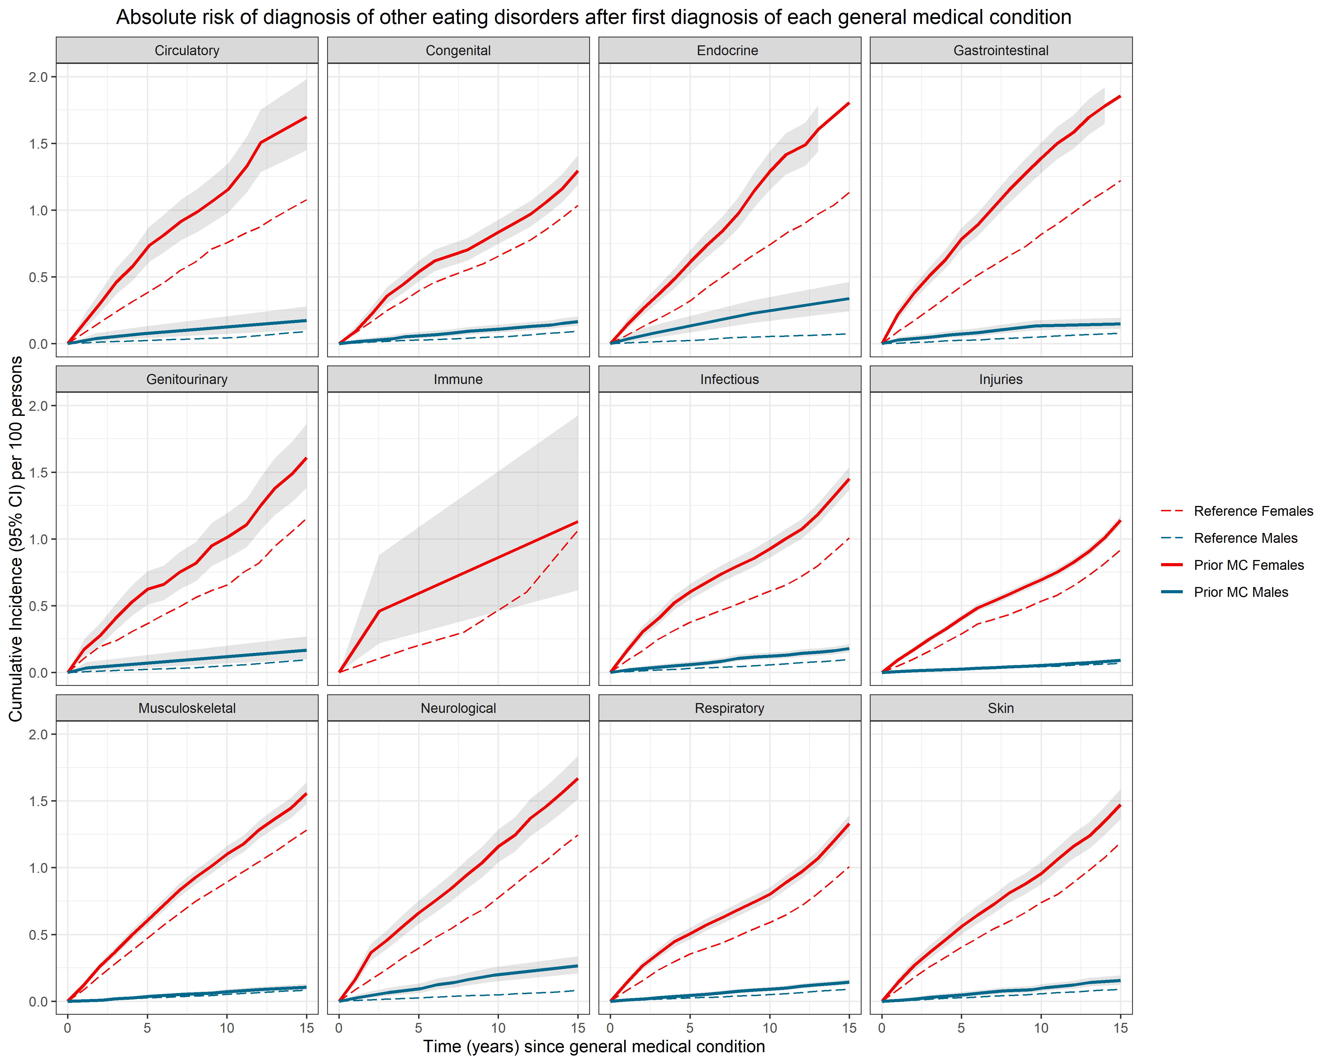

NB. Numbers for prior immune disorders-later OED for males were too small to meet the regulations for reporting Danish register data.

Figure S9A and S9B. Absolute risks for general medical conditions and bulimia nervosa
Figure A shows estimates of absolute risks for a later diagnosis of bulimia nervosa (BN), following a diagnosis of a general medical condition (MC), for all persons. The cumulative incidence per 100 persons (solid lines for those with the prior disorder of interest, dashed lines for the matched reference groups) of receiving a diagnosis of each later disorder of interest, after a diagnosis of the prior disorder of interest. Shaded grey areas around the lines for those with the prior disorder of interest represent 95% confidence intervals (in some panels obscured by the estimates line). The horizontal axes show the time since first diagnosis of the prior disorder. The vertical axes show the cumulative incidence per 100 persons (and 95% CI).
Figure B shows sex-specific absolute risks for a later diagnosis of BN, following a diagnosis of a MC. Males are shown in blue and females in red.
A – prior MCs-later BN, all persons
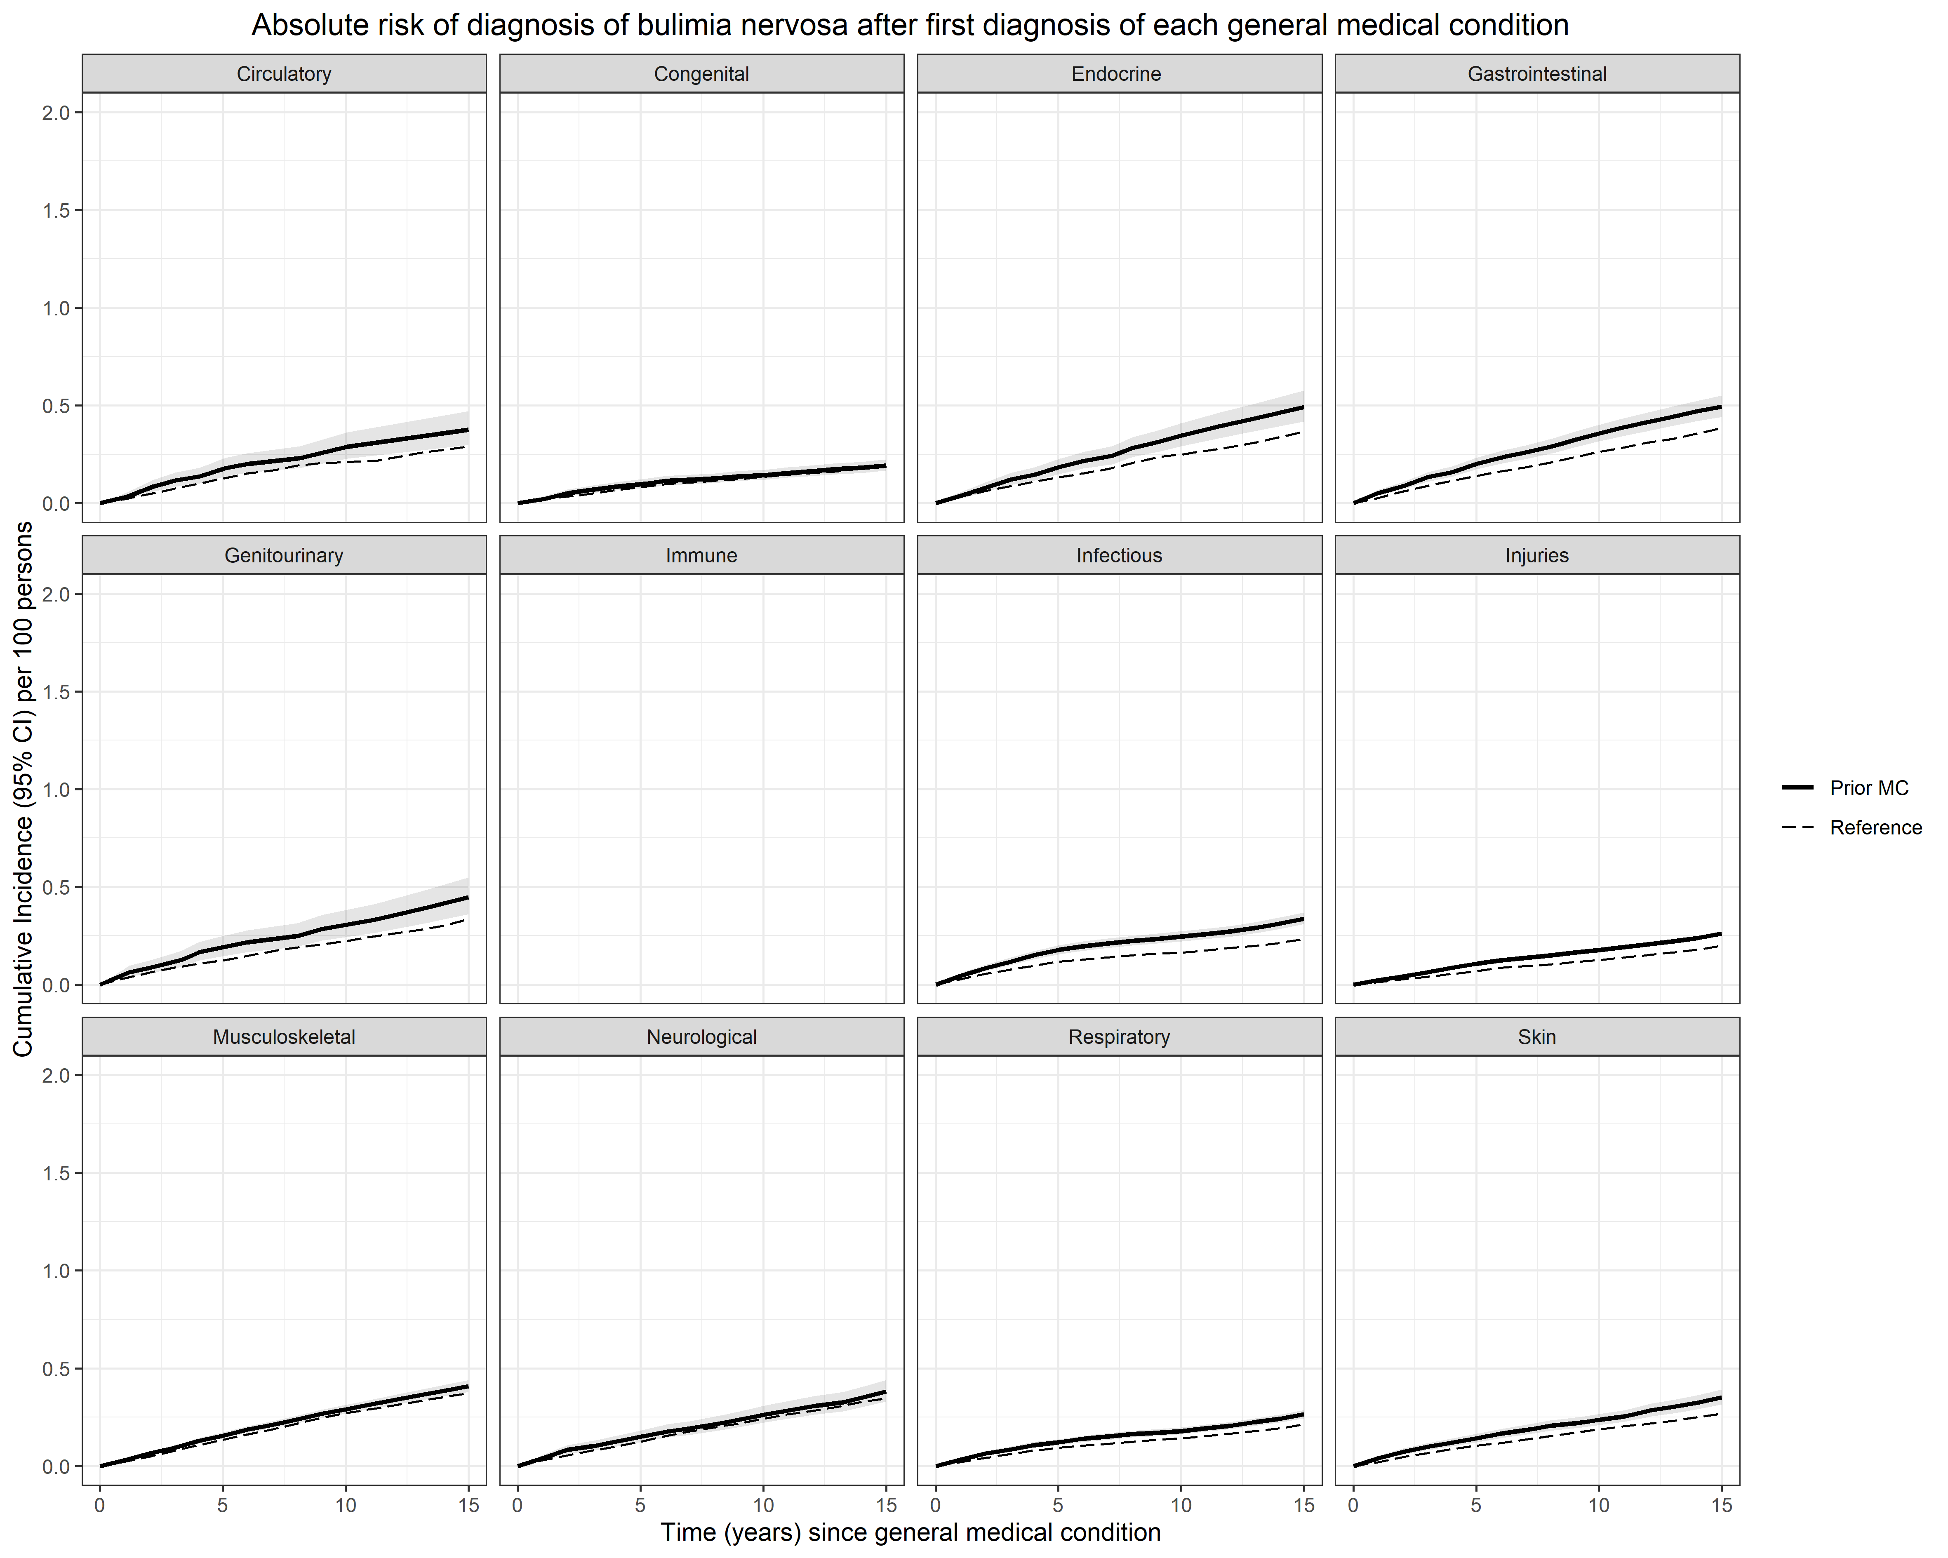

NB. Numbers for prior immune disorders-later BN were too small to meet the regulations for reporting Danish register data.

B – prior MCs-later BN, sex specific
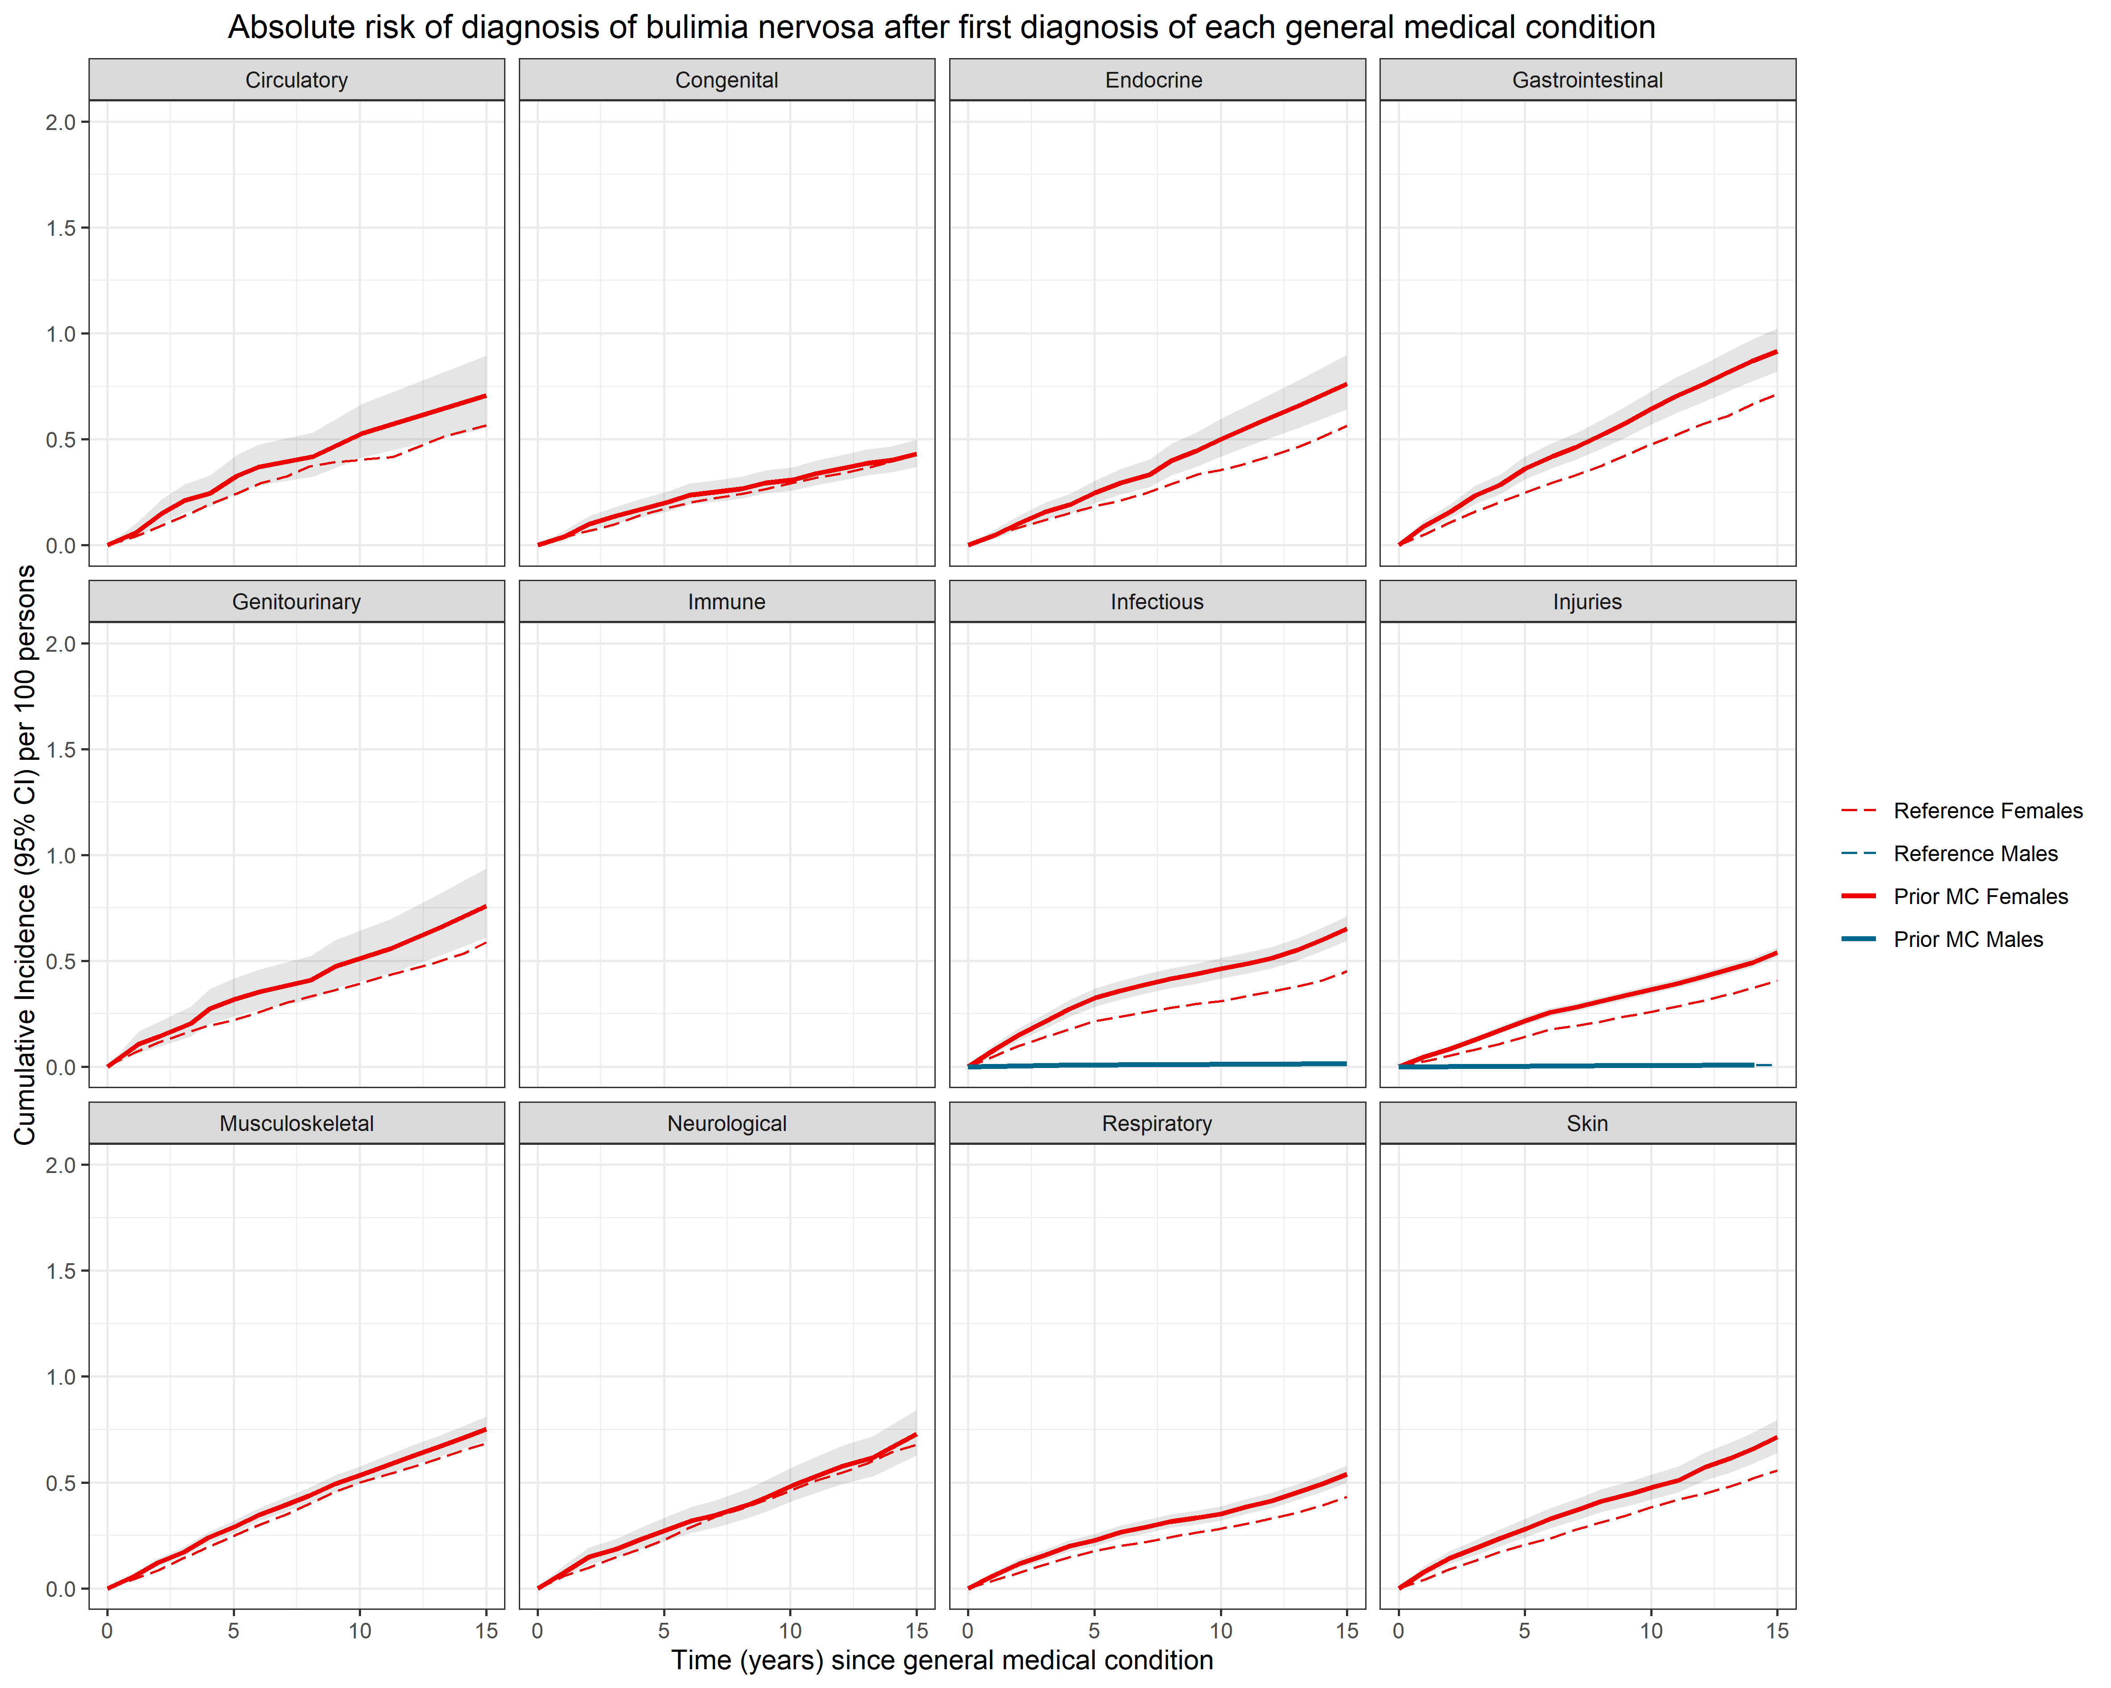

NB. Numbers for later BN for males were too small for all MCs except infections and injuries to meet the regulations for reporting Danish register data.

Figure S10A and S10B. Absolute risks for general medical conditions and eating disorders not otherwise specified
Figure A shows estimates of absolute risks for a later diagnosis of eating disorders not otherwise specified (EDNOS), following a diagnosis of a general medical condition (MC), for all persons. The cumulative incidence per 100 persons (solid lines for those with the prior disorder of interest, dashed lines for the matched reference groups) of receiving a diagnosis of each later disorder of interest, after a diagnosis of the prior disorder of interest. Shaded grey areas around the lines for those with the prior disorder of interest represent 95% confidence intervals (in some panels obscured by the estimates line). The horizontal axes show the time since first diagnosis of the prior disorder. The vertical axes show the cumulative incidence per 100 persons (and 95% CI).
Figure B shows sex-specific absolute risks for a later diagnosis of EDNOS, following a diagnosis of a MC. Males are shown in blue and females in red.
A – prior MCs-later EDNOS, all persons
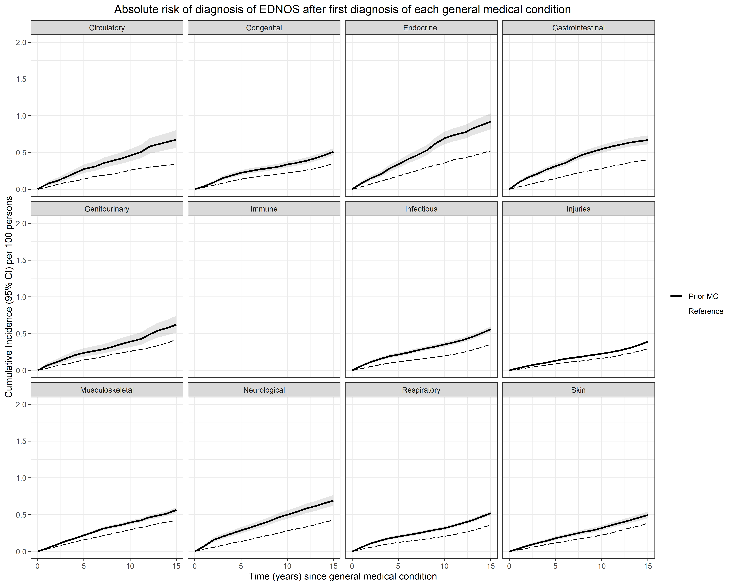

NB. Numbers for prior immune disorders-later EDNOS were too small to meet the regulations for reporting Danish register data.

B – prior MCs-later EDNOS, sex specific
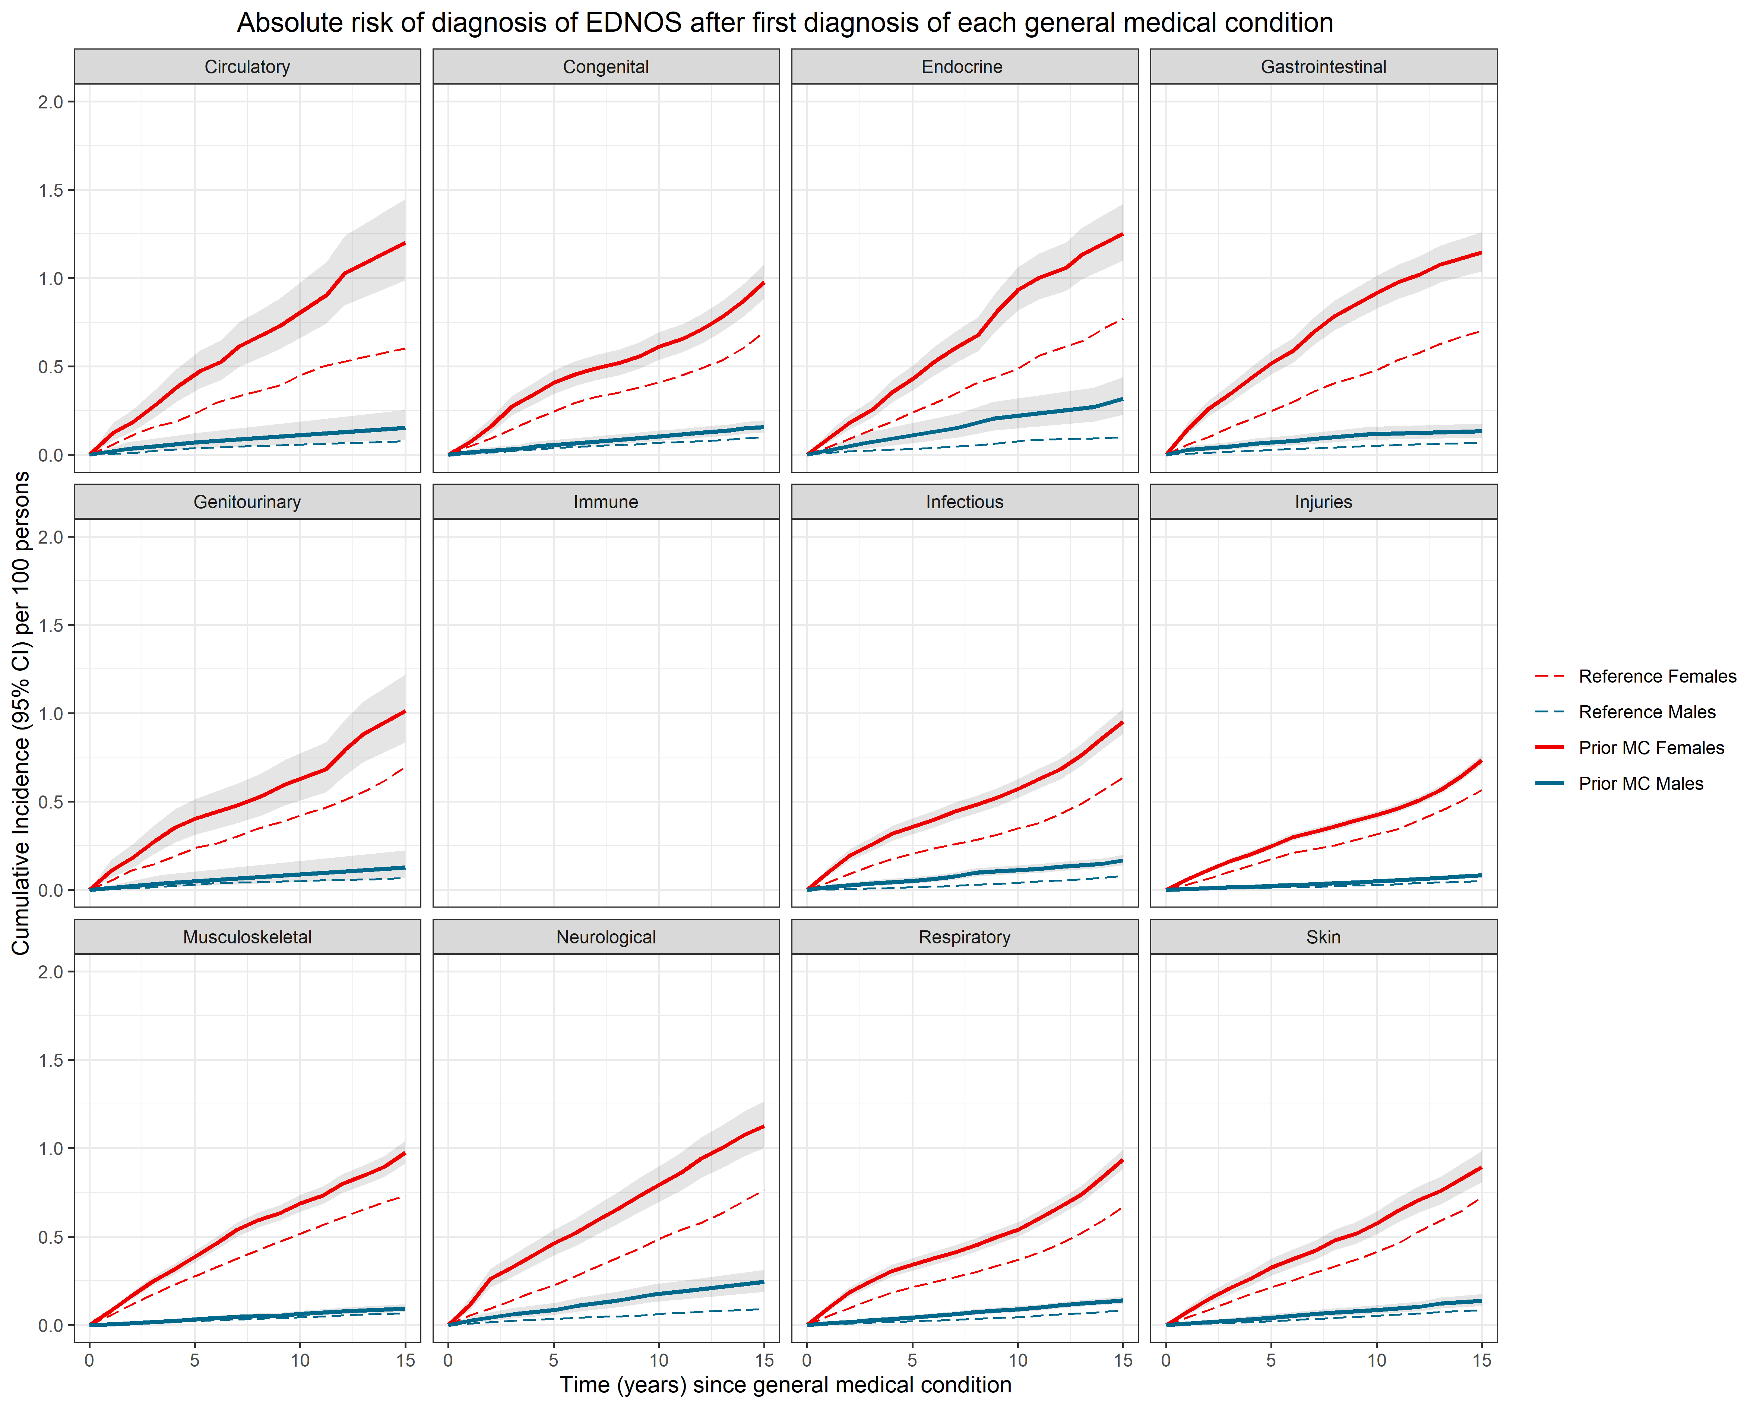

NB. Numbers for prior immune disorders-later EDNOS for males were too small to meet the regulations for reporting Danish register data.

References
1. Pedersen CB. The Danish Civil Registration System. Scand J Public Health 2011;39:22-5.
2. Mors O, Perto GP, Mortensen PB. The Danish Psychiatric Central Research Register. Scandinavian Journal of Public Health 2011;39:54-7.
3. Lynge E, Sandegaard JL, Rebolj M. The Danish National Patient Register. Scandinavian Journal of Public Health 2011;39:30-3.
4. World Health Organization. International classification of diseases: Manual of the international statistical classification of diseases, injuries and causes of death (ICD-8). Geneva: WHO; 1967.
5. World Health Organization. International classification of diseases and related health problems, 10th revision. Geneva: World Health Organization; 1992.
6. Thornton LM, Watson HJ, Jangmo A, et al. Binge-eating disorder in the Swedish national registers: Somatic comorbidity. Int J Eat Disord 2017;50:58-65.
7. Helweg-Larsen K. The Danish Register of Causes of Death. Scand J Public Health 2011;39:26-9.
8. Plana-Ripoll O, Pedersen CB, Holtz Y, et al. Exploring Comorbidity Within Mental Disorders Among a Danish National Population. JAMA Psychiatry 2019;76:259–70.
9. Momen NC, Plana-Ripoll O, Agerbo E, et al. Association between Mental Disorders and Subsequent Medical Conditions. N Engl J Med 2020;382:1721-31.
10. Xu R, O'Quigley J. Estimating average regression effect under non-proportional hazards. Biostatistics 2000;1:423-39.

