Supplementary Materials

1. Supplementary Methods

1.1. Data

1.1.1. The exclusion criteria
The exclusion criteria for patients were as follows: (1) the existence of a neurological disorder; (2) a history of drug dependence or abuse; (3) pregnancy; and (4) major physical illness such as cardiovascular disease or hepatitis, as assessed by clinical evaluations and medical records. Another exclusion criteria for the patient group was any other DSM-IV axes I comorbidity. Another exclusion criterion for the HCs group was a history of known psychiatric illness in first-degree relatives based on clinical interviews with participants.

1.1.2. MRI acquisition and preprocessing procedures
The MRI examinations were performed on a whole-body 3.0 T MRI scanner (Siemens Trio, Erlangen, Germany) with a 12-channel head coil. Participants were fitted with soft ear plugs, positioned comfortably in the coil and instructed to relax with their eyes closed but not to fall asleep and remain still. Head motion was minimized with foam pads. High-resolution three-dimensional T1-weighted images were acquired using a spoiled gradient recalled sequence with TR/TE = 1900/2.26 ms, flip angle = 9°, 176 sagittal slices with 1 mm slice thickness, field of view (FOV) = 240 × 240 mm² and matrix size = 256 × 256, yielding an in-plane resolution of 0.94 × 0.94 mm². The rs-fMRI data were also collected using an echo planar imaging (EPI) sequence but with the following settings: TR/TE = 2000/30 ms, fip angle = 90°, slice thickness = 3 mm with a 1-mm gap, FOV = 240×240 mm², matrix size =64×64, and yielding an in-plane resolution of = 3.125×3.125 mm². Each scan lasted 400 s (ie, 200 volumes).
All MRI data analyses were done with SPM12 (Welcome Department of Imaging Neuroscience, London, UK; http://www.fil.ion.ucl.ac.uk/spm) and CONN (http://www.nitrc.org/projects/conn), which incorporates a series of methods to both minimize the influence of head motion artifacts and allow for valid identification of correlated and anti-correlated network.¹ As fMRI-based functional connectivity is susceptible to in-scanner motion artefacts, appropriate preprocessing and signal cleaning is key to address potential spurious correlations in resting-state networks. We used the Artifact Detection Tools (ART, http://www.nitrc.org/projects/artifact_detect) which is implemented in CONN to identify problematic time points during the scan. Specifically, an image was defined as an outlier image if the head displacement in x, y, or z direction was greater than 0.5 mm from the previous frame, or if the global mean intensity in the image was greater than 3 standard deviations from the mean image intensity for the entire resting scan. If more than 30% volumes were defined as outlier images, we excluded the runs from subsequent analysis. Three participants were dropped due to excessive head motion. The temporal timeseries characterizing the estimated participant motion, 3 rotation and 3 translation parameters, their squared versions, their derivates and the squared derivates (known as the Friston-24-expansion² and artifactual covariates (one covariate per artifactual time point consisting of 0’s everywhere and a “1” for the artifactual time point), were used as nuisance regressors in the first level general linear model (GLM).
Anatomical volumes were segmented into grey matter, white matter, and CSF areas, and the resulting masks were eroded (one voxel erosion) to minimize partial volume effects. The union of the eroded white-matter maps and ventricle masks were transformed to the native functional space and used for extracting noise-signal for anatomical CompCor correction.³ Then, 6 CompCor parameters (the BOLD timeseries within the participant-specific white matter mask (3 PCA parameters) and CSF mask (3 PCA parameters)), the Friston-24 motion parameters and the linear trend were removed from the timeseries data with a GLM. The resulting residual BOLD timeseries were band-pass filtered (0.008Hz < f < 0.09Hz).

1.2. Analyses

1.2.1. Group independent component analysis (Group-ICA)

1.2.1.1. Independent Component Analysis (ICA)
A data-driven technique of group spatial ICA was performed using the CONN on the preprocessed images, which decomposed the data into spatial independent components (ICs). Specifically, the CONN toolbox implementation uses Calhoun’s group-level ICA approach with variance normalization preconditioning, subject-level dimensionality reduction, subject/condition concatenation of BOLD signal data along the temporal dimension, group-level dimensionality reduction (to the target number of dimensions/components), fast-ICA for estimation of independent spatial components, and GICA1 back-projection for individual subject-level spatial map estimation.⁴ Group-level components were estimated using a 64-dimensions subject-level dimensionality reduction step, followed by 30- component group-level dimensionality reduction and fast-ICA with a hyperbolic tangent contrast function. To identify the components of interest, the similarity of each group-level spatial map with canonical resting-state networks⁵ was quantified using spatial correlation and confirmed by visual inspection. Then 26 ICs were categorized into nine subnetworks as ROIs for further analysis. The nine subnetworks were visual network (VIS), sensorimotor network (SMN), dorsal attention network (DAN), ventral attention network (VAN), affective/limbic network (AN), fronto-parietal network (FPN), default mode network (DMN), subcortical (SC) and cerebellar (CB) networks (see Figure S1 and Figure 2; Supplementary Table S2).

1.2.1.2. Functional connectivity analysis
Pearson correlation coefficients between each pair of ICs were computed to assess functional connectivity (FC). The 2016 unique correlation values in each participant’s 64 x 64 RSFC matrix were converted to normally distributed z-scores using the Fisher transformation for second-level GLM analyses. In the second-level analysis, connectivity maps from all participants were entered into GLM to compute group differences in FCs between HCs and all patients, with age, gender and head motion as covariates. Statistical significance for all comparisons was thresholded at connection-wise p < 0.001, cluster-level FDR-corrected p < 0.05.⁶ The correlation coefficients of each participant were extracted for the subsequent regularized canonical correlation analysis (rCCA).

1.2.2. rCCA
CCA is a multivariate statistical method to identify latent, linear relations from two different sources of multivariate data⁷ and the first model represents canonical correlations corresponding to the maximum co-variation between the two sets of variables. However, the classical CCA is prone to overfitting when it is applied to high-dimensional datasets directly where the number of variables exceeds the sample size or when the variables are highly correlated.⁸ The rCCA is a multivariate procedure that seeks maximal correlations between linear combinations of variables in both sets, with regularization to achieve sparsity, which can be used to address the issue caused by CCA.⁹ The optimal regularization parameters for the rCCA are estimated using leave-one-out cross-validation on the tuning set, and the significant rCCA model was estimated via a non-parametric permutation approach (n=1000) using the canonical correlation.
To acquire a strong correspondence between neurobiological substrates and symptom features and select a subset of relevant, non-redundant connectivity features for subsequent clustering analysis, we first used Spearman’s rank correlation to identify FC features that were significantly correlated (p < 0.005) with scores of each item of HAMD and HAMA. Then the rCCA was used to define a low-dimensional representation of those FC features and clinical symptoms (HAMA and HAMD) simultaneously. In addition, the clinical symptoms and FC loadings for this component were evaluated using the Pearson correlations between each HAMD/HAMA item and canonical variate in rCCA model, respectively (see figure S2).

1.2.3. K-means clustering algorithms for categorically subtyping MDD

1.2.3.1. k-means clustering algorithm
K-means clustering was implemented to identify potential MDD subtypes. First, the two dimensional variates (representing connectivity and clinical symptoms respectively) of the first component derived from the significant rCCA models were submitted to k-means clustering in the R package factoextra.¹⁰ Then, it computes k-means by using the set of cluster centers (defined in the previous step) as the initial cluster centers and optimizes the clustering for obtaining final partitioning. Finally, visualization of the k-means clusters was performed in principal component coordinates.
Based on the subtypes determined by the k-means analysis, we compared subtypes on demographic (age and duration) and clinical assessments (HAMD, HAMA total scores) using two-sample t-tests. The Wilcoxon signed-rank test was used to compare subtypes on each symptom-item score, and chi-square tests were used to examine group differences in gender, education level, and family history. Statistical significance was set as two-tailed p<0.05.

1.2.3.2. Cluster Validation
The optimal number of clusters using the “Nbclust” package in R.¹¹ The validity of k-means clustering was verified by the silhouette index and the total within-cluster sum of square (WCSS) in the “Nbclust” package in R.¹² The stability of the cluster solution was tested by the Jaccard coefficient using a bootstrap technique (n = 1000) in the ‘fpc’ package in R.¹³
The silhouette index is a combined measure assessing intra-cluster homogeneity and inter-cluster separation. It is calculated by measuring how similar that point is to points in its own cluster when compared to points in other clusters. The clustering results with the silhouette index >0.51 representing a reasonable cluster structure. The elbow method is used to determine the optimal number of clusters in k-means clustering. The WCSS measures the squared average distance of all the points within a cluster to the cluster centroid. To calculate WCSS, the Euclidean distance between a given point and the centroid to which it is assigned is determined. This is iterated for all points in the cluster, and then sum the values for the cluster is divided by the number of points. Finally, you calculate the average across all clusters.
The Jaccard coefficient is defined as the size of the intersection divided by the size of the union of the assigned clusters and the resulting partitions from resampling pipelines. It provides estimation of the frequency with which similar clusters were recovered in the data. The clustering results with Jaccard coefficient >0.5 are considered stable. See Figure S3 for detailed information.

1.2.4. Partial least square regression analysis (PLSR)
We applied PLSR to create a low-dimensional representation that relates symptoms to network connectivity and predicts clinical measures in each subtype. PLSR relates a predictor matrix (X) and a response matrix (Y), by identifying linear combinations of variables in both matrices that maximally covary together. All procedures were conducted in pls package in R.¹⁴ We first constructed a PLSR model for both subtype1 and subtype2, with their corresponding subtype-differentiated connectivity features as X (predictors) and subtype-differentiated symptom items as Y (response). In addition, to assess the association of connectivity alterations and commonly affected symptoms in MDD patients, we also conducted a PLSR model for the whole MDD group with overlapping connectivity abnormalities in MDD, subtype1 and subtype2 as X (predictors) and two core symptoms affected by almost all patients (>99%) as Y (responses).
All PLSR models were fitted to the data respectively and performance was evaluated by means of leave-one-out cross-validation (LOOCV) and jack-knife tests.^{15,16} For the first two models, two and five components were the optimal number of components in subtype 1 and 2 respectively. For maximal simplicity, we conducted primary analyses with the two cluster solution. For the model for the whole MDD group, the optimal number of components was two. The statistical significance of the variance explained by all PLSR models was tested by permuting the response variables 1,000 times. Finally, we plotted all significant regression coefficients after jackknife tests using pls package in R.^{17,18}

2. Supplementary Figures
Figure S1. Component space matching with Yeo’s seven networks. The spatial matching between extracted 30 ICs by group ICA and Yeo seven networks template was implemented in CONN. The larger the size of the red square indicates that the IC matched the template better matched the specific networks. In addition, we included the bilateral subcortical (ICA_25 and ICA_29) and cerebellar (ICA_1) networks.

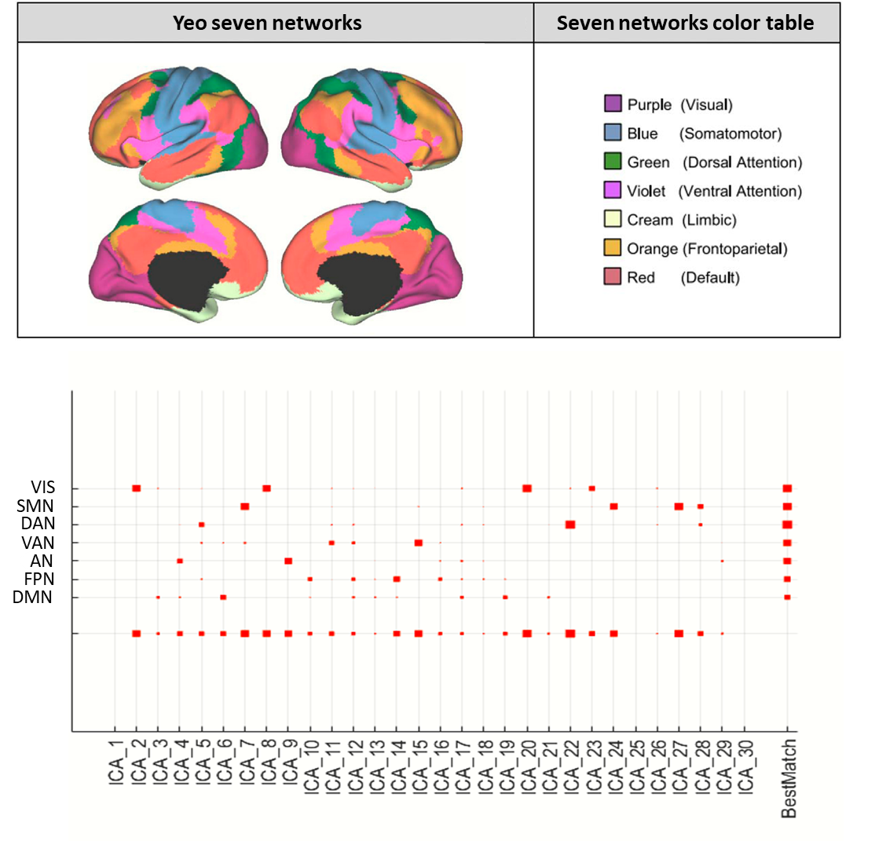
Figure S2. The results of regularized canonical correlation analysis. A. The scatterplot illustrates the correlation between the connectivity canonical variate and the clinical canonical variate of the first component derived from the significant rCCA models. B. Functional connectivity feature loadings are represented as the Pearson correlations between 64 functional nodes (ROIs) and the connectivity canonical variate 1. C. Clinical symptom feature loadings are represented between each HAMD and HAMA item and clinical canonical variate 1.
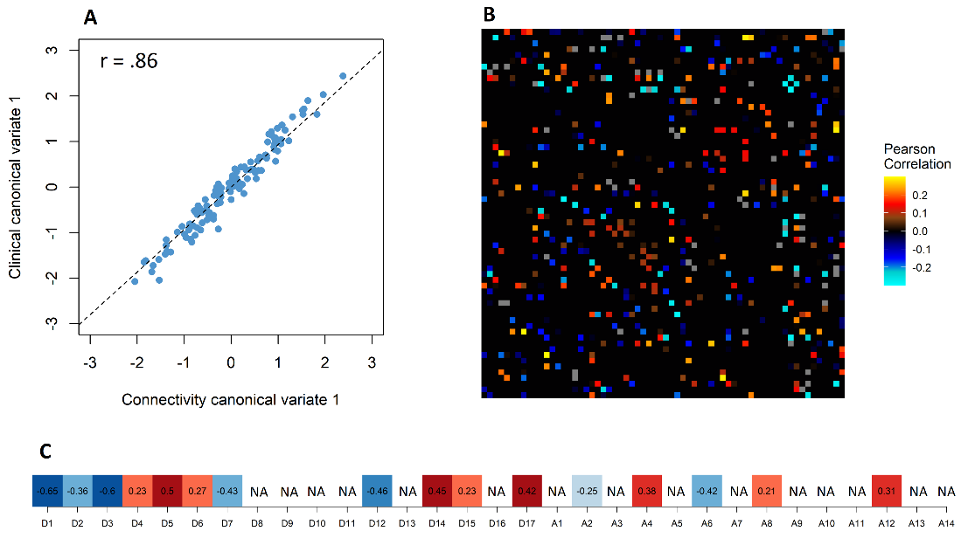
Figure S3. Analyses to determine the optimal number of clusters and validity indices of k-means clustering based on the feature vectors of individual participant’s weight derived from the connectivity and symptoms matrices of canonical correlation analysis).
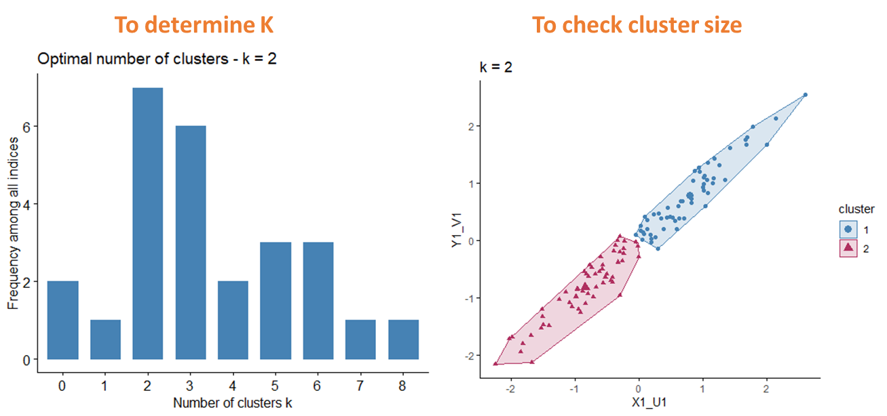
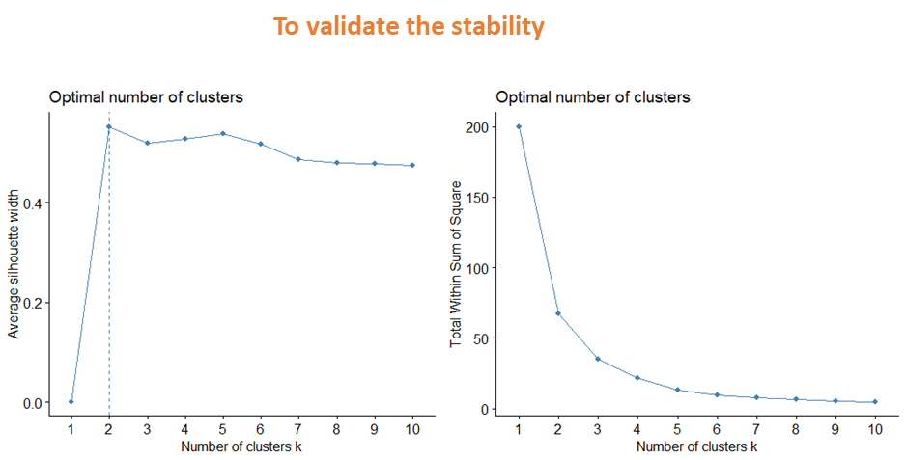

3. Supplementary Tables

Table S1: Demographics for the Total Sample
Mean (SD) | MDD (n=115) | HC (n=129) | P-value
Age | 32.07(11.57) | 32.95 (10.39) | 0.530
Sex (M/F) | 40/75 | 57/72 | 0.135
Handedness (R/L) | 105/10 | 129/7 | 0.190
Depression Symptoms
HAMD-Score | 25.72 (5.47)
Anxiety Symptoms
HAMA-Score | 24.40 (9.23)

Table S2. Peak Coordinates of ICNs
ICN regions Peak (mm) ICN regions Peak (mm) X Y Z X Y Z
Visual networks |  |  |  | (15)
(2) |  |  |  | L Insular gyrus | -41 | 7 | 6
L fusiform gyrus | -33 | -66 | -10 | R Insular gyrus | 43 | 8 | 6
R fusiform gyrus | 35 | -63 | -10 | Affective networks
(8) |  |  |  | (4)
Bi intracalcarine gyrus | 1 | -66 | 8 | L amygdala+hippocampal+temporal pole | -35 | 2 | -30
(20) |  |  |  | R amygdala+hippocampal+temporal pole | 33 | 1 | -29
Bi occipital pole | 0 | -91 | -4 | (9)
(23) |  |  |  | Bi frontal orbital/medial gyrus | 0 | 29 | -14
L lateral occipital gyrus | -24 | -87 | 26 | Frontal-parirtal networks
R lateral occipital gyrus | 26 | -84 | 28 | (10)
Somatomotor networks |  |  |  | L superior/middle frontal gyrus | -36 | 26 | 32
(7) |  |  |  | L lateral occipital gyrus | -39 | -61 | 47
L superior temporal gyrus | -52 | -21 | 6 | R cereb-crus II | 38 | -68 | -42
R superior temporal gyrus | 55 | -17 | 4 | L posterior cingulate gyrus | -2 | -33 | 36
(24) |  |  |  | (12)
L precentral gyrus | -52 | -9 | 31 | L posterior supramarginal gyrus | -56 | -46 | 36
R precentral gyrus | 53 | -7 | 31 | R posterior supramarginal gyrus | 60 | -42 | 35
(27) |  |  |  | (14)
Bi postcentral gyrus | 0 | -27 | 65 | R middle frontal gyrus | 33 | 24 | 47
(28) |  |  |  | R angular gyrus | 45 | -55 | 44
L paracentral lobule | -36 | -28 | 57 | R frontal pole | 38 | 53 | -3
R paracentral lobule | 37 | -26 | 57 | L cerebellum-crus II | -37 | -69 | -44
Dorsal attention networks |  |  |  | (16)
(5) |  |  |  | Bi anterior cingulate gyrus | 1 | -11 | 29
L middle temporal gyrus | -51 | -60 | 5 | Default mode networks
R middle temporal gyrus | 53 | -52 | 7 | (3)
L Inferior frontal gyrus | -41 | 8 | 30 | L lateral occipital gyrus | -37 | -77 | 32
R Inferior frontal gyrus | 44 | 17 | 28 | R lateral occipital gyrus | 42 | -71 | 30
R middle frontal gyrus | 43 | 3 | 57 | L parahippocampal gyrus | -27 | -38 | -16
(18) |  |  |  | R parahippocampal gyrus | 28 | -34 | -16
L Inferior temporal gyrus | -52 | -48 | -18 | L precuneous | -13 | -55 | 11
R Inferior temporal gyrus | 53 | -45 | -17 | R precuneous | 15 | -52 | 13
L cerebellum lobule VIII | -33 | -48 | -56 | (6)
R cerebellum lobule VIII | 33 | -47 | -58 | Bi paracingulate gyrus+superior frontal gyrus | 0 | 40 | 16
Bi cuneal gyrus | 3 | -78 | 46 | Bi anterior cingulate gyrus | 1 | --9 | 36
R Inferior temporal gyrus | 57 | -18 | -31 | (13)
(22) |  |  |  | L inferior frontal gyrus+frontal orbital gyrus | -46 | 30 | -3
L lateral occipital gyrus | -20 | -64 | 50 | R inferior frontal gyrus+frontal orbital gyrus | 46 | 30 | 0
R lateral occipital gyrus | 23 | -63 | 50 | BI superior frontal gyrus | 1 | 39 | 45
Ventral attention networks |  |  |  | (19)
(11) |  |  |  | Bi posterior cingulate gyrus+precuneous | 1 | -51 | 31
L supramarginal gyrus | -59 | -29 | 33 | Subcortical networks
R supramarginal gyrus | 60 | -27 | 35 | (25)
L Frontal pole | -42 | 38 | 17 | Bi caudate+putamen | 0 | 2 | 6
R Frontal pole | 44 | 43 | 8 | (29)
L central opercular gyrus | -44 | 0 | 13 | Bi thalamus | 1 | -20 | 1
L frontal orbital gyrus | -29 | 36 | -12 | Cerebellar networks
(15) |  |  |  | (1)
Bi superior frontal gyrus | 4 | 2 | 55 | Bi cerebellum | 0 | -82 | -34
4. References for Supplementary Materials

1. Whitfield-Gabrieli S, Nieto-Castanon A. Conn: a functional connectivity toolbox for correlated and anticorrelated brain networks. Brain Connect. 2012;2(3):125-41.
2. Friston KJ, Williams S, Howard R, Frackowiak RS, Turner R. Movement-related effects in fMRI time-series. Magnetic resonance in medicine. 1996;35(3):346-55.
3. Behzadi Y, Restom K, Liau J, Liu TT. A component based noise correction method (CompCor) for BOLD and perfusion based fMRI. NeuroImage. 2007;37(1).
4. Calhoun VD, Adali T, Pearlson GD, Pekar JJ. A method for making group inferences from functional MRI data using independent component analysis. Hum Brain Mapp. 2001;14(3):140-51.
5. Yeo BT, Krienen FM, Sepulcre J, Sabuncu MR, Lashkari D, Hollinshead M, et al. The organization of the human cerebral cortex estimated by intrinsic functional connectivity. 2011.
6. Schrepf A, Kaplan CM, Ichesco E, Larkin T, Harte SE, Harris RE, et al. A multi-modal MRI study of the central response to inflammation in rheumatoid arthritis. Nature communications. 2018;9(1):2243.
7. Krzanowski W. Principles of multivariate analysis: OUP Oxford; 2000.
8. Dinga R, Schmaal L, Penninx BW, van Tol MJ, Veltman DJ, van Velzen L, et al. Evaluating the evidence for biotypes of depression: Methodological replication and extension of. 2019;22:101796.
9. González I, Déjean S, Martin P, Baccini AJJoSS. CCA: An R package to extend canonical correlation analysis. 2008;23(12):1-14.
10. Kassambara A. Practical guide to cluster analysis in R: Unsupervised machine learning: Sthda; 2017.
11. Charrad M, Ghazzali N, Boiteau V, Niknafs A, Charrad MMJJoss. Package ‘nbclust’. 2014;61:1-36.
12. Rousseeuw PJJJoc, mathematics a. Silhouettes: a graphical aid to the interpretation and validation of cluster analysis. 1987;20:53-65.
13. Hennig CJJoma. Dissolution point and isolation robustness: robustness criteria for general cluster analysis methods. 2008;99(6):1154-76.
14. Mandal AS, Romero-Garcia R, Hart M, Suckling JJm. Genetic, Cellular, and Connectomic Characterization of the Adult Human Brain Regions Commonly Plagued by Glioma. 2020.
15. Gidskehaug L, Anderssen E, Flatberg A, Alsberg BK. A framework for significance analysis of gene expression data using dimension reduction methods. BMC Bioinformatics. 2007;8:346.
16. Martens H, Martens MJFq, preference. Modified Jack-knife estimation of parameter uncertainty in bilinear modelling by partial least squares regression (PLSR). 2000;11(1-2):5-16.
17. Wehrens R, Mevik B-H. The pls package: principal component and partial least squares regression in R. 2007.
18. Tobias RD, editor An introduction to partial least squares regression. Proceedings of the twentieth annual SAS users group international conference; 1995: SAS Institute Inc Cary.

