Supplementary material

Supplemental 1. Deviations from protocol
- We used a quality assessment tool that was developed to assess ethnic density studies specifically (see Supplemental 6) and GRADE assessments (Supplemental 7) rather than the assessment specified in the protocol.
- In the protocol it was not specified that a three-level meta-analysis would be used. The justification for using this method rather than a method of meta-analysis that does not account for the hierarchical structure of data is outlined in the main paper.
- Methods used to categorise minority group samples were not detailed in the protocol. We also did not specify how we would decide which studies to include if there were overlapping datasets. Justifications for both are outlined in the main paper.
- Our eligibility criteria were refined to only include within-groups ethnic density studies i.e., those that compared risk within the ethnic minority group between ethnic density exposures, as opposed to between-groups studies which compare risk between the ethnic minority and majority at different ethnic density exposures. It would not have been appropriate to combine within- and between-group studies in the meta-analysis. We opted to only include the former given evidence of social drift in majority groups into high ethnic density areas (e.g., Termorshuizen et al., 2014) which may result in artefactually stronger between-group effect sizes. To derive a more reliable estimate, we also decided to only include studies that used multilevel modelling to account for non-independence of data and studies that adjusted for individual- and area-level confounds (minimally age, sex, and area-level deprivation).
- The protocol did not specify that effect sizes would be standardised. This decision was made after observing that included studies measured exposure differently which presented challenges for the meta-analysis. Rather than excluding studies based on how they quantified group density, we chose to rescale each effect size to estimate the response in risk to a ten percentage-point decrease in group density. Ten percentage-point was used because this was a common method used by included studies. Strengths and limitations of this approach have been outlined in the main paper.

Supplemental 2. Full list of search terms
- Population
Psychosis*
Psychotic*
Schizophrenia
Schizoaffective*
Bipolar*
“Manic depress*”
“Severe mental illness”
“Mental distress”
Hallucinat*
Delusion*
Paranoi*

- Ethnic density terms
Minorit*
“Ethnic density”
“Ethnic enclave”
“Ethnic composition”
“Group density”

- Outcome measures
Incidence
Prevalence
ICD*
DSM*
PANSS
CAARMS
SIPS
PSQ
Symptom*
“Psycho* proneness”
“Psycho* experiences”
“Psycho* syndrome”
“Psycho* disorder”
“Psycho* risk”
“Ultra-high risk”
“At-risk mental state”

- Geographical terms
Neighbo*
Residential
County
Local*
Area
Zone
District
Ecological
Geograph*
Community
Municipal
Spatial
State
Tract
“Electoral ward”
“Output area”
“Dissemination area”

Combine each term in A, B, C, D with OR

Then A AND B AND C AND D AND E

Supplemental 3. PsycINFO search

Set# | Searched for | Databases | Results
S1 | MAINSUBJECT.EXACT.EXPLODE("Psychosis") | PsycINFO | 111926
S2 | Psychotic* | PsycINFO | 99406
S3 | Schizophrenia* | PsycINFO | 141692
S4 | Schizoaffective* | PsycINFO | 6880
S5 | Bipolar* | PsycINFO | 47111
S6 | “Manic depress*” | PsycINFO | 5157
S7 | “Severe mental illness” | PsycINFO | 4871
S8 | “Mental distress” | PsycINFO | 1548
S9 | Hallucinat* | PsycINFO | 16724
S10 | Delusion* | PsycINFO | 16174
S11 | Paranoi* | PsycINFO | 16040
S12 | S1 OR S2 OR S3 OR S4 OR S4 OR S6 OR S7 OR S8 OR S9 OR S10 OR S11 | PsycINFO  These databases are searched for part of your query. | 203429
S13 | MAINSUBJECT.EXACT.EXPLODE("Minority Groups") | PsycINFO | 14945
S14 | Minorit* | PsycINFO | 57035
S15 | "Ethnic density" | PsycINFO | 151
S16 | "Ethnic enclave" | PsycINFO | 93
S17 | "Ethnic composition" | PsycINFO | 644
S18 | "Group density" | PsycINFO | 61
S19 | S14 OR S15 OR S16 OR S17 OR S18 | PsycINFO  These databases are searched for part of your query. | 57714
S20 | Incidence | PsycINFO | 58024
S21 | Prevalence | PsycINFO | 119359
S22 | ICD* | PsycINFO | 9800
S23 | DSM* | PsycINFO | 81940
S24 | PANSS | PsycINFO | 3461
S25 | CAARMS | PsycINFO | 91
S26 | SIPS | PsycINFO | 1146
S27 | PSQ | PsycINFO | 322
S28 | Symptom* | PsycINFO | 341715
S29 | "Psycho* proneness" | PsycINFO | 393
S30 | “Psycho* experiences” | PsycINFO | 914
S31 | “Psycho* syndrome” | PsycINFO | 278
S32 | “Psycho* disorder” | PsycINFO | 3228
S33 | “Psycho* risk” | PsycINFO | 585
S34 | “Ultra-high risk” | PsycINFO | 861
S35 | “At-risk mental state” | PsycINFO | 467
S36 | S20 OR S21 OR S22 OR S23 OR S24 OR S25 OR S26 OR S27 OR S28 OR S29 OR S30 OR S31 OR S32 OR S33 OR S34 OR S35 | PsycINFO  These databases are searched for part of your query. | 525155
S37 | Neighbo* | PsycINFO | 26715
S38 | Residential | PsycINFO | 36892
S39 | County | PsycINFO | 32611
S40 | Local* | PsycINFO | 118264
S41 | Area | PsycINFO | 340290
S42 | Zone | PsycINFO | 15557
S43 | District | PsycINFO | 40986
S44 | Ecological | PsycINFO | 32296
S45 | Geograph* | PsycINFO | 30787
S46 | Community | PsycINFO | 380131
S47 | Municipal | PsycINFO | 5491
S48 | Spatial | PsycINFO | 98692
S49 | State | PsycINFO | 933384
S50 | Tract | PsycINFO | 18706
S51 | “Electoral ward” | PsycINFO | 18
S52 | “Output area” | PsycINFO | 35
S53 | “Dissemination area” | PsycINFO | 4
S54 | S37 OR S38 OR S39 OR S40 OR S41 OR S42 OR S43 OR S44 OR S45 OR S46 OR S47 OR S48 OR S49 OR S50 OR S51 OR S52 OR S53 | PsycINFO  These databases are searched for part of your query. | 1679313
S55 | S12 AND S19 AND S36 AND S54 | PsycINFO  These databases are searched for part of your query. | 456

Supplemental 4. Screening for non-English papers (n=14)

Author | Paper | Language | Eligible for narrative review or meta-analysis?
Adriaanse et al., (2018) | Psychotische ervaringen bij jeugdigen met een migratieachtergrond: Prevalentie, impact en culturele context (English translation: Prevalence, impact and cultural context of psychotic experiences among ethnic minority youth) | Dutch | Exclude – no group density analyses
Binbay et al., (2016) | Yeni Bir Sosyal Ortama Uyum Sürecinde Psikotik Yaşantılar (English translation: Psychotic Experiences in the Adaptation Process to a New Social Environment) | Turkish | Exclude – no group density analyses
Chapireau (2005) | Les nouveaux longs séjours en établissements de soins spécialisés en psychiatrie : résultats d’une enquête nationale sur un échantillon représentatif (1998-2000) (English translation: Old and new long stay patients in French psychiatric institutions : results from a national random survey with two-year follow-up (1998-2000)) | French | Exclude – outcomes not specific to psychosis, no group density analyses
Egea et al., (2004) | Trastorno esquizofreniforme. Estudio prospective de 5 años de seguimiento (English translation: Schizophreniform disorder. A five year prospective study) | Spanish | Exclude – no group density analyses
Faerden, Waal, & Rønnow (1995) | Langsiktige psykiatriske pasienter i en sektor av Oslo (English translation: Long-term psychiatric patients in a sector of Oslo) | Norwegian | Exclude – outcomes not specific to psychosis, no group density analyses
Hódi (1989) | A pszichózisok és öngyilkosságok területi és etnikai megoszlása a Vajdaságban (English translation: The regional and ethnic distribution of psychoses and suicides in Voivodina Province, Yugoslavia). | Hungarian | Exclude – no group density analyses
Wenxing et al., (2015) | 云南省西盟佤族自治县精神障碍现况调查 (English translation: A cross-sectional study of mental disorders in Ximeng Wa Autonomous County of Yunnan Province) | Chinese | Exclude – no group density analyses
Melle et al., (2016) | Verbesserung der Ergebnisse: Einflussfaktoren auf das Hilfesuchverhalten von Zuwanderern und ethnischen Minderheiten mit psychotischen Ersterkrankungen (English translation: Improving outcomes: Factors influencing help-seeking behaviors in immigrants and ethnic minorities with first-episode psychosis) | German | Exclude – no primary data (confirmed by author)
Meurice et al., (2013) | Peut-on prédire, dès l’enfance, les risques de développer la schizophrénie à l’âge adulte ? Une étude rétrospective centrée sur l’hypersensibilité prémorbide; premiers résultats (English translation: Is it possible to predict, as early as childhood, the risk of developing schizophrenia in adulthood? A retrospective study focused on premorbid hypersensitivity; first results) | French | Exclude – no group density analyses
Mena et al., (2002) | Estudio descriptivo de trastornos mentales en minorías étnicas residentes en un área urbana de Barcelona (English translation: Descriptive study of mental disorders in ethnic minorities residing in an urban area of Barcelona) | Spanish | Exclude – no group density analyses
Picarda & Ineichen (1995) | La santé mentale des minorités ethniques au Royaume-Uni (English translation: The mental health of ethnic minorities in the United Kingdom) | French | Exclude – review paper, no primary data, no new papers found in reference list
Plancke & Amariei (2017) | Hospitalisations psychiatriques de longue durée (English translation: Long-term psychiatric hospitalizations) | French | Exclude – no group density analyses, outcomes not specific to psychosis
van der Stoep (2016) | Culturele diversiteit in de forensische  psychiatrie; een exploratief onderzoek  in Forensisch Psychiatrisch Centrum  de Oostvaarderskliniek (English translation: Cultural diversity in the forensics  psychiatry; an exploratory study  in Forensic Psychiatric Center  the Oostvaarders clinic) | Dutch | Exclude – no group density analyses
Vilain et al., (2013) | Les facteurs de risque environnementaux de la schizophrénie (English translation: Environmental risk factors for schizophrenia: A review) | French | Exclude – review paper, no primary data, no new papers found in reference list

Supplemental 5. Example of calculations for rescaling effect sizes

“African” group from Schofield, Thygesen, Das-Munshi et al., (2017)
To rescale effect sizes and their corresponding 95% confidence intervals, we extracted the ethnic density percentage for each category, e.g., for the African group (Schofield, Thygesen, Das-Munshi et al., 2017), this was 3.7-18.5% (REF/highest quintile), 1.7-3.7% (4th quintile), 0.9-1.7% (3rd quintile), 0.4-0.9% (2nd quintile), and <0.4% (1st/lowest quintile). We took a mid-point or given estimate for each category (in this case: 11.1, 2.7, 1.3, 0.65, 0.3) and subtracted each of these values from the reference category. Taking the effect size for the 4th quintile as an example, we subtracted 2.7 (midpoint for 4th quintile) from 11.1 (midpoint for 1st quintile/REF category) which gave 8.4. We then wanted to rescale the raw effect size to reflect the response in risk to a 10% reduction in ethnic density so we used the following formula: exp[Log[1.20]*(10/8.4)] which gives a rescaled effect size of 1.24. We used the same formulae to calculate the confidence intervals (0.77-2.01). These values were then converted to their natural logarithmic form, from which log standard errors and sampling variances were computed. We followed these steps to rescale all 75 effect sizes unless of course, the papers already reported effect sizes associated with a ten-percentage point decrease in ethnic density e.g., Das-Munshi, Bécares, Boydell et al., (2012).

Supplemental 6. Quality assessment checklist for ethnic density studies taken from Bécares, Dewey, & Das-Munshi (2018)
Quality criteria | Score
Type of study
Cross-sectional, case-control | 1
Cohort | 2
Exposure
Explicitly defines ethnic density exposure | 1
Ethnicity
Self-ascribed ethnicity | 1
Language of interview
Language of interview in own language if English not preferred language | 1
Outcome
Assessed with structured instrument | 1
Validated instrument used to assess outcome | 1
Reliable instrument used to assess outcome | 1
Instrument validated in racial/ ethnic group | 1
Outcome assessment blind to exposure status | 1
Sample size and power calculation
n>500 | 1
Response rates
For case-control/ cross-sectional studies – Response rates
>60% | 1
For cohort studies – Rate of attrition compared to baseline
>60% | 1
Response rates similar across racial/ ethnic groups or weighted to allow for differential non-response | 1
Methods
Estimate available adjusted for area-level deprivation  Adjusts with one variable for area-level deprivation  Adjusts with composite measure of area-level deprivation | 1  2
Appropriate statistical methods used (e.g. multi-level modelling or robust standard errors to account for clustered data) | 1
Cohort studies - Assesses dose-response | 1

Supplemental 7. GRADE assessments

GRADE assessment table for psychosis outcomes:
Group | No. of studies | Study design | Risk of bias | Inconsistency | Indirectness | Imprecision | Other considerations | Pooled ES (95% CI) for subgroup | Certainty
Non-affective psychosis | 5 | 2 observational  3 longitudinal | Not serious | Not serious | Not serious | Not serious | Dose response gradient | OR 1.14  (1.04 to 1.25) | ⨁⨁⨁◯  MODERATE
Subclinical psychosis | 3 | 3 observational | Not serious | Not serious | Not serious | Not serious | Dose response gradient | OR 1.12  (0.96 to 1.31) | ⨁⨁⨁◯  MODERATE
Antipsychotic prescriptions | 1 | 1 observational | Not serious | Not serious | Serious | Not serious | Dose response gradient | OR 1.04  (0.95 to 1.17) | ⨁⨁◯◯  LOW
Any psychosis | 1 | 1 observational | Not serious | Not serious | Not serious | Serious | Strong association  Dose response gradient | OR 1.90  (1.43 to 2.53) | ⨁⨁⨁◯  MODERATE
Affective psychosis | 2 | 1 observational  1 longitudinal | Not serious | Not serious | Not serious | Not serious | Dose response gradient | OR 1.16  (1.04 to 1.28) | ⨁⨁⨁◯  MODERATE
Other psychoses | 1 | Longitudinal | Not serious | Not serious | Not serious | Not serious | Dose response gradient | OR 1.07  (1.00 to 1.16) | ⨁⨁⨁◯  MODERATE

GRADE assessment table for crude minority subgroups:
Group | No. of studies | Study design | Risk of bias | Inconsistency | Indirectness | Imprecision | Other considerations | Pooled ES (95% CI) for subgroup | Certainty
Black | 7 | 5 observational  2 longitudinal | Not serious | Not serious | Serious | Not serious | Strong association,  dose response gradient | OR 1.62  (1.17 to 2.24) | ⨁⨁⨁◯  MODERATE
Asian | 4 | 2 observational  2 longitudinal | Not serious | Not serious | Not serious | Not serious | Dose response gradient | OR 1.16  (0.93 to 1.45) | ⨁⨁⨁◯  MODERATE
White other | 3 | observational studies | Not serious | Not serious | Not serious | Serious | Dose response gradient | OR 1.24  (0.77 to 1.97) | ⨁⨁◯◯  LOW
Other ethnic group | 3 | 1 observational  1 longitudinal | Not serious | Not serious | Serious | Not serious | Dose response gradient | OR 1.07  (0.97 to 1.17) | ⨁⨁◯◯  LOW
Combined migrant group | 2 | 1 observational  1 longitudinal | Serious | Not serious | Not serious | Not serious | Dose response gradient | OR 1.08  (1.00 to 1.16) | ⨁⨁◯◯  LOW
Combined ethnic minority group | 1 | observational study | Not serious | Not serious | Not serious | Serious |  | OR 1.13  (0.63 to 2.03) | ⨁⨁◯◯  LOW
Other social characteristic | 2 | 1 observational  1 longitudinal | Not serious | Not serious | Not serious | Not serious | Dose response gradient | OR 1.02  (0.86 to 1.20) | ⨁⨁⨁◯  MODERATE

Supplemental 8. Output showing full model and model fit after each of the levels were removed
Full model:
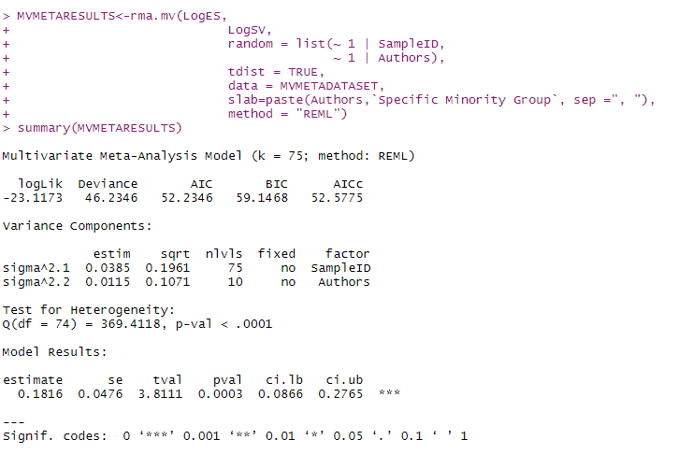
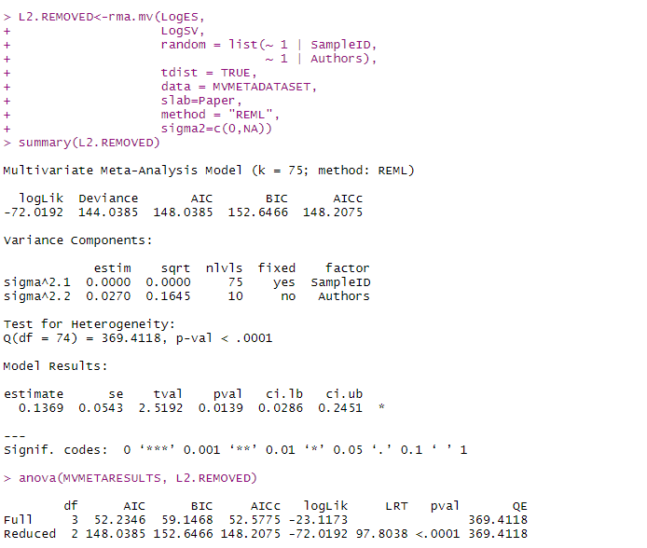
Level two removed:

Level 3 removed:
Level 3 removed:
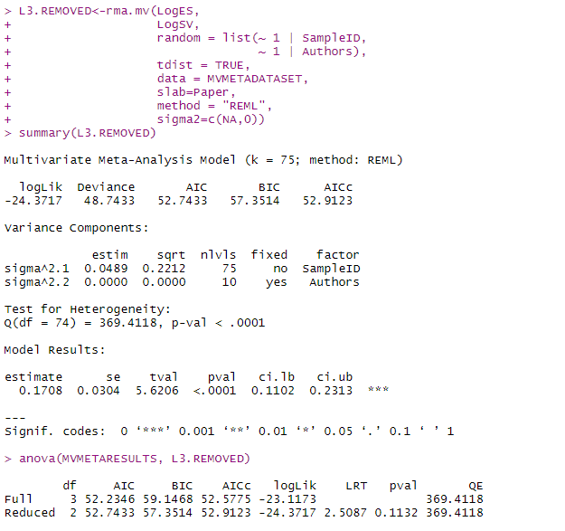
Level 3 removed:

Supplemental 9. Crude and specific minority moderator tests for ethnic minorities and migrants only
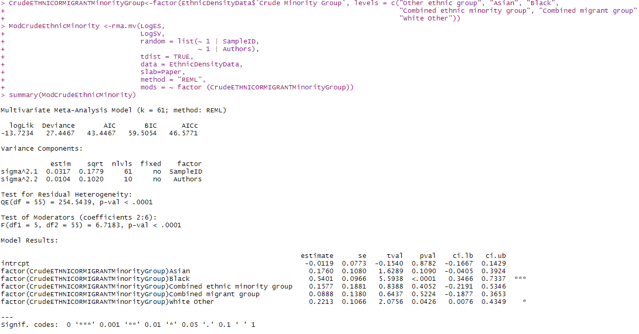
Crude:

Specific:
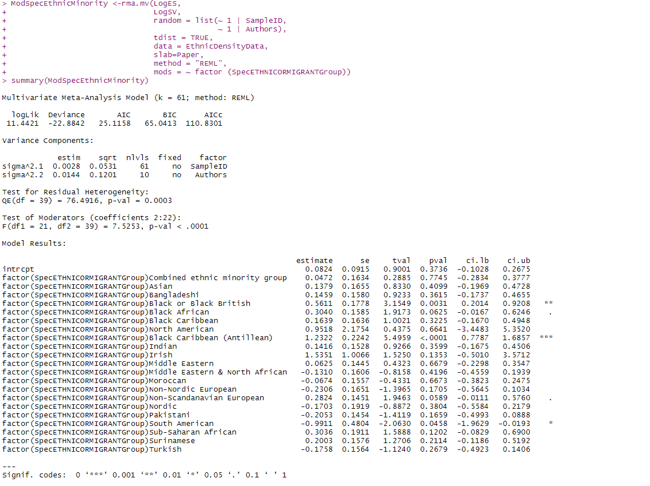

Supplemental 10. Moderator test results for specific minority groups (all samples)
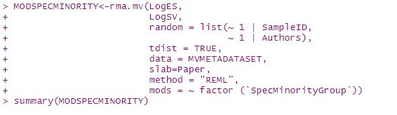

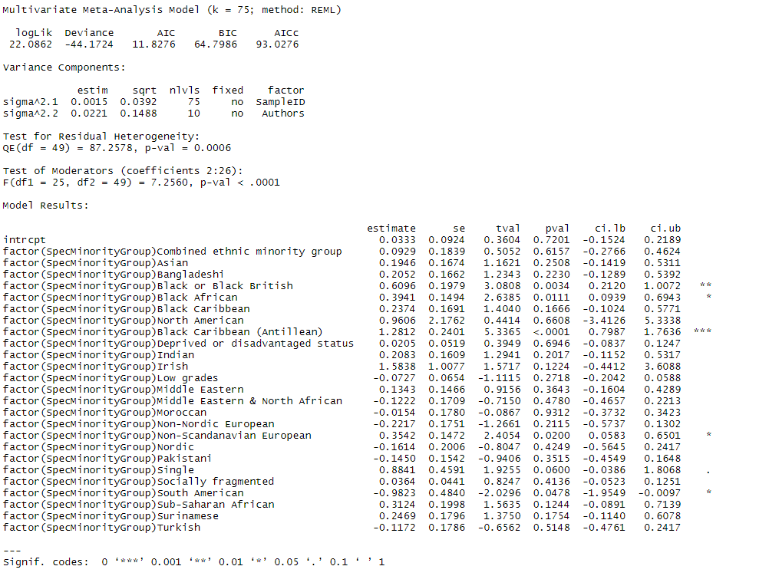

Supplemental 11. Leave-one-out analysis for individual samples (n=75)

Sample ID | Paper | Estimates | LBs | UBs | p.vals
1 | Bécares et al., (2009) - Black Caribbean - Subclinical | 1.197424274 | 1.084689182 | 1.321876 | 0.00052
2 | Bécares et al., (2009) - Indian - Subclinical | 1.200092336 | 1.089610839 | 1.321776 | 0.000335
3 | Bécares et al., (2009) - Pakistani - Subclinical | 1.211046497 | 1.106794029 | 1.325119 | 6.47E-05
4 | Bécares et al., (2009) - Bangladeshi - Subclinical | 1.196901168 | 1.083901406 | 1.321681 | 0.000554
5 | Das-Munshi et al., (2012) - Irish - Subclinical | 1.196708706 | 1.08872372 | 1.315404 | 0.000313
6 | Das-Munshi et al., (2012) - Black Caribbean - Subclinical | 1.202720102 | 1.091641903 | 1.325101 | 0.000301
7 | Das-Munshi et al., (2012) - Bangladeshi - Subclinical | 1.198875711 | 1.088691361 | 1.320212 | 0.000352
8 | Das-Munshi et al., (2012) - Indian - Subclinical | 1.19610088 | 1.086843051 | 1.316342 | 0.000381
9 | Das-Munshi et al., (2012) - Pakistani -Subclinical | 1.201666787 | 1.09033815 | 1.324363 | 0.000333
10 | Dykxhoorn, Lewis, Hollander, Kirkbride & Dalman (2020) - Nordic | 1.203677629 | 1.093592878 | 1.324844 | 0.000249
11 | Dykxhoorn, Lewis, Hollander, Kirkbride & Dalman (2020) - Non-Nordic European | 1.206339827 | 1.095070549 | 1.328915 | 0.00024
12 | Dykxhoorn, Lewis, Hollander, Kirkbride & Dalman (2020) - Asian | 1.189852361 | 1.07821423 | 1.313049 | 0.000756
13 | Dykxhoorn, Lewis, Hollander, Kirkbride & Dalman (2020) - Middle Eastern & North African | 1.203726996 | 1.093298772 | 1.325309 | 0.000259
14 | Dykxhoorn, Lewis, Hollander, Kirkbride & Dalman (2020) - Sub-Saharan African | 1.188914515 | 1.076322354 | 1.313285 | 0.000888
15 | Dykxhoorn, Lewis, Hollander, Kirkbride & Dalman (2020) - North American | 1.198842474 | 1.090203597 | 1.318307 | 0.000292
16 | Dykxhoorn, Lewis, Hollander, Kirkbride & Dalman (2020) - South American | 1.203854218 | 1.0944829 | 1.324155 | 0.000225
17 | Menezes et al., (2011) - Migrant status - SZ | 1.204734747 | 1.089008711 | 1.332759 | 0.00045
18 | Richardson et al., (2018) - Overall minority group - NAP | 1.204233366 | 1.091097925 | 1.3291 | 0.000347
19 | Richardson et al., (2018) - Overall minority group -AP | 1.198759509 | 1.08687213 | 1.322165 | 0.000433
20 | Schofield et al., (2011) - Black - High ethnic density - Any psychosis | 1.188286563 | 1.095643057 | 1.288764 | 6.56E-05
21 | Schofield et al., (2011) - Black - Mid ethnic density - Any psychosis | 1.185638519 | 1.095777841 | 1.282868 | 5.1E-05
22 | Schofield et al., (2011) - Black - Low ethnic density - Any psychosis | 1.183345833 | 1.095826208 | 1.277855 | 4.1E-05
23 | Schofield et al., (2011) - Black - Lowest ethnic density - Any psychosis | 1.191329876 | 1.094422673 | 1.296818 | 0.000101
24 | Schofield et al., (2016) - Black African - Subclinical | 1.200582784 | 1.089868981 | 1.322543 | 0.000334
25 | Schofield et al., (2016) - Black Caribbean - Subclinical | 1.195122676 | 1.085041015 | 1.316373 | 0.000449
26 | Schofield et al., (2016) - Disadvantaged social class - Subclinical | 1.213949632 | 1.097647762 | 1.342574 | 0.000263
27 | Schofield et al., (2016) - Single household status - Subclinical | 1.194147187 | 1.083685884 | 1.315868 | 0.000501
28 | Schofield et al., (2017) - African - High ethnic density - NAP | 1.199594665 | 1.090863685 | 1.319163 | 0.00028
29 | Schofield et al., (2017) - African - Mid ethnic density - NAP | 1.200557618 | 1.091128951 | 1.320961 | 0.000286
30 | Schofield et al., (2017) - African - Low ethnic density - NAP | 1.192942945 | 1.086721759 | 1.309547 | 0.000328
31 | Schofield et al., (2017) - African - Lowest ethnic density - NAP | 1.19570159 | 1.088820934 | 1.313074 | 0.000293
32 | Schofield et al., (2017) - Non-Scandanavian European - High ethnic density - NAP | 1.197605453 | 1.090075444 | 1.315743 | 0.000278
33 | Schofield et al., (2017) - Non-Scandanavian European - Mid ethnic density - NAP | 1.199470709 | 1.090998445 | 1.318728 | 0.000274
34 | Schofield et al., (2017) - Non-Scandanavian European - Low ethnic density - NAP | 1.198112541 | 1.090367756 | 1.316504 | 0.000275
35 | Schofield et al., (2017) - Non-Scandanavian European - Lowest ethnic density - NAP | 1.195127947 | 1.088462621 | 1.312246 | 0.000297
36 | Schofield et al., (2017) - Asian - High ethnic density - NAP | 1.201147448 | 1.091152846 | 1.32223 | 0.000294
37 | Schofield et al., (2017) - Asian - Mid ethnic density - NAP | 1.201907692 | 1.091070536 | 1.324004 | 0.000309
38 | Schofield et al., (2017) - Asian - Low ethnic density - NAP | 1.201214287 | 1.091164715 | 1.322363 | 0.000295
39 | Schofield et al., (2017) - Asian - Lowest ethnic density - NAP | 1.196761082 | 1.089487527 | 1.314597 | 0.000286
40 | Schofield et al., (2017) - Middle Eastern - High ethnic density - NAP | 1.201745699 | 1.091505585 | 1.32312 | 0.000291
41 | Schofield et al., (2017) - Middle Eastern - Mid ethnic density - NAP | 1.202810381 | 1.091159592 | 1.325886 | 0.00032
42 | Schofield et al., (2017) - Middle Eastern- Low ethnic density - NAP | 1.201810558 | 1.091528616 | 1.323235 | 0.000291
43 | Schofield et al., (2017) - Middle Eastern - Lowest ethnic density - NAP | 1.199943168 | 1.091180311 | 1.319547 | 0.000275
44 | Termorshuizen et al., (2018) - Turkish - High ethnic density - Antipsychotic prescriptions | 1.203087228 | 1.093213349 | 1.324004 | 0.000253
45 | Termorshuizen et al., (2018) - Turkish - Mid ethnic density - Antipsychotic prescriptions | 1.203610931 | 1.093343905 | 1.324999 | 0.000256
46 | Termorshuizen et al., (2018) - Turkish - Low ethnic density - Antipsychotic prescriptions | 1.203508814 | 1.093834351 | 1.32418 | 0.00024
47 | Termorshuizen et al., (2018) - Turkish - Lowest ethnic density - Antipsychotic prescriptions | 1.203217357 | 1.09374995 | 1.323641 | 0.000238
48 | Termorshuizen et al., (2018) - Moroccan - High ethnic density - Antipsychotic prescriptions | 1.201005684 | 1.092201303 | 1.320649 | 0.000256
49 | Termorshuizen et al., (2018) - Moroccan - Mid ethnic density - Antipsychotic prescriptions | 1.203339184 | 1.093777347 | 1.323876 | 0.000239
50 | Termorshuizen et al., (2018) - Moroccan - Low ethnic density - Antipsychotic prescriptions | 1.202543675 | 1.093361852 | 1.322628 | 0.000241
51 | Termorshuizen et al., (2018) - Moroccan - Lowest ethnic density - Antipsychotic prescriptions | 1.202397349 | 1.093260909 | 1.322428 | 0.000242
52 | Termorshuizen et al., (2018) - Surinamese - High ethnic density - Antipsychotic prescriptions | 1.192375025 | 1.082514616 | 1.313385 | 0.000527
53 | Termorshuizen et al., (2018) - Surinamese - Mid ethnic density - Antipsychotic prescriptions | 1.197478394 | 1.08860035 | 1.317246 | 0.000331
54 | Termorshuizen et al., (2018) - Surinamese - Low ethnic density - Antipsychotic prescriptions | 1.200301009 | 1.091504171 | 1.319942 | 0.000269
55 | Termorshuizen et al., (2018) - Surinamese - Lowest ethnic density - Antipsychotic prescriptions | 1.1963054 | 1.087192119 | 1.31637 | 0.000369
56 | Termorshuizen et al., (2018) - Antillean - High ethnic density - Antipsychotic prescriptions | 1.198656216 | 1.090035599 | 1.318101 | 0.000296
57 | Termorshuizen et al., (2018) - Antillean - Mid ethnic density - Antipsychotic prescriptions | 1.194727694 | 1.085528269 | 1.314912 | 0.000416
58 | Termorshuizen et al., (2018) - Antillean - Low ethnic density - Antipsychotic prescriptions | 1.189902843 | 1.079306545 | 1.311832 | 0.000674
59 | Termorshuizen et al., (2018) - Antillean - Lowest ethnic density - Antipsychotic prescriptions | 1.184120226 | 1.071832397 | 1.308172 | 0.001164
60 | Zammit et al., (2010) - Migrant status - NAP | 1.200938676 | 1.093541232 | 1.318884 | 0.000215
61 | Zammit et al., (2010) - Migrant status - AP | 1.199727832 | 1.09069797 | 1.319657 | 0.000288
62 | Zammit et al., (2010) - Migrant status - SZ | 1.200389611 | 1.092191228 | 1.319307 | 0.000248
63 | Zammit et al., (2010) - Migrant status - Other | 1.200428084 | 1.092242738 | 1.319329 | 0.000247
64 | Zammit et al., (2010) - Socially fragmented - NAP | 1.200616293 | 1.092737024 | 1.319146 | 0.000234
65 | Zammit et al., (2010) - Socially fragmented - AP | 1.198384969 | 1.088089957 | 1.31986 | 0.000369
66 | Zammit et al., (2010) - Socially fragmented - SZ | 1.199842192 | 1.090996199 | 1.319547 | 0.00028
67 | Zammit et al., (2010) - Socially fragmented - Other | 1.200024152 | 1.091332208 | 1.319541 | 0.000271
68 | Zammit et al., (2010) - Deprived - NAP | 1.200212626 | 1.091840045 | 1.319342 | 0.000257
69 | Zammit et al., (2010) - Deprived - AP | 1.198502777 | 1.088405795 | 1.319737 | 0.000357
70 | Zammit et al., (2010) - Deprived - SZ | 1.200726735 | 1.093304114 | 1.318704 | 0.000219
71 | Zammit et al., (2010) - Deprived - Other | 1.19998113 | 1.091294803 | 1.319492 | 0.000271
72 | Zammit et al., (2010) - Low grades - NAP | 1.20117337 | 1.094621132 | 1.318098 | 0.000189
73 | Zammit et al., (2010) - Low grades - AP | 1.200628663 | 1.093225531 | 1.318584 | 0.00022
74 | Zammit et al., (2010) - Low grades - SZ | 1.200057175 | 1.091826955 | 1.319016 | 0.000255
75 | Zammit et al., (2010) - Low grades - Other | 1.200631333 | 1.092936704 | 1.318938 | 0.000229

Estimates not from original papers, these represent the recalculated ESs & CIs for subgroup i.e., each estimate has been standardised to reflect 10% decrease in group density
Outcome used in one large scale study (Termorshuizen et al., 2018) - antipsychotic prescriptions
Large ES, Wide CIs and only one study in subgroup
Estimates not from original papers, these represent the recalculated ESs & CIs for subgroup i.e., each estimate has been standardised to reflect 10% decrease in group density
Outcome used in one large scale study (Termorshuizen et al., 2018) - antipsychotic prescriptions
Wide CIs for subgroup’s pooled estimate
Outcome used in one large scale study (Termorshuizen et al., 2018) - antipsychotic prescriptions
Concerns regarding the reliability and validity of the psychosis measure in one study (Menezes, Georgiades, & Boyle, 2011) - self-reported lifetime prevalence of diagnosed Schizophrenia or other psychosis
Wide CIs for subgroup’s pooled estimate and only one study

