Supplementary Material

Figure S1. Interactive effects of emotional abuse and serum brain derived neurotrophic factor (sBDNF) levels on suicidal behavior at baseline (N=1094) and at follow-up (N=884).
Figure S2. Interactive effects of physical abuse and serum brain derived neurotrophic factor (sBDNF) levels on suicidal behavior at baseline (N=1094) and at follow-up (N=884).
Figure S3. Interactive effects of sexual abuse and serum brain derived neurotrophic factor (sBDNF) levels on suicidal behavior at baseline (N=1094) and at follow-up (N=884).
Table S1. Characteristics compared by serum brain derived neurotrophic factor (sBDNF) levels median value (23.3ng/mL) at baseline.
Table S2. Characteristics compared by previous suicidal attempt before the study enrolment.
Table S3. Characteristics compared by Brief Psychiatric Rating Scale (BPRS) suicidality item score at baseline.
Table S4. Associations between treatment step after 12 week and prospective suicidal behaviour (N=884). Data are N (%).
Table S5. Individual effects of childhood abuse types on suicidal behavior at baseline (N=1094).
Table S6. Individual effects of childhood abuse types on suicidal behavior during one year follow-up (N=884).
Table S7. Effects of childhood abuse and serum brain derived neurotrophic factor (sBDNF) levels with suicidal behaviour by age.
Figure S1. Interactive effects of emotional abuse and serum brain derived neurotrophic factor (sBDNF) levels on suicidal behavior at baseline (N=1094) and at follow-up (N=884).

Figure legends: Data are odds ratios (95% confidence intervals) adjusted for age, sex, living alone, religious affiliation, monthly income, atypical feature, number of depressive episodes, number of physical disorders, smoking status, and scores on Hospital Anxiety & Depression Scale-anxiety subscale and Alcohol Use Disorders Identification Test for previous suicidal attempt and baseline suicidal severity evaluated at baseline; as well as treatment step for increased suicidal severity and fatal/non-fatal suicide attempt during the follow-up.
*P<0.05; †P<0.01; ‡P<0.001.

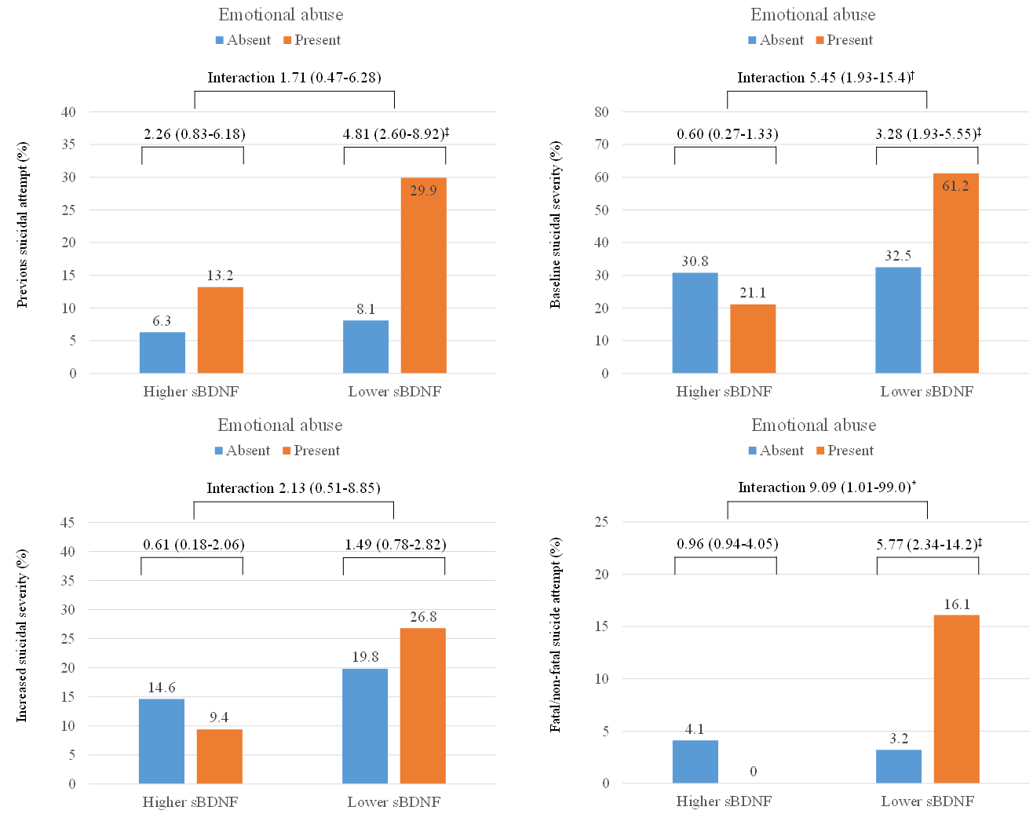
Figure S2. Interactive effects of physical abuse and serum brain derived neurotrophic factor (sBDNF) levels on suicidal behavior at baseline (N=1094) and at follow-up (N=884).

Figure legends: Data are odds ratios (95% confidence intervals) adjusted for age, sex, living alone, religious affiliation, monthly income, atypical feature, number of depressive episodes, number of physical disorders, smoking status, and scores on Hospital Anxiety & Depression Scale-anxiety subscale and Alcohol Use Disorders Identification Test for previous suicidal attempt and baseline suicidal severity evaluated at baseline; as well as treatment step for increased suicidal severity and fatal/non-fatal suicide attempt during the follow-up.
*P<0.05; †P<0.01; ‡P<0.001.

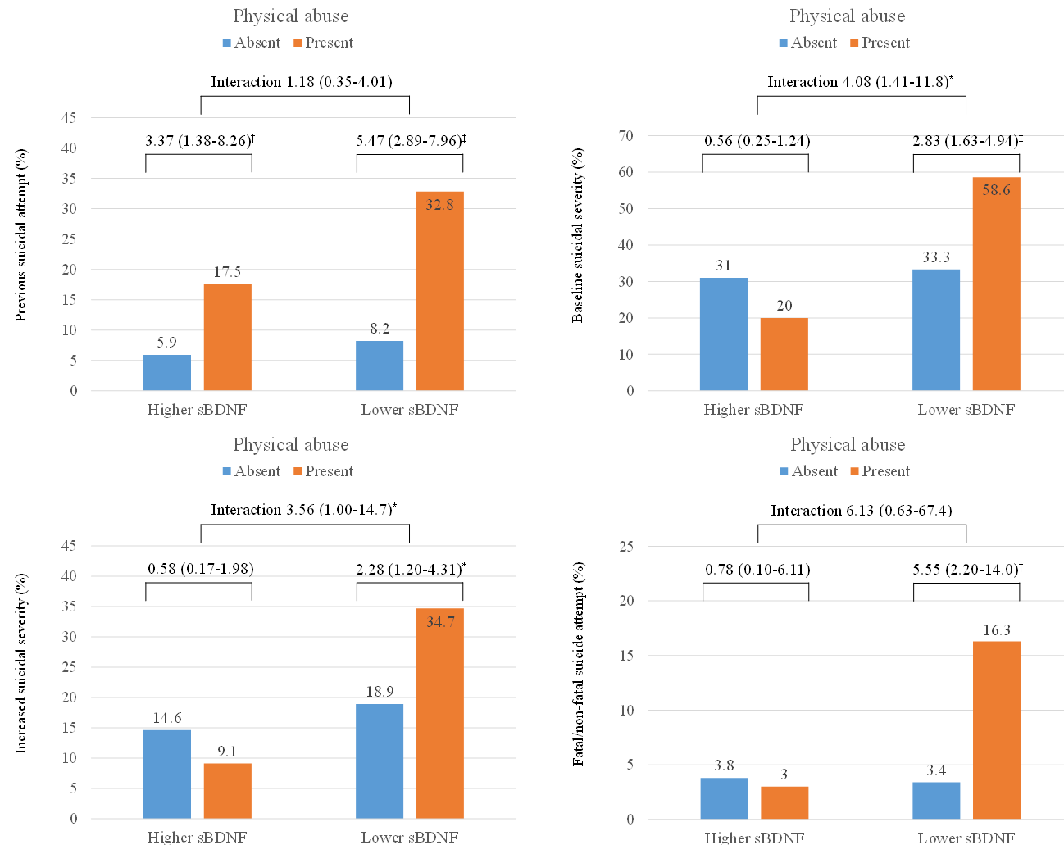
Figure S3. Interactive effects of sexual abuse and serum brain derived neurotrophic factor (sBDNF) levels on suicidal behavior at baseline (N=1094) and at follow-up (N=884).

Figure legends: Data are odds ratios (95% confidence intervals) adjusted for age, sex, living alone, religious affiliation, monthly income, atypical feature, number of depressive episodes, number of physical disorders, smoking status, and scores on Hospital Anxiety & Depression Scale-anxiety subscale and Alcohol Use Disorders Identification Test for previous suicidal attempt and baseline suicidal severity evaluated at baseline; as well as treatment step for increased suicidal severity and fatal/non-fatal suicide attempt during the follow-up.
*P<0.05; †P<0.01; ‡P<0.001.

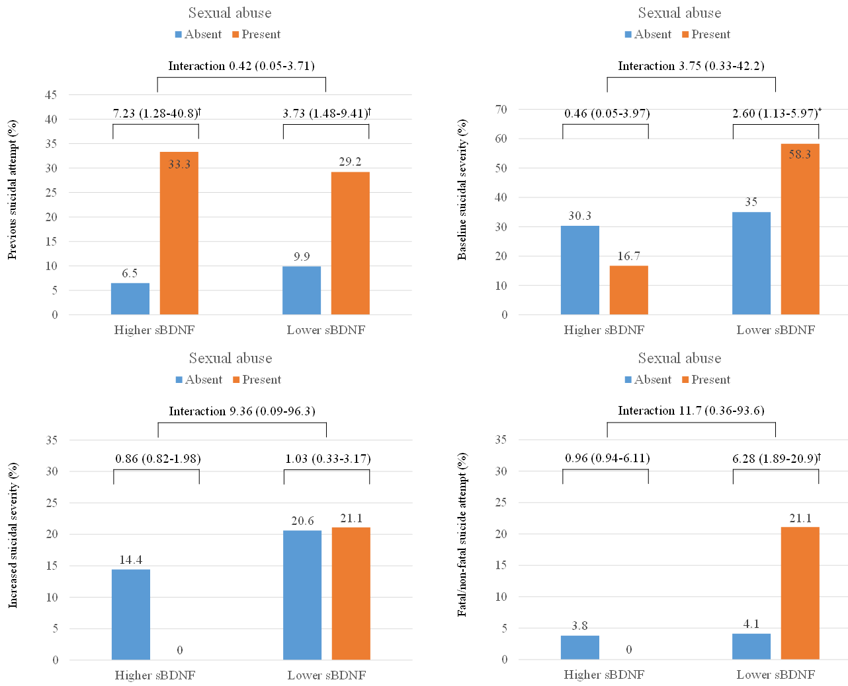
Table S1. Characteristics compared by serum brain derived neurotrophic factor (sBDNF) levels median value (23.3ng/mL) at baseline.
 | Higher  sBDNF (N=547) | Lower  sBDNF (N=547) | Statistical coefficients | P-value
Socio-demographic characteristics
Age, mean (SD) years | 56.5 (14.2) | 57.4 (15.5) | t=-0.975 | 0.330
Sex, N (%) female | 357 (65.3) | 396 (72.4) | χ²=6.480 | 0.011
Education, mean (SD) years | 9.1 (4.9) | 9.1 (4.7) | t=+0.101 | 0.920
Marital status, N (%) unmarried | 157 (28.7) | 170 (31.1) | χ²=0.737 | 0.391
Living alone, N (%) | 71 (13.0) | 96 (17.6) | χ²=4.417 | 0.036
Religious non-affiliation, N (%) | 245 (44.8) | 238 (43.5) | χ²=0.182 | 0.670
Unemployed status, N (%) | 156 (28.5) | 160 (29.3) | χ²=0.071 | 0.790
Monthly income, N (%) <2,000 USD | 330 (60.3) | 323 (59.0) | χ²=0.186 | 0.666
Clinical characteristics
Major depressive disorder, N (%) | 463 (84.6) | 470 (85.9) | χ²=0.357 | 0.550
Melancholic feature, N (%) | 83 (15.2) | 82 (15.0) | χ²=0.007 | 0.933
Atypical feature, N (%) | 33 (6.0) | 36 (6.6) | χ²=0.139 | 0.709
Age at onset, mean (SD) years | 51.5 (16.0) | 52.2 (17.4) | t=-0.711 | 0.477
Duration of illness, mean (SD) years | 5.0 (8.3) | 5.2 (9.7) | t=-0.288 | 0.774
Number of depressive episodes, mean (SD) | 1.1 (1.4) | 1.1 (1.5) | t=-0.164 | 0.870
Duration of present episode, mean (SD) months | 7.7 (10.7) | 7.1 (10.0) | t=+0.905 | 0.366
Family history of depression, N (%) | 86 (15.8) | 74 (13.5) | χ²=1.106 | 0.293
Number of physical disorders, mean (SD) | 1.5 (1.2) | 1.7 (1.3) | t=-2.503 | 0.012
Current smoker, N (%) | 57 (10.4) | 66 (12.1) | χ²=0.244 | 0.621
Assessment scales, mean (SD) scores
Hospital Anxiety & Depression Scale-depression subscale | 13.6 (4.0) | 13.7 (3.9) | t=-0.498 | 0.619
Hospital Anxiety & Depression Scale-anxiety subscale | 11.8 (4.0) | 11.8 (4.1) | t=-0.306 | 0.759
Alcohol Use Disorders Identification Test | 5.0 (8.3) | 5.7 (9.4) | t=-1.355 | 0.176
Treatment step over 1 year (N=884), N (%)
Step 1 | 204 (37.3) | 236 (43.1) | χ²=4.804 | 0.187
Step 2 | 183 (33.5) | 162 (29.6)
Step 3 | 104 (19.0) | 104 (19.0)
Step 4 | 56 (10.2) | 45 (8.2)
ªFor patients with an insufficient response or uncomfortable side effects, next treatment steps (1, 2, 3, and 4 or over) with alternative strategies (switching, augmentation, combination, and mixtures of these approaches) were administered considering measurements and patient preference at 3, 6, 9, and 12 weeks, and at 6, 9, and 12 months.

Table S2. Characteristics compared by previous suicidal attempt before the study enrolment.
 | Absent (N=998) | Present (N=96) | Statistical coefficients | P-value
Socio-demographic characteristics
Age, mean (SD) years | 57.9 (14.4) | 46.9 (15.5) | t=+7.124 | <0.001
Sex, N (%) male | 301 (30.2) | 40 (41.7) | χ²=5.404 | 0.020
Education, mean (SD) years | 8.9 (4.8) | 10.9 (4.5) | t=-3.857 | <0.001
Marital status, N (%) unmarried | 285 (28.6) | 42 (43.8) | χ²=9.646 | 0.002
Living alone, N (%) | 150 (15.0) | 17 (17.7) | χ²=0.486 | 0.486
Religious non-affiliation, N (%) | 422 (42.3) | 61 (63.5) | χ²=16.049 | <0.001
Unemployed status, N (%) | 288 (28.9) | 28 (29.2) | χ²=0.004 | 0.949
Monthly income, N (%) <2,000 USD | 609 (61.0) | 44 (45.8) | χ²=8.397 | 0.004
Clinical characteristics
Major depressive disorder, N (%) | 843 (84.5) | 90 (93.8) | χ²=6.010 | 0.014
Melancholic feature, N (%) | 156 (15.6) | 9 (9.4) | χ²=2.676 | 0.102
Atypical feature, N (%) | 53 (5.3) | 16 (16.7) | χ²=19.112 | <0.001
Age at onset, mean (SD) years | 53.2 (16.1) | 38.0 (16.5) | t=+8.810 | <0.001
Duration of illness, mean (SD) years | 4.7 (8.7) | 8.8 (11.6) | t=-3.415 | 0.001
Number of depressive episodes, mean (SD) | 1.0 (1.4) | 2.1 (2.0) | t=-5.426 | <0.001
Duration of present episode, mean (SD) months | 7.2 (10.4) | 9.1 (9.7) | t=-1.682 | 0.093
Family history of depression, N (%) | 146 (14.6) | 14 (14.6) | χ²=0.001 | 0.990
Number of physical disorders, mean (SD) | 1.7 (1.3) | 1.3 (1.3) | t=+2.453 | 0.114
Current smoker, N (%) | 102 (10.2) | 21 (21.9) | χ²=15.037 | 0.001
Assessment scales, mean (SD) scores
Hospital Anxiety & Depression Scale-depression subscale | 13.6 (3.9) | 14.3 (4.2) | t=-1.777 | 0.076
Hospital Anxiety & Depression Scale-anxiety subscale | 11.7 (4.0) | 12.8 (4.3) | t=-2.492 | 0.013
Alcohol Use Disorders Identification Test | 4.7 (8.3) | 11.7 (12.0) | t=-5.576 | <0.001
Treatment step over 1 year (N=884), N (%)
Step 1 | 303 (37.3) | 23 (31.9) | χ²=10.151 | 0.017
Step 2 | 268 (33.0) | 18 (25.0)
Step 3 | 157 (19.3) | 15 (20.3)
Step 4 | 84 (10.3) | 16 (22.2)
ªFor patients with an insufficient response or uncomfortable side effects, next treatment steps (1, 2, 3, and 4 or over) with alternative strategies (switching, augmentation, combination, and mixtures of these approaches) were administered considering measurements and patient preference at 3, 6, 9, and 12 weeks, and at 6, 9, and 12 months.

Table S3. Characteristics compared by Brief Psychiatric Rating Scale (BPRS) suicidality item score at baseline.
 | 0~2  (N=732) | 3~7  (N=362) | Statistical coefficients | P-value
Socio-demographic characteristics
Age, mean (SD) years | 58.1 (14.0) | 54.6 (16.2) | t=+3.508 | <0.001
Sex, N (%) female | 503 (68.7) | 250 (69.1) | χ²=0.013 | 0.908
Education, mean (SD) years | 9.1 (4.7) | 9.0 (4.9) | t=+0.287 | 0.774
Marital status, N (%) unmarried | 198 (27.0) | 129 (35.6) | χ²=8.521 | 0.004
Living alone, N (%) | 100 (13.7) | 67 (18.5) | χ²=4.399 | 0.036
Religious non-affiliation, N (%) | 297 (40.6) | 186 (51.4) | χ²=11.473 | 0.001
Unemployed status, N (%) | 195 (26.6) | 121 (33.4) | χ²=5.430 | 0.020
Monthly income, N (%) <2,000 USD | 427 (58.3) | 226 (62.4) | χ²=1.690 | 0.194
Clinical characteristics
Major depressive disorder, N (%) | 606 (82.8) | 327 (90.3) | χ²=10.985 | 0.001
Melancholic feature, N (%) | 109 (14.9) | 56 (15.5) | χ²=0.063 | 0.801
Atypical feature, N (%) | 38 (5.2) | 31 (8.6) | χ²=4.661 | 0.031
Age at onset, mean (SD) years | 53.5 (16.2) | 48.6 (17.3) | t=+4.627 | <0.001
Duration of illness, mean (SD) years | 4.6 (8.6) | 6.0 (9.9) | t=-2.341 | 0.020
Number of depressive episodes, mean (SD) | 1.0 (1.4) | 1.3 (1.5) | t=-3.868 | <0.001
Duration of present episode, mean (SD) months | 7.1 (9.7) | 7.9 (11.6) | t=-1.179 | 0.239
Family history of depression, N (%) | 113 (15.4) | 47 (13.0) | χ²=1.168 | 0.280
Number of physical disorders, mean (SD) | 1.6 (1.2) | 1.7 (1.3) | t=-0.522 | 0.602
Current smoker, N (%) | 64 (8.7) | 59 (16.3) | χ²=8.914 | 0.003
Assessment scales, mean (SD) scores
Hospital Anxiety & Depression Scale-depression subscale | 12.9 (4.0) | 15.2 (3.4) | t=-9.961 | <0.001
Hospital Anxiety & Depression Scale-anxiety subscale | 10.9 (3.9) | 13.6 (3.7) | t=-11.123 | <0.001
Alcohol Use Disorders Identification Test | 5.1 (8.6) | 5.8 (9.3) | t=-1.183 | 0.237
Treatment step over 1 year (N=884), N (%)
Step 1 | 233 (39.2) | 93 (32.1) | χ²=7.271 | 0.007
Step 2 | 193 (32.5) | 93 (32.1) | (linear)
Step 3 | 110 (18.5) | 62 (21.4)
Step 4 | 58 (9.8) | 42 (14.5)
ªFor patients with an insufficient response or uncomfortable side effects, next treatment steps (1, 2, 3, and 4 or over) with alternative strategies (switching, augmentation, combination, and mixtures of these approaches) were administered considering measurements and patient preference at 3, 6, 9, and 12 weeks, and at 6, 9, and 12 months.

Table S4. Associations between treatment step after 12 week and prospective suicidal behaviour (N=884). Data are N (%).
 |  | Treatment step after 12 week |  |  |  | Statistical coefficients
 |  | Step 1 | Step 2 | Step 3 | Step 4 | χ² | P-value
Increased suicidal severityª | Absent (N=729) | 286 (39.2) | 234 (32.1) | 141 (19.3) | 68 (9.3) | 20.831 | <0.001
 | Present (N=155) | 40 (25.8) | 52 (33.5) | 31 (20.0) | 32 (20.6)
Fatal/non-fatal suicidal attempt | Absent (N=846) | 318 (37.6) | 272 (32.2) | 165 (19.5) | 91 (10.8) | 8.338 | 0.040
 | Present (N=38) | 8 (21.1) | 14 (36.8) | 7 (18.4) | 9 (23.7)
ªIncrease in Brief Psychiatric Rating Scale suicidality item score during the follow-up compared to the baseline.

Table S5. Individual effects of childhood abuse types on suicidal behavior at baseline (N=1094).
Exposure | Group | N | Previous suicidal attempt |  |  |  | Higher baseline suicidal severityª
 |  |  | No. (%) presence | OR (95% CI) |  |  | No. (%) presence | OR (95% CI)
 |  |  |  | Unadjusted | Adjusted^{b} |  |  | Unadjusted | Adjusted^{b}
Emotional abuse | Absent | 989 | 71 (7.2) | 1.00 | 1.00 |  | 313 (31.6) | 1.00 | 1.00
 | Present | 105 | 25 (23.8) | 4.04 (2.43-6.73)‡ | 2.00 (1.08-3.70)* |  | 49 (46.7) | 1.89 (1.26-2.84)† | 1.27 (0.80-2.02)
Physical abuse | Absent | 996 | 70 (7.0) | 1.00 | 1.00 |  | 320 (32.1) | 1.00 | 1.00
 | Present | 98 | 26 (26.5) | 4.78 (2.87-7.96)‡ | 2.71 (1.49-4.95)† |  | 42 (42.9) | 1.58 (1.04-2.42)* | 1.07 (0.65-1.74)
Sexual abuse | Absent | 1064 | 87 (8.2) | 1.00 | 1.00 |  | 347 (32.6) | 1.00 | 1.00
 | Present | 30 | 9 (30.0) | 4.81 (2.14-10.83)‡ | 3.10 (1.24-7.71)* |  | 15 (50.0) | 2.07 (1.00-4.28)* | 1.35 (0.60-3.05)
ªBrief Psychiatric Rating Scale suicidality item score 4 (moderate) ~ 7 (extremely severe).
^{b}Adjusted for age, sex, living alone, religious affiliation, monthly income, atypical feature, number of depressive episodes, number of physical disorders, smoking status, and scores on Hospital Anxiety & Depression Scale-anxiety subscale and Alcohol Use Disorders Identification Test.
*P<0.05; †P<0.01; ‡P<0.001.

Table S6. Individual effects of childhood abuse types on suicidal behavior during one year follow-up (N=884).
Exposure | Group | N | Increased suicidal severityª |  |  |  | Fatal/non-fatal suicide attempt
 |  |  | No. (%) presence | OR (95% CI) |  |  | No. (%) presence | OR (95% CI)
 |  |  |  | Unadjusted | Adjusted^{b} |  |  | Unadjusted | Adjusted^{b}
Emotional abuse | Absent | 796 | 137 (17.2) | 1.00 | 1.00 |  | 29 (3.6) | 1.00 | 1.00
 | Present | 88 | 18 (20.5) | 1.23 (0.71-2.14) | 0.94 (0.51-1.74) |  | 9 (10.2) | 3.01 (1.38-6.59)† | 1.43 (0.56-3.69)
Physical abuse | Absent | 802 | 135 (16.8) | 1.00 | 1.00 |  | 29 (3.6) | 1.00 | 1.00
 | Present | 98 | 20 (24.4) | 1.59 (0.93-2.73) | 1.23 (0.68-2.22) |  | 9 (11.0) | 3.29 (1.50-7.21)† | 1.56 (0.62-3.94)
Sexual abuse | Absent | 859 | 151 (17.6) | 1.00 | 1.00 |  | 34 (4.0) | 1.00 | 1.00
 | Present | 25 | 4 (16.0) | 0.89 (0.30-2.64) | 0.84 (0.27-2.60) |  | 4 (16.0) | 4.62 (1.50-14.21)† | 4.39 (1.22-15.80)*
ªIncrease in Brief Psychiatric Rating Scale suicidality item score during the follow-up compared to the baseline.
^{b}Adjusted for age, sex, living alone, religious affiliation, monthly income, atypical feature, number of depressive episodes, number of physical disorders, smoking status, scores on Hospital Anxiety & Depression Scale-anxiety subscale and Alcohol Use Disorders Identification Test, and treatment step.
*P<0.05; †P<0.01; ‡P<0.001.

Table S7. Effects of childhood abuse and serum brain derived neurotrophic factor (sBDNF) levels with suicidal behaviour by age.
Age, year | Suicidal behaviour | Childhood abuse | sBDNF | N | No. (%) presence | OR (95% CI)^{c} | p-value for interaction
<31 | Previous suicidal attempt | Absent | Higher | 23 | 2 (8.7) | 1.00 | 0.544
 |  |  | Lower | 16 | 4 (25.0) | 3.50 (0.56-22.03)
 |  | Present | Higher | 10 | 2 (20.0) | 1.00
 |  |  | Lower | 28 | 8 (28.6) | 1.60 (0.28-9.24)
 | Higher baseline suicidal severityª | Absent | Higher | 23 | 11 (47.8) | 1.00 | 0.116
 |  |  | Lower | 16 | 7 (43.8) | 0.85 (0.24-3.06)
 |  | Present | Higher | 10 | 3 (30.0) | 1.00
 |  |  | Lower | 28 | 18 (64.3) | 4.20 (0.88-19.94)
 | Increased suicidal severity^{b} | Absent | Higher | 14 | 4 (28.6) | 1.00 | 0.361
 |  |  | Lower | 15 | 5 (33.3) | 1.25 (0.26-6.07)
 |  | Present | Higher | 8 | 1 (12.5) | 1.00
 |  |  | Lower | 26 | 10 (38.5) | 4.38 (0.47-41.07)
 | Fatal/  non-fatal suicide attempt | Absent | Higher | 14 | 1 (7.1) | 1.00 | 0.283
 |  |  | Lower | 15 | 1 (6.7) | 0.93 (0.05-16.42)
 |  | Present | Higher | 8 | 0 (0.0) | 1.00
 |  |  | Lower | 26 | 4 (15.4) | 1.18 (1.00-1.39)*
31-60 | Previous suicidal attempt | Absent | Higher | 248 | 20 (8.1) | 1.00 | 0.466
 |  |  | Lower | 198 | 19 (9.6) | 1.21 (0.63-2.34)
 |  | Present | Higher | 32 | 7 (21.9) | 1.00
 |  |  | Lower | 40 | 14 (35.0) | 1.92 (0.67-5.55)
 | Higher baseline suicidal severityª | Absent | Higher | 248 | 81 (33.2) | 1.00 | 0.005
 |  |  | Lower | 198 | 61 (31.0) | 0.90 (0.60-1.35)
 |  | Present | Higher | 32 | 6 (18.8) | 1.00
 |  |  | Lower | 40 | 20 (51.3) | 4.56 (1.54-13.53)†
 | Increased suicidal severity^{b} | Absent | Higher | 196 | 20 (10.2) | 1.00 | 0.068
 |  |  | Lower | 166 | 26 (15.7) | 1.63 (0.88-3.05)
 |  | Present | Higher | 25 | 1 (4.0) | 1.00
 |  |  | Lower | 32 | 10 (31.3) | 10.91 (1.29-92.30)*
 | Fatal/  non-fatal suicide attempt | Absent | Higher | 196 | 9 (4.6) | 1.00 | 0.066
 |  |  | Lower | 166 | 5 (3.0) | 0.65 (0.21-1.97)
 |  | Present | Higher | 25 | 1 (4.0) | 1.00
 |  |  | Lower | 32 | 6 (18.8) | 5.54 (0.62-49.41)
>60 | Previous suicidal attempt | Absent | Higher | 211 | 5 (2.4) | 1.00 | 0.148
 |  |  | Lower | 241 | 9 (3.7) | 1.60 (0.53-4.85)
 |  | Present | Higher | 15 | 0 (0.0) | 1.00
 |  |  | Lower | 24 | 5 (20.8) | 1.26 (1.03-1.55)*
 | Higher baseline suicidal severityª | Absent | Higher | 211 | 57 (27.0) | 1.00 | 0.030
 |  |  | Lower | 241 | 76 (31.5) | 1.24 (0.83-1.87)
 |  | Present | Higher | 15 | 3 (20.0) | 1.00
 |  |  | Lower | 24 | 15 (62.5) | 6.67 (1.47-30.21)*
 | Increased suicidal severity^{b} | Absent | Higher | 166 | 31 (18.7) | 1.00 | 0.459
 |  |  | Lower | 206 | 42 (20.4) | 1.12 (0.67-1.87)
 |  | Present | Higher | 14 | 3 (21.4) | 1.00
 |  |  | Lower | 16 | 2 (12.5) | 0.52 (0.07-3.70)
 | Fatal/  non-fatal suicide attempt | Absent | Higher | 166 | 5 (3.0) | 1.00 | -
 |  |  | Lower | 206 | 6 (2.9) | 0.97 (0.29-3.22)
 |  | Present | Higher | 14 | 0 (0.0) | -
 |  |  | Lower | 16 | 0 (0.0) | -
ªBrief Psychiatric Rating Scale suicidality item score 4 (moderate) ~ 7 (extremely severe).
^{b}Increase in Brief Psychiatric Rating Scale suicidality item score during the follow-up compared to the baseline.
^{c}Adjusted for age, sex, living alone, religious affiliation, monthly income, atypical feature, number of depressive episodes, number of physical disorders, smoking status, and scores on Hospital Anxiety & Depression Scale-anxiety subscale and Alcohol Use Disorders Identification Test for previous suicidal attempt and baseline suicidal severity evaluated at baseline; as well as treatment step for increased suicidal severity and fatal/non-fatal suicide attempt during the follow-up.
*P<0.05; †P<0.01.

