Supplement to ‘Investigating the causal nature of the relationship between subcortical brain volume and substance use.‘
Emma Logtenberg¹*, Martin F Overbeek¹*, Joëlle A Pasman², Abdel Abdellaoui¹, Maartje Luijten², Ruth J van Holst¹, Jacqueline M Vink², Damiaan Denys¹, Sarah E Medland³, Karin JH Verweij¹, Jorien L Treur¹
*Shared first author
1. Department of Psychiatry, Amsterdam UMC, University of Amsterdam, the Netherlands
2. Behavioural Science Institute, Radboud University Nijmegen, the Netherlands
3. QIMR Berghofer Medical Research Instititute, Brisbane, QLD, Australia

Content
- Guidelines followed for this study 1
- GWAS and meta-analysis procedures 2-4
- Supplementary Figure 1 (visual overview of datasets used) 5
- Supplementary Figures 2-4 (scatterplots main findings) 6-7
- SNPs included in the genetic instruments 8-16
Guidelines followed for this study
Please note that this is not a traditional observational / epidemiological study and therefore the traditional STROBE guidelines could not be used. No standard, validated guidelines are currently available for Mendelian randomization studies, but we did adhere to the stead, we adhere as much as possible to the STROBE-MR guidelines (Davey Smith et al., 2019). These are available online as a pre-print, and currently still under development (https://peerj.com/preprints/27857/).

GWAS and meta-analysis procedures
GWAS subcortical brain volumes
To perform the GWAS on subcortical brain volumes in UK Biobank participants, we first extracted UKB participants of European ancestry. Individuals of non-European ancestry, as determined by Principal Component Analysis in GCTA¹, were excluded. We performed Single Nucleotide Polymorphism (SNP) quality control on unrelated Europeans (N=312,927) – using the Hapmap 3 reference panel – filtering out SNPs with MAF < 0.01, missingess > 0.05 and HWE p < 10⁻¹⁰, leaving 1,246,531 SNPs. After also adding related participants, we created a dataset of 1,246,531 common, QC-ed SNPs for 456,064 UK Biobank participants of European ancestry. For a more detailed description of our QC and data processing pipeline, see Abdellaoui et al., 2019².
Of the total, QC-ed UK Biobank dataset, 37,119 participants had MRI-imaging data on subcortical brain volumes available. We performed GWAS for seven subcortical brain regions; nucleus accumbens (UKB data fields 25023 (left) and 25024 (right)), amygdala (25021 (left) and 25022 (right)), caudate (25013 (left) and 25014 (right)), hippocampus (25019 (left) and 25020 (right)), pallidum (25017 (left) and 25018 (right)), putamen (25015 (left) and 25016 (right)), and thalamus (25011 (left) and 25012 (right)). For each brain region, we first summed the left and right volume measures (in mm³). For the GWAS, we ran a linear mixed model (LMM) GWAS using fastGWA³. As covariates, we added a sparse genetic relatedness matrix (GRM) which controls for cryptic relatedness as well as population stratification⁴ and the first 25 principle components (PCs), and we applied LDSC-intercept based genomic control (GC)². Other covariates that were added were sex, age and total brain volume (UKB data field 25010).
After performing GWAS for subcortical brain structures in all participants, we also ran GWAS for subcortical brain structures stratified for smoking status (to allow Mendelian randomization analyses with cigarettes per day as the exposure variable, see main paper). All 37,119 UK Biobank participants described above had provided information on their lifetime smoking behaviour (UKB data field 20160), falling into the category of either ever smoker (n=14,564) or never smoker (n=22,555). We performed GWAS using the exact same approach described above, in these two groups separately.
Meta-analysis GWAS samples subcortical brain volumes
We performed a meta-analysis of the summary statistics from our GWAS analyses on UK Biobank participants (the complete sample described above) and the summary statistics from a previous ENIGMA GWAS⁵ for all brain regions. We performed this meta-analysis in METAL⁶, and it was based on sample size (instead of standard error) because there was measurement variance in the original samples. SNPs with a sample size below 1,000 were not included in the meta-analysis. Subsequently, the LD score regression intercept was calculated using LDSC⁷. Z-scores resulting from the meta-analysis were converted to betas using the formula $β=\frac{z-score}{\sqrt{N}*\frac{1}{\sqrt{EAF(1-EAF)}}}$ (following procedures from Taylor et al., 2016⁸). The corresponding standard error was computed using$se=\frac{β}{z-score}$. We corrected the standard error for genomic inflation with the LD score regression intercept with ${se}_{corrected}=\sqrt{{se}^{2}*intercept}$ and computed corresponding p-values in R. To create genetic instruments for exposures, we clumped significant (5e-08 / 1e-05) hits using PLINK, using R² <0.01 and 10,000 kb as our independence threshold.
Meta-analysis GWAS samples substance use
We performed a meta-analysis of the summary statistics from the single largest available GWAS on smoking and alcohol use⁹ (excl. UK-Biobank) and the summary statistics from 23andMe (requested from 23andMe, Inc) for smoking initiation, cigarettes per day, smoking cessation, and alcohol per week in METAL⁶, based on sample size. Subsequently, the LD score regression intercept was calculated using LDSC⁷. Z-scores resulting from the meta-analysis were converted to betas with similar procedures as described above. To create genetic instruments for exposures, we selected the SNPs (rs-numbers) that were reported to be significantly related with the traits in the original GSCAN paper⁹ and extracted their estimates (betas, standard errors and p-values) from our own meta-analysis.
References
1. Yang, J., Lee, S. H., Goddard, M. E. & Visscher, P. M. GCTA: A tool for genome-wide complex trait analysis. Am. J. Hum. Genet. 88, 76–82 (2011).
2. Abdellaoui, A. et al. Genetic correlates of social stratification in Great Britain. Nat. Hum. Behav. 3, 1332–1342 (2019).
3. Jiang, L. et al. A resource-efficient tool for mixed model association analysis of large-scale data. Nat. Genet. 51, 1749–1755 (2019).
4. Yang, J., Zaitlen, N. A., Goddard, M. E., Visscher, P. M. & Price, A. L. Advantages and pitfalls in the application of mixed-model association methods. Nature Genetics 46, 100–106 (2014).
5. Hibar, D. P. et al. Common genetic variants influence human subcortical brain structures. Nature 520, 224–229 (2015).
6. Willer, C. J., Li, Y. & Abecasis, G. R. METAL: fast and efficient meta-analysis of genomewide association scans. Bioinforma. Appl. NOTE 26, 2190–2191 (2010).
7. Bulik-Sullivan, B. et al. An atlas of genetic correlations across human diseases and traits. Nat Genet 47, 1236–1241 (2015).
8. Taylor, A. E. et al. Investigating causality in the association between 25(OH)D and schizophrenia. (2016). doi:10.1038/srep26496
9. Liu, M. et al. Association studies of up to 1.2 million individuals yield new insights into the genetic etiology of tobacco and alcohol use. Nat. Genet. 1 (2019). doi:10.1038/s41588-018-0307-5

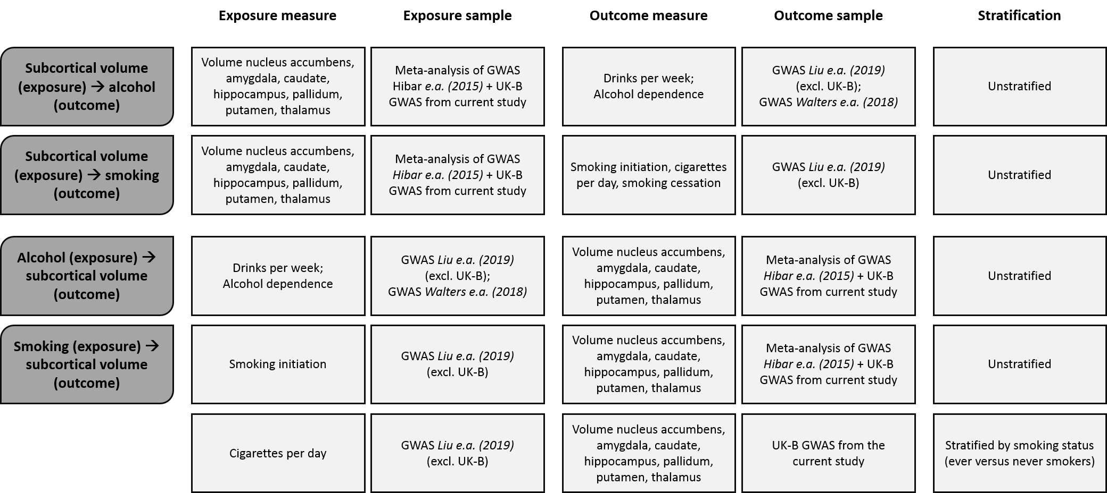

Supplementary Figure 1. Visual overview of all the datasets and (exposure and outcome) measures that were used in our Mendelian randomization analyses

Scatterplots main findings

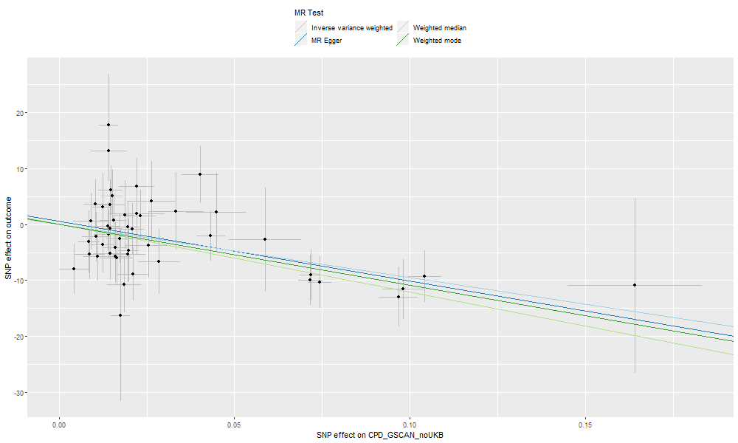
Supplementary Figure 2a. Scatterplot with IVW, weighted median, weighted mode, and MR-Egger results for cigarettes per day as the exposure and hippocampal volume as the outcome – in smokers
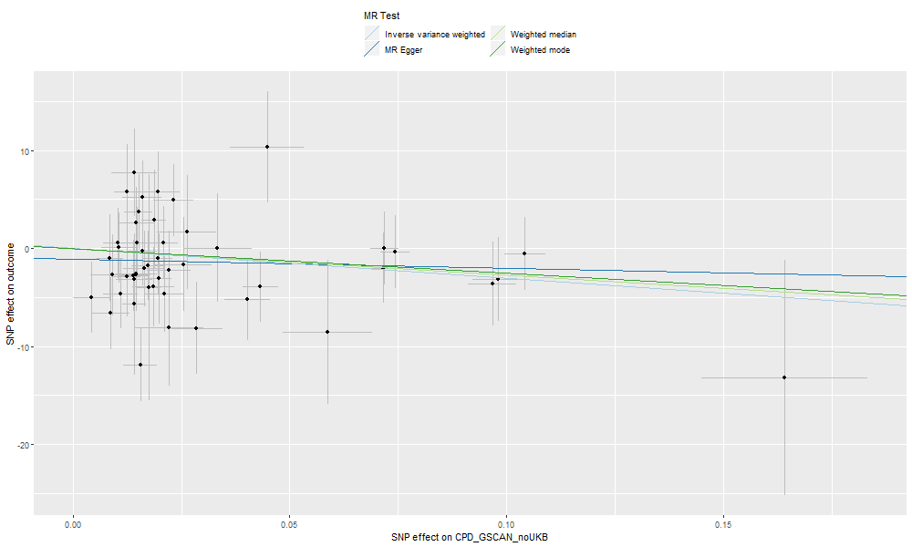
Supplementary Figure 2b. Scatterplot with IVW, weighted median, weighted mode, and MR-Egger results for cigarettes per day as the exposure and hippocampal volume as the outcome – in never smokers
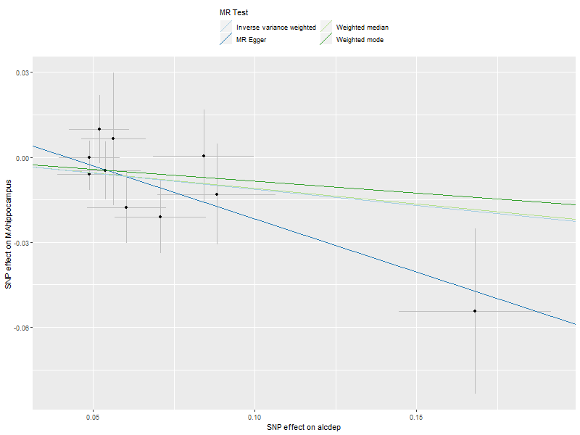
Supplementary Figure 3. Scatterplot with IVW, weighted median, weighted mode, and MR-Egger results for alcohol dependence as the exposure and hippocampal volume as the outcome
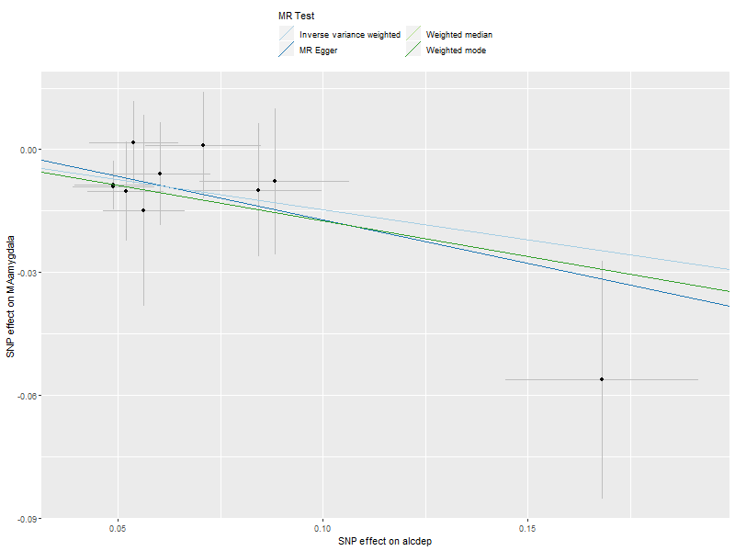
Supplementary Figure 4. Scatterplot with IVW, weighted median, weighted mode, and MR-Egger results for alcohol dependence as the exposure and amygdala volume as the outcome

SNPs included in the genetic instruments
Below is an overview of the SNPs that were included in the various genetic instruments used for Mendelian randomization analyses. Note that we selected SNPs which had initially, that is, in the original, full GWAS study, been reported as genome-wide associated (p<5E-08), to include in the instruments. In the case of smoking initiation, smoking cessation, cigarettes smoked per day and alcohol drinks per week, we excluded UK Biobank from the original GWAS study to prevent sample overlap (which causes bias in MR), and then took the effect estimates from meta-analyses of the remaining samples. This means that for some of the included SNPs for those exposures the significance level may not be p<5E-08.
SNPs included for subcortical brain volumes as exposures:
 | Nucleus accumbens | Amygdala 5E-08 | Amygdala 1E-05 | Caudate | Hippocampus | Pallidum | Putamen | Thalamus
1 | rs1178320 | rs2347701 | rs10130307 | rs10439608 | rs10494303 | rs11196876 | rs10439608 | rs11827239
2 | rs11916858 | rs79340609 | rs10504722 | rs10800064 | rs11068205 | rs11639504 | rs10765500 | rs12146713
3 | rs2153960 |  | rs10850141 | rs10887759 | rs11245365 | rs11976703 | rs11196979 | rs16956241
4 | rs2608301 |  | rs10868746 | rs112510871 | rs11737577 | rs12445022 | rs11197861 | rs1789167
5 | rs321414 |  | rs111592563 | rs115053453 | rs12189145 | rs12703184 | rs11204421 | rs321348
6 | rs34255419 |  | rs11230889 | rs11669745 | rs12523793 | rs1291602 | rs11576262 | rs385301
7 | rs34312154 |  | rs116991338 | rs11676147 | rs13089287 | rs1328360 | rs11765218 | rs429358
8 | rs3789364 |  | rs11790097 | rs117407140 | rs2279681 | rs196798 | rs1187155 | rs45499402
9 | rs4148557 |  | rs118133428 | rs1187155 | rs2287509 | rs2231142 | rs12197456 | rs62288104
10 | rs62288106 |  | rs118182651 | rs12256016 | rs3111623 | rs28439696 | rs12457893 | rs7026018
11 | rs6658111 |  | rs12251016 | rs12749024 | rs429358 | rs2844510 | rs12806934 | rs75179968
12 | rs66717543 |  | rs12363897 | rs12952581 | rs58499557 | rs2974367 | rs13403450 | rs76928645
13 | rs7940646 |  | rs12586189 | rs13172721 | rs61921502 | rs34658078 | rs1346914 | rs806794
14 |  |  | rs12605433 | rs1347008 | rs62063437 | rs34736685 | rs1430332
15 |  |  | rs13100173 | rs1422191 | rs62374671 | rs4887023 | rs1544528
16 |  |  | rs13124981 | rs1743179 | rs6664992 | rs6037025 | rs2139559
17 |  |  | rs132867 | rs17764251 | rs6876370 | rs6058317 | rs2244479
18 |  |  | rs17150071 | rs17773700 | rs7040792 | rs62079082 | rs2710880
19 |  |  | rs202923 | rs208829 | rs77956314 | rs6723226 | rs3131633
20 |  |  | rs2336943 | rs2196448 |  | rs73186053 | rs314688
21 |  |  | rs2347701 | rs2817145 |  | rs76891681 | rs3815071
22 |  |  | rs28399637 | rs28366595 |  | rs7950543 | rs398652
23 |  |  | rs4586727 | rs28535536 |  | rs8014725 | rs4714854
24 |  |  | rs4797344 | rs2910056 |  | rs9426738 | rs4748999
25 |  |  | rs4818252 | rs2926043 |  | rs9922520 | rs4916907
26 |  |  | rs61353762 | rs34259020 |  |  | rs556151
27 |  |  | rs61921502 | rs34811474 |  |  | rs6138937
28 |  |  | rs62282701 | rs3820870 |  |  | rs62136802
29 |  |  | rs62359209 | rs4888010 |  |  | rs634368
30 |  |  | rs6658111 | rs4984975 |  |  | rs6428671
31 |  |  | rs6979446 | rs4985152 |  |  | rs7101609
32 |  |  | rs7014578 | rs55830072 |  |  | rs7734654
33 |  |  | rs707097 | rs56000151 |  |  | rs79787807
34 |  |  | rs7539819 | rs6135525 |  |  | rs8017172
35 |  |  | rs7604451 | rs62037364 |  |  | rs806794
36 |  |  | rs76436457 | rs62082217 |  |  | rs9838026
37 |  |  | rs79340609 | rs62365541
38 |  |  | rs80223973 | rs6483195
39 |  |  | rs895330 | rs6703416
40 |  |  | rs9853475 | rs7040561
41 |  |  |  | rs7084454
42 |  |  |  | rs7198936
43 |  |  |  | rs7245004
44 |  |  |  | rs72631228
45 |  |  |  | rs73144681
46 |  |  |  | rs75268943
47 |  |  |  | rs7747401
48 |  |  |  | rs7949956
49 |  |  |  | rs8017172
50 |  |  |  | rs888234
51 |  |  |  | rs9369275
52 |  |  |  | rs9903088
53 |  |  |  | rs994539
Note that if the number of SNPs differed slightly for different exposure-outcome combinations, we report the instrument with the largest amount of SNPs here.

SNPs included for substance use behaviours as exposures:
 | Smoking initiation | Cigarettes per day | Alcohol dependence | Alcohol drinks per week
1 | rs10042827 | rs1024323 | rs113659074 | rs10004020
2 | rs1004787 | rs10454798 | rs1154445 | rs10028756
3 | rs10060196 | rs10519203 | rs1229863 | rs1004787
4 | rs1008078 | rs10742683 | rs1229984 | rs10085696
5 | rs1022376 | rs1115019 | rs34929220 | rs10236149
6 | rs1022528 | rs11264100 | rs3811802 | rs10438820
7 | rs10233018 | rs113001570 | rs4388946 | rs10506274
8 | rs10272990 | rs117824460 | rs6827898 | rs10750025
9 | rs10279261 | rs11846838 | rs79171978 | rs10753661
10 | rs1030015 | rs11940255 | rs894368 | rs10876188
11 | rs10446419 | rs12438181 |  | rs10978550
12 | rs10490159 | rs12924872 |  | rs11030084
13 | rs1050847 | rs13253502 |  | rs1123285
14 | rs1059490 | rs143200968 |  | rs113443718
15 | rs10698713 | rs146009840 |  | rs1154414
16 | rs10789369 | rs1592485 |  | rs11625650
17 | rs10805858 | rs182317 |  | rs11692435
18 | rs10853981 | rs2084533 |  | rs11739827
19 | rs10858334 | rs215600 |  | rs11940694
20 | rs10873871 | rs2236951 |  | rs12088813
21 | rs10885480 | rs2273500 |  | rs1217091
22 | rs10905461 | rs258321 |  | rs1229984
23 | rs10914684 | rs2741351 |  | rs12499107
24 | rs10935779 | rs28681284 |  | rs1260326
25 | rs10945141 | rs28813180 |  | rs12655091
26 | rs10953957 | rs3025383 |  | rs12795042
27 | rs10966092 | rs34973462 |  | rs12907323
28 | rs11057005 | rs4144686 |  | rs13024996
29 | rs1106363 | rs4236926 |  | rs13032049
30 | rs11076962 | rs4485470 |  | rs13066454
31 | rs11078713 | rs56113850 |  | rs13094887
32 | rs1108130 | rs59208569 |  | rs13107325
33 | rs1109480 | rs6078373 |  | rs13250583
34 | rs11162019 | rs62447179 |  | rs13383034
35 | rs1116690 | rs632811 |  | rs17029090
36 | rs11191269 | rs699165 |  | rs1713676
37 | rs11192347 | rs7125588 |  | rs17177078
38 | rs11258417 | rs72740955 |  | rs17665139
39 | rs1126757 | rs7281463 |  | rs2011092
40 | rs112725451 | rs73229090 |  | rs2165670
41 | rs113230003 | rs7431710 |  | rs2178197
42 | rs1139897 | rs75596189 |  | rs2180870
43 | rs114976176 | rs7599488 |  | rs2472297
44 | rs1150668 | rs7766641 |  | rs2764771
45 | rs11587399 | rs78408772 |  | rs281379
46 | rs11594623 | rs790564 |  | rs2854334
47 | rs11611651 | rs7951365 |  | rs28601761
48 | rs11642231 | rs8040868 |  | rs28680958
49 | rs11651955 | rs8192726 |  | rs28929474
50 | rs11678980 |  |  | rs35034355
51 | rs11692435 |  |  | rs35538052
52 | rs11713899 |  |  | rs36052336
53 | rs1173461 |  |  | rs3748034
54 | rs117657830 |  |  | rs378421
55 | rs11766326 |  |  | rs3803800
56 | rs11768481 |  |  | rs3809162
57 | rs117734003 |  |  | rs4092465
58 | rs11780471 |  |  | rs4501255
59 | rs11783093 |  |  | rs4548913
60 | rs11791671 |  |  | rs4690727
61 | rs118202 |  |  | rs4699791
62 | rs11872397 |  |  | rs4815364
63 | rs1187820 |  |  | rs4842786
64 | rs11889814 |  |  | rs4916723
65 | rs11956866 |  |  | rs4938230
66 | rs12022778 |  |  | rs500321
67 | rs12027999 |  |  | rs5024204
68 | rs12053870 |  |  | rs55872084
69 | rs12130857 |  |  | rs55932213
70 | rs12195240 |  |  | rs56030824
71 | rs12244388 |  |  | rs56337305
72 | rs12474587 |  |  | rs58107686
73 | rs12517438 |  |  | rs60654199
74 | rs12530388 |  |  | rs62044525
75 | rs12563365 |  |  | rs62250685
76 | rs12633090 |  |  | rs6460047
77 | rs12642744 |  |  | rs6787172
78 | rs12714017 |  |  | rs682011
79 | rs12739243 |  |  | rs6951574
80 | rs12740789 |  |  | rs705687
81 | rs12755632 |  |  | rs7074871
82 | rs12855717 |  |  | rs7185555
83 | rs12878369 |  |  | rs72859280
84 | rs12918191 |  |  | rs77165542
85 | rs1291821 |  |  | rs79139602
86 | rs13007361 |  |  | rs7950166
87 | rs13066050 |  |  | rs79616692
88 | rs13109980 |  |  | rs823114
89 | rs13110073 |  |  | rs828867
90 | rs13261666 |  |  | rs9607814
91 | rs13319205 |  |  | rs9838144
92 | rs13392222 |  |  | rs9950000
93 | rs13437771
94 | rs1373178
95 | rs1381287
96 | rs1381775
97 | rs1385108
98 | rs1389171
99 | rs13906
100 | rs139896
101 | rs1413119
102 | rs1435479
103 | rs1435672
104 | rs1435741
105 | rs1445649
106 | rs1449012
107 | rs147052174
108 | rs1514176
109 | rs1518393
110 | rs1549979
111 | rs1555445
112 | rs1561112
113 | rs1565735
114 | rs160631
115 | rs1632941
116 | rs16826827
117 | rs16828799
118 | rs1713676
119 | rs1714521
120 | rs17165769
121 | rs17197663
122 | rs1722666
123 | rs17229285
124 | rs1733760
125 | rs1737329
126 | rs1759433
127 | rs17616642
128 | rs17692129
129 | rs1772572
130 | rs1799068
131 | rs1811739
132 | rs181508347
133 | rs1834306
134 | rs1863161
135 | rs1889571
136 | rs1901477
137 | rs1910236
138 | rs1927901
139 | rs1930371
140 | rs1935571
141 | rs1944689
142 | rs2010921
143 | rs2028269
144 | rs2063976
145 | rs2155646
146 | rs2173019
147 | rs2196356
148 | rs221988
149 | rs2276825
150 | rs2279829
151 | rs2289791
152 | rs2306866
153 | rs2319545
154 | rs2344976
155 | rs2378662
156 | rs238896
157 | rs2526390
158 | rs2539706
159 | rs2587507
160 | rs2637869
161 | rs2710634
162 | rs2734390
163 | rs2796793
164 | rs281296
165 | rs28408682
166 | rs28441558
167 | rs28717373
168 | rs2901785
169 | rs290601
170 | rs2925128
171 | rs2938134
172 | rs2939756
173 | rs2952251
174 | rs2959084
175 | rs301807
176 | rs3098272
177 | rs3115418
178 | rs3172494
179 | rs3218116
180 | rs329124
181 | rs34342129
182 | rs34399632
183 | rs34553878
184 | rs34940743
185 | rs34970111
186 | rs35375873
187 | rs35656245
188 | rs357304
189 | rs359247
190 | rs359431
191 | rs3740977
192 | rs3764351
193 | rs3800227
194 | rs3810496
195 | rs3811038
196 | rs3820277
197 | rs3843905
198 | rs3847244
199 | rs3909281
200 | rs3934797
201 | rs4044321
202 | rs42417
203 | rs4264267
204 | rs4275621
205 | rs4310804
206 | rs4476253
207 | rs4543050
208 | rs45444697
209 | rs4674916
210 | rs4674993
211 | rs4727189
212 | rs4752018
213 | rs4759229
214 | rs4785187
215 | rs4788676
216 | rs4790874
217 | rs4818005
218 | rs4822102
219 | rs4837631
220 | rs4877285
221 | rs4886207
222 | rs4912332
223 | rs540860
224 | rs55786907
225 | rs55913542
226 | rs55944129
227 | rs56208390
228 | rs56367474
229 | rs56902655
230 | rs57153235
231 | rs58400863
232 | rs586699
233 | rs59537158
234 | rs6011779
235 | rs6050446
236 | rs6058782
237 | rs6073075
238 | rs60833441
239 | rs61533748
240 | rs61884449
241 | rs61886926
242 | rs619087
243 | rs61959481
244 | rs62007780
245 | rs62052916
246 | rs62098013
247 | rs62106258
248 | rs62137126
249 | rs62180324
250 | rs62193862
251 | rs62246017
252 | rs62340589
253 | rs62618693
254 | rs6265
255 | rs6437769
256 | rs6438436
257 | rs644740
258 | rs6452785
259 | rs6497840
260 | rs6568832
261 | rs67050670
262 | rs6730325
263 | rs6731872
264 | rs6750107
265 | rs6750529
266 | rs6756212
267 | rs67777803
268 | rs6782116
269 | rs6874731
270 | rs6890961
271 | rs6936160
272 | rs6948707
273 | rs6968380
274 | rs6986430
275 | rs6993429
276 | rs7024924
277 | rs7026534
278 | rs7072776
279 | rs7134009
280 | rs71367544
281 | rs71592686
282 | rs71602617
283 | rs7188873
284 | rs7192140
285 | rs72780746
286 | rs72789626
287 | rs72790288
288 | rs72898831
289 | rs72938304
290 | rs73008357
291 | rs7333559
292 | rs73831818
293 | rs74697736
294 | rs748832
295 | rs7505855
296 | rs75210106
297 | rs75674569
298 | rs75919030
299 | rs7600835
300 | rs7631379
301 | rs7640107
302 | rs76460663
303 | rs7657022
304 | rs76608582
305 | rs76841737
306 | rs7696257
307 | rs77215829
308 | rs77283305
309 | rs7743165
310 | rs7802996
311 | rs7809303
312 | rs7836565
313 | rs7867822
314 | rs7901883
315 | rs7929518
316 | rs7943721
317 | rs79476395
318 | rs7969559
319 | rs8005334
320 | rs80054503
321 | rs8027457
322 | rs8050598
323 | rs8083764
324 | rs8096225
325 | rs8103660
326 | rs876793
327 | rs910912
328 | rs925524
329 | rs9288999
330 | rs9302604
331 | rs9323328
332 | rs9331343
333 | rs951740
334 | rs9538162
335 | rs9540731
336 | rs9545155
337 | rs9627272
338 | rs963354
339 | rs9787523
340 | rs9826984
341 | rs9841807
342 | rs9850597
343 | rs9922607
344 | rs9936784
345 | rs9941217
346 | rs9987376
Note that if the number of SNPs differed slightly for different exposure-outcome combinations, we report the instrument with the largest amount of SNPs here.

