Appendix 1. Additional description of the methods.

Evaluation of Single Administrative Codes for ECT

Due to the risk of miscoding, a prior study using VA data excluded all patients receiving only one ECT procedural codes.18 Therefore, when individuals in our sample had only one administrative code for ECT procedure documented in their EMR history, we sought confirmation for the purported procedure through a review of clinical notes in the EMR. We applied the following confirmatory word to screen for true instances of ECT: “ECT”, “(ECT)”, “Electroconvulsive.” We applied these word searches to all clinical notes for the patients with a single isolated administrate code for ECT. Of 125,549 ECT procedures identified between January 1, 2000 and January 1, 2017, 3316 were a patient’s only ECT procedure during that time period. In 2029 cases there was no indication of ECT in any clinical note. These 2029 possible ECT treatments were not used for additional analysis. In 1,287 cases the single administrative indication of ECT included some mention of ECT in a clinical note and these cases were retained in analysis. We sought to confirm of procedure for excluding these events. We took a random sample of 3316 isolated administrative notes for ECT and evaluated them as either true ECT or not ECT using our text search process above, and independent review by two different psychiatrists with experience with ECT. We then calculated a kappa statistic to assess the agree of agreement among three “reviewers”: two psychiatrist reviewers and the natural language processing algorithm.There results showed a kappa statistic of 0.96 indicating excellent agreement between the reviewers and suggesting that our text search procedure was successful in excluding administrative codes of ECT made in error. For confirmation we used our text search administrative codes of ECT treatments that occurred in series. We found no situation in which ECT was not mentioned in the clinical notes.

Full Propensity Score Matching Model

Propensity Score Matching was based on a logistic regression predicting receipt of ECT. This model was developed based on differences between case and control groups demonstrated in table 1 and stepwise variable selection to identify the predictors which maximize predicted probability of ECT. The final model used for PS match had a ROC of 0.887 for prediction of ECT.

The full logistic model is listed below along with the ROC.

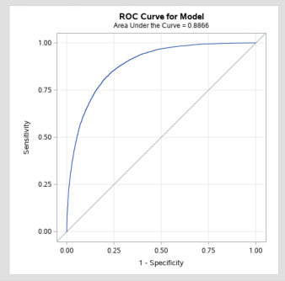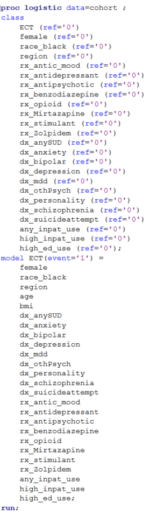

The full propensity score matched model, along with the matching specifications per SAS PS Match procedure is listed below;

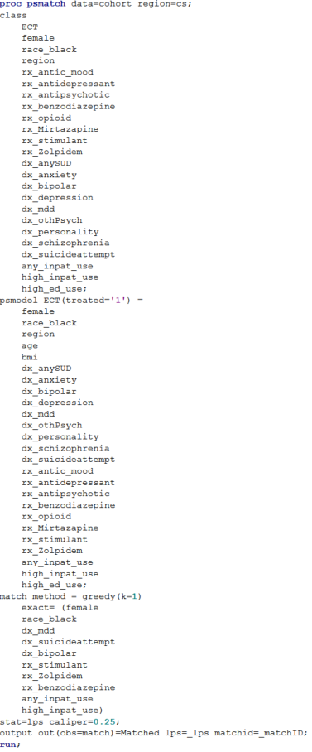

The following descriptive and statistical measures illustrate that balance yielded by propensity score matching process in the final matched population.

Predicted probability of receipt of ECT in full population (**before matching**)

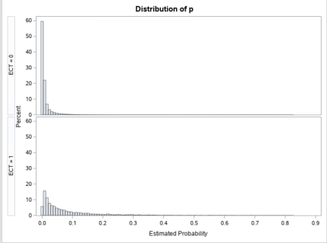

Predicted probability of receipt of ECT in full population (**after matching**)

|  |  |  |
| --- | --- | --- |
|  | N | Median Predicated Prob (IQR) |
| Total | 15,194 | 0.339 (0.055) |
| Case (ECT=1) | 10,097 | 0.337 (0.055) |
| Control (ECT=1) | 5,097 | 0.343 (0.052) |

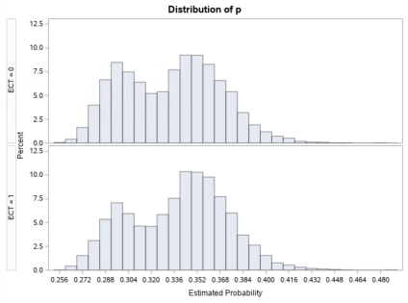

**Propensity Score Information in Full and Matched Sample**

|  |  |  |  |  |  |
| --- | --- | --- | --- | --- | --- |
|  | **Standardized Mean Difference in Logit Propensity Score**  **(Case(ECT=1) - Control (ECT=0))** | | | | |
|  | **Mean Difference** | **Standard Deviation** | **Standardized Difference** | **Percent Reduction** | **Variance Ratio** |
| **All** | **0.067** | **0.069** | **0.96** | **--** | **15.35** |
| **Matched** | **0.003** | **--** | **0.05** | **95.00** | **1.17** |

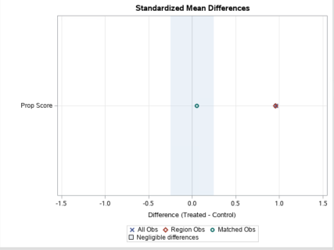

**For more information on mean differences as a measure of matching balance and statistical calculations for standardized differences, see SAS see PSMatch Documentation (p. 7714):** [**https://support.sas.com/documentation/onlinedoc/stat/142/psmatch.pdf**](https://support.sas.com/documentation/onlinedoc/stat/142/psmatch.pdf)

**Statistical Test of Balance**

Kolmogorov Smirnov test examines whether the distribution of a variable (in this case propensity score) is the same across different groups

|  |  |  |  |
| --- | --- | --- | --- |
| Kolmogorov-Smirnov Test for Propensity Score Classified by Case-Control status | | | |
| Case/ Control | N | Empirical Distribution Functional at Maximum | Deviation fromMeans at Maximum |
| Case (ECT) | 5097 | 0.916 | -0.69 |
| Control (Inpatient) | 10097 | 0.930 | 0.49 |
| Value of propensity Score at Max = 0.21335 | | | |

|  |  |
| --- | --- |
| Kolmogorov-Smirnov Two-Sample Test (asymptotic) | |
| Ksa 0.8455 | Pr>Ksa 0.4704 |

The non-significant p-value (0.47) indicates that that there is no significant different in the distribution of the propensity score between the case and the control group in the final matched population.

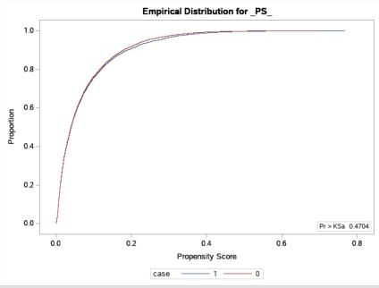

For more information on this test and the computation of the Kolmogorov-Smirnov Statistic and empirical distribution functions see SAS Supporting documentation of Proc NPar1Way (page 6747): <https://support.sas.com/documentation/onlinedoc/stat/142/npar1way.pdf>