Data analysis
This section provides am more detailed information about the statistical procedure and the used software. Network stability and accuracy was measured by methods previously described in details (1). We used R-package bootnet to establish robustness (2).
Network estimation
We estimated Gaussian Graphical Models (GGM) for pairwise association parameters between all nodes. In the GGM, edges can be understood as conditional dependence relations among symptoms: If two symptoms are connected in the resulting graph, they are dependent after controlling for all other symptoms. Symptoms that are not connected are conditionally independent. With 8 symptom nodes, 28 pairwise association parameters are estimated. The estimation of so many parameters may lead to a number of spurious connections; we thus controlled for these false positives by using the least absolute shrinkage and selection operator (LASSO; 1) which sets very small edges to zero. This procedure employs a regularization technique that conservatively identifies only the relevant edges, and accurately discovers the underlying network structure (4). More details on these estimation techniques, including a tutorial, is available elsewhere (5).
The symptom network was estimated for all symptoms of the ADNM-8 and ADNM-4 using the R-package qgraph (6). Networks were estimated using regularized partial correlation models in the R-package qgraph that present the unique, independent relationships between symptoms (7). The network is weighted and undirected due to the cross-sectional nature of the study. Questionnaire data of Adjustment disorder symptoms (8-item ADNM version) were answered at an ordinal scale; thus, we estimated a matrix of polychoric correlations.
Visualization with the Graphical Lasso This method directly estimates the inverse of the covariance matrix (8). It shrinks small edges and many parameters to zero by estimating a penalized maximum likelihood solution based on the Extended Bayesian Information Criterion (EBIC) (9). For ease of visual comparison, the networks were restricted to a consistent “average layout,” presented across samples.
Network stability of the ADNM-8
There are no clear boundaries to interpret the results of the stability analyses. The confidence intervals around the edge weights were moderately large (Figure SM2). The generally large bootstrapped CIs imply that interpreting the order of most edges in the network should be done with care. This may also indicate that many edge-weights likely do not significantly differ from one another. About two third of the nonzero edges had 95%-CIs that did not include zero and only the CIs of the strongest edges did not overlap with the CIs of smaller edges. In the Ghana sample one third of the nonzero edges had 95%-CIs that did not include zero.
We performed two procedures to check the accuracy and stability of the results: (A) the accuracy of estimated edge-weights (figure SM2), (B) the stability of centrality indices (figure SM3) after subsetting the data (10). The accuracy of the estimated edge-weights was satisfactory for the three samples (Ghana 0.59 CI 95% 0.52, 0.67, Kenya 0.68 CI 95% 0.59, 0.75, and Nigeria 0.75 CI 95% 0.67, 1). The correlation stability coefficient for the strength centrality metric was below the suggested 0.5 threshold for strong stability (10) for the Kenya (.03 CI 95% 0, 0.05) and the Nigeria (0.13 CI 95% .05, .21), and above the suggested threshold of 0.25 for moderate stability for the Ghana sample (0.28 CI 95% .21, .36). The centrality strength indexes were not stable under subsetting cases in the Kenya and Nigeria samples. Considering the cutoff 0.25 for satisfactory stability (10), the Ghana sample had sufficient stability across imputations, yet centrality index should be referred cautiously.
The correlation of the original strength centrality order with the order of the strength centrality in subsets was reduced after dropping a substantial number of participants (Figure SM3), which means that the strength estimate can be considered unstable mainly in Nigeria and Kenya. Figure SM4 displays the edges that significantly differ from each other and Figure SM5 displays the centrality estimates of all eight items that significantly differ from each other.
Network stability of the ADNM-4
The confidence intervals around the edge weights were moderately large (Figure SM7), in particular in the Ghana sample and least in the Nigeria sample. The generally large bootstrapped CIs imply that interpreting the order of most edges in the network should be done with care. This may also indicate that many edge-weights likely do not significantly differ from one another. About 90% of the nonzero edges had 95%-CIs that did not include zero and only the CIs of the strongest edges did not overlap with the CIs of smaller edges.
The accuracy of the estimated edge-weights (figure SM7) was satisfactory for the three samples (Ghana 0.44 CI 95% 0.36, 0.52, Kenya 0.52 CI 95% 0.44, 0.59, and Nigeria 0.75 CI 95% 0.67, 1). The correlation stability coefficient for the strength centrality metric (figure SM8) was higher than the suggested 0.5 threshold for strong stability (6) for Ghana (.52 CI 95% 0.44, 0.59), Kenya (0.52 CI 95% 0.44, 0.59) and Nigeria (0.60 CI 95% .52, .67). This indicates that the centrality strength indexes are stable under subsetting cases in all samples. Figure SM11 displays the edges that significantly differ from each other and Figure SM12 displays the centrality estimates of all eight items that significantly differ from each other.
Network Comparisons
Overall connectivity can be summarized by global strength and is defined as the weighted absolute sum of all edges in the network. The distance S, based on global strength, between two networks is presented. The Invariant Network Structure concerns the structure of the network as a whole. The test of network structure invariance evaluates the observed value of M in the data against the reference distribution of M that arises from random permutation of group membership across cases (11).

Table 1.
F statistics, Means and Standard deviations of the ADNM items of the three samples
ADNM items | Ghana | Kenya | Nigeria | F (2,2051) | η²
Preoccupation

Item 1: I have to think about the stressful situation repeatedly | 2.46 (.96)_{a} | 2.69 (.92)_{b} | 2.50 (.91)_{a} | 15.95*** | .012
Item 2: I have to think about the stressful situation a lot and this is a great burden to me (Item 1 in ADNM-4) | 2.28 (1.09)_{a} | 2.49 (1.04)_{b} | 2.28 (1.01)_{a} | 12.75*** | .010
Item 4: I constantly get memories of the stressful situation and can’t do anything to stop them (Item 2 in ADNM-4) | 2.11 (.96)_{a} | 2.25 (1.04)_{b} | 2.06 (.98)_{a} | 9.65*** | .010
Item 5: My thoughts often revolve around anything related to the stressful situation | 2.21 (1.00)_{a} | 2.29 (.99)_{b} | 2.16 (.99)_{a} | 4.76*** | .003
Failure to adapt

Item 3: Since the stressful situation, I find it difficult to concentrate on certain things (Item 3 in ADNM-4) | 2.12 (.97)_{a} | 2.40 (1.04)_{b} | 2.02 (.96)_{a} | 37.15*** | .030
Item 6: Since the stressful situation, I don’t like going to work or carrying out necessary tasks in everyday life (Item 4 in ADNM-4) | 1.68 (.92)_{a} | 1.82 (.97)_{b} | 1.58 (.82)_{a} | 17.63*** | .010
Item 7: Since the stressful situation, I can no longer sleep properly | 1.89 (.96)_{a} | 2.06 (1.01)_{b} | 1.77 (.92)_{a} | 23.18*** | .020
Item 8: Overall, the stressful situation affected me strongly in my personal relationships, my leisure activities, or in other important areas of life | 1.80 (.94)_{a} | 1.94 (.99)_{b} | 1.73 (.91)_{a} | 13.67*** | .010

Note. All p values are <.001, Means sharing a common subscript are not significantly different at α = .01 according to Bonferroni significant difference procedure.

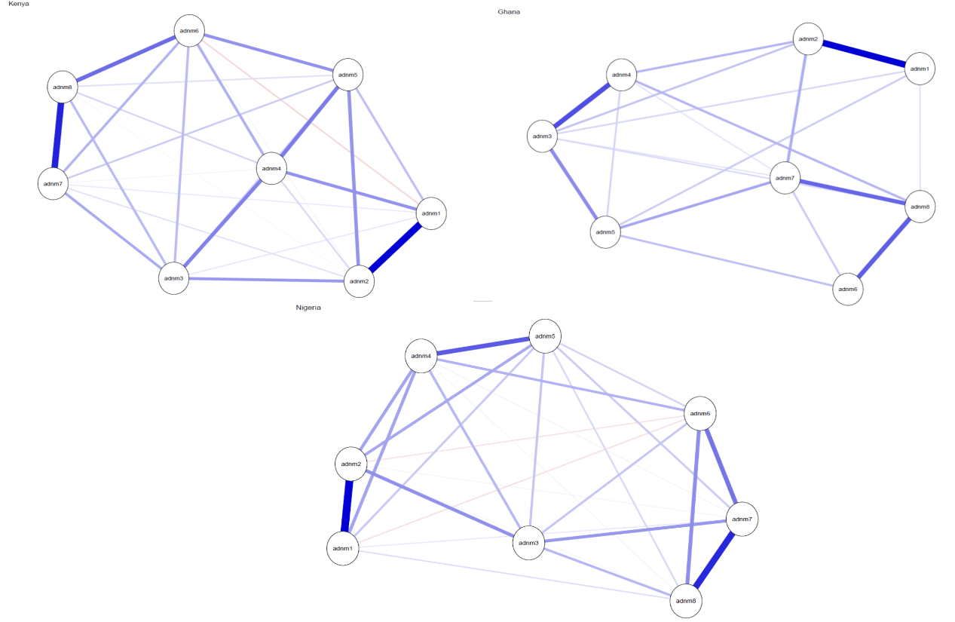
Fig SM1. ADNM-8: Networks of Adjustment Disorder symptoms in three African samples. Nodes represent Adjustment Disorder items and edges Regularized partial correlations with LASSO penalty. Distances among nodes and thickness of edges relate to size of their partial correlations. Blue edges indicate positive relations. ADNM 1: Repeated thoughts, ADNM 2: Sense of burden; ADNM 4: Thoughts revolve, ADNM 5: Difficulties concentrating; ADNM 3: Constant memories, ADNM 6: Work/tasks difficulties; ADNM 7: Sleeping problems ADNM 8: Functional Impairment. The full items can be found in table 1.

Fig SM2. Standardised node strength centrality for the cross-sample networks of the ADNM-8. ADNM 1: Repeated thoughts, ADNM 2: Sense of burden; ADNM 3: Difficulties concentrating; ADNM 4: Constant memories; ADNM 5: Thoughts revolve; ADNM 6: Work/tasks difficulties; ADNM 7: Sleeping problems ADNM 8: Functional Impairment. The full items can be found in Table 1.
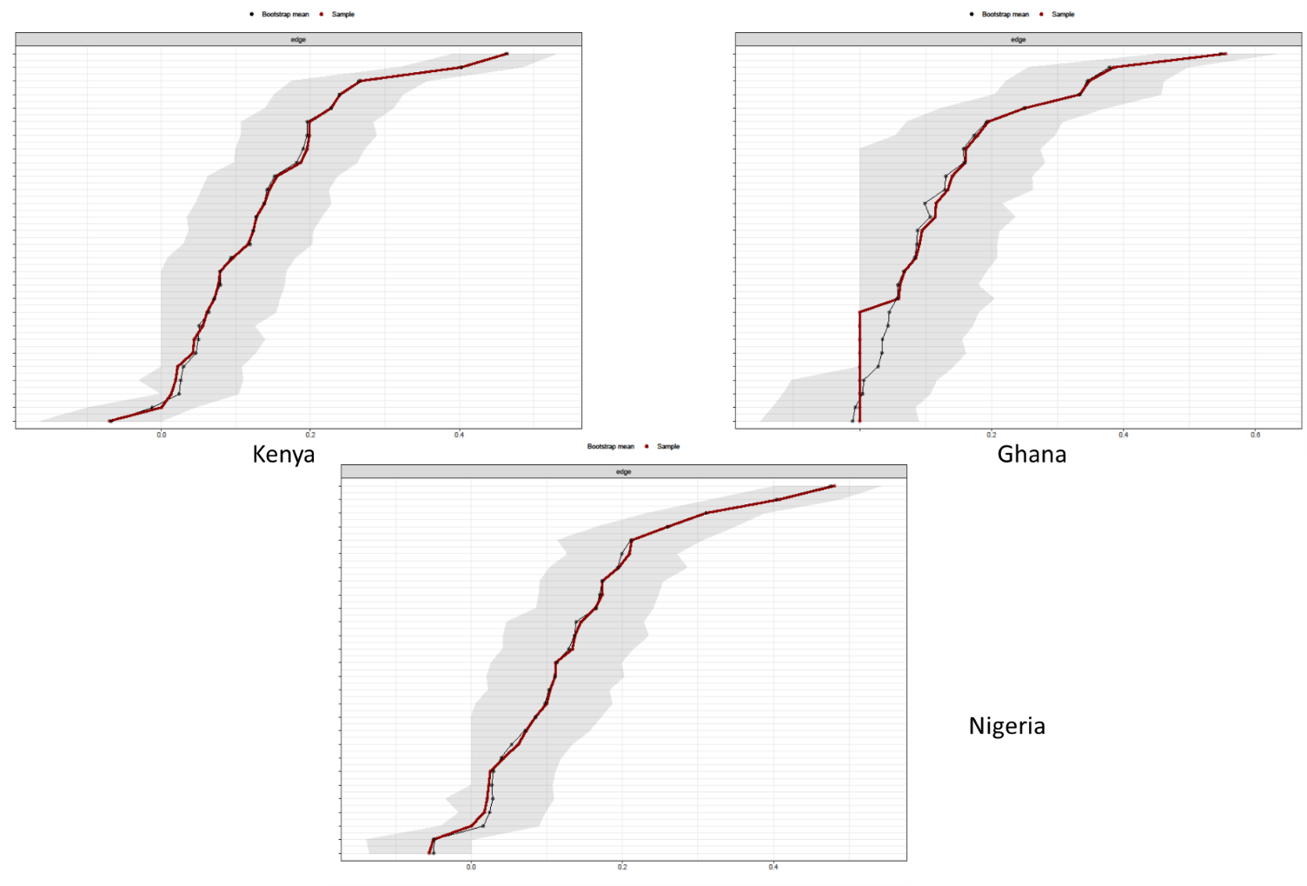
Fig SM3. Stability analysis – ADNM-8 - accuracy of edge weights. Red lines are Point estimates and grey are the 95% bootstrap confidence intervals of network edges (based on partial correlations between items) for the three estimated networks.

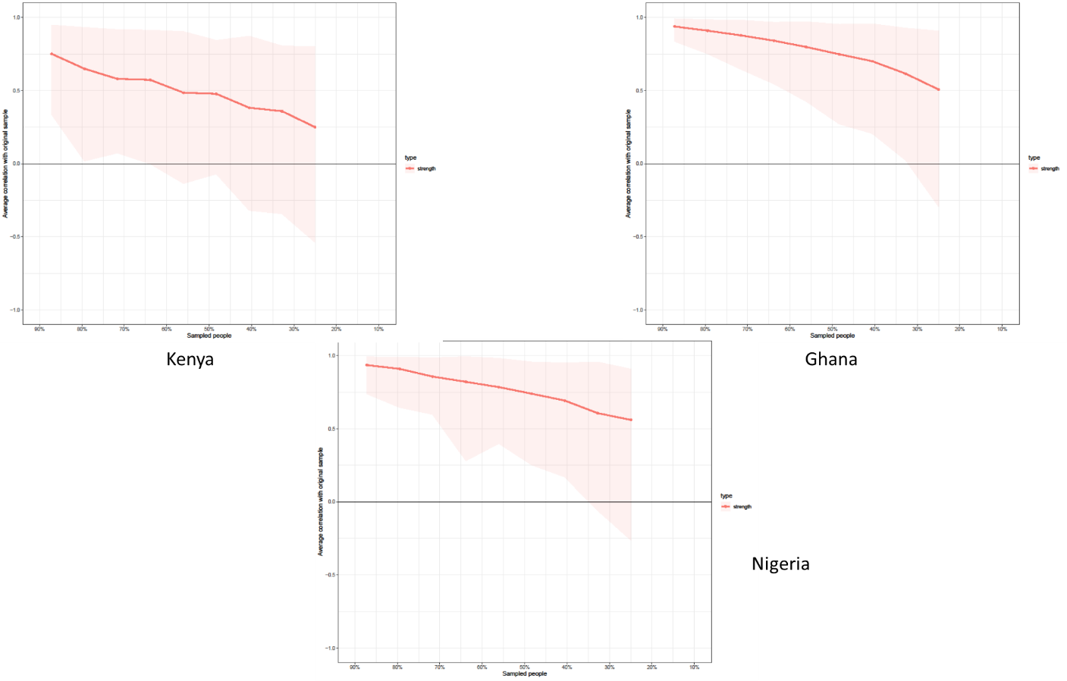

Figure SM4. Stability Analysis. ADNM-8 - Centrality bootstrap. Correlation of the original strength centrality order with the order of strength centrality in subsets of the data. The correlation after dropping a substantial number of participants is high for the centrality metric strength, which means that this centrality estimate can be considered stable in all three samples.
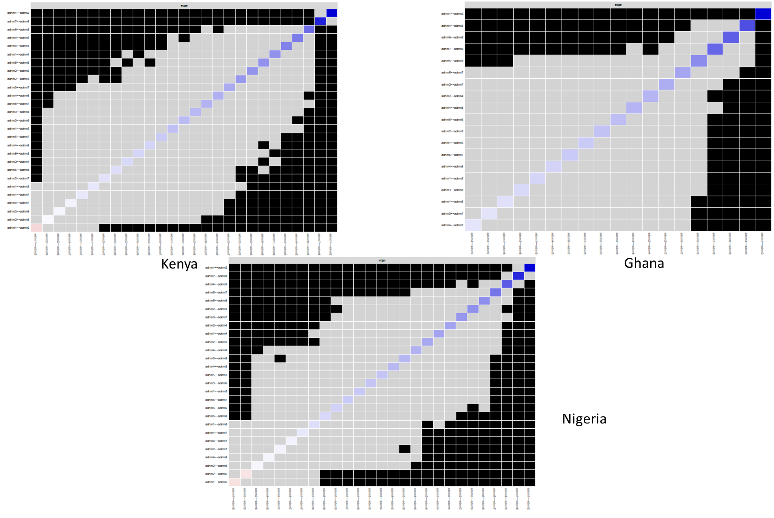
Figure SM5. Edge weights difference test. ADNM-8 - Black boxes represent significant differences between edge weights. The test does presently not correct for multiple testing.

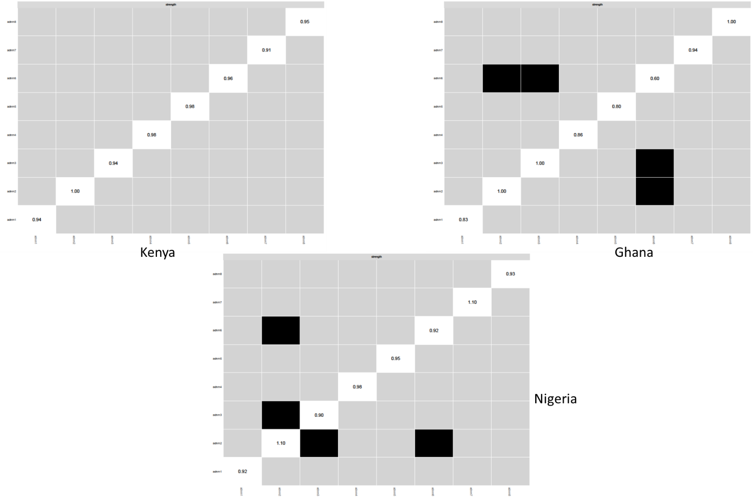
Figure SM6. Centrality difference test. Standardized strength centrality values are shown in the diagonal, black boxes represent significant differences in centrality estimates. The test does presently not correct for multiple testing.
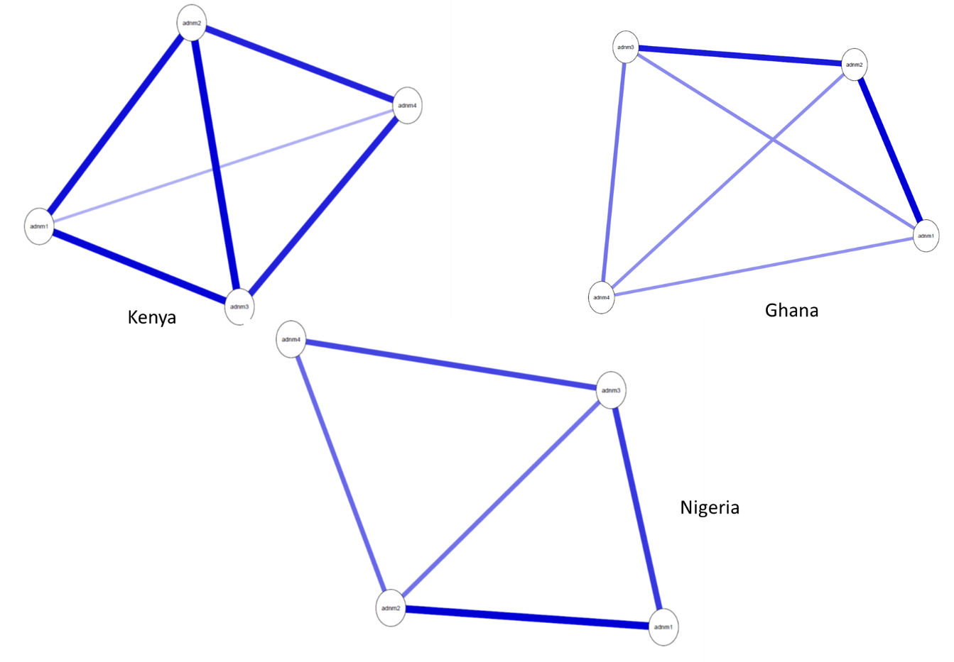
Fig SM7. ADNM-4: Networks of Adjustment Disorder symptoms in three African samples. Nodes represent Adjustment Disorder items and edges Regularized partial correlations with LASSO penalty. Distances among nodes and thickness of edges relate to size of their partial correlations. Blue edges indicate positive relations. ADNM 1: Repeated thoughts, ADNM 2: Sense of burden; ADNM 4: Thoughts revolve, ADNM 5: Difficulties concentrating; ADNM 3: Constant memories, ADNM 6: Work/tasks difficulties; ADNM 7: Sleeping problems ADNM 8: Functional Impairment. The full items can be found in table 1.

Fig SM8. Standardized node strength centrality for the cross-sample networks of the ADNM-4. ADNM 1: Sense of burden; ADNM 2: Constant memories; ADNM 3: Difficulties concentrating, ADNM 4: Work/tasks difficulties. The full items can be found in Table 1.

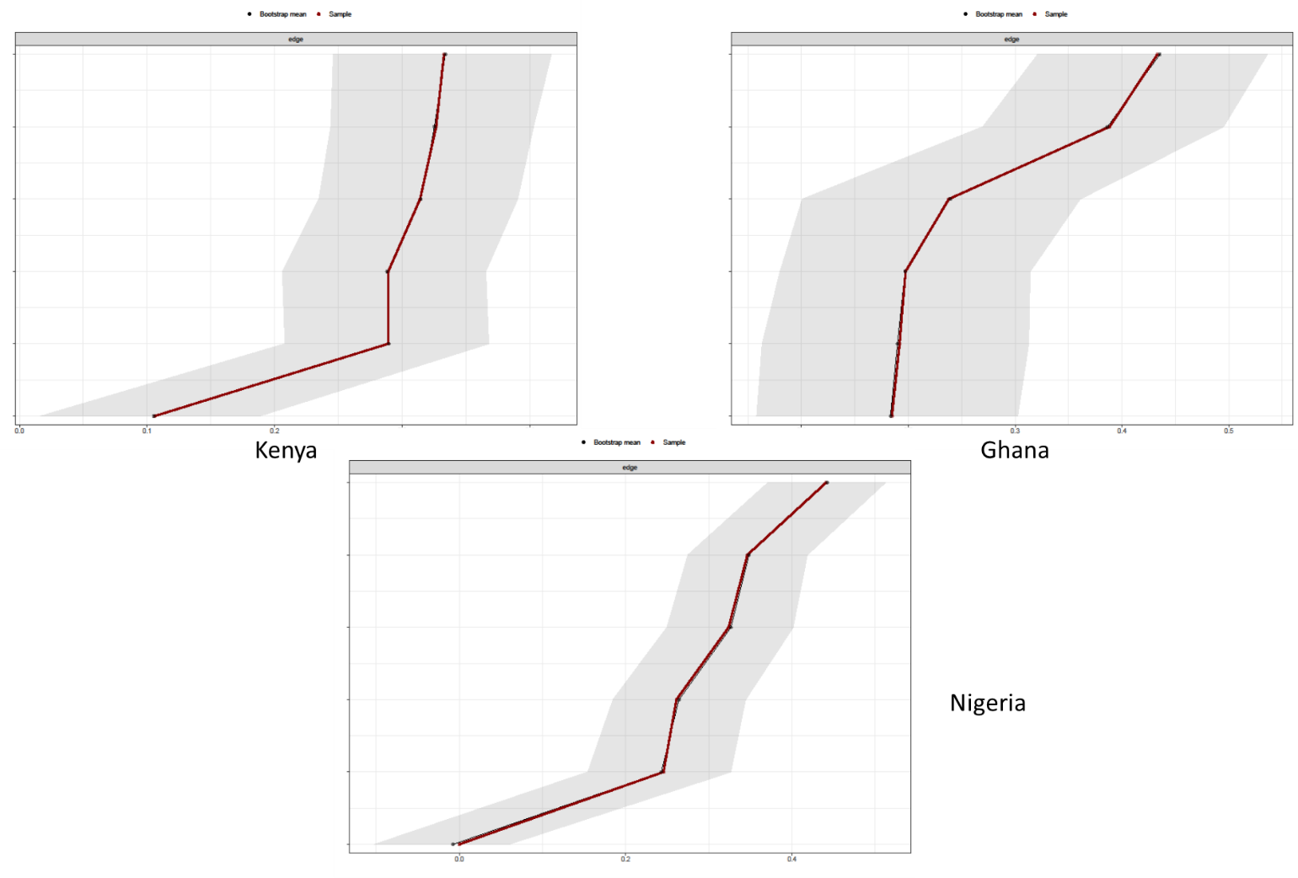
Fig SM9. Stability analysis – ADNM 4 - accuracy of edge weights. Red lines are Point estimates and grey are the 95% bootstrap confidence intervals of network edges (based on partial correlations between items) for the three estimated networks.
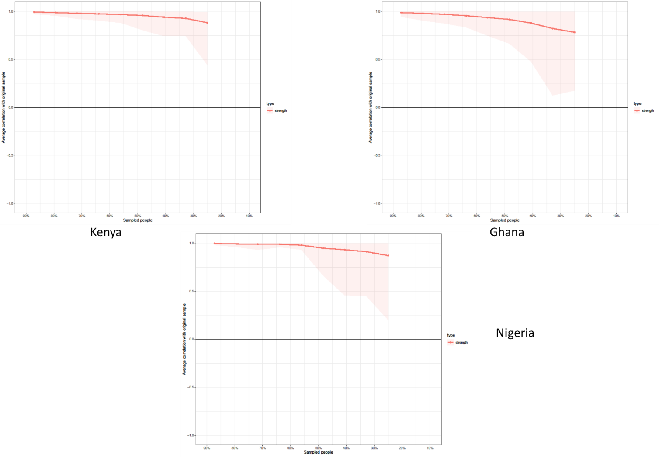
Figure SM10. Stability Analysis. ADNM-4 - Centrality bootstrap. Correlation of the original strength centrality order with the order of strength centrality in subsets of the data. The correlation after dropping a substantial number of participants is high for the centrality metric strength, which means that this centrality estimate can be considered stable in all three samples.
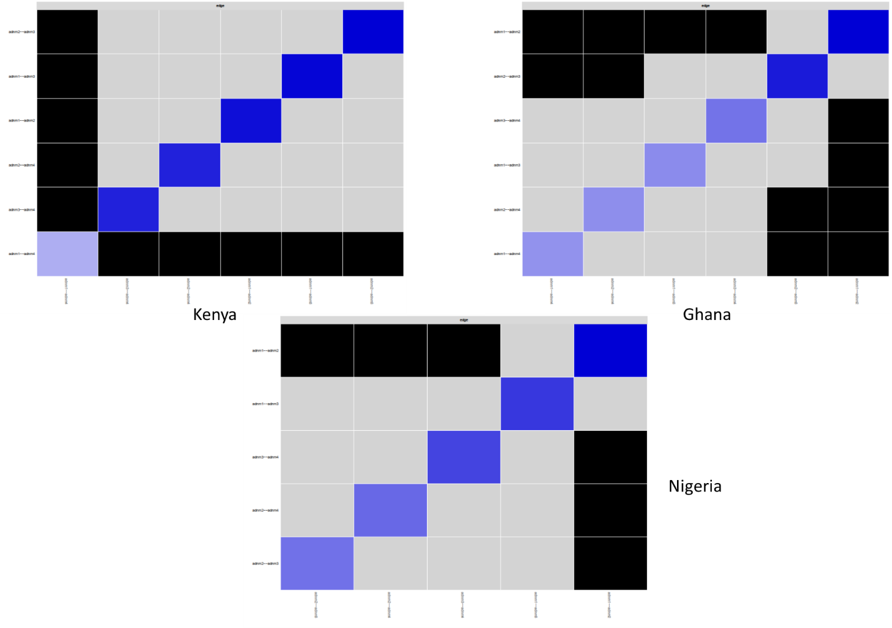
Figure SM11. Edge weights difference test. ADNM-4. Black boxes represent significant differences between edge weights. The test does presently not correct for multiple testing.

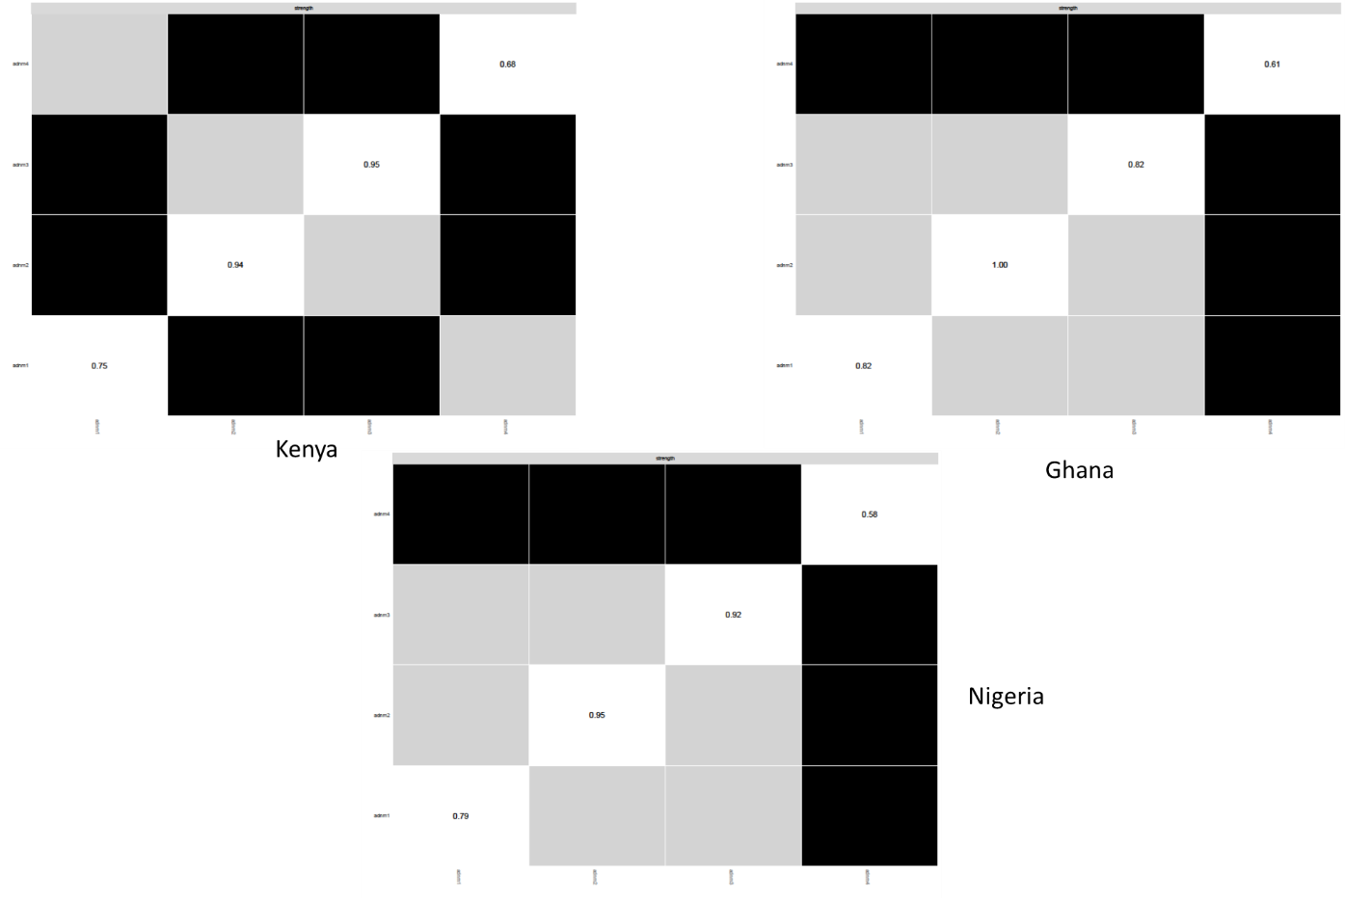

Figure SM12. Edge weights difference test. ADNM-4 - Black boxes represent significant differences between edge weights. The test does presently not correct for multiple testing.

1. Knefel M, Karatzias T, Ben-Ezra M, Cloitre M, Lueger-Schuster B, Maercker A. The replicability of ICD-11 complex post-traumatic stress disorder symptom networks in adults. Br J Psychiatry 2019; 214(6): 361-368. Available from: https://doi.org/10.1192/bjp.2018.286 2. Epskamp S. Package ‘bootnet’: Bootstrap Methods for Various Network Estimation Routines; 2015. Available from: URL: https://cran.r-project.org/web/packages/bootnet/index.html.
3. Friedman J, Hastie T, Tibshirani R. Sparse inverse covariance estimation with the graphical lasso. Biostatistics 2008; 9(3):432–41.
4. van Borkulo CD, Borsboom D, Epskamp S, Blanken TF, Boschloo L, Schoevers RA et al. A new method for constructing networks from binary data. Sci Rep 2014; 4:5918.
5. Epskamp S, Fried EI. A tutorial on regularized partial correlation networks. Psychol Methods 2017. Available from: URL: https://arxiv.org/abs/1604.08462.
6. Epskamp S, Cramer AOJ, Waldorp LJ, Schmittmann VD, Borsboom D. Qgraph: Network visualizations of relationships in psychometric data. J Stat Softw 2012; 48: 1–8.
7. Knefel M, Karatzias T, Ben-Ezra M, Cloitre M, Lueger-Schuster B, Maercker A. The replicability of ICD-11 complex post-traumatic stress disorder symptom networks in adults. Br J Psychiatry 2019; 204: 361–8.
8. Friedman J, Hastie T, Tibshirani R. Sparse inverse covariance estimation with the graphical lasso. Biostatistics 2008; 9: 432–41.
9. Foygel R, Drton M. Extended Bayesian information criteria for Gaussian graphical models. In Advances in Neural Information Processing Systems 23: 24th Annual Conference on Neural Information Processing Systems 2010, NIPS 2010: 2020–8. , 2010.
10. Epskamp S, Borsboom D, Fried EI. Estimating psychological networks and their accuracy: A tutorial paper. Behav Res Methods 2017.
11. van Borkulo CD, Boschloo L, Kossakowski JJ, Tio P, Schoevers RA, Borsboom D, et al. Comparing network structures on three aspects: A permutation test. , 2017 (http://dx.doi.org/10.13140/RG.2.2.29455.38569).

