SUPPLEMENTARY MATERIAL

LCMM analysis of ADHD trajectories
All assessed cohort participants were evaluated for ADHD symptoms in 2004, 2008, 2011, and 2015, at the ages of 11, 15, 18, and 22 years. Since all assessments were made in the same year with all cohort members, we assumed that there was no variation between subjects related to age. As Proust-Lima et al. (2017) recommended, we centered the time at the age of 11 and divided the resulting values by 10. This approach resulted in the transformation of time values (0 = 11, 0.4 = 15, 0.7 = 18, and 1.1 = 22). All participants who were assessed at least once in the four waves of the study entered the analysis. We tested linear, quadratic, and cubic models, both for fixed and random effects.
The LCMM package also allows us to model non-linear relations of the latent variable and the measured outcome. Thus, we tested different link functions between the outcome measure and the latent process, mainly through the use of spline transformations with varying numbers of nodes, both with equal distances between nodes and with nodes in quintiles of the latent process. Best models were chosen by their fit measures, mainly BIC and relative entropy, by the degree of certainty in classifying participants in their respective classes and the model plausibility concerning ADHD literature. Covariates were tested in a 3-step method for the regression analysis that evaluated the associations of gender, educational, and comorbidity variables for each trajectory. The use of the 3-step instead of the 1-step approach was considered adequate for our analysis as the LCMM model had high individuals’ correct classification indices (Schoot et al., 2017).

Supplementary Table 1. Comparisons of different LCMM models
 | BIC | AIC | Entropy | Class 1  No. (%) | Class 2  No. (%) | Class 3  No. (%)
All cohort (n=4676)
Model with 1 class | 34091.84 | 34001.53 | 1.0000000 | 4676 (100.0) | - | -
Model with 2 classes | 33763.00 | 33653.34 | 0.8033426 | 3834 (82.0) | 842 (18.0) | -
Model with 3 classes | 33635.22 | 33506.22 | 0.7415084 | 3621 (77.4) | 825 (17.6) | 230 (4.9)
Model with 4 classes* | - | - | - | - | - | -
Those with ADHD at 22 years of age (n=540)
Model with 1 class | 5129.863 | 5074.072 | 1.0000000 | 540 (100.0) | - | -
Model with 2 classes | 4947.168 | 4878.503 | 0.8562796 | 422 (78.1) | 118 (21.9) | -
Model with 3 classes* | - | - | - | - | - | -
Model with 4 classes* | - | - | - | - | - | -
Model for all cohort: linear fixed effects, linear random effects, non-structured matrix of variance-covariance of random effects, link function between the latent variable and the measured outcome were reached by splines transformation with eight nodes in the quantiles of the latent variable (28).
Model for those with ADHD at 22 years of age: linear fixed effects, linear random effects, diagonal variance-covariance matrix of the random-effects (idiag argument of lcmm function from lcmm R package), link function between the latent variable and the measured outcome were reached by splines transformation with eight nodes in the quantiles of the latent variable (28).
*Models that did not converge.

Supplementary Table 2. Comparisons of different LCMM models in those with ADHD at 22 years considering only self-report information (n=540)
 | BIC | AIC | Entropy | Class 1 (%) | Class 2 (%) | Class 3 (%)
Model with 1 class | 4094.22 | 4034.14 | 1.0000000 | 100.0 | - | -
Model with 2 classes | 4096.33 | 4023.38 | 0.9742012 | 99.3 | 0.7 | -
Model with 3 classes | 3510.59 | 3424.76 | 0.9537874 | 12.6 | 32.6 | 54.8
Model with 4 classes* | - | - | - | - | - | -
*Models with 4 or more classes did not converge.

Supplementary Figure 1. ADHD trait trajectories in those with ADHD at 22 years considering only self-report information at the ages of 11, 18 and 22 years of age (n=540):
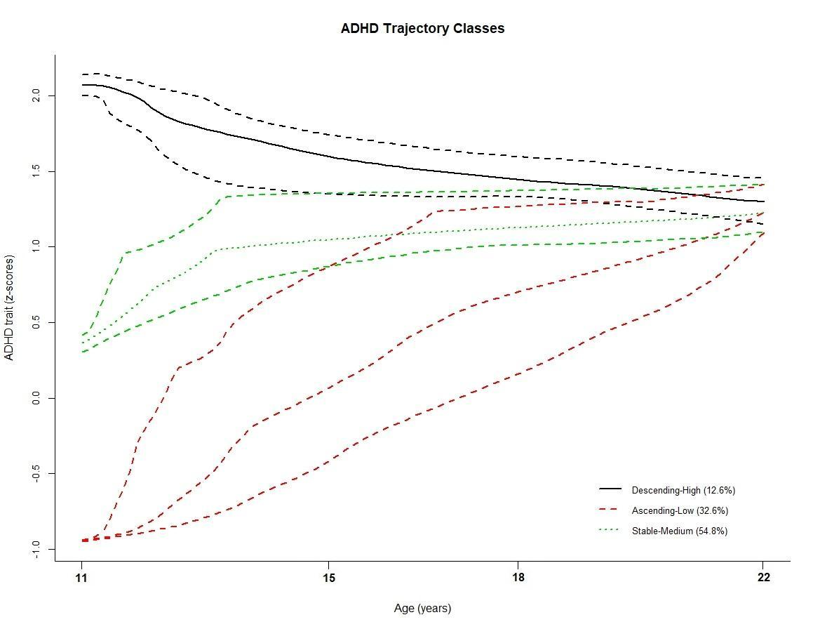

Supplementary Figure 2. ADHD trait trajectories in all cohort with 95% CI (n=4676):
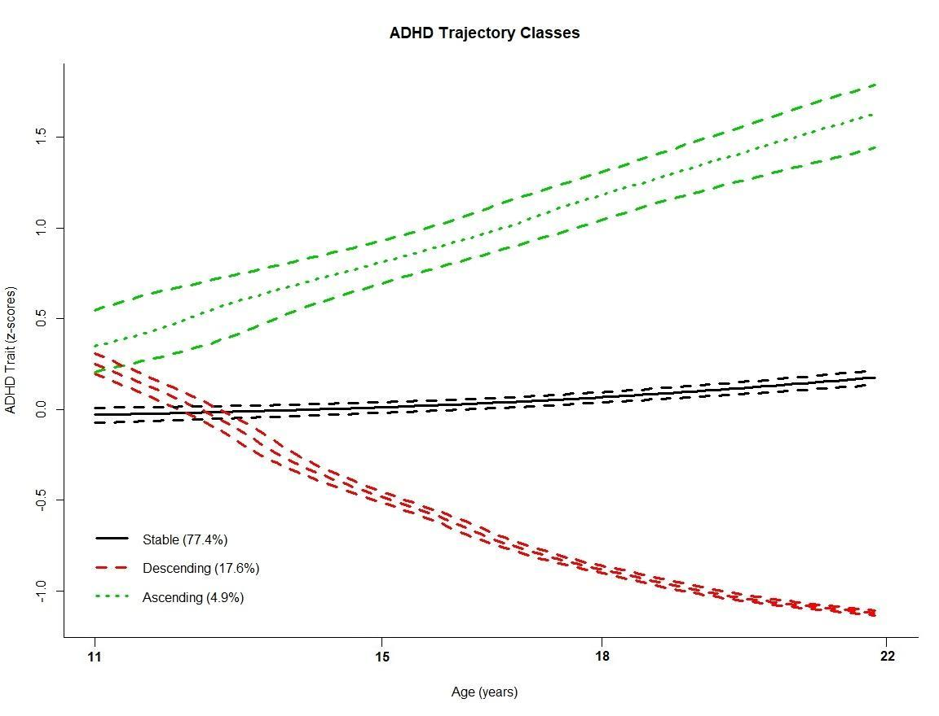

Supplementary Figure 3. ADHD trait trajectories in those with ADHD at 22 years with 95% CI (n=540):
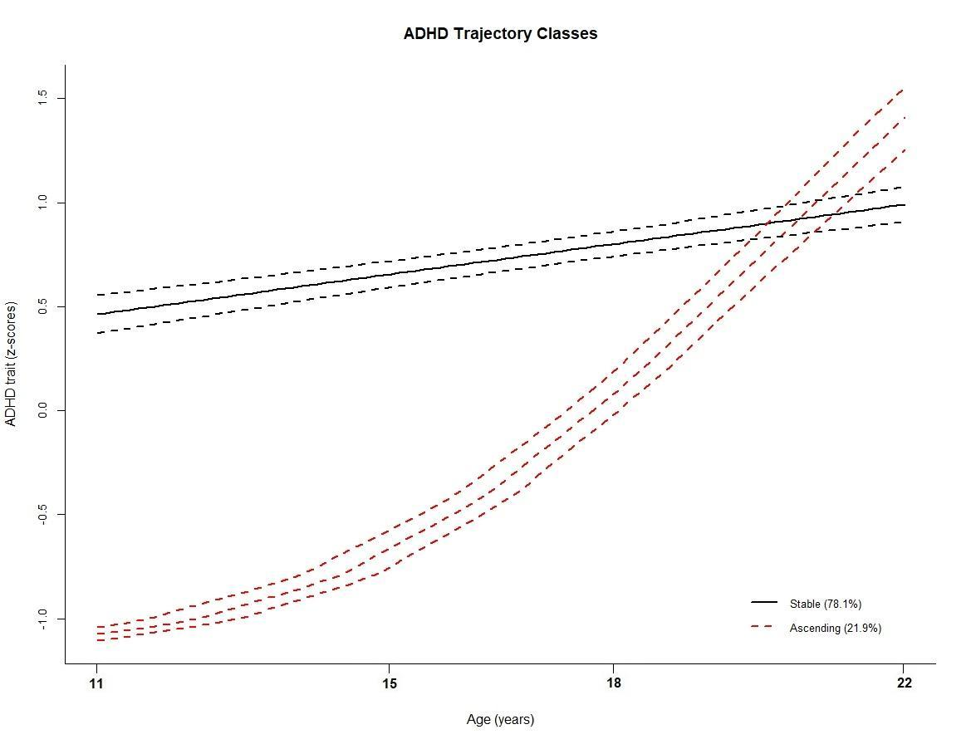

REFERENCES:
Proust-Lima C, Philipps V, Liquet B. Estimation of Extended Mixed Models Using Latent Classes and Latent Processes: The R Package lcmm. J Stat Softw [Internet]. 2017;78(2).
Rens van de Schoot, Marit Sijbrandij, Sonja D. Winter, Sarah Depaoli & Jeroen K. Vermunt (2017) The GRoLTS-Checklist: Guidelines for Reporting on Latent Trajectory Studies, Structural Equation Modeling: A Multidisciplinary Journal, 24:3, 451-467.

