Supplementary Information

Supplementary Table 1. Demographic information for the GWAS samples
 |  |  | Sample sizes
 |  | GWS loci | Total | Cases | Controls ª
Psychiatric disorders
SCZ | Ripke et al. (2014) | 108 | 82,315 | 35,476 | 46,839
BIP | Sklar et al. (2011) | 2 | 16,731 | 7,481 | 9,250
MDD | Wray et al. (2018) | 44 | 173,005 | 59,851 | 113,154
ASD | Grove et al. (2017) | 5 | 46,350 | 18,381 | 27,969
ADHD | Demontis et al. (2017) | 12 | 55,374 | 20,183 | 35,191
Cross-disorder | Smoller et al. (2013) | 4 | 61,220 | 33,332 | 27,888
Subcortical volumes
Accumbens | Hibar et al. (2015) | 0 | 13,112 | - | -
Amygdala | Hibar et al. (2015) | 0 | 13,160 | - | -
Caudate | Hibar et al. (2015) | 0 | 13,171 | - | -
Hippocampus | Hibar et al. (2015) | 2 | 13,163 | - | -
Pallidum | Hibar et al. (2015) | 0 | 13,142 | - | -
Putamen | Hibar et al. (2015) | 4 | 13,145 | - | -
Thalamus | Hibar et al. (2015) | 0 | 13,193 | - | -
ICV | Hibar et al. (2015) | 1 | 11,373 | - | -
GWS, Genome-wide significant; SCZ, Schizophrenia; BIP, Bipolar Disorder; MDD, Major Depression Disorder; ASD, Autism Spectrum Disorder; ADHD, Attention Deficit Hyperactivity Disorder; ICV, Intracranial volume. ª Controls or pseudo-controls from trio samples.

Supplementary Figure 1. Genetic correlations (r_{g}) of each psychiatric disorder with subcortical and intracranial volumes in cross-disorder samples. *p<0.05. Error bars indicates SE of the r_{g}.

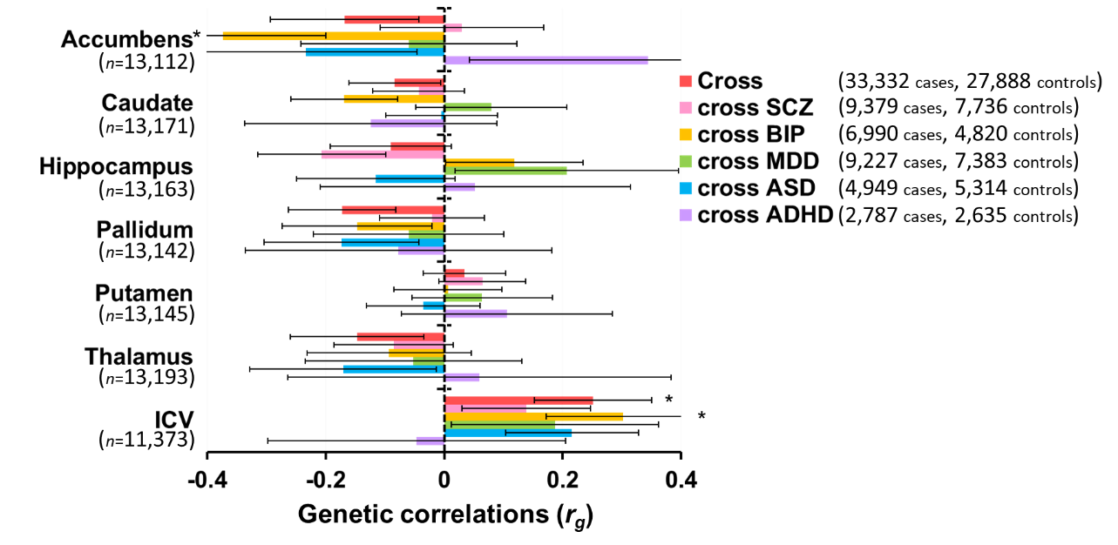

Supplementary Methods

Psychiatric disorders and Subcortical volumes
To calculate genetic correlations attributable to genome-wide single nucleotide polymorphisms [SNPs (polygenicity; many small genetic effects)] between the psychiatric disorders and the subcortical and intracranial volumes, we extracted GWAS results for psychiatric disorders and subcortical volumes (Supplementary Table 1). GWAS summary statistics on five psychiatric disorders from the PGC and the iPSYCH¹⁻⁶ [SCZ (PGC2), BIP, MDD (MDD2), ASD (iPSYCH-PGC GWAS-2017), ADHD (ADHD2017) and the cross-disorder GWAS] were available in a public database (https://www.med.unc.edu/pgc/results-and-downloads). GWAS summary statistics regarding the volumes of seven subcortical brain regions (the nucleus accumbens, amygdala, caudate nucleus, hippocampus, pallidum, putamen and thalamus) and the ICV were calculated by the ENIGMA2 study⁷ and made available in a public database (http://enigma.ini.usc.edu/research/download-enigma-gwas-results/).

(i) SCZ
The samples from the SCZ Working Group of the PGC consisted of 32,405 SCZ cases and 42,221 controls of European ancestry, 1,235 trio samples of European ancestry, and 1,836 SCZ cases and 3,383 controls from East Asia.² Cases were diagnosed according to the DSM-III, DSM-IV or ICD10 criteria. Individuals with SCZ or schizoaffective disorder were included as cases. These samples were genotyped using different arrays for each study site. QC and imputation were performed for each dataset separately. The applied QC parameters for retaining SNPs and subjects were as follows: SNP missingness <0.05 (before sample removal); subject missingness <0.02; deviation from autosomal heterozygosity (|F_{het}| <0.2); SNP missingness <0.02 (after sample removal); difference in SNP missingness between cases and controls of <0.02; and deviation from Hardy-Weinberg equilibrium (HWE) (p<1.0×10⁻⁶ in controls or p<1.0×10⁻¹⁰ in cases). Genotype imputation was performed using the 1000 Genomes Project Phase 1 dataset as a reference panel. SNPs with imputation quality (INFO>0.6) were retained.

(ii) BIP
The samples from the PGC BIP Working Group comprised 20,352 BIP cases and 31,358 controls of European descent.⁸ Diagnoses were assigned according to the DSM-IV or Research Diagnostic Criteria (RDC). Cases had the following diagnoses: BIP type 1 (84%), BIP type 2 (11%) and schizoaffective disorder bipolar (4%), and other BIP diagnoses (1%). These samples were genotyped using different arrays for each site. Individual genotype data were processed using the PGC pipeline² for standardized QC, imputation, and analysis. The applied QC parameters were same as mentioned above. Genotype imputation was performed using the 1000 Genomes Project Phase 3 dataset as a reference panel. SNPs with imputation quality (INFO ≥0.3) and MAF ≥0.01 were retained.

(iii) MDD
The samples from the PGC MDD Working Group comprised 59,851 MDD cases and 113,154 controls of European descent.⁴ Cases met international consensus criteria (DSM-IV, ICD-9, or ICD-10) for a lifetime diagnosis of MDD. These samples were genotyped using different arrays for each study site. QC and imputation were performed for each dataset separately. QC were performed according to standards from the PGC or the similar pipeline. Genotype imputation was performed using the 1000 Genomes Project Phase 1 dataset as a reference panel.

(iv) ASD
The samples from the PGC ASD Working Group and the iPSYCH comprised 18,381 ASD cases and 27,969 controls of European descent.⁵ Cases including childhood autism, atypical autism, Asperger’s syndrome and other/unspecified pervasive developmental disorders were diagnosed as ASD according to the ICD10, DSM-IV, Autism Diagnostic Interview-Revised (ADI-R), Autism Diagnostic Observation Schedule (ADOS) or other instrument. These samples were genotyped using different arrays for each study site. QC and imputation were performed for each dataset separately. Ricopili,² the pipeline developed by the PGC, was used for QC and imputation. Genotype imputation was performed using the 1000 Genomes Project Phase 3 dataset as a reference panel.

(v) ADHD
The samples from the PGC ADHD Working Group and the iPSYCH comprised 20,183 ADHD cases and 35,191 controls of mainly European descent.⁶ Cases were diagnosed according to the DSM-IV or ICD10 criteria. QC procedures were performed on the genotyped markers and individuals in each cohort using a standardized pipeline. Genotype imputation was performed using the 1000 Genomes Project Phase 3 dataset as a reference panel.

(vi) Cross-disorder
The samples from the PGC Cross-disorder Working Group comprised 33,332 cases and 27,888 controls among the five disorder groups: ASD (4,788 trio cases, 4,788 trio pseudo-controls, 161 cases, 526 controls), ADHD (1,947 trio cases, 1,947 trio pseudo-controls, 840 cases, 688 controls), BIP (6,990 cases, 4,820 controls), MDD (9,227 cases, 7,383 controls), and SCZ (9,379 cases, 7,736 controls), of European ancestry.¹ These samples were not related. All patients met criteria from the DSM-III or DSM-IV for each disorder. Genotyped data were processed through the same QC, imputation, and analysis process. The applied QC parameters for retaining SNPs and subjects were as follows: SNP missingness <0.05 (before sample removal); subject missingness <0.02; SNP missingness <0.02 (after sample removal); difference in SNP missingness between cases and controls of <0.02; and deviation from HWE (p<1.0×10⁻⁶ in controls). Genotype imputation was performed using the CEU+TSI Hapmap Phase 3 dataset as a reference panel.

(vii) Subcortical volumes
The samples from the ENIGMA consortium consisted of 13,688 participants of European ancestry.⁷ 21% of the participants were diagnosed as patients with anxiety, Alzheimer’s disease, ADHD, BIP, epilepsy, MDD or SCZ. The brain measures were obtained from structural MRI data collected at participating sites. Brain scans were processed at each site locally, following a standardized protocol procedure (http://enigma.ini.usc.edu/protocols/imaging-protocols/). These samples were genotyped using different arrays for each study site. QC filtering was applied to remove genotyped SNPs with low MAF (<0.01), poor genotype call rate (<0.95), and deviations from HWE (p<1.0×10⁻⁶). Genotype imputation was performed using the 1000 Genomes Project Phase 1 dataset as a reference panel.

1 Smoller JW, Ripke S, Lee PH, Neale B, Nurnberger JI, Santangelo S et al. Identification of risk loci with shared effects on five major psychiatric disorders: a genome-wide analysis. Lancet 2013; 381: 1371-1379.
2 Ripke S, Neale BM, Corvin A, Walters JT, Farh KH, Holmans PA et al. Biological insights from 108 schizophrenia-associated genetic loci. Nature 2014; 511: 421-427.
3 Sklar P, Ripke S, Scott LJ, Andreassen OA, Cichon S, Craddock N et al. Large-scale genome-wide association analysis of bipolar disorder identifies a new susceptibility locus near ODZ4. Nat Genet 2011; 43: 977-983.
4 Wray NR, Ripke S, Mattheisen M, Trzaskowski M, Byrne EM, Abdellaoui A et al. Genome-wide association analyses identify 44 risk variants and refine the genetic architecture of major depression. Nat Genet 2018; 50: 668-681.
5 Grove J, Ripke S, Als TD, Mattheisen M, Walters R, Won H et al. Common risk variants identified in autism spectrum disorder. bioRxiv 2017.
6 Demontis D, Walters RK, Martin J, Mattheisen M, Als TD, Agerbo E et al. Discovery Of The First Genome-Wide Significant Risk Loci For ADHD. bioRxiv 2017.
7 Hibar DP, Stein JL, Renteria ME, Arias-Vasquez A, Desrivieres S, Jahanshad N et al. Common genetic variants influence human subcortical brain structures. Nature 2015; 520: 224-229.
8 Stahl EA, Breen G, Forstner AJ, McQuillin A, Ripke S, Trubetskoy V et al. Genome-wide association study identifies 30 loci associated with bipolar disorder. Nat Genet 2019; 51: 793-803.

