Osimo et al; Cardiac structure and function in schizophrenia: a cardiac MR imaging study

SUPPLEMENTARY INFORMATION

Supplementary figures

Supplementary Figure 1: Cardiac Measurements in Patients with Schizophrenia and Healthy Controls.
The graph shows cardiac measurements in patients with schizophrenia and healthy controls. There were no significant differences in left and right ventricle ejection fractions (LVEF p=0.94, RVEF p=0.97), in indexed left ventricular mass (LVMi, p=0.75), or in pulse wave velocity (PWV, p=0.59).
The points are individual patients’ values. In the box and whisker plot, the solid horizontal line is the median, the lower and upper hinges correspond to the first and third quartiles (the 25th and 75th percentiles), and the whiskers extends from the hinge to the largest/smallest value no further than 1.5*inter-quartile range from the hinge.
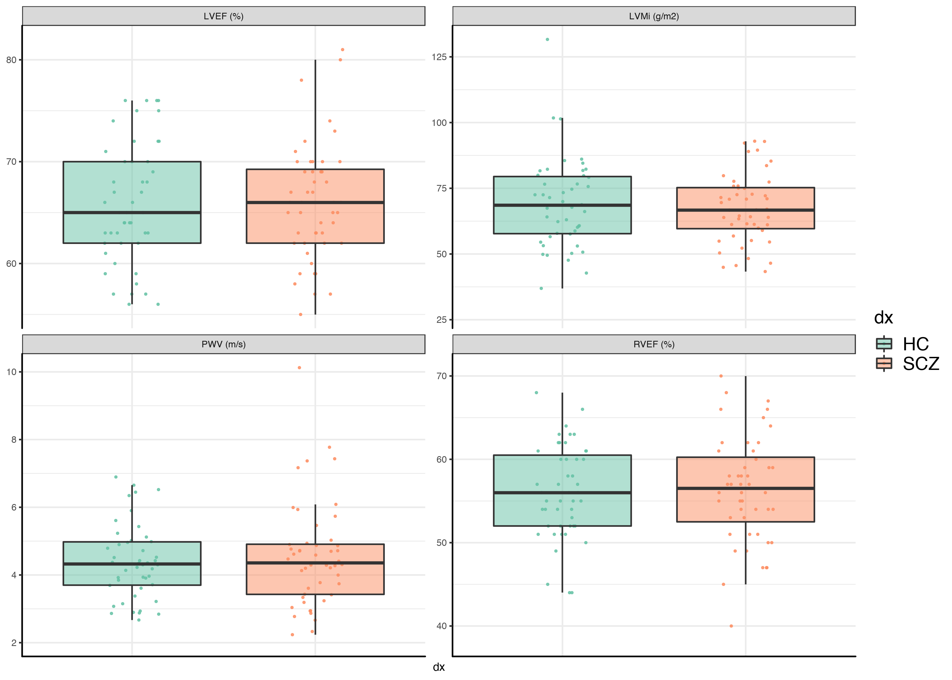

Supplementary Tables

Supplementary Table 1: CMR-Derived Cardiac Measurements in Patients with Schizophrenia and Matched Healthy Controls
Subjects in the two groups were matched for age, sex, ethnicity, BMI.
LVEDVi: indexed LV end-diastolic volume; LVESVi: indexed LV end-systolic volume; LVSVi: indexed LV stroke volume; LVMi: indexed LV mass; RVEDVi: indexed RV end-diastolic volume; RVESVi: indexed RV end-systolic volume; RVSVi: indexed RV stroke volume; EF: ejection fraction; PWV: pulse-wave velocity; BSA: body surface area; BH: Benjamini & Hochberg; SD: standard deviation; CI: confidence interval
 |  |  |  | Un-adjusted analysis |  |  | Adjusted for smoking (N of cigarettes) |  | Adjusted for activity levels |  | Adjusted for both smoking and activity levels
 | Schizophrenia  N=40  Mean (SD) | HCs  N=39  Mean (SD) | Normal range of parameters in males < 60 years (1) | Schizophrenia  F (1, 77), p | BH-adjusted p value | Effect size (Cohen’s d; 95% CI) | Schizophrenia F (2, 75), p | BH-adjusted p value | Schizophrenia F (2, 75), p | BH-adjusted p value | Schizophrenia F (2, 75), p | BH-adjusted p value
LVEDVi (ml/m2) | 68.48 (10.95) | 80.38 (17.40) | 64, 100 | -11.90, 0.0005 | 0.001 | -0.82;  -0.35--1.29 | -11.68, 0.001 | 0.004 | -8.67, 0.015 | 0.04 | -8.47, 0.024 | 0.048
LVESVi (ml/m2) | 23.45 (6.13) | 28.10 (9.67) | 17, 39 | -4.65, 0.01 | 0.02 | -0.58;  -0.12--1.03 | -4.42, 0.025 | 0.04 | -3.02, 0.12 | 0.19 | -2.80, 0.177 | 0.18
LVSVi (ml/m2) | 45.10 (7.38) | 52.35 (9.49) | 43, 67 | -7.25, 0.0003 | 0.001 | -0.85;  -0.39--1.32 | -7.24, 0.001 | 0.003 | -5.64, 0.01 | 0.04 | -5.64, 0.011 | 0.04
LVMi (g/m2) | 68.44 (12.61) | 70.11 (17.23) | 57, 91 | -1.67, 0.62 | 0.75 | -0.11;  -0.34-0.56 | -2.5, 0.50 | 0.65 | -0.04, 0.99 | 0.99
RVEDVi (ml/m2) | 80.88 (12.60) | 96.21 (24.68) | 63, 111 | -15.32, 0.0008 | 0.002 | -0.79;  -0.32--1.25 | -14.79, 0.002 | 0.006 | -10.89, 0.02 | 0.04 | -10.38, 0.038 | 0.06
RVESVi (ml/m2) | 35.84 (8.80) | 43.20 (15.65) | 18, 46 | -7.36, 0.01 | 0.02 | -0.58;  -0.12--1.04 | -7.10, 0.02 | 0.04 | -5.24, 0.09 | 0.16 | -4.99, 0.13 | 0.15
RVSVi (ml/m2) | 45.01 (7.54) | 53.10 (10.87) | 39, 71 | -8.09, 0.0002 | 0.001 | -0.87;  -0.40--1.33 | -7.79, 0.0008 | 0.003 | -5.80, 0.01 | 0.04 | -5.52, 0.021 | 0.048
LV EF (%) | 66.08 (5.71) | 65.85 (6.04) | 57, 75 | 0.23, 0.86 | 0.94 | 0.04;  -0.49-0.40 | -0.10, 0.94 | 0.99 | -0.37, 0.80 | 0.97
RV EF (%) | 55.90 (6.50) | 55.95 (5.76) | 50, 78 | -0.05, 0.97 | 0.97 | -0.01;  -0.44-0.46 | -0.02, 0.99 | 0.99 | -0.08, 0.96 | 0.99
LV concentricity (g/ml) | 1.01 (0.17) | 0.88 (0.17) | <0.91 | 0.13, 0.002 | 0.003 | 0.73;  0.27-1.19 | 0.10, 0.01 | 0.02 | 0.11, 0.01 | 0.04 | 0.09, 0.043 | 0.06
Septal thickness (mm) | 10.49 (1.62) | 8.79 (1.37) | <15mm | 1.71, 0.000003 | 0.00004 | 1.13;  0.65-1.62; | 1.79, 0.000004 | 0.00004 | 1.71, 0.00002 | 0.0002 | 1.81, 0.000016 | 0.0001
PWV (m/s) | 4.75 (1.58) | 4.52 (1.03) | N/A | 0.23, 0.44 | 0.59 | 0.18;  -0.62-0.28 | 0.13, 0.68 | 0.82 | 0.08, 0.81 | 0.97

Supplementary Table 2: CMR-Derived Cardiac Measurements in Patients with Schizophrenia and Matched Healthy Controls – Results adjusted for smoking as a binary factor
Subjects in the two groups were matched for age, sex, ethnicity, BMI.
BH: Benjamini & Hochberg

 | Adjusted for scanner difference
 | Schizophrenia F (2, 78), p | BH-adjusted p value
Indexed LV end-diastolic volume | -12.92, 0.0008 | 0.0025
Indexed LV end-systolic volume | -5.03, 0.02 | 0.033
Indexed LV stroke volume | -7.89, 0.0005 | 0.0025
Indexed LV mass | -4.20, 0.27 | 0.36
Indexed RV end-diastolic volume | -15.15, 0.003 | 0.008
Indexed RV end-systolic volume | -7.02, 0.03 | 0.048
Indexed RV stroke volume | -8.27, 0.0008 | 0.002
LV ejection fraction | 0.012, 0.99 | 0.99
RV ejection fraction | -0.40, 0.80 | 0.87
LV concentricity (LV mass / LVEDV) | 0.09, 0.03 | 0.048
Septal thickness | 1.48, 0.0002 | 0.002
Pulse wave velocity | 0.14, 0.69 | 0.82

Supplementary Table 3: CMR-Derived Cardiac Measurements in Patients with Schizophrenia and Matched Healthy Controls – Results adjusted for scanner
Subjects in the two groups were matched for age, sex, ethnicity, BMI.
BH: Benjamini & Hochberg

 | Adjusted for scanner difference
 | Schizophrenia F (2, 78), p | BH-adjusted p value
Indexed LV end-diastolic volume | -11.96, 0.0004 | 0.001
Indexed LV end-systolic volume | -4.68, 0.01 | 0.02
Indexed LV stroke volume | -7.29, 0.0002 | 0.001
Indexed LV mass | -1.67, 0.63 | 0.75
Indexed RV end-diastolic volume | -15.34, 0.0008 | 0.002
Indexed RV end-systolic volume | -7.33, 0.01 | 0.02
Indexed RV stroke volume | -8.13, 0.0002 | 0.001
LV ejection fraction | 0.23, 0.87 | 0.94
RV ejection fraction | -0.09, 0.94 | 0.95
LV concentricity (LV mass / LVEDV) | 0.12, 0.002 | 0.003
Septal thickness | 1.70, 2.45e-06 | 0.00003
Pulse wave velocity | 0.24, 0.44 | 0.59

Supplementary Table 4: Results of the linear regression analysis of the relationship between CMR-Derived Cardiac Measurements and total chlorpromazine-equivalent dose
 | R² | F(1,37), p | BH-adjusted p value
Indexed LV end-diastolic volume | 0.14 | 0.01, 0.02 | 0.18
Indexed LV end-systolic volume | 0.12 | 0.006, 0.03 | 0.18
Indexed LV stroke volume | 0.09 | 0.005, 0.06 | 0.21
Indexed LV mass | 0.09 | 0.01, 0.07 | 0.21
Indexed RV end-diastolic volume | 0.06 | 0.009, 0.12 | 0.29
Indexed RV end-systolic volume | 0.04 | 0.005, 0.25 | 0.43
Indexed RV stroke volume | 0.05 | 0.004, 0.19 | 0.38
LV ejection fraction | 0.01 | -0.001, 0.46 | 0.61
RV ejection fraction | <0.001 | <0.001, 0.94 | 0.99
LV concentricity (LV mass / LVEDV) | 0.01 | <0.001, 0.85 | 0.99
Septal thickness | 0.02 | <0.001, 0.37 | 0.56
Pulse wave velocity | <0.001 | <0.001, 0.99 | 0.99

Supplementary Table 5: Results of the linear regression analysis of the relationship between CMR-Derived Cardiac Measurements and the natural logarithm of total chlorpromazine-equivalents/years
 | R² | F(1,35), p | BH-adjusted p value
Indexed LV end-diastolic volume | 0.001 | -0.21, 0.87 | 0.94
Indexed LV end-systolic volume | 0.004 | -0.27, 0.71 | 0.94
Indexed LV stroke volume | 0.0003 | 0.07, 0.92 | 0.94
Indexed LV mass | 0.006 | 0.72, 0.63 | 0.94
Indexed RV end-diastolic volume | 0.008 | -0.80, 0.60 | 0.94
Indexed RV end-systolic volume | 0.013 | -0.75, 0.49 | 0.94
Indexed RV stroke volume | 0.0001 | -0.06, 0.94 | 0.94
LV ejection fraction | 0.01 | 0.46, 0.49 | 0.94
RV ejection fraction | 0.02 | 0.65, 0.39 | 0.94
LV concentricity (LV mass / LVEDV) | 0.008 | 0.01, 0.60 | 0.94
Septal thickness | 0.02 | 0.18, 0.37 | 0.94
Pulse wave velocity | 0.09 | 0.32, 0.08 | 0.92

Supplementary References:

1. Kawel-Boehm N, Maceira A, Valsangiacomo-Buechel ER, Vogel-Claussen J, Turkbey EB, Williams R, et al. Normal values for cardiovascular magnetic resonance in adults and children. Journal of Cardiovascular Magnetic Resonance. 2015; 17(1): 29.

