Supplementary Figure S1: Flow charts of the data set for prefabricated housing

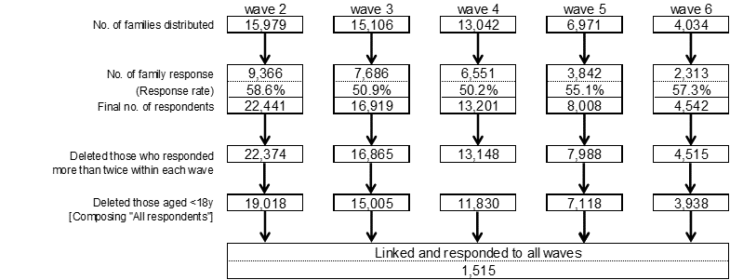

Supplementary Figure S2: Flow charts of the data set for private housing

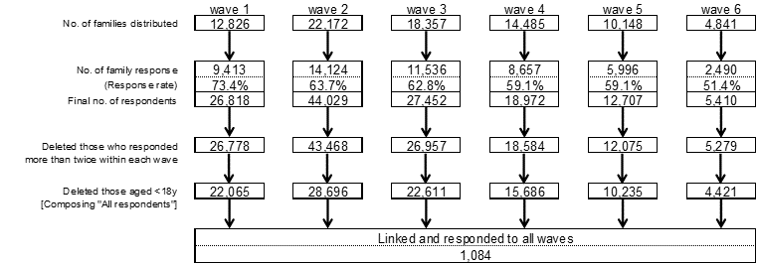

Supplementary Table S1: Comparison of K6 Scores Between Those Who Did Or Did Not Respond To All Waves

 |  | Sample 1: Private housing |  |  |  | Sample 2: Prefabricated housing
 |  | All waves |  | Not all waves |  | All waves |  | Not all waves
 |  | n (%) |  | n (%) |  | n (%) |  | n (%)
wave 1
 | Mean K6 scores (SD¹) | 5.54 (5.26) |  | 5.18 (5.28) |  |  |  | -
 | [No. of respondents to all six items] | [n=969] |  | [n=18,098]
 | p-value² | 0.04
wave 2
 | Mean K6 scores (SD¹) | 4.50 (4.80) |  | 4.57 (5.06) |  | 4.90 (5.33) |  | 4.95 (5.36)
 | [No. of respondents to all six items] | [n=932] |  | [n=22,623] |  | [n=1,153] |  | [n=12,814]
 | p-value² | 0.67 |  |  |  | 0.75
wave 3
 | Mean K6 scores (SD¹) | 4.18 (4.61) |  | 4.28 (4.92) |  | 4.50 (4.89) |  | 4.75 (5.21)
 | [No. of respondents to all six items] | [n=985] |  | [n=18,798] |  | [n=1,231] |  | [n=10,603]
 | p-value² | 0.55 |  |  |  | 0.09
wave 4
 | Mean K6 scores (SD¹) | 4.16 (4.60) |  | 4.13 (4.91) |  | 4.58 (5.01) |  | 4.68 (5.16)
 | [No. of respondents to all six items] | [n=969] |  | [n=12,864] |  | [n=1,249] |  | [n=8,056]
 | p-value² | 0.86 |  |  |  | 0.55
wave 5
 | Mean K6 scores (SD¹) | 3.86 (4.52) |  | 3.93 (4.89) |  | 4.26 (4.97) |  | 4.38 (5.24)
 | [No. of respondents to all six items] | [n=962] |  | [n=8,168] |  | [n=1,293] |  | [n=4,686]
 | p-value² | 0.65 |  |  |  | 0.44
wave 6
 | Mean K6 scores (SD¹) | 3.95 (4.57) |  | 3.94 (4.72) |  | 4.03 (4.81) |  | 4.24 (5.16)
 | [No. of respondents to all six items] | [n=983] |  | [n=3,036] |  | [n=1,280] |  | [n=1,989]
 | p-value² | 0.96 |  |  |  | 0.24
¹Standard deviation
² t-test

Supplementary Table 2: Individual predictors of initial support and psychological distress (Sample 1, private housing only)

Effect | Estimate (b) | F | P value
Wave | -.14 | 19.09 | .0001
Sex (female) | 0.99 | 17.21 | .0001
Age | 0.29 | 11.19 | .001
Psychiatric history | .04 | 74.79 | .0001
Spousal support | -1.06 | 15.62 | .0001
Child support | -0.46 | 1.06 | .31
Sibling support | .17 | 0.15 | .70
Friend support | -0.55 | 3.84 | .05

Note: Two-level, random effect model (AIC 25487, BIC=25152, χ2 (3) = 2653.98 p<.0001).

