Supplementary information

Figure 1: Details results of patient recruitment.

Cases matched for gender, age, diagnosis individually (n = 296)

Total number of subjects for SC: N=145

Total number of subjects for EI: N=145

Subject excluded because not fulfil the longitudinal diagnostic criteria (n=3)

Subject excluded because not fulfil the longitudinal diagnostic criteria (n=3)

Deceased
(n = 16)
Refused
(n = 12)
Failed tracing
(n = 15)
Deceased
(n = 7)
Refused
(n = 17)
Failed tracing
(n = 14)
Received early intervention program (EI) (n = 148)

Received standard care treatment (SC) (n = 148)

Interviewed (n = 107)
Interviewed (n = 102)

Figure 2a Results of Silhouette method for optimal number of cluster for the early intervention group
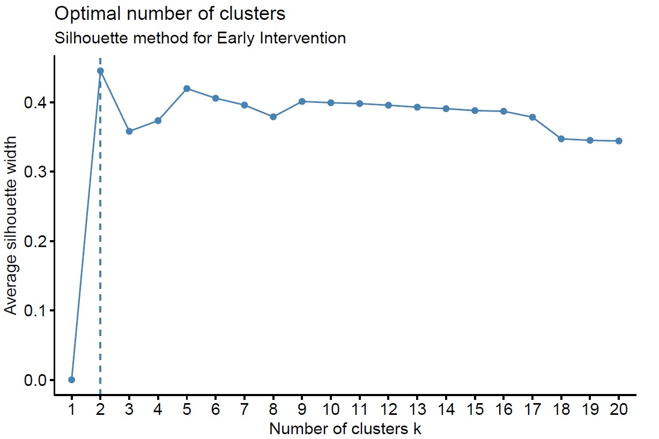
Figure 2b Results of Silhouette method for optimal number of cluster for the standard care group
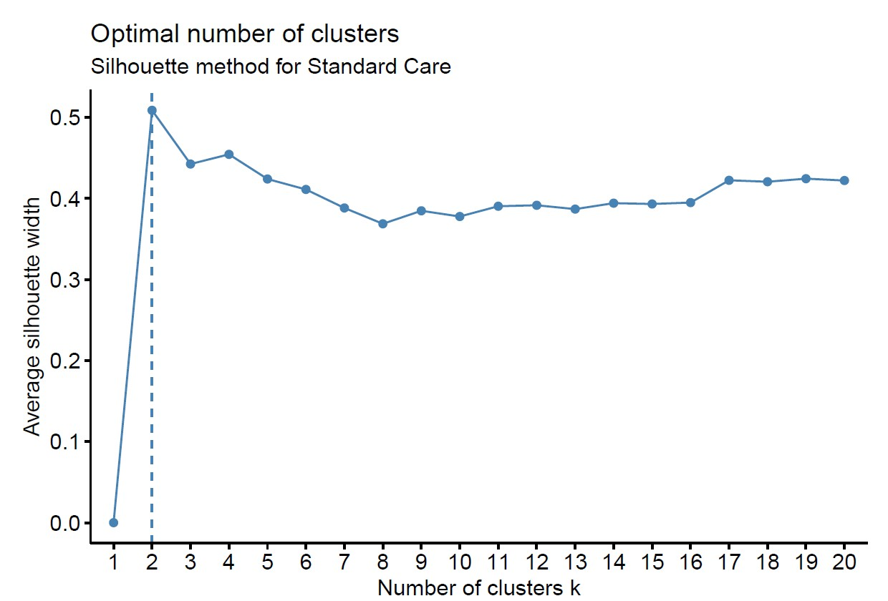
Supplementary Table 1. Comparison of unweighted and propensity score reweighted patients characteristics* by early intervention group (EI) and standard care group (SC).
Variable | Unweighted |  |  |  | PS reweighted(IPSW)
 | All | EI | SC | P | All | EI | SC | P
Gender |  |  |  | 0.907† |  |  |  | 0.795†
Female | 0.493 | 0.490 | 0.497 |  | 0.496 | 0.488 | 0.504
Male | 0.507 | 0.510 | 0.503 |  | 0.504 | 0.512 | 0.496
Age of onset (1-y increase) | 21.017 | 20.917 | 21.117 | 0.602‡ | 21.083 | 20.925 | 21.238 | 0.430‡
Education year (1-y increase) | 10.841 | 10.841 | 10.841 | 1.000‡ | 10.879 | 10.942 | 10.818 | 0.669‡
* Gender are expressed as the proportion, age of onset and education year are expressed as the mean value.
† A two-sided $χ^{2}$test was used.
‡ A two-sided $t$test was used.

 | Good employment cluster  (N=98) | Poor employment cluster  (N=47) | χ² | P-value
Presence of relapse
Year 1 (N, %) | 13 (13.3) | 8 (17.0) | 0.36 | 0.55
Year 2 (N, %) | 33 (33.7) | 25 (53.2) | 5.02 | 0.025
Year 3 (N, %) | 39 (39.8) | 30 (63.8) | 7.36 | 0.007

Supplementary Table 2 Relationship of years of relapse and cluster groupings among the early intervention group
χ²: Chi-square test

Supplementary Table 3 Multivariate analysis of factors relating to longitudinal employment comparing the improved and poor group for early intervention and standard care group
 | Early intervention |  |  | Standard care
 | OR | 95% CI | P | OR | 95% CI | P
Demographics
Years of education | 1.24 | 1.02 -1.50 | 0.030 | 1.11 | 0.94 -1.31 | 0.22
Sex |  |  |  | 0.47 | 0.21-1.06 | 0.068
Variables during first three years  Total months of FT employment in year one | 1.19 | 1.09 -1.30 | <0.0001 | 1.29 | 1.14 -1.45 | <0.0001
Mean CGI-SCH negative over 3 years |  |  |  | 0.43 | 0.22-0.84 | 0.013
Number of relapse over 3 years | 0.65 | 0.43 -0.97 | 0.036
Number of hospitalization over 3 years |  |  |  | 0.73 | 0.48 -1.10 | 0.14
CGI-SCH: Clinical Global Impressions - Schizophrenia scale; FT: full time; OR: odds ratio; CI: confidence interval

