Supplementary Table 1: Baseline carer and patient demographic and clinical characteristics by randomisation group

|  |  |  |  |  |
| --- | --- | --- | --- | --- |
| **-** | **Carer** | | **Patient** | |
|  | **TAU (n=87)** | **Intervention (n=173)** | **TAU (n=87)** | **Intervention (n=173)** |
| **Age (years)~** | 56.1 (12.3)  range: 27,89 | 62.0 (14.6)  range: 18,88 | 78.0 (9.9)  range: 53,96 | 79.9 (8.3)  range: 55,95 |
| **Sex\***Female | 62 (71.3%) | 116 (67.1%) | 50 (57.5%) | 102 (59.0%) |
| **Ethnicity\***White UK | 65 (74.7%) | 131 (76.2%) | 61 (70.1%) | 126 (72.8%) |
| White other | 5 (5.8%) | 10 (5.8%) | 6 (6.9%) | 14 (8.1%) |
| Black and minority | 17 (19.5%) | 31 (18.0%) | 20 (23.0%) | 33 (19.1%) |
| **Marital Status\***Not currently married | 25 (28.7%) | 61 (35.3%) | 47 (54.0%) | 92 (53.2%) |
| **Education\***No qualifications | 18 (20.7%) | 45 (26.0%) | 44 (51.2%) | 73 (44.5%) |
| School level | 33 (37.9%) | 51 (29.5%) | 16 (18.6%) | 28 (17.1%) |
| Further education | 36 (41.4%) | 77 (44.5%) | 26 (30.2%) | 63 (38.4%) |
| **Work** *Full time | 28 (32.2%) | 36 (20.8%) | n/a | n/a |
| Part time | 20 (23.0%) | 27 (15.6%) | n/a | n/a |
| Retired | 23 (26.4%) | 80 (46.2%) | n/a | n/a |
| Not working | 16 (18.4%) | 30 (17.3%) | n/a | n/a |
| **Living With Carer**\* | n/a | n/a | 50 (57.5%) | 113 (65.3%) |
| **Relationship to patient \*** Partner | 31 (35.6%) | 78 (45.1%) | n/a | n/a |
| Child | 42 (48.3%) | 71 (41.0%) | n/a | n/a |
| Other | 14 (16.1%) | 24 (13.9%) | n/a | n/a |
| **NPI Total~** | n/a | n/a | 26.6 (20.1)(n=86) | 24.0 (19.0)(n=171) |
| **CDR overall Score~** | n/a | n/a | 1.3 (0.6) (n=87) | 1.2 (0.6) (n=171) |
| **Zarit** | 38.1 (17.0)(n=84) | 35.3 (18.4)(n=165) | n/a | n/a |
| **HADS-T score** | 14.8 (7.4) | 13.5 (7.3) | n/a | n/a |
| **HADS-A score** | 9.3 (4.3) | 8.1 (4.4) | n/a | n/a |
| **HADS-D** | 5.5 (3.9) | 5.4 (3.8) | n/a | n/a |
| **QOL-AD** | n/a | n/a | 29.9 (6.9) | 30.2(6.9) |
| **HADS Anxiety Case**(score of ≥9 )* | 48 (55.2%) | 85 (49.4%) | n/a | n/a |
| **HADS Depression** C**ase** (score ≥9)* | 17 (19.5%) | 36 (20.9%) | n/a | n/a |
| **Cost** (£, over 4-month period pre-baseline) | 315 | 218 | 3205 | 2446 |

HADS= Hospital Anxiety and Depression Scale, CDR =Clinical Dementia Scale MCTS= Modified Conflict Tactics Scale, Zarit = Zarit Burden Interview, NPI = Neuropsychiatric Inventory, Qol-AD = Quality of Life- Alzheimer’s disease, HSQ = Health Status Questionnaire ~ Data are mean (Standard deviation) *Data are number and percentage. If some people did not complete the measure n is indicated in the table.

Supplementary Figure 1

Supplementary figure 1: The START intervention

Each session includes:

* Stress reduction exercises
* Interactive exercises
* Between session practice tasks
* Recap on previous session
* Record forms

Delivered to individuals

Each session lasts 60 minutes

Carers keep manual and add personal content in sessions

Therapeutic approach:

* Builds on existing skills and resources
* Validates carers emotional experiences
* Encourages carers to try out new strategies and continue to use what works
* Supports carers to find their own solutions rather than offering advice
* Focuses on troubleshooting difficulties in making changes
* Combines acceptance based, solution focused and emotion focused approaches

Common elements and processes

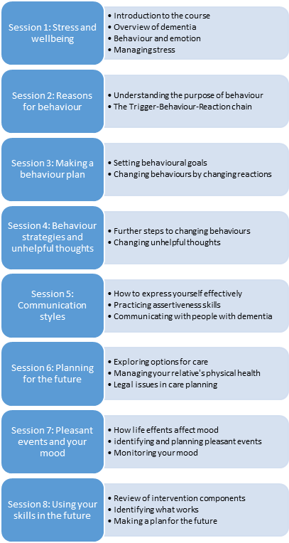

cORE SESSION COMPONENTS

SESSION

**Supplementary Table 2: Summaries of patient death, care home admission, withdrawal and complete follow-up by treatment group.**

|  |  |  |  |  |
| --- | --- | --- | --- | --- |
| End Status | Number (Percentage) of participants per group | | All Participants |  |
| TAU Group | START Group | P-value |
| Death | 21 (24.1%) | 32 (18.5%) | 53 (20.4%) | 0.37 |
| Care home admission | 25 (28.7%) | 58 (33.5%) | 83 (31.9%) | 0.52 |
| Remain in study at 72 months and not known to have died or been admitted to care home | 13 (14.9%) | 34 (19.7%) | 47 (18.1%) | 0.45 |
| Lost to follow up/withdrawal prior to 72 months | 24 (27.6%) | 43 (24.9%) | 67 (25.8%) | 0.75 |
| Censored at 24 months due to non-participation in extension study | 4 (4.6%) | 6 (3.5%) | 10 (3.8%) | 0.74 |
| Total | 87 | 173 | 260 |  |

**Supplementary Figure 2 Multi-state model for patient care home admission and death. Direction of arrows represent the passage of time.**



λHI(t) denotes the instantaneous rate of transition from the ‘living at home’ state to the ‘care home admission’ state. λHD(t) denotes the instantaneous rate of transition from the ‘living at home’ state to the ‘death’ state