**Supplementary File 1**

**QualityRights** is WHO’s global initiative to increase access to good quality mental health services and to promote the human rights of people with psychosocial, intellectual and cognitive disabilities. It offers a new approach to mental health care which is rights-based and recovery-oriented.

The five main objectives of the QualityRights initiative are to:

* Build capacity to combat stigma and discrimination and promote the rightsBuild capacity to understand and promote human rights and recovery.
* Improve the quality of care and human rights conditions in mental health and related services.
* Create community-based and recovery-oriented services that respect and promote human rights.
* Develop a civil society movement to conduct advocacy and influence policy-making.
* Reform national policies and legislations in line with the Convention on the Rights of Persons with Disabilities (CRPD) and other international human rights standards.

Two key products are the WHO QualityRights Assessment Toolkit and the WHO QualityRights capacity building materials which are described below

**The WHO QualityRights assessment toolkit** whichoutlines the standards to be achieved in mental health services and which also helps guide countries on how to measure this. The assessment toolkit provides guidance on how to set up a multi‐disciplinary assessment body and conduct a comprehensive assessment of services involving interviews with service users, families and staff, as well as observation and documentation review of the service. The tools to enable these aspects of the assessment are provided in the toolkit. Reporting forms for the assessment are also available for individual services as well as to summarise the assessment findings for the country.

The five themes and standards of the toolkit are based on the Convention on the Rights of Persons with Disabilities (CRPD) and cover:

* + the social and physical conditions of the mental health service;
  + whether the service is promoting a recovery-based approach and also addressing physical health needs not just and mental health
  + whether legal capacity is being promoted through supported decision making and advance directives – are people making their own decisions about treatment and care and are they given support to do so, or are decisions being made by other people?
  + whether the service is free from violence, coercion and abuse
  + And the degree to which services are promoting independent living and inclusion in the community.

An additional module on Transforming services and promoting rights in mental health and social services has also been developed to directly address the quality and human rights gaps identified as part of the assessment process. The module promotes a participatory approach to achieve culture change and to develop and implement concrete action plans for improvement and transformation.

<https://www.who.int/mental_health/publications/QualityRights_toolkit/en/>

**The WHO QualityRights capacity building materials** build capacity on rights and the skills to put these rights into practice.  The modules have been developed in collaboration with more than 100 national and international actors including: disabled people’s organisations; NGOs; people with lived experience; family and care partners, and mental health professionals

The core training modules cover the following topics: *Human rights, Mental health, disability and human rights, Recovery and the right to health in mental health and social services, Legal capacity and the right to decide in mental health and social services, Mental health and social services free from coercion, violence and abuse*. These modules provide stakeholders with the knowledge and tools to enable them to apply the CRPD and other human rights principles in the community and in the context of mental health services.

In addition, a number of specialized training modules have been created to provide people with more in depth knowledge and skills around specific topics, including: *Supported decision-making and advance planning;* *Strategies to end seclusion and restraint; Recovery practices for mental health and well being*

Guidance modules developed as part of the initiative also include: *One-to-one peer support by and for people with lived experience; Peer support groups by and for people with lived experience;*

*Civil society organizations to promote human rights in mental health and related areas; Advocacy for mental health, disability and human rights; Person-centred recovery planning for mental health and well-being - a self-help tool.* These materials have drawn substantially upon the vast knowledge and expertise of NGOs, DPOs and people with lived experience.

<https://www.who.int/mental_health/policy/quality_rights/guidance_training_tools/en/>

**UN Convention on the Rights of Persons with Disabilities.**

At the time of publication of this article, 177 countries have ratified the Convention on the Rights of Persons with Disabilities. By ratifying this Convention, States Parties agree to undertake a range of measures to ensure that people with disabilities, including people with mental health conditions or psychosocial disabilities, can enjoy their human rights on an equal basis with others. Actions include the adoption of laws, policies and other measures to realize the rights recognized in the Convention as well as the modification or abolition of existing laws, policies, regulations, customs and practices that discriminate against persons with disabilities.

The Convention is overseen by the Committee on the Rights of Persons with Disabilities, made up of twelve independent experts responsible for interpreting the rights outlined in the Convention and for monitoring the implementation of the Convention by the States Parties. All States parties are required to submit regular reports to the Committee on how the rights are being implemented at national level. The Committee reviews these country reports as well as any parallel reports submitted by civil society actors, UN agencies or others, and makes recommendations (known as ‘Concluding Observations’) on measures that the country should take in order to better promote and protect the rights in the Convention.

In relation to mental health, the Committee has called upon States Parties to repeal laws, policies and practices that allow for coercive practices, in particular, involuntary admission and treatment. Although States have agreed to be bound by the rights of the Convention, countries have been extremely slow in implementing measures to end coercive practices in mental health.

In addition to the Convention itself, there is also an Optional Protocol to the Convention on the Rights of Persons with Disabilities which countries can chose to ratify in addition to the CRPD. To date 92 countries have ratified the Optional Protocol. The protocol allows for complaints to be submitted to the CRPD Committee by individuals and groups whose rights have been violated under the CRPD. The Committee reviews complaints, and if it determines that a violation has occurred, it issues a decision requiring that the violation be remedied and for the country to provide follow up information. However, although the Committee’s decisions are not enforceable, they are nevertheless of great value in providing an authoritative interpretation of the CRPD and its requirements for all States Parties.

**Statistical Analysis**

**Service assessment data:** QualityRights Toolkit assessment data from intervention and comparison group services was analysed using chi-square test for changes at the ‘*Theme*s’ level and at the ‘*Standards*’ level.

For analysis, the ratings of the toolkit were converted into an ordinal scale as follows:

A/F (criterion/standard/*Theme* achieved in full) = 3

A/P (criterion/standard/*Theme* achieved partially) = 2

A/I (criterion/standard/*Theme* achievement initiated) =1

N/I (criterion/standard/*Theme* not initiated) = 0

**Staff assessment data:** The combined dataset of staff working at services in intervention and comparison group were analysed. The effect of the intervention is the trend over time (pre- to post-intervention) between intervention and comparison groups. The baseline data were analyzed using t-test and chi-square test to explore any differences in characteristics between the comparison and intervention samples. There were no significant differences at baseline between the two groups in demographic characteristics including age, type of job, and duration of employment.

An exploratory factor analysis (EFA) was carried out using the Staff Attitude to Coercion Scale and the CAMI Scale using the maximum likelihood method with pair-wise deletion and Varimax rotation. Data collected on 15 items of the Coercion Scale were aggregated in three factors with Eigen values greater than 1 and explained about 33.1% of the variance. Items with factor loadings >= 0.45 were used to define factors. The factors are labeled based on the items loaded on each factor. Factor 1 views coercion as a requirement for protection of patients. Factor 2 views coercion as treatment. Factor 3 views coercion as offensive to patients. For the impact analysis, average scores were calculated for each of the factors. Agreement with sentences loaded on ‘coercion as protection’ and ‘coercion for treatment’ indicates a more coercive attitude, i.e., higher scores for these factors indicate a more coercive attitude. Agreement with sentences loaded on ‘coercion is offensive’ (i.e., high scores) indicates a less coercive attitude.

Similarly, an EFA on 40 items of the CAMI scale extracted two factors with Eigen values greater than 2 and explained about 27.4% of the variance. A low score for a given attitudinal factor indicates a high level of agreement with the sentences/items constituting that factor. Factor 1 (fear and avoidance) is a negative factor and low scores on this subscale indicate negative attitudes. Factor 2 (tolerance and pro-integration) is a positive factor, and low scores for this factor indicate positive attitudes.

The effect of intervention was the mean difference between intervention and comparison arms. Generalized linear models were fitted for follow-up scores as dependent variables. The analysis included adjustment for the characteristics imbalanced at baseline as well as baseline values of dependent variables. Adjustment for clustering effects was also conducted because the facility was primary sampling unit and the intervention was given at the group level. For data collected on staff, education was added to the model after examining baseline characteristics.

**Service user & caregiver data**

For service users and caregivers, because data was collected on two separate cohorts at baseline and at follow-up for both arms, the characteristics of those enrolled in intervention and comparison groups at baseline and at follow-up were assessed for any differences at both pre and post-intervention. For each outcome measure, impact was estimated as the difference in regression-adjusted mean values between the baseline values and follow-up values. Type of patient (inpatient/outpatient) and medical diagnosis of the user were fitted as covariates to control for any residual confounding that might arise from unbalanced randomization at the group level. Similarly, the impact of the intervention on caregivers was assessed using regression analysis adjusted for clustering effect and gender.

Supplementary Table 1 (Supplementary Material)

|  |  |  |
| --- | --- | --- |
|  | Intervention services (n=6) | Comparison services (n =3) |
| Wards | 40 | 13 |
| Beds | 790 | 115 |
| Admissions/month | 715 | 210 |
| Outpatient units | 6 | 3 |
| Outpatient contacts/day | 655 | 250 |
| Total staff (clinical & non-clinical) | 220 | 56 |

Supplementary Table 2 (Supplementary Material): Number of *Standards* with improved scores at follow-up over baseline assessed by *Theme* (n= number of *Standards*)

|  |  |  |  |  |  |  |  |
| --- | --- | --- | --- | --- | --- | --- | --- |
| *Theme* | Intervention | | | Comparison | | | Test statistics |
| N | No change (%) | Improved (%) | n | No change  (%) | Improved  (%) |
| *Theme* 1 *Standards* | 111 | 69 (62.2) | 42 (37.8) | 41 | 36 (87.8) | 5 (12.2) | Chi-square (df) = 9.217 (1) p= 0.002\* |
| *Theme* 2 *Standards* | 80 | 46 (57.5) | 34 (42.5) | 30 | 30 (100.0) | 0 (0.0) | Chi-square (df) = 18.454 (1) p= 0.000\* |
| *Theme* 3 *Standards* | 64 | 26 (40.6) | 38 (59.4) | 24 | 22 (91.7) | 2 (8.3) | Chi-square (df) = 18.341 (1) p= 0.000\* |
| *Theme* 4 *Standards* | 75 | 38 (50.7) | 37 (49.3) | 26 | 24 (92.3) | 2 (7.7) | Chi-square (df) = 14.124 (1) p= 0.000\* |
| *Theme* 5 *Standards* | 64 | 52 (81.3) | 12 (18.8) | 24 | 24 (100.0) | 0 (0.0) | Chi-square (df) = 5.211 (1) p= 0.022\* |

Supplementary Table 3 (Supplementary Material): Characteristics of staff at baseline across intervention and control groups

|  |  |  |  |
| --- | --- | --- | --- |
| Characteristics | | Intervention  (n=232) % | Comparison (n=31) % |
| Age (yrs) | 19–35 | 44.7 | 22.6 |
| 36–50 | 33.5 | 45.2 |
| >50 | 22.8 | 32.3 |
| Gender | Female | 44.7 | 61.3 |
| Male | 55.3 | 38.7 |
| Marital status | Unmarried | 15.2 | 9.7 |
| Married | 84.8 | 90.3 |
| Number of children | 0 | 26.8 | 12.9 |
| 1 | 23.0 | 22.6 |
| 2 | 30.7 | 51.6 |
| 3+ | 19.5 | 12.9 |
| Education (yrs) | <=10 | 24.9 | 19.3 |
| 11–12 | 23.3 | 9.7 |
| 13–15 | 18.7 | 32.3 |
| 15–18 | 22.1 | 12.9 |
| >18 | 10.9 | 25.8 |
| Designation | Doctor | 8.1 | 19.3 |
| Nurses | 24.1 | 32.3 |
| Attendant | 51.0 | 29.0 |
| Other/admin | 16.7 | 19.3 |

All differences non-significant at 0.05 significance level.

Supplementary Table 4 (Supplementary Material): Characteristics of service users enrolled at baseline and follow-up by study group

|  |  |  |  |  |  |
| --- | --- | --- | --- | --- | --- |
| **Characteristics** | | Intervention | | Comparison | |
|  | | Pre (n=698) | Post (n=652) | Pre (n=345) | Post (n=290) |
| Age (years) | 19–30 | 26.3 | 27.3 | 32.0 | 32.5 |
| 31–50 | 59.5 | 62.0 | 58.0 | 56.9 |
| 50+ | 14.1 | 10.6 | 10.0 | 10.6 |
| Gender | Female | 27.8 | 25.8 | 24.4 | 23.1 |
| Male | 72.1 | 74.1 | 59.8 | 76.1 |
| Education (years) | <10 | 39.0 | 37.1 | 39.4 | 34.0 |
| 10–12 | 25.0 | 27.1 | 26.4 | 26.5 |
| 13–14 | 20.8 | 21.0 | 17.5 | 18.4 |
| 15+ | 15.0 | 14.8 | 16.7 | 21.0 |
| Marital status | Unmarried | 30.0 | 33.3 | 30.6 | 33.7 |
| Married | 70.0 | 66.7 | 69.4 | 66.3 |
| Employed | No | 47.6 | 48.2 | 40.6 | 42.5 |
| Yes | 52.3 | 51.8 | 59.4 | 57.5 |
| Number of Children | 0 | 44.0 | 46.1 | 41.1 | 46.6 |
| 1 | 12.8 | 13.1 | 11.4 | 12.2 |
| 2 | 24.0 | 24.1 | 26.7 | 22.9 |
| 3+ | 19.1 | 16.7 | 20.8 | 19.4 |
| Diagnosis | Severe MD | 49.3 | 50.5 | 24.3 | 29.7 |
| Common MD | 27.7 | 30.7 | 45.8 | 50.0 |
| Alcohol/substance use | 10.0 | 7.3 | 10.3 | 5.6 |
| Epilepsy | 9.7 | 7.7 | 6.1 | 3.4 |
| Unclassified/not diagnosed | 3.3 | 3.8 | 13.4 | 11.2 |
| Duration of illness | Up to 1 year | 10.1 | 10.2 | 15.5 | 15.0 |
| 1.1–5 years | 30.0 | 30.5 | 37.0 | 36.0 |
| 5.1–10 years | 26.6 | 25.3 | 26.8 | 23.5 |
| 10.1–15 years | 14.1 | 15.0 | 13.0 | 14.7 |
| >15 years | 19.1 | 19.1 | 7.6 | 10.7 |
| Type of user | In-patient | 25.4 | 22.8 | 19.0 | 12.2 |
| Out-patient | 74.6 | 77.2 | 81.0 | 87.8 |

Supplementary Table 5 (Supplementary Material): Characteristics of the caregiver enrolled at baseline and follow-up in intervention and control group

|  |  |  |  |  |  |
| --- | --- | --- | --- | --- | --- |
| Characteristics | | Intervention | | Comparison | |
|  | | Pre  (n=303) | Post  (n=291) | Pre  (n=117) | Post  (n=109) |
| Age (yrs) | 19–29 | 20.1 | 22.8 | 25.6 | 25.7 |
| 30–39 | 24.0 | 24.4 | 27.4 | 28.4 |
| 40–49 | 25.0 | 23.4 | 22.2 | 22.0 |
| 50+ | 30.9 | 29.4 | 24.8 | 23.9 |
| Gender | Female | 33.9 | 30.7 | 40.2 | 23.9 |
| Male | 66.1 | 69.3 | 59.8 | 76.1 |
| Education (yrs) | <10 | 45.0 | 40.6 | 42.7 | 38.5 |
| 10–12 | 34.6 | 38.3 | 43.6 | 36.7 |
| >12 | 20.4 | 21.1 | 13.7 | 24.8 |
| Marital status | Unmarried | 17.3 | 16.5 | 17.9 | 18.3 |
| Married | 82.7 | 83.5 | 82.1 | 81.7 |
| Number of children | 0 | 22.5 | 24.1 | 26.5 | 26.6 |
| 1 | 12.8 | 14.2 | 11.1 | 11.9 |
| 2 | 34.6 | 32.3 | 35.9 | 33.9 |
| 3+ | 30.1 | 29.4 | 26.5 | 27.5 |
| Live with user | no | 18.7 | 8.6 | 15.4 | 13.8 |
| yes | 81.3 | 91.4 | 84.6 | 86.2 |
| Duration of care | Up to 5 years | 37.4 | 47.7 | 55.6 | 44.3 |
| 5.1–10 years | 23.5 | 20.2 | 20.5 | 26.4 |
| 10.1–15 years | 18.7 | 11.9 | 13.7 | 10.4 |
| 15+ years | 20.4 | 20.2 | 10.3 | 18.9 |
| Support from family and community | No | 28.7 | 34.7 | 12.0 | 18.3 |
| Yes | 71.3 | 65.3 | 88.0 | 81.7 |
| Health problems | No | 73.7 | 79.2 | 75.2 | 87.2 |
| Yes | 26.3 | 20.8 | 24.8 | 12.8 |
| Type of Facility | Mental health facility | 71.3 | 69.6 | 12.0 | 15.6 |
| General hospital | 28.7 | 30.4 | 88.0 | 84.4 |

Supplementary Figure 1 (Supplementary Material)



Supplementary Figure 2 (Supplementary Material): Impact of intervention by different clinical and nonclinical staff groups

Coercion as Protection sub-scale

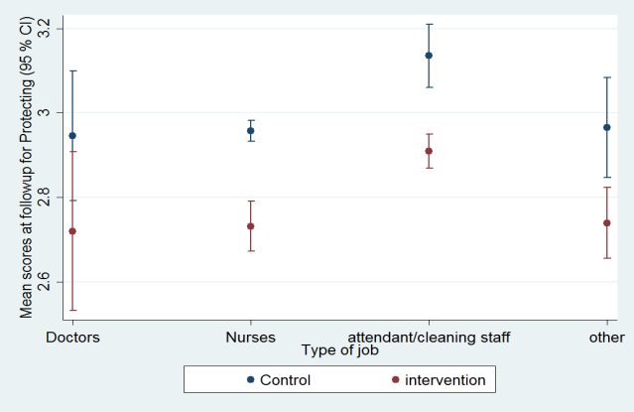

Supplementary Figure 3 (Supplementary Material): Impact of Intervention by different clinical and nonclinical staff groups

Coercion as Treatment sub-scale

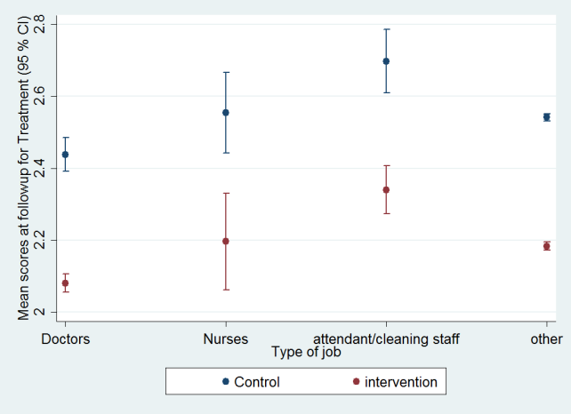

Supplementary Figure 4 (Supplementary Material): Impact of intervention by different clinical and nonclinical staff groups

Coercion as offensive sub-scale

C:\Users\Rama Kawade\Documents\ILS\stata data\Graph_offending.tif

Supplementary Figure 5 (Supplementary Material): Impact of intervention by different clinical and nonclinical staff groups

CAMI sub-scale: Fear and avoidance

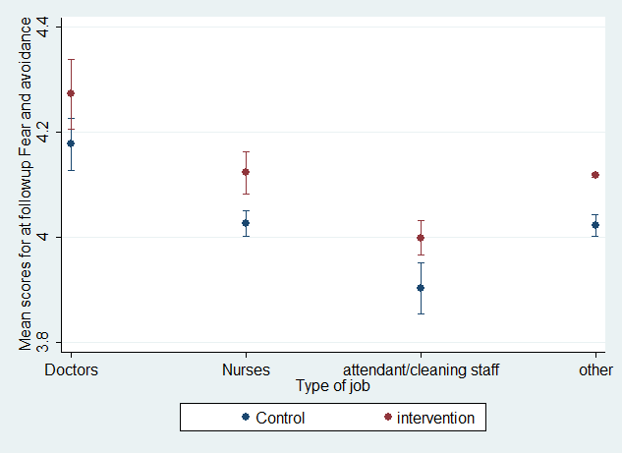

Supplementary Figure 6 (Supplementary Material): Impact of intervention by different clinical and nonclinical staff groups

CAMI sub-scale: Tolerance and pro-integration

