Supplementary Material
Figure S1- Clinical phenotyping across psychopathology domains of Suicide Ideators compared to Non-Suicidal youth.
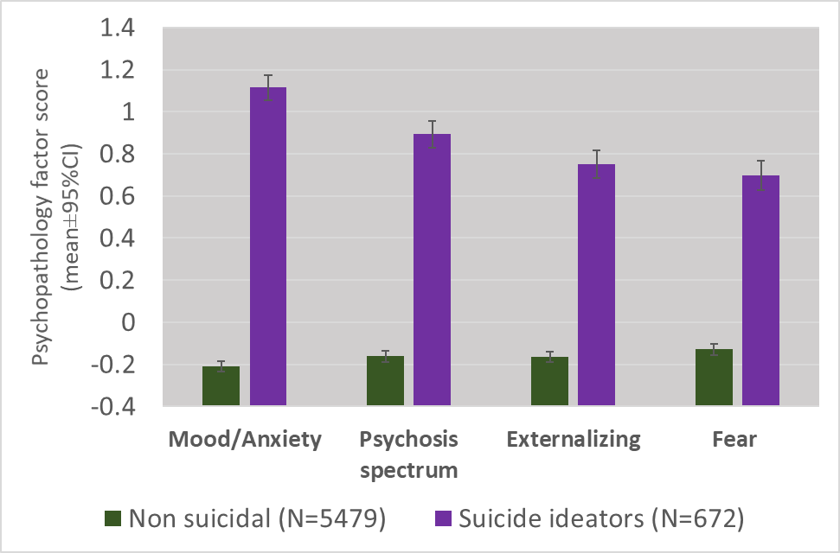
Comparison between lifetime Suicide Ideators and Non-Suicidal youth. In all four psychopathology domains, Suicide Ideators showed increased symptomatology, regardless of gender or pubertal status, controlling for age and socioeconomic status (linear regression with psychopathology factor scores as the dependent variable and suicide ideation as independent variable, controlling for gender, pubertal status, age and socioeconomic status, p<.001 for all psychopathology domains).

Figure S2- Clinical phenotyping across psychopathology domains of youth without suicide ideation, with lifetime (not current) suicide ideation, and with current thoughts of suicide/death/dying.

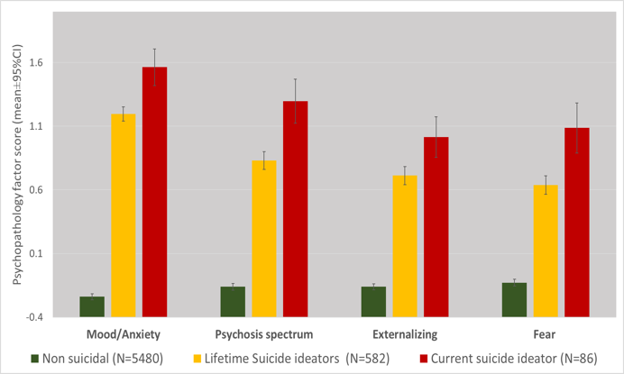
Figure S3- Comparison of level of function estimated by C-GAS score (Means ± 95% CI) of youth without suicide ideation, with lifetime (not current) suicide ideation, and with current thoughts of suicide/death/dying.
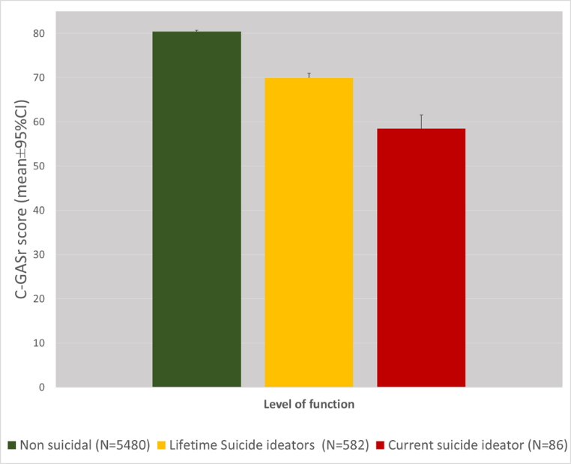
Figure S4- Comparison of the number of false positive responses in the CPT between Suicide Ideators and Non-Suicidal youth. Suicide Ideators did not differ in the frequency of false positive responses in the CPT compared to non-suicidal youth in pre and post-pubertal males or females (Mann Whitney U-test, all p’s>.26).

Supplemental Table 1- Main effect and interactions of age with SI and sex in association with clinical function and overall cognitive performance in youth.
 | Level of Function (CGAS)
 | beta | t | P
Suicide ideation (SI) | -0.307 | -25.313 | <.001
Sex effect | 0.025 | 2.095 | 0.036
Age effect | 0.002 | 0.187 | 0.852
SI X Sex |  | 2.561 | 0.010
SI X Age |  | 0.725 | 0.468
Sex X Age |  | 0.783 | 0.433
SI X Sex X Age |  | 0.082 | 0.934
 | Cognitive performance (Overall accuracy on CNB)
 | beta | t | P
Suicide ideation (SI) | 0.038 | 3.153 | 0.002
Sex effect | 0.003 | 0.269 | 0.788
Age effect | 0.017 | 1.435 | 0.151
SI X Sex |  | 0.094 | 0.925
SI X Age |  | 0.165 | 0.869
Sex X Age |  | 3.767 | <.001
SI X Sex X Age |  | 0.923 | 0.356
Linear regression models with level of function (C-GAS score, upper panel) or overall cognitive performance (CNB accuracy score, lower panel) as the dependent variable; and suicidal ideation, sex, age and their interactions as the independent variables, controlling for socioeconomic status. SI= Lifetime suicidal ideation. C-GAS=Children Global Assessment Scale. CNB= Penn Computerized Neurocognitive Battery. Significant p-values are marked in bold.

Supplementary Table 2- Clinical function and overall cognitive performance of youth with thoughts of suicide/death/dying compared to Non-Suicidal youth.
 | Level of Function (CGAS)
 | Model A |  |  | Model B |  |  | Model C |  |  | Model D
 | beta | t | P | beta | t | P | beta | t | P | beta | t | P
Suicide ideation/Thoughts of death (SI) | -0.246 | -21.170 | <.001 | -0.248 | -21.263 | 0.000 | -0.172 | -14.262 | <.001 | -0.102 | -8.750 | <.001
Sex effect | 0.020 | 1.667 | 0.095 | 0.019 | 1.616 | 0.106 | 0.040 | 3.430 | 0.001 | 0.014 | 1.270 | 0.204
Puberty effect | 0.011 | 0.916 | 0.360 | 0.007 | 0.562 | 0.574 | 0.013 | 1.136 | 0.256 | -0.008 | -0.747 | 0.455
SI X Sex |  | 3.861 | <.001 |  | 3.795 | <.001 |  | -2.980 | 0.003 |  | -4.369 | <.001
SI X Puberty |  | 0.486 | 0.627 |  | 0.239 | 0.811 |  | 0.637 | 0.524 |  | -1.021 | 0.308
Sex X Puberty |  | 0.884 | 0.377 |  | 1.105 | 0.269 |  | 1.511 | 0.131 |  | 0.925 | 0.355
SI X Sex X Puberty |  | 0.064 | 0.949 |  | 0037 | 0.971 |  | 0.227 | 0.820 |  | 0.147 | 0.883
 | Cognitive performance (Overall accuracy on CNB)
 | Model A |  |  | Model B |  |  | Model C |  |  | Model D
 | beta | t | P | beta | t | P | beta | t | P | beta | t | P
Suicide ideation/Thoughts of death (SI) | 0.054 | 4.738 | <.001 | 0.043 | 3.788 | <.001 | 0.048 | 3.987 | <.001 | 0.083 | 6.870 | <.001
Sex effect | 0.010 | 0.856 | 0.392 | 0.012 | 1.067 | 0.286 | 0.010 | 0.901 | 0.368 | -0.010 | -0.900 | 0.368
Puberty effect | 0.035 | 3.062 | 0.002 | 0.038 | 3.262 | 0.001 | 0.033 | 2.835 | 0.005 | 0.036 | 3.110 | 0.002
SI X Sex |  | 1.763 | 0.078 |  | 1.902 | 0.057 |  | -1.861 | 0.063 |  | -1.820 | 0.069
SI X Puberty |  | 0.695 | 0.487 |  | 0.816 | 0.415 |  | 0.645 | 0.519 |  | 0.609 | 0.543
Sex X Puberty |  | 0.777 | 0.437 |  | 1.160 | 0.246 |  | 0.685 | 0.494 |  | 0.691 | 0.489
SI X Sex X Puberty |  | 0.806 | 0.420 |  | 0.687 | 0.492 |  | 0.815 | 0.415 |  | 0.902 | 0.367
Linear regression models with level of function (C-GAS score) or overall cognitive performance (CNB accuracy score) as the dependent variable and suicidal ideation/ thoughts of death, sex, puberty and their interactions as the independent variables, controlling for age (puberty regressed), socioeconomic status, race, lifetime depression and general psychopathology factor score. SI= Thoughts of suicide/death/dying. C-GAS=Children Global Assessment Scale. CNB= Penn Computerized Neurocognitive Battery. Model A controls for age and socioeconomic status; Model B controls for age, race and parents’ separation status; Model C controls for age, socioeconomic status, and lifetime depression; Model D controls for age, socioeconomic status, and general psychopathology. Significant p-values are marked in bold.

