The process of whole exome sequencing and quality control
Peripheral blood was collected from all participants, and genomic DNA was extracted according to a standard phenol–chloroform procedure. Exome sequencing was performed by Macrogen (http://www.macrogen.com/), a commercial service. DNA sample was prepared according to the Illumina Protocol. Targeted enrichment was performed with TruSeq Exome Enrichment Kit optimized for Illumina sequencing. Briefly, genomic DNA was sheared to 350-400 base pair using Illumina adapters. The fragment was end repaired and polyA was ligated to the 3'and 5' end and Illumina adapters. The size selected product was PCR amplified, and the final product was validated using the Agilent Bioanalyzer. Two steps of hybridization and wash were needed for construction. PCR was used to amplify the enriched DNA library for sequencing which produced 101bp end reads, approximately 6-10 billion base calls were generated for each sample. PCR was performed with the same PCR primer cocktail used in TruSeq DNA Sample Preparation. The Enrichment Kit is designed to cover 62 Mb exomic sequences. Quality control of raw data was conducted by FastQC software(1). Raw read data were visualized using the Integrative Genome Viewer (IGV)(2).
Quality control (QC):
Individual level QC: Individual level quality control was conducted on raw and clean variant to make sure avoiding false positive variants. A suite of per-individual metrics, which included the total number of alternate alleles, dbSNP coverage (build137), and Transition/Transversion (Ti/Tv) ratio, and variant quality recalibration (VQSR) were calculated. From available exome data, we extracted common variants and estimated per-individual heterozygosity, pairwise relatedness, and sex-check using PLINK(3). We also use EIGENSOFT (4) to perform population stratification analysis. After calculating all of metrics above, we remove 6 samples (3 cases and 3 controls), and delete these samples for following analysis.

Variants QC: Variants quality control was conducted by KGGSeq software (5). These parameters were included (1) Variants were kept if the minimum overall sequencing quality scores≧50 (--seq-qual 50) and the minimum overall mapping quality score≧20 (--seq-mq 20); (2) The minimal genotyping quality per genotype≧30 (--gty-qual 30) and the minimal read depth per genotype≧30 (--gty-qual 30); (3) The fraction of the reads carrying alternative allele≦5% at a reference-allele homozygous genotype (--gty-af-ref 0.05), the fraction of the reads carrying alternative allele≧25% at a heterozygous genotype (--gty-af-het 0.25), and the fraction of the reads carrying alternative allele≧75% at a alternative-allele homozygous genotype(--gty-af-alt 0.75); (4) Minimal observed number of non-missing genotypes in all samples as 50 (--min-obs 50); (5) Variants in controls with the Hardy-Weinberg test p value≧0.00001 (--hwe-control 1.0E-5); (6) Variants with "FILTER" matching the VQSR labels.

References
1. Andrews S. FastQC: A quality control tool for high throughput sequence data. Reference Source. 2010.
2. Thorvaldsdóttir H, Robinson JT, Mesirov JP. Integrative Genomics Viewer (IGV): high-performance genomics data visualization and exploration. Briefings in bioinformatics. 2013; 14(2): 178-92.
3. Purcell S, Neale B, Todd-Brown K, Thomas L, Ferreira MAR, Bender D, et al. PLINK: a tool set for whole-genome association and population-based linkage analyses. The American Journal of Human Genetics. 2007; 81(3): 559-75.
4. Price AL, Patterson NJ, Plenge RM, Weinblatt ME, Shadick NA, Reich D. Principal components analysis corrects for stratification in genome-wide association studies. Nature genetics. 2006; 38(8): 904-9.
5. Li M-X, Gui H-S, Kwan JS, Bao S-Y, Sham PC. A comprehensive framework for prioritizing variants in exome sequencing studies of Mendelian diseases. Nucleic acids research. 2012; 40(7): e53-e.

Supplementary Table1 15 brain regions were used to compute the coexpression network
STR | Striatum
MD | Mediodorsal nucleus of thalamus
AMY | Amygdaloid complex
HIP | Hippocampus
A1C | Primary auditory cortex | Neocortical regions
M1C | Primary motor cortex
S1C | Primary somatosensory cortex
V1C | Primary visual cortex
DFC | Dorsolateral prefrontal cortex
MFC | Anterior (rostral) cingulate (medial prefrontal) cortex
OFC | Orbital frontal cortex
VFC | Ventrolateral prefrontal cortex
ITC | Inferolateral temporal cortex
STC | Posterior (caudal) superior temporal cortex
IPC | Posteroinferior (ventral) parietal cortex

Supplementary Table 2 The correlation coefficient among 5 original FA variables
Brain areas | PUN_R | PUN_L | ACC_L | ACC_R | EN
PUN_R | 1 | 0.85 | 0.58 | 0.585 | 0.682
PUN_L | 0.85 | 1 | 0.617 | 0.608 | 0.692
ACC_L | 0.58 | 0.617 | 1 | 0.632 | 0.504
ACC_R | 0.585 | 0.608 | 0.632 | 1 | 0.52
EN | 0.682 | 0.692 | 0.504 | 0.52 | 1

PUN: precuneus; ACC: anterior cingulate cortex; EN: extra-nuclear; R: right; L: left

Supplementary Table3 The correlation coefficient between the first component and any of 5 original FA
First Component | Brain regions | Coefficients
PC1 | ACC_L | -0.625 | Case
PC1 | ACC_R | -0.602 | Case
PC1 | EN | -0.767 | Case
PC1 | PUN_L | -0.976 | Case
PC1 | PUN_R | -0.936 | Case
PC1 | ACC_L | -0.566 | Control
PC1 | ACC_R | -0.569 | Control
PC1 | EN | -0.673 | Control
PC1 | PUN_L | -0.952 | Control
PC1 | PUN_R | -0.928 | Control

PUN: precuneus; ACC: anterior cingulate cortex; EN: extra-nuclear; R: right; L: left

Supplementary Table 4 Subnetwork with 207 genes
SF3A3 | MICA | LIPC | SUMO2 | PSMB8 | UBASH3B | NGEF | TRIM8
CHRM4 | GGA3 | MGRN1 | RERE | PSMB3 | GRHPR | PCF11 | EIF2B4
INPP5B | GLYCTK | EEF1A2 | TRIM39 | UBE2D2 | DNAJA3 | TSEN2 | FANCL
TRIM10 | PTBP2 | SMARCD1 | ZKSCAN4 | RNF5 | SERPING1 | ZCCHC7 | RRAS
ENO1 | DNAJA1 | PBRM1 | HIST1H2BE | HSPD1 | MATR3 | EIF2AK2 | IRF3
OTUD7B | DLST | PLCB2 | LSM1 | AMFR | PCGF6 | ASH2L | ARHGAP1
RNF165 | ALAS1 | PLCL1 | CLIC1 | PTN | HIST1H4C | PSMD6
LASP1 | L3MBTL2 | ISYNA1 | HLA-B | GPD1 | HIST1H4B | BAG4
MED19 | HIST1H1E | NUDT21 | SEC11A | PRKCD | HIST1H4A | BCL2L12
MAGOH | EHMT2 | CLP1 | HIST1H4I | FANCA | HIST1H4E | TSSK6
HLA-G | CSNK2B | DFNA5 | SETD8 | RAF1 | HIST1H4D | LTB
HLA-F | LSM2 | GIGYF2 | SETD7 | CHEK1 | HIST1H4H | PLEKHO1
VPS37B | HSPA1L | SREBF2 | PRPF3 | EP300 | HIST1H4J | TAF5
ALDH5A1 | DCP1B | NFKBIA | UBA52 | AKT3 | HIST1H4K | SUPT7L
THOC7 | NRGN | RBBP5 | RPL13A | HIST1H3I | HIST1H4L | HIST1H2BF
PPM1G | ST13 | CXXC1 | HIST1H3A | HIST1H3H | NRBP1 | HIST1H2BC
PUF60 | MYO5B | DHX16 | HIST1H2AB | HIST1H3G | CPNE7 | HIST1H2BI
CTNND1 | PACSIN3 | GTF2H4 | FXR1 | ZNF408 | CDK2AP1 | EIF4E2
ACTR1A | PPARG | HSPA1A | RFWD3 | RPL29 | NFKBIE | HIST1H2BM
RANGAP1 | ING1 | PSME4 | HIST1H3D | RPLP1 | DCP1A | ACVR2B
GLG1 | MKL1 | LTA | HIST1H3B | RPS11 | TNF | TRIM26
TRIM31 | SFMBT1 | DNAJB1 | HIST1H3C | RPS13 | SYNJ1 | MDC1
TCF19 | HIST1H2BA | ATXN7 | PRMT1 | GNL3 | ZBTB5 | ADIPOR2
FSD2 | HIST1H2AA | NFX1 | PSMA6 | BAG1 | SRF | HSPE1
F2 | DDB2 | TRIM54 | HLA-C | HSP90AB1 | RBX1 | DENR
 | PBX3 | CHCHD2 | PIAS2 | HSPA1B | CNTN2 | IDH3B
 | NCAN | HIST1H2BB | CCHCR1 | HIST1H3J | LIPG | PSPH
 |  | INHBA | RBL2 | CDC5L | VARS | YLPM1
 |  | DIP2A | PSMB9 | TTC23 | DGKI | MAD1L1
 |  |  | TRIM27 | TAP1 | DGKZ | EI24

Supplementary Table 5 Genes in four modules for PGC-1
Yellow module | Blue module | Brown module | Turquoise module | Turquoise module
BCL2L12 | HSP90AB1 | RPS11 | EEF1A2 | TAF5
CDK2AP1 | DNAJA1 | RPL29 | LASP1 | NFX1
CLIC1 | CHCHD2 | UBA52 | ACTR1A | GIGYF2
DGKI | PSMB3 | RPL13A | NCAN | MKL1
ENO1 | MATR3 | RPLP1 | SREBF2 | LIPG
GRHPR | NUDT21 | RPS13 | PBX3 | PCF11
HLA-B | SUMO2 | PPM1G | CTNND1 | ZCCHC7
HLA-C | UBE2D2 | PUF60 | DNAJB1 | CLP1
HLA-F | HSPD1 | PRMT1 | NGEF | PRPF3
HLA-G | PTBP2 | RNF5 | AMFR | CHEK1
IRF3 | RBX1 | LSM2 | IDH3B | SETD8
L3MBTL2 | EI24 | ISYNA1 | SMARCD1 | DCP1B
LTB | ST13 | CSNK2B | AKT3 | MDC1
MICA | ALAS1 | EHMT2 | PBRM1 | EIF2AK2
NFKBIA | TRIM8 | PLEKHO1 | ZBTB5 | SFMBT1
PIAS2 | GLG1 | MED19 | RANGAP1 | ZKSCAN4
PSMB8 | SF3A3 | VPS37B | VARS | DFNA5
PSMB9 | THOC7 | CXXC1 | RAF1 | ACVR2B
PSPH | GNL3 | ADIPOR2 | NRBP1 | FANCA
PTN | CDC5L | SEC11A | DLST | TSEN2
RRAS | LSM1 | CNTN2 | YLPM1 | DIP2A
SERPING1 | FXR1 | TRIM26 | RNF165 | CPNE7
TAP1 | HSPE1 | GTF2H4 | DNAJA3 | DGKZ
TTC23 | DENR | TRIM39 | MGRN1 | PLCB2
 | PSMA6 | SUPT7L | SRF | HIST1H4E
 | EIF4E2 | EIF2B4 | RERE | GPD1
 | MAGOH | BAG4 | NRGN | HIST1H2BC
 | ASH2L | MAD1L1 | ING1 | INHBA
 | RBBP5 | NFKBIE | TRIM27 | HIST1H4H
 | BAG1 | DDB2 | EP300 | ATXN7
 | FANCL | SYNJ1 | RBL2 | PRKCD
 | ARHGAP1 | ZNF408 | GGA3 | MYO5B
 | PSMD6 | PLCL1 | DHX16 | TRIM54
 | SETD7 | CCHCR1 | ALDH5A1 | PPARG
 | UBASH3B | HIST1H3D | PSME4 | FSD2
 | PACSIN3 | OTUD7B | CHRM4
 | INPP5B | HIST1H4I | TCF19
 | PCGF6 | HIST1H2BF | RFWD3
 | GLYCTK | TSSK6 | DCP1A

Supplementary Table 6 GO Enrichment Analysis of Genes in each module
GO Terms | Raw P value | Adjusted P Value
Yellow module
antigen processing and presentation of exogenous peptide antigen via MHC class I, TAP-dependent | 1.60e-11 | 6.50e-09
antigen processing and presentation of exogenous peptide antigen via MHC class I | 2.33e-11 | 9.46e-09
antigen processing and presentation of peptide antigen via MHC class I | 1.26e-10 | 5.12e-08
innate immune response | 3.15e-09 | 1.28e-06
MHC class I receptor activity | 1.23e-08 | 7.87e-07
MHC class I protein complex | 5.69e-11 | 4.38e-09
MHC protein complex | 1.07e-09 | 8.24e-08
Blue module
lysine N-methyltransferase activity | 0.0001 | 0.0008
histone-lysine N-methyltransferase activity | 0.0001 | 0.0008
macromolecular complex | 8.77e-05 | 0.0006
Brown module
SRP-dependent cotranslational protein targeting to membrane | 3.68e-09 | 4.71e-07
viral infectious cycle | 3.09e-08 | 2.17e-06
histonemethyltransferase activity | 0.0001 | 0.0029
proteinmethyltransferase activity | 0.0003 | 0.0043
N-methyltransferase activity | 0.0003 | 0.0043
S-adenosylmethionine-dependent methyltransferase activity | 0.0013 | 0.0123
histone-lysine N-methyltransferase activity | 0.0032 | 0.0199
lysine N-methyltransferase activity | 0.0035 | 0.0199
protein-lysine N-methyltransferase activity | 0.0035 | 0.0199
Turquoise module
RNA polymerase II core promoter proximal region sequence-specific DNA binding | 0.0001 | 0.0043
core promoter proximal region DNA binding | 0.0005 | 0.0092
phosphotransferase activity, alcohol group as acceptor | 0.0010 | 0.0158
intracellular organelle | 9.98e-08 | 1.77e-06

Supplementary Figure 1 The plot of the first two principal components of 93 patients with schizophrenia and 134 controls

Supplementary Figure 2 FA was significantly reduced in the left and right anterior cingulate cortex, left and right precuneus and extra-nuclear in patients with schizophrenia compared to controls in schizophrenic patients compared to controls (FDR corrected p < 0.01, cluster size ≥ 100).

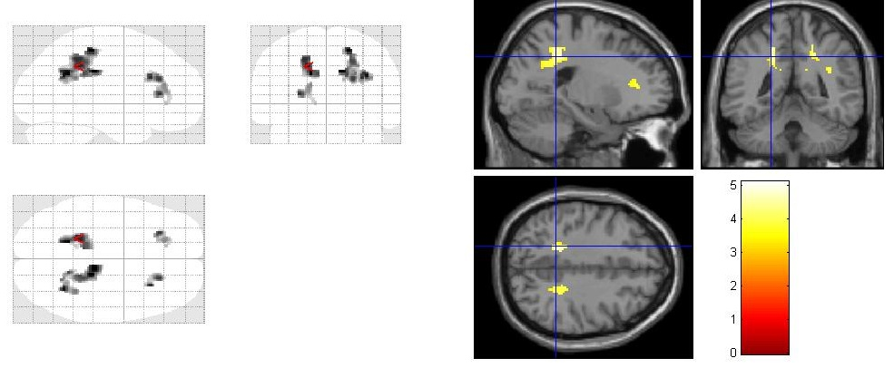

Supplementary Figure 3 The histograms are colored based on different percentiles: 70% (cyan), 90% (pink) and 99% (red), red dashed line shows the parameters of the sub-network in question.

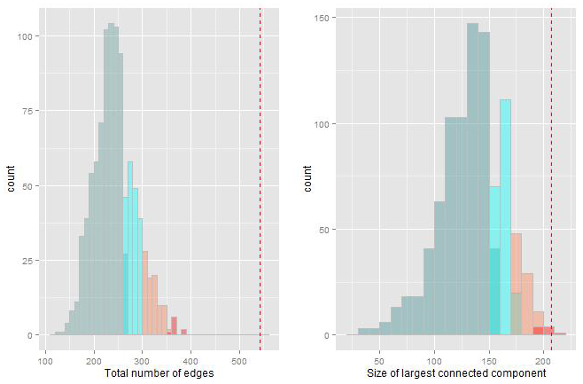

Supplementary Figure 4 Temporal patterns of gene expression as summarized by the average expression level of genes in each module.

