Supplementary Material
Figure s1: PANSS positive, negative and general subscale scores in those with SEN, divided into SIS/CBCL groupings, and controls at each timepoint.
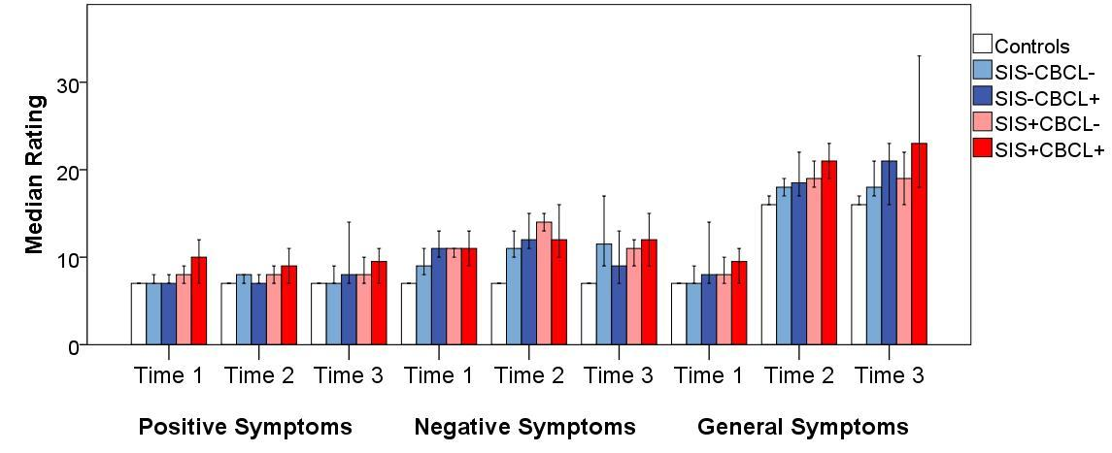

PANSS, Positive and Negative Syndrome Scale; SEN, Special Educational Needs; SIS, Structured Interview for Schizotypy; CBCL, Childhood Behavioural Checklist.

Figures s2-s4: Breakdown of PANSS scores by individual symptoms for the SEN group.
Figure s2
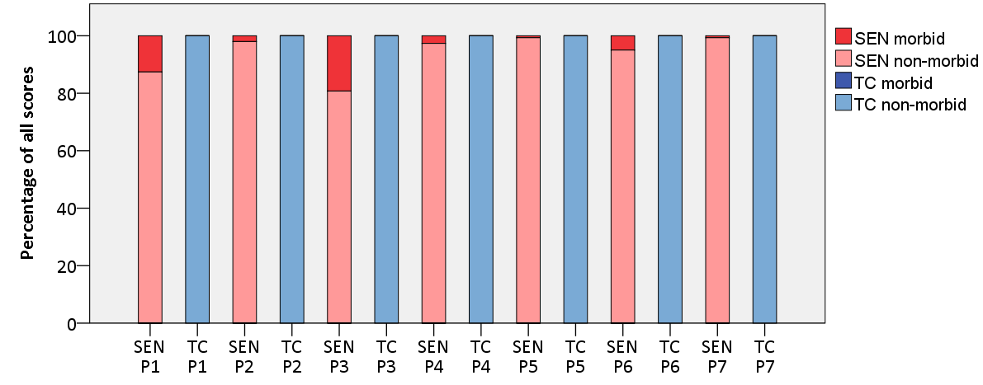
Figure s3
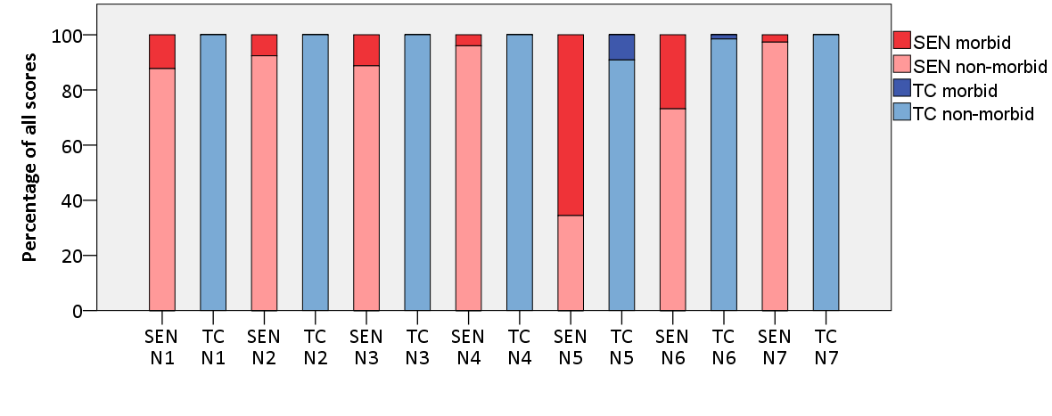
Figure s4
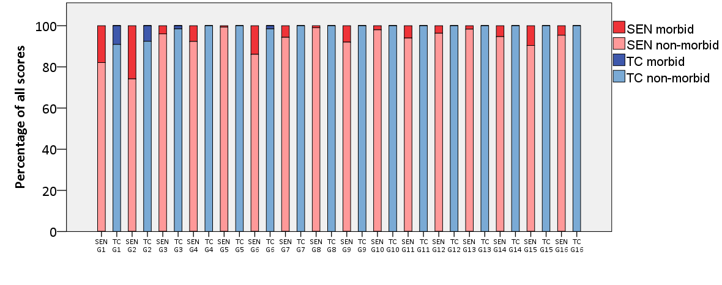
Y axis represents the percentage of all ratings made for participants throughout the study. Darker colours represent the proportion of these ratings which were scores as 3 or more.
PANSS, Positive and Negative Syndrome Scale; SEN, special educational needs group; TC, typical controls.
P1 – delusions, P2 – conceptual disorganisation, P3 – hallucinations, P4 – excitement, P5 – grandiosity, P6 – suspiciousness, P7 – hostility; N1 – blunted affect, N2 – emotional withdrawal, N3 – poor rapport, N4 – passive-apathetic social withdrawal, N5 – difficulty in abstract thinking, N6 – lack of spontaneity and flow of conversation, N7 – stereotyped thinking; G1 - somatic concern, G2 – anxiety, G3 – guilt, G4 – tension, G5 – mannerisms and posturing, G6 – depression, G7 – motor retardation, G8 – uncooperativeness, G9 – unusual thought content, G10 – disorientation, G11 – poor attention, G12 – lack of judgement and insight, G13 – disturbance of volition, G14 – poor impulse control, G15 – preoccupation, G16 – active social avoidance

