Appendix
Association between particulate matter air pollution and risk of suicide and depression: a systematic review and meta-analysis

Authors and affiliations:
Xuelin Gu, Qisijing Liu, Furong Deng, Xueqin Wang, Hualiang Lin, Xinbiao Guo, Shaowei Wu

Table of contents
Table S1. Detailed search strategy
Table S2. Quality assessment using Newcastle-Ottawa Scale (NOS) scales for (A) case-crossover and (B) cohort studies
Table S3. Results of sensitivity analyses omitting one study each at a time
Table S4. Results of PM concentration in different study locations.

Figure of contents
Figure S1. Funnel plots of publication bias analyses

Table S1. Detailed search strategy
Database | Search strategy
Pubmed | #1 ("Air Pollution"[Mesh]) OR ("Particulate Matter"[Mesh]) OR "Air Pollution" OR "Air pollutant*" OR "Particulate Matter" OR "PM2.5" OR "PM10"  #2 ("Depression"[Mesh]) OR ("Depressive Disorder"[Mesh]) OR ("Suicide"[Mesh]) OR "Depression" OR "Depressive Disorder*" OR "Suicide" OR "depressive symptom*" OR "depressed mood"  #3 #1 AND #2
Medline | #1 (MH "Air Pollution") OR (MH "Air Pollutants") OR (MH "Particulate Matter") OR "Air Pollution" OR "air pollutant*" OR "Particulate Matter" OR "PM2.5" OR "PM10"  #2 (MH "Depression") OR (MH "Depressive Disorder") OR (MH "Suicide") OR "Depression" OR "Depressive Disorder*" OR "Suicide" OR "depressive symptom*" OR "depressed mood"  #3 #1 AND #2
Embase | #1 'air pollution'/exp/mj OR 'air pollutant*'/mj OR 'particulate matter'/exp/mj OR 'PM2.5'/mj OR 'PM10'/mj  #2 'depression'/exp/mj OR 'suicide'/exp/mj OR 'depressive symptom*'/mj OR 'depressive disorder'/mj OR 'depressed mood'/mj  #3 #1 AND #2
OVID | ((air pollution or air pollutant* or particulate matter or PM2 5 or PM10) and (depression or depressive symptom* or depressive disorder or depressed mood or suicide)).ti,ab,kw.
Web of science | （"air pollution" or "air pollutant*" or "particulate matter" or "PM2.5" or "PM10"） and ("depression" or "depressive symptom*" or "depressive disorder" or "depressed mood" or "suicide")
SIGLE | (depression or depressive or suicide) and (air pollution or air pollutant or particulate matter or PM2.5 or PM10)
Social Care Online | (depression or depressive or suicide) and (air pollution or air pollutant or particulate matter or PM2.5 or PM10)
British National Bibliography for Report Literature | (depression or depressive or suicide) and (air pollution or air pollutant or particulate matter or PM2.5 or PM10)
NITS | (depression or depressive or suicide) and (air pollution or air pollutant or particulate matter or PM2.5 or PM10)

Table S2. Quality assessment using Newcastle-Ottawa Scale (NOS) for (A) case-crossover and (B) cohort studies

(A) Case-crossover Study | Outcome | Selection |  |  |  | Comparability |  | Exposure |  |  | Total | Grading
 |  | Case definition | Representa-tiveness | Selection of controls | Definition of controls | Adjusted for demographic characteristic | Adjusted for meteorological variables | Ascertainment | Consistent method | Non-response rate
Kim, et al. (2010) | Suicide | 0 | 1 | 1 | 1 | 1 | 1 | 1 | 1 | 1 | 8 | High
Bakian, et al. (2015) | Suicide | 0 | 1 | 1 | 1 | 1 | 1 | 1 | 1 | 1 | 8 | High
Lin, et al. (2016) | Suicide | 0 | 1 | 1 | 1 | 1 | 1 | 1 | 1 | 1 | 8 | High
Casas, et al. (2017) | Suicide | 0 | 1 | 1 | 1 | 1 | 1 | 1 | 1 | 1 | 8 | High
Li, et al. (2018) | Suicide | 0 | 1 | 1 | 1 | 1 | 1 | 1 | 1 | 1 | 8 | High
Kim, et al. (2018) | Suicide | 0 | 1 | 1 | 1 | 1 | 1 | 1 | 1 | 1 | 8 | High
Cho, et al. (2014) | Depression | 0 | 1 | 1 | 1 | 1 | 1 | 1 | 1 | 1 | 8 | High
Szyszkowicz, et al. (2016) | Depression | 0 | 1 | 1 | 1 | 1 | 1 | 1 | 1 | 1 | 8 | High
Wang, et al. (2018) | Depression | 0 | 1 | 1 | 1 | 1 | 1 | 1 | 1 | 1 | 8 | High

(B) Cohort study | Outcome | Selection |  |  |  | Comparability |  | Outcome |  |  | Total | Grading
 |  | Representativeness of the exposed cohort | Selection of the non-exposed cohort | Ascertainment of exposure | Outcome not present at start | Adjusted for demographic characteristic | Adjusted for meteorological variables | Ascertai-nment | Enough follow-up | Adequacy of follow up of cohort
Min, et.al. (2018) | Suicide | 1 | 1 | 1 | 1 | 1 | 1 | 0 | 1 | 1 | 8 | High
Kim, et al. (2016) | Depression | 1 | 1 | 1 | 1 | 1 | 0 | 0 | 1 | 1 | 7 | High
Zijlema, et al. (2016) | Depression | 1 | 1 | 1 | 0 | 1 | 0 | 1 | 0 | 0 | 5 | Medium
Kioumourtzoglou, et al. (2017) | Depression | 0 | 1 | 1 | 1 | 1 | 0 | 1 | 1 | 1 | 7 | High
Pun, et al. (2017) | Depression | 1 | 1 | 1 | 0 | 1 | 0 | 1 | 0 | 1 | 6 | Medium

Table S3. Results of sensitivity analyses omitting one study each at a time.
Analytic setting | OR(95%CI) | I-squared value | P Value for heterogeneity
(A) Depression associated with PM_{2.5}
Omitting Kim, et al.(2016) | 1.16(1.04,1.30) ** | 99.92% | <.001
Omitting Zijlema, et al.(2016)-FINRISK | 1.14(1.02,1.28) * | 99.92% | <.001
Omitting Zijlema, et al.(2016)-KORA | 1.19(1.07,1.33) ** | 99.92% | <.001
Omitting Zijlema, et al.(2016)-LifeLines | 1.19(1.07,1.33) ** | 99.92% | <.001
Omitting Szyszkowicz, et al.(2016)-male | 1.26(1.05,1.50) * | 99.91% | <.001
Omitting Szyszkowicz, et al.(2016)-male | 1.26(1.06,1.49) ** | 99.89% | <.001
Omitting Kioumourtzoglou, et al.(2017) | 1.21(1.08,1.37) ** | 99.92% | <.001
Omitting Pun, et al.(2017) | 1.03(1.01,1.05) ** | 87.42% | <.001
Omitting Wang, et al.(2018) | 1.19(1.07,1.33) ** | 99.92% | <.001
Overall | 1.19(1.07,1.33) ** | 99.91% | <.001
(B) Depression associated with PM₁₀
Omitting Cho, et al.(2014) | 0.91(0.55,1.52) | 0 | .817
Omitting Zijlema, et al.(2016)-FINRISK | 0.90(0.55,1.48) | 0 | .834
Omitting Zijlema, et al.(2016)-KORA | 0.99(0.62,1.56) | 0 | .831
Omitting Zijlema, et al.(2016)-LifeLines | 0.99(0.65,1.52) | 0 | .973
Omitting Wang, et al.(2018) | 0.94(0.60,1.47) | 0 | .802
Overall | 0.95(0.63,1.44) | 0 | .908
(C) Suicide associated with PM_{2.5}
Omitting Kim, et al.(2010) | 1.05(0.99,1.11) | 95.76% | <.001
Omitting Bakian, et al.(2015) | 1.02(1.00,1.04) * | 0 | .978
Omitting Li, et al.(2018) | 1.08(1.08,1.09) ** | 0 | .820
Omitting Kim, et al.(2018) | 1.05(0.99,1.12) • | 95.73% | <.001
Overall | 1.05(0.99,1.11) • | 93.63% | <.001
(D) Suicide associated with PM₁₀
Omitting Kim, et al.(2010) | 1.42(0.70,2.85) | 99.76% | <.001
Omitting Bakian, et al.(2015) | 1.40(0.55,3.58) | 99.75% | <.001
Omitting Lin, et al.(2016) | 1.39(0.71,2.75) | 99.76% | <.001
Omitting Casas, et al.(2017) | 1.41(0.56,3.55) | 99.52% | <.001
Omitting Min, et al.(2018) | 1.01(1.00,1.03) | 0 | .965
Omitting Kim, et al.(2018) | 1.42(0.71,2.87) | 99.76% | <.001
Overall | 1.34(0.71,2.54) | 99.69% | <.001
** 0<P<0.01; * 0.01<P<0.05; • 0.05<P<0.10.

Table S4. Results of PM concentration in different study locations.

Study Location | PM_{2.5}  Mean/(μg/m³) | PM₁₀ Mean/(μg/m³)
North America | 10.76 | 33.21
Europe | 25.00 | 26.50
Asia | 46.75 | 75.57

Figure S1. Funnel plots of publication bias analyses
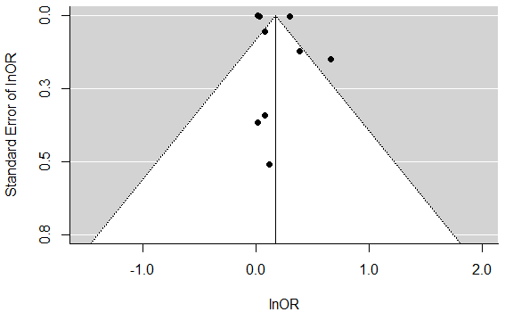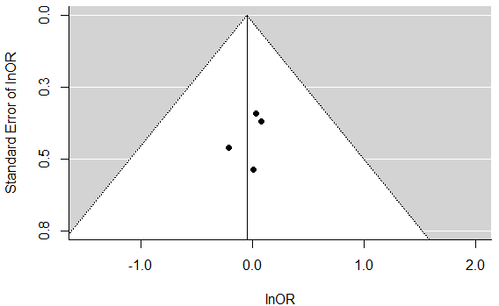
(A) Depression associated with PM_{2.5} (B) Depression associated with PM₁₀
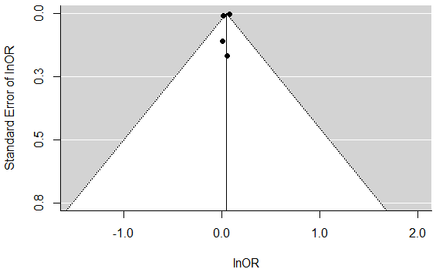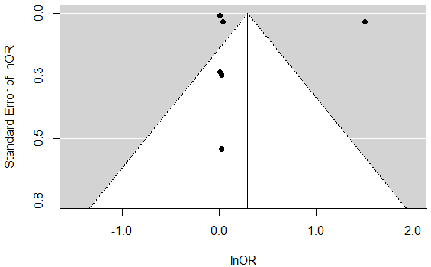
(C) Suicide associated with PM_{2.5} (D) Suicide associated with PM₁₀

