Supplementary Materials
to
The replicability ICD-11 Complex Posttraumatic Stress Disorder symptoms in adults. A cross-cultural analysis of its network structure in representative population samples from Germany, Israel, the UK, and the US.
Matthias Knefel, PhD¹, Thanos Karatzias, PhD^{2,3}, Menachem Ben-Ezra, PhD⁴, Marylene Cloitre, PhD^{5,6}, Brigitte Lueger-Schuster, PhD¹, Andreas Maercker, MD PhD⁷

¹Faculty of Psychology, University of Vienna, Vienna, Austria
²School of Health & Social Care, Edinburgh Napier University, Edinburgh, Scotland
³Rivers Centre for Traumatic Stress, NHS Lothian, Edinburgh, Scotland
⁴School of Social Work, Ariel University, Ariel, Israel
⁵National Center for PTSD, Veterans Affairs Palo Alto Health Care System, Palo Alto, CA, USA
⁶Department of Psychiatry and Behavioral Sciences, Stanford University, Stanford, California, USA
⁷Division of Psychopathology, Department of Psychology, University of Zurich, Zurich, Switzerland

* Correspondence to Matthias.knefel@univie.ac.at
Department of Applied Psychology: Health, Development, Enhancement and Intervention
Faculty of Psychology, University of Vienna, Vienna, Austria
Liebiggasse 5, 1080 Vienna, Austria

Data analysis
This section provides am more detailed information about the statistical procedure and the used software.
Missing values
In the whole sample, we excluded twelve persons from the analysis due to too many missing values in the 12 ITQ items (20% or more missing values). In the remaining sample, there were a total of 69 missing values (0.52% of all data points). To rule out a possible bias introduced by excluding twelve individuals and using pairwise complete observations for the analysis, we additionally used a multiple imputation technique to estimate missing values for the German and the US samples. The predictive mean matching approach is implemented in the R-package hmisc and is a more nonparametric approach that will work for categorical as well as continuous predictors (1). For the present analysis, we used the following settings of the function aregImpute: number of multiple imputations = 10; number of knots = 0; the correlation matrices using the imputed datasets were then compared to the correlation matrices using the non-imputed datasets. The matrices were very similar; the mean difference of the correlation coefficients was .001 in the German and the US sample. A χ²-test comparing the matrices showed no significant differences (p = 1.0). We thus decided to report the non-imputed results in the main analysis for better comparability with other studies using the same approach.
Network estimation
We estimated Gaussian Graphical Models (GGM) for pairwise association parameters between all nodes. In the GGM, edges can be understood as conditional dependence relations among symptoms: If two symptoms are connected in the resulting graph, they are dependent after controlling for all other symptoms. Symptoms that are not connected are conditionally independent. With 12 symptom nodes, 66 pairwise association parameters are estimated. The estimation of so many parameters may lead to a number of spurious connections; we thus controlled for these false positives by using the least absolute shrinkage and selection operator (LASSO; 2) which sets very small edges to zero. This procedure employs a regularization technique that conservatively identifies only the relevant edges, and accurately discovers the underlying network structure (3). More details on these estimation techniques, including a tutorial, is available elsewhere (4). Since PTSD symptoms can be considered ordered-categorical, the estimation of the 12-item networks are based on the polychoric correlations among symptoms.
One aim of our study was to compare the networks of four different samples. We thus used the fused graphical lasso (FGL) to jointly estimate the network structures of the four samples, taken into account possible similarities (5). The FGL is a valid method that can lead to a more accurate estimation of network structures than estimating networks individually (5, 6).This method comes close to estimating networks independently, if the true networks are distinct and exploiting similarities would not improve model fit. Thus, true differences are allowed to emerge. This property makes the FGL a good method for estimating networks in different groups (7). We used the R-package EstimateGroupNetwork (8) for network estimation employing the k-fold cross-validation for parameter selection as implemented in the package.
Network inference
We used three parameters to describe the connectedness of each node in the four jointly estimated networks: the centrality index node strength, the predictability of each node, and the bridge strength. Strength refers to the sum of all edges connected to a specific node (9). Other centrality parameters, betweenness and closeness, can often not be estimated reliably (10) and are thus not investigated in the present study. Predictability refers to the estimated shared variance of each node with all of its neighbors (11). We estimated predictability using the R-package mgm (12). Strength and predictability both provide information on the connectedness of each node within the symptom network. While strength can be regarded as a relative metric, predictability is an absolute measure of connectedness. Bridge strength is a parameter to estimate the strength of each node in connecting different communities. In the present study, those communities are the six PTSD symptoms and the six DSO symptoms. Bridge strength represents the sum of the absolute value of all edges that exist between a node in the PTSD community and all nodes in the DSO community and vice-versa. We estimated bridge strength using the R-package networktools (13).
Network stability
Network stability estimation was only recently introduced (10). At the moment, there is no method available to test the stability of jointly estimated networks. We thus followed the procedure by 14 (14) and examined the stability of the individually estimated networks. We used the R-package bootnet (15) and bootstrapped 95% confidence intervals around the edge weights, estimated the correlation-stability coefficient for strength centrality (ranging from 0–1; values above 0.25 imply moderate stability, above 0.5 strong stability; 10), and computed the edge-weights difference test and the centrality difference test for each network.
Network comparison
To obtain an index of the degree of similarity across the samples, we correlated the edge weights across the four networks (16). We then used the R-package NetworkComparisonTest (NCT; 17) for several comparisons (14). First, we used an overall test to investigate whether all edges in all pairs of networks were identical. Second, we applied post hoc comparisons using the Holm-Bonferroni correction for multiple testing to estimate the number of edges that differed between each pair of networks. Third, we tested whether the sum of all edge weights within each network (global strength) differed across the networks. Fourth, we averaged the edge weights across the four networks and visualized the resulting cross-sample network. Finally, we constructed a network to visualize the differences and similarities of the edges across the samples using the standard deviation of each edge across the four networks (16).

Results
Network stability
There are no clear boundaries to interpret the results of the stability analyses. The confidence intervals around the edge weights were moderately large, indicating a moderate accuracy of the network estimation (Figure S1). About one third of the nonzero edges had 95%-CIs that did not include zero and only the CIs of the strongest edges did not overlap with the CIs of smaller edges. The correlation stability coefficient for the strength centrality metric was above the suggested 0.5 threshold for strong stability (10) for the German (0.52), the UK (0.60), and the US (0.67) samples and above the suggested threshold of 0.25 for moderate stability for the Israeli sample (0.44). The correlation of the original strength centrality order with the order of the strength centrality in subsets is high, even after dropping a substantial number of participants (Figure S2), which means that the strength estimate can be considered stable in all four samples. Figure S3 displays the edges that significantly differ from each other and Figure S4 displays the centrality estimates of all twelve items that significantly differ from each other.
Network comparison
We constructed a network to visualize the differences and similarities of the edges across the samples using the standard deviation of each edge across the four networks (Figure S5). In this network, each edge represents the variation of the edges across the four sample specific networks. The largest variation could be observed between dist and close (0.13). For most edges, the inter-network variation was negligibly small.

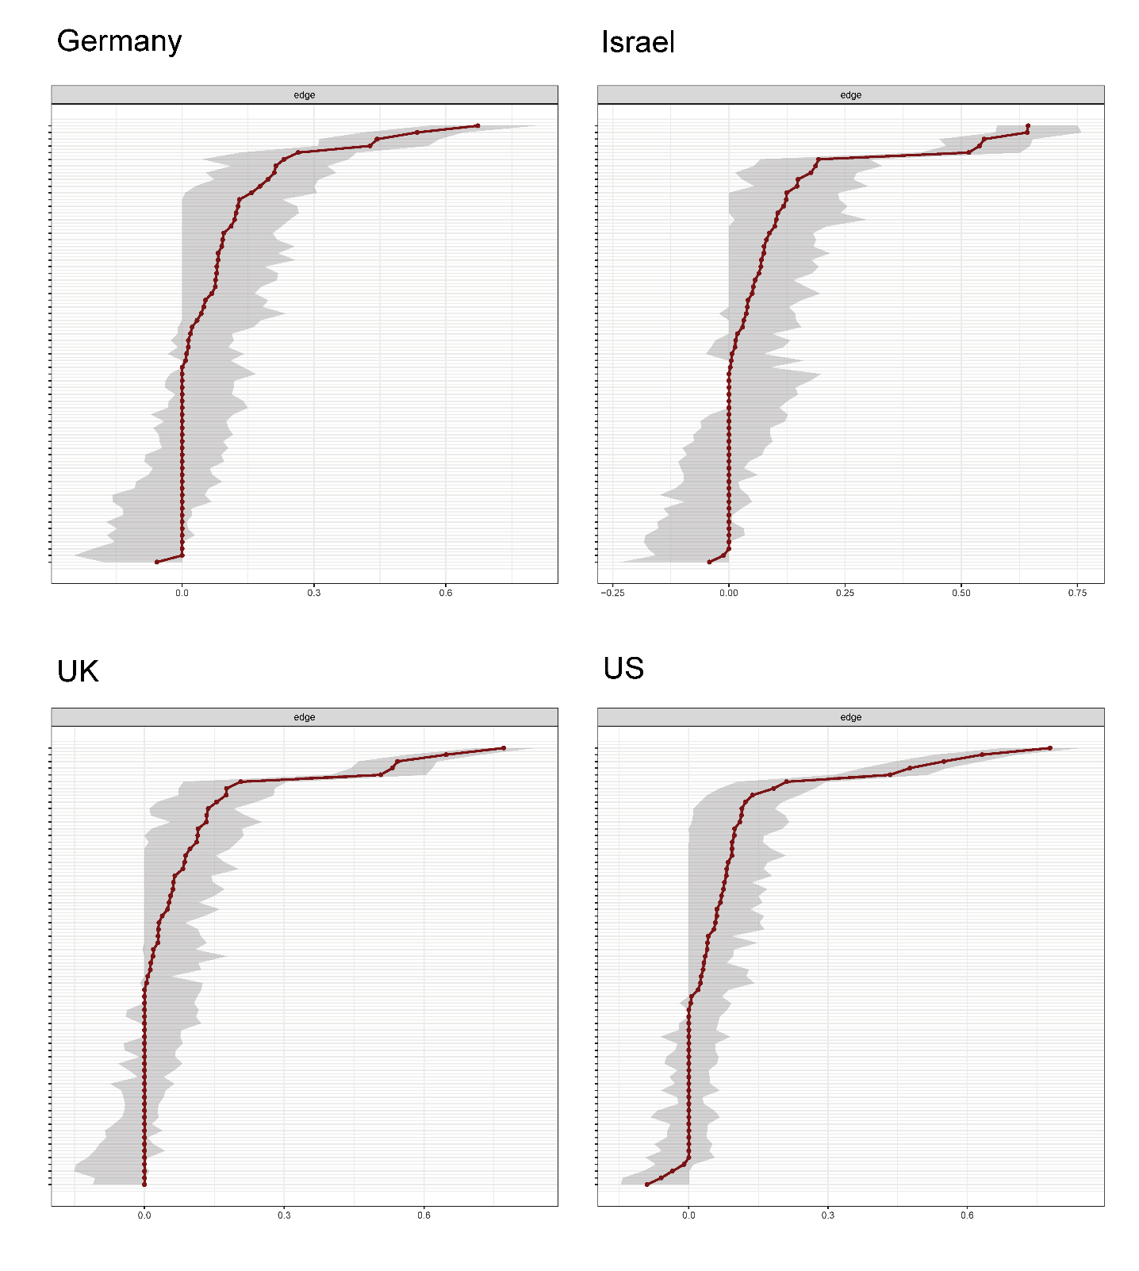
Figure S1. Stability analysis. Accuracy of edge weights. Bootstrapped confidence intervals (CIs) of the edge weights for the four individually estimated networks, derived from non-parametric bootstrap (nBoot=1000) analyses using R-package bootnet (Epskamp et al., 2017). The red line indicates the edge weight values and the grey area the 95% CIs.

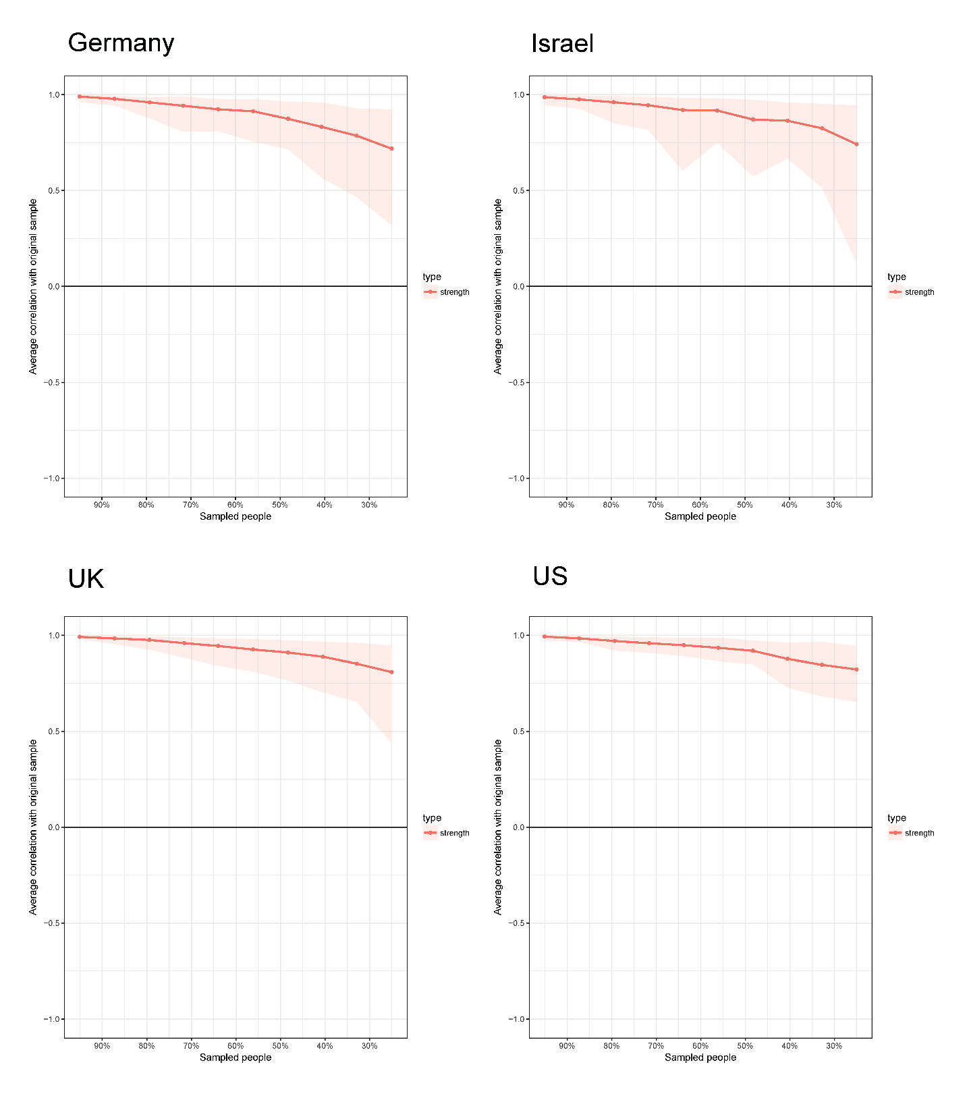
Figure S2. Stability Analysis. Centrality bootstrap. Correlation of the original strength centrality order with the order of strength centrality in subsets of the data. The correlation after dropping a substantial number of participants is high for the centrality metric strength, which means that this centrality estimate can be considered stable in all four samples.

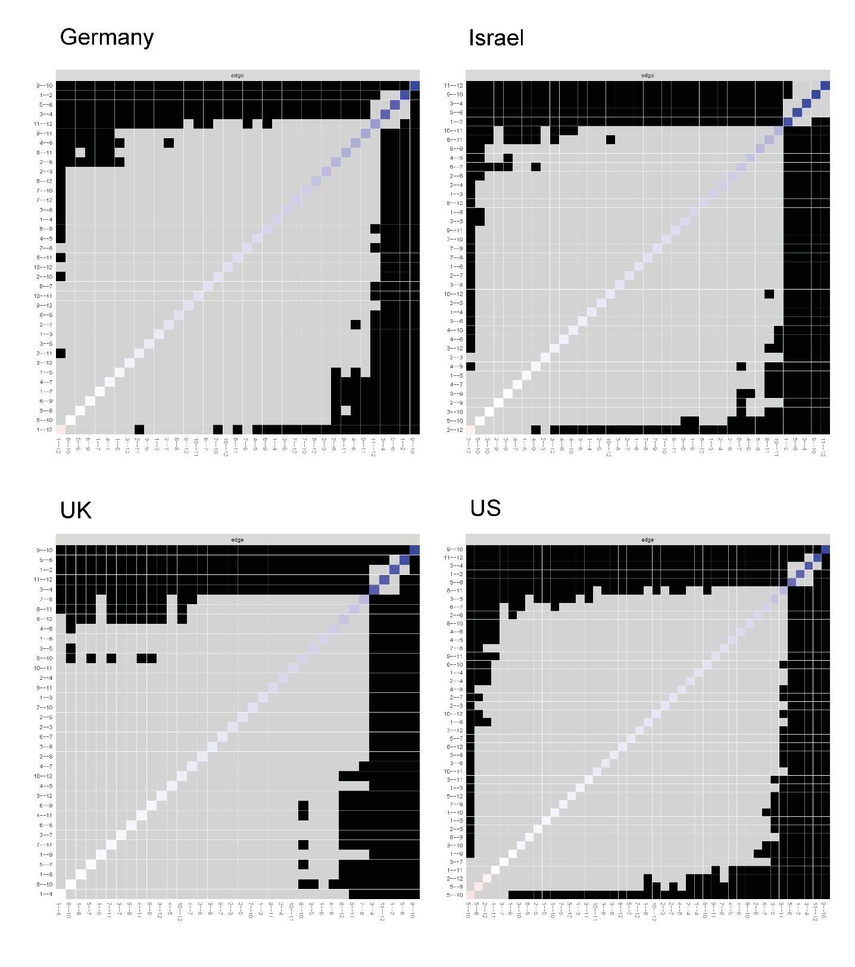
Figure S3. Edge weights difference test. Black boxes represent significant differences between edge weights. The test does presently not correct for multiple testing.

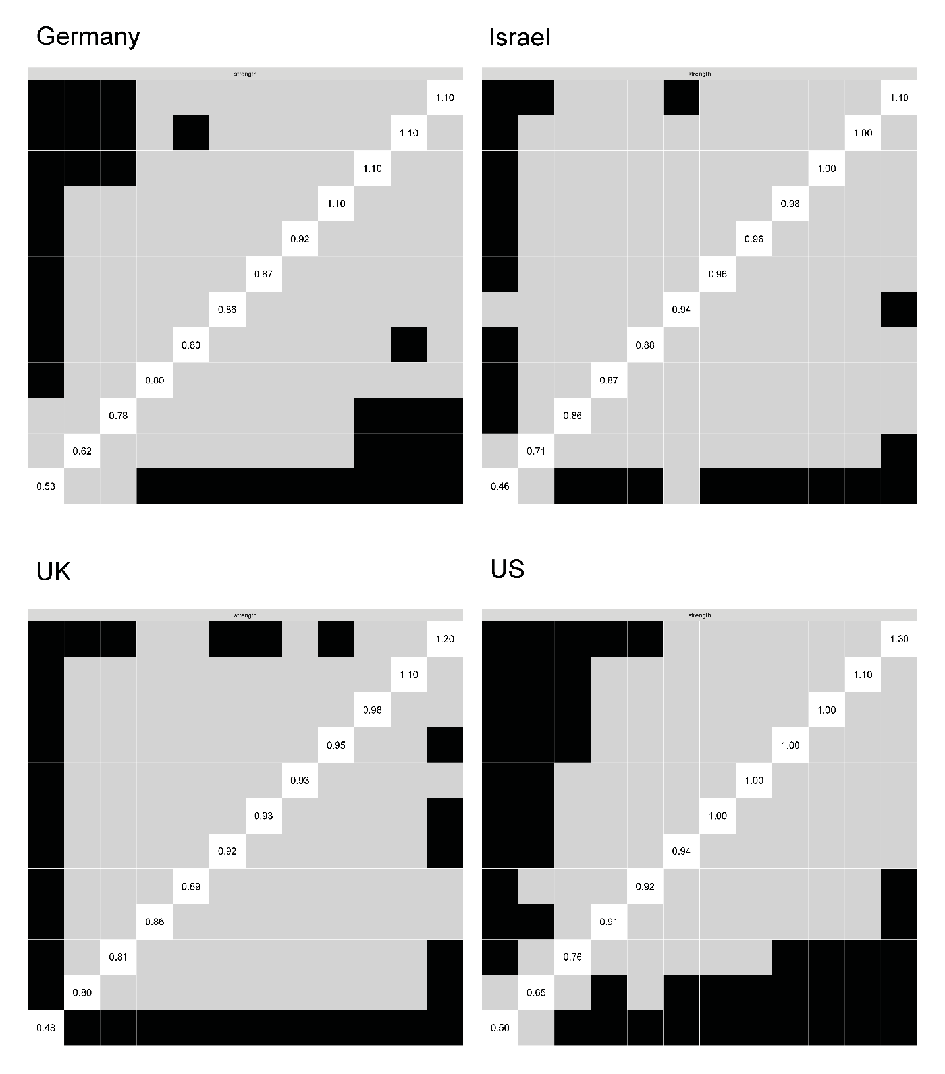
Figure S4. Centrality difference test. Standardized strength centrality values are shown in the diagonal, black boxes represent significant differences in centrality estimates. The test does presently not correct for multiple testing.

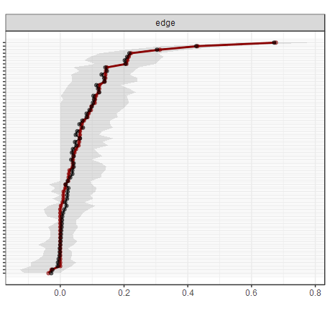 | 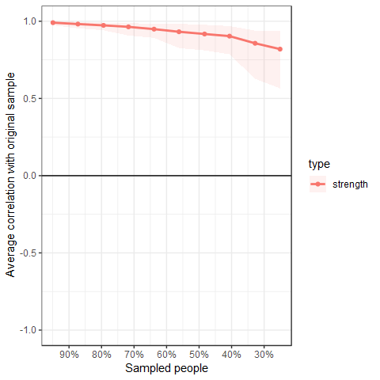
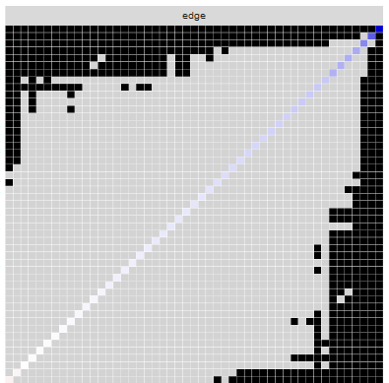 | 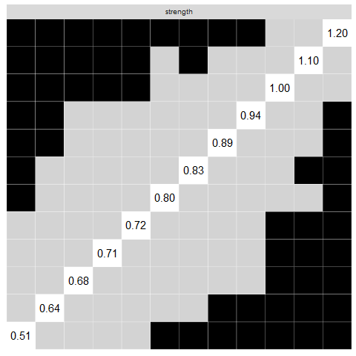
Figure S5. Stability analysis, edge weights- and centrality difference test for group with a diagnosis (n=512). See Figures S1-S4 for detailed description.

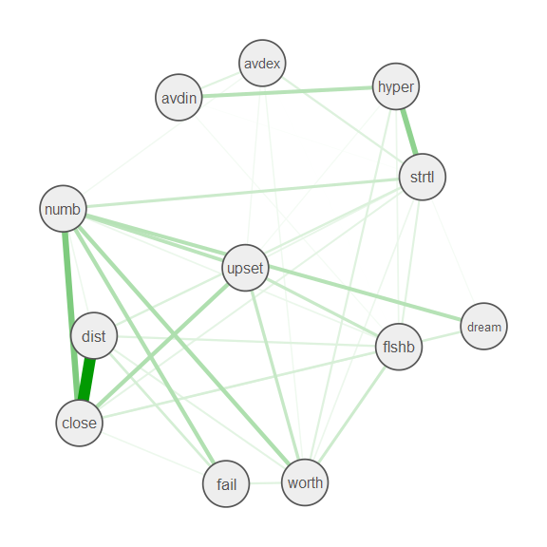
Figure S6. Cross-sample variability network. Each edge depicts the standard deviation of this edge across the four networks; Strong edges mean strong variation of the respective edge across the four samples. Small edges (<0.01) were omitted from printing

Literature Cited
1. Harrell FE. Package ‘Hmisc’: Harrell Miscellaneous. Available from: URL: http://biostat.mc.vanderbilt.edu/Hmisc,
2. Friedman J, Hastie T, Tibshirani R. Sparse inverse covariance estimation with the graphical lasso. Biostatistics 2008; 9(3):432–41.
3. van Borkulo CD, Borsboom D, Epskamp S, Blanken TF, Boschloo L, Schoevers RA et al. A new method for constructing networks from binary data. Sci Rep 2014; 4:5918.
4. Epskamp S, Fried EI. A tutorial on regularized partial correlation networks. Psychol Methods 2017. Available from: URL: https://arxiv.org/abs/1604.08462.
5. Costantini G, Richetin J, Preti E, Casini E, Epskamp S, Perugini M. Stability and variability of personality networks. A tutorial on recent developments in network psychometrics. Pers Indiv Differ 2017.
6. Danaher P, Wang P, Witten DM. The joint graphical lasso for inverse covariance estimation across multiple classes. J R Stat Soc Series B Stat Methodol 2014; 76(2):373–97.
7. Richetin J, Preti E, Costantini G, Panfilis C de. The centrality of affective instability and identity in Borderline Personality Disorder: Evidence from network analysis. PLoS ONE 2017; 12(10):e0186695.
8. Costantini G, Epskamp S. EstimateGroupNetwork: Perform the Joint Graphical Lasso and Selects Tuning Parameters; 2017. Available from: URL: https://CRAN.R-project.org/package=EstimateGroupNetwork.
9. Opsahl T, Agneessens F, Skvoretz J. Node centrality in weighted networks: Generalizing degree and shortest paths. Soc Networks 2010; 32(3):245–51.
10. Epskamp S, Borsboom D, Fried EI. Estimating psychological networks and their accuracy: A tutorial paper. Behav Res Methods 2017.
11. Haslbeck JMB, Fried EI. How predictable are symptoms in psychopathological networks? A reanalysis of 18 published datasets. Psychol Med 2017; 47(16):2767–76.
12. Haslbeck JMB. Package 'mgm': Estimating Mixed Graphical Models; 2015. Available from: URL: https://cran.r-project.org/web/packages/mgm/index.html.
13. Jones P. Package 'networktools': Tools for Identifying Important Nodes in Networks; 2018. Available from: URL: https://CRAN.R-project.org/package=networktools.
14. Fried EI, Eidhof MB, Palic S, Costantini G, Huisman-van Dijk HM, Bockting, CLH et al. Replicability and generalizability of Posttraumatic Stress Disorder (PTSD) networks: A cross-cultural multisite study of PTSD symptoms in four trauma patient samples. Clin Psychol Sci 2018.
15. Epskamp S. Package ‘bootnet’: Bootstrap Methods for Various Network Estimation Routines; 2015. Available from: URL: https://cran.r-project.org/web/packages/bootnet/index.html.
16. Rhemtulla M, Fried EI, Aggen SH, Tuerlinckx F, Kendler KS, Borsboom D. Network analysis of substance abuse and dependence symptoms. Drug Alcohol Depend 2016.
17. van Borkulo CD, Boschloo L, Kossakowski JJ, Tio P, Schoevers RA, Borsboom D et al. Network Comparison Test - Comparing network structures on three aspects: A permutation test; 2017. Available from: URL: https://github.com/cvborkulo/NetworkComparisonTest.

