Supplementary Appendix 1

Treatment resistant bipolar depression (TRBD) definition consensus - 1st round items

Part 1. TRBD and MTRBD initial pharmacological treatment definition criteria
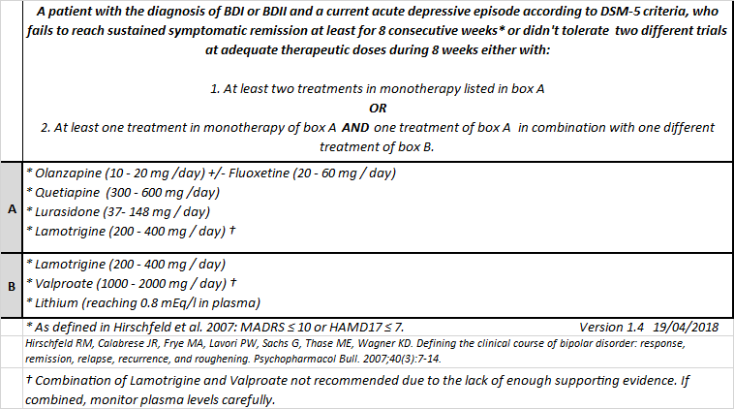1. Besides the lack of response and/or intolerance, the main definition should also include the possibility of patient’s refusal to the treatment.
2. The minimal duration of 8 consecutive weeks at therapeutic doses of each trial should remain as part of the main definition.
3. The requirement of at least 2 different trials as described in points 1 and/or 2 are sufficient to satisfy the criteria for TRBD definition and the initial pharmacological treatment in MTRBD.
4. Aripiprazole should be included as an option in Box A of the criteria.
5. Fluoxetine (in combination to olanzapine), should be included as a therapeutic option in box A.
6. Minimum Lithium plasma levels should be changed from 0.8 to 0.6 mEQ /L in box B.
7. Lower doses of Quetiapine (100 - 300 mg/d) should also be considered effective in box B.
8. The warning about the inefficacy of the Lamotrigine and Valproate combination should remain in the current criteria.

Part 2. MTRBD definition criteria
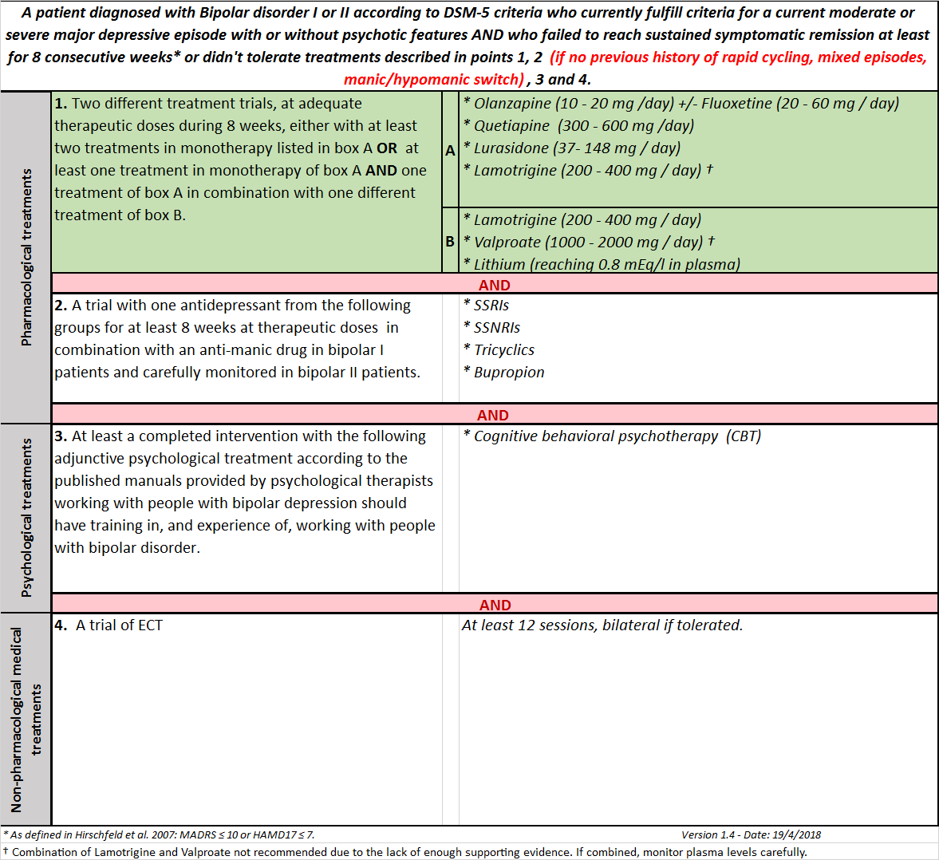
9. Besides the lack of response and/or intolerance, the main MTRBD definition should also include the possibility of patient’s refusal to the treatment.
10. Antidepressants in general should be included in the criteria for MTRBD only if no previous history of rapid cycling, mixed states or previous manic/hypomanic switches associated to antidepressants are present.
11. Antidepressants in general should be included in the criteria of MTRBD only in cases with bipolar type II diagnosis, BUT NOT bipolar type I.
12. Antidepressants in general should be included in the criteria of MTRBD for cases with bipolar type I and bipolar type II, BUT stressing that in bipolar type I an antimanic drug should also be prescribed simultaneously.
13. Antidepressants in general should be included in the criteria of MTRBD for cases with bipolar type I and bipolar type II, BUT stressing that an antimanic drug should also be prescribed simultaneously in BOTH types.
14. If included, the antidepressants that would be part of the criteria for MTRBD should be SSRIs and Bupropion, BUT NOT SSNRIs and Tricyclics.
15. If included, the antidepressants that would be part of the criteria for MTRBD should be SSRIs, SNRIs and Bupropion, BUT NOT Tricyclics.
16. If included, the antidepressants that would be part of the criteria for MTRBD should be SSRIs, SNRIs, Bupropion and Tricyclics.
17. Only CBT should be considered as an adjunctive psychological treatment in the criteria for MTRBD.
18. Besides CBT, other psychological treatments options should be included in Point 3. (If you think this either "Essential" or "Important", please specify in the Comment box below, which other other psychological treatment should be included and why).
19. No psychological treatment should be included in the criteria for MTRBD as there is not enough supporting evidence about them for the acute treatment of bipolar depressive episodes.
20. The minimum number of 12 sessions of ECT sessions should be increased as there are a significant percentage of patients showing response with more sessions.

Part 3. Challenging diagnostic and treatment issues
21. The criteria for TRBD and MTRBD should include a mandatory medical screening to rule out organic or pharmacological causes in every case in which the condition is considered. This should include a complete physical examination and laboratory tests (CBC, TSH, Vitamin B-12, Electrolytes including calcium, phosphate, and magnesium levels, cortioid levels, renal and liver function tests).
22. The criteria for TRBD and MTRBD should include a mandatory medical screening and laboratory tests to rule out HIV and Syphilis.
23. The criteria for TRBD and MTRBD should include a screening method to rule out sleep apnoea in every case in which the condition is considered.
24. The criteria for TRBD and MTRBD should include a throughout review of potential perpetuating/exacerbating factors of other already known organic comorbidities or treatments side effects.
25. Both TRBD and MTRBD definition criteria should only be applied to adults.
26. Both TRBD and MTRBD definition criteria should be applied either to bipolar I or II with some additional recommendations for each type.
27. The criteria for TRBD and MTRBD could also be applied to cases with mixed features mentioning special considerations regarding treatment in these situations (e.g. Avoid antidepressants).
28. The consensus manuscript should include a sentence about the importance of assessing general health conditions such as diet and physical exercise and providing interventions accordingly to address them, in addition to the treatments described for both TRBD and MTRBD.
29. The consensus manuscript should include a paragraph about most prevalent comorbid psychiatric conditions in bipolar disorder (i.e. Substance use disorders, Borderline personality disorders, Anxiety disorders) affecting treatment decisions and how these could be addressed.
30. The consensus manuscript should include a section about bipolar disorder in different life stages (i.e. elderly, peri-natal) affecting treatment decisions and how these could be addressed.
31. The consensus manuscript should stress the need of continuous monitoring of suicidality during the course of whole bipolar depressive episode treatment.
32. The consensus manuscript should emphasize the need of using antipsychotic drugs at dosages for the treatment of psychotics symptoms when they are present.
33. The consensus manuscript should include a box listing which pharmacological treatments were excluded from the criteria and the main evidence-based reason of the exclusion.

