Supplementary Table 1. Bivariate associations between the 116 serotonergic SNPs and antisocial outcomes
 | General delinquency  (13 years) | Conduct disorder symptoms  (15 years) | Antisocial personality disorder symptoms  (21 years) | Property- violent crime  (21 years) | Intimate partner violence  (21 years)
SNPs |  |  | t / ꭓ²
 | 5-HTR_{1A}
rs878567 | .57 | .01 | 3.20 | 1.82 | 3.20
rs6295 | .57 | .01 | 3.20 | 1.82 | 3.20
 | 5-HTR_{2A}
rs3125 | .33 | .52 | .36 | .92 | 1.22
rs7322347 | 2.44 | 1.36 | 1.11 | 1.77 | 2.61
rs7997012 | 2.02 | .56 | 1.83 | 4.70^{T} | .01
rs977003 | 3.49 | 1.49 | .61 | 1.42 | 2.58
rs6561333 | 3.58 | .87 | 1.33 | 3.54 | .25
rs1923885 | 2.71 | 2.86 | .64 | .77 | .78
rs1923886 | 2.06 | .53 | 1.46 | 3.27 | .46
rs7330636 | 2.71 | 2.86 | .67 | .27 | .78
rs1923887 | .06 | .00 | 2.47 | .67 | .23
rs1745837 | .39 | 2.65 | 2.45 | 4.90^{T} | 2.68
rs9567739 | 1.87 | 1.06 | 2.89 | 1.70 | 3.63
rs655888 | .39 | 2.48 | 1.74 | 3.60 | 2.87
rs7984966 | 4.87 | 2.71 | .28 | 2.80 | 2.38
rs1885884 | 2.07 | 3.12 | .54 | 2.01 | 1.22
rs9534496 | 1.07 | 2.20 | 2.05 | .07 | 11.58**
rs9526240 | 1.07 | 1.91 | 1.84 | .09 | 13.55***
rs2224721 | 2.15 | 1.90 | 1.08 | .87 | 1.73
rs9316233 | .17 | 3.46 | 1.30 | .15 | .34
rs6561335 | 3.37 | 1.05 | 3.21 | 1.11 | 4.96^{T}
rs1928042 | 2.08 | .33 | .80 | .34 | 1.70
rs2770293 | 2.08 | .53 | 3.49 | .68 | 6.30*
rs9316235 | 4.34 | .58 | 2.67 | .97 | 9.86**
rs582385 | 2.33 | .58 | .87 | 2.33 | 1.17
rs6561336 | .91 | .525 | 3.50 | 2.99 | 2.98
rs972979 | .65 | .08 | 1.20 | 2.89 | 4.20
rs2770304 | 1.98 | .60 | .07 | 3.25 | 6.79*
rs985934 | .65 | .06 | 1.37 | 2.84 | 4.73^{T}
rs927544 | 1.02 | .29 | .96 | .42 | 4.19
rs4941573 | .91 | 3.01 | 2.90 | 3.52 | 1.91
rs1328684 | 1.72 | 2.54 | 1.14 | .04 | .89
rs2070040 | 3.56 | .39 | 1.78 | .79 | 6.78*
rs9534511 | 3.90 | 1.08 | 1.52 | 2.63 | 8.94*
rs4142900 | 8.45* | 2.09 | 5.39^{T} | .06 | 5.76^{T}
rs9534512 | 5.95^{T} | 1.55 | 3.72 | .03 | 8.30*
5-HTR_{2C}
rs508865 | 1.04 | .58 | .11 | 1.01 | 2.29
 | General delinquency  (13 years) | Conduct disorder symptoms  (15 years) | Antisocial personality disorder symptoms  (21 years) | Property-violent crime  (21 years) | Intimate partner violence  (21 years)
SNPs | t / ꭓ²
rs3795182 | .74 | .13 | .58 | .02 | 0.6
rs498207 | 1.24 | .21 | .01 | .72 | 3.01
rs2497551 | .92 | .13 | .30 | .48 | 5.71*
rs2497530 | .80 | .04 | .84 | .33 | 5.27*
5-HTR_{5A}
rs1440454 | 1.42 | 1.85 | 1.58 | .46 | 3.50
rs2581842 | 1.42 | .97 | 1.23 | .40 | 3.24
rs2873379 | .28 | 3.64 | 1.28 | 10.67** | 3.07
rs1017488 | .13 | 3.95 | 1.13 | 8.37* | 2.95
rs1881691 | 1.80 | 3.29 | .11 | .66 | 1.43
rs6320 | .66 | .84 | 2.84 | 7.85* | .78
rs2241859 | 1.84 | 2.12 | .33 | .50 | 1.79
rs6597455 | .27 | 3.59 | .40 | 1.15 | .91
rs731107 | .19 | 2.77 | .69 | 1.20 | 1.51
rs1657268 | .62 | .46 | .10 | .29 | 2.02
rs1440449 | .62 | .41 | .12 | .66 | 2.58
5-HTR₆
rs6693503 | 6.37* | 1.19 | .24 | .09 | 8.27*
rs9659997 | 6.37* | .77 | .17 | .14 | 9.28**
5-HTR₇
rs1418213 | .14 | .77 | .59 | .51 | 2.36
rs11599921 | - | 3.23^{T} | 4.25* | 2.97^{T} | .81
rs7904560 | 1.36 | 4.35 | 4.89^{T} | 1.17 | .66
rs12261011 | 3.58 | .07 | .69 | 6.77* | .34
rs12259401 | 7.36* | 6.15* | 2.84 | 3.70 | 1.54
rs10785973 | .08 | 3.15 | .53 | 3.05 | .06
rs4520504 | 7.36* | 6.44* | 2.59 | 3.12 | 1.36
rs12259062 | 3.09 | 3.19 | 3.56 | 10.24** | 1.32
rs1891311 | .08 | 1.43 | 2.15 | 1.29 | .54
MAOA
rs3788862 | .56 | .05 | .61 | 2.56 | .46
rs5905702 | .69 | .01 | .44 | 2.73 | 1.04
rs5906729 | .69 | .00 | .30 | 2.92 | .95
rs3788863 | .56 | .01 | .44 | 2.73 | .41
rs5906893 | .48 | .08 | .30 | 2.02 | .36
rs1465108 | .61 | .03 | .19 | 2.18 | .87
rs5906938 | .48 | .08 | .30 | 2.02 | .36
rs5906957 | .33 | .78 | .79 | 2.93^{T} | 1.77
rs5906974 | .61 | .03 | .19 | 2.18 | .87
rs3027397 | .21 | .10 | .08 | 2.56 | .47
rs3027400 | .72 | .49 | .06 | 2.02 | 1.73
rs3027405 | 1.16 | .04 | .30 | .49 | .01
rs2072744 | .72 | .35 | .00 | 2.91 | 1.65
rs979606 | 1.50 | .49 | .08 | 2.18 | 1.62
 | General delinquency  (13 years) | Conduct disorder symptoms  (15 years) | Antisocial personality disorder symptoms  (21 years) | Property-violent crime  (21 years) | Intimate partner violence  (21 years)
SNPs | t / ꭓ²
rs2239448 | 1.73^{T} | .33 | .00 | 1.04 | 2.08
MAOB
rs5952799 | .01 | 1.02 | 2.42 | .03 | .04
SLC6A4
rs3813034 | .89 | .44 | 3.81 | 1.02 | 3.17
rs1042173 | .89 | .49 | 4.24 | .53 | 3.14
rs3794808 | 1.26 | .78 | 1.84 | .44 | 6.46*
rs4583306 | 1.26 | 1.68 | 1.94 | .09 | 2.63
rs2020942 | 1.67 | 2.14 | .94 | .64 | .15
rs6354 | .28 | .39 | 2.57 | 1.74 | 1.00
rs2020936 | .28 | .39 | 3.61 | 1.98 | 1.09
TPH-1
rs10741734 | 2.59 | .98 | 6.36* | 1.97 | .11
rs1800532 | 2.59 | 1.50 | 6.60* | 1.97 | .11
rs10488683 | .06 | .57 | .72 | 4.46 | .14
rs10832876 | .43 | 2.75 | .12 | 2.54 | .05
rs685657 | 2.59 | 2.16 | 5.96^{T} | 2.96 | .26
rs10488682 | .43 | 2.75 | .12 | 2.54 | .05
rs623580 | 5.99* | 5.13^{T} | 7.74* | .84 | .12
rs652458 | 2.59 | 2.16 | 5.96^{T} | 2.96 | .26
rs546383 | 2.78 | 1.55 | 5.46^{T} | 3.07 | .40
TPH-2
rs4448731 | 1.85 | .28 | .49 | 2.83 | 1.95
rs10748185 | 1.98 | .11 | .44 | 2.94 | 2.31
rs4565946 | 3.10 | .31 | 2.10 | 2.36 | 3.62
rs11179000 | 7.19* | 1.04 | 1.48 | 4.54 | .14
rs17110489 | 3.27 | 3.84 | 1.10 | 1.32 | 1.54
rs7955501 | 1.69 | .77 | 4.45 | .39 | 1.54
rs17110532 | 4.84^{T} | 4.34 | 2.09 | 3.81 | 2.14
rs6582073 | .71 | 1.06 | 7.28* | 1.26 | 2.06
rs4760750 | 71 | 1.23 | 6.31* | .74 | 2.71
rs2046582 | 4.93^{T} | 6.31* | .86 | 3.29 | .70
rs10506645 | 4.94^{T} | 4.34 | 1.56 | 2.29 | .98
rs10879350 | 9.21** | 3.14 | 3.13 | 2.48 | 1.91
rs4760820 | .80 | .01 | .08 | .48 | .84
rs1386498 | .64 | .21 | 2.36 | .81 | 1.34
rs1487278 | 4.97^{T} | 9.26** | 1.04 | 2.25 | .95
rs11179050 | 5.75^{T} | .68 | 2.10 | .43 | 4.33
rs1487275 | 1.62 | 3.94 | .74 | 2.10 | 1.78
rs2200579 | 6.82* | .30 | 2.19 | .40 | 3.22
rs11179052 | 4.46 | .17 | .98 | .19 | 3.55
rs11179056 | .13 | .63 | 4.41 | 7.88* | 2.51
rs4469933 | 4.46 | .16 | 1.13 | .05 | 3.89
*** p ≤ .001; ** p ≤ .01; * p ≤ .05; ^{T} < .10.

Supplementary Figure 1. Linkage-disequilibrium plots and haplotypes derived in Haploview for each serotonergic candidate gene.
(a) Linkage-disequilibrium plots (R²); (b) Haplotype blocks and superalleles, “▼” identifies TagSNPs.

Panel 1. 5-HTR_{2A}
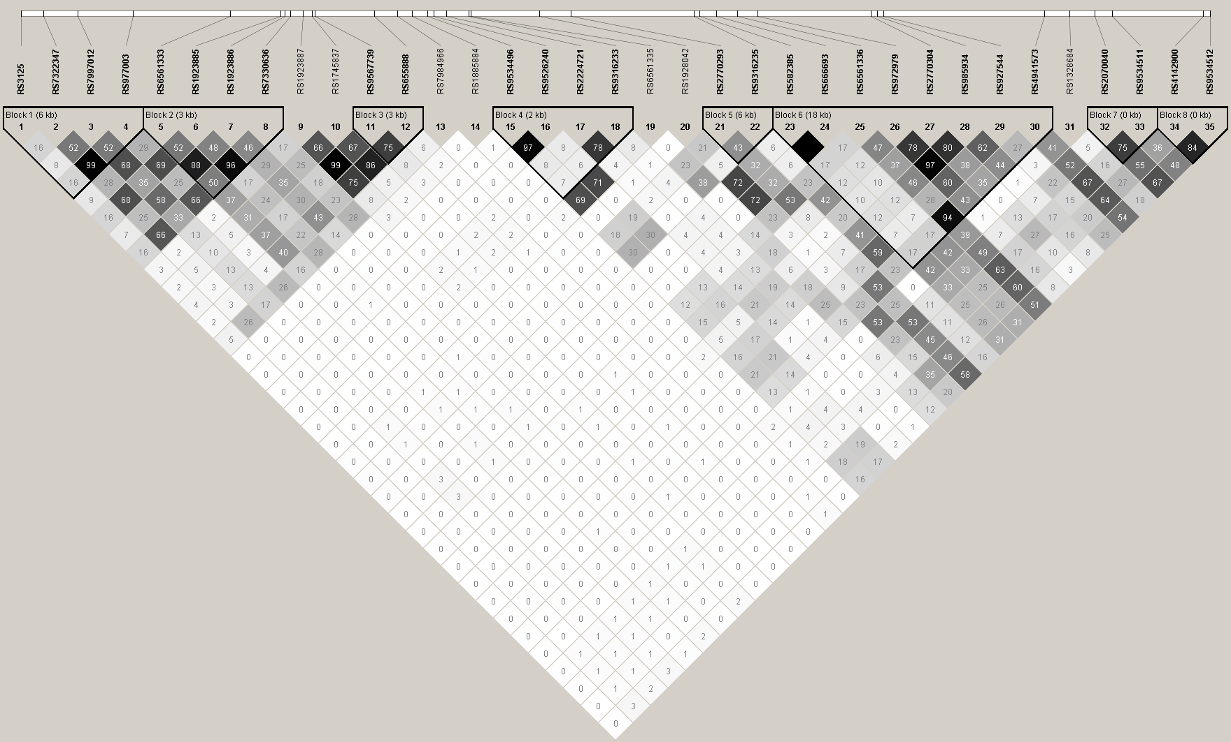
(a) Linkage-disequilibrium plot (R²)

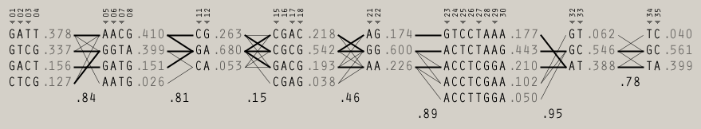
(b) Haplotypes

Panel 2. 5-HTR_{2C}
(a) Linkage-disequilibrium plot (R²) (b) Haplotype
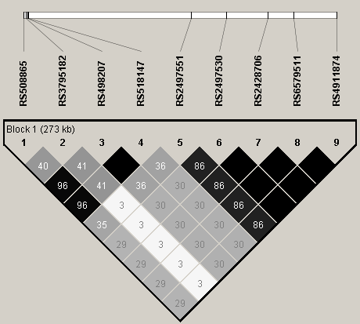
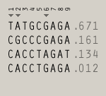

Panel 3. 5-HTR_{5A}
(a) Linkage-disequilibrium plot (R²) (b) Haplotypes
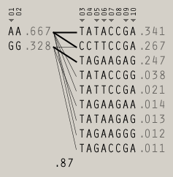
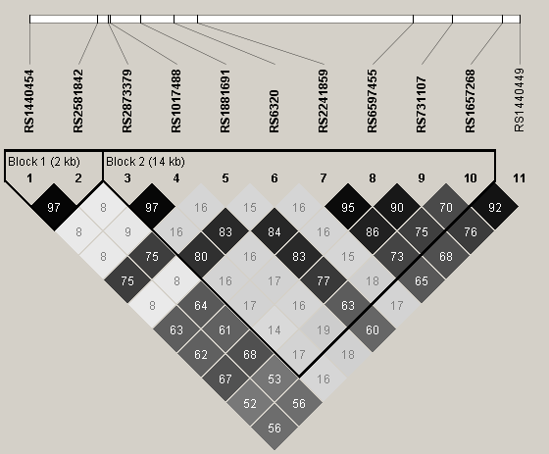

Panel 4. 5-HTR₆
(a) Linkage-disequilibrium plot (R²) (b) Haplotype
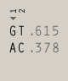
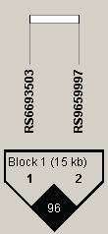

Panel 5. 5-HTR₇
(a) Linkage-disequilibrium plot (R²) (b) Haplotypes
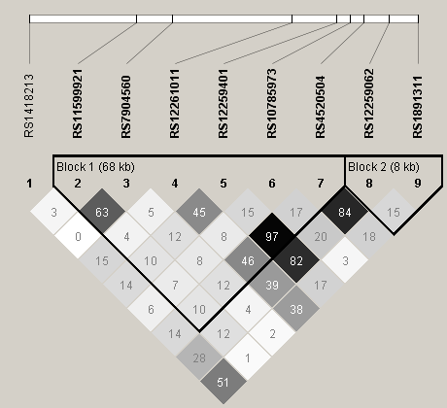
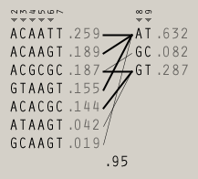

Panel 6. MAOA
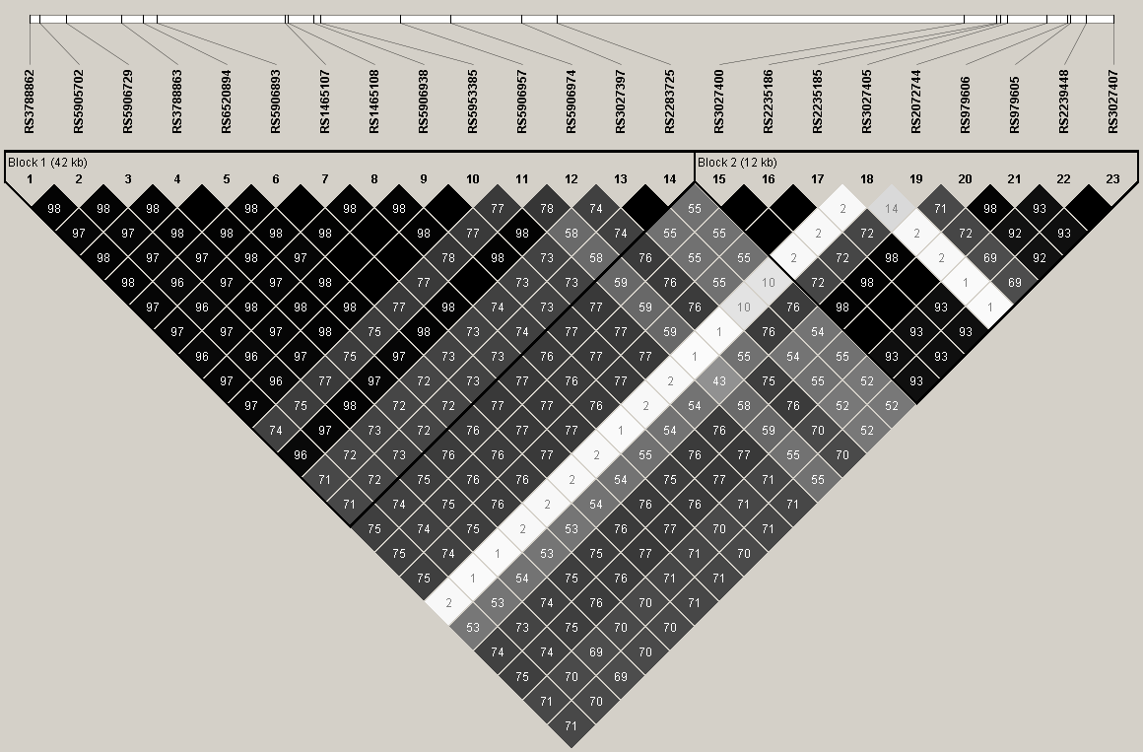
(a) Linkage-disequilibrium plot (R²)

(b) Haplotypes
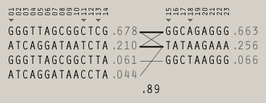

Panel 7. SLC6A4
(a) Linkage-disequilibrium plot (R²) (b) Haplotypes
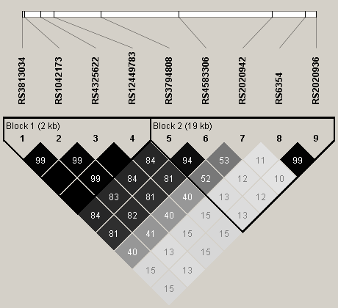
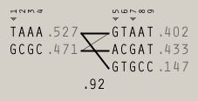

Panel 8. TPH-1
(a) Linkage-disequilibrium plot (R²) (b) Haplotype
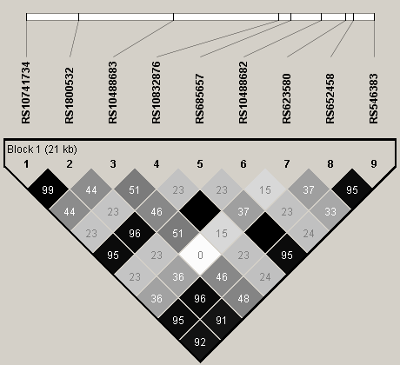
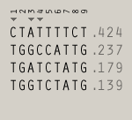

Panel 9. TPH-2
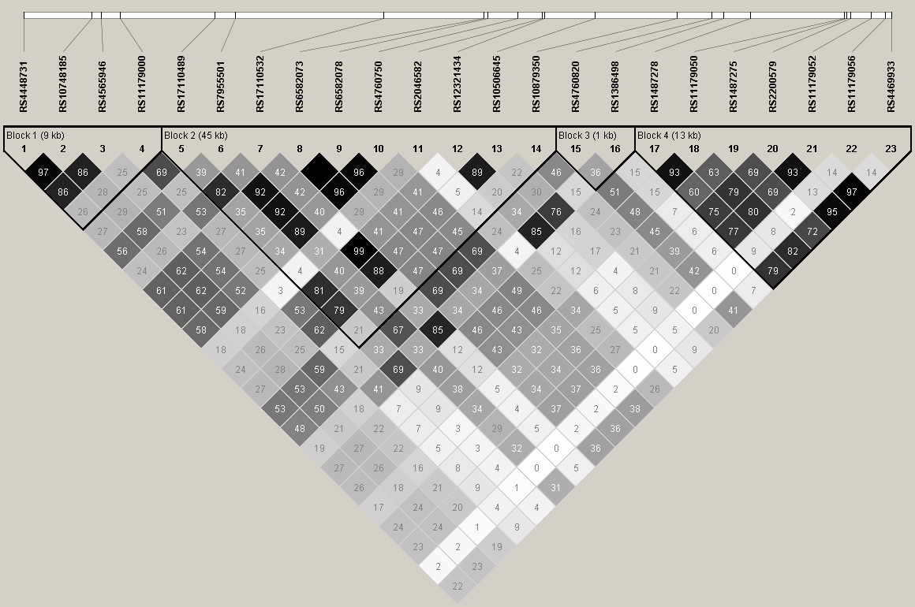
(a) Linkage-disequilibrium plot (R²)

(b) Haplotypes
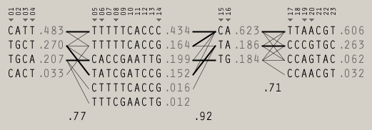

Supplementary Figure 2. Distribution of the total number of haplotype-based superalleles included in the multilocus genetic profile risk score for each antisocial outcome.
(a) General delinquency, (b) Conduction disorder symptoms, (c) Antisocial personality disorder symptoms, (d) Property-violent crimes, and (e) Intimate partner violence.

(a) (b)

(c) (d)

(e)

Supplementary Figure 3. Post-hoc sensitivity analyses examining the proportion of explained variance for each antisocial behavior according to the use of more (or less) liberal significance thresholds for the inclusion
of the haplotype-based superalleles in the multilocus genetic profile risk scores.
(a) General delinquency, (b) Conduct disorder symptoms, (c) Antisocial personality disorder symptoms,
(d) Property-violent crimes, and (e) Intimate partner violence.

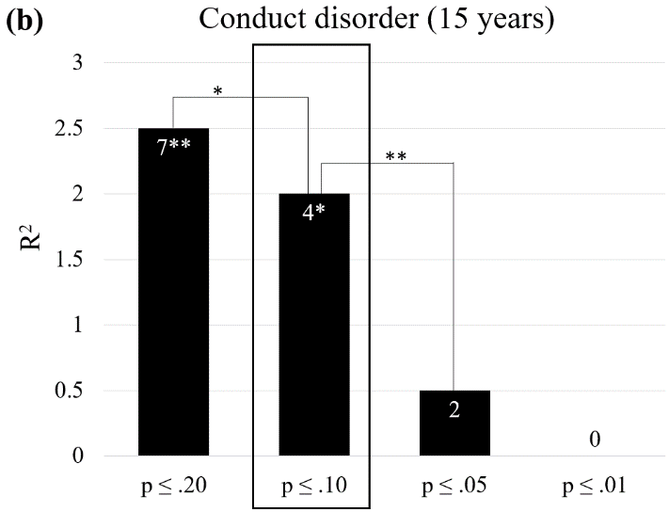
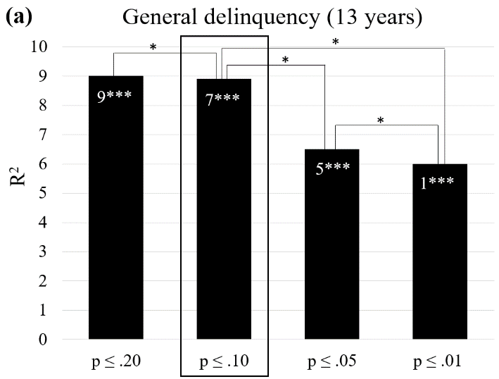

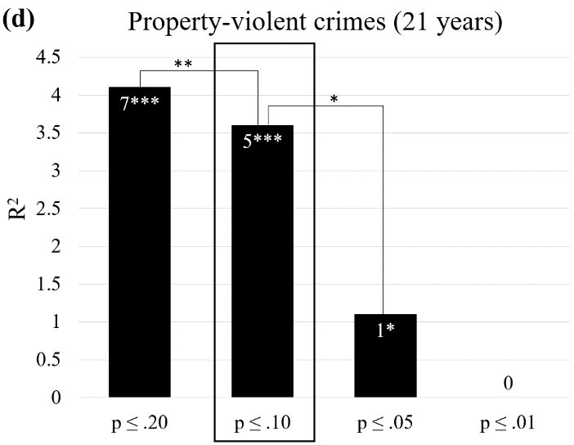
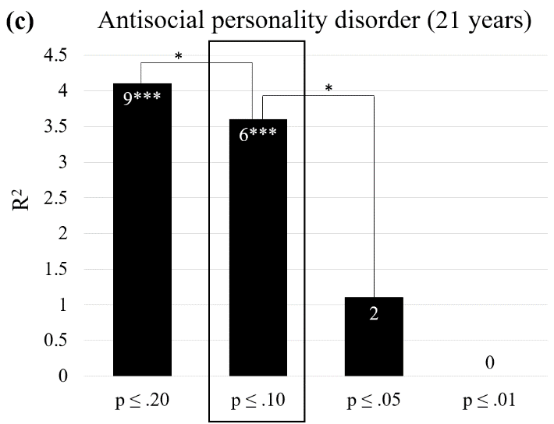

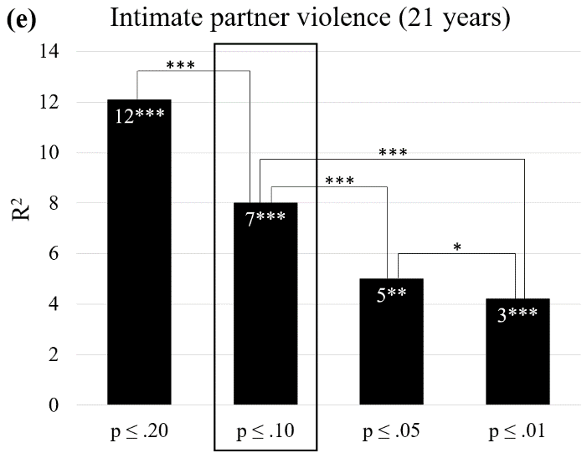

Notes: The numbers inserted in the bars indicate the number of haplotype-based superalleles included in the multilocus genetic profile risk scores. The asterisks inserted in the bars specify whether the multilocus genetic profile risk score is significantly associated with each outcome. The framed bars represent the thresholds for significance selected in the main analyses. R² ⁼ portion of the variance explained by the multilocus genetic profile risk score. *** = p˂.001; ** = p˂.01; * = p˂.05.
Supplementary Figure 4. Distribution of the total number of haplotype-based superalleles included in the multilocus genetic profile protective score for each antisocial outcome.
(a) General delinquency, (b) Property-violent crimes, and (c) Intimate partner violence.

(a) (b)

(c)

