Supplementary Material A systematic review and meta-analysis on the prevalence of personality disorders in the general adult population in Western countries

Table 1s Study IDs, Study Name and References of Included Studies in Meta-Analysis
Table 2s Prisma Checklist
Table 3s Search Strategy
Fig. 1s Risk of Bias Assessment of Studies included in Meta-Analysis using an adapted Version of the Newcastle-Ottawa Risk of Bias Scale

Fig. 2s Prevalence of Cluster A Personality Disorders
Fig. 3s Prevalence of Cluster B Personality Disorders
Fig. 4s Prevalence of Cluster C Personality Disorders

Study ID | Study | References
1 | NESARC I, II | Trull TJ, Jahng S, Tomko RL, Wood PK, Sher KJ. Revised NESARC personality disorder diagnoses: gender, prevalence, and comorbidity with substance dependence disorders. J Pers Disord 2010; 24 (4): 412–26.
 |  | Grant BF, Hasin DS, Stinson FS, Dawson DA, Chou SP, Ruan WJ et al. Prevalence, correlates, and disability of personality disorders in the United States: results from the national epidemiologic survey on alcohol and related conditions. J Clin Psychiatry 2004; 65 (7): 948–58.
 |  | Grant JE, Mooney ME, Kushner MG. Prevalence, correlates, and comorbidity of DSM-IV obsessive-compulsive personality disorder: results from the National Epidemiologic Survey on Alcohol and Related Conditions. J Psychiatr Res 2012; 46 (4): 469–75.
 |  | Tomko RL, Trull TJ, Wood PK, Sher KJ. Characteristics of borderline personality disorder in a community sample: comorbidity, treatment utilization, and general functioning. J Pers Disord 2014; 28 (5): 734–50.
 |  | Cox BJ, Pagura J, Stein MB, Sareen J. The relationship between generalized social phobia and avoidant personality disorder in a national mental health survey. Depress Anxiety 2009; 26 (4): 354–62.
 |  | Compton WM, Conway KP, Stinson FS, Colliver JD, Grant BF. Prevalence, correlates, and comorbidity of DSM-IV antisocial personality syndromes and alcohol and specific drug use disorders in the United States: results from the national epidemiologic survey on alcohol and related conditions. J Clin Psychiatry 2005; 66 (6): 677–85.
 |  | Grant BF, Stinson FS, Dawson DA, Chou SP, Ruan WJ, Pickering RP. Co-occurrence of 12-month alcohol and drug use disorders and personality disorders in the United States: results from the National Epidemiologic Survey on Alcohol and Related Conditions. Arch Gen Psychiatry 2004; 61 (4): 361–8.
 |  | Stinson FS, Dawson DA, Goldstein RB, Chou SP, Huang B, Smith SM et al. Prevalence, correlates, disability, and comorbidity of DSM-IV narcissistic personality disorder: results from the wave 2 national epidemiologic survey on alcohol and related conditions. J Clin Psychiatry 2008; 69 (7): 1033–45.
 |  | Pulay AJ, Stinson FS, Dawson DA, Goldstein RB, Chou SP, Huang B et al. Prevalence, correlates, disability, and comorbidity of DSM-IV schizotypal personality disorder: results from the wave 2 national epidemiologic survey on alcohol and related conditions. Prim Care Companion J Clin Psychiatry 2009; 11 (2): 53–67.
 |  | Zanarini MC, Horwood J, Wolke D, Waylen A, Fitzmaurice G, Grant BF. Prevalence of DSM-IV borderline personality disorder in two community samples: 6,330 English 11-year-olds and 34,653 American adults. J Pers Disord 2011; 25 (5): 607–19.
2 | NESARC III | Goldstein RB, Chou SP, Saha TD, Smith SM, Jung J, Zhang H et al. The Epidemiology of Antisocial Behavioral Syndromes in Adulthood: Results From the National Epidemiologic Survey on Alcohol and Related Conditions-III. J Clin Psychiatry 2017; 78 (1): 90–8.
3 | NCS-R | Lenzenweger MF, Lane MC, Loranger AW, Kessler RC. DSM-IV personality disorders in the National Comorbidity Survey Replication. Biol Psychiatry 2007; 62 (6): 553–64.
4 | Samuels et al., 2002 | Samuels J, Eaton WW, Bienvenu OJ, Brown CH, Costa PT, Nestadt G. Prevalence and correlates of personality disorders in a community sample. Br J Psychiatry 2002; 180: 536–42.
5 | Ekselius et al., 2001 | Ekselius L, Tillfors M, Furmark T, Fredrikson M. Personality disorders in the general population: DSM-IV and ICD-10 defined prevalence as related to sociodemographic profile. Pers Individ Dif 2001; 30 (2): 311–20.
6 | LEGEND & SHIP | Arens EA, Stopsack M, Spitzer C, Appel K, Dudeck M, Völzke H et al. Borderline personality disorder in four different age groups: a cross-sectional study of community residents in Germany. J Pers Disord 2013; 27 (2): 196–207.
7 | ANSMHWB | Jackson HJ, Burgess PM. Personality disorders in the community: a report from the Australian National Survey of Mental Health and Wellbeing. Soc Psychiatry Psychiatr Epidemiol 2000; 35 (12): 531–8.
 |  | Lewin TJ, Slade T, Andrews G, Carr VJ, Hornabrook CW. Assessing personality disorders in a national mental health survey. Soc Psychiatry Psychiatr Epidemiol 2005; 40 (2): 87–98.
 |  | Jackson HJ, Burgess PM. Personality disorders in the community: results from the Australian National Survey of Mental Health and Well-being Part III. Relationships between specific type of personality disorder, Axis 1 mental disorders and physical conditions with disability and health consultations. Soc Psychiatry Psychiatr Epidemiol 2004; 39 (10): 765–76.
 |  | Andrews G, Henderson S, Hall W. Prevalence, comorbidity, disability and service utilisation. Overview of the Australian National Mental Health Survey. Br J Psychiatry 2001; 178: 145–53.
 |  | Jackson HJ, Burgess PM. Personality disorders in the community: results from the Australian National Survey of Mental Health and Wellbeing Part II. Relationships between personality disorder, Axis I mental disorders and physical conditions with disability and health consultations. Soc Psychiatry Psychiatr Epidemiol 2002; 37 (6): 251–60.
8 | BNSPM | Coid J, Yang M, Tyrer P, Roberts A, Ullrich S. Prevalence and correlates of personality disorder in Great Britain. Br J Psychiatry 2006; 188: 423–31.
 |  | Torres AR, Moran P, Bebbington P, Brugha T, Bhugra D, Coid JW et al. Obsessive-compulsive disorder and personality disorder: evidence from the British National Survey of Psychiatric Morbidity 2000. Soc Psychiatry Psychiatr Epidemiol 2006; 41 (11): 862–7.
 |  | Singleton N, Bumpstead R, O'Brien M, Lee A, Meltzer H. Psychiatric morbidity among adults living in private households, 2000. Int Rev Psychiatry 2003; 15 (1-2): 65–73.
 |  | Yang M, Coid J, Tyrer P. Personality pathology recorded by severity: national survey. Br J Psychiatry 2010; 197 (3): 193–9.
9 | Dereboy et al., 2014 | Dereboy C, Güzel HS, Dereboy F, Okyay P, Eskin M. Personality disorders in a community sample in Turkey: prevalence, associated risk factors, temperament and character dimensions. Int J Soc Psychiatry 2014; 60 (2): 139–47.
10 | NEMESIS-2 | Have M ten, Verheul R, Kaasenbrood A, van Dorsselaer S, Tuithof M, Kleinjan M et al. Prevalence rates of borderline personality disorder symptoms: a study based on the Netherlands Mental Health Survey and Incidence Study-2. BMC Psychiatry 2016; 16: 249.
Table 1s Study IDs, Study Name and References of Included Studies in Meta-Analysis

Section/topic | # | Checklist item | Reported on page #
TITLE
Title | 1 | Identify the report as a systematic review, meta-analysis, or both. | 1
ABSTRACT
Structured summary | 2 | Provide a structured summary including, as applicable: background; objectives; data sources; study eligibility criteria, participants, and interventions; study appraisal and synthesis methods; results; limitations; conclusions and implications of key findings; systematic review registration number. | 2
INTRODUCTION
Rationale | 3 | Describe the rationale for the review in the context of what is already known. | 3
Objectives | 4 | Provide an explicit statement of questions being addressed with reference to participants, interventions, comparisons, outcomes, and study design (PICOS). | 3
METHODS
Protocol and registration | 5 | Indicate if a review protocol exists, if and where it can be accessed (e.g., Web address), and, if available, provide registration information including registration number. | 4
Eligibility criteria | 6 | Specify study characteristics (e.g., PICOS, length of follow-up) and report characteristics (e.g., years considered, language, publication status) used as criteria for eligibility, giving rationale. | 4
Information sources | 7 | Describe all information sources (e.g., databases with dates of coverage, contact with study authors to identify additional studies) in the search and date last searched. | 4
Search | 8 | Present full electronic search strategy for at least one database, including any limits used, such that it could be repeated. | Table 3s
Study selection | 9 | State the process for selecting studies (i.e., screening, eligibility, included in systematic review, and, if applicable, included in the meta-analysis). | 4
Data collection process | 10 | Describe method of data extraction from reports (e.g., piloted forms, independently, in duplicate) and any processes for obtaining and confirming data from investigators. | 4,5
Data items | 11 | List and define all variables for which data were sought (e.g., PICOS, funding sources) and any assumptions and simplifications made. | 5
Risk of bias in individual studies | 12 | Describe methods used for assessing risk of bias of individual studies (including specification of whether this was done at the study or outcome level), and how this information is to be used in any data synthesis. | 5
Summary measures | 13 | State the principal summary measures (e.g., risk ratio, difference in means). | 5
Synthesis of results | 14 | Describe the methods of handling data and combining results of studies, if done, including measures of consistency (e.g., I²) for each meta-analysis. | 5

Section/topic | # | Checklist item | Reported on page #
Risk of bias across studies | 15 | Specify any assessment of risk of bias that may affect the cumulative evidence (e.g., publication bias, selective reporting within studies). | 5
Additional analyses | 16 | Describe methods of additional analyses (e.g., sensitivity or subgroup analyses, meta-regression), if done, indicating which were pre-specified. | 5
RESULTS
Study selection | 17 | Give numbers of studies screened, assessed for eligibility, and included in the review, with reasons for exclusions at each stage, ideally with a flow diagram. | 5,6
Study characteristics | 18 | For each study, present characteristics for which data were extracted (e.g., study size, PICOS, follow-up period) and provide the citations. | 6, Table 1, 1s
Risk of bias within studies | 19 | Present data on risk of bias of each study and, if available, any outcome level assessment (see item 12). | 6-7
Results of individual studies | 20 | For all outcomes considered (benefits or harms), present, for each study: (a) simple summary data for each intervention group (b) effect estimates and confidence intervals, ideally with a forest plot. | Fig. 2s, 3s, 4s
Synthesis of results | 21 | Present results of each meta-analysis done, including confidence intervals and measures of consistency. | 7,8, Table 2
Risk of bias across studies | 22 | Present results of any assessment of risk of bias across studies (see Item 15). | Fig. 1s
Additional analysis | 23 | Give results of additional analyses, if done (e.g., sensitivity or subgroup analyses, meta-regression [see Item 16]). | 8
DISCUSSION
Summary of evidence | 24 | Summarize the main findings including the strength of evidence for each main outcome; consider their relevance to key groups (e.g., healthcare providers, users, and policy makers). | 9
Limitations | 25 | Discuss limitations at study and outcome level (e.g., risk of bias), and at review-level (e.g., incomplete retrieval of identified research, reporting bias). | 10
Conclusions | 26 | Provide a general interpretation of the results in the context of other evidence, and implications for future research. | 11,12
FUNDING
Funding | 27 | Describe sources of funding for the systematic review and other support (e.g., supply of data); role of funders for the systematic review. | 12

Table 2s Prisma Checklist

Example of a search strategy for PsycInfo
1 | personality disorder$ OR axis ii disorder$.ti (5521)
2 | personality disorder$ OR axis ii disorder$.ab (11733)
3 | prevalence.ti OR prevalence.ab (60461)
4 | epidemiology OR epidemiologic*.ti (3291)
5 | epidemiology OR epidemiologic*.ab (20181)
6 | 1 OR 2 (11965)
7 | 3 OR 4 OR 5 (76993)
8 | 6 AND 7 (1406)

Table 3s Search Strategy

Fig. 1s Risk of Bias Assessment of Studies included in Meta-Analysis using an adapted Version of the Newcastle-Ottawa Risk of Bias Scale

Study | Prevalence rate [95% CI]
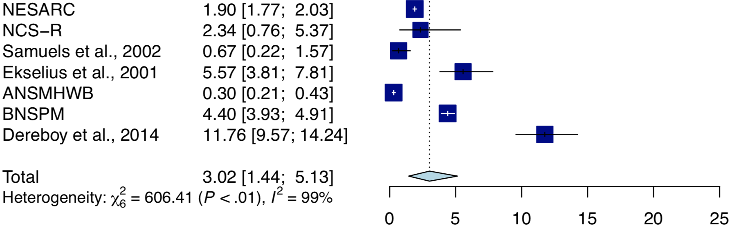
Paranoid
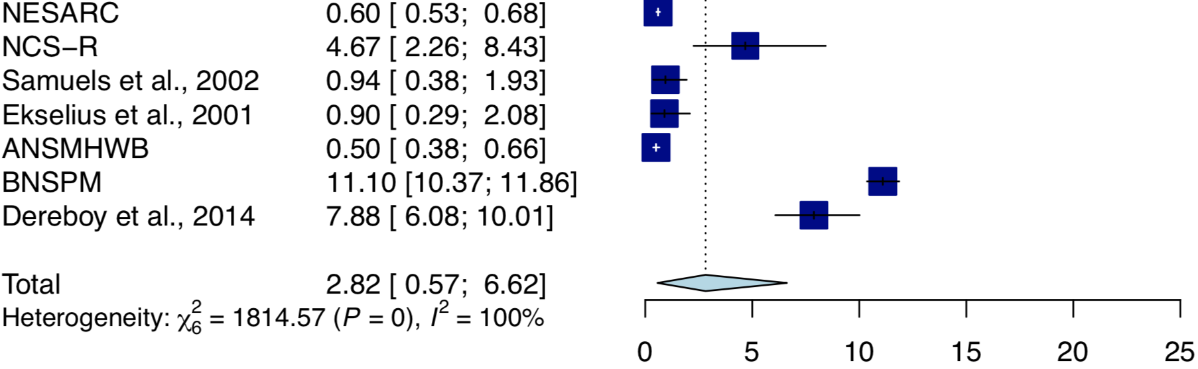
Schizoid
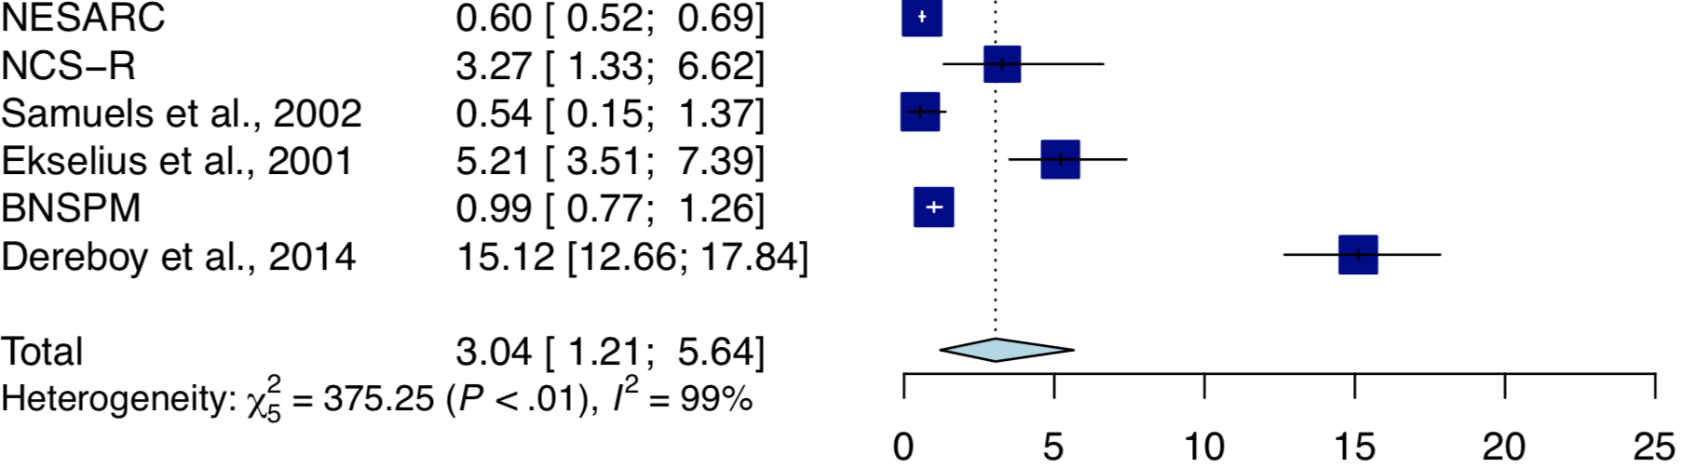
Schizotypal
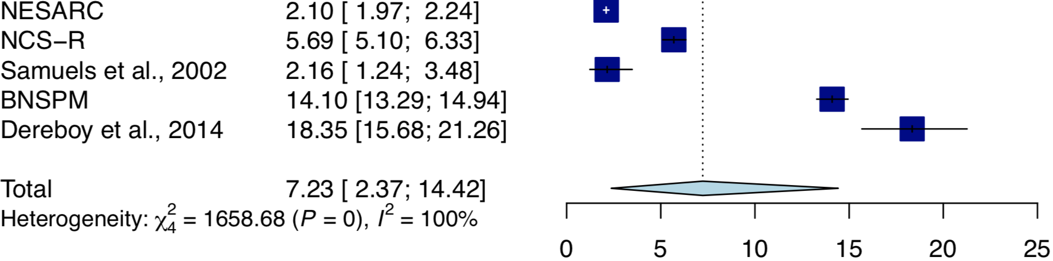
Any Cluster A

Fig. 2s Prevalence of Cluster A Personality Disorders
Note: Studies NESARC = National Epidemiologic Survey on Alcohol and Related Conditions, NCS-R = National Comorbidity Survey-Replication, ANSMHWB = Australian National Survey of Mental Health and Wellbeing Part II, BNSPM = British National Survey of Psychiatric Morbidity 2000.

Study | Prevalence rate [95% CI]
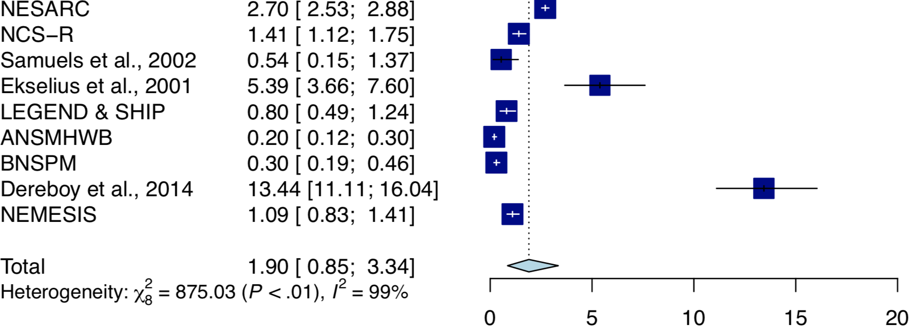
Borderline
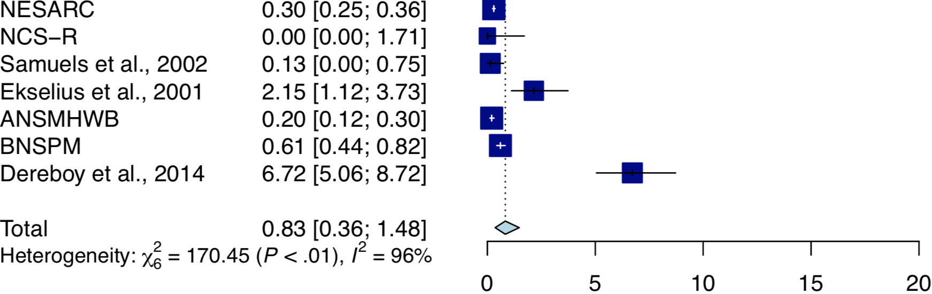
Histrionic
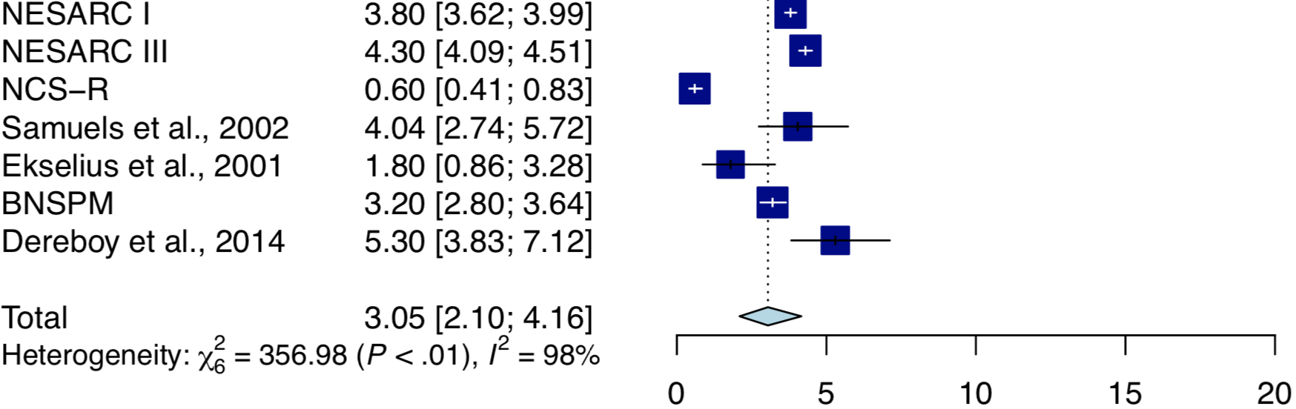
Antisocial
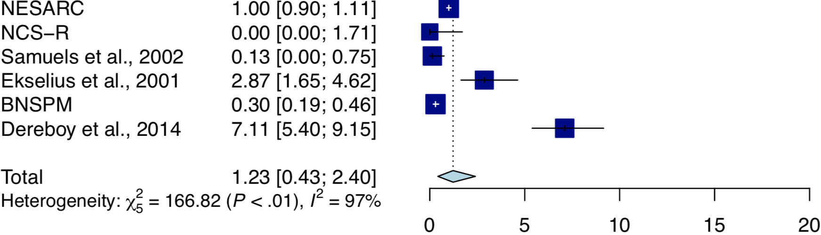
Narcissistic
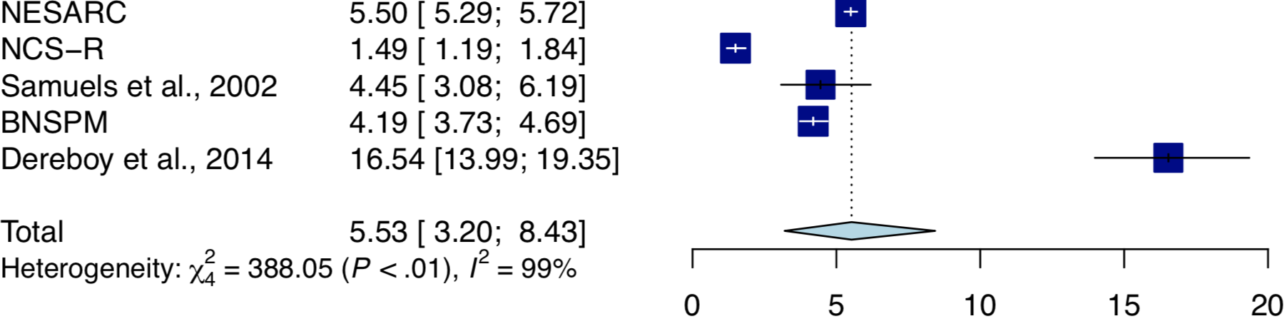
Any Cluster B

Fig. 3s Prevalence of Cluster B Personality Disorders
Note: Studies NESARC = National Epidemiologic Survey on Alcohol and Related Conditions, NCS-R = National Comorbidity Survey-Replication, LEGEND = Life-Events and Gene-Environment Interaction in Depression; SHIP = Study of Health in Pomerania, ANSMHWB = Australian National Survey of Mental Health and Wellbeing Part II, BNSPM = British National Survey of Psychiatric Morbidity 2000, NEMESIS-Netherlands Mental Health Survey and Incidence Study-2.

Study | Prevalence rate [95% CI]
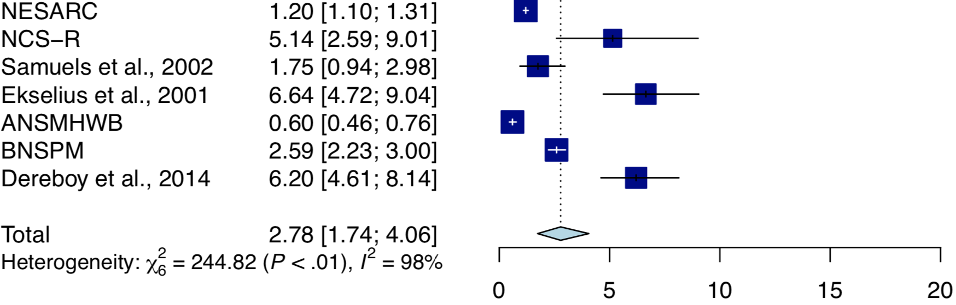
Avoidant
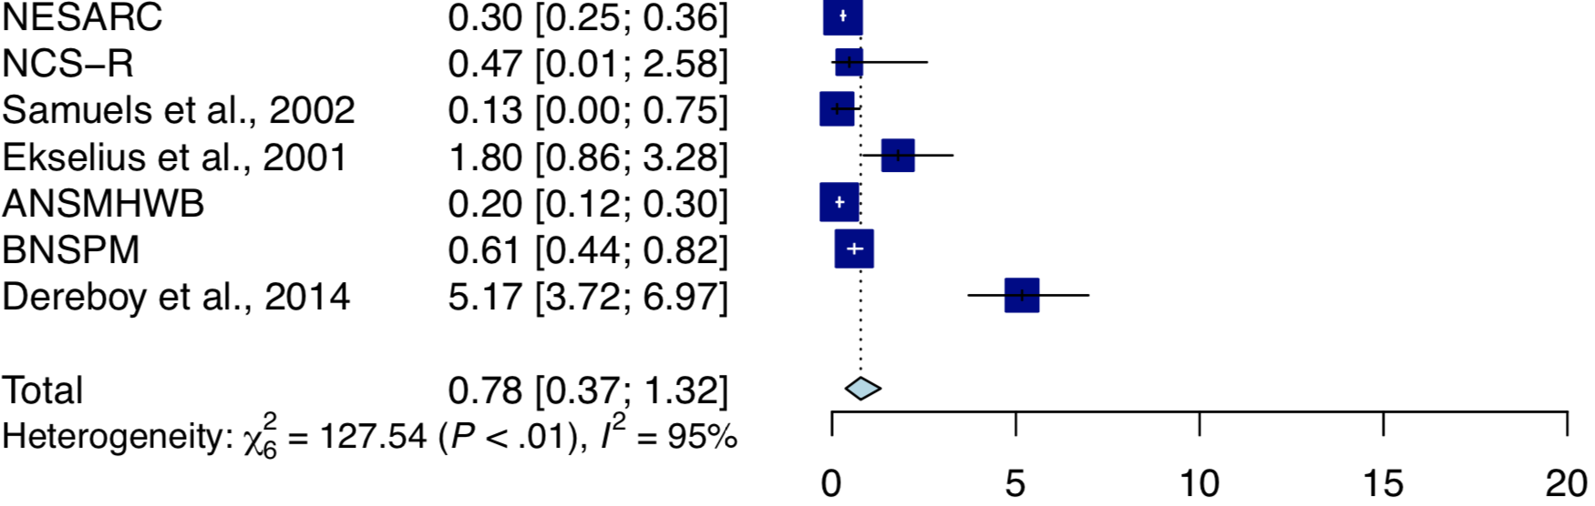
Dependent
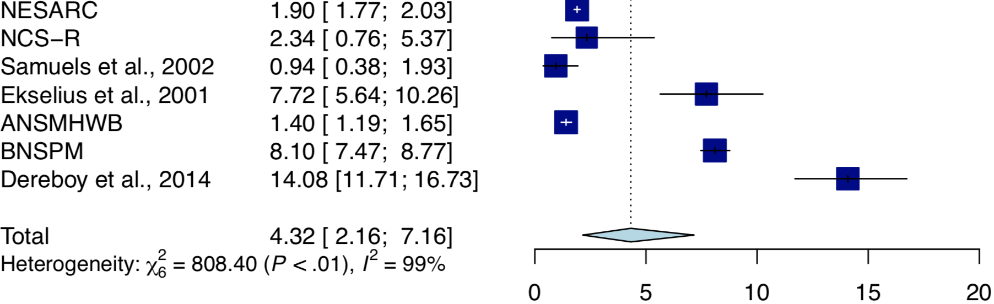
Obsessive-Compulsive
Any Cluster C
Fig. 4s Prevalence of Cluster C Personality Disorders
Note: Studies NESARC = National Epidemiologic Survey on Alcohol and Related Conditions, NCS-R = National Comorbidity Survey-Replication, ANSMHWB = Australian National Survey of Mental Health and Wellbeing Part II, BNSPM = British National Survey of Psychiatric Morbidity 2000.

