Supplementary Online Content
Fanfan Zheng, Baoliang Zhong, Xiaoyu Song, Wuxiang Xie. Persistent depressive symptoms and cognitive decline in older adults: the English Longitudinal Study of Ageing. British Journal of Psychiatry.

Supplementary Table 1. Linear associations between sum of CES-D scores (wave 1 and wave 2, range: 0-16) and baseline cognitive scores: cross-sectional analyses using multiple linear regressions
Supplementary Table 2. Adjusted relative risk (RR) of mild cognitive impairment (MCI) associated with depressive symptoms
Supplementary Table 3. Comparison of baseline characteristics between participants included (n=7610) and excluded because of loss to follow-up (n=1263)
Supplementary Table 4. Association between sum of CES-D scores (wave 1 and wave 2, range: 0-16) and rate of change in cognitive scores (points/year): longitudinal analyses using linear mixed models, with multiple imputation for missing data for cognitive tests at wave 3 to wave 7, n=8873
Supplementary Table 5. Mean difference in rate of change in cognitive scores (points/year) comparing the number of waves with depressive symptoms (wave 1 to wave 2): longitudinal analyses using linear mixed models, with multiple imputation for missing data for cognitive tests at wave 3 to wave 7, n=8873
Supplementary Table 6. Prevalence of depressive symptoms at wave 1 to wave 7, according to the number of occasions (wave 1 to wave 2) with depressive symptoms
Supplementary Figure 1. Flow chart showing process of inclusion of the study population
Supplementary Figure 2. Baseline cognitive scores and 95% confidence intervals by the number of waves with depressive symptoms (wave 1 to wave 2).

This supplementary material has been provided by the authors to give readers additional information about their work.
Supplementary Table 1. Linear associations between sum of CES-D scores (wave 1 and wave 2, range: 0-16) and baseline cognitive scores: cross-sectional analyses using multiple linear regressions
Baseline cognitive scores | Model 1* |  |  | Model 2**
Baseline cognitive scores | β (95% CI) | P value |  | β (95% CI) | P value
Global cognitive scores | –0.446 (–0.499 to –0.394) | <0.001 |  | –0.310 (–0.365 to –0.255) | <0.001
Memory scores | –0.164 (–0.185 to –0.143) | <0.001 |  | –0.119 (–0.141 to –0.096) | <0.001
Executive function scores | –0.273 (–0.314 to –0.232) | <0.001 |  | –0.183 (–0.226 to –0.140) | <0.001
Orientation scores | –0.010 (–0.013 to –0.006) | <0.001 |  | –0.008 (–0.012 to –0.005) | <0.001
*Model 1: adjusted for baseline age and sex.
**Model 2: further adjusted for baseline body mass index, education, marital status, current smoking, alcoholic drink, antidepressant medication, hypertension, diabetes, depressive symptoms×diabetes interaction, coronary heart disease, stroke, chronic lung disease, and cancer.
CES-D, Center for Epidemiologic Studies Depression.
Supplementary Table 2. Adjusted relative risk (RR) of mild cognitive impairment (MCI) associated with depressive symptoms
 | RR (95% CI) of MCI by number of waves with depressive symptoms |  |  | For each 1 increase | P for trend
 | 0 (n=5928) | 1 (episodic, n=1157) | 2 (persistent, n=525) | For each 1 increase | P for trend
Model 1* | 0.00 (ref) | 1.17 (1.11 to 1.22) | 1.39 (1.29 to 1.50) | 1.18 (1.14 to 1.21) | <0.001
Model 2** | 0.00 (ref) | 1.13 (1.08 to 1.19) | 1.28 (1.18 to 1.40) | 1.13 (1.10 to 1.17) | <0.001
*Model 1: adjusted for time, baseline age and sex.
**Model 2: further adjusted for baseline body mass index, education, marital status, current smoking, alcoholic drink, antidepressant medication, hypertension, diabetes, depressive symptoms×diabetes interaction, coronary heart disease, stroke, chronic lung disease, and cancer.

Supplementary Table 3. Comparison of baseline characteristics between participants included (n=7610) and excluded because of loss to follow-up (n=1263)
Characteristic | Included (n=7610) | Loss to follow-up (n=1263) | P for difference*
Age (years) | 65.2±10.1 | 69.0±11.4 | <0.001
Women (%) | 4338 (57.0) | 693 (54.9) | 0.156
Body mass index (kg/m²) | 27.9±4.4 | 27.7±4.0 | 0.155
Systolic blood pressure (mm Hg) | 136.0±18.5 | 138.8±20.4 | 0.001
Diastolic blood pressure (mm Hg) | 75.8±10.8 | 75.1±12.2 | 0.141
Education ≥NVQ3/GCE A level (%) | 2521 (33.1) | 266 (21.1) | <0.001
Living alone (%) | 2493 (32.8) | 467 (37.0) | 0.003
Current smoking (%) | 1151 (15.1) | 234 (18.5) | 0.002
Alcoholic drink ≥once per week (%) | 4217 (55.4) | 567 (44.9) | <0.001
Hypertension (%) | 3177 (41.8) | 517 (40.9) | 0.587
Diabetes (%) | 588 (7.6) | 119 (9.4) | 0.024
Coronary heart disease (%) | 521 (6.9) | 119 (9.4) | 0.001
Stroke (%) | 196 (2.6) | 63 (5.0) | <0.001
Chronic lung disease (%) | 377 (5.0) | 87 (6.9) | 0.004
Cancer (%) | 396 (5.2) | 87 (6.9) | 0.015
Depressive symptoms at wave 1 (%) | 1088 (14.3) | 240 (19.0) | <0.001
Depressive symptoms at wave 2 (%) | 1119 (14.7) | 251 (19.9) | <0.001
Depressive symptoms at both wave 1 and wave 2 (%) | 525 (6.9) | 124 (9.8) | <0.001
Global cognitive scores | 34.3±8.6 | 30.1±9.6 | <0.001
Memory scores | 10.2±3.5 | 8.7±3.8 | <0.001
Executive function scores | 20.3±6.4 | 17.8±6.7 | <0.001
Orientation scores | 3.78±0.50 | 3.63±0.75 | <0.001
The results are presented as mean±SD or n (%).
*The differences between participants included and excluded were tested using t-tests or chi-square tests.
Supplementary Table 4. Association between sum of CES-D scores (wave 1 and wave 2, range: 0-16) and rate of change in cognitive scores (points/year): longitudinal analyses using linear mixed models, with multiple imputation for missing data for cognitive tests at wave 3 to wave 7, n=8873
Model terms for cognitive scores | β (95% CI)* | P value
Global cognitive scores
Time | –0.216 (–0.245 to –0.187) | <0.001
CES-D scores | –0.289 (–0.339 to –0.240) | <0.001
CES-D scores × Time | –0.011 (–0.018 to –0.004) | 0.001
Memory scores
Time | –0.086 (–0.097 to –0.075) | <0.001
CES-D scores | –0.103 (–0.121 to –0.084) | <0.001
CES-D scores × Time | –0.004 (–0.006 to –0.001) | 0.004
Executive function scores
Time | –0.101 (–0.123 to –0.078) | <0.001
CES-D scores | –0.175 (–0.213 to –0.138) | <0.001
CES-D scores × Time | –0.005 (–0.011 to –0.001) | 0.009
Orientation scores
Time | –0.011 (–0.014 to –0.009) | <0.001
CES-D scores | –0.009 (–0.012 to –0.006) | <0.001
CES-D scores × Time | –0.001 (–0.002 to –0.001) | <0.001
*Adjusted for baseline age, sex, body mass index, education, marital status, current smoking, alcoholic drink, antidepressant medication, hypertension, diabetes, depressive symptoms×diabetes interaction, coronary heart disease, stroke, chronic lung disease, and cancer.
CES-D, Center for Epidemiologic Studies Depression.
Supplementary Table 5. Mean difference in rate of change in cognitive scores (points/year) comparing the number of waves with depressive symptoms (wave 1 to wave 2): longitudinal analyses using linear mixed models, with multiple imputation for missing data for cognitive tests at wave 3 to wave 7, n=8873
 | Mean difference (95% CI) in rate of change by number of waves with depressive symptoms |  |  | P for trend
 | 0 (n=5928) | 1 (episodic, n=1157) | 2 (persistent, n=525) | P for trend
Global cognitive scores
Model 1* | 0.000 (ref) | –0.063 (–0.126 to 0.001) | –0.137 (–0.230 to –0.044) | 0.001
Model 2** | 0.000 (ref) | –0.063 (–0.125 to 0.001) | –0.137 (–0.230 to –0.044) | 0.001
Memory scores
Model 1* | 0.000 (ref) | –0.024 (–0.047 to 0.000) | –0.046 (–0.081 to –0.011) | 0.003
Model 2** | 0.000 (ref) | –0.024 (–0.047 to –0.000) | –0.046 (–0.081 to –0.011) | 0.003
Executive function scores
Model 1* | 0.000 (ref) | –0.029 (–0.076 to 0.020) | –0.073 (–0.145 to –0.002) | 0.031
Model 2** | 0.000 (ref) | –0.028 (–0.076 to 0.020) | –0.073 (–0.145 to –0.002) | 0.035
Orientation scores
Model 1* | 0.000 (ref) | –0.004 (–0.009 to 0.002) | –0.013 (–0.020 to –0.005) | 0.002
Model 2** | 0.000 (ref) | –0.004 (–0.010 to 0.001) | –0.014 (–0.021 to –0.005) | 0.001
*Model 1: adjusted for baseline age and sex.
**Model 2: further adjusted for baseline body mass index, education, marital status, current smoking, alcoholic drink, antidepressant medication, hypertension, diabetes, depressive symptoms×diabetes interaction, coronary heart disease, stroke, chronic lung disease, and cancer.
Supplementary Table 6. Prevalence of depressive symptoms at wave 1 to wave 7, according to the number of occasions (wave 1 to wave 2) with depressive symptoms
Prevalence of depressive symptoms | Number of waves with depressive symptoms at wave 1 and wave 2 |  |  |  |  |  |  |  | P for trend*
Prevalence of depressive symptoms | 0 (no) |  |  | 1 (episodic) |  |  | 2 (persistent) |  | P for trend*
Prevalence of depressive symptoms | N** | n (%) |  | N | n (%) |  | N | n (%) | P for trend*
At wave 1 (2002-2003) | 5928 | 0 (0.0) |  | 1157 | 563 (48.7) |  | 525 | 525 (100.0) | <0.001
At wave 2 (2004-2005) | 5928 | 0 (0.0) |  | 1157 | 594 (51.3) |  | 525 | 525 (100.0) | <0.001
At wave 3 (2006-2007) | 5616 | 370 (6.6) |  | 1070 | 304 (28.4) |  | 482 | 315 (65.4) | <0.001
At wave 4 (2008-2009) | 4895 | 367 (7.5) |  | 893 | 250 (28.0) |  | 384 | 231 (60.2) | <0.001
At wave 5 (2010-2011) | 4538 | 366 (8.1) |  | 827 | 256 (31.0) |  | 344 | 204 (59.3) | <0.001
At wave 6 (2012-2013) | 4173 | 310 (7.4) |  | 734 | 174 (23.7) |  | 297 | 145 (48.8) | <0.001
At wave 7 (2014-2015) | 3638 | 244 (6.7) |  | 640 | 168 (26.3) |  | 251 | 127 (50.6) | <0.001
The results are presented as or n (%).
*Calculated by using the chi-square test for trend.
**N means sample size in the group.
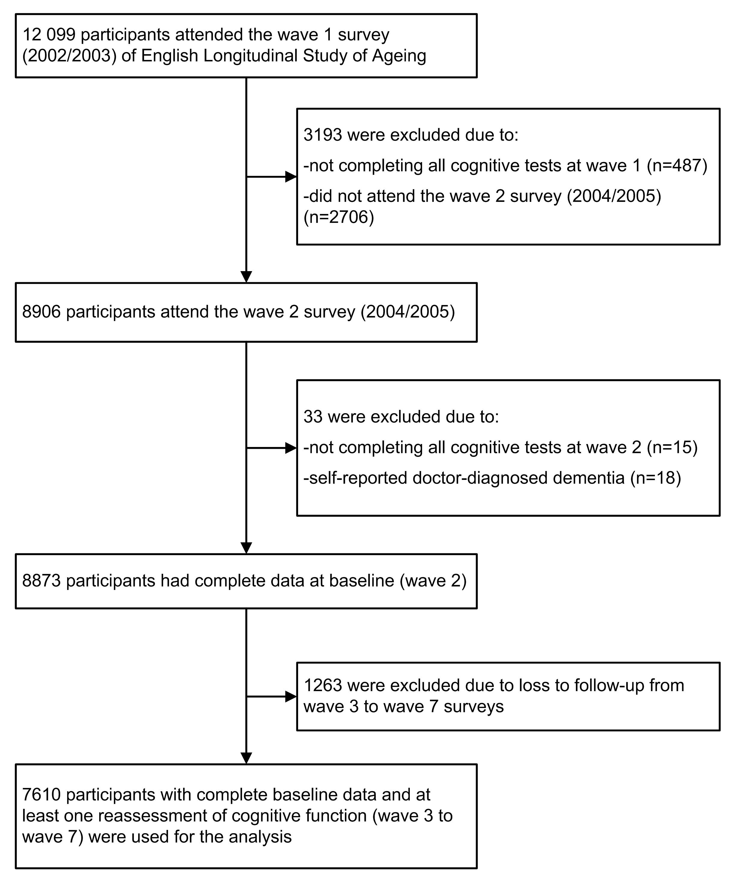
Supplementary Figure 1. Flow chart showing process of inclusion of the study population
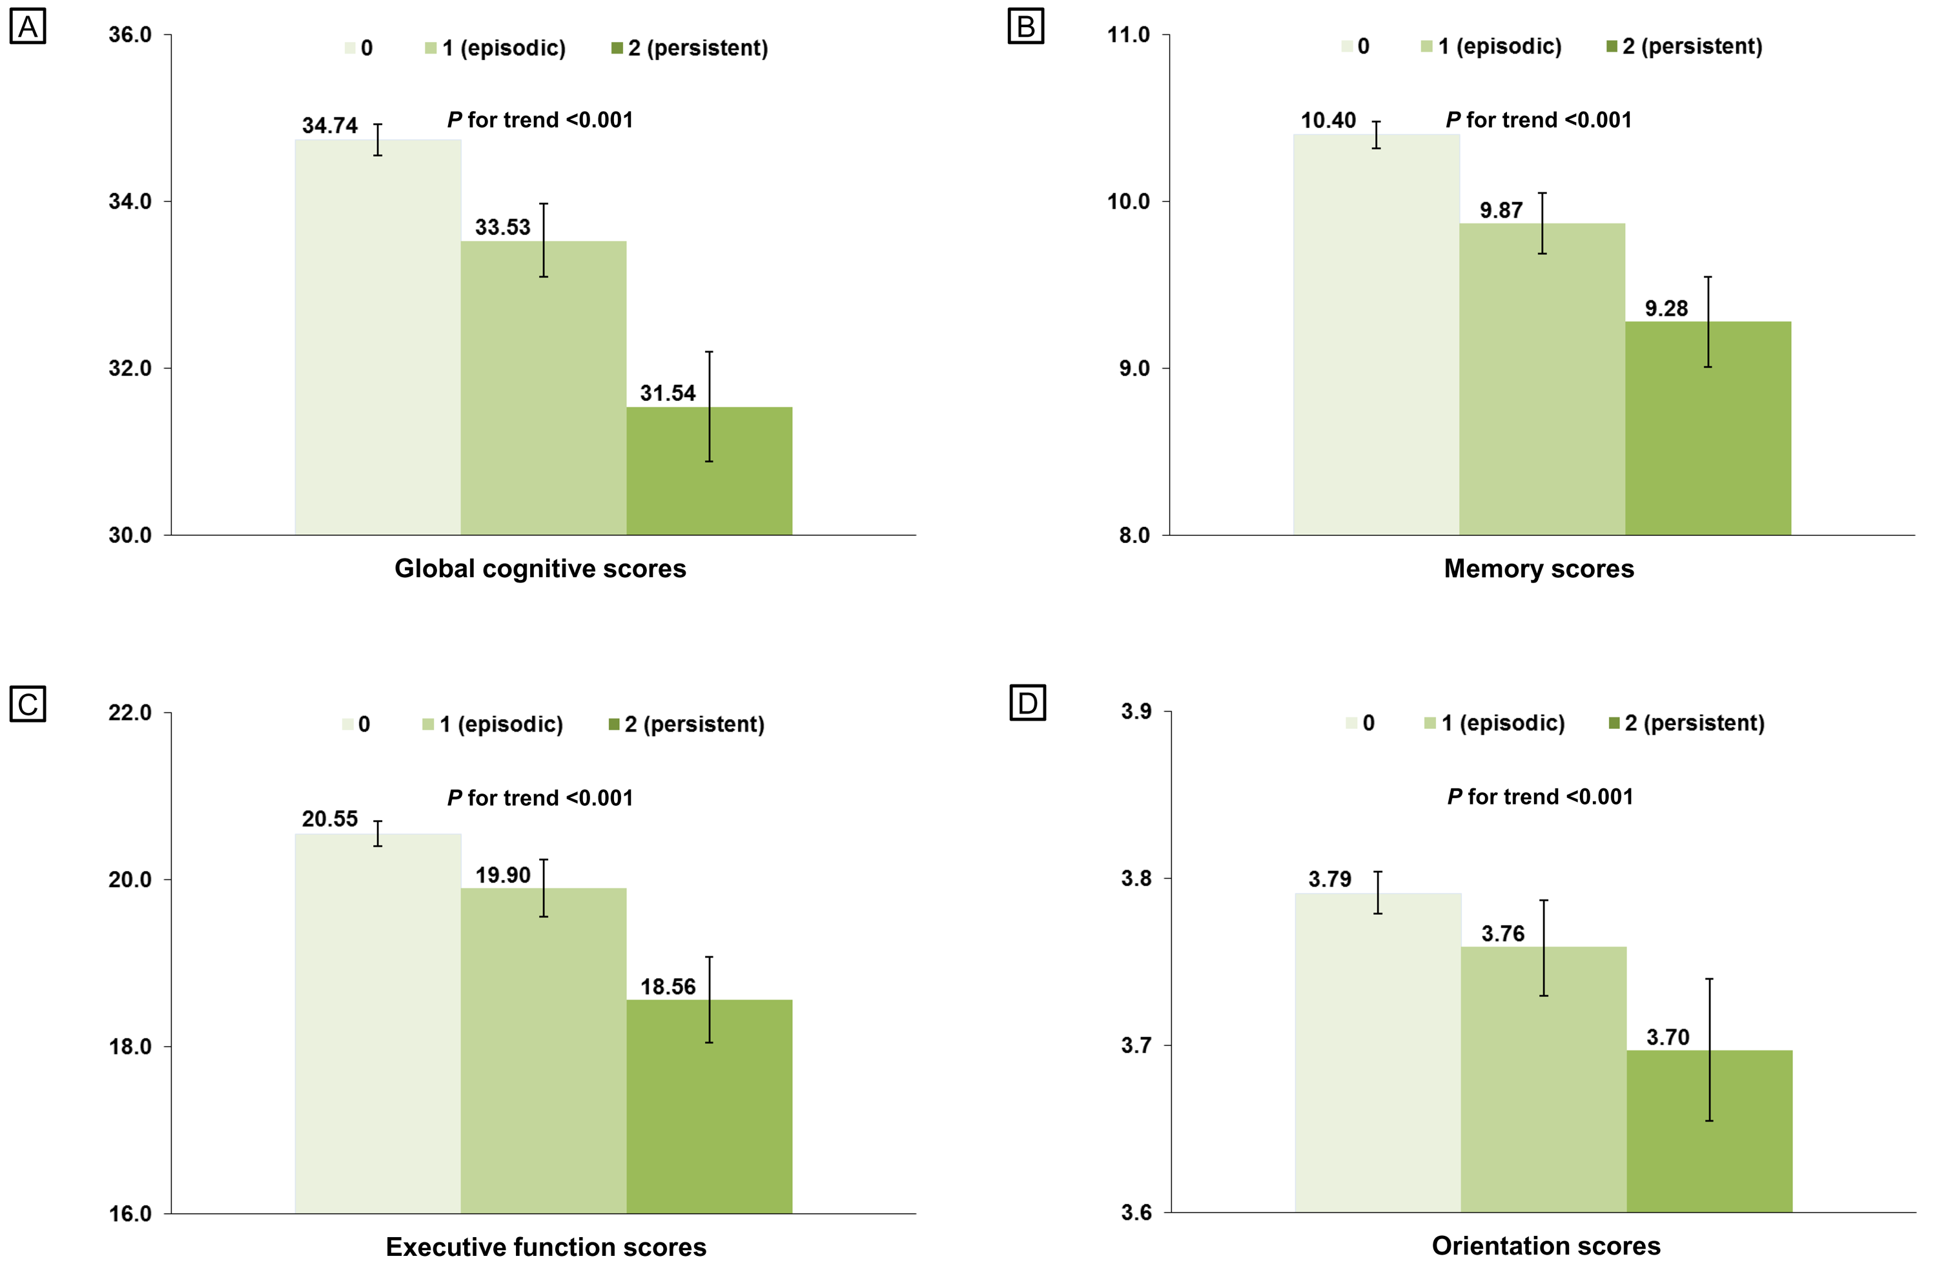
Supplementary Figure 2. Baseline cognitive scores and 95% confidence intervals by the number of waves with depressive symptoms (wave 1 to wave 2). Cross-sectional analyses using analyses of covariance, adjusted for baseline age, sex, body mass index, education, marital status, current smoking, alcoholic drink, antidepressant medication, hypertension, diabetes, depressive symptoms×diabetes interaction, coronary heart disease, stroke, chronic lung disease, and cancer.

