Supplementary Table 1: Specific antibody levels

Percentages shown represent the percentage of patients below the respective cutoff value in the first column. Data shown represent mean values. * Independent t test (normally distributed) or † Mann-Whitney (non-normally distributed, according to D’Agostino-Pearson Normality Testing). Levels of significance: */† p<0.05, **/†† p<0.005, ***/††† p<0.0005, ****/†††† p<0.0001, ns non-significant.

Supplementary Table 2: Linear regression analysis
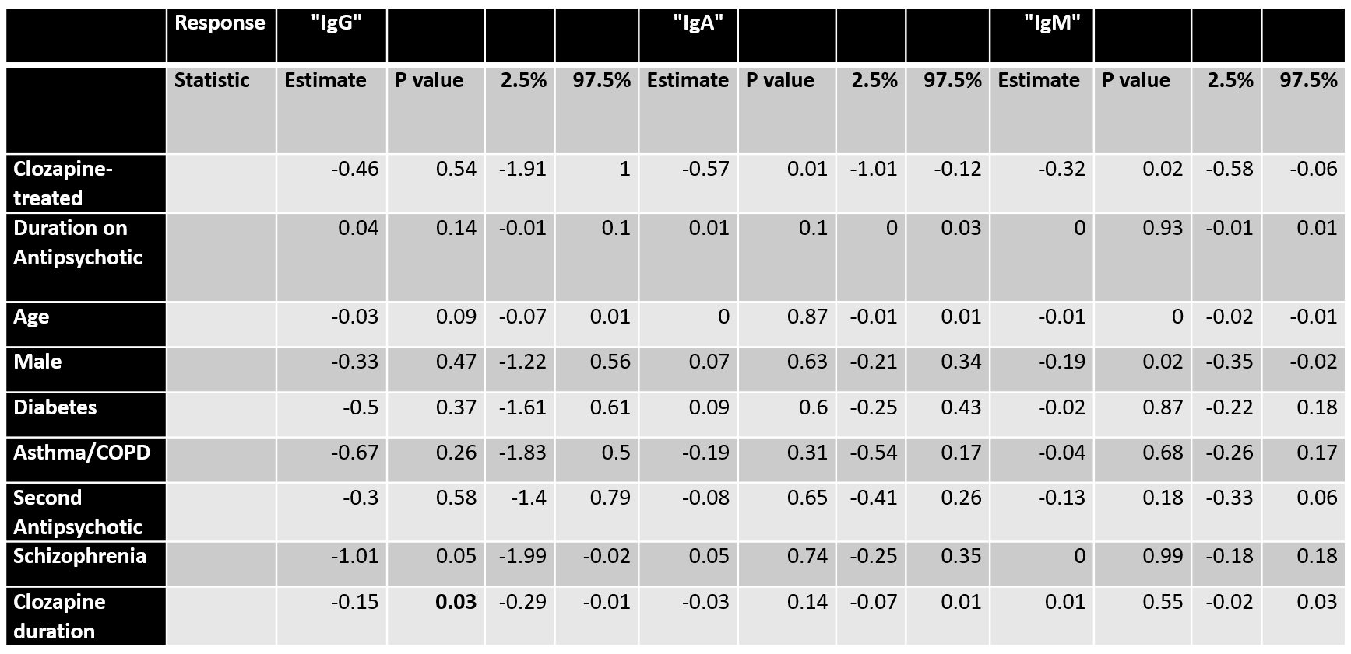
Linear regression of IgA/IgG/IgM on Clozapine or other antipsychotic use, adjusting for demographics and co-morbidities. For IgG: significant annual decrease on Clozapine (decrease of 0.15 g/L/year, p = 0.03); for IgA: significant global decrease on Clozapine (decrease of 0.57 g/L, p = 0.01); for IgM: significant global decrease on Clozapine (decrease of 0.32 g/L, p = 0.02).

Supplementary Table 3: Modeled impact of clozapine duration on serum IgG
 | Predicted impact on serum IgG of starting antipsychotic therapy in a 40 year old male:
Antipsychotic: | Duration/ years | 0 | 5 | 10 | 15 | 20 | 25
Clozapine | Lower Limit 95% CI | 9.79 | 9.38 | 8.66 | 7.63 | 6.43 | 5.16
 | Mean IgG, g/L | 11.31 | 10.61 | 9.9 | 9.2 | 8.49 | 7.79
 | Upper Limit 95% CI | 12.83 | 11.83 | 11.15 | 10.77 | 10.55 | 10.41
Non-Clozapine | Lower Limit 95% CI | 10.65 | 10.77 | 10.82 | 10.8 | 10.72 | 10.59
 | Mean IgG g/L | 11.77 | 11.82 | 11.87 | 11.93 | 11.98 | 12.03
 | Upper Limit 95% CI | 12.88 | 12.87 | 12.93 | 13.05 | 13.24 | 13.47

