Online supplement C. Schematic overview of the differing and corresponding elements in the two treatments.

 | NNBT | STreSS
Number of participants | n=43 | n=41
Environment | The therapy garden Nacadia® – outdoors  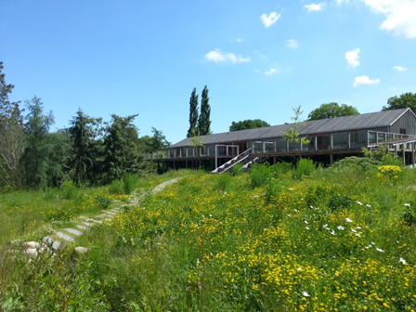 | At clinics – indoors  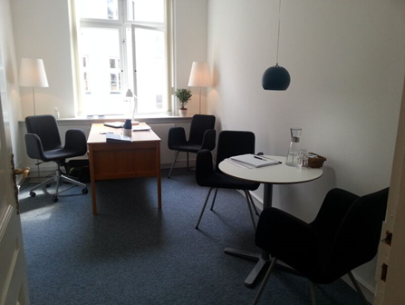
Therapists and other staff | 2 therapists and 1 gardener | 1 therapist
Length of treatment | 10 weeks | 10 weeks
Treatment content | 96 hours, including:  - 79 hours in the garden  - 10x1/2 hours of individual therapeutic conversations  - 4x3 hours of group transition conversations | 20 hours, including:  - 16 hours of individual therapeutic conversations  - 4x1 hours of individual transition conversations
Treatment setup | Groups of max. 8 and min. 4 participants | Individual

