Online supplement B1.Overview of participants recruited from the different sources.

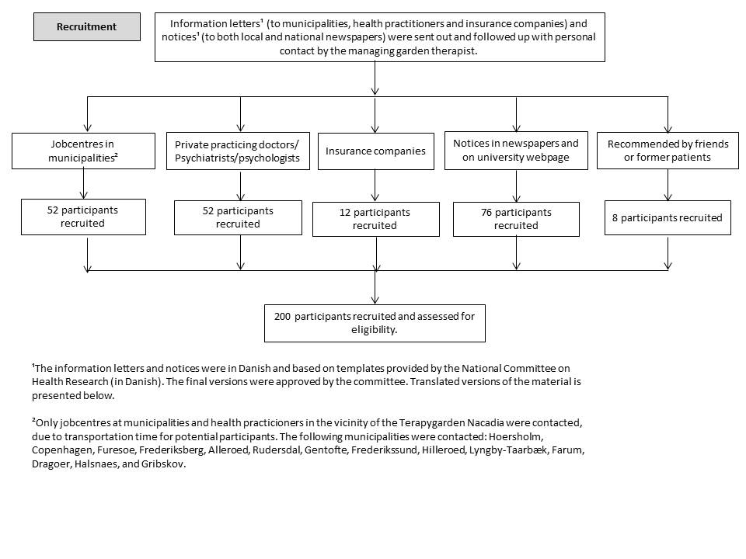

Online supplement B2: Informationletter to municipalities and health practioners

Treatment of and research into serious cases of stress - NEST
In August 2013, a treatment and research project started, which is designed to compare the effects of garden therapy and individual cognitive behavioural therapy.
The project is receiving financial support from the Tryg Foundation, and the treatment is provided free of charge to both the test subjects and local authorities.

Treatment goals
- to bring test subjects closer to a return to work
- to ameliorate stress symptoms and teach subjects to cope with and prevent stress
- to improve physical and mental balance
- to enhance quality of life
- to regain previous skills and acquire new ones that reduce and prevent stress.

Nature-based therapy
The emphasis is on creating a safe and peaceful environment that meets the individual subject on their own terms – in other words, the treatment is tailored to the individual.
The garden is used as a therapeutic tool that gives subjects the time and opportunity to immerse themselves in nature. Gardening activities are an important element in the treatment. They are optional and consist of specific tasks determined by the season and the subjects’ abilities. The treatment incorporates aspects of mindfulness, encouraging subjects to spot patterns of inappropriate behaviour and actions that might trigger stress. The project also involves practising new and more appropriate approaches to work and everyday life.
The subjects attend therapeutic counselling sessions for half an hour per week for eight of the weeks of the project.
The garden-therapy treatment is in groups of max. eight subjects, under the guidance of two garden therapists.

Control group: intensive individual cognitive behavioural therapy

Subjects for the individual cognitive behavioural therapy are attending 16 sessions with a psychologist in Hørsholm or Hillerød over 10 weeks. During these sessions, the subject and therapist explore difficulties in the subject’s everyday life and work. They jointly set targets for the therapy and find methods that will help the subject better cope with and accept their symptoms and discomfort.
The subject will learn to recognise the interrelationships between their thoughts, feelings, senses and actions. The focus may be on changing thought patterns in ways that make it easier for the subject to relate to the challenges and the stress they face in life right now. The project also provides information and an opportunity to talk about stress and stress management, as well as individually tailored exercises that teach the subjects new ways of thinking and acting. Subjects will also be expected to do exercises at home between sessions.
Follow up and get back to work
The project includes follow-up on the subjects at one, three, six and 12 months after the end of the treatment.
Some subjects will have a job to return to. For those who do not, the project has linked up with consultants from Incita and Væksthuset. The local authority pays the job consultants, who work with the subject and therapist to identify opportunities, limitations and wishes in relation to getting a job. This process starts in week six of the treatment. If the subject would like to try a work placement – and the caseworker agrees – the consultants can help arrange this after treatment has been completed. Similar projects have shown that there is a need for a gradual return to full-time work following a course of treatment like this. We therefore recommend that subjects and caseworkers consider possible work placements.
The doctor:
For a patient to be considered for the project, their doctor must attest that they have been unfit for work due to stress for 3–24 months, and have not worked at all in the last three months prior to the start of the treatment.
The doctor must also attest that the patient has no other underlying significant and untreated physical or mental disorders, and that they are not potentially suicidal or abusers of alcohol or drugs. However, stress-related anxiety or depression are not obstacles to participation.
The local authority:
As the treatment involves three-hour sessions of garden therapy three times a week, the local authority concerned must be prepared to recognise that the treatment will be the patient’s primary activity during the 10-week period. To that end, we have entered into an agreement with the following councils – Rudersdal, Hørsholm, Allerød, Furesø, Frederiksberg and the City of Copenhagen. They are aware of the project and are generally positive about it.

Start dates

14 October 2013, 3 February, 22 April, 11 August 2014

The whole treatment runs for ten weeks, with gardening sessions on Monday, Wednesday and Friday, 9:30 am–12:30 pm. During the last two weeks only on two days.

Each group consists of max. eight subjects for both garden therapy and cognitive therapy.
After the initial evaluation, lots are drawn to allocate subjects to the two different forms of therapy.

Subjects:
In order to participate in the project, it is important that the patient:
- is aged 20–60
- has read about the project, e.g. on www.nacadia.dk, and still wants to take part
- is prepared to accept that lots will be drawn and they may be allocated to either garden therapy or individual cognitive therapy
- wants to return to work – and this is a realistic prospect
- is able to travel to the garden therapy sessions in Hørsholm three mornings a week, or to individual therapy sessions in Hørsholm/Hillerød
- is prepared to accept that it may be a demanding process in which they may at times falter or regress, and which often requires subjects to challenge themselves mentally/psychologically
- is not about to undergo any major upheaval in life, such as relocation, divorce, etc.
- is prepared to spend most of the time outdoors all year round
- is able to be part of a group (not too high a degree of social phobia)
- is prepared to fill out a set of questionnaires five times in the course of a year, and be interviewed by researchers approx. three times
- is prepared to explore mindfulness through meditation and yoga, and to spend an hour doing physical exercise each day at home (for those allocated to garden therapy) or practice exercises at home (for those allocated to cognitive therapy).

Contact details:
E-mail Ulrik Sidenius at ulriksp@life.ku.dk or call +45 3533 6786 if you have any questions or would like to book a time for a preliminary talk on the phone.

Online supplement B3: Notice to local and national newspapers

